John Russell Strauss
902455731
Fundamentals of Computer Graphics
Vector Fields

A vector field is an infinitely continuous space which takes the form of a vector. We can defin a vector field

where M and N are functions of x and y. That is, the vector in a vector field depends on the observed location within the field. To visualize a vector field, we can designate a certain interval of sample points and display the resulting vectors at each location in the field. An example of a vector field in life is gravitational force. While two bodies in space exhibit forces on each other, the strength of that force depends on its proximity to the other body, and thus the vector fields representing these forces are a function of the planets’ sizes and distances to each other.

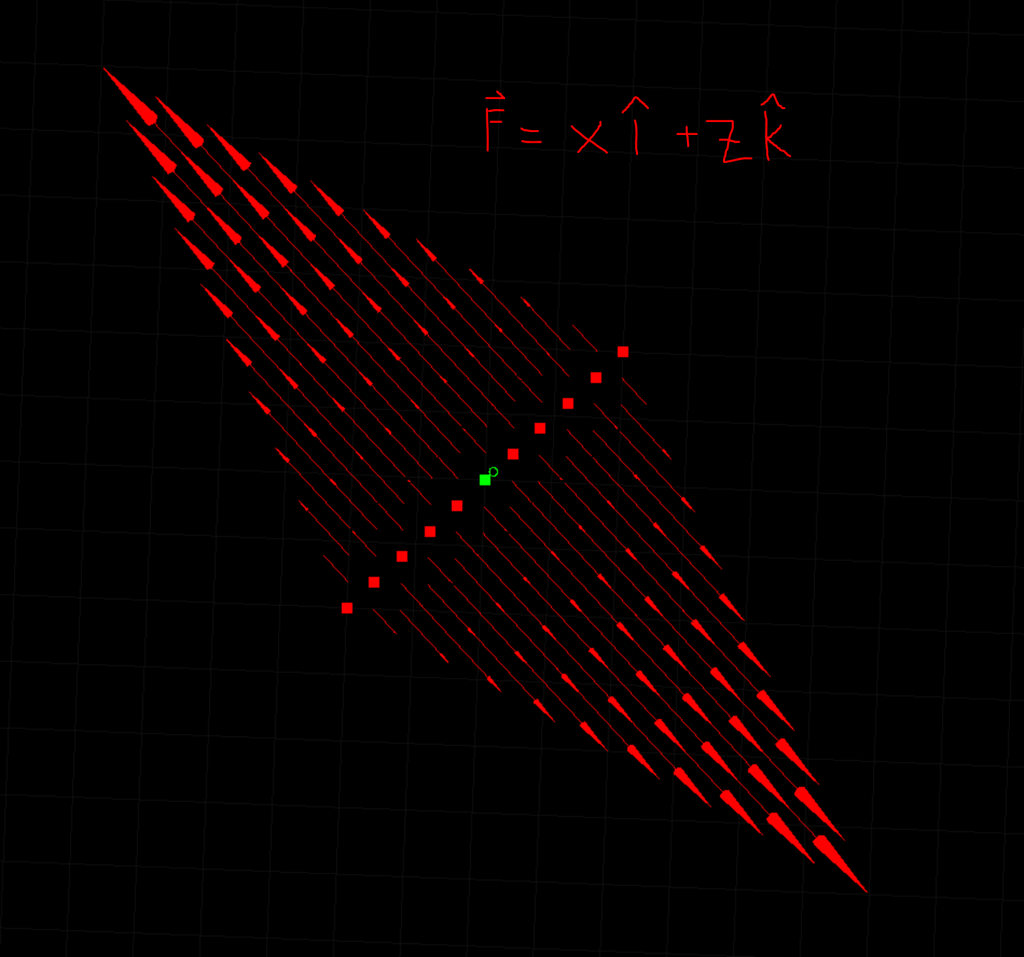
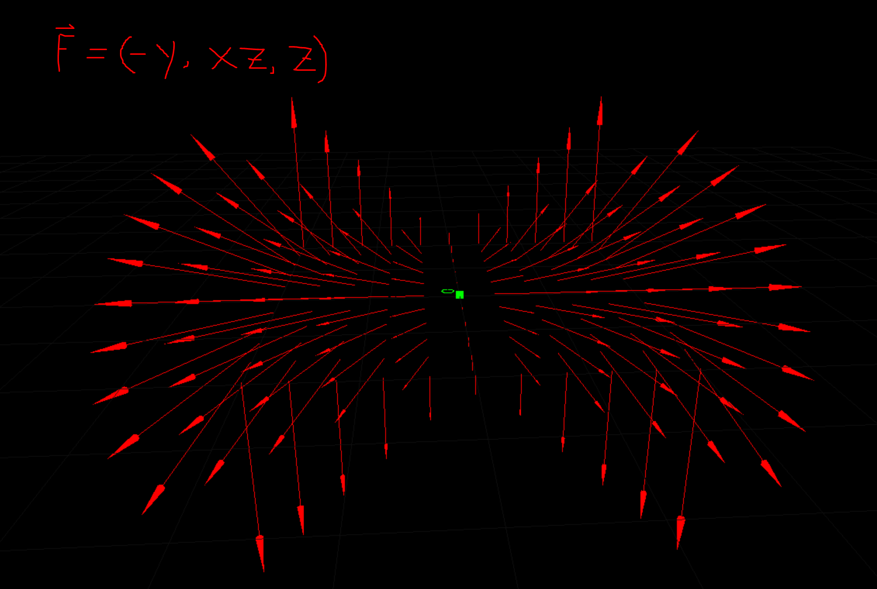

Vector fields are commonly used to move particles. You might imagine a feather blowing in the wind where the field represents the wind—we could trace the trajectory of the feather by applying force to it at every location as it moves. We may also want to use a vector field to apply forces to many particles at once, such as smoke rising from a bonfire or water in a hurricane.

References
- MIT OpenCourseWare 18.02 Multivariate Calculus, Denis Auroux - https://www.youtube.com/watch?v=xrypSZU8cBE

