eProject is a client – server application and required Microsoft SQL server to be running the application database on a “server” on your network.

If your network is currently not running a SQL Server then download and install the free Microsoft SQL Server Express edition from here:

32 bit version <https://www.microsoft.com/betaexperience/pd/SQLEXPDBMT32/enus/default.aspx>

64 bit version

<https://www.microsoft.com/betaexperience/pd/SQLEXPDBMT64/enus/default.aspx>

### Install SQL Server Express 2008 R2 (32 bit version)

1. Launch the installer and click on “New installation or add features to an existing installation”. A Please wait dialog will pop up followed by a rule check.

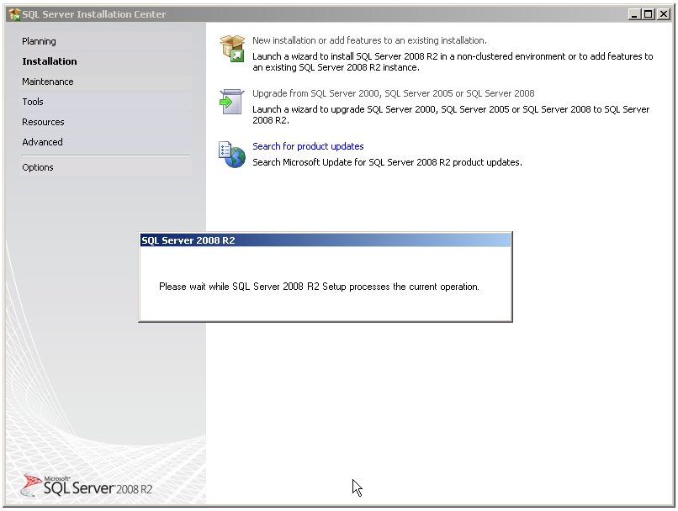

1. Click OK when the rule check completes successfully. Agree to the license terms and click on next to install the support files.

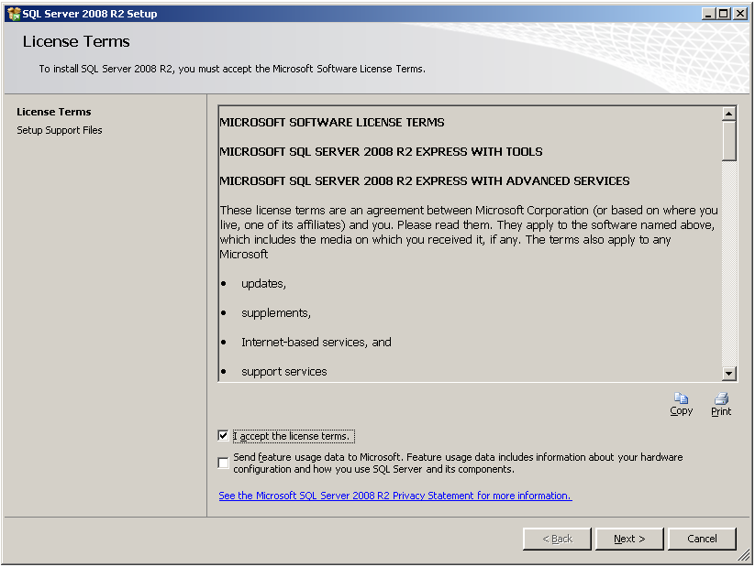

1. Tip: If any support rules fail do not close the installer. Fix the problem then click re-run.

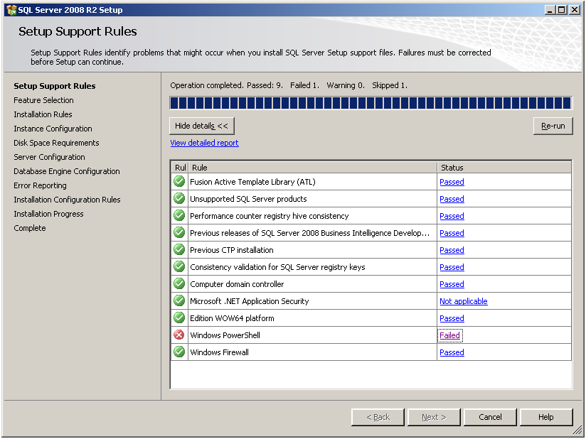

1. Leave the default feature selection unchanged.

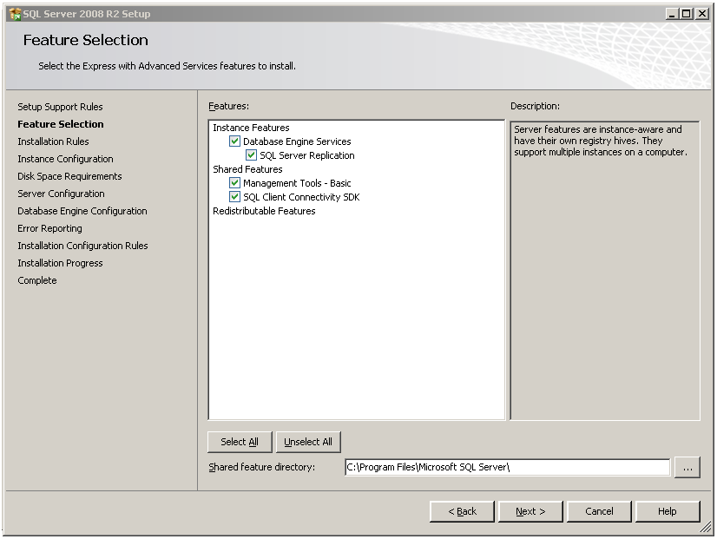

1. Leave the default instance configuration

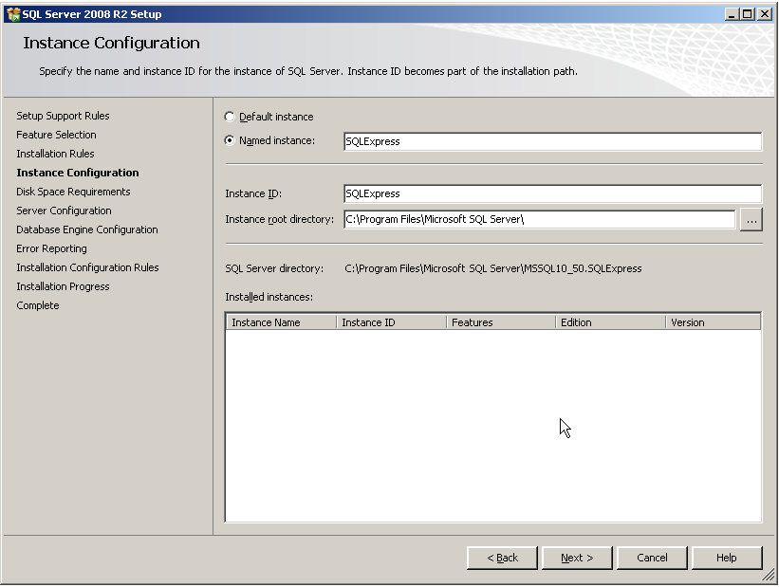

1. Set the account for the database engine. Suggest using the system account.

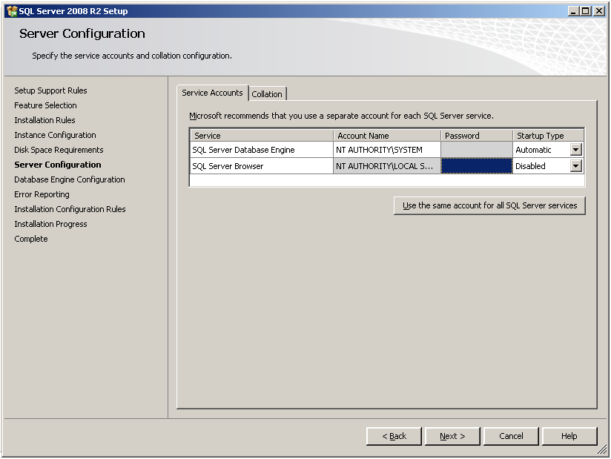

1. On the engine configuration set security to mixed mode and enter a password. This password will be used in the connection string from the workstation installs of eProject.

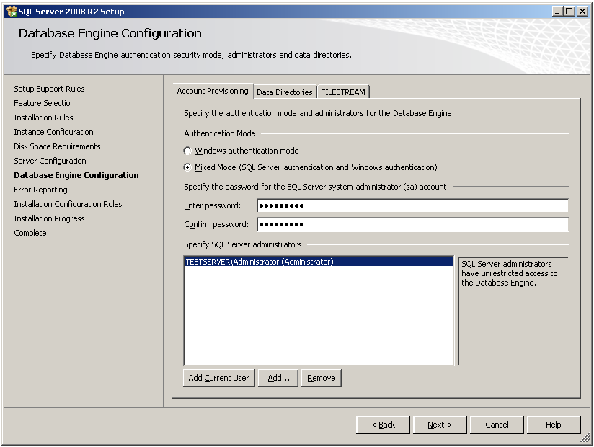

1. Click next and check the box to send error reports to Microsoft. This helps Microsoft find problems and make the product better. The installation should then commence.
2. By default SQL Express does not have remote connections enebled. This must be manually enabled so that client workstations can connect to databases.
   1. Open SQL Server Configuration Manager. Click Start -> Programs -> Microsoft SQL Server 2008 R2 -> Configuration Tools -> SQL Server Configuration Manager.
   2. On SQL Server Configuration Manager, select SQL Server Services on the left window. If the state on SQL Server Browser is not running, you have to configure and start the service. Otherwise, you can skip to step .

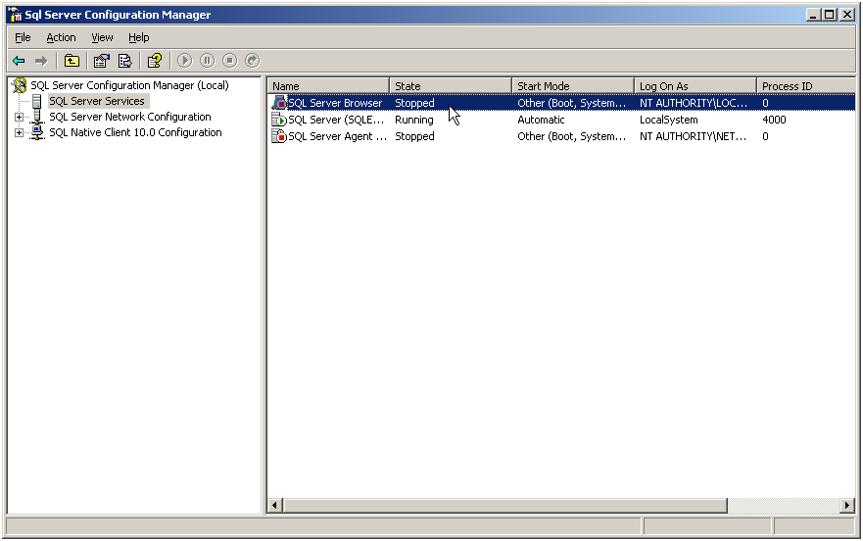

* 1. Double-click on SQL Server Browser, the Properties window will show up. Set the account for start SQL Server Browser Service. In this example, I set to Local Service account.

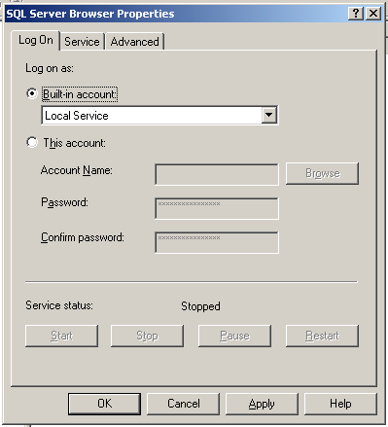

* 1. On SQL Server Browser Properties, move to Service tab and change Start Mode to Automatic. Therefore, the service will be start automatically when the computer starts. Click OK to apply changes.

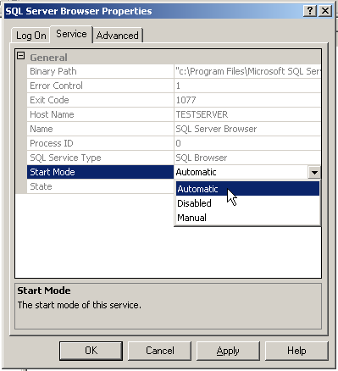

* 1. Back to SQL Server Configuration Manager, right-click on SQL Server Bowser on the right window and select Start to start the service.
  2. On the left window, expand SQL Server Network Configuration -> Protocols for SQLEXPRESS. You see that TCP/IP protocol status is disabled.
  3. Right-click on TCP/IP and select Enable to enable the protocol.

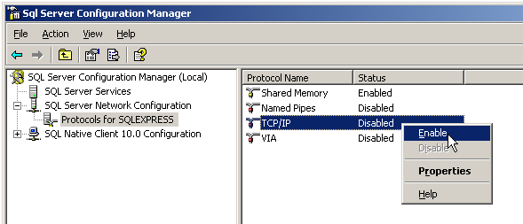

* 1. There is a pop-up shown up that you have to restart the SQL Service to apply changes.

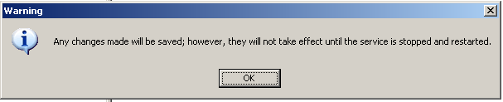

* 1. On the left window, select SQL Server Services. Select SQL Server (SQLEXPRESS) on the right window -> click Restart. The SQL Server service will be restarted.

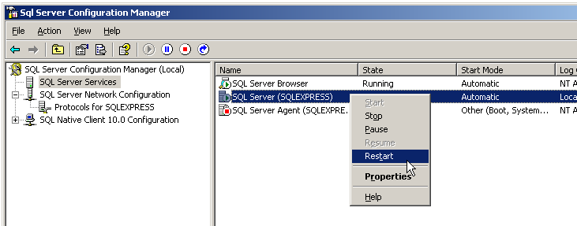

* 1. You should now be able to connect to SQL Server remote and can continue with building the eProject Database.

### Install the eProject Database

1. The eProject Database will be installed using eProject.DB.Install.exe. It is suggested that you try and install the database from a workstation to check that your SQL Server is accessible from a remote machine.
2. The installer will search for available SQL Servers on your local network. Use the drop down to select the server you have just installed. The username should be sa and the password should be whatever you used in step 7.0.

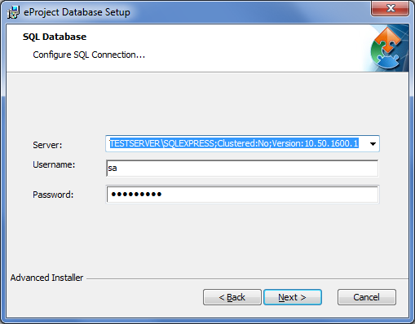

1. Click next to execute the SQL install scripts and complete the installation of the database.

### Install the eProject Client

1. Once the database is successfully installed you can continue installing the eProject application on your workstations.
2. Run eProject.Client.Setup.exe and accept the license agreement.
3. On the database connection string page enter the full connecting string to the newly installed SQL Server database.

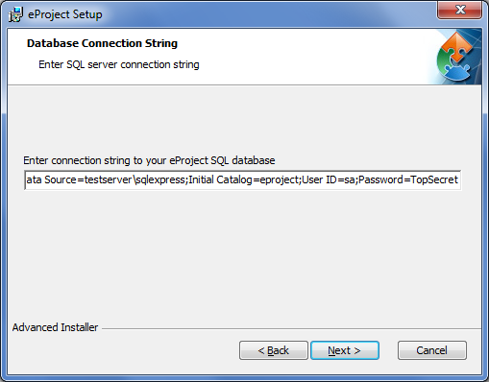

The default connection string is

Data Source=<servername>\sqlexpress;Initial Catalog=eproject;User ID=sa;Password=<password>

Replace <servername> with the machine name of the server you installed SQL Server on.

Replace <password> with the password you created for the sa user account.

1. Continue setting up the application as described in the help file.

C:\Program Files\eProject\eProject.chm 