Screening Report

This report summarizes results from all dose-response experiments. **Consult assay documentation for detailed experimental procedures.**

## Experimental Data Heat Map

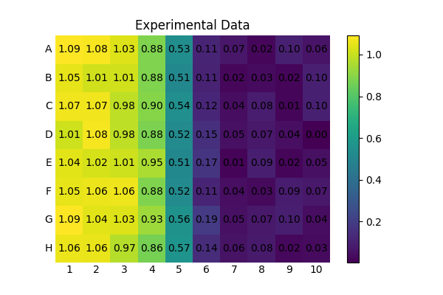

## Sample IC50s

|  |  |
| --- | --- |
| Sample ID | IC50 [M] |
| Sample 1 | 1.175E-05 |
| Sample 2 | 1.222E-05 |
| Sample 3 | 9.502E-06 |
| Sample 4 | 1.036E-05 |
| Sample 5 | 1.044E-05 |
| Sample 6 | 1.028E-05 |
| Sample 7 | 9.515E-06 |
| Sample 8 | 9.896E-06 |

## Model Fits

