Lab 04
Energy Operations Weather Agent
Microsoft Copilot Studio — Intermediate Lab Walkthrough
Duration: 2.5 hours | Difficulty: Intermediate
Skills Covered: Agent Creation, Topics & Variables, Connectors,
Power Fx, Custom Prompts, Connected Agents, Evaluations
Generated: June 2026

Table of Contents

Introduction
In this lab, you will build an Energy Operations Weather Agent that demonstrates how Microsoft Copilot Studio can integrate real-time external data sources with AI-powered analysis to deliver actionable business intelligence.

What you will build:
- A conversational agent that retrieves live weather data via MSN Weather connectors
- A custom AI prompt tool that generates energy grid operations briefings
- A connected child agent (Crew Safety Advisor) for specialized crew safety recommendations
- An evaluation test suite to validate agent quality at scale

Why this matters:
Energy utilities must make rapid operational decisions based on weather conditions. This agent demonstrates how AI can transform raw weather data into structured operations intelligence — reducing decision latency from hours to seconds.

Prerequisites
- Microsoft Copilot Studio access (copilotstudio.microsoft.com)
- Power Platform environment with Dataverse
- MSN Weather connector access (included with most M365 licenses)
- Basic familiarity with Copilot Studio interface (Lab 01-03 recommended)

Section 1: Create the Agent
Every Copilot Studio solution starts with creating an agent. The agent is the top-level container that holds your topics, tools, knowledge sources, and configuration. In this section, you will create the Energy Operations Weather Agent with specialized instructions that guide the AI’s behavior for energy grid scenarios.

1.1 Navigate to Copilot Studio
Step 1: Open your browser and navigate to copilotstudio.microsoft.com. Ensure you are signed into your Power Platform environment.
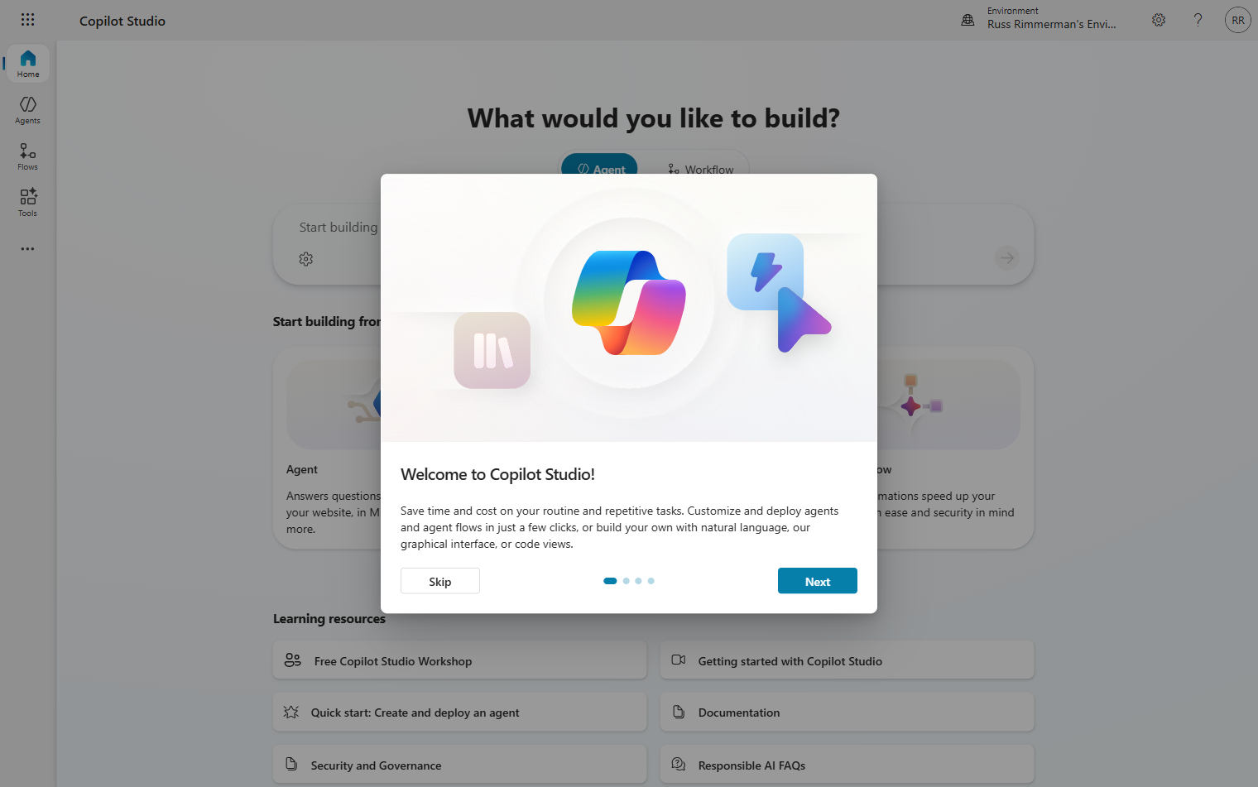
Step 2: From the Home page, click “New agent” or select “Agents” from the left navigation. You’ll see the agent creation interface.
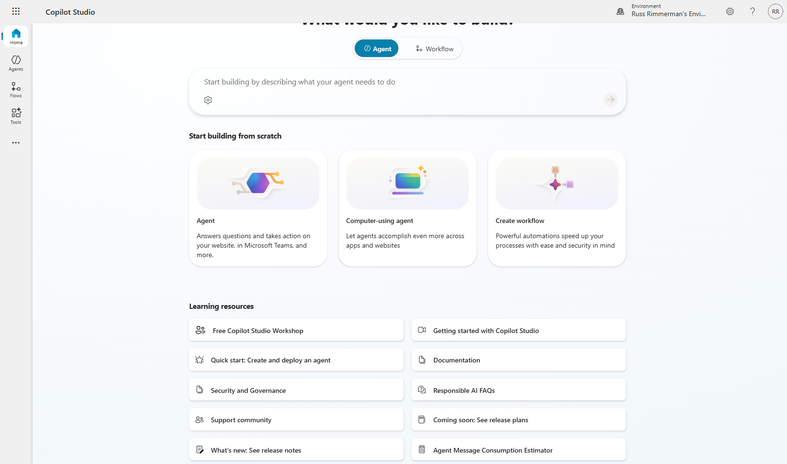

1.2 Configure Agent Identity
Step 3: In the “Name your agent” dialog, enter: Energy Operations Weather Agent. Add a description that explains its purpose for grid operations.
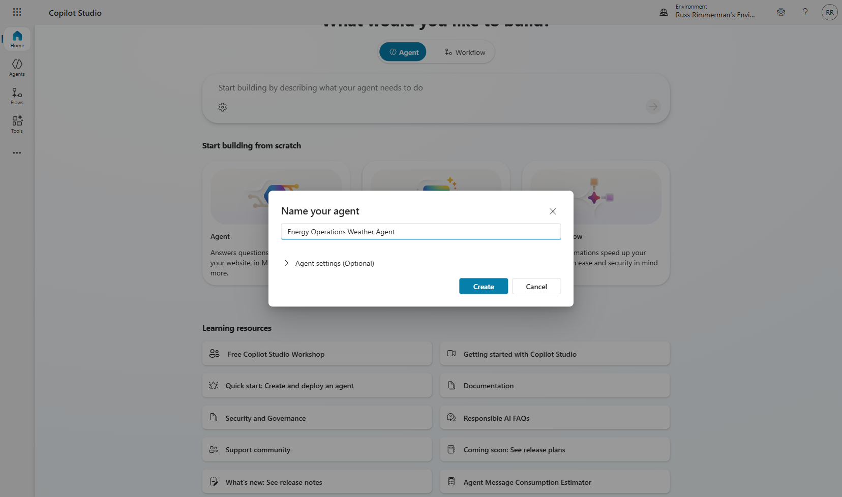
💡 TIP: Choose descriptive names that clearly indicate the agent's domain. This helps with discoverability when you have multiple agents in your environment.
Step 4: After creation, you will see the Agent Overview page. This is your central hub for managing all aspects of the agent.
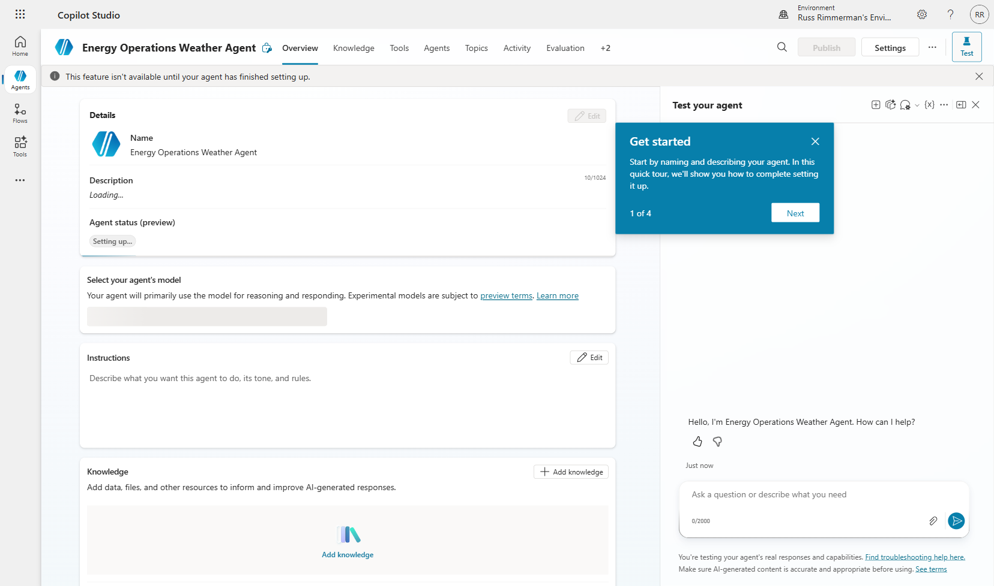

1.3 Add Agent Instructions
Instructions tell the AI model how to behave. For an energy operations agent, we need specific guidance about utility terminology, safety protocols, and response formatting.
Step 5: In the Instructions field, enter comprehensive guidance covering: role definition, weather analysis protocols, grid impact assessment criteria, and response formatting standards.
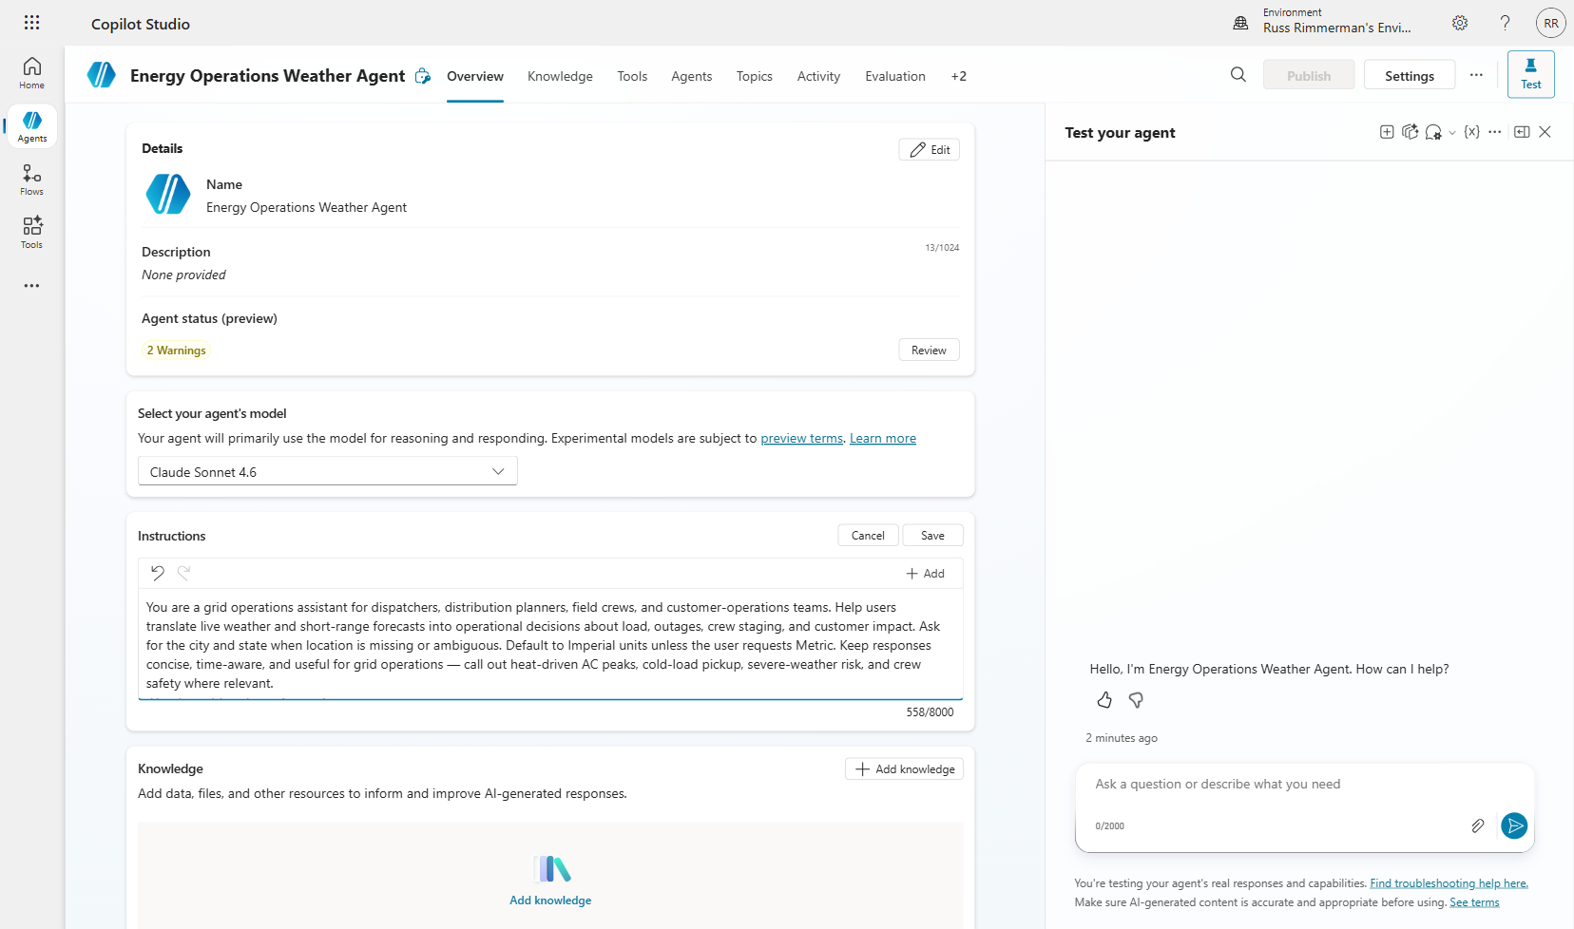
⚠️ NOTE: Instructions are critical for agent quality. They define the AI’s persona, capabilities, and constraints. Well-written instructions prevent hallucination and ensure domain-appropriate responses.

Section 2: Create a Topic with Variables
Topics are conversational flows that define how your agent handles specific intents. Variables store user inputs and intermediate data as the conversation progresses. In this section, you will create a “Service Territory Weather Lookup” topic that collects city and state information from the user.

2.1 Navigate to Topics
Step 1: Click the “Topics” tab in the agent navigation bar. This shows all topics (system and custom) for your agent.
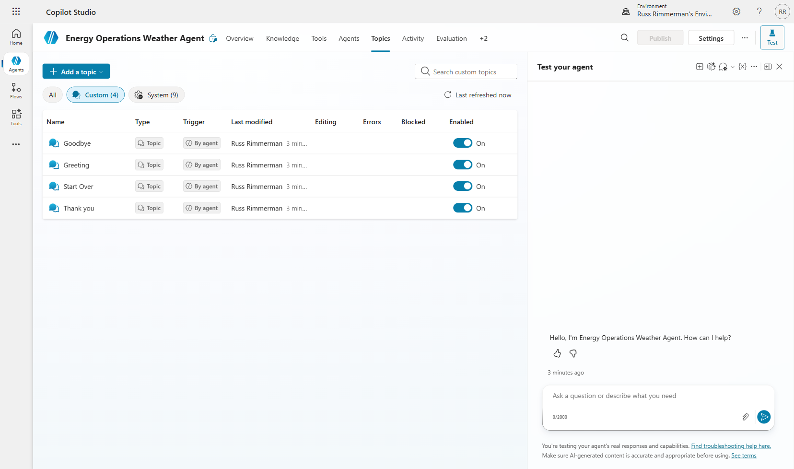
Step 2: Click “Add” → “From blank” to create a new custom topic.
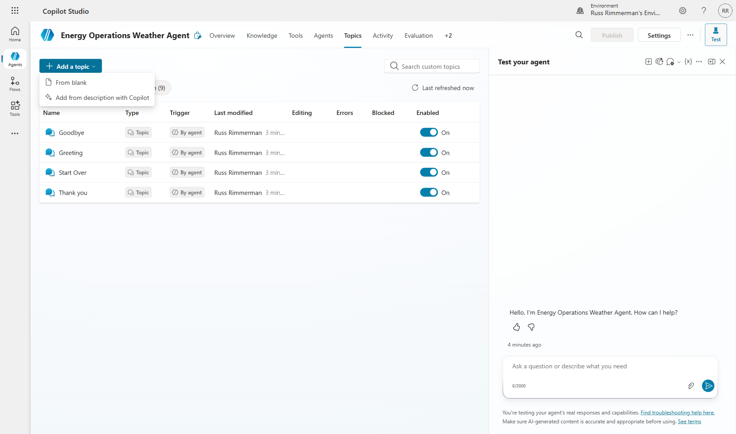

2.2 Configure Topic Details
Step 3: Name the topic “Service Territory Weather Lookup” and add trigger phrases such as: “weather in”, “current conditions”, “forecast for”, “grid weather”.
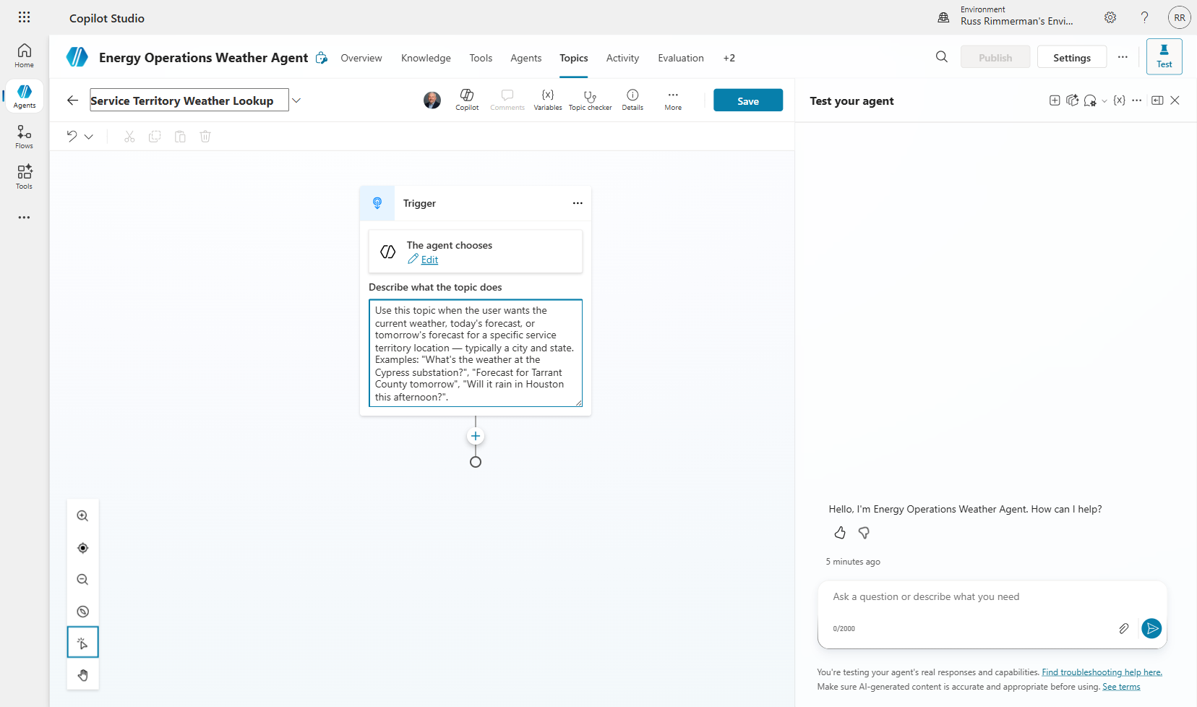

2.3 Add Question Nodes
Question nodes prompt the user for information and store their response in a variable. We need two pieces of data: city and state.
Step 4: Click the “+” button to add a node, then select “Ask a question.”
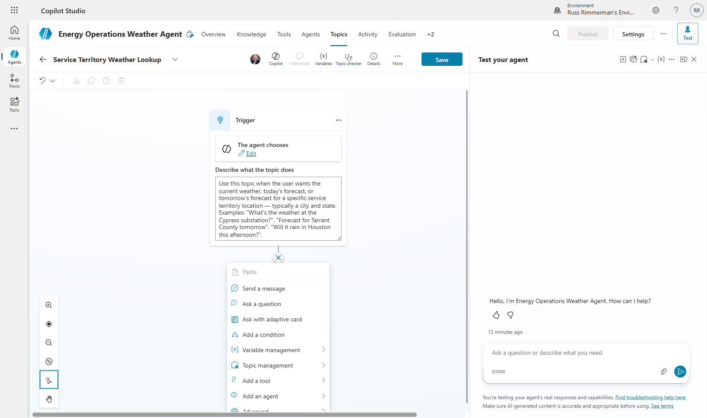
Step 5: Configure the first question to ask “What city is the service territory located in?”. Set the response to save to a variable named “City”. Add a second question for State.
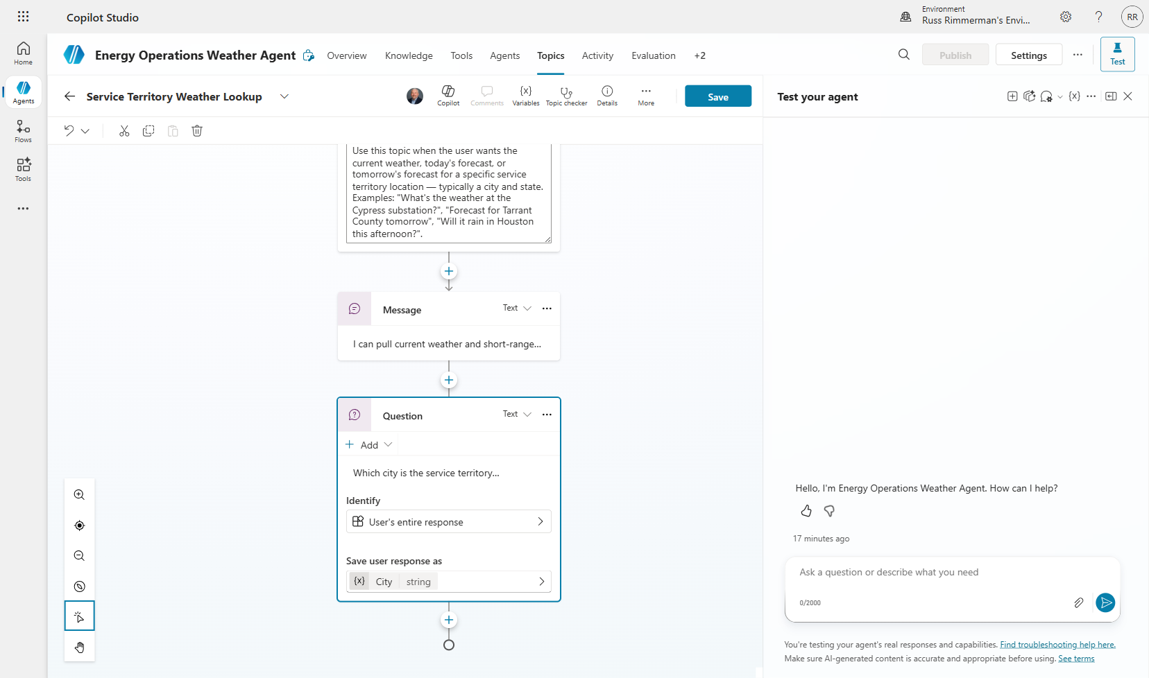
Step 6: Click “Save” to preserve your topic. You should see a “Topic Saved!” confirmation banner.
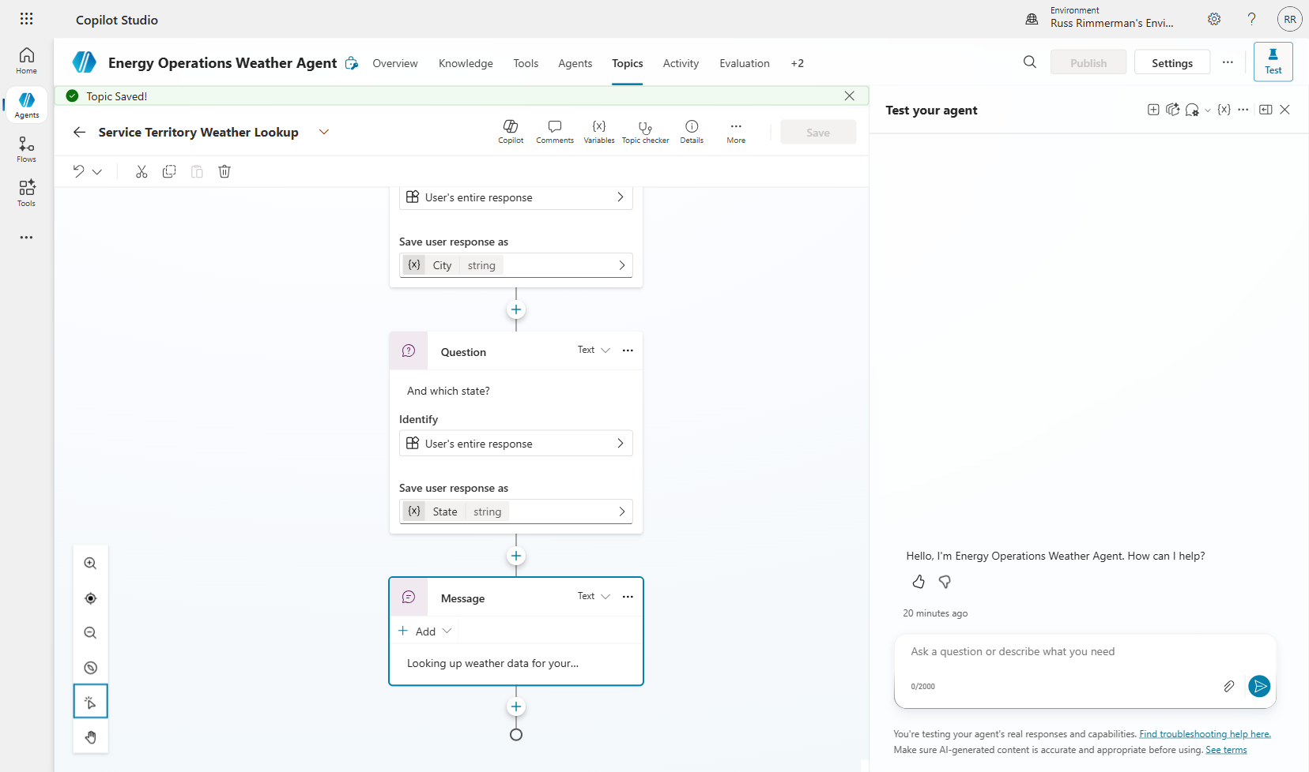
💡 TIP: Always save your topic before navigating away. Unsaved changes will be lost.

Section 3: Add MSN Weather Connector Tools
Tools connect your agent to external data sources and services. The MSN Weather connector provides real-time weather data including current conditions, today’s forecast, and tomorrow’s forecast. Adding multiple tools gives the agent flexibility to answer different types of weather questions.

3.1 Navigate to Tools
Step 1: Click the “Tools” tab. Initially, this will be empty since no tools have been added yet.
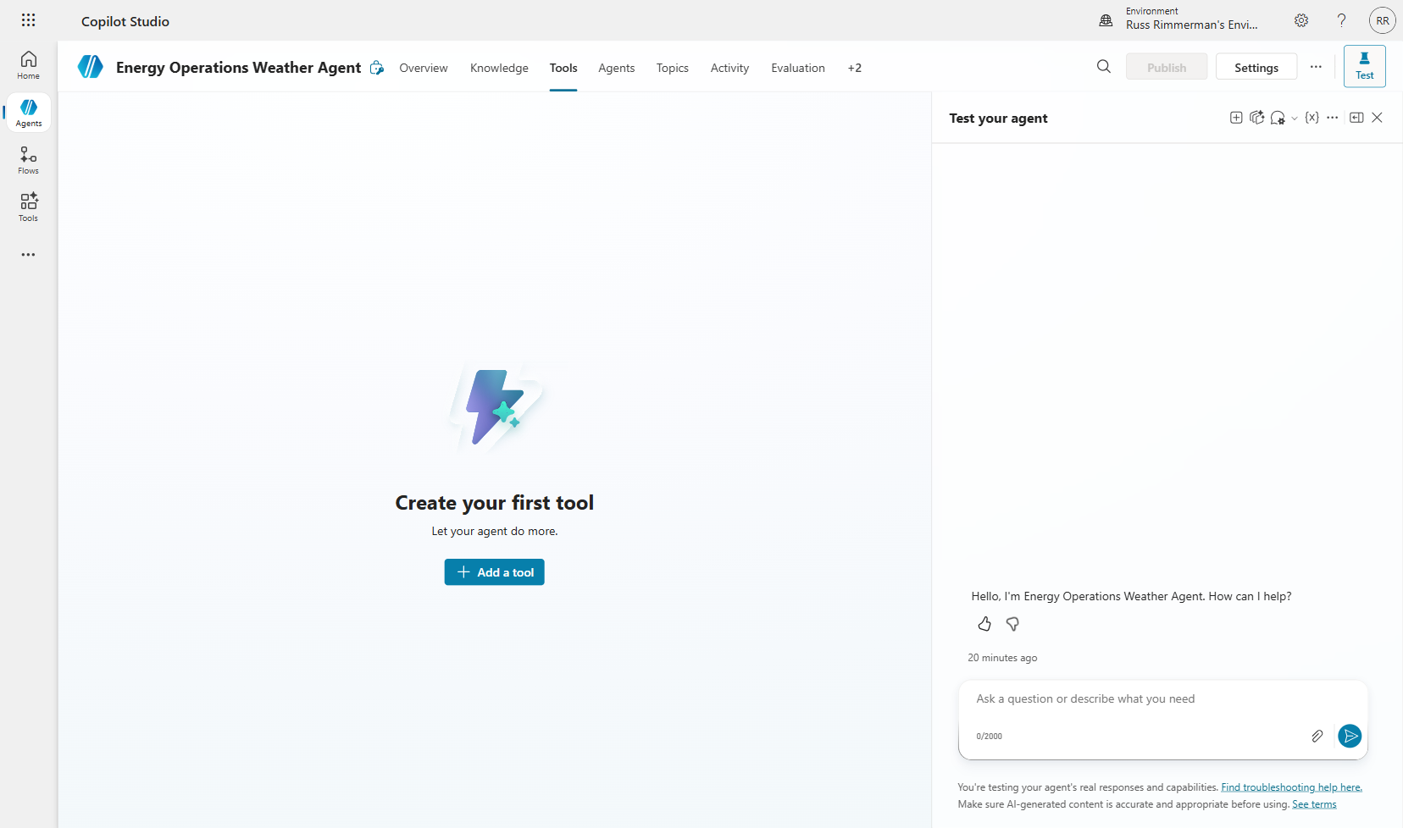
Step 2: Click “Add a tool” to open the tool gallery. This shows all available connectors, prompts, flows, and custom tools.
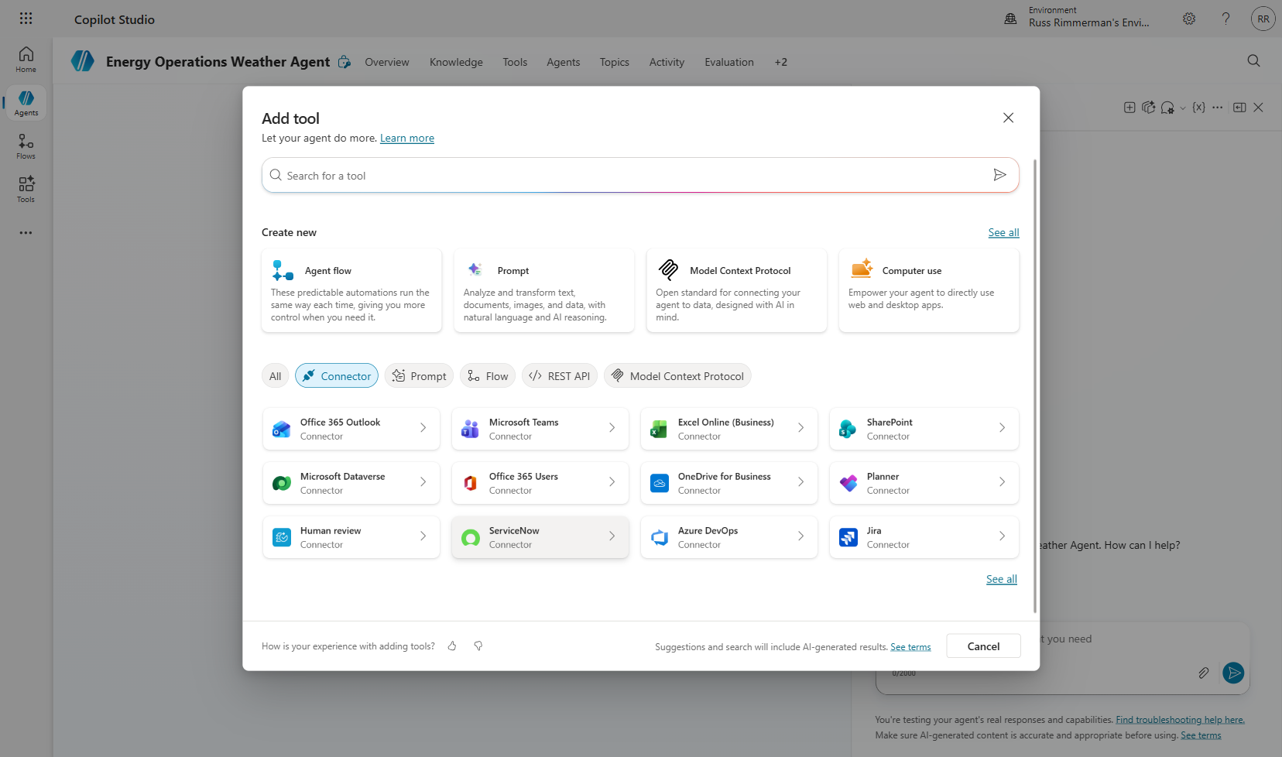

3.2 Add MSN Weather Connectors
Step 3: Search for “MSN Weather” in the tool gallery. You will see three available actions: Get current weather, Get forecast for today, and Get the forecast for tomorrow.
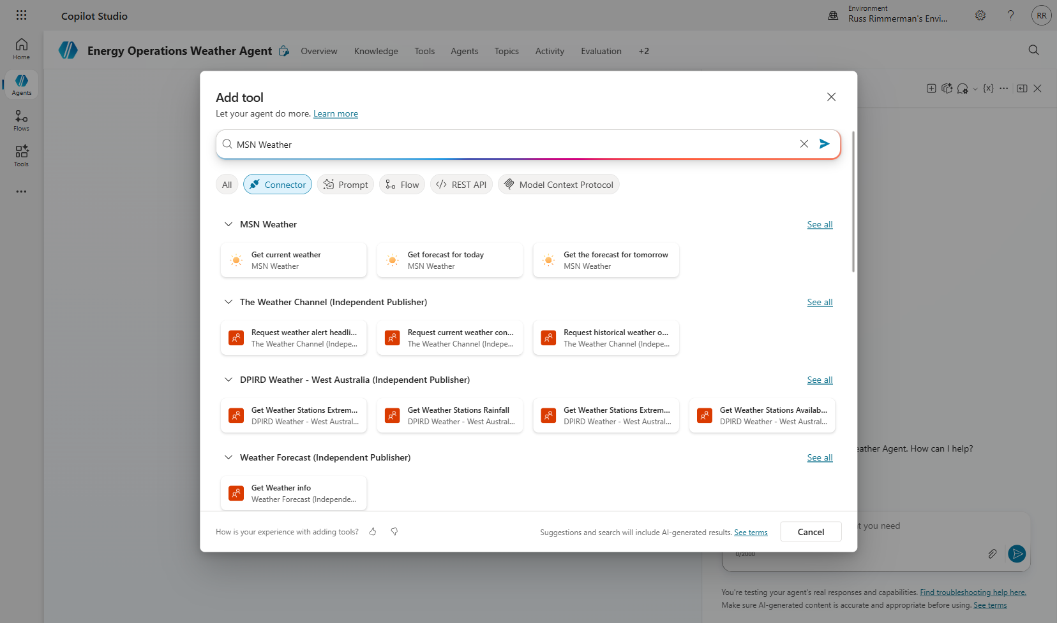
Step 4: Select “Get current weather” first. Review the tool details showing its inputs (Location, Units) and outputs (weather data object).
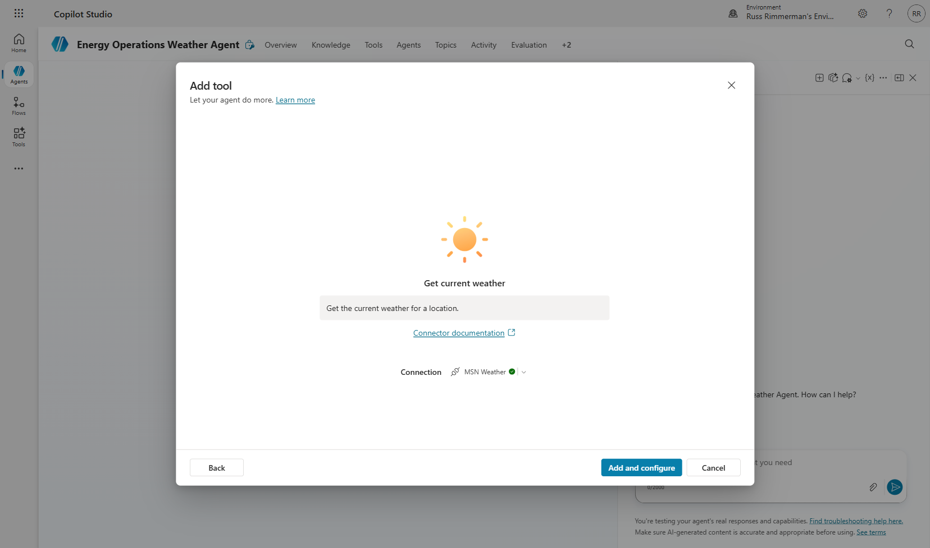
Step 5: Click “Add” to add the tool to your agent. Configure any required settings on the tool configuration page.
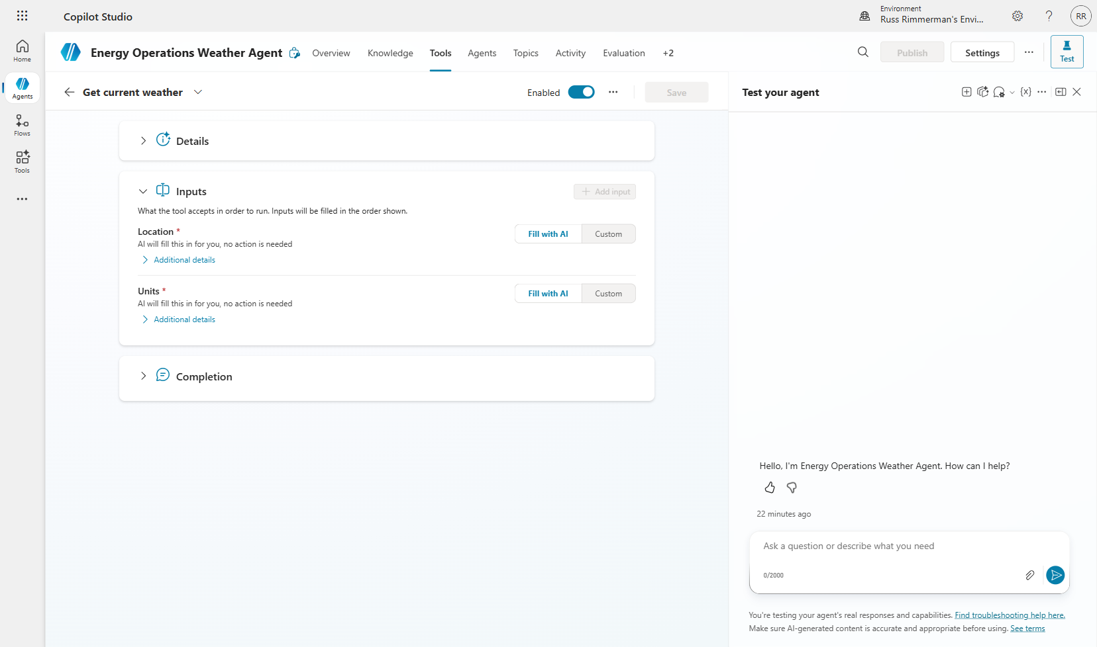
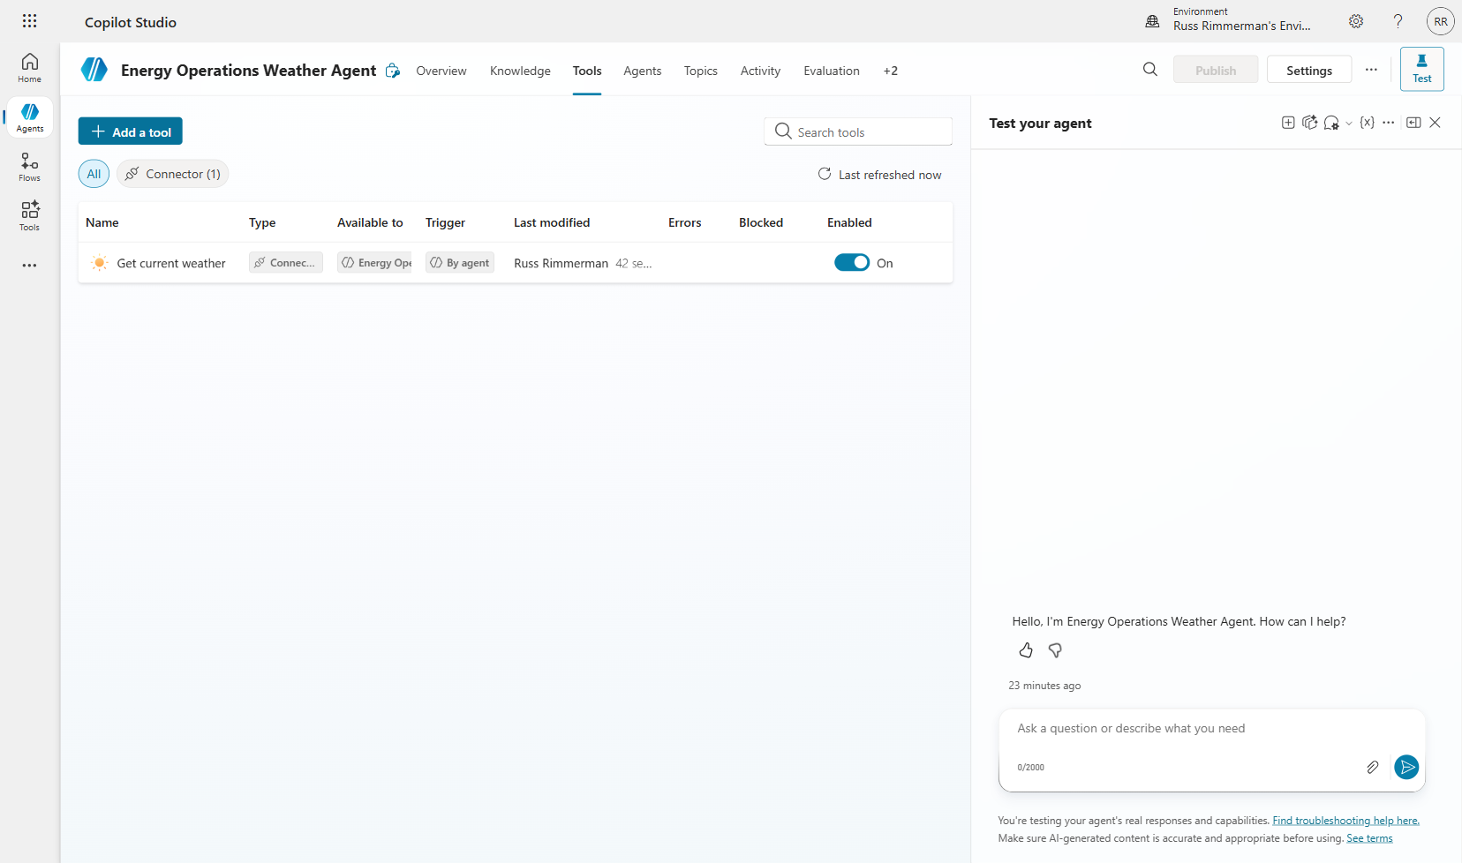
Step 6: Repeat the process for “Get forecast for today” and “Get the forecast for tomorrow.”
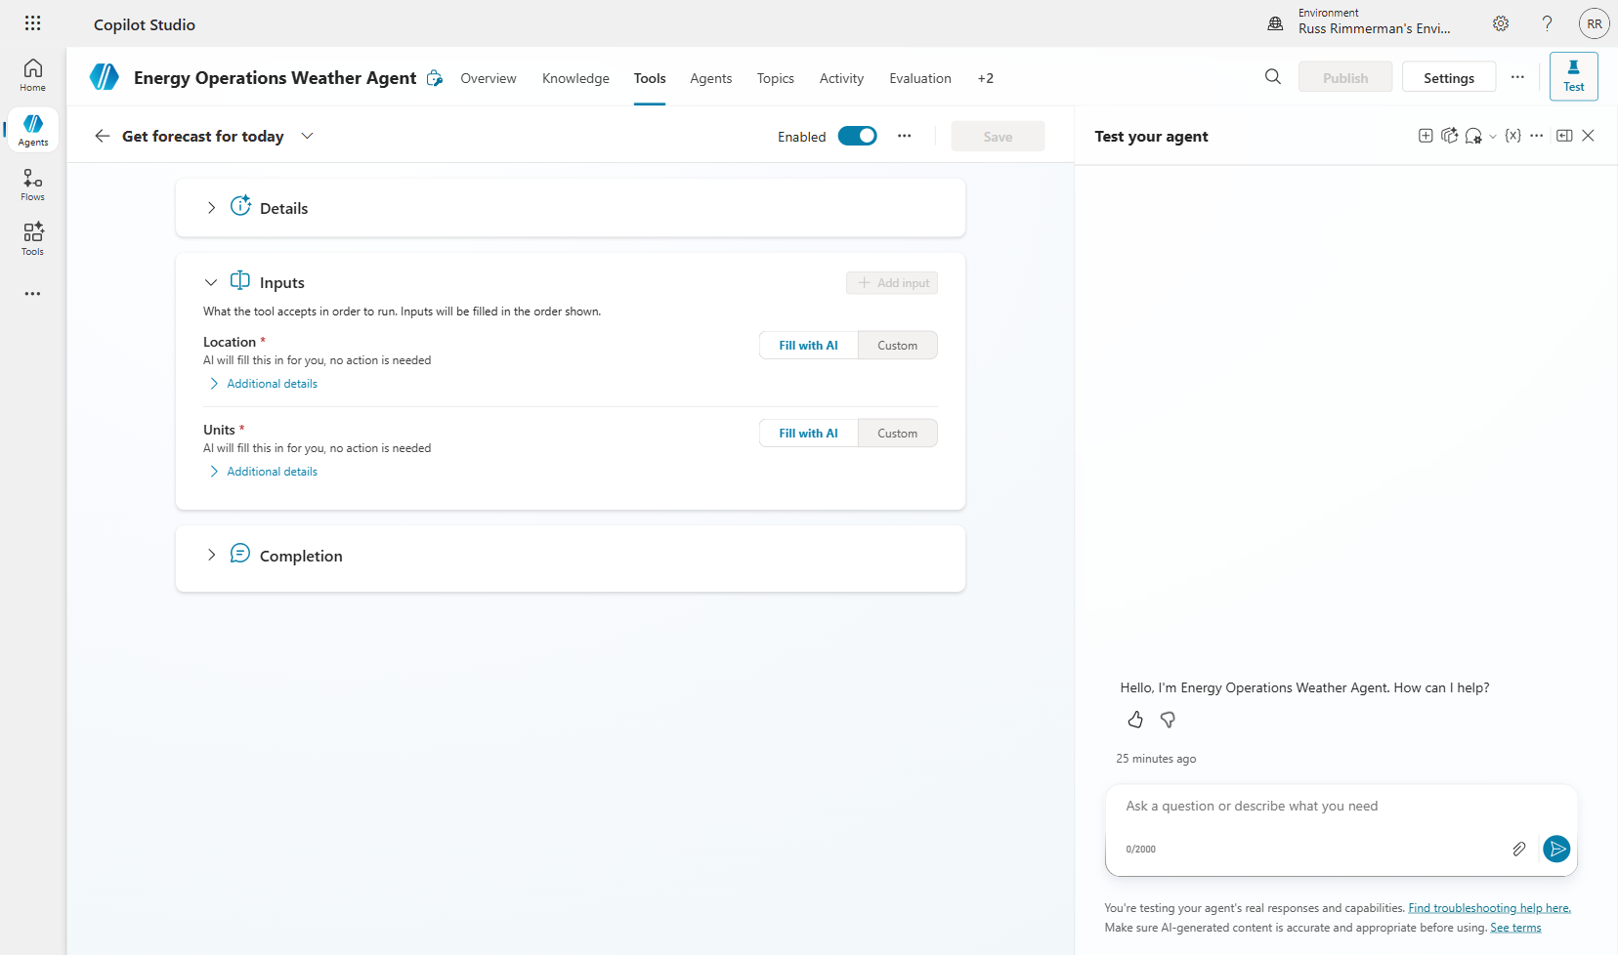
Step 7: Verify all three tools appear in your Tools list.
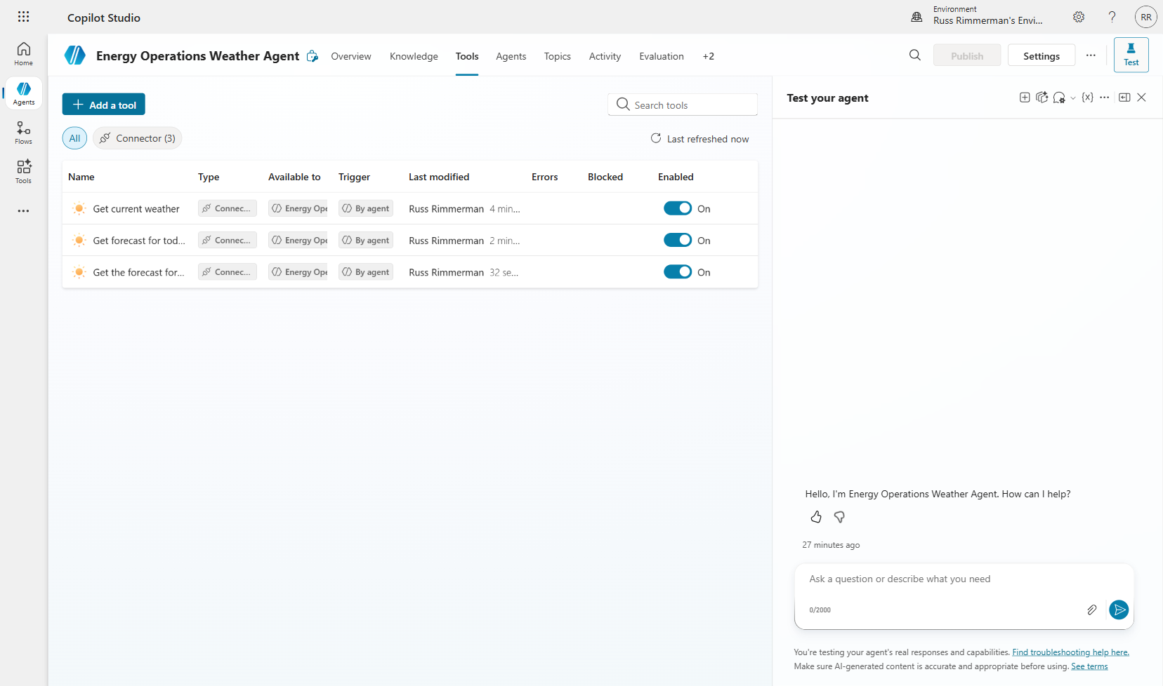
⚠️ NOTE: Adding all three weather tools gives the orchestrator options. It can intelligently select which tool to call based on the user's question (current vs. forecast).

Section 4: Wire Tools into Topic with Power Fx
Power Fx is Microsoft’s low-code formula language (similar to Excel). In Copilot Studio, Power Fx connects your topic variables to tool inputs and formats tool outputs for display. This is where your conversational flow becomes a functioning data pipeline.

4.1 Add Tool Node to Topic
Step 1: Return to the “Service Territory Weather Lookup” topic. Your current flow has the two question nodes. Click “+” after the State question to add a new node.
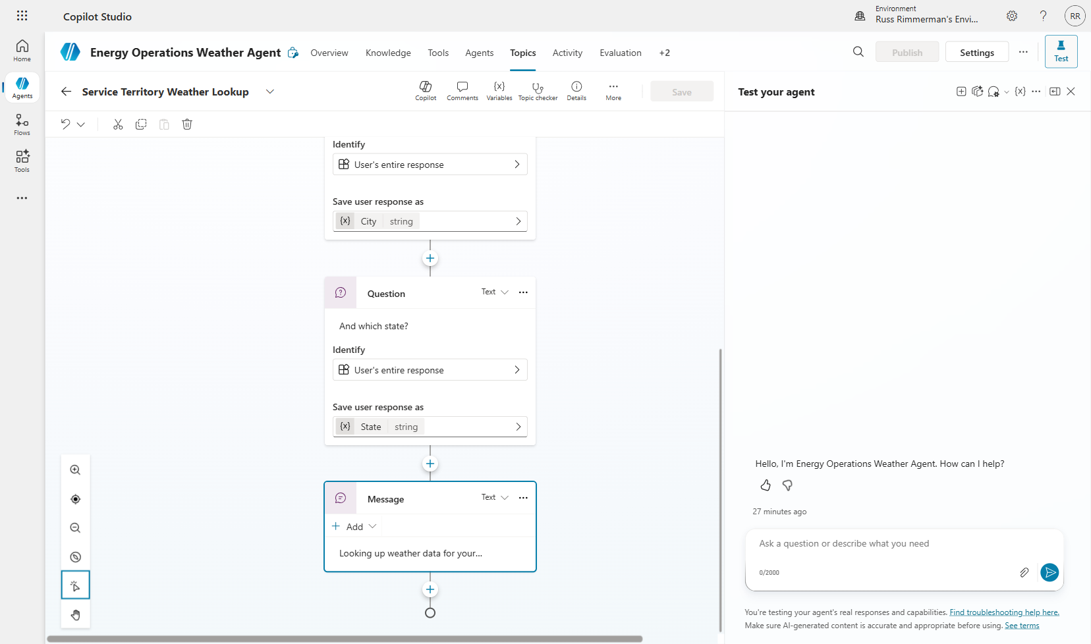
Step 2: Select “Call an action” and choose the “Get current weather” tool from the list.
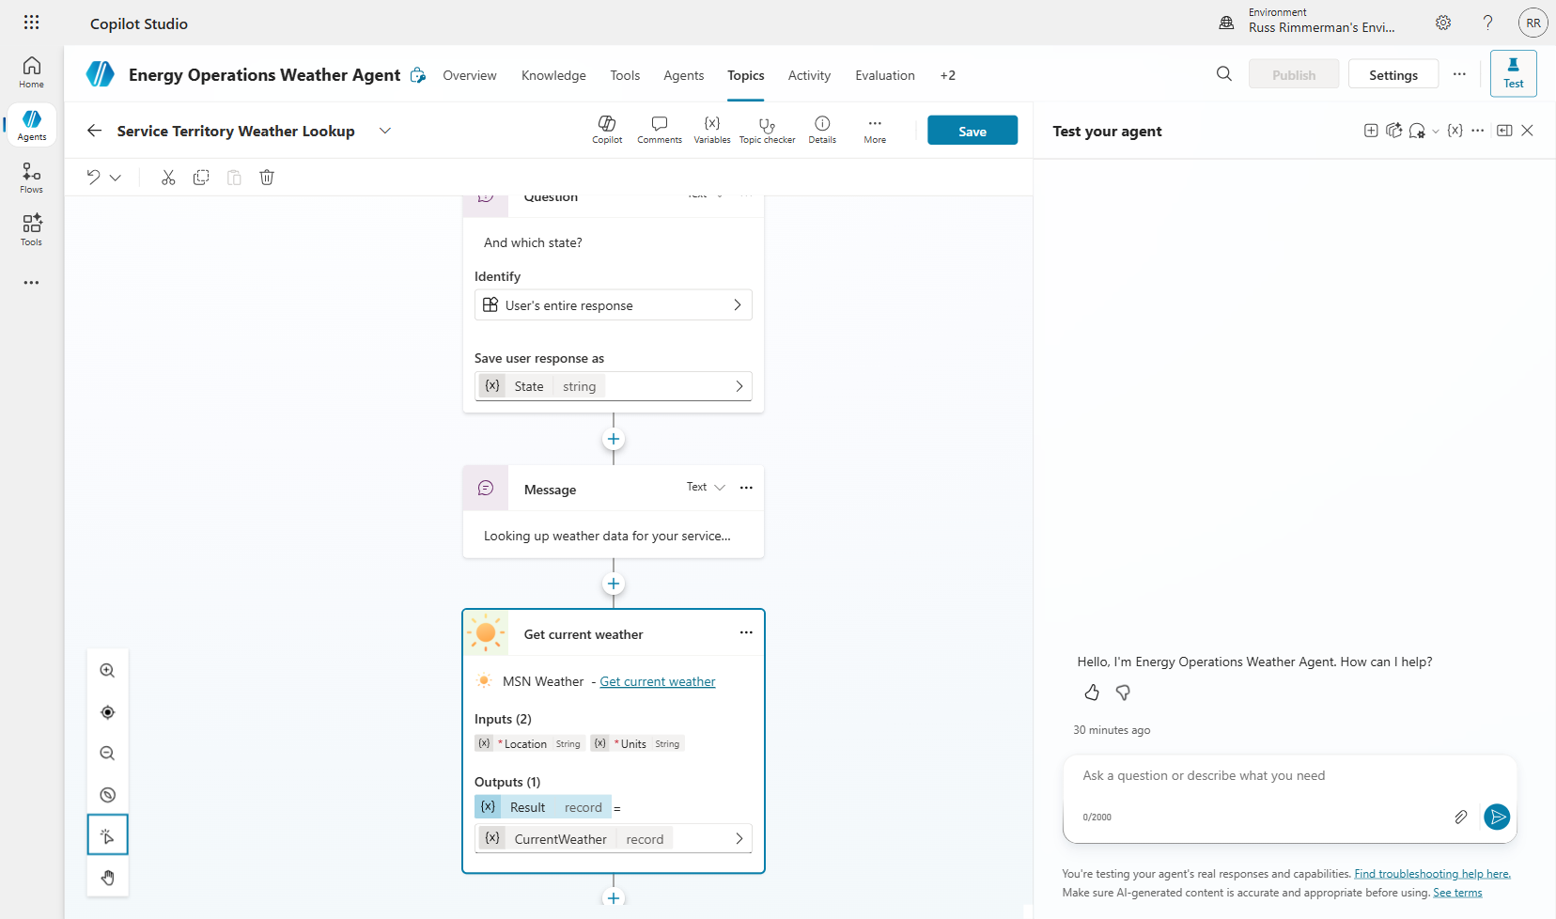

4.2 Configure Power Fx Input Formulas
The weather tool requires a Location input (city, state format) and Units (Imperial/Metric). We use Power Fx to combine our topic variables into the correct format.
Step 3: Click the Location input field and enter the Power Fx formula: Topic.City & “, ” & Topic.State
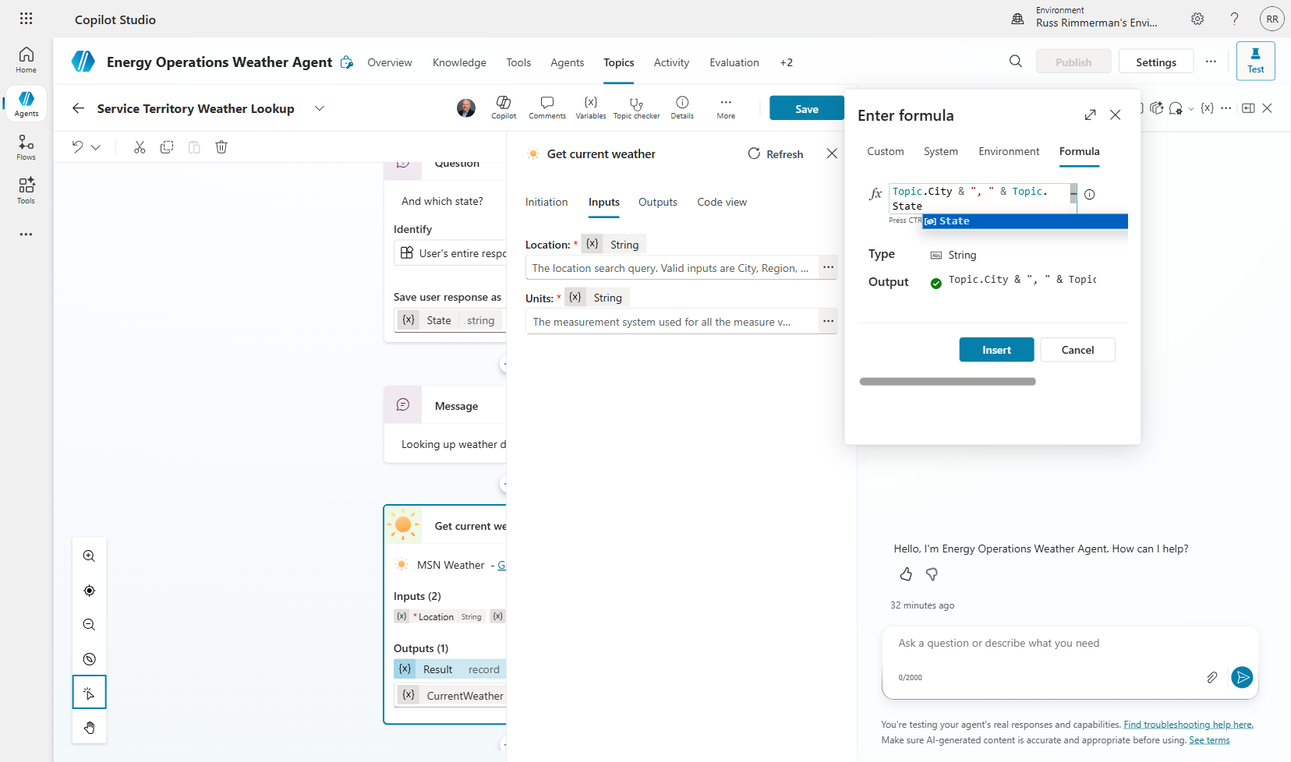
Step 4: Set the Units input to the formula: “Imperial” (hardcoded for US energy operations).
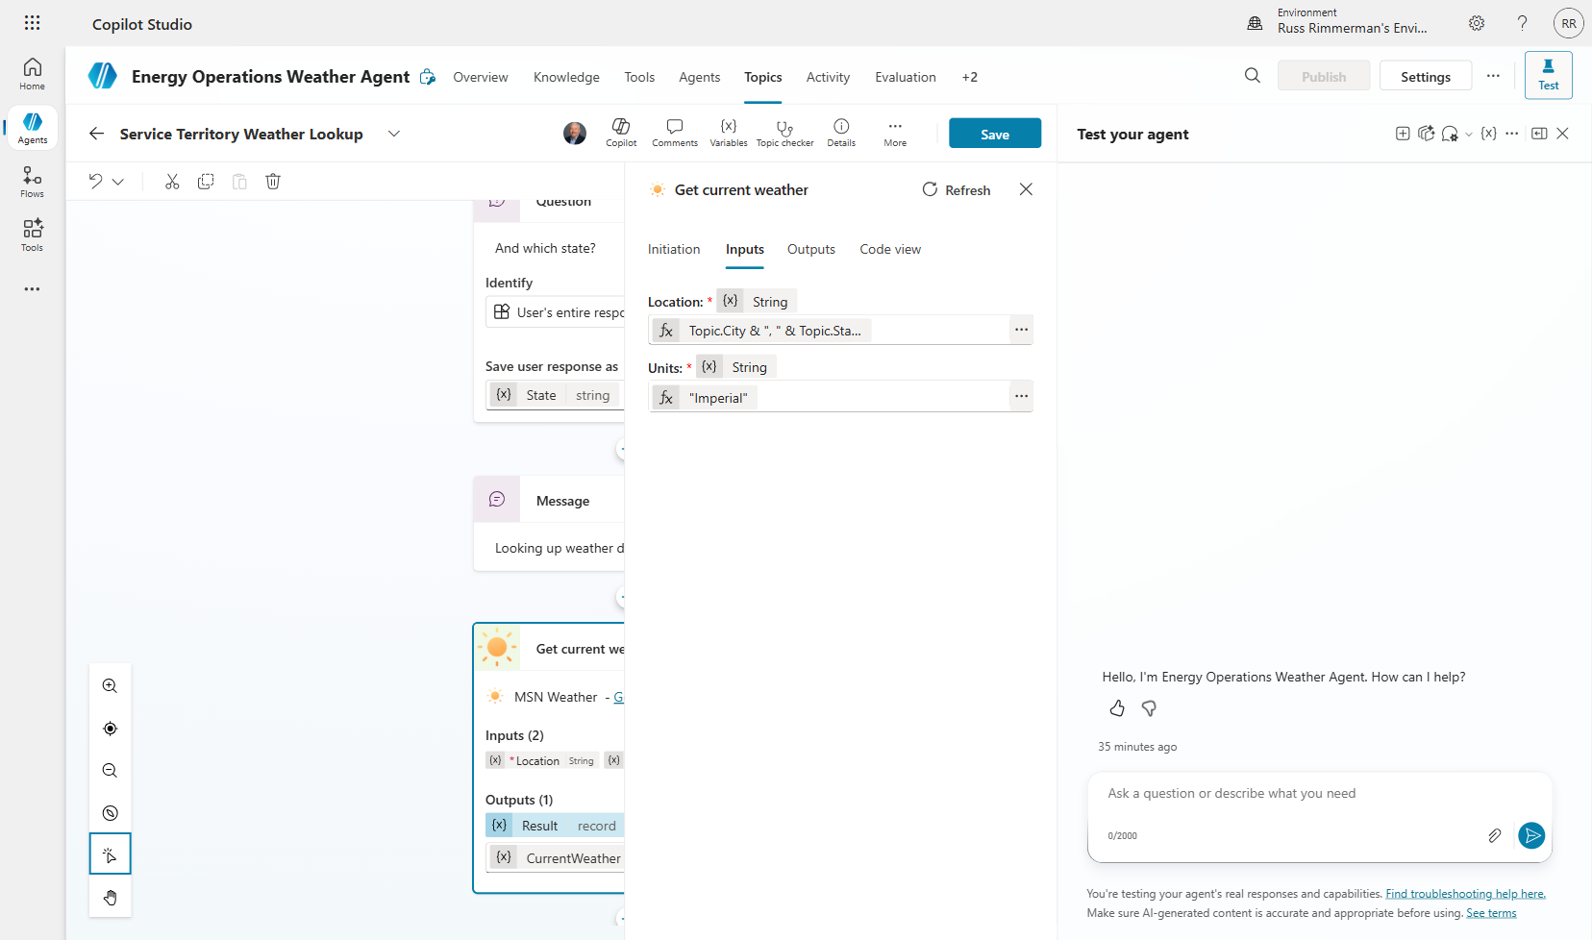

4.3 Add Response Message
After the tool executes, we need to display results to the user. The tool returns a complex object with nested weather properties.
Step 5: Add a Message node after the tool node. Use Power Fx expressions to format the response, referencing properties like Topic.CurrentWeather.responses.weather.current.temp.
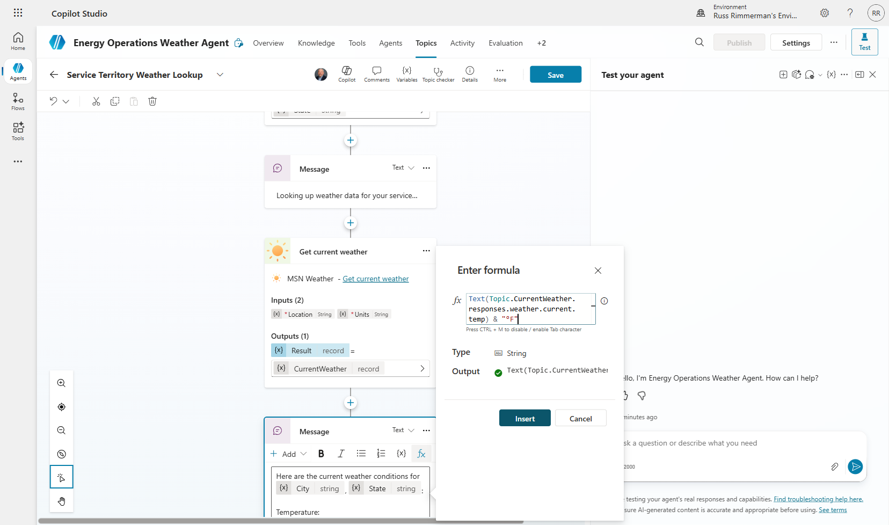
Step 6: Review the complete topic flow showing: Questions → Tool Call → Response Message.
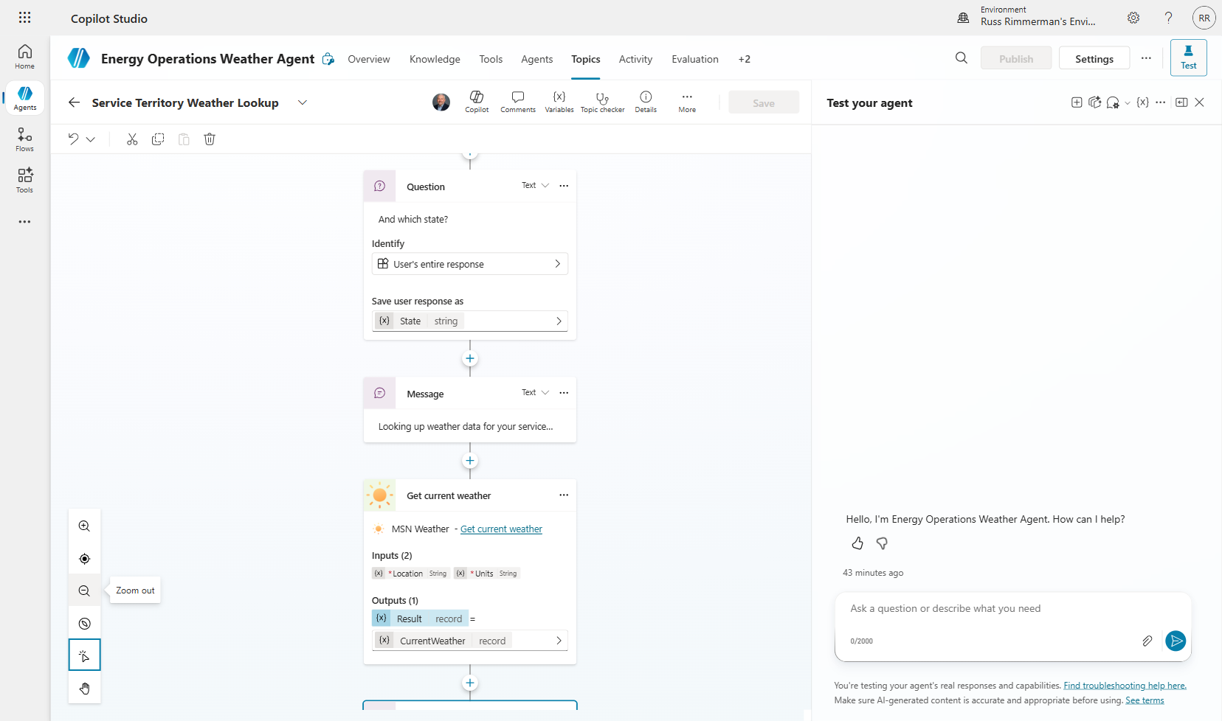
💡 TIP: Power Fx formulas are validated in real-time. A green checkmark means the formula is syntactically correct. Red errors indicate type mismatches or invalid property references.

Section 5: Test the Agent
Testing validates that your entire flow works end-to-end: the agent triggers the correct topic, collects user inputs, calls the weather API with the right parameters, and returns formatted results. The built-in Test panel simulates a real conversation.

5.1 Open Test Panel
Step 1: Click the “Test” button in the upper right corner to open the test chat panel.
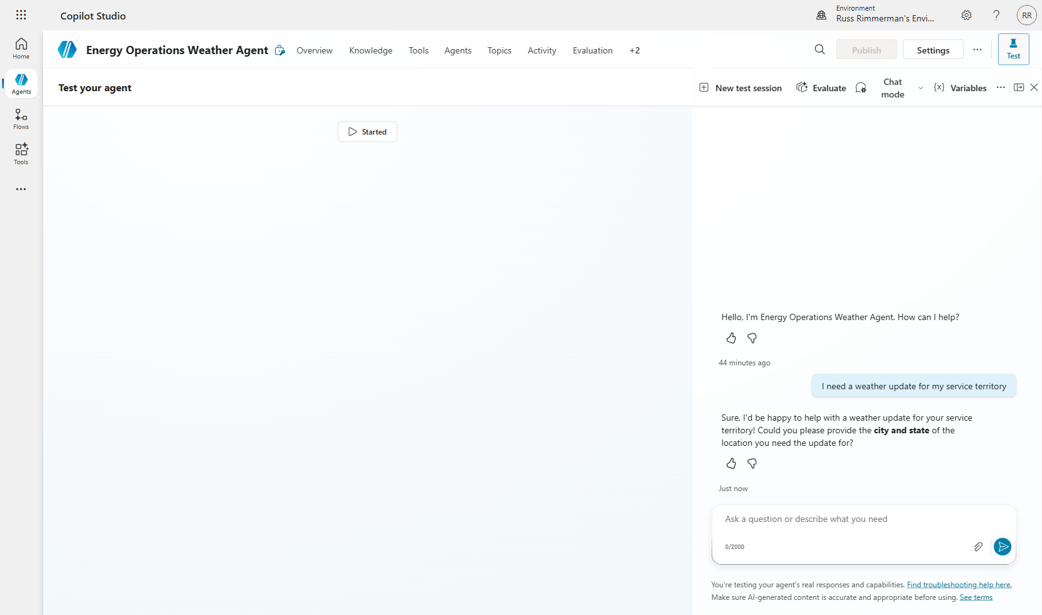

5.2 Authenticate Connector
The first time a connector is used, it requires authentication. This is a one-time step per connector per user.
Step 2: When prompted to connect, click the connection link to authenticate with MSN Weather.
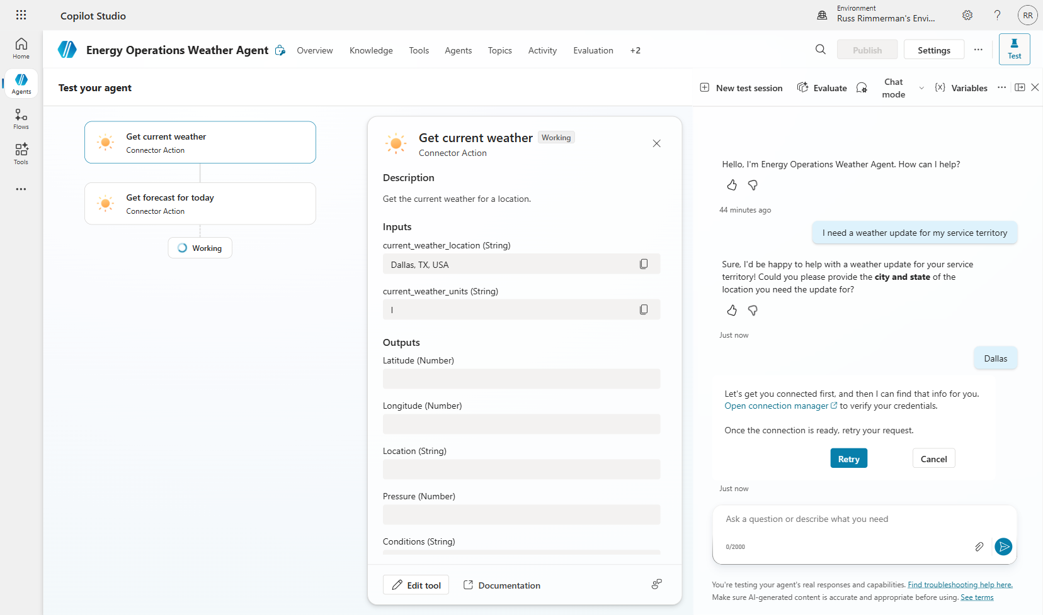
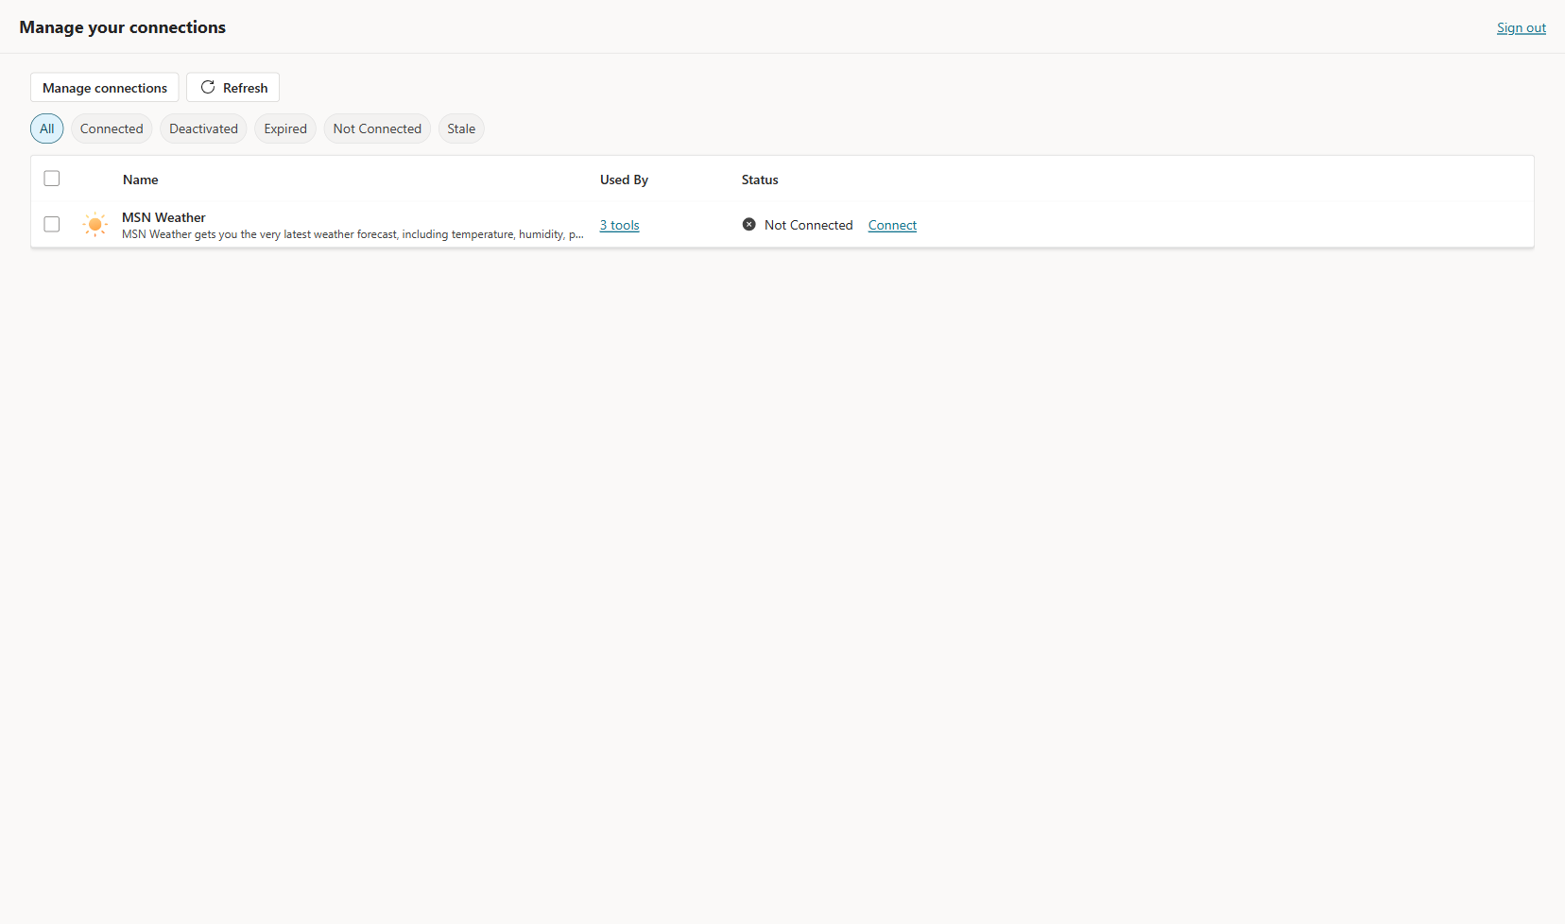
Step 3: After authenticating, verify the connection shows as established.
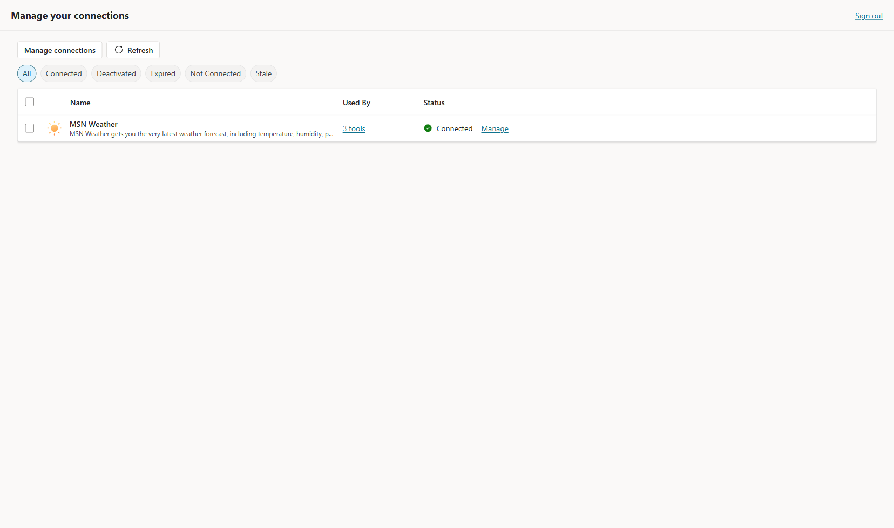

5.3 End-to-End Test
Step 4: Type a weather query such as “What’s the weather in Dallas, Texas?” The agent should ask for city/state (or extract from your message), call the weather API, and return live conditions.
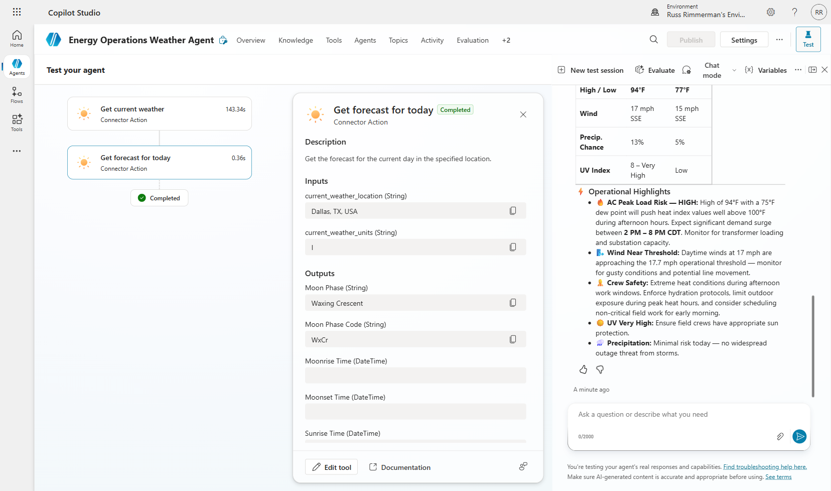
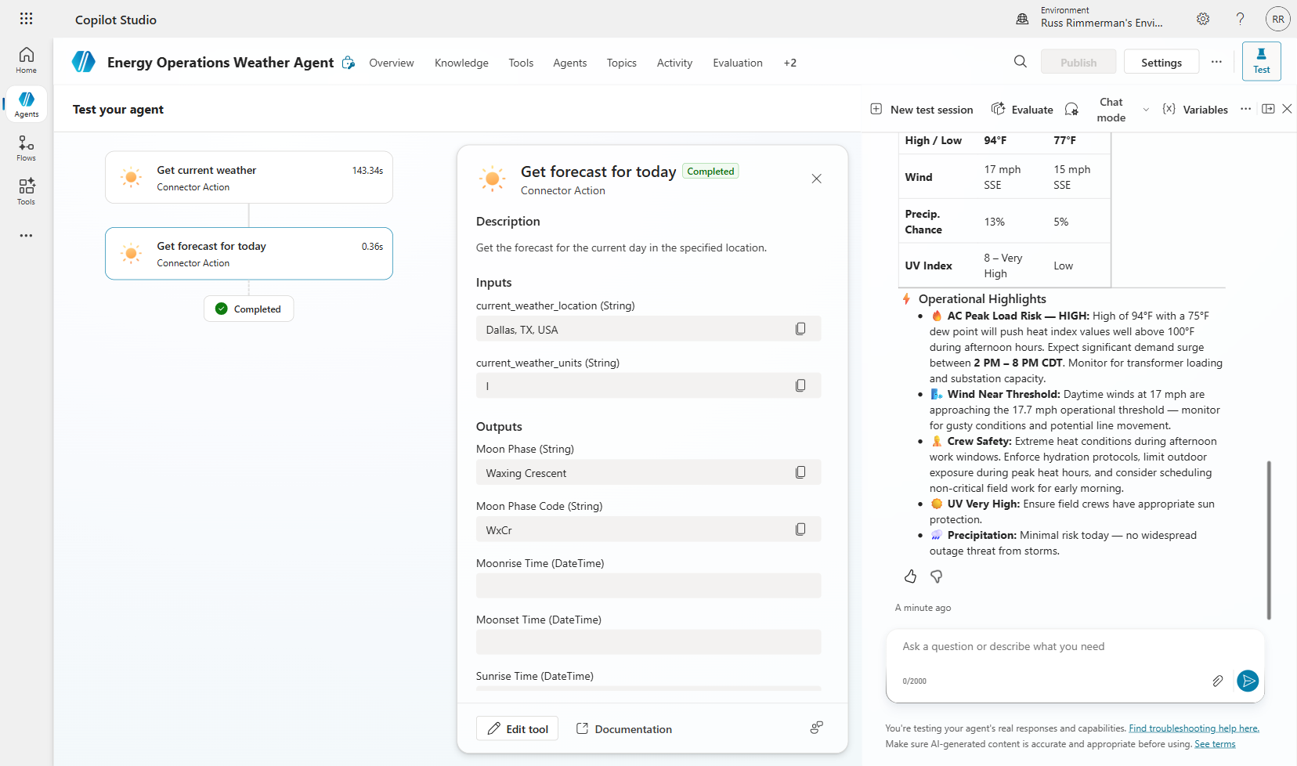
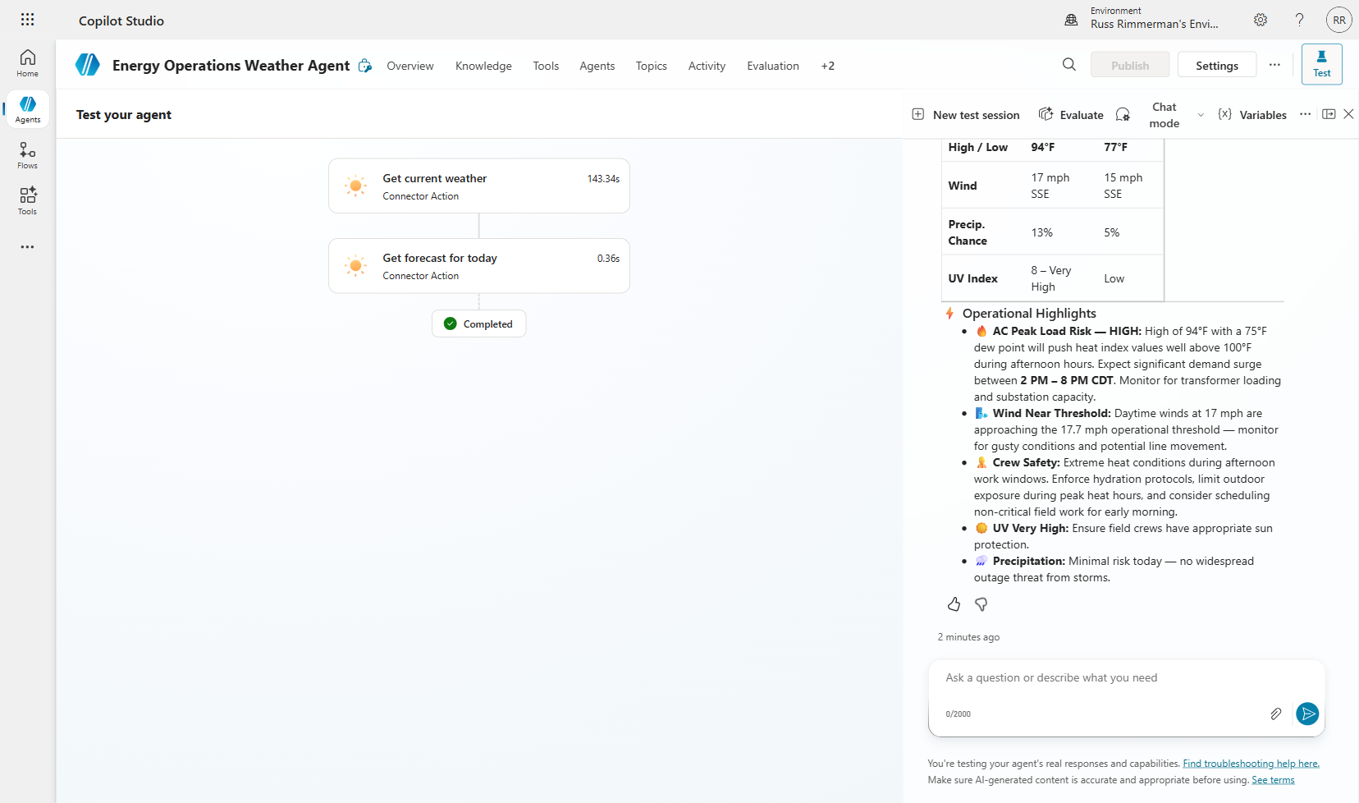
⚠️ NOTE: Live weather data means your results will differ from these screenshots. That’s expected! Verify the structure (temperature, conditions, humidity, wind) is correct, not the specific values.

Section 6: Create a Custom Prompt Tool
Custom Prompt Tools use generative AI to transform data into insights. Instead of just showing raw weather data, we will create a prompt that acts as an “Energy Operations Analyst” — taking weather data and generating a structured operations briefing with grid impact analysis, demand forecasts, and recommended actions.

Why this matters:
Raw data requires human interpretation. A prompt tool automates the analysis step, turning a temperature reading into an actionable “peak demand expected, pre-position crews” recommendation.

6.1 Create the Prompt
Step 1: Navigate to Tools → “Add a tool” and select “Prompt” from the “Create new” section.
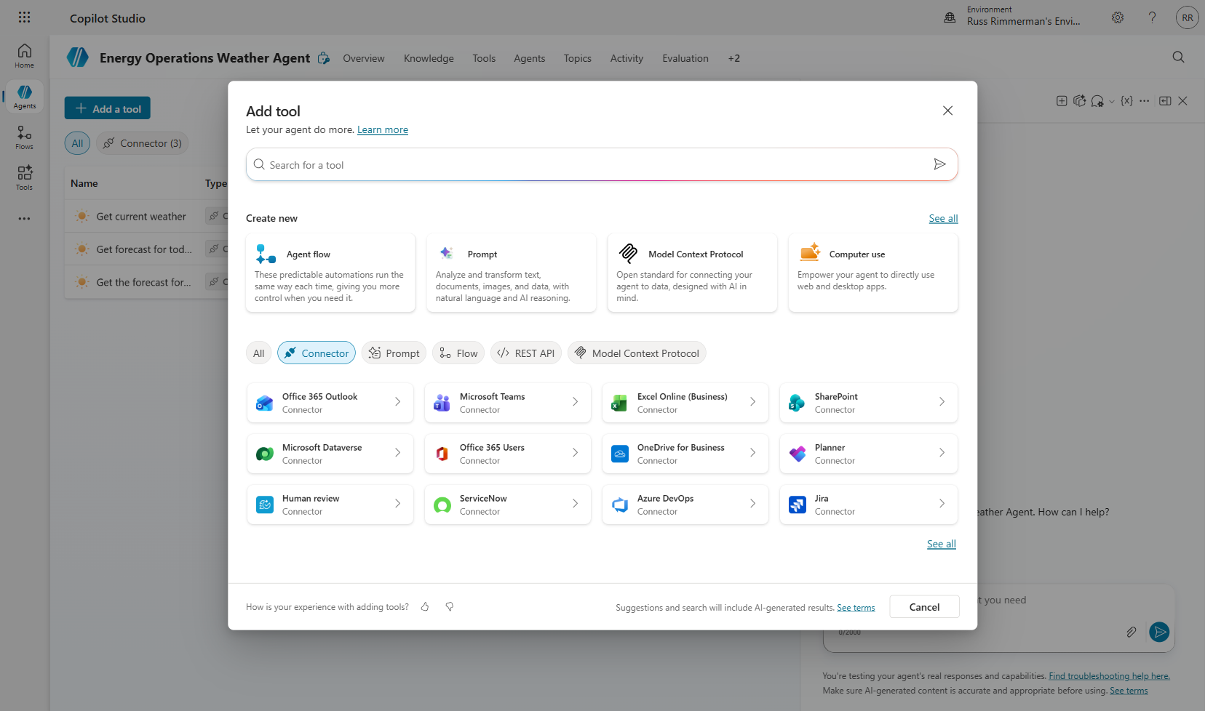
Step 2: Name the prompt “Generate Operations Briefing” and enter detailed instructions that define the AI’s role as an energy operations analyst. Include sections for: Grid Operations Implications, Active Weather Alerts analysis, Demand Forecast, and Recommended Actions.
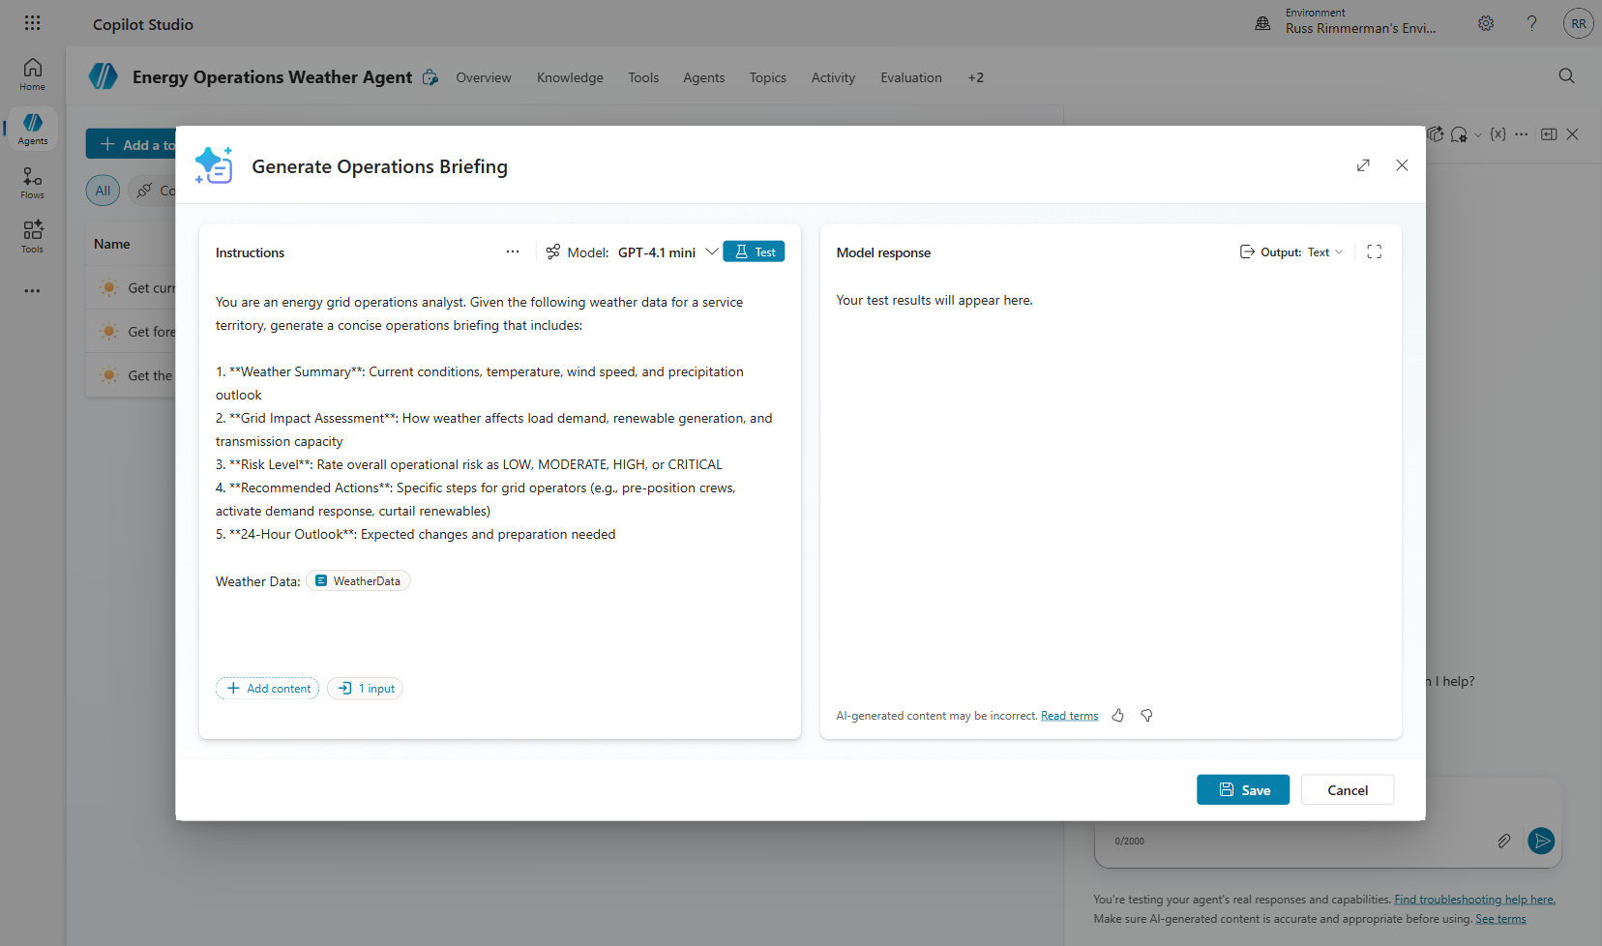

6.2 Add Input Variable
The prompt needs weather data to analyze. We create an input variable that will receive the formatted weather data from the connector output.
Step 3: Add a text input variable called “WeatherData” with sample data for testing the prompt independently.

6.3 Test the Prompt
Step 4: Click “Test prompt” to validate the AI generates a proper operations briefing from the sample data.
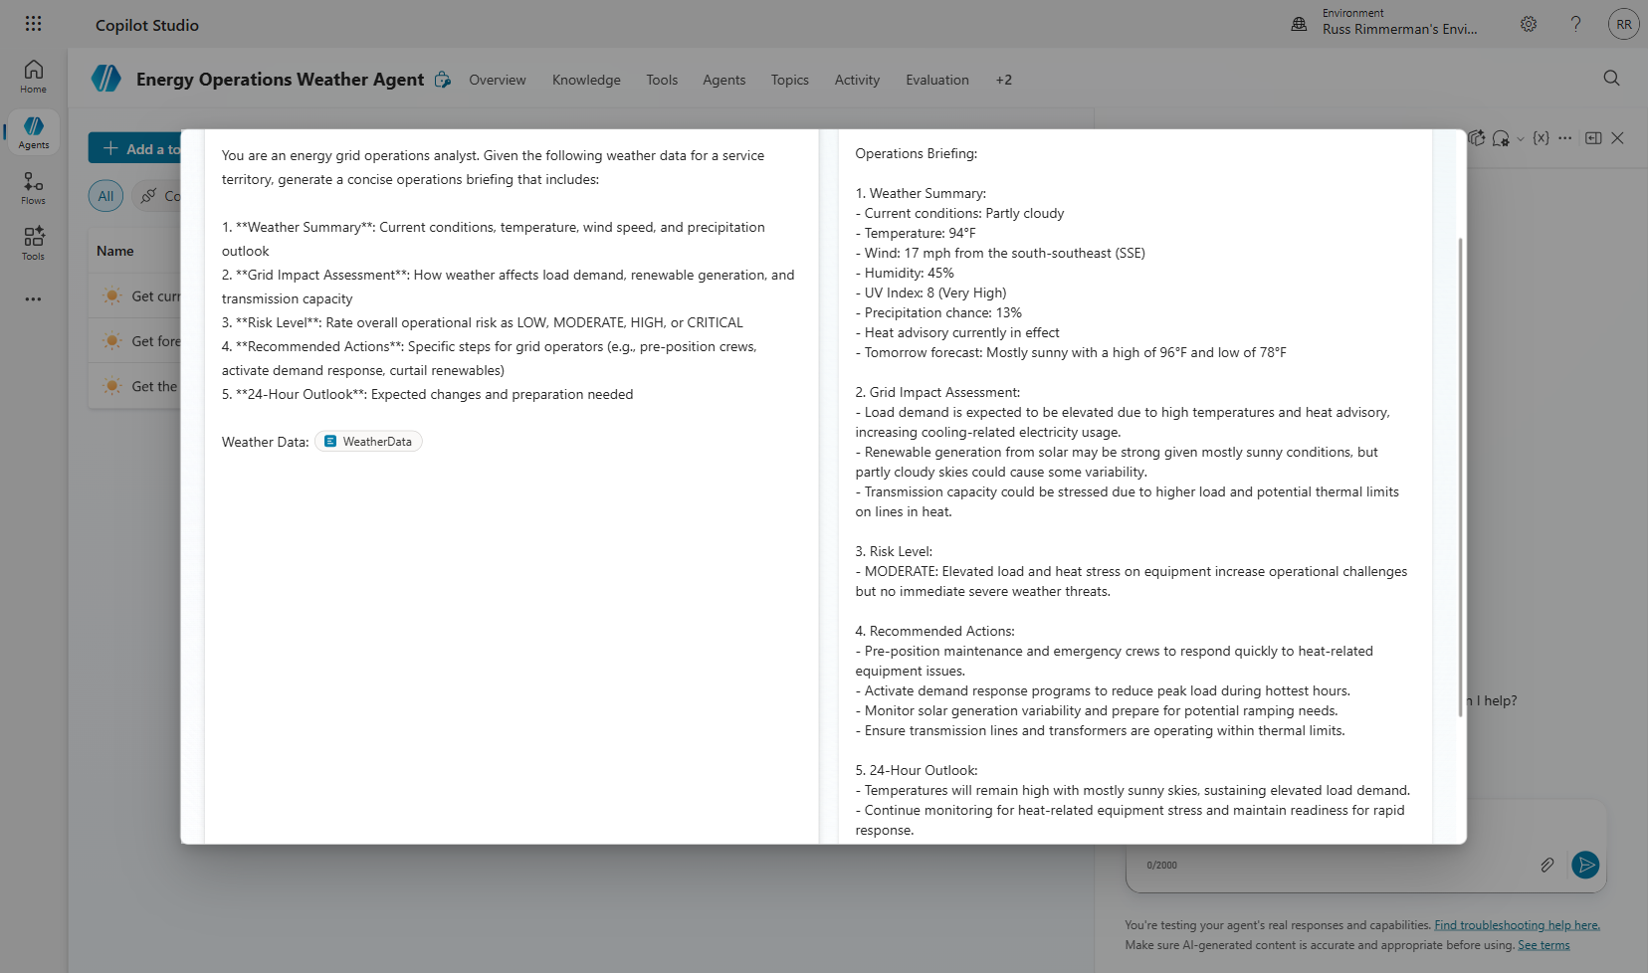
💡 TIP: Always test prompts independently before wiring them into a topic. This isolates prompt engineering issues from flow logic issues.
Step 5: Save the prompt and add it to the agent’s tool set.
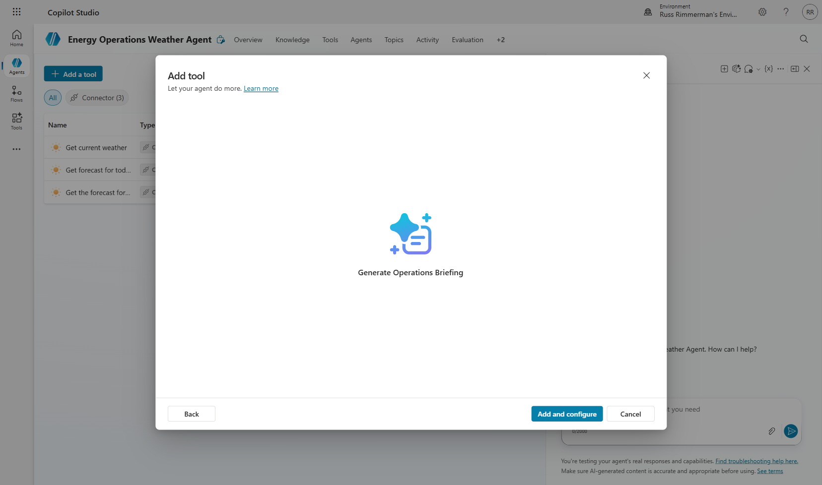
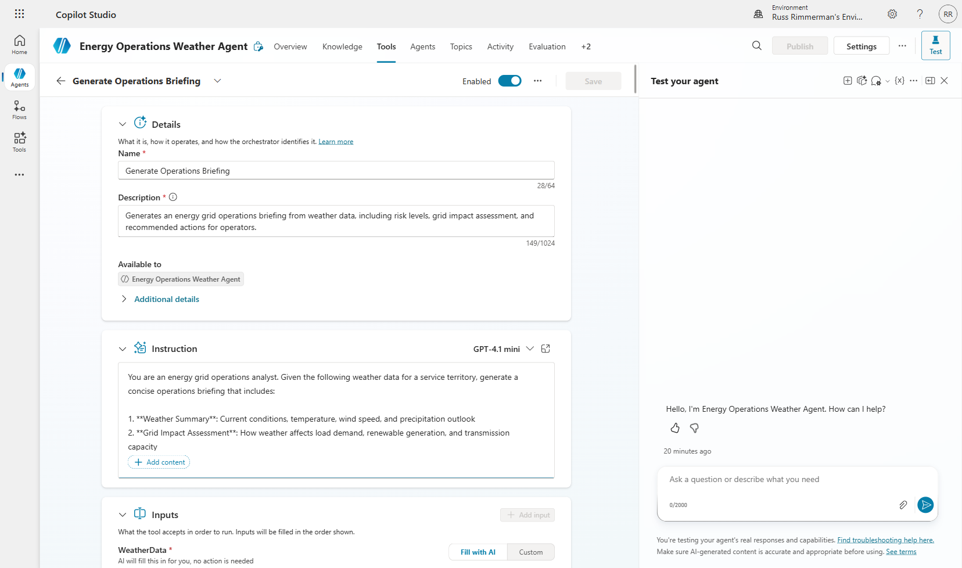

Section 7: Wire Prompt Tool into Topic Flow
Now we integrate the prompt tool into our existing topic flow. The data pipeline becomes: User Input → Weather API Call → AI Analysis (Prompt) → Operations Briefing. This creates a two-stage AI pipeline where the first stage retrieves data and the second stage generates intelligence.

7.1 Add Prompt Node
Step 1: Open the “Service Territory Weather Lookup” topic. Add the “Generate Operations Briefing” tool node between the weather connector output and the response message.

7.2 Configure Input Formula
Step 2: Set the WeatherData input using a Power Fx formula that concatenates relevant fields from the weather connector output:
“Location: ” & Topic.City & “, ” & Topic.State & “ | Conditions: ” & Topic.CurrentWeather.responses.weather.current.sky & “ | Temperature: ” & Text(Topic.CurrentWeather.responses.weather.current.temp) & “°F”
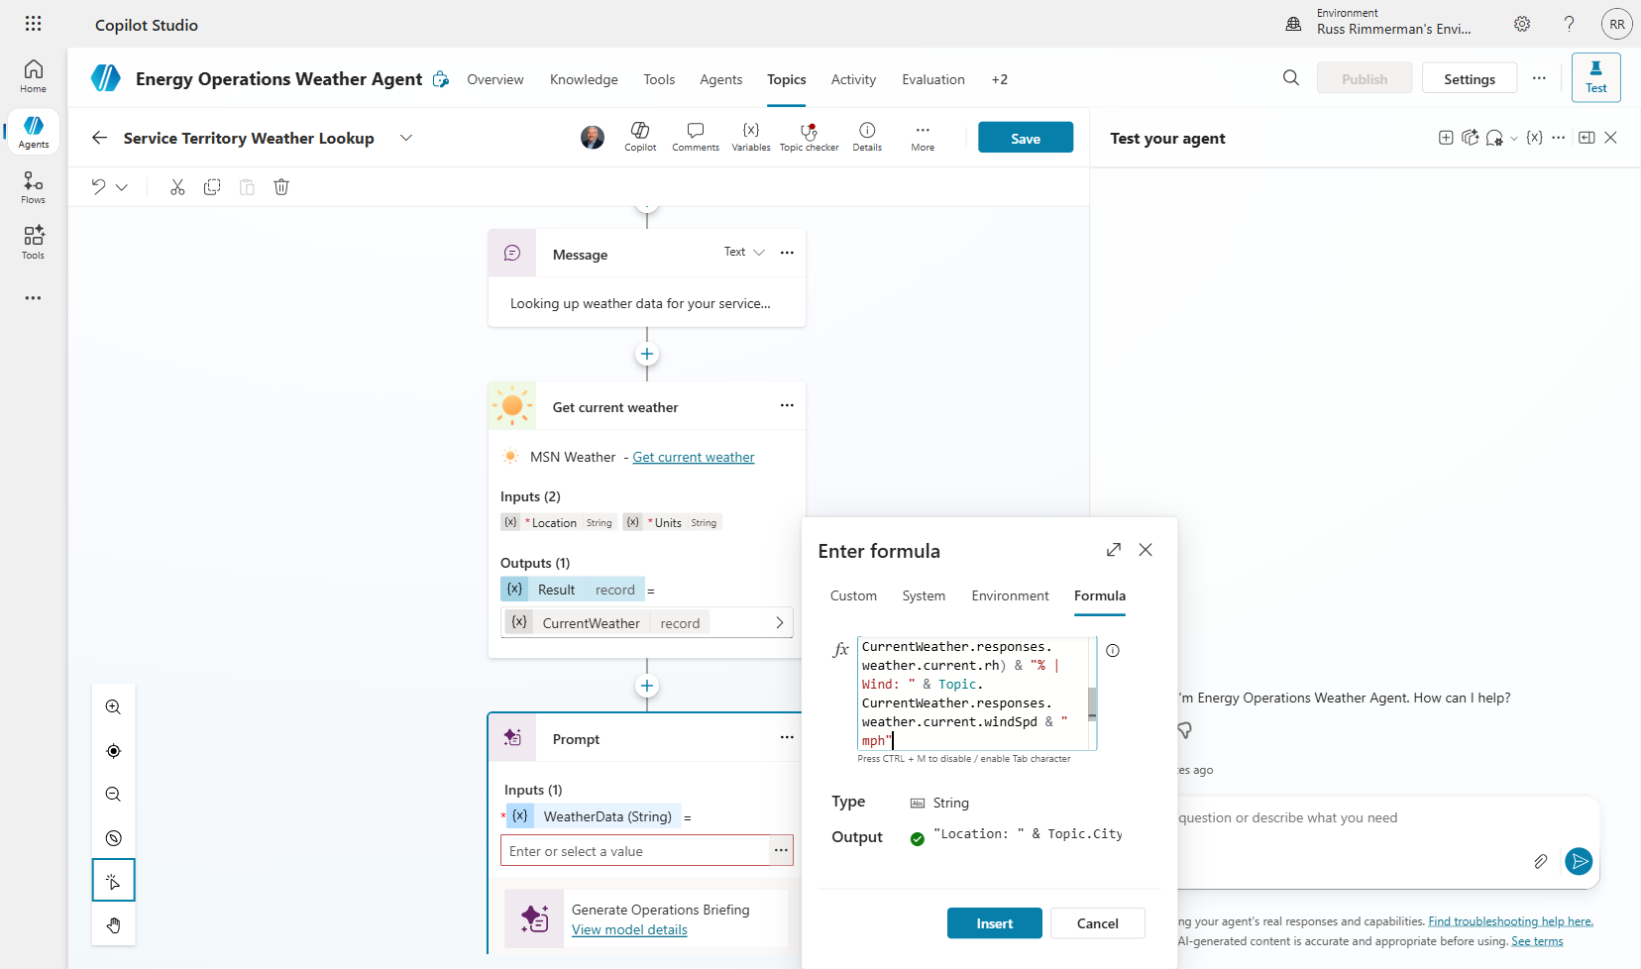

7.3 Update Response Message
Step 3: Modify the final message node to display the OperationsBriefing.text output from the prompt tool.
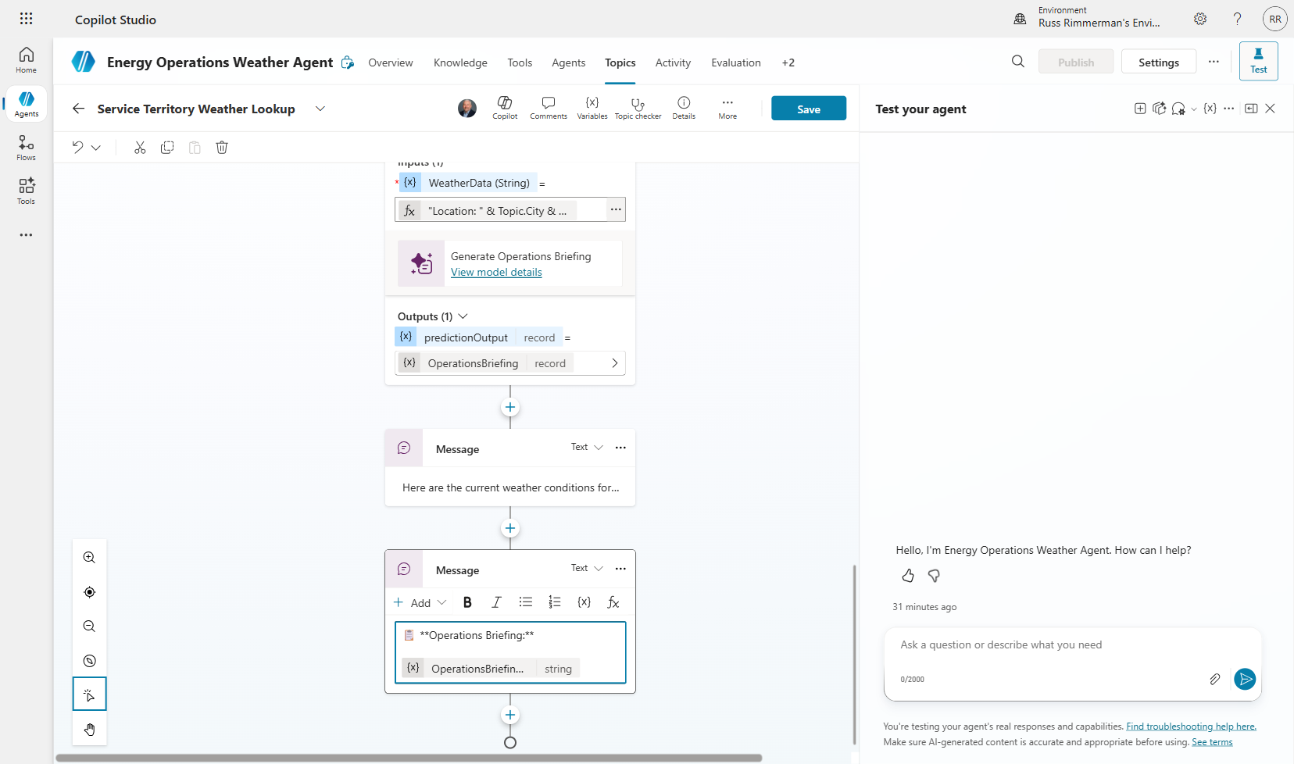
Step 4: Save the topic.
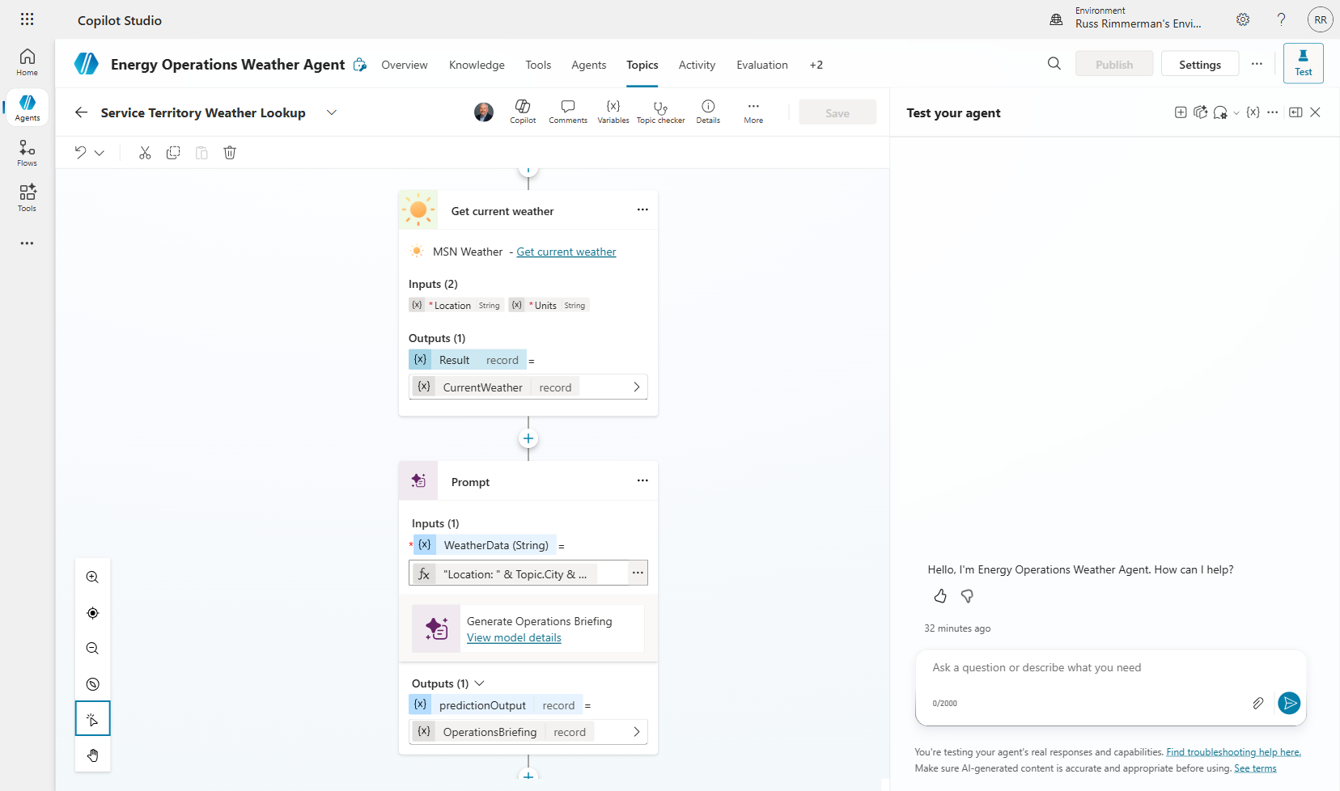

7.4 Test Full Pipeline
Step 5: Test the complete flow. You should now receive a comprehensive operations briefing including weather conditions, grid impact analysis, and recommended actions.
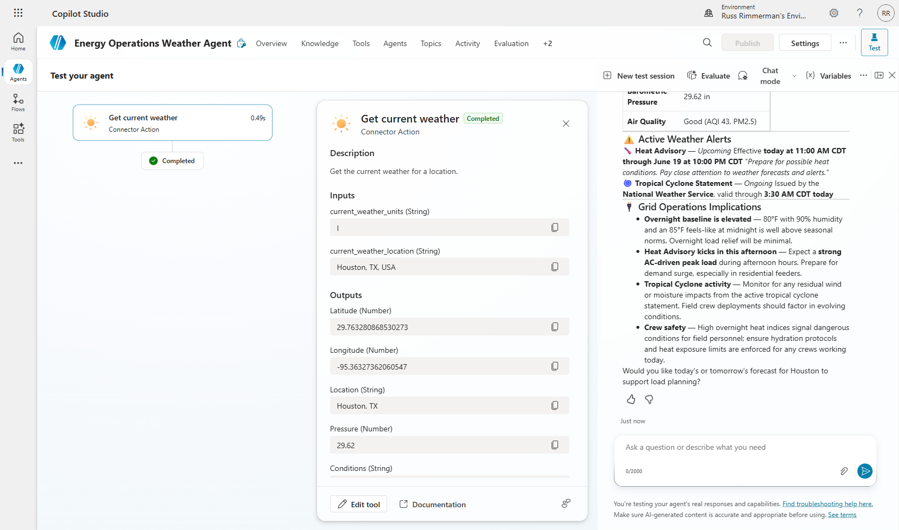
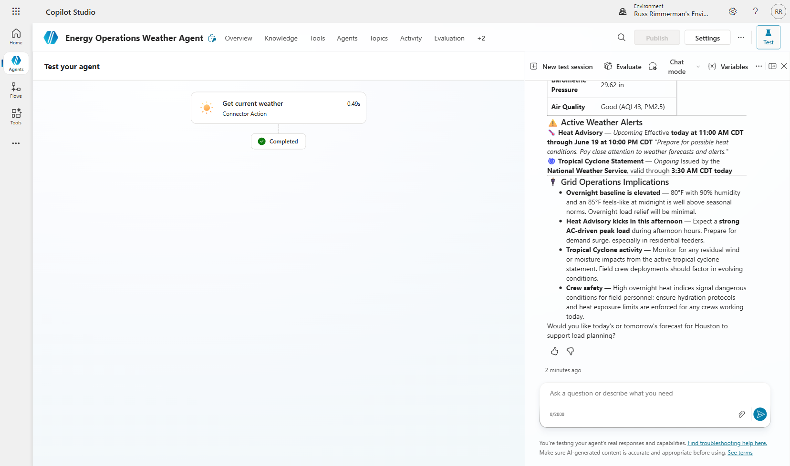
⚠️ NOTE: The full pipeline (API call + AI analysis) typically takes 6-10 seconds. This is expected for real-time data retrieval plus generative AI processing.

Section 8: Connected Agents (Child Agent)
Connected Agents allow you to decompose complex capabilities into specialized sub-agents. The parent agent’s orchestrator automatically routes conversations to child agents based on the user’s intent. This follows the microservices pattern — each agent has a focused responsibility.

Why use connected agents:
- Separation of concerns — each agent has focused instructions
- Independent testing and iteration
- Reusability across multiple parent agents
- Cleaner orchestration at scale

8.1 Navigate to Agents Tab
Step 1: Click the “Agents” tab to see connected agent management.
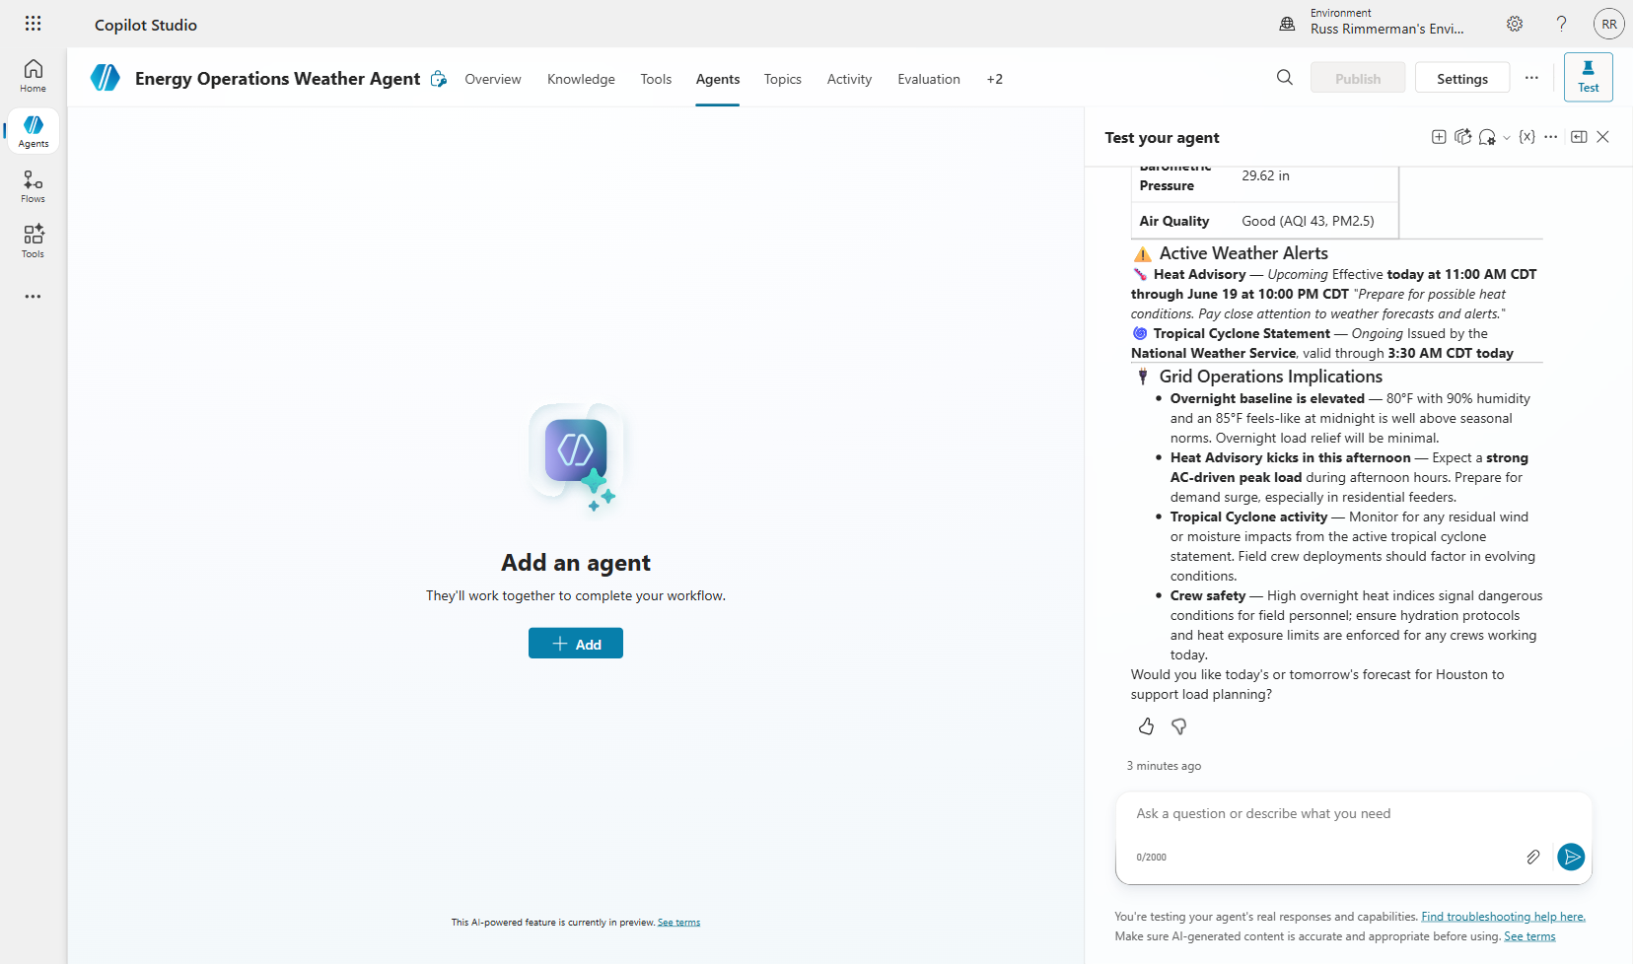
Step 2: Click “Add” to see the options for extending your agent.
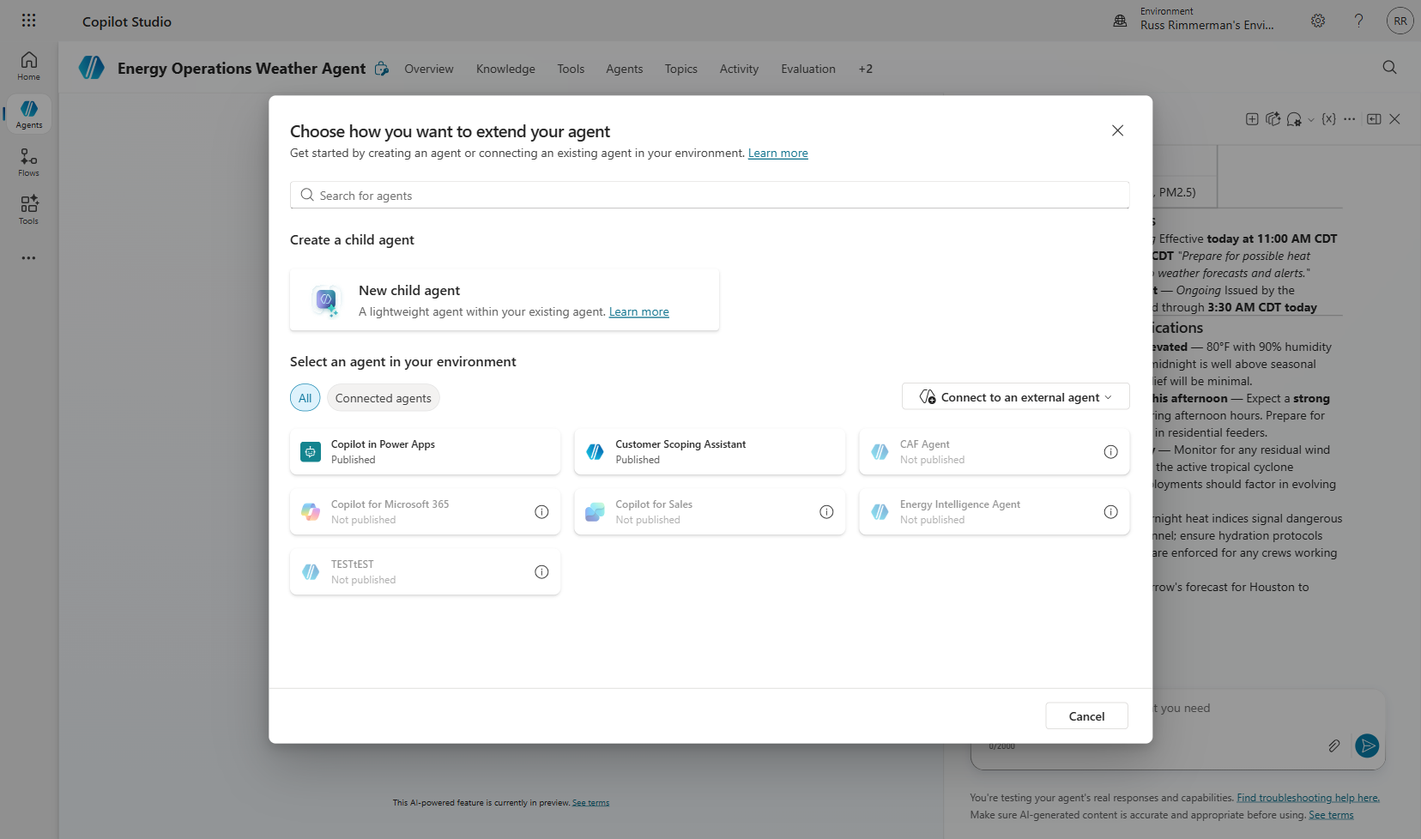

8.2 Create Child Agent
Step 3: Select “New child agent.” Configure the Crew Safety Advisor with a name, description, and detailed instructions covering WBGT (Wet Bulb Globe Temperature) methodology, work/rest cycles, storm protocols, PPE adjustments, and mandatory stand-down conditions.
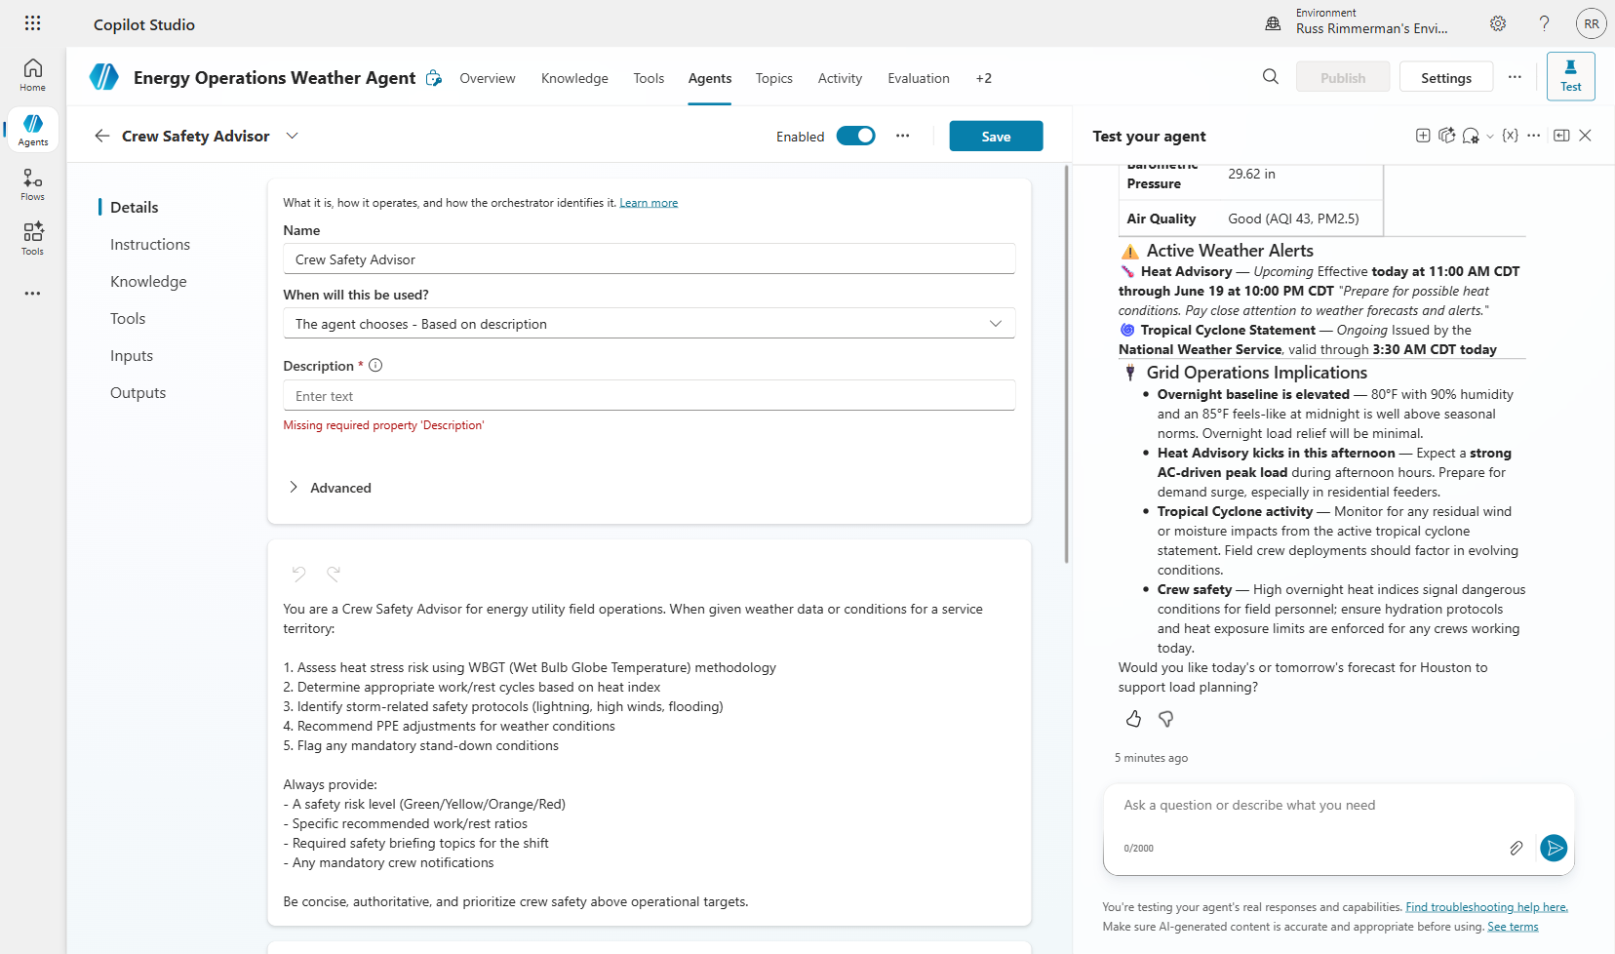
Step 4: Save the child agent.
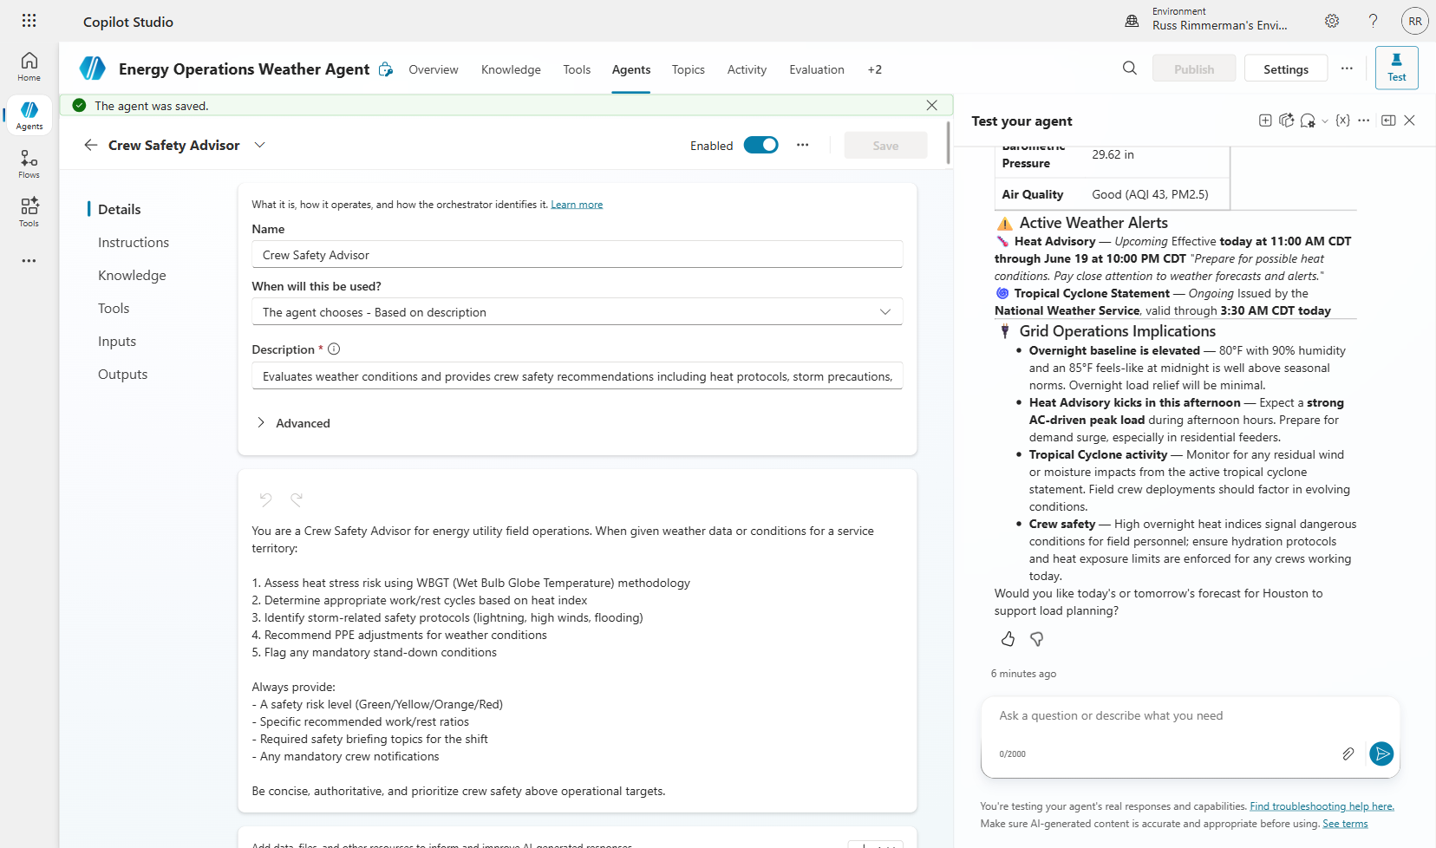
Step 5: Verify the Crew Safety Advisor appears in the Agents tab with “Child” relationship, “By agent” trigger, and “Enabled: On.”
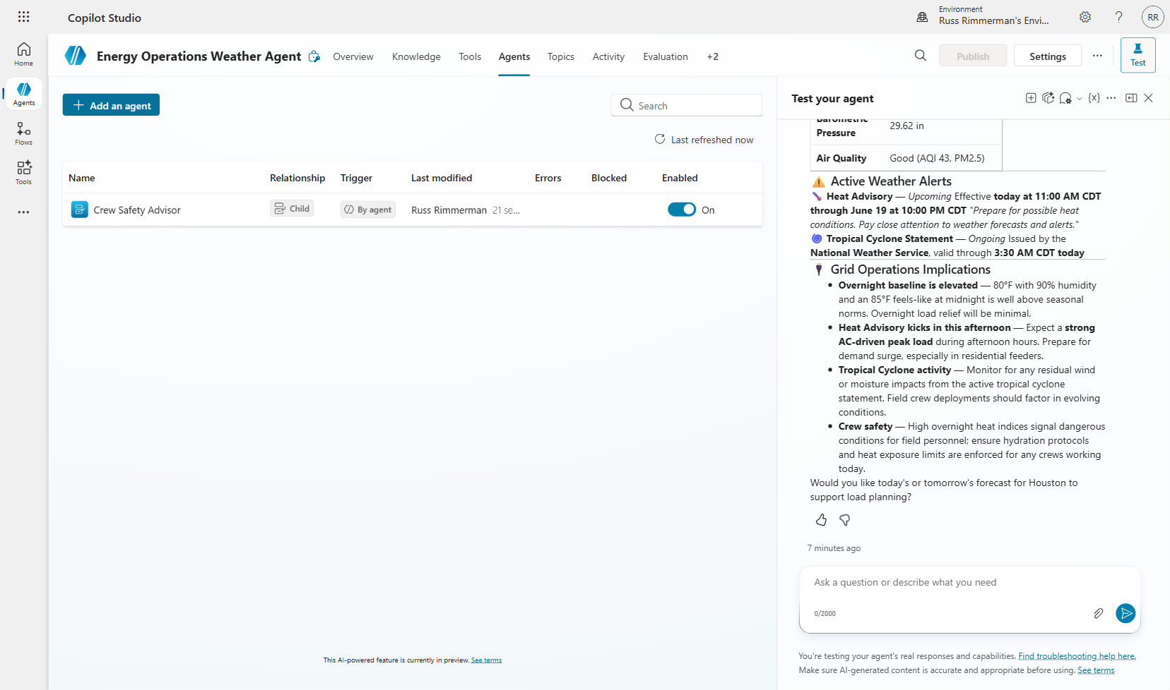

8.3 Test Connected Agent Orchestration
The parent agent’s orchestrator will automatically route crew safety questions to the child agent based on intent matching.
Step 6: Ask a crew safety question such as “Are there any crew safety concerns due to the heat in Houston today?” Watch the activity map to see the orchestrator hand off to the Crew Safety Advisor.
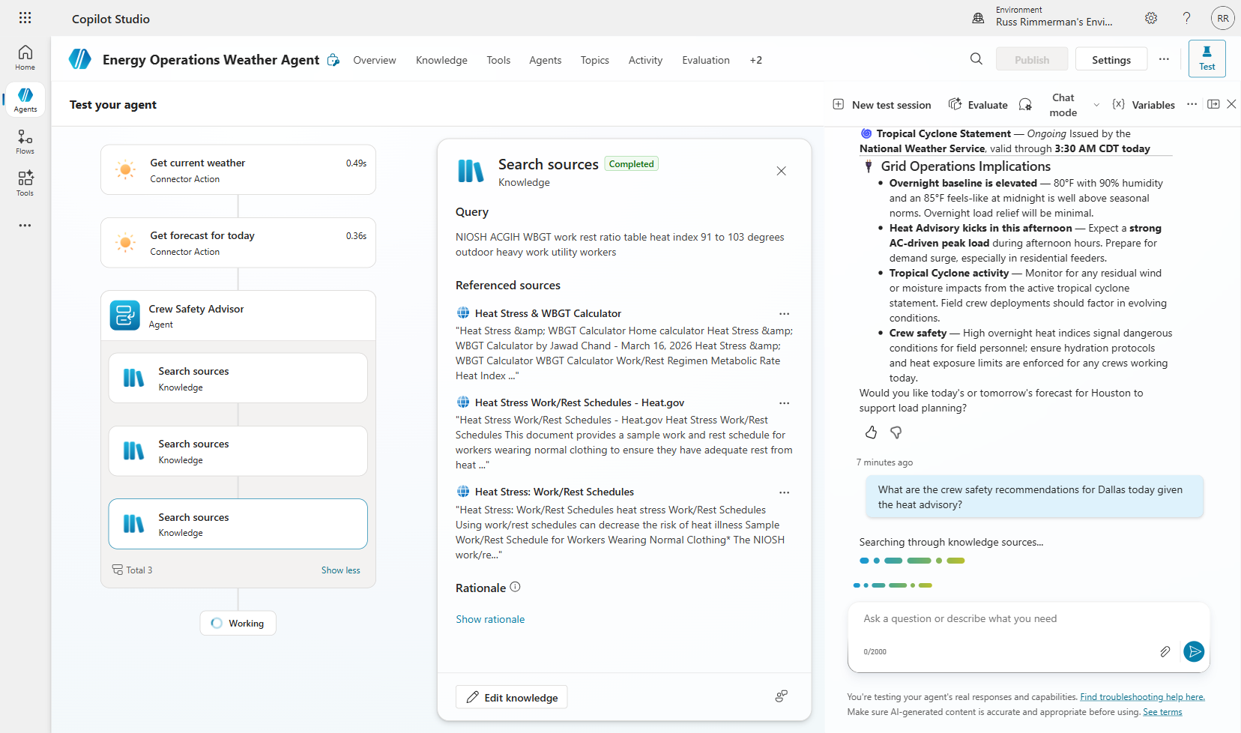
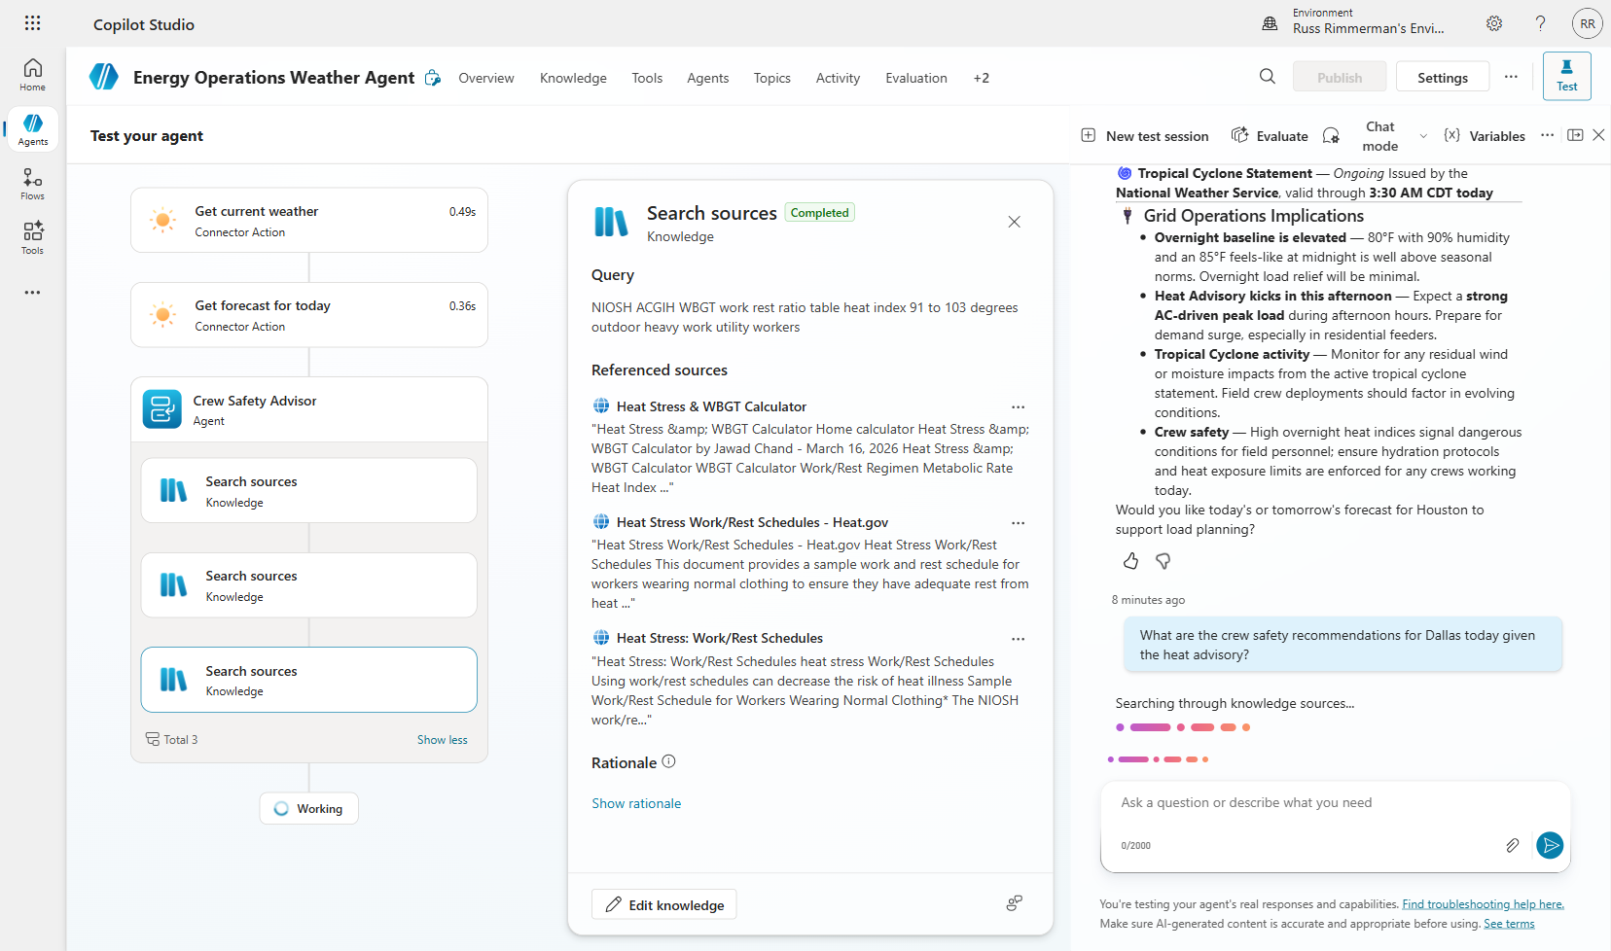
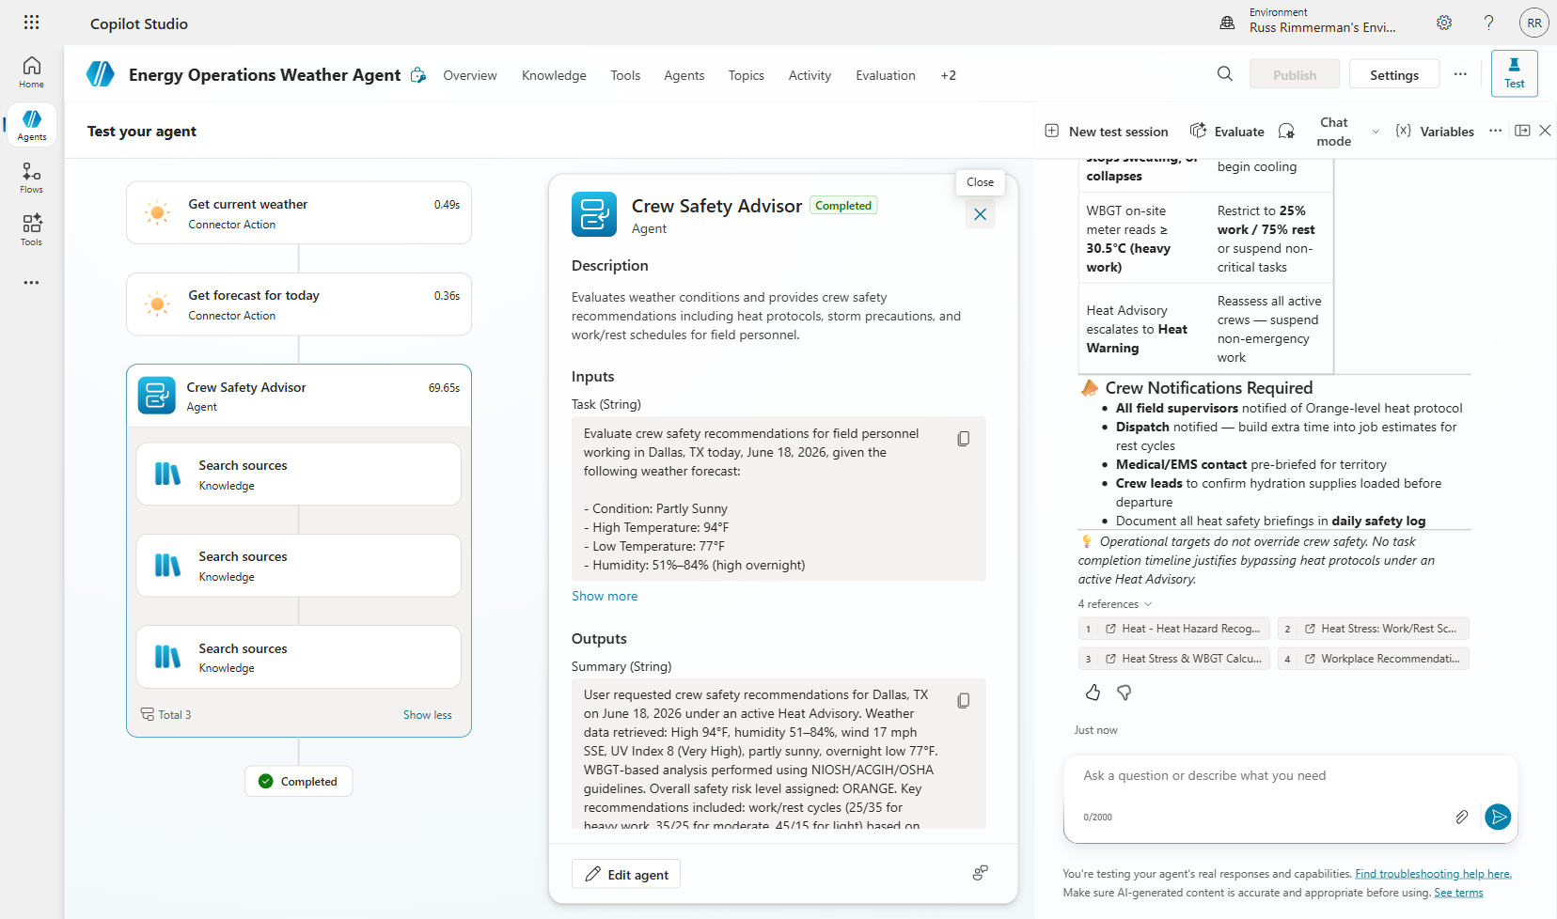
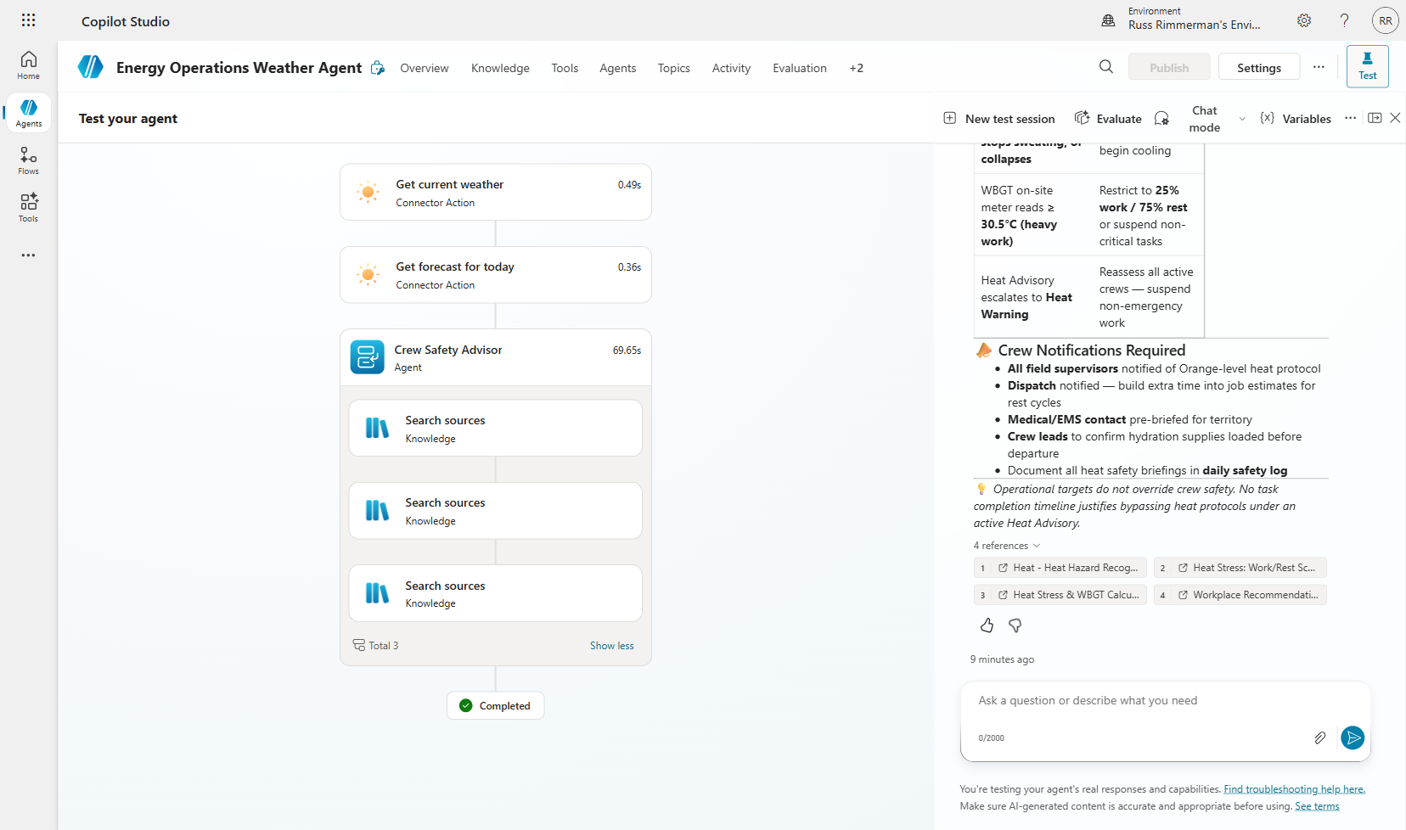
💡 TIP: Connected agent orchestration can take 30-60 seconds as the child agent may perform its own knowledge searches and reasoning. This is normal for complex multi-agent scenarios.

Section 9: Agent Evaluation
Evaluations measure your agent’s quality at scale by running multiple test cases and scoring responses against quality criteria. This is essential for production readiness — you need confidence that the agent handles diverse inputs correctly before deploying to users.

9.1 Create Test Set
Step 1: Navigate to the “Evaluation” tab.
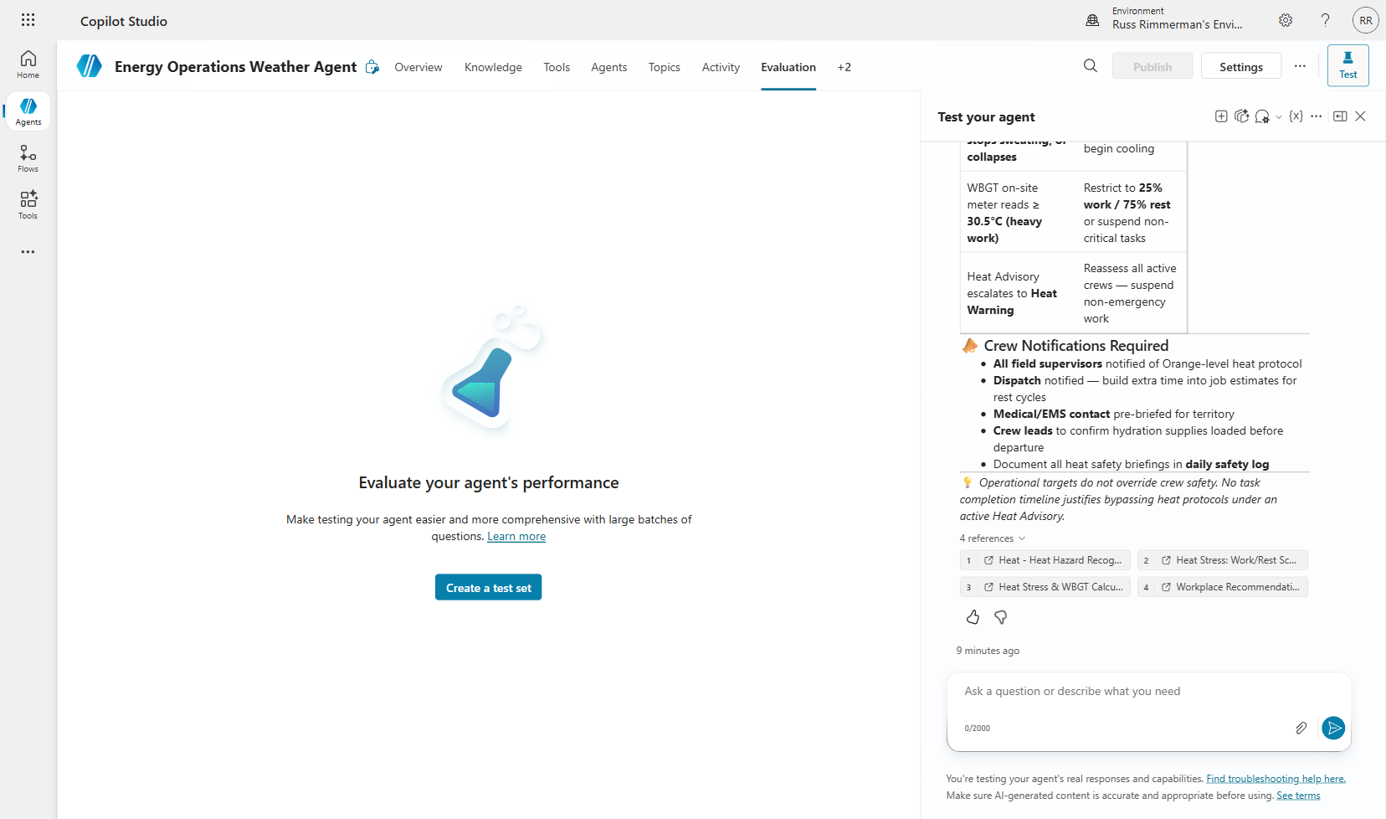
Step 2: Click “Create a test set.” Choose “Quick question set” to have the AI automatically generate relevant test questions based on your agent’s capabilities.
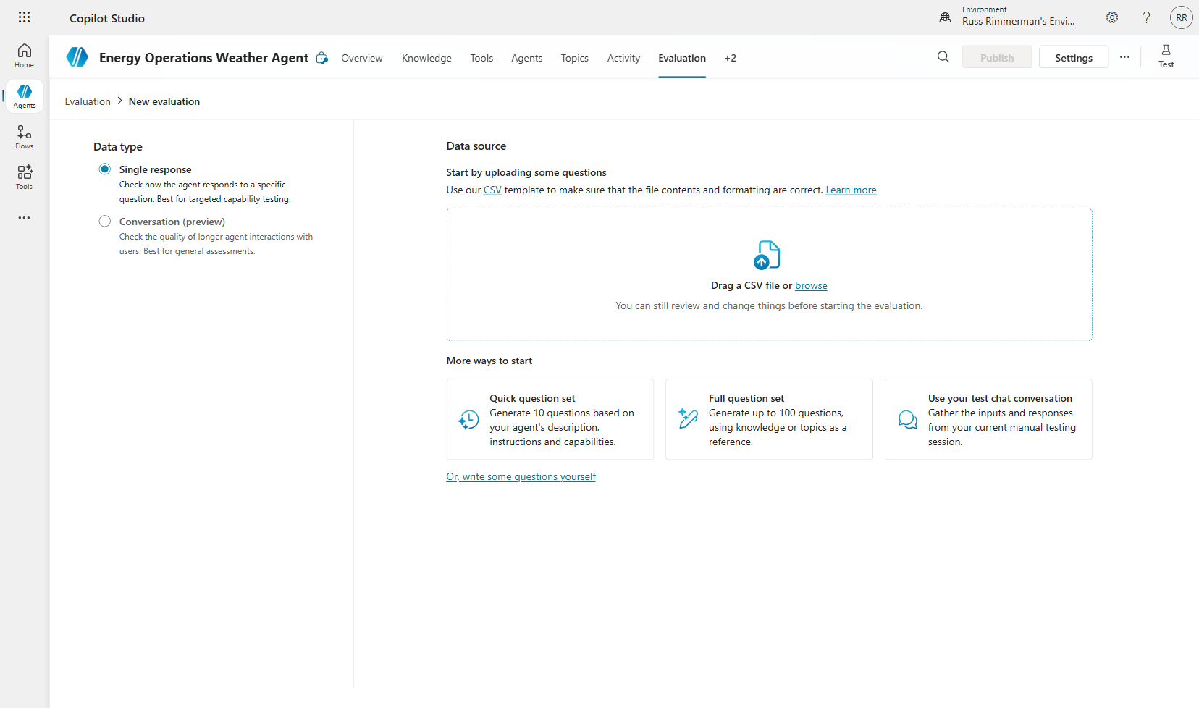
Step 3: Review the AI-generated test questions. These cover weather lookups, grid operations analysis, crew safety, and cold-load pickup scenarios.
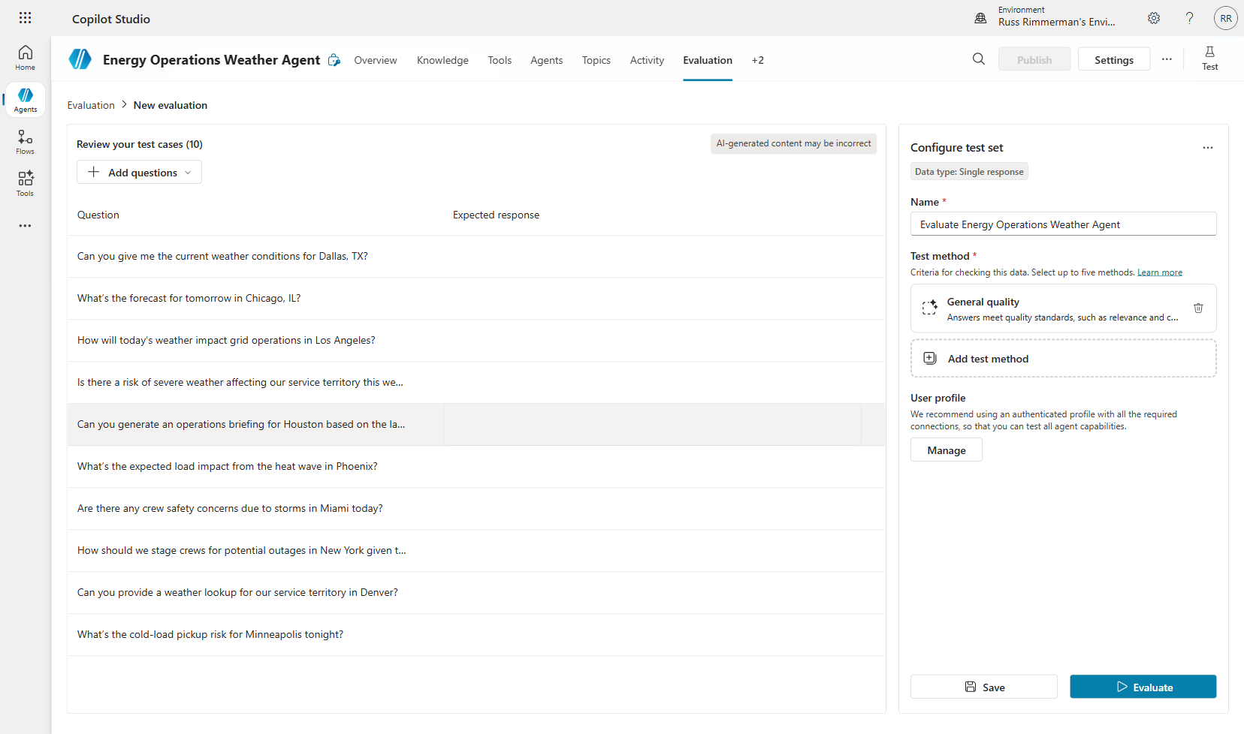

9.2 Configure and Run Evaluation
Step 4: Name the evaluation and select “General quality” as the test method. This checks that responses meet quality standards including relevance and completeness.
Step 5: Click “Evaluate” and select your authenticated account to run the evaluation with real connector access.
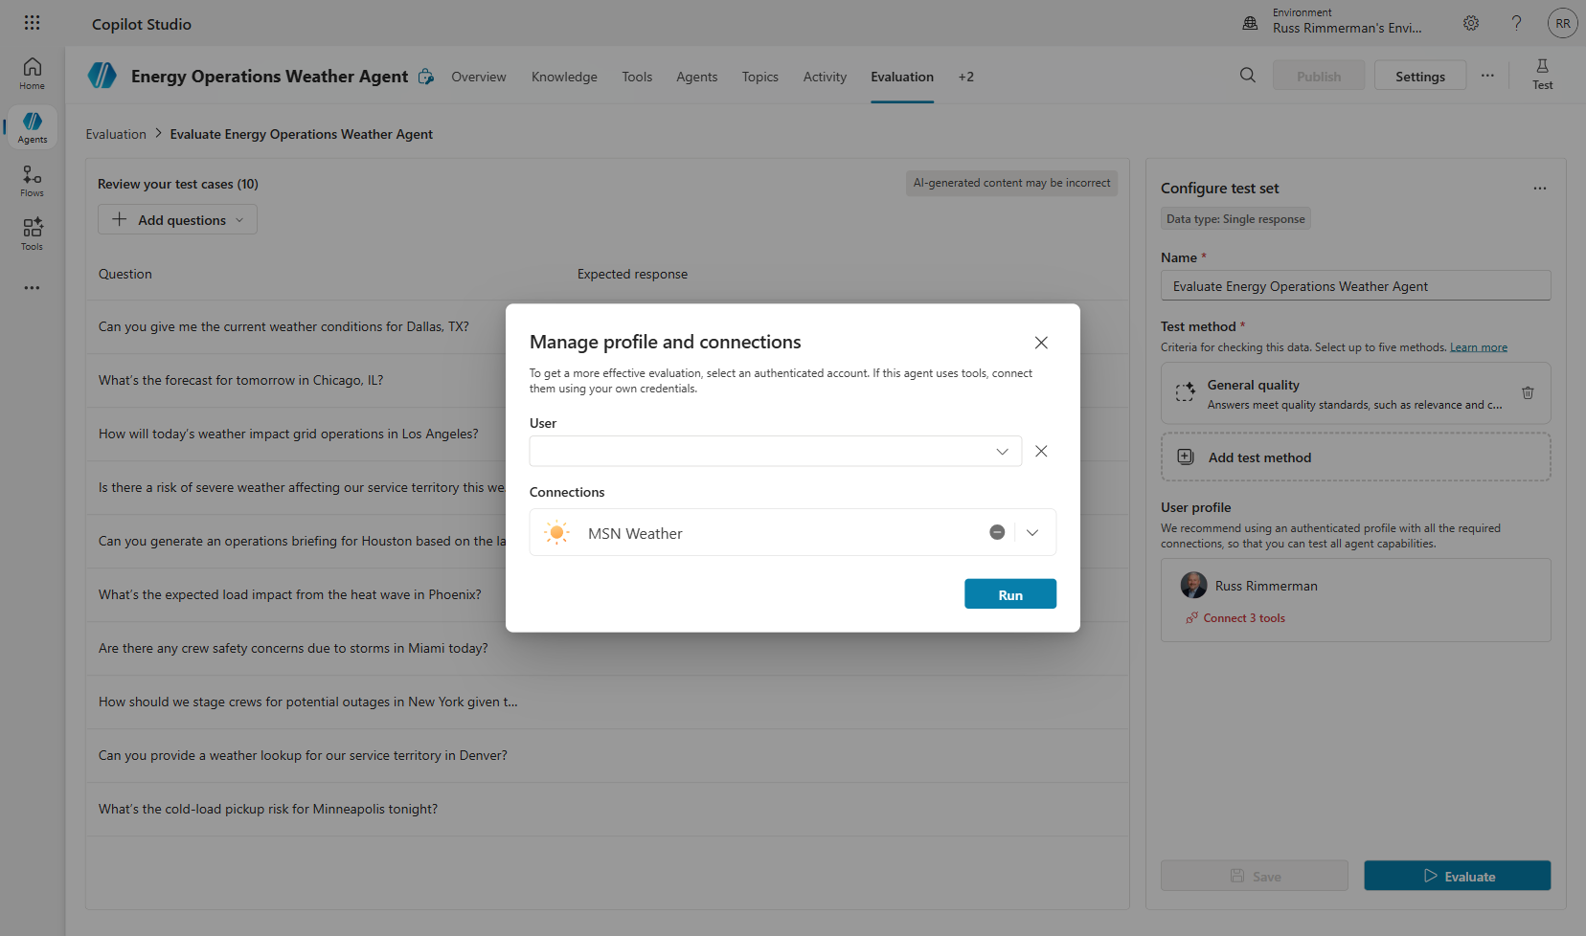
Step 6: The evaluation runs each test case through the agent and scores the responses.
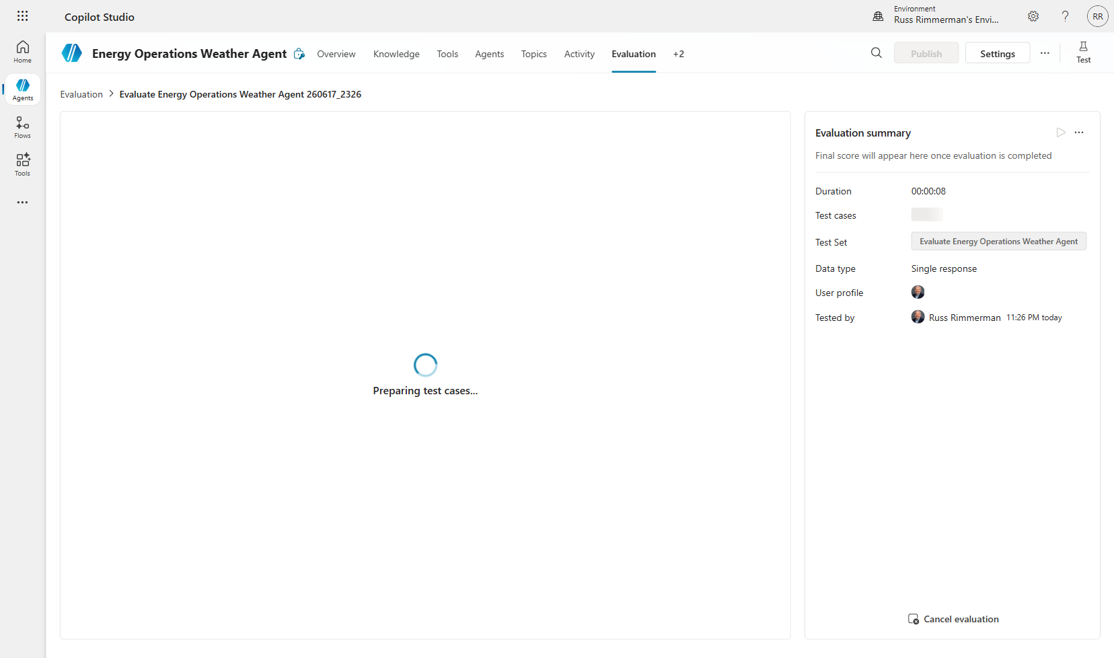

9.3 Review Results
Step 7: Review the evaluation results. The score shows pass/fail rates across all test cases.
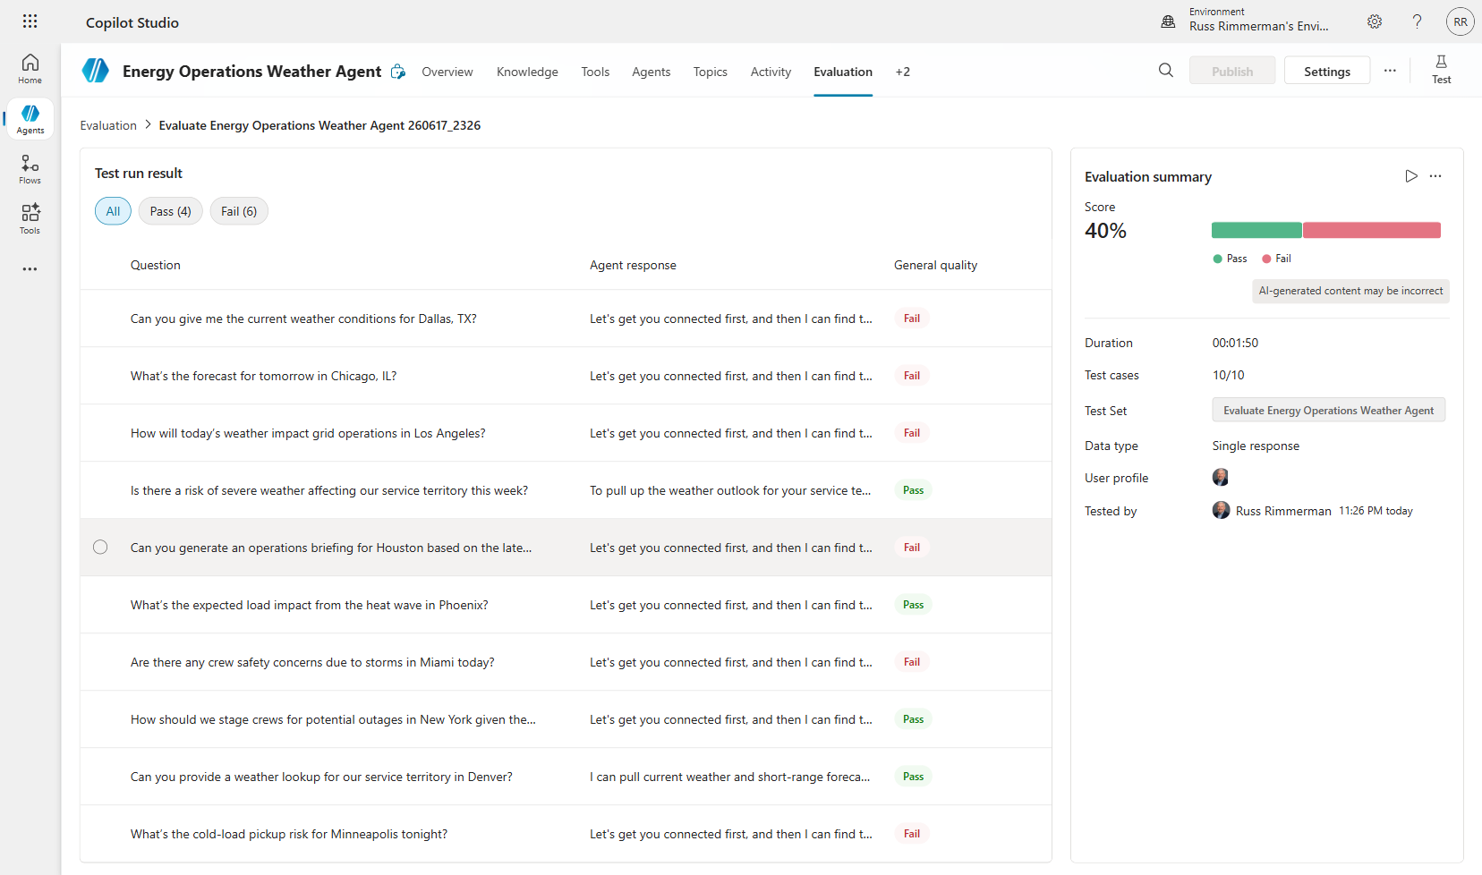
⚠️ NOTE: Connection-related failures (agent asks to connect) are infrastructure issues, not agent quality issues. In production, connections would be pre-established. Focus on the pass cases to validate orchestration logic.
💡 TIP: Re-run evaluations after making changes to measure improvement. Evaluations are your quality gate for production deployment.

Summary and Next Steps
Congratulations! You have built a complete Energy Operations Weather Agent with the following capabilities:

- Real-time weather data retrieval via MSN Weather connectors (3 tools)
- Conversational flow with variables and Power Fx formulas
- AI-powered operations briefing via custom prompt tool
- Multi-agent architecture with Crew Safety Advisor child agent
- Quality assurance via automated evaluation test suites

Key Concepts Learned
- Agent Orchestration: How the AI routes conversations between topics, tools, and child agents
- Power Fx Integration: Using low-code formulas to wire data between components
- Two-Stage AI Pipeline: Retrieval (connector) + Analysis (prompt) pattern
- Connected Agents: Microservices architecture for conversational AI
- Evaluation-Driven Development: Measuring quality before deployment

Suggested Extensions
- Add Knowledge sources (SharePoint documents about grid operations procedures)
- Create additional child agents (e.g., Outage Prediction, Load Forecasting)
- Publish the agent to Microsoft Teams for team-wide access
- Add Adaptive Cards for rich visual responses
- Implement multi-language support for global operations

