Microsoft Copilot Studio
Introductory Lab Workshop
Building, Configuring, and Publishing AI Agents
Duration: 1.5 Hours | Level: Intermediate
Lab Guide — Hands-On Workshop

Table of Contents
Section 1: Ways to Build a Copilot Studio Agent ...................................... 3
Section 2: Tool Use with Connectors (MSN Weather) ................................ 8
Section 3: Model Selection — Choosing the Right AI Model ...................... 18
Section 4: Publishing & Sharing — M365 Copilot, Teams, & SharePoint ... 22
Appendix: Additional Resources ................................................................ 28

Section 1: Ways to Build a Copilot Studio Agent
Copilot Studio provides multiple pathways to create agents, each suited to different skill levels and use cases. Understanding these options helps you choose the fastest path to a working agent that meets your business requirements.

1.1 Describe to Build (Natural Language)
The simplest way to create an agent is by describing what you want it to do in natural language. Copilot Studio's AI interprets your description and generates a complete agent configuration, including suggested topics, instructions, and knowledge sources.

This approach is ideal for rapid prototyping and when you have a clear idea of the agent's purpose but don't want to configure every detail manually.

Step 1: Navigate to copilotstudio.microsoft.com and sign in with your Microsoft 365 account.
Step 2: On the home page, you'll see the prompt: "What would you like to build?" with the Agent tab selected.
Step 3: Type a natural language description of your agent in the text box. For example: "Create an agent that helps employees check weather conditions for field operations."
Step 4: Click the Send arrow. Copilot Studio generates the agent with pre-configured instructions, suggested topics, and knowledge settings.
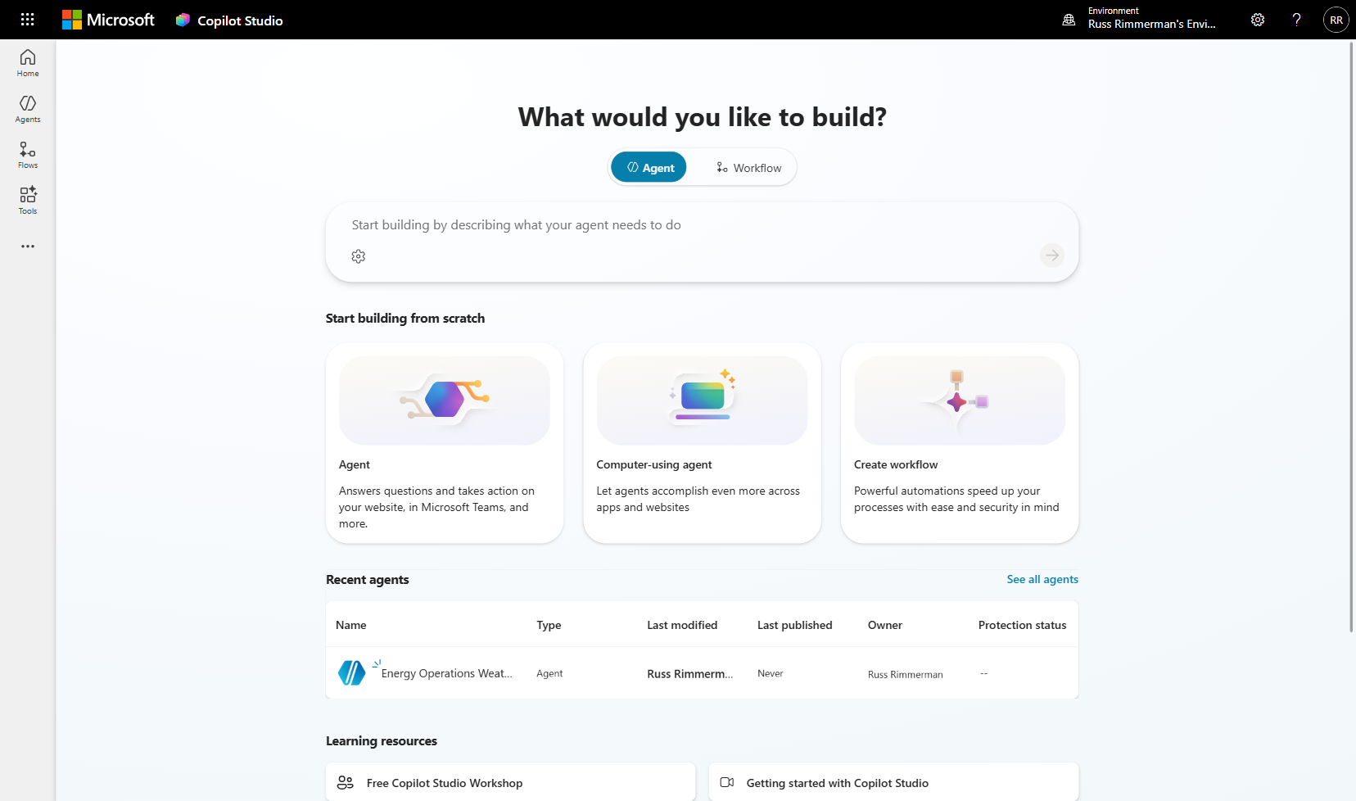
Figure 1.1 — Copilot Studio home page showing the describe-to-build text box and scratch-build options
💡 Tip: The describe-to-build approach creates a solid starting point. You can always refine the generated configuration afterward.

1.2 Build from Scratch (Blank Agent)
Building from scratch gives you complete control over every aspect of your agent. You start with a blank canvas and manually configure the agent's name, description, instructions, topics, tools, and knowledge sources.

This approach is recommended when you have specific requirements that need precise configuration, or when you're building agents for production use where every behavior must be intentional.

Step 1: On the home page, scroll down to "Start building from scratch" and click the Agent card.
Step 2: In the dialog that appears, enter a Name for your agent (e.g., "Energy Operations Weather Agent").
Step 3: Optionally add a Description and Instructions. The instructions tell the AI how to behave — its persona, rules, and response style.
Step 4: Click Create. Your agent's Overview page opens with all configuration sections.
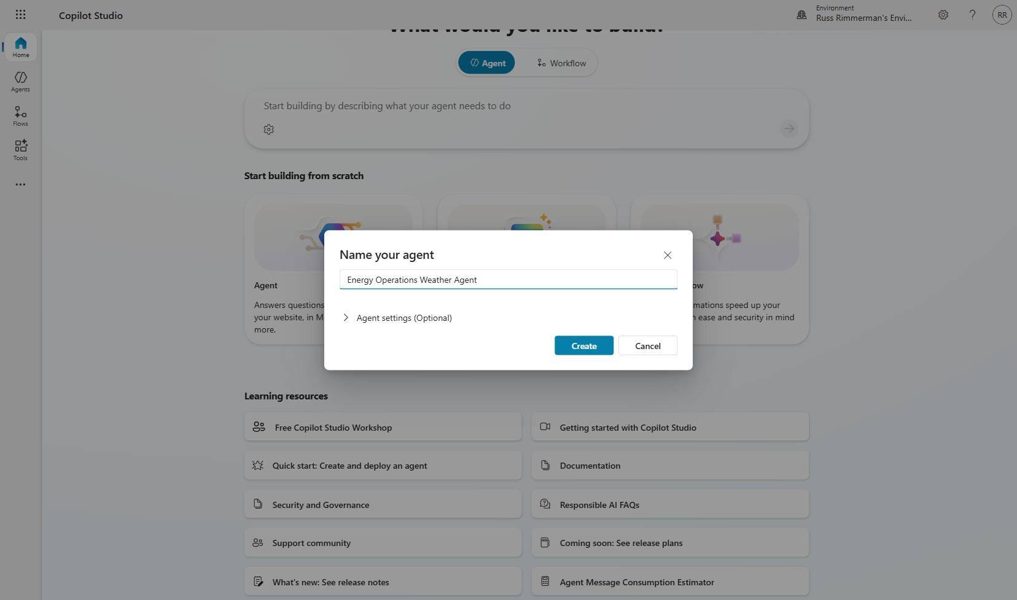
Figure 1.2 — Agent creation dialog for building from scratch
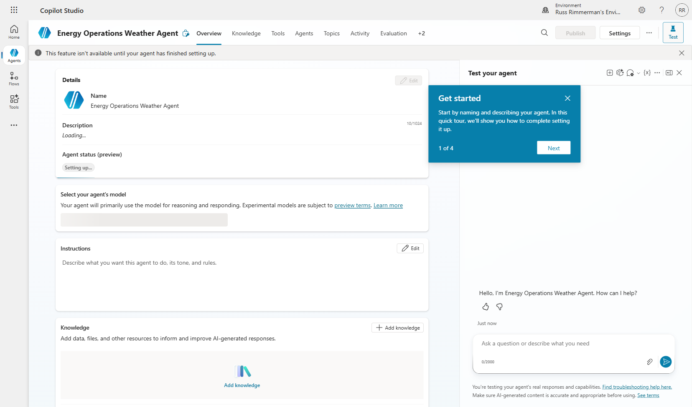
Figure 1.3 — A newly created agent's Overview page

1.3 Computer-Using Agent
Computer-using agents are a newer capability that allows your agent to interact directly with apps and websites on behalf of the user. These agents can navigate UI elements, fill forms, click buttons, and perform multi-step workflows across different applications.

This is particularly powerful for automating tasks that don't have APIs — the agent literally uses the computer like a human would. Use cases include legacy application automation, cross-application workflows, and data entry tasks.

📝 Note: Computer-using agents are a premium feature and may require additional licensing. They're best suited for workflows that span multiple applications without available APIs.

1.4 Create Workflow
While not an "agent" in the conversational sense, Copilot Studio also supports creating Power Automate workflows directly from the home page. Workflows are event-driven automations that run in the background — triggered by conditions like a new email, a form submission, or a schedule.

Workflows complement agents by handling behind-the-scenes automation while agents handle user-facing interactions.

1.5 Choosing the Right Approach
- Describe to Build: Best for rapid prototyping, proof of concept, or when you're exploring what's possible. Good for getting started quickly.
- Build from Scratch: Best for production agents where you need precise control over behavior, topics, and tool integration. Recommended for this lab.
- Computer-Using Agent: Best for automating UI-based tasks across apps and websites that lack APIs.
- Workflow: Best for background automations that don't require user interaction (e.g., scheduled data processing, automated notifications).

💡 Tip: For this lab, we'll use the Build from Scratch approach so you understand every component of agent configuration. Once you're comfortable, describe-to-build becomes a powerful accelerator.

Section 2: Tool Use with Connectors (MSN Weather)
Tools are the bridge between your agent's conversational AI and real-world data and services. When a user asks a question that requires external information — like current weather conditions — the agent invokes a tool to fetch that data and incorporates it into its response.

In this section, you'll learn how to add the MSN Weather connector as a tool, configure it with Power Fx formulas to pass dynamic user inputs, and wire it into a conversational topic that collects location information from the user.

⚠️ Important: You'll need to authenticate with the MSN Weather connector when testing. The connector is free but requires a Microsoft account connection.

2.1 Creating a Conversational Topic
Topics are the building blocks of conversation in Copilot Studio. Each topic defines a specific conversational flow — what the agent asks, what it does with user responses, and what tools it calls. Topics use trigger phrases to determine when they should activate.

Step 1: Navigate to the Topics tab in your agent.
Step 2: Click Add > From blank to create a new topic.
Step 3: Name the topic (e.g., "Service Territory Weather Lookup") and add a description.
Step 4: Add trigger phrases — these are example sentences users might say to activate this topic (e.g., "What's the weather?", "Check conditions", "Weather report for my area").
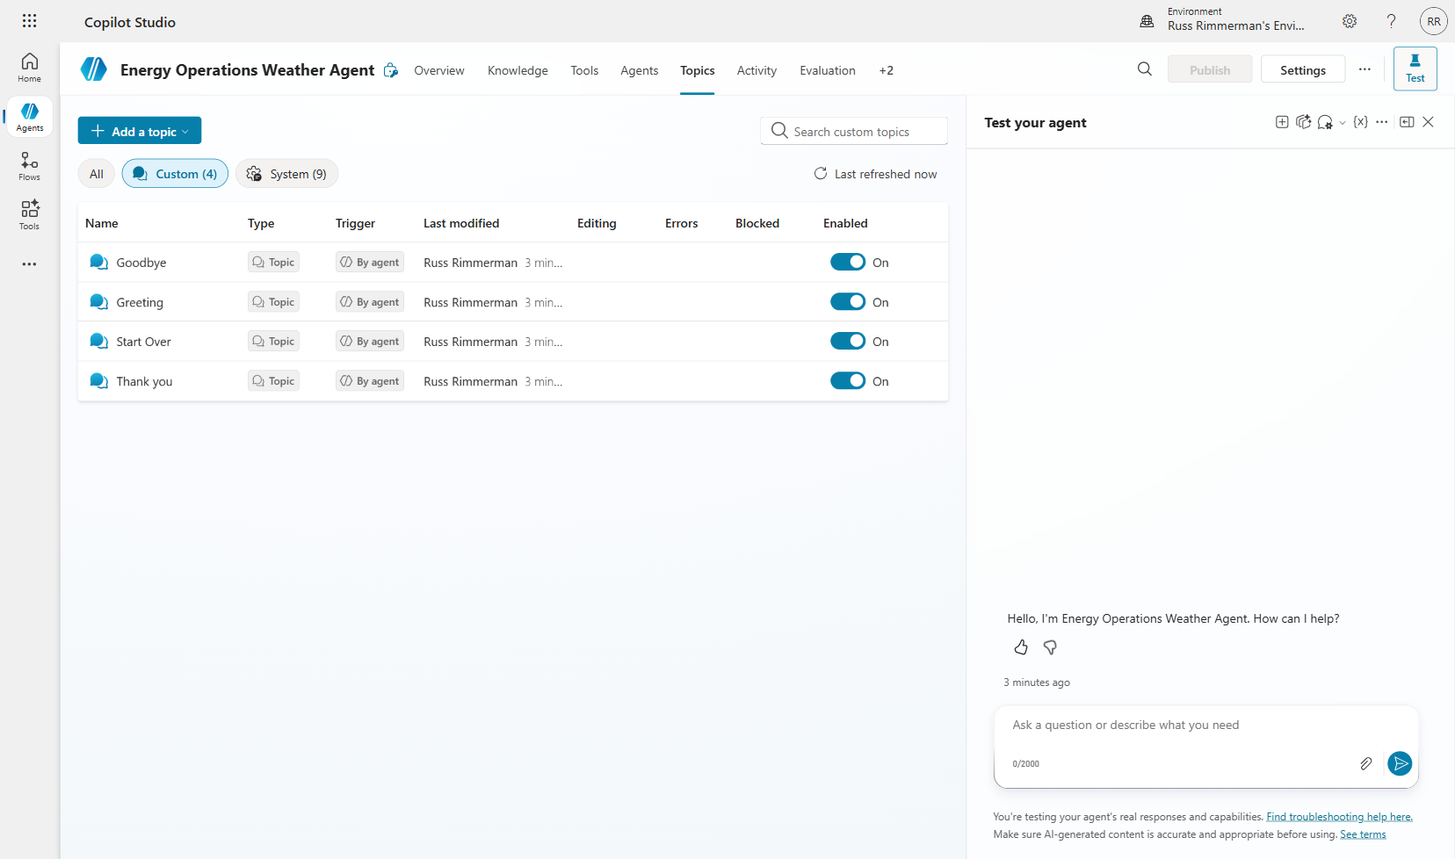
Figure 2.1 — The Topics tab where you manage conversation flows
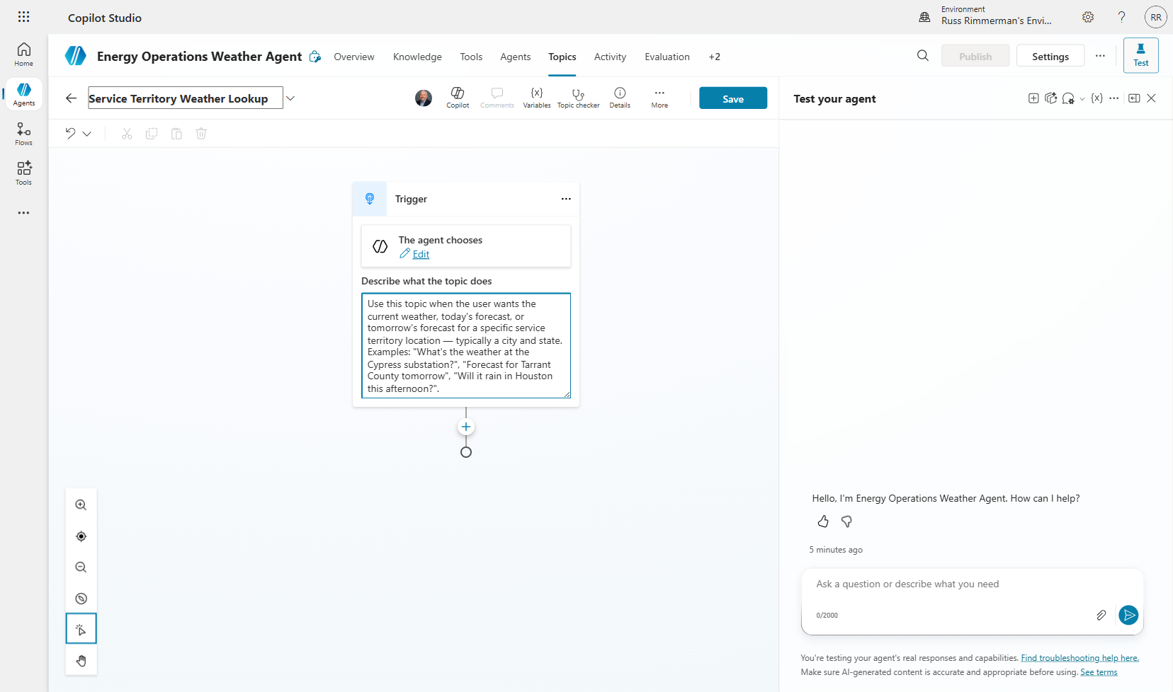
Figure 2.2 — Topic configuration with name and description

2.2 Adding Question Nodes to Collect User Input
Before your agent can call a weather tool, it needs to know the location. Question nodes prompt the user for specific information and store their responses in variables that can be used downstream.

Step 1: In the topic canvas, click the "+" button to add a node.
Step 2: Select "Ask a question" from the menu.
Step 3: Enter the question text: "What city would you like the weather for?"
Step 4: Set the response type to "User's entire response" — this captures the full text the user types.
Step 5: Rename the output variable to something meaningful like "City" by clicking the variable name.
Step 6: Repeat to add a second question: "What state?" with variable name "State".
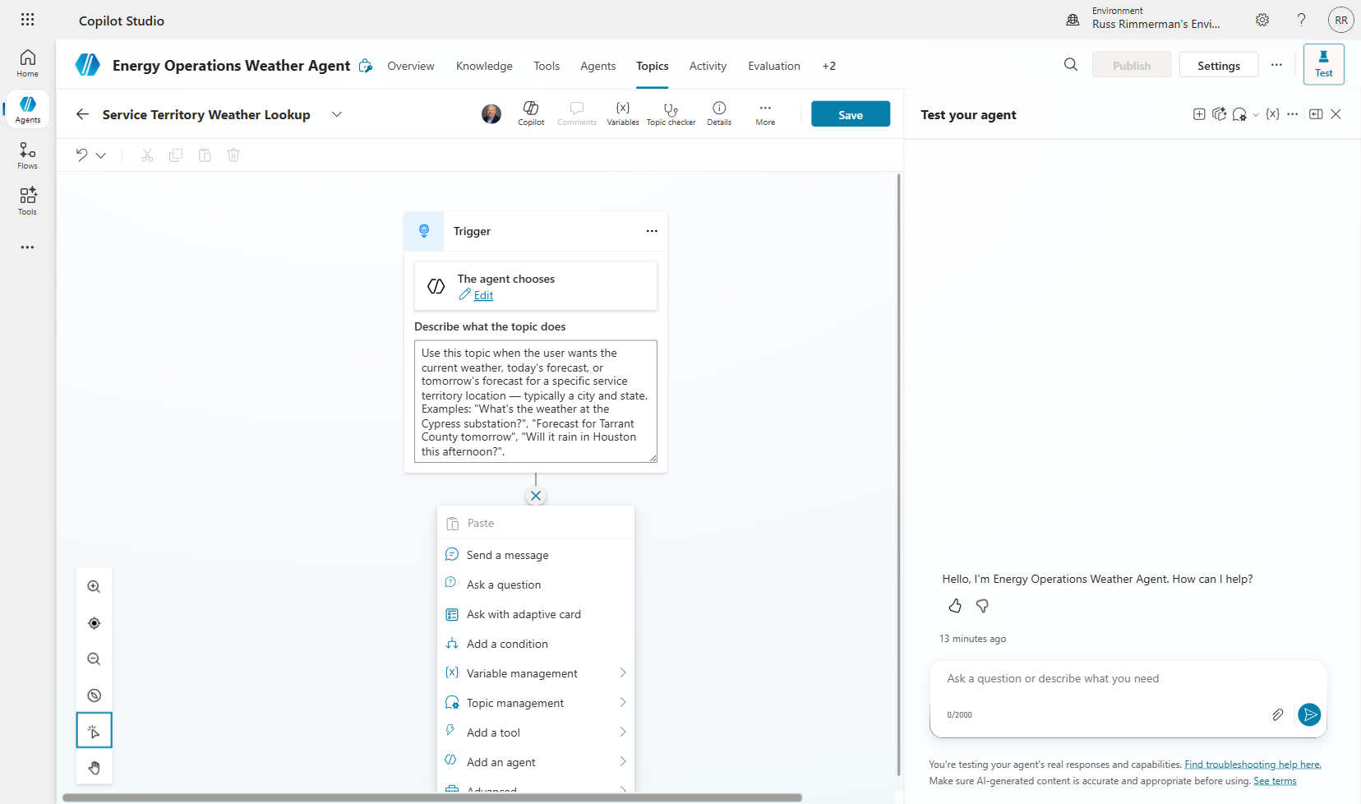
Figure 2.3 — The Add Node menu showing available node types
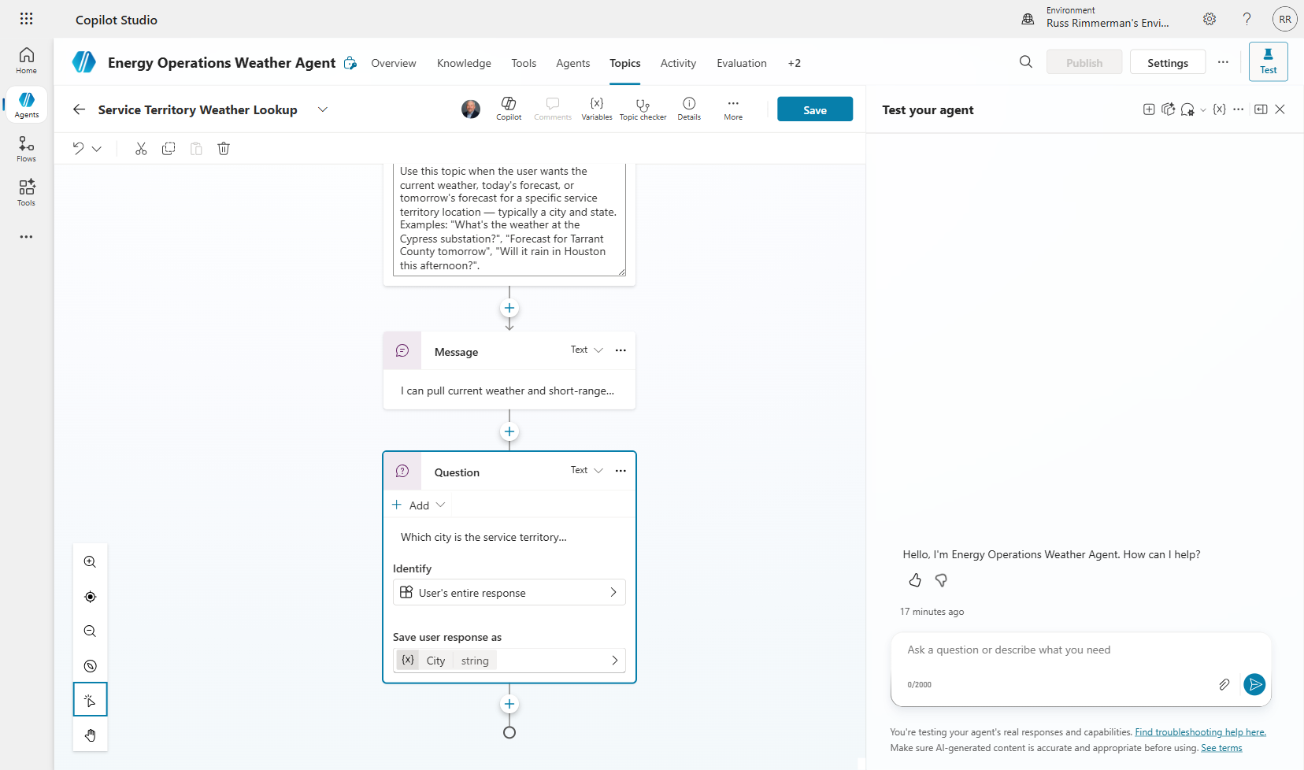
Figure 2.4 — Question node configured to ask for the city

2.3 Adding the MSN Weather Connector as a Tool
Connectors are pre-built integrations with hundreds of services. The MSN Weather connector provides real-time weather data, forecasts, and conditions for any location worldwide. Adding it as a tool makes it available for your agent to call.

Step 1: Navigate to the Tools tab and click "Add a tool".
Step 2: In the search dialog, type "MSN Weather" to find the connector.
Step 3: You'll see multiple actions available: "Get current weather", "Get forecast for today", "Get the forecast for tomorrow", etc.
Step 4: Select "Get current weather" and click "Add tool".
Step 5: Review the tool's input parameters (Location, Units) and output schema.
Step 6: Repeat for "Get forecast for today" and any other weather actions you want.
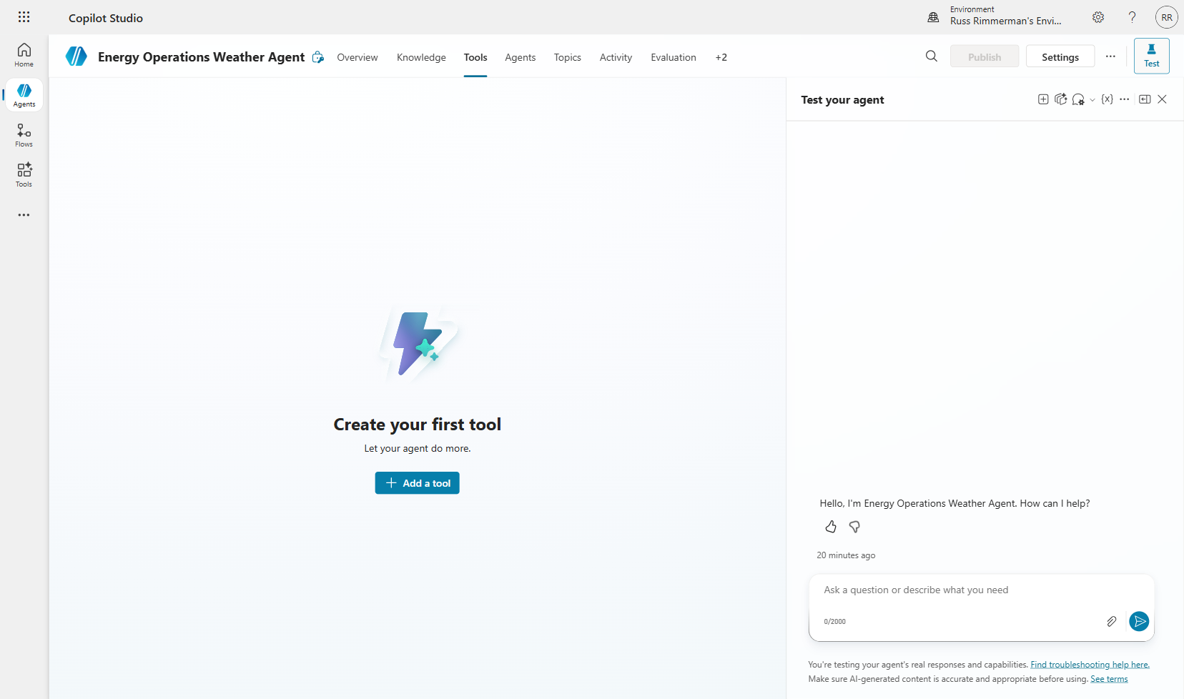
Figure 2.5 — The Tools tab before adding any tools
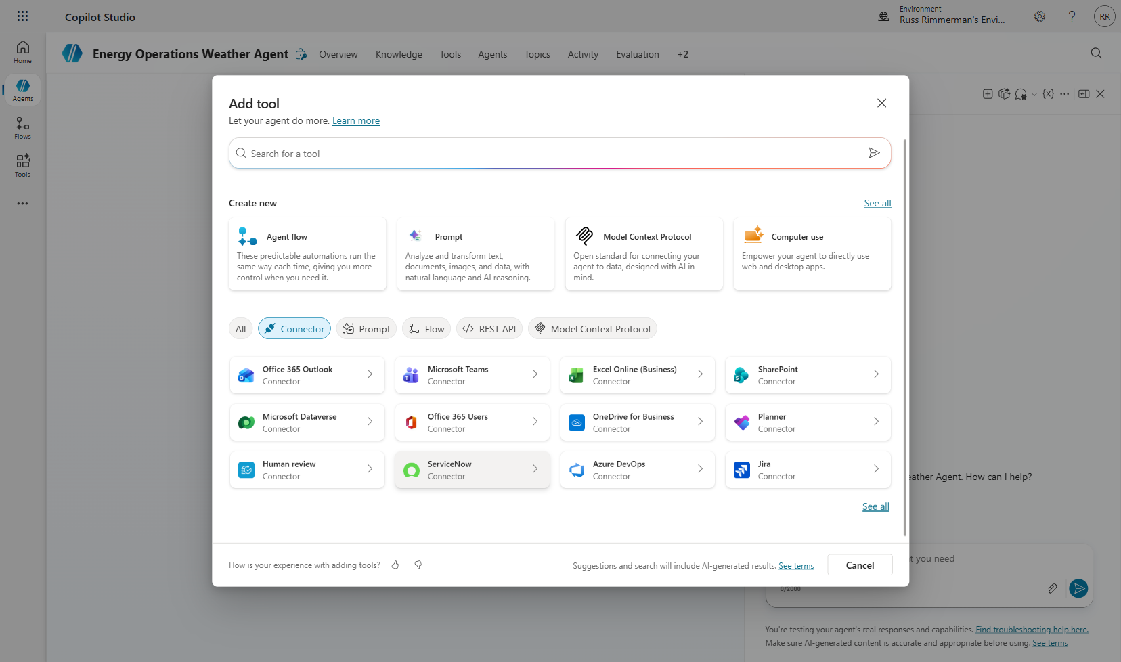
Figure 2.6 — The Add Tool dialog for searching connectors
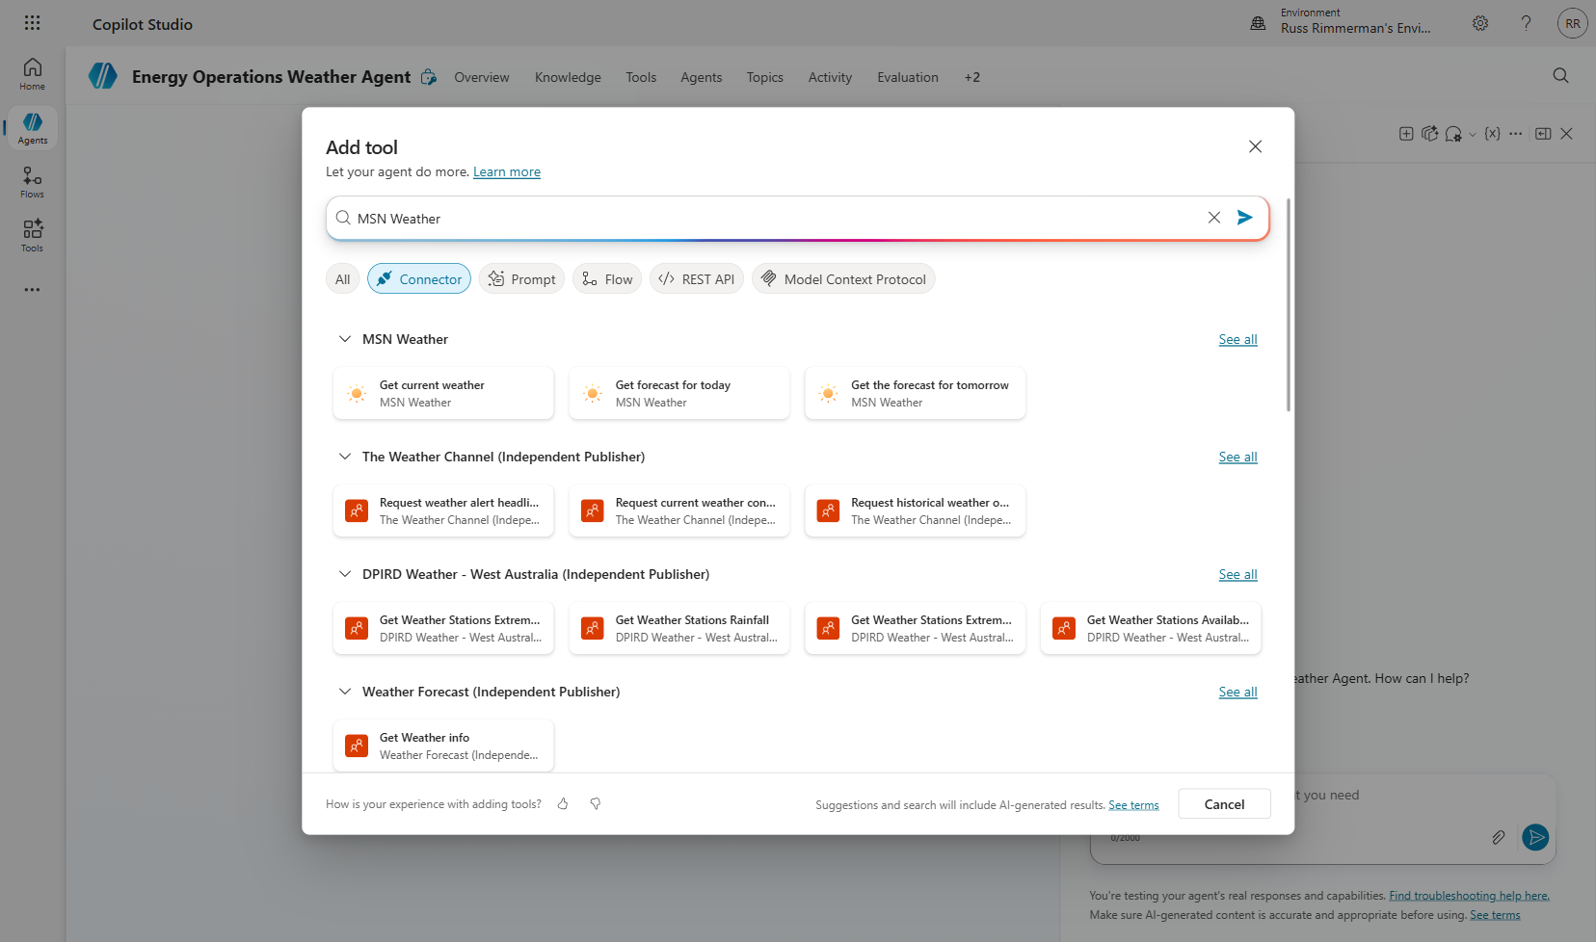
Figure 2.7 — Searching for the MSN Weather connector
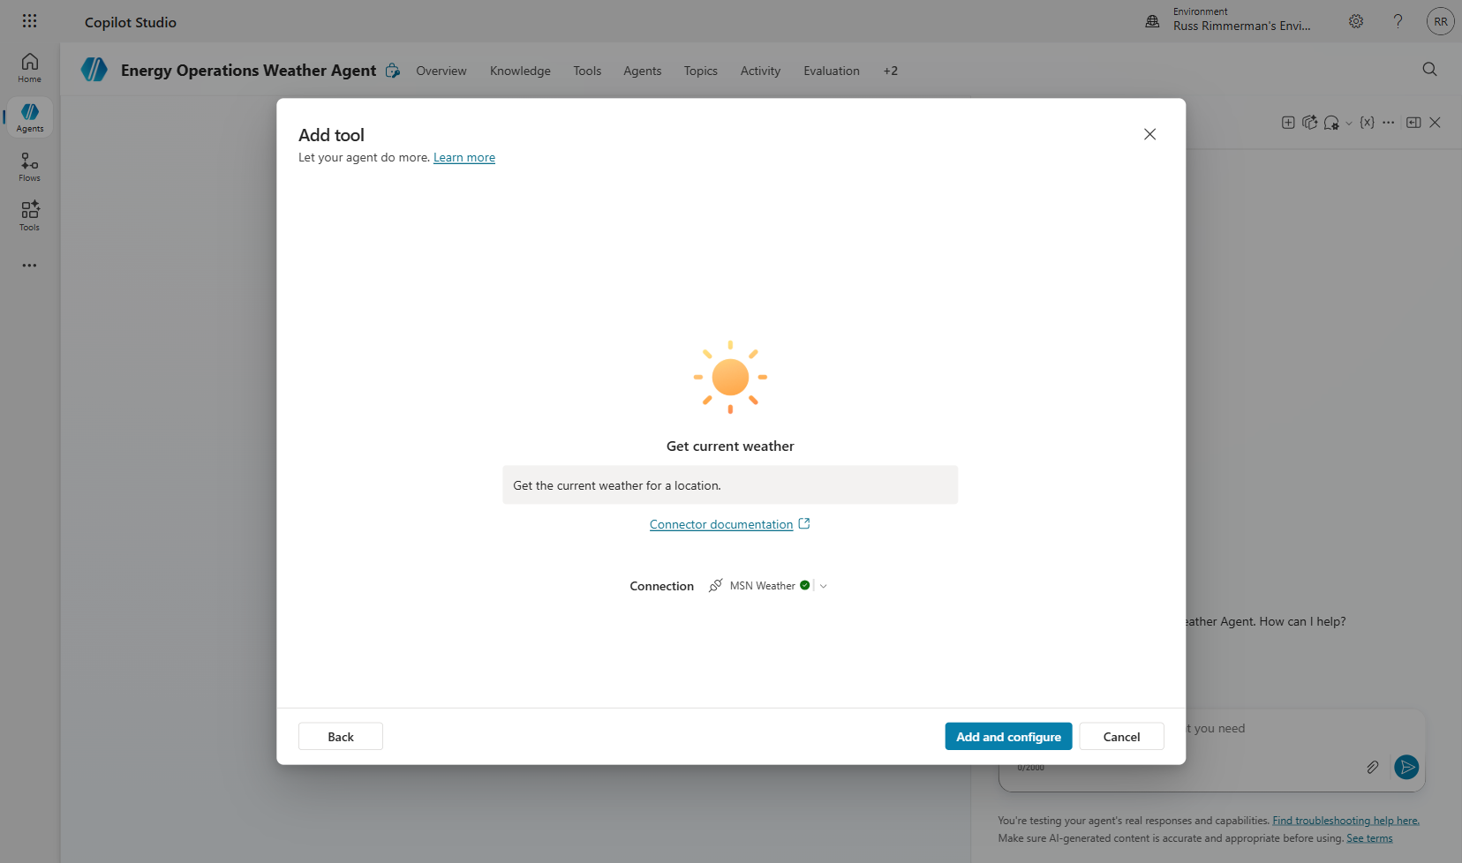
Figure 2.8 — MSN Weather Get Current Weather tool details
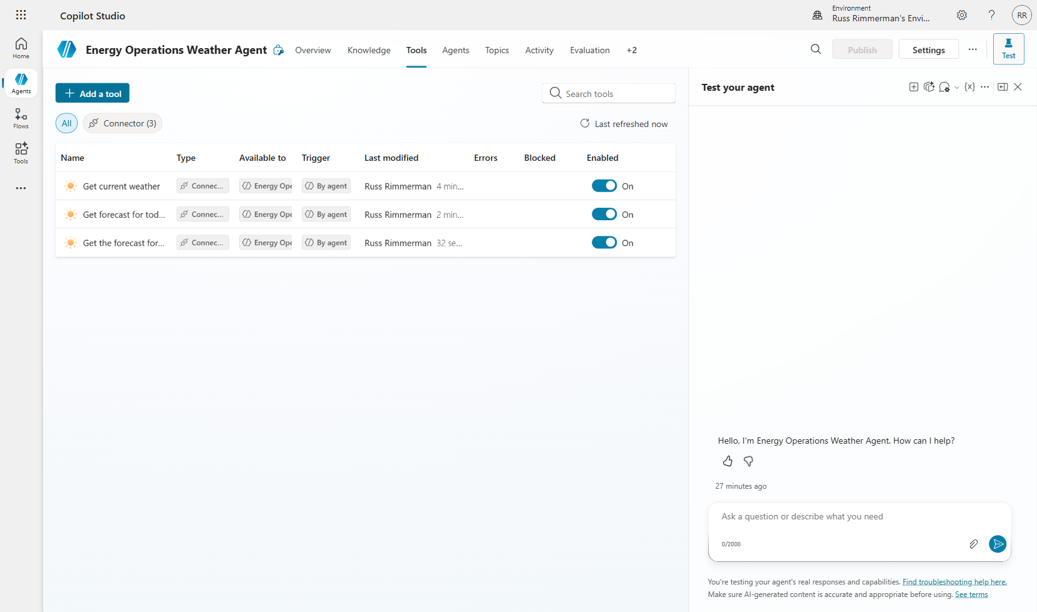
Figure 2.9 — Three MSN Weather tools added to the agent

2.4 Wiring Tools into Topics with Power Fx
Now comes the critical step: connecting your conversational topic to the tools. You'll use Power Fx formulas to dynamically pass the user's city and state values from your question variables into the tool's input parameters.

Power Fx is a low-code formula language (similar to Excel formulas) used throughout the Power Platform. In Copilot Studio, you use it to set tool input values, format outputs, and build dynamic responses.

Step 1: Return to your topic canvas and click "+" after the question nodes to add a "Call an action" node.
Step 2: Select the "Get current weather" tool from the list.
Step 3: For the Location input, click the formula (fx) button and enter:
Topic.City & ", " & Topic.State
This concatenates the city and state variables with a comma separator, creating a proper location string like "Dallas, Texas".

Step 4: For the Units input, enter: "Imperial" (or use a variable if you want users to choose).
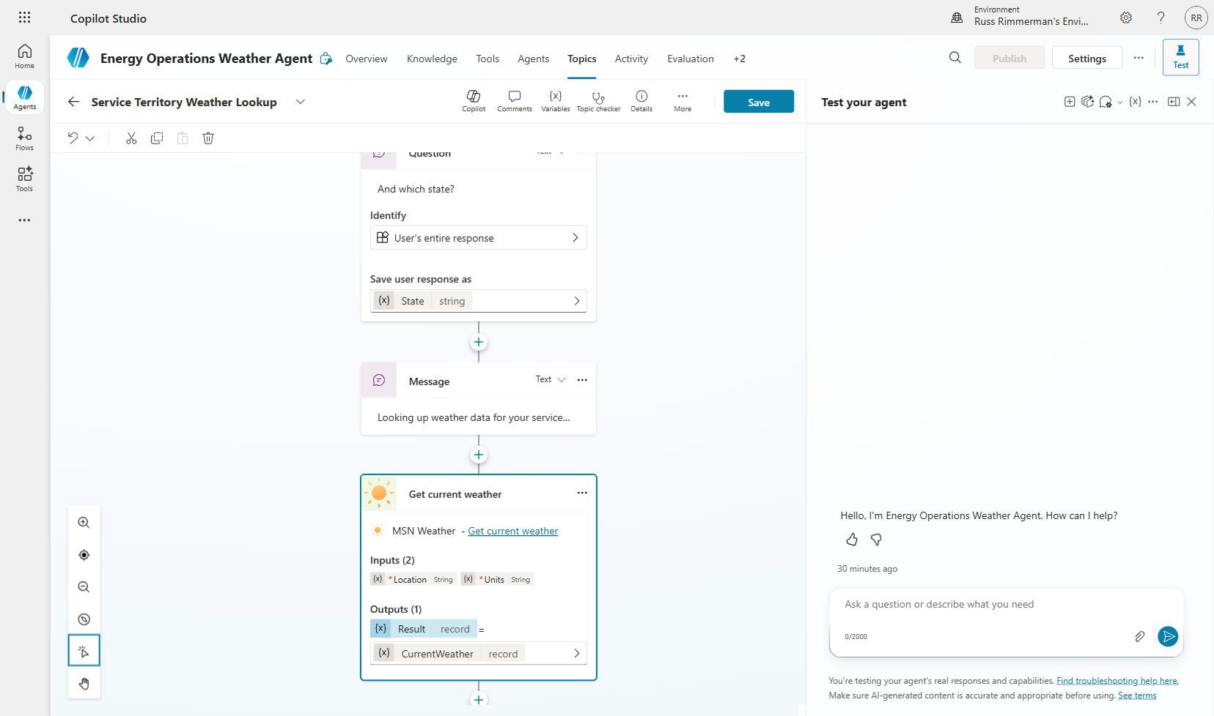
Figure 2.10 — Tool call node added to the topic canvas
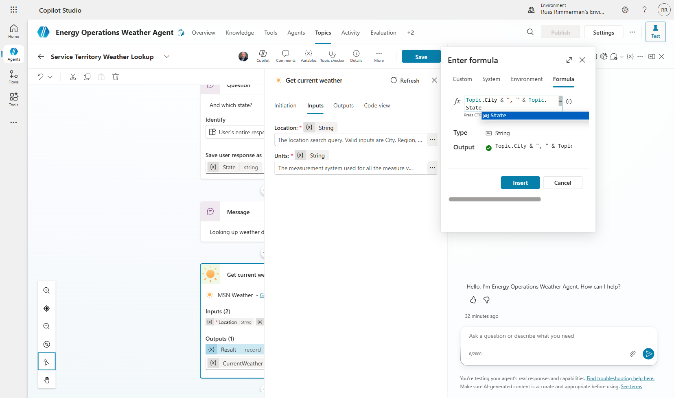
Figure 2.11 — Power Fx formula for the location parameter
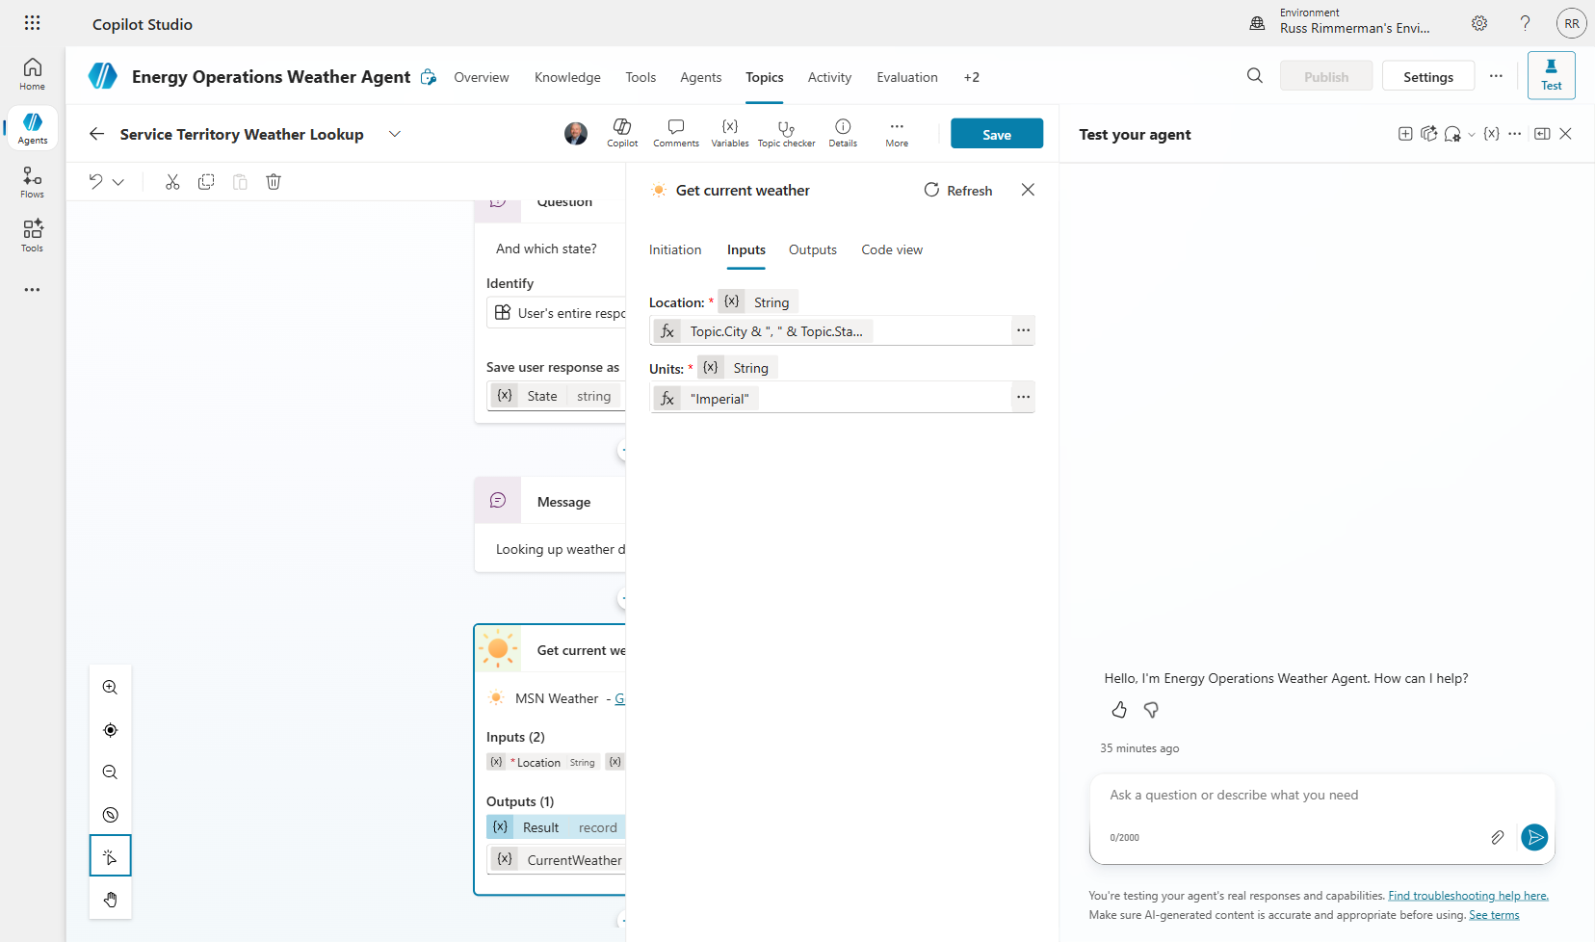
Figure 2.12 — All tool inputs configured

2.5 Testing Your Agent with the Weather Tool
Testing validates that your topic correctly collects user input, passes it to the tool, and returns meaningful results. The Test pane on the right side of the screen lets you interact with your agent in real time.

Step 1: Click the Test button in the top-right toolbar to open the test pane.
Step 2: Type a trigger phrase like "What's the weather?" to activate your topic.
Step 3: When prompted, enter a city (e.g., "Dallas") and state (e.g., "Texas").
Step 4: The first time, you'll be prompted to authenticate with the MSN Weather connector. Click the connection link and sign in.
Step 5: After authentication, the agent calls the tool and returns live weather data.
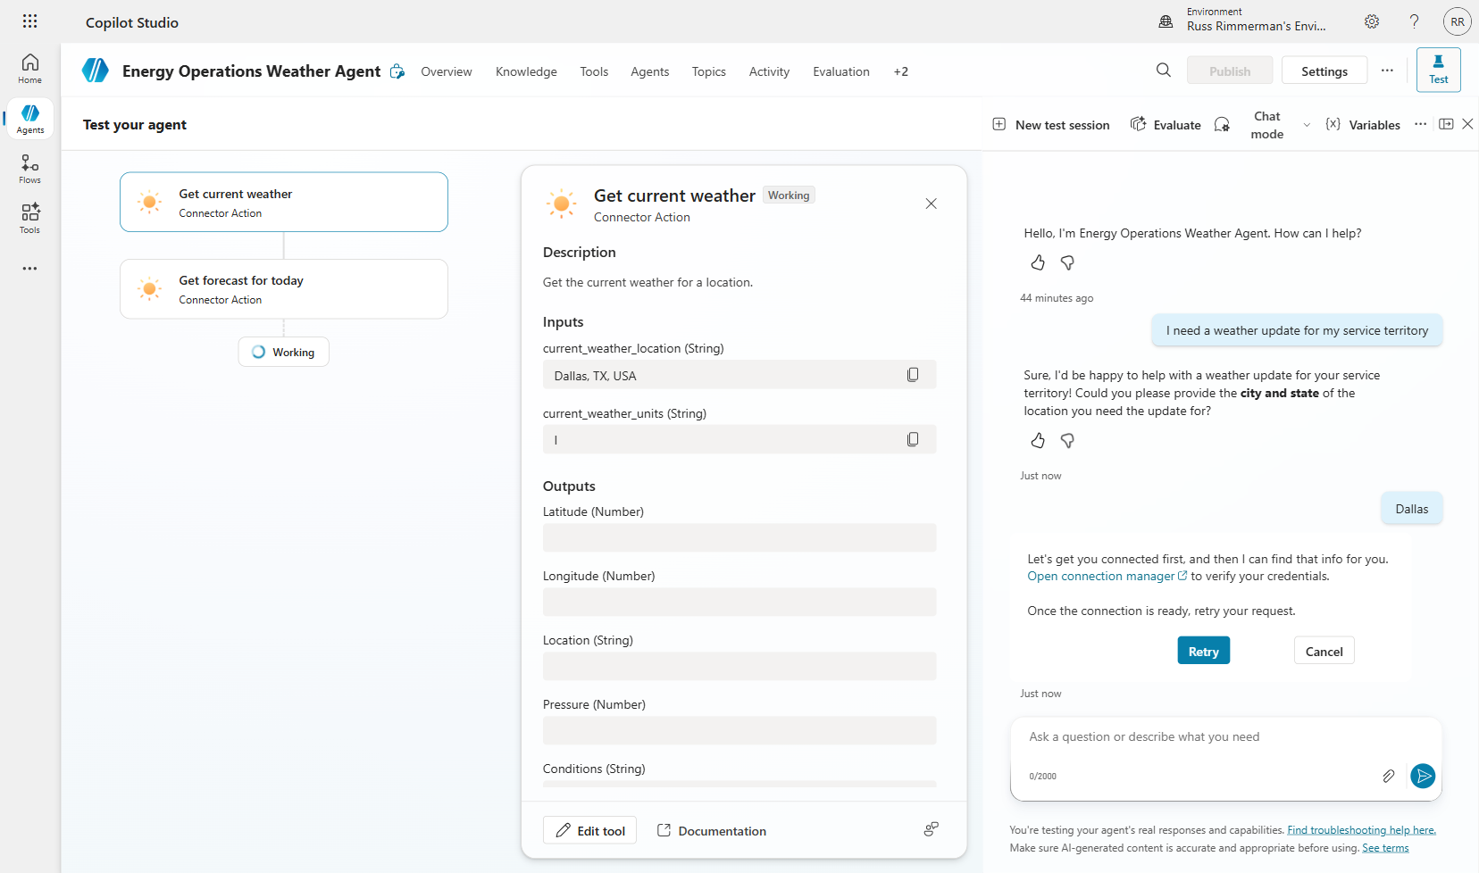
Figure 2.13 — Connection authentication required on first use
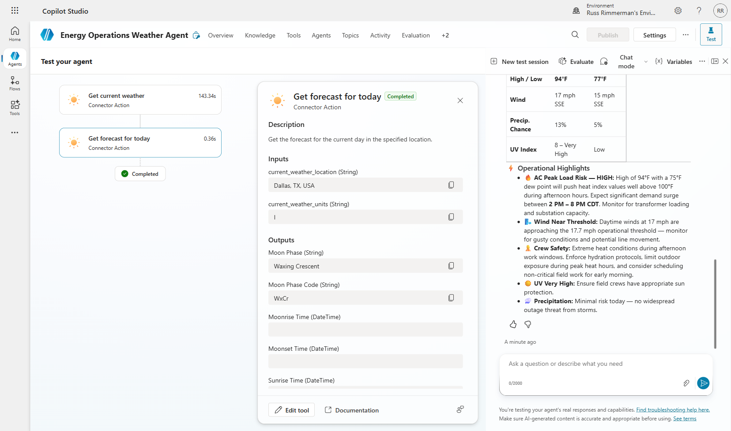
Figure 2.14 — Successful weather response from the agent
💡 Tip: If the agent returns an error, check your Power Fx formula syntax. Common issues include missing quotes around the comma-space separator or incorrect variable names.

Section 3: Model Selection — Choosing the Right AI Model
Copilot Studio supports multiple foundation models from different providers, each with distinct strengths. Your model choice affects response quality, reasoning depth, latency, and cost. Understanding these tradeoffs is essential for building effective agents.

3.1 Accessing Model Selection
The model selector is prominently placed on your agent's Overview page, making it easy to experiment with different models during development.

Step 1: Navigate to your agent's Overview page.
Step 2: Scroll to the "Select your agent's model" section.
Step 3: Click the dropdown to see all available models.
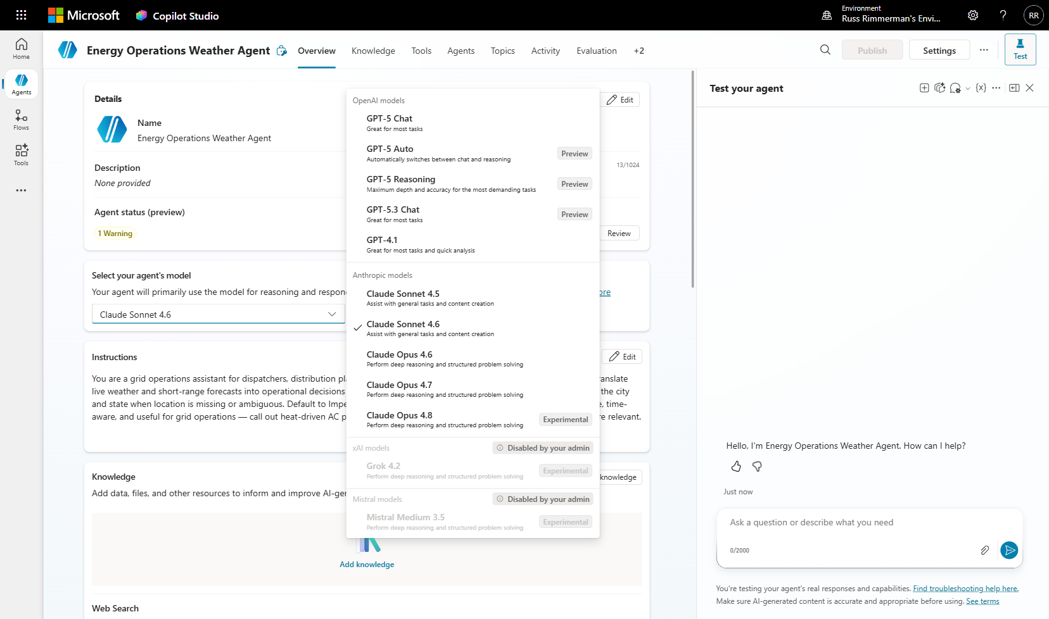
Figure 3.1 — The model selection dropdown showing all available models

3.2 OpenAI Models

GPT-5 Chat
The flagship OpenAI model, generally available. GPT-5 Chat is "great for most tasks" — it excels at natural conversation, instruction following, and general-purpose reasoning. This is the default for most production agents.
- Best for: General-purpose agents, customer support, FAQ bots, content generation.
- Tradeoff: Balanced quality and speed. Good default choice.

GPT-5 Auto
Automatically switches between chat and reasoning modes based on the complexity of each request. When a simple question comes in, it responds quickly in chat mode. When a complex multi-step problem arrives, it engages deeper reasoning.
- Best for: Agents that handle both simple and complex queries. Good when you can't predict question complexity.
- Tradeoff: May have slightly higher latency on complex questions due to reasoning activation.
📝 Note: GPT-5 Auto is in Preview — expect continued improvements.

GPT-5 Reasoning
Maximum depth and accuracy for the most demanding tasks. This model takes more time to "think" before responding, producing more thorough and accurate answers for complex analytical, mathematical, or multi-step problems.
- Best for: Data analysis, complex decision support, technical troubleshooting, legal/compliance review.
- Tradeoff: Higher latency and cost per response. Not ideal for simple Q&A.

GPT-4.1
A previous-generation model that remains available for backward compatibility and cost optimization. Still performant for many use cases and may offer faster response times.
- Best for: Cost-sensitive deployments, high-volume simple queries, migration scenarios.

3.3 Anthropic Models

Claude Sonnet (4.5 / 4.6)
Claude Sonnet models are designed to "assist with general tasks and content creation." They offer strong instruction-following, nuanced writing, and careful reasoning. Sonnet models are optimized for a balance of quality and speed.
- Best for: Content creation, summarization, document analysis, conversational agents that need nuanced, well-structured responses.
- Tradeoff: Excellent writing quality. May handle creative and analytical tasks differently than GPT models.

Claude Opus (4.6 / 4.7 / 4.8)
Opus models "perform deep reasoning and structured problem solving." These are Anthropic's most capable models, suited for complex analysis, coding, math, and strategic thinking.
- Best for: Complex analytical tasks, code generation, strategic planning, research synthesis.
- Tradeoff: Higher cost and latency than Sonnet, but significantly more capable for complex tasks.
📝 Note: Claude Opus 4.8 is labeled Experimental — ideal for testing but may change behavior between updates.

3.4 Other Model Families
Copilot Studio also shows model families from additional providers (such as xAI's Grok and Mistral models), though availability depends on your organization's admin settings. If a model family shows "Disabled by your admin," your tenant administrator has restricted those models via governance policies.

💡 Tip: Talk to your tenant admin if you need access to additional model families. Organizations often restrict models based on data residency, compliance, or cost management policies.

3.5 Choosing the Right Model for Your Use Case

Use Case | Recommended Model | Why
General customer support | GPT-5 Chat | Fast, reliable, great instruction-following
Mixed simple/complex queries | GPT-5 Auto | Adapts reasoning depth automatically
Data analysis / complex reasoning | GPT-5 Reasoning or Claude Opus | Deep thinking for accurate analysis
Content creation / writing | Claude Sonnet 4.6 | Nuanced, well-structured prose
Code generation / technical | Claude Opus 4.7 | Strong at structured problem-solving
Cost-sensitive / high-volume | GPT-4.1 | Lower cost per response
Experimentation / cutting edge | Claude Opus 4.8 (Exp.) | Latest capabilities for testing
Table 3.1 — Model selection guide by use case

💡 Tip: Start development with a capable model (GPT-5 Chat or Claude Sonnet) to get your agent working correctly, then experiment with other models to optimize for your specific quality/cost/speed requirements.

3.6 Advanced Generative AI Settings
Beyond model selection, the Settings → Generative AI page provides additional controls over how your agent uses AI:

- Orchestration Mode: Choose between dynamic orchestration (AI decides which tools and knowledge to use) or classic orchestration (behavior is limited to explicitly defined topics). Dynamic is recommended for most agents.
- Deep Reasoning (Preview): Enables advanced reasoning for AI actions — useful for complex multi-step tool calling but is a premium feature.
- Connected Agents: Toggle whether other agents can connect to and use this agent as part of a multi-agent workflow.
- Response Formatting: Set global formatting rules for your agent's responses (e.g., "always use bullet points", "make proper nouns bold").
- Retired Models: Option to continue using a retired model for 30 additional days during migration.
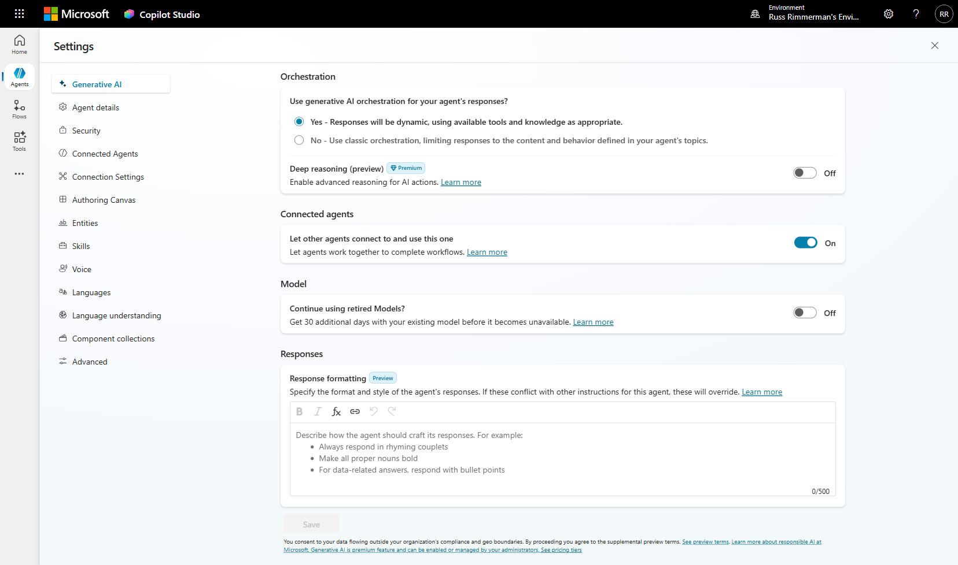
Figure 3.2 — The Settings > Generative AI page with orchestration and model options

Section 4: Publishing & Sharing — M365 Copilot, Teams, & SharePoint
Building an agent is only half the journey — getting it into users' hands is equally important. Copilot Studio offers multiple publishing channels, each suited to different scenarios. This section covers the three primary Microsoft channels and best practices for each.

4.1 Understanding the Publishing Flow
Publishing in Copilot Studio follows a two-step process:

- 1. Publish the agent: Click the Publish button in the top toolbar. This creates a published version of your agent that users can interact with. The Publish button becomes enabled after you make changes to your agent.
- 2. Configure channels: After publishing, navigate to the Channels tab to enable specific distribution channels (Teams, SharePoint, M365 Copilot, etc.).

⚠️ Important: You must publish your agent before it becomes available in any channel. The Channels tab shows 'Not published' until you complete this step.

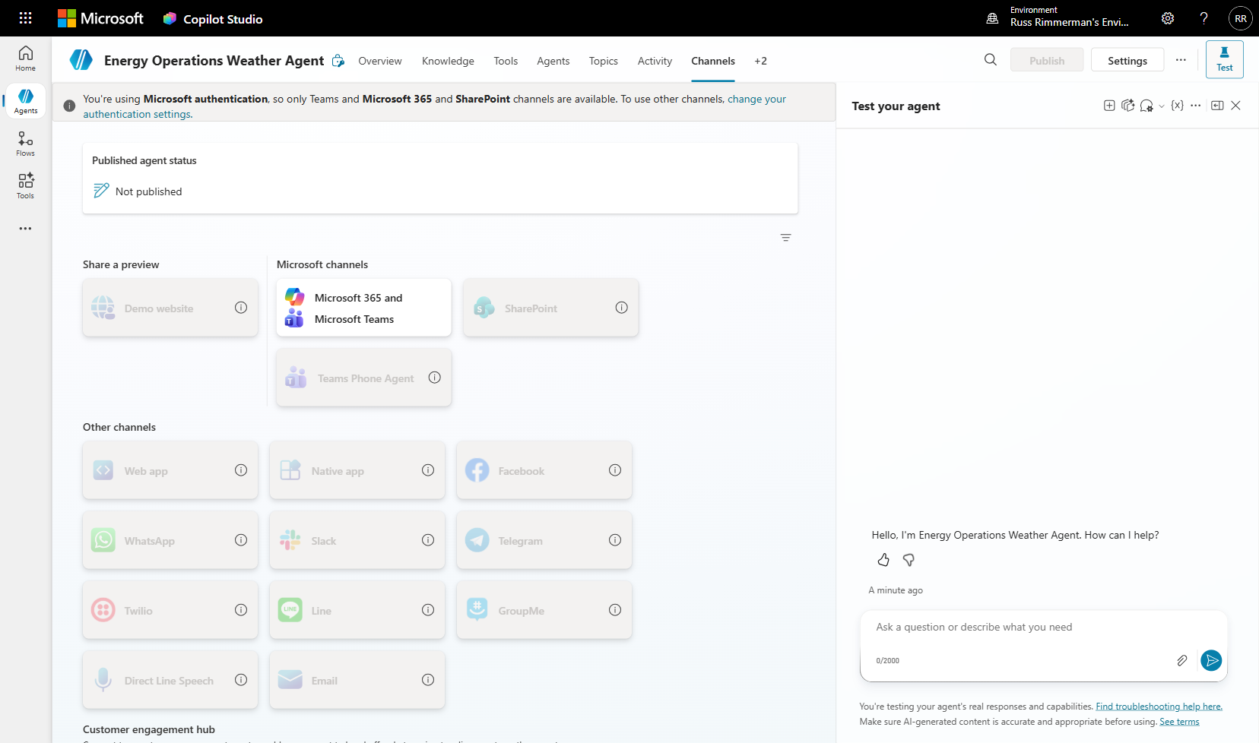
Figure 4.1 — The Channels page showing all available distribution channels

4.2 Publishing to Microsoft 365 Copilot
Publishing your agent to the Agent Store inside Microsoft 365 Copilot is the most powerful distribution option. It makes your agent discoverable within the M365 workflows your organization already uses — Copilot, Outlook, Word, Excel, PowerPoint, and more.

What Users Experience
- The agent appears in the Agent Store — the central hub inside M365 Copilot.
- Users can find, install, and use the agent directly within Copilot and other M365 apps.
- The agent can be invoked conversationally alongside other Copilot capabilities.

How to Enable
Step 1: Navigate to the Channels tab and click "Microsoft 365 and Microsoft Teams".
Step 2: In the channel details panel, ensure the checkbox "Make agent available in Microsoft 365 Copilot" is checked.
Step 3: Click "Add channel" to save.
Step 4: Use "Edit details" to customize the agent's icon, description, and metadata that appear in the Agent Store.
Step 5: Click "Availability options" to control who can access the agent (individual users, security groups, or the entire organization).
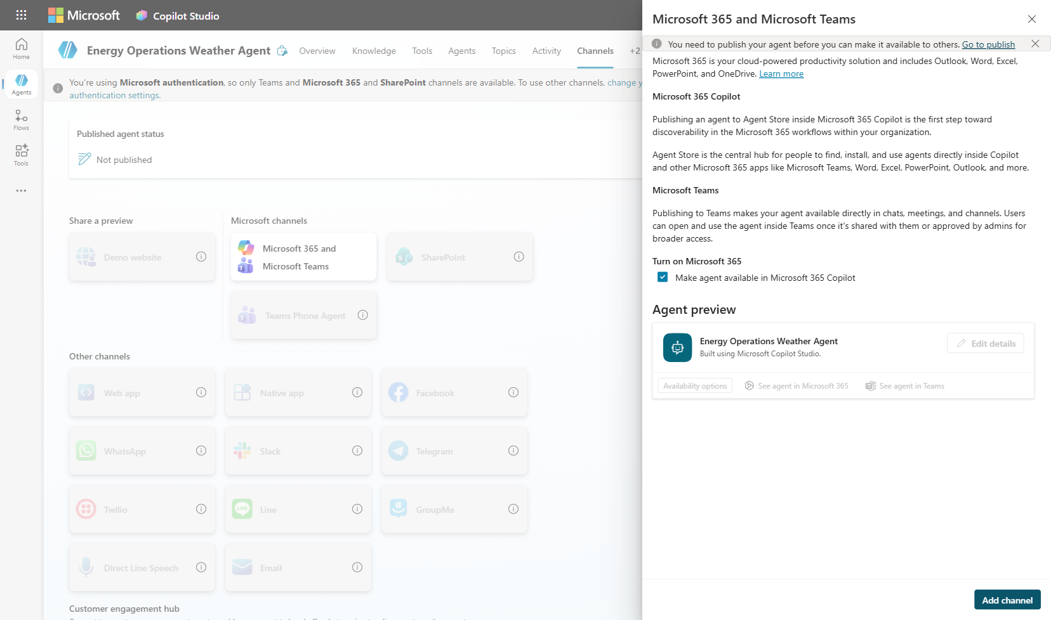
Figure 4.2 — Microsoft 365 and Microsoft Teams channel configuration

Admin Approval Requirements
Depending on your organization's policies, publishing to M365 Copilot may require admin approval:
- Self-service: Some organizations allow makers to publish agents directly to users.
- Admin approval required: In managed environments, an IT admin must approve the agent before it appears in the Agent Store.
- The approval process ensures governance over what agents are available organization-wide.

💡 Tip: Before publishing to production, test thoroughly using the Test pane and Evaluation tab. Once published, any issues affect real users.

4.3 Publishing to Microsoft Teams
Publishing to Teams makes your agent available directly in chats, meetings, and channels. Users can open and use the agent inside Teams once it's shared with them or approved by admins for broader access.

Distribution Options in Teams
- Direct share: Share the agent with specific users or groups by name or email.
- Teams app catalog: Submit the agent as a Teams app to your organization's app catalog for broader discovery.
- Admin-managed deployment: IT admins can pin the agent to specific users' Teams sidebars for maximum visibility.

How to Enable
Step 1: The Microsoft Teams channel is automatically included when you enable the "Microsoft 365 and Microsoft Teams" channel.
Step 2: After publishing, click "See agent in Teams" to open and test the agent directly in your Teams client.
Step 3: Use "Availability options" to configure who can access the agent within Teams.

Best Practices for Teams
- Add suggested prompts: Help users discover what your agent can do by adding example conversation starters.
- Configure a greeting message: The built-in 'Greeting' topic sends a welcome message when users first open the agent.
- Test in Teams before broad rollout: The Teams experience may differ slightly from the Copilot Studio test pane.
- Consider Teams-specific features: Agents can participate in group chats and channel conversations, not just 1:1.

4.4 Publishing to SharePoint
The SharePoint channel allows you to embed your agent directly into SharePoint pages, making it accessible to users browsing your intranet or team sites. This is ideal for department-specific agents that serve a particular team or function.

Embedding Options
- SharePoint web part: Add a Copilot Studio web part to any SharePoint page. Users can interact with the agent directly on the page.
- Site-wide deployment: Embed the agent across an entire SharePoint site for consistent access.

How to Enable
Step 1: Navigate to the Channels tab and locate "SharePoint" under Microsoft channels.
Step 2: Click the SharePoint tile to open the configuration panel.
Step 3: Follow the instructions to add the agent's web part to your SharePoint page using the provided configuration.

Best Practices for SharePoint
- Match the agent to the page context: An HR agent on an HR portal, an IT helpdesk agent on the IT support site.
- Use knowledge sources from the same SharePoint site: Add the site's document libraries as knowledge sources so the agent can answer questions about the content on that page.
- Configure authentication: SharePoint agents inherit the Microsoft authentication setting, ensuring only authenticated users can interact.

4.5 Authentication Considerations
Your authentication settings directly affect which channels are available:

- Microsoft authentication (default): Only Microsoft channels are available — Teams, M365 Copilot, and SharePoint. This is the most secure option and recommended for enterprise agents.
- No authentication: All channels become available (Facebook, Slack, web apps, etc.), but the agent cannot access user-specific data or verify identity.
- Custom authentication: Use OAuth or SAML providers for non-Microsoft identity systems while maintaining security.

📝 Note: For enterprise deployments, Microsoft authentication is strongly recommended. It provides single sign-on, user context (like knowing who's asking), and compliance with organizational security policies.

4.6 Other Distribution Channels
Beyond the three primary Microsoft channels, Copilot Studio supports a wide range of third-party and custom channels:

- Web app — Embed in any website using a JavaScript snippet
- Native app — Integrate into iOS/Android apps via Direct Line API
- Facebook Messenger — Connect to Facebook Pages
- WhatsApp — Reach users on WhatsApp Business
- Slack — Deploy to Slack workspaces
- Telegram, Twilio, Line, GroupMe — Additional messaging platforms
- Direct Line Speech — Voice-enabled agent interactions
- Email — Respond to emails as a conversational agent

Additionally, Customer engagement hub integrations are available for Dynamics 365 Contact Center, Telephony, Genesys, LivePerson, Salesforce, and ServiceNow — enabling agent-to-live-agent handoff in contact center scenarios.

Appendix: Additional Resources

Helpful Links
- Microsoft Copilot Studio documentation: https://learn.microsoft.com/copilot-studio/
- Power Fx reference: https://learn.microsoft.com/power-platform/power-fx/overview
- Connector catalog: https://learn.microsoft.com/connectors/connector-reference/
- Copilot Studio pricing: https://www.microsoft.com/copilot/copilot-studio#pricing
- Responsible AI FAQs: https://learn.microsoft.com/copilot-studio/responsible-ai-overview

Lab Summary
In this 1.5-hour lab, you learned:

- Four ways to build agents in Copilot Studio: describe-to-build, blank canvas, computer-using agents, and workflows.
- How to add external tools using connectors (MSN Weather) and wire them into topics with Power Fx formulas.
- How to choose the right AI model for your use case — GPT-5, Claude Sonnet, Claude Opus, and their tradeoffs.
- How to publish and share agents across Microsoft 365 Copilot, Teams, and SharePoint with appropriate governance.

What's Next?
- Advanced Lab: Build a full Energy Operations Weather Agent with custom prompt tools, connected child agents, and evaluation test suites.
- Explore knowledge sources: Add SharePoint, Dataverse, and website content to your agent.
- Build multi-agent architectures: Use connected agents to decompose complex workflows.
- Implement governance: Set up DLP policies, model restrictions, and approval workflows for production agents.

— End of Lab —

