1. Open an MS-DOS command window.
   1. 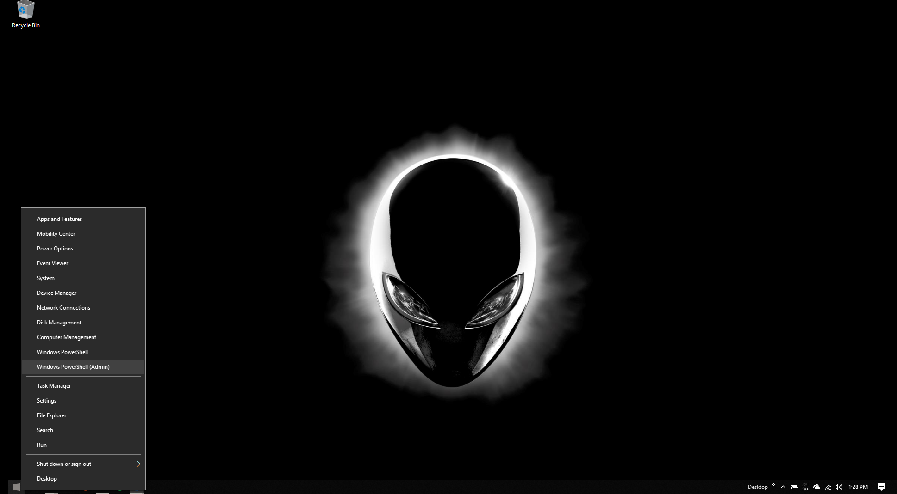

Figure 1"Right Clicking" your mouse will allow you to get to the MS-DOS prompt menu, or in my case with Windows 10....MS-DOS command prompt has been replaced by Windows PowerShell(This is what Microsoft is replacing MS-DOS with).

1. Create a directory called **BatchFiles** on the root of **C: drive**. You can use this directory to save your batch files.
   1. 

Figure 2Inside Powershell type mkdir (This stands for make dir) followed by the name of the directory you would like to create. If you notice the PS C:\>...This stands for where you are in your directory.

* 1. 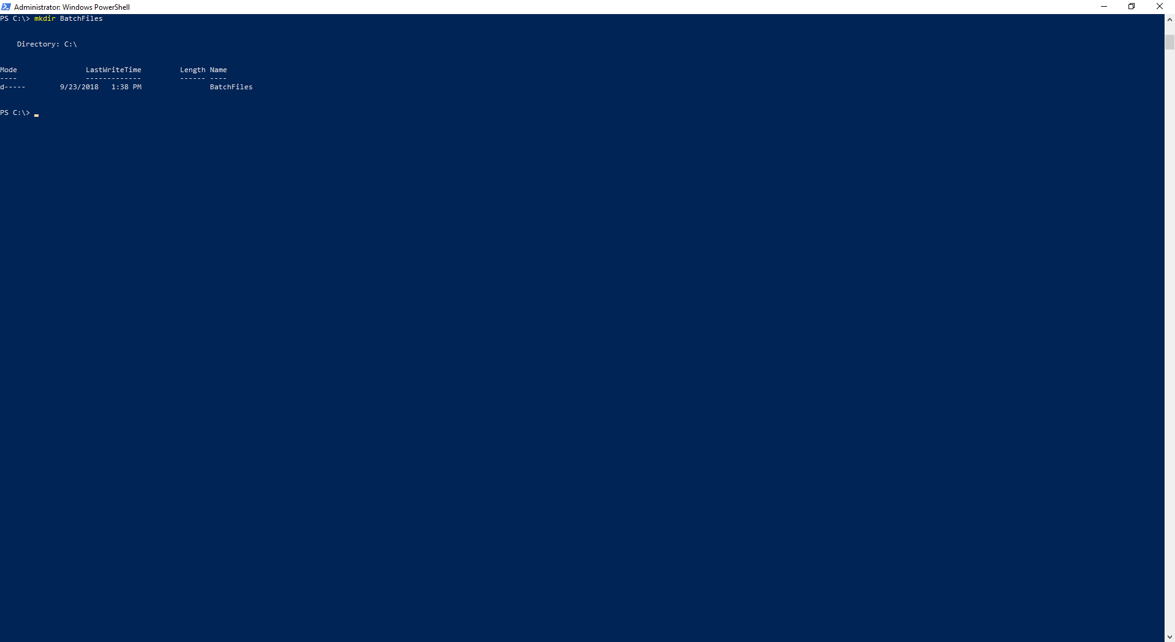

Figure Output showing the BatchFiles Directory was created.

1. Create a notepad file called Ex1.bat in the Batch folder.
   1. 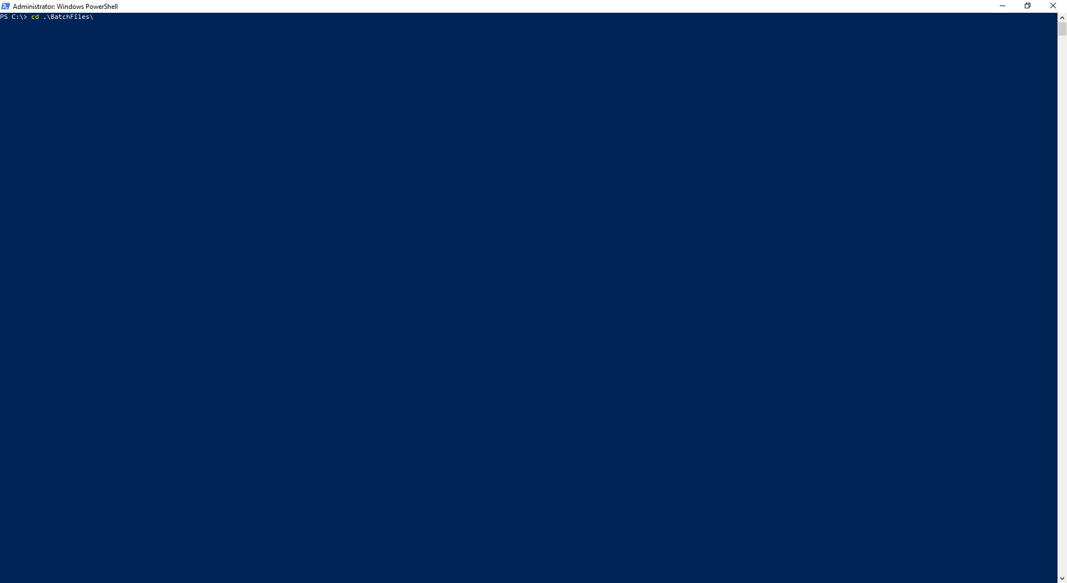

Figure To switch directories use the cd command, which stands for change directories...cd to the BatchFiles

Figure

* 1. 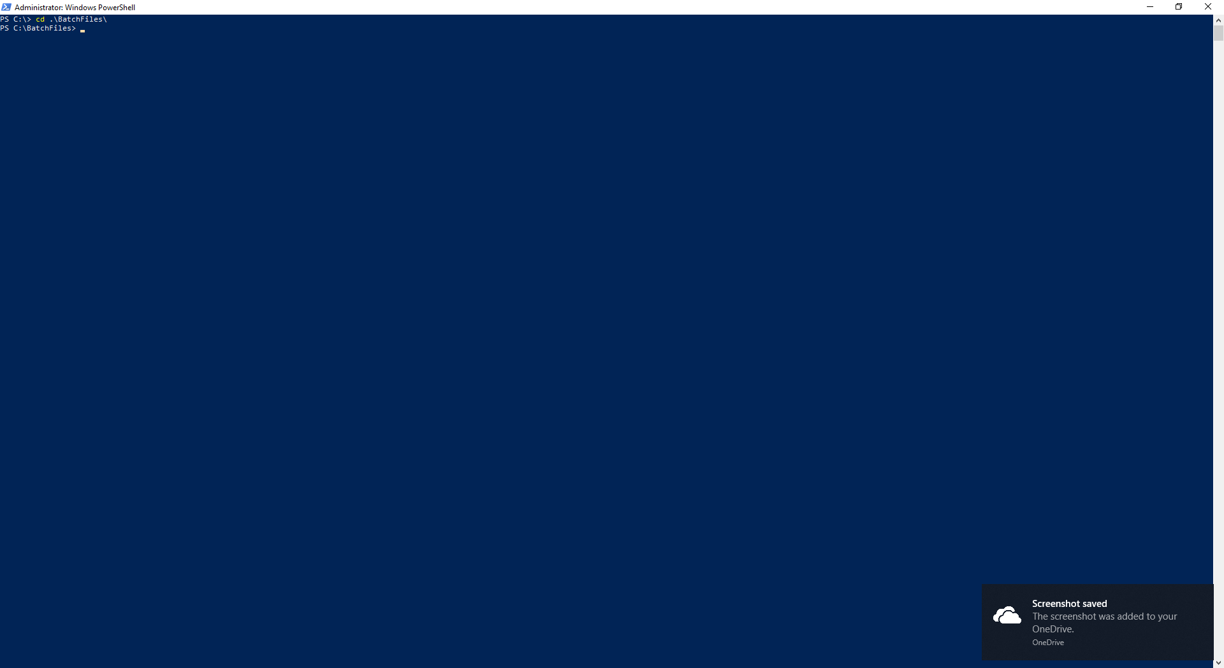

Figure You can see by the PS C:\BatchFiles>....We are now in the BatchFiles directory.

* 1. 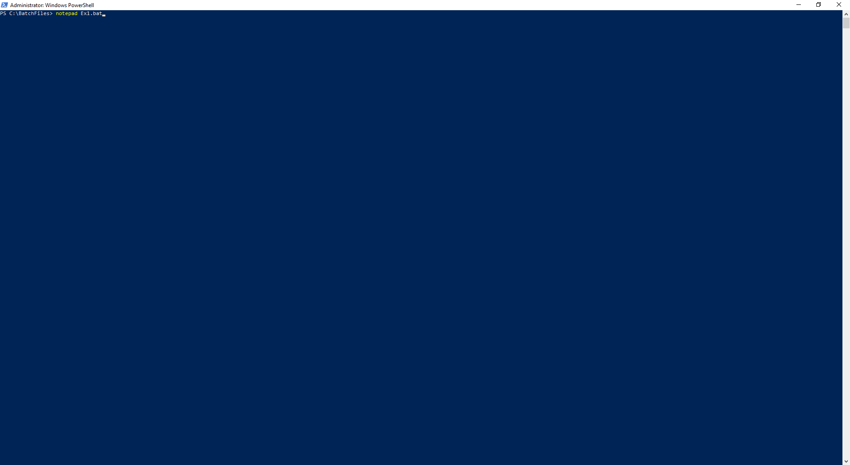

Figure Using the command notepad and either an existing filename or a new filename will open or create a file. We created a file called Ex1.bat.

* 1. A screenshot of a social media post

     Description generated with very high confidence

Figure File created, and a notepad window opened.

1. Type in the following lines into the file and save. Each line below is a command.

cls

ver

pause  
dir c:\windows

* 1. A screenshot of a cell phone

     Description generated with very high confidence
  2. Save file with file>save file

1. Before continuing, can you remember what the effect of each of the 4 commands that you have typed into the file? If not – look them up in the help.
   1. cls - Clear screen
   2. ver – Displays current version number
   3. pause – allows a program to be paused until a key is pressed, this will display a message to the user to “Press any key to continue”
   4. dir c:\windows – change directory to the windows directory
2. Make sure you are in the **Batchfiles** folder.
   1. A screenshot of a cell phone

      Description generated with high confidence

Figure Notice the C:\BatchFIles indicating im in the BatchFiles directory.

1. Key in DIR and **MAKE SURE**  you see a file called EX1.BAT
   1. A screenshot of a cell phone

      Description generated with very high confidence

Figure File Ex1.bat listed in the directory

1. At the prompt, type in the name of the batch file i.e. Ex1 and press **Enter**.
   1. A screenshot of a cell phone

      Description generated with high confidence

Figure To execute a batch file type .\ indicating to windows you would like to run a file.

1. Understand the outcome.
   1. A screenshot of a cell phone

      Description generated with very high confidence

Figure Outputed Windows version via the ver command with the pause command you can see the press any key to continue.

* 1. A screenshot of a cell phone

     Description generated with very high confidence

Figure You can see where the pause left off after the pause, then the bat file executes a dir c:\windows which displays all the files inside the directory.

1. Put the command **@ECHO OFF** as the first line into Ex1.bat. Run the batch file again. What is effect of this statement?
   1. A screenshot of a cell phone

      Description generated with very high confidence

Figure Runs the same commands as before, but the prompt is now gone....the echo off command just displays the output of the bat file.

1. Mini Exercies:
   1. Create a batch file called FIRST.BAT that displays the current time and date.
      1. 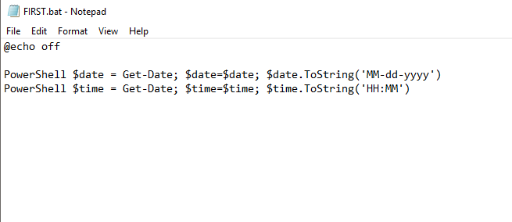

Figure Adjusted my script for the newer PowerShell commands, but this is the script I am using to echo the time to the command line

* + 1. A screenshot of a cell phone

       Description generated with high confidence

Figure You can see the date echoed out followed by the time (Note the time is listed in 24 Hour format).

* 1. Create a batch file called SECOND.BAT that first clears the screen and then displays the contents of the current directory in order by the size of the files.
     1. A screenshot of a cell phone

        Description generated with very high confidence

Figure Created file SECOND.bat via notepad

* + 1. 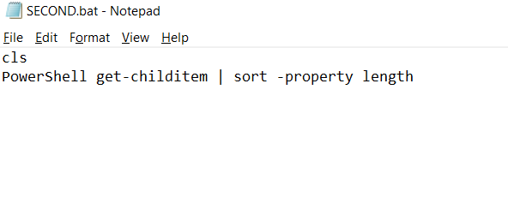

Figure Code for Second.bat to display the files inside current directory, by filesize.

* + 1. A screenshot of a cell phone

       Description generated with very high confidence

Figure Files listed by size for directory