**James Montgomery Flagg**

**Abstract**

James Montgomery Flagg, American artist, Illustrator and painter. Probably best know for his work during the first World War for the “Uncle Sam wants you for the US. Army” posters. These posters became a very important piece of American History and still recognizable almost a century later. During his 83 years as an artist, arguably his most famous work was as a graphic designer with the Uncle Sam poster. During this paper we will explore Flagg’s life, focusing on his work as a graphic designer, and “prolific illustrator” (Illustrationchronicles.com). Flagg’s’ career began earlier than most and was gainfully employed before he turned sixteen (bpib.com). We will further explore his contributions as a graphic designer examining several of his most important works.

1. Involvement in the Division of Pictorial Publicity (DPP). Being too old to enlist Flagg contributed the way he knew how via illustrations for the DPP. He worked amongst other artists who would eventually be quite prolific. His advertisements for WWI, and WWII would be what he is most remembered for, and are still referenced today. The three advertisements below featuring uncle Sam are prime examples of the type of work Flagg created for the DPP that he became known for.

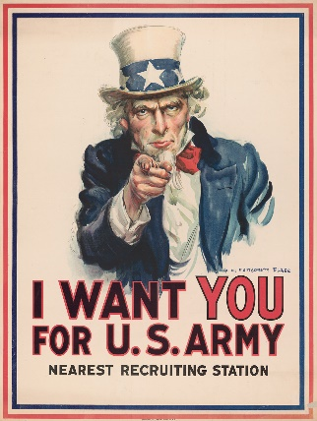 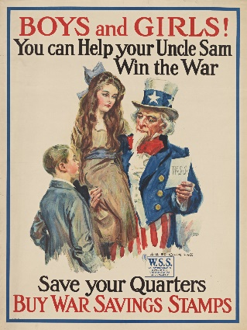 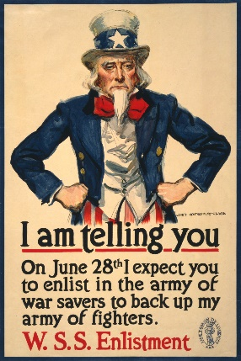

* 1. Illustration Chronicles.

1. Flagg was most eccentric and was eager to hobnob with celebrities which bolstered his ego. As such the Uncle Sam depicted in Flagg’s ads were highly personalized to reflect Flagg’s handsome features. In addition to his resemblance in Uncle Sam, Flagg would even sit for other artists to feature as this only bolstered his playboy persona.
2. As the wars concluded advertisements had fallen into a theme of mass publications with quick deadlines and fast turnarounds. Flagg’s methods more akin to a true illustrator were becoming delinquent as photography could quickly go to press. “The only difference between a fine artist and an illustrator is that the latter can draw, eats three square meals a day, and can afford to pay for them.”- James Montgomery Flagg. ((“James Montgomery Flagg”) Flagg was most notably known for his “exquisite images through deft strokes of the pen” (“James Montgomery Flagg”)

**Bibliography**

*“I Want YOU!” – The Story of James Montgomery Flagg's Iconic Poster*,Illustration Chronicles, https://illustrationchronicles.com/I-Want-YOU-The-Story-of-James-Montgomery-Flagg-s-Iconic-Poster, Accessed 22 Feb. 2019.

*James Montgomery Flagg*, Lambiek Comiclopedia, https://www.lambiek.net/artists/f/flagg_jm.htm, Accessed 22 Feb 2019.

*James Montgomery Flagg,* Norman Rockwell Museum, https://www.illustrationhistory.org/artists/james-montgomery-flagg, Accessed 22 Feb 2019.

*James Montgomery Flagg,* Spartacus Educational, [*https://spartacus-educational.com/ARTflagg.htm*. Accessed 22 Feb 2019](https://spartacus-educational.com/ARTflagg.htm.%20Accessed%2022%20Feb%202019)

*James Montgomery Flagg,* Illustrators,[www.bpib.com/illustra2/flagg.htm](http://www.bpib.com/illustra2/flagg.htm) Accessed 22 Feb 2019