**Worksheet1 (For practice only, not be collected for grading)**  
  
1. Mr. Gregory sold several cars this week. Here is some data about the cars he sold.  
  
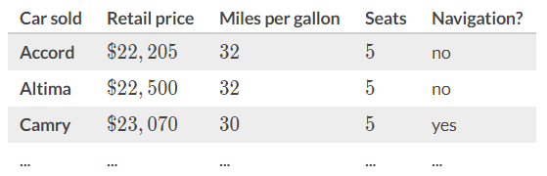

a. **The individuals (or units) in this data set are:**

b. Identify the variables and their types:

2. How is sample related to a population?  
  
  
  
3. Identify the population and the sample.  
  
a. A study of 33, 043 infants in Italy was conducted to find a link between a heart rhythm abnormality and sudden infant death syndrome.  
  
  
  
b. A survey of 961 major-appliance shoppers found that 23% bought extended warranties.  
  
  
  
  
c. To gather information about starting salaries at companies listed in the Standard & Poor’s 500, a researcher contacts 65 of the 500 companies.

4. Classify each variable as qualitative or quantitative.   
a. Number of bicycles sold in 1 year by a large sporting goods store.

b. Colors of baseball caps in a store.

c. Times it takes to cut a lawn.

d. Capacity in cubic feet of six truck beds.

e. Classification of children in a day care center (infant, toddler, preschool).

f. Weights of fish caught in Lake George.

g. Marital status of faculty members in a large university.

h. Student ID  
i. Zip code of a location

5. For each study, identify both the parameter and the statistic in the study.

a. Nexium is a drug that can be used to reduce the acid produced by the body and heal damage to the esophagus. A researcher wants to estimate the proportion of patients taking Nexium that are healed within 8 weeks. A random sample of 224 patients suffering from acid reflux disease is obtained, and 213 of those patients were healed after 8 weeks.  
  
  
  
  
b. A researcher wants to estimate the average farm size in Kansas. From a simple random sample of 40 farms, the researcher obtains a sample mean farm size of 731 acres.

c. An education official wants to estimate the proportion of adults aged 18 or older who had read at least one book during the previous year. A random sample of 1006 adults aged 18 or older is obtained, and 835 of those adults had read at least one book during the previous year.  
  
  
  
  
  
d. The International Dairy Foods Association (IDFA) wants to estimate the average amount of calcium male teenagers consume. From a random sample of 50 male teenagers, the IDFA obtained a sample mean of 1081 milligrams of calcium consumed.  
  
  
  
  
6. In a recent study, volunteers who had 8 hours of sleep were three times more likely to answer questions correctly on a math test than were sleep-deprived participants. Make an inference based on the results of this study.  
  
  
  
  
7. Study shows that senior citizens who live in Florida have better memories than senior citizens who do live in Florida.  
a. Make an inference based on the results of this study.  
  
  
b. What is wrong with this type of reasoning?