**1. Why we need to go for lamba expression.**

To give the implementation of a functional Interface .

Syntax

(arg1, arg2...) -> { body }

 or

(type1 arg1, type2 arg2...) -> { body }

Ex:-

**interface** Sayable {

**public** String say();

}

**public** **class** LambdaExpressionExample3 {

**public** **static** **void** main(String[] args) {

Sayable s = () -> {

**return** "I have nothing to say.";

};

System.***out***.println(s.say());

}

}

**2. What is functional interface. Is it possible to write default method in function**

**Interface. Can we overide the default methods. Write and demonstrate.**

Functional Interface is a interface which contain only one abstract method .

Note:- it may contain multiple default and static method but only one abstact method.

Default method get override but static method never get override.

* [Built-in Functional Interfaces in Java 8 are:](https://blog.knoldus.com/functional-interfaces-in-java-8/#built-in-functional-interfaces-in-java-8-are)
  + [Consumer – BiConsumer](https://blog.knoldus.com/functional-interfaces-in-java-8/#consumer-biconsumer)
  + [Predicate-BiPredicate](https://blog.knoldus.com/functional-interfaces-in-java-8/#predicate-bipredicate)
  + [Function](https://blog.knoldus.com/functional-interfaces-in-java-8/#function)
  + [Unary Operator](https://blog.knoldus.com/functional-interfaces-in-java-8/#unary-operator)
  + [Binary Operator](https://blog.knoldus.com/functional-interfaces-in-java-8/#binary-operator)

**3. What is Method reference how you implemented in your project.**

A method reference is the shorthand syntax for a lambda expression that contains just one method call.

**Syntax:-**

Object :: methodName

**Types of Method References**

There are four type method references that are as follows:

1. Static Method Reference.
2. Instance Method Reference of a particular object.
3. Constructor Reference.

Ex:-

Employee.java:-

**package** com.fullcreative.Entity;

@Data

**public** **class** Employee {

**private** String name;

**private** String address;

**private** Long mobilenumber;

**private** String email;

**private** **float** salary;

**public** Employee() {

System.***out***.println("I got call through constructor ref");

}

**public** Employee(String name, String address, Long mobilenumber, String email, **float** salary) {

**super**();

**this**.name = name;

**this**.address = address;

**this**.mobilenumber = mobilenumber;

**this**.email = email;

**this**.salary = salary;

}

**public** **void** display() {

System.***out***.println(toString());

}

}

EmployeeResponse.java:-

**package** com.fullcreative.Entity;

@Data

**public** **class** EmployeeResponse {

**private** String name;

**private** String email;

**private** **float** salary;

}

IconstuctorRef.java:-

**package** com.fullcreative.Entity;

@FunctionalInterface

**public** **interface** IContructorRef {

**public** Employee getEmployee();

}

Imethodref.java:-

**package** com.fullcreative.Entity;

**public** **interface** IMethodRef {

**public** **void** doTask();

}

EmployeeDao.java:-

**package** com.fullcreative.Dao;

**import** java.util.ArrayList;

**import** java.util.List;

**import** com.fullcreative.Entity.Employee;

**public** **class** EmployeeDao {

**public** **static** List<Employee> getEmployee() {

List<Employee> list = **new** ArrayList<>();

list.add(**new** Employee("Rustam","Banglore",880844433l,"rustam@gmail.com", 1000.0f));

list.add(**new** Employee("amir", "Delhi", 9857745678l, "amir@gmail.com", 900.0f));

list.add(**new** Employee("atul", "Banglore", 983937323l, "atul@gmail.com", 1500.0f));

list.add(**new** Employee("saddam","Banglore",7884757693l,"saddam@gmail.com", 800.0f));

list.add(**new** Employee("reshabh","Lukhnow",39878433l, "reshabh@gmail.com", 550.0f));

list.add(**new** Employee("Roy", "Telangana", 897584738l, "roy@gmail.com", 700.0f));

list.add(**new** Employee("akhil", "Chennai", 5927483648l, "akhil@gmail.com", 200.0f));

list.add(**new** Employee("raj", "Patna", 89374848l, "raj@gmail.com", 100.0f));

list.add(**new** Employee("deepak", "Nanital", **null**, "deepak@gmail.com", 300.0f));

list.add(**new** Employee("niketan", "Banglore", 897457454l, **null**, 600.0f));

list.add(**new** Employee("anmol", **null**, 897457454l, **null**, 400.0f));

**return** list;

}

// public static List<Employee> getEmployee() {

// return IntStream.rangeClosed(1, 10)

// .mapToObj(i->new Employee("employee"+i, "city"+i, new Random().nextLong(7777777777l, 9999999999l), "employee"+i+"@gmail.com",new Random().nextFloat(5000)))

// .collect(Collectors.toList());

// }

**static** **float** *avg*=0;

**public** **static** **void** average(Employee list) {

**float** salary = list.getSalary();

*avg*+=salary;

System.***out***.println(*avg*);

}

}

**package** com.fullcreative.service;

**import** java.util.List;

**import** java.util.stream.Collectors;

**import** com.fullcreative.Dao.EmployeeDao;

**import** com.fullcreative.Entity.Employee;

**import** com.fullcreative.Entity.EmployeeResponse;

**import** com.fullcreative.Entity.IContructorRef;

**import** com.fullcreative.Entity.IMethodRef;

**public** **class** MethodReference {

**public** **static** **void** main(String[] args) {

List<Employee> employee = EmployeeDao.*getEmployee*();

**for** (Employee emp : employee) {

System.***out***.println(emp);

}

System.***out***.println("***************************");

// 1 static method reference

employee.forEach(MethodReference::*print*);

MethodReference mapper = **new** MethodReference();

//2 giving pre defined functional interface implemention through method ref

Runnable runnable = mapper::threadTask;

Thread thread = **new** Thread(runnable);

thread.start();

// 3 custom functional interface implementation using method reference

IMethodRef ref = mapper::threadTask;

ref.doTask();

// 4 calling custom method of convoter

List<EmployeeResponse> collect = employee.stream().map(mapper::convoter).collect(Collectors.*toList*());

System.***err***.println(collect);

// 5 By defualt getter method Employee::getSalary are static in lamda exp

**float** totalSum=employee.stream().map(Employee::getSalary)

.reduce((**float**) 0, (v1, v2) -> v1 + v2);

System.***out***.println(totalSum);

//-----------Constructor implementation--->

IContructorRef ref2=Employee::**new**;

Employee employee2 = ref2.getEmployee();

employee2.display();

}

// ---------All these method are written in different class------------>

**private** **static** **void** print(Employee list) {

System.***out***.println(list);

}

**private** EmployeeResponse convoter(Employee emp) {

EmployeeResponse response = **new** EmployeeResponse();

response.setName(emp.getName());

response.setEmail(emp.getEmail());

response.setSalary(emp.getSalary());

**return** response;

}

**private** **void** threadTask() {

**for** (**int** i = 0; i < 10; i++) {

System.***out***.println(i * 2);

**try** {

Thread.*sleep*(1000);

} **catch** (Exception e) {

e.printStackTrace();

}

}

}

}

Output:-

Employee [name=Rustam, address=Banglore, mobilenumber=8808404433, email=rustam@gmail.com, salary=1000.0]

.

.

.

Employee [name=anmol, address=null, mobilenumber=897457454, email=null, salary=400.0]

**********************************************************

Employee [name=Rustam, address=Banglore, mobilenumber=8808404433, email=rustam@gmail.com, salary=1000.0]

.

.

.

Employee [name=anmol, address=null, mobilenumber=897457454, email=null, salary=400.0]

0

0

2

2

.

.

.

18

18

[EmployeeResponse [name=Rustam, email=rustam@gmail.com, salary=1000.0], EmployeeResponse [name=amir, email=amir@gmail.com, salary=900.0],

.

.

.

EmployeeResponse [name=niketan, email=null, salary=600.0], EmployeeResponse [name=anmol, email=null, salary=400.0]]

7050.0

I got call through constructor ref

Employee [name=null, address=null, mobilenumber=null, email=null, salary=0.0]

**4. Explain about stream api. What are the benefits.** **explain few stream methods**

**you used in your project.**

 Stream API is used to process collections of objects.

A stream is a sequence of objects that supports various methods which can be pipelined to produce the desired result.

Note:-

**A stream does not store data and, in that sense, is not a data structure. It also never modifies the underlying data source.**

**Method used in Stream Api:-**

#### **1. forEach**

it loops over the stream elements, calling the supplied function on each element.

**Ex:- empList.stream().forEach(e -> e.salaryIncrement(10.0));**

#### **2. map**

map() produces a new stream after applying a function to each element of the original stream. The new stream could be of different type.

Ex:-

**Integer[] empIds = { 1, 2, 3 };**

**List<Employee> employees = Stream.of(empIds)**

**.map(employeeRepository::findById)**

**.collect(Collectors.toList());**

#### **3. collect**

**List<Employee> employees = empList.stream().collect(Collectors.toList());**

#### **4. filter**

this produces a new stream that contains elements of the original stream that pass a given test (specified by a Predicate).

Ex:-

**Integer[] empIds = { 1, 2, 3, 4 };**

**List<Employee> employees = Stream.of(empIds)**

**.map(employeeRepository::findById)**

**.filter(e -> e != null)**

**.filter(e -> e.getSalary() > 200000)**

**.collect(Collectors.toList());**

In the example above, we first filter out null references for invalid employee ids and then again apply a filter to only keep employees with salaries over a certain threshold.

#### **5. findFirst**

findFirst() returns an Optional for the first entry in the stream; the Optional can, of course, be empty:

Ex**:-**

**Integer[] empIds = { 1, 2, 3, 4 };**

**Employee employee = Stream.of(empIds)**

**.map(employeeRepository::findById)**

**.filter(e -> e != null)**

**.filter(e -> e.getSalary() > 100000)**

**.findFirst()**

**.orElse(null);**

Here, the first employee with the salary greater than 100000 is returned. If no such employee exists, then null is returned.

#### **6. toArray**

We saw how we used collect() to get data out of the stream. If we need to get an array out of the stream, we can simply use toArray():

**Employee[] employees = empList.stream().toArray(Employee[]::new);**

The syntax Employee[]::new creates an empty array of Employee – which is then filled with elements from the stream.

#### **7. flatMap**

A stream can hold complex data structures like Stream<List<String>>. In cases like this, flatMap() helps us to flatten the data structure to simplify further operations:

**List<List<String>> namesNested = Arrays.asList(**

**Arrays.asList("Jeff", "Bezos"),**

**Arrays.asList("Bill", "Gates"),**

**Arrays.asList("Mark", "Zuckerberg"));**

**List<String> namesFlatStream = namesNested.stream()**

**.flatMap(Collection::stream)**

**.collect(Collectors.toList());**

Notice how we were able to convert the Stream<List<String>> to a simpler Stream<String> – using the flatMap() API.

#### **8. peek**

We saw forEach() earlier in this section, which is a terminal operation. However, sometimes we need to perform multiple operations on each element of the stream before any terminal operation is applied.

peek() can be useful in situations like this.

**Employee[] arrayOfEmps = {**

**new Employee(1, "Jeff Bezos", 100000.0),**

**new Employee(2, "Bill Gates", 200000.0),**

**new Employee(3, "Mark Zuckerberg", 300000.0)**

**};**

**List<Employee> empList = Arrays.asList(arrayOfEmps);**

**empList.stream()**

**.peek(e -> e.salaryIncrement(10.0))**

**.peek(System.out::println)**

**.collect(Collectors.toList());**

Here, the first peek() is used to increment the salary of each employee. The second peek() is used to print the employees. Finally, collect() is used as the terminal operation.

### **Method Types and Pipelines**

**As we’ve been discussing, Java stream operations are divided into intermediate and terminal operations.**

Intermediate operations such as filter() return a new stream on which further processing can be done. Terminal operations, such as forEach(), mark the stream as consumed, after which point it can no longer be used further.

**A stream pipeline consists of a stream source, followed by zero or more intermediate operations, and a terminal operation.**

Here’s a sample stream pipeline, where empList is the source, filter() is the intermediate operation and count is the terminal operation:

**Long empCount = empList.stream()**

**.filter(e -> e.getSalary() > 200000)**

**.count();**

Some operations are deemed**short-circuiting operations**. Short-circuiting operations allow computations on infinite streams to complete in finite time:

**Stream<Integer> infiniteStream = Stream.iterate(2, i -> i * 2);**

**List<Integer> collect = infiniteStream**

**.skip(3)**

**.limit(5)**

**.collect(Collectors.toList());**

Here, we use short-circuiting operations skip() to skip first 3 elements, and limit() to limit to 5 elements from the infinite stream generated using iterate().

#### **9. sorted**

sorts the stream elements based on the comparator passed we pass into it.

For example, we can sort Employees based on their names:

**List<Employee> employees = empList.stream()**

**.sorted((e1, e2) -> e1.getName().compareTo(e2.getName()))**

**.collect(Collectors.toList());**

Note that short-circuiting will not be applied for sorted().

This means, in the example above, even if we had used findFirst() after the sorted(), the sorting of all the elements is done before applying the findFirst(). This happens because the operation cannot know what the first element is until the entire stream is sorted.

#### **10.min and max**

As the name suggests, min() and max() return the minimum and maximum element in the stream respectively, based on a comparator.

They return an Optional since a result may or may not exist (due to, say, filtering):

**Employee firstEmp = empList.stream()**

**.min((e1, e2) -> e1.getId() - e2.getId())**

**.orElseThrow(NoSuchElementException::new);**

We can also avoid defining the comparison logic by using Comparator.comparing():

**Employee maxSalEmp = empList.stream()**

**.max(Comparator.comparing(Employee::getSalary))**

**.orElseThrow(NoSuchElementException::new);**

#### **11. distinct**

distinct() does not take any argument and returns the distinct elements in the stream, eliminating duplicates. It uses the equals() method of the elements to decide whether two elements are equal or not:

**List<Integer> intList = Arrays.asList(2, 5, 3, 2, 4, 3);**

**List<Integer> distinctIntList = intList.stream()**

**.distinct().collect(Collectors.toList());**

#### **12. allMatch, anyMatch, and noneMatch**

These operations all take a predicate and return a boolean. Short-circuiting is applied and processing is stopped as soon as the answer is determined:

**List<Integer> intList = Arrays.asList(2, 4, 5, 6, 8);**

**boolean allEven = intList.stream().allMatch(i -> i % 2 == 0);**

**boolean oneEven = intList.stream().anyMatch(i -> i % 2 == 0);**

**boolean noneMultipleOfThree = intList.stream().noneMatch(i -> i % 3 == 0);**

Note:-

**allMatch()** checks if the predicate is true for all the elements in the stream. Here, it returns false as soon as it encounters 5, which is not divisible by 2.

**anyMatch()** checks if the predicate is true for any one element in the stream. Here, again short-circuiting is applied and true is returned immediately after the first element.

**noneMatch()** checks if there are no elements matching the predicate. Here, it simply returns false as soon as it encounters 6, which is divisible by 3.

### **13. Java Stream Specializations**

From what we discussed so far, Stream is a stream of object references. However, there are also the IntStream, LongStream, and DoubleStream – which are primitive specializations for int, long and double respectively. These are quite convenient when dealing with a lot of numerical primitives.

These specialized streams do not extend Stream but extend BaseStream on top of which Stream is also built.

As a consequence, not all operations supported by Stream are present in these stream implementations. For example, the standard min() and max() take a comparator, whereas the specialized streams do not.

#### **Creation**

The most common way of creating an IntStream is to call mapToInt() on an existing stream:

**Integer latestEmpId = empList.stream()**

**.mapToInt(Employee::getId)**

**.max()**

**.orElseThrow(NoSuchElementException::new);**

Here, we start with a Stream<Employee> and get an IntStream by supplying the Employee::getId to mapToInt. Finally, we call max() which returns the highest integer.

We can also use IntStream.of() for creating the IntStream:

**IntStream.of(1, 2, 3);**

or IntStream.range():

**IntStream.range(10, 20)**

which creates IntStream of numbers 10 to 19.

One important distinction to note before we move on to the next topic:

**Stream.of(1, 2, 3)**

This returns a Stream<Integer> and not IntStream.

Similarly, using map() instead of mapToInt() returns a Stream<Integer> and not an IntStream.:

**empList.stream().map(Employee::getId);**

#### **14.Specialized Operations**

Specialized streams provide additional operations as compared to the standard Stream – which are quite convenient when dealing with numbers.

For example sum(), average(), range() etc:

**Double avgSal = empList.stream()**

**.mapToDouble(Employee::getSalary)**

**.average()**

**.orElseThrow(NoSuchElementException::new);**

### **15.Reduction Operations**

**A reduction operation (also called as fold) takes a sequence of input elements and combines them into a single summary result by repeated application of a combining operation.**

We already saw few reduction operations like findFirst(), min() and max().

Let’s see the general-purpose reduce() operation in action.

#### **reduce**

The most common form of reduce() is:

T reduce(T identity, BinaryOperator<T> accumulator)

where identity is the starting value and accumulator is the binary operation we repeated apply.

For example:

**Double sumSal = empList.stream()**

**.map(Employee::getSalary)**

**.reduce(0.0, Double::sum);**

Here, we start with the initial value of 0 and repeated apply Double::sum() on elements of the stream. Effectively we’ve implemented the DoubleStream.sum() by applying reduce() on Stream.

### **15.Advanced collect**

We already saw how we used Collectors.toList() to get the list out of the stream. Let’s now see few more ways to collect elements from the stream.

#### **joining**

**String empNames = empList.stream()**

**.map(Employee::getName)**

**.collect(Collectors.joining(", "))**

**.toString();**

**assertEquals(empNames, "Jeff Bezos, Bill Gates, Mark Zuckerberg");**

Collectors.joining() will insert the delimiter between the two String elements of the stream. It internally uses a java.util.StringJoiner to perform the joining operation.

#### **toSet**

We can also use toSet() to get a set out of stream elements:

**@Test**

**public void whenCollectBySet_thenGetSet() {**

**Set<String> empNames = empList.stream()**

**.map(Employee::getName)**

**.collect(Collectors.toSet());**

**assertEquals(empNames.size(), 3);**

**}**

#### **toCollection**

We can use Collectors.toCollection() to extract the elements into any other collection by passing in a Supplier<Collection>. We can also use a constructor reference for the Supplier:

**@Test**

**public void whenToVectorCollection_thenGetVector() {**

**Vector<String> empNames = empList.stream()**

**.map(Employee::getName)**

**.collect(Collectors.toCollection(Vector::new));**

**assertEquals(empNames.size(), 3);**

**}**

Here, an empty collection is created internally, and its add() method is called on each element of the stream.

#### **partitioningBy**

We can partition a stream into two – based on whether the elements satisfy certain criteria or not.

Let’s split our List of numerical data, into even and ods:

**@Test**

**public void whenStreamPartition_thenGetMap() {**

**List<Integer> intList = Arrays.asList(2, 4, 5, 6, 8);**

**Map<Boolean, List<Integer>> isEven = intList.stream().collect(**

**Collectors.partitioningBy(i -> i % 2 == 0));**

**assertEquals(isEven.get(true).size(), 4);**

**assertEquals(isEven.get(false).size(), 1);**

**}**

Here, the stream is partitioned into a Map, with even and odds stored as true and false keys.

#### **groupingBy**

groupingBy() offers advanced partitioning – where we can partition the stream into more than just two groups.

It takes a classification function as its parameter. This classification function is applied to each element of the stream.

The value returned by the function is used as a key to the map that we get from the groupingBy collector:

**@Test**

**public void whenStreamGroupingBy_thenGetMap() {**

**Map<Character, List<Employee>> groupByAlphabet = empList.stream()**

**.collect(Collectors.groupingBy(e -> new Character(e.getName().charAt(0))));**

**assertEquals(groupByAlphabet.get('B').get(0).getName(), "Bill Gates");**

**assertEquals(groupByAlphabet.get('J').get(0).getName(), "Jeff Bezos");**

**assertEquals(groupByAlphabet.get('M').get(0).getName(), "Mark Zuckerberg");**

**}**

In this quick example, we grouped the employees based on the initial character of their first name.

#### **mapping**

groupingBy() discussed in the section above, groups elements of the stream with the use of a Map.

However, sometimes we might need to group data into a type other than the element type.

Here’s how we can do that; we can use mapping() which can actually adapt the collector to a different type – using a mapping function:

**@Test**

**public void whenStreamMapping_thenGetMap() {**

**Map<Character, List<Integer>> idGroupedByAlphabet = empList.stream().collect(**

**Collectors.groupingBy(e -> new Character(e.getName().charAt(0)),**

**Collectors.mapping(Employee::getId, Collectors.toList())));**

**assertEquals(idGroupedByAlphabet.get('B').get(0), new Integer(2));**

**assertEquals(idGroupedByAlphabet.get('J').get(0), new Integer(1));**

**assertEquals(idGroupedByAlphabet.get('M').get(0), new Integer(3));**

**}**

Here mapping() maps the stream element Employee into just the employee id – which is an Integer – using the getId() mapping function. These ids are still grouped based on the initial character of employee first name.

#### **reducing**

reducing() is similar to reduce() – which we explored before. It simply returns a collector which performs a reduction of its input elements:

**@Test**

**public void whenStreamReducing_thenGetValue() {**

**Double percentage = 10.0;**

**Double salIncrOverhead = empList.stream().collect(Collectors.reducing(**

**0.0, e -> e.getSalary() * percentage / 100, (s1, s2) -> s1 + s2));**

**assertEquals(salIncrOverhead, 60000.0, 0);**

**}**

Here reducing() gets the salary increment of each employee and returns the sum.

reducing() is most useful when used in a multi-level reduction, downstream of groupingBy() or partitioningBy(). To perform a simple reduction on a stream, use reduce() instead.

For example, let’s see how we can use reducing() with groupingBy():

@Test

public void whenStreamGroupingAndReducing_thenGetMap() {

Comparator<Employee> byNameLength = Comparator.comparing(Employee::getName);

Map<Character, Optional<Employee>> longestNameByAlphabet = empList.stream().collect(

Collectors.groupingBy(e -> new Character(e.getName().charAt(0)),

Collectors.reducing(BinaryOperator.maxBy(byNameLength))));

assertEquals(longestNameByAlphabet.get('B').get().getName(), "Bill Gates");

assertEquals(longestNameByAlphabet.get('J').get().getName(), "Jeff Bezos");

assertEquals(longestNameByAlphabet.get('M').get().getName(), "Mark Zuckerberg");

}

Here we group the employees based on the initial character of their first name. Within each group, we find the employee with the longest name.

### **Parallel Streams**

Using the support for parallel streams, we can perform stream operations in parallel without having to write any boilerplate code; we just have to designate the stream as parallel:

**@Test**

**public void whenParallelStream_thenPerformOperationsInParallel() {**

**Employee[] arrayOfEmps = {**

**new Employee(1, "Jeff Bezos", 100000.0),**

**new Employee(2, "Bill Gates", 200000.0),**

**new Employee(3, "Mark Zuckerberg", 300000.0)**

**};**

**List<Employee> empList = Arrays.asList(arrayOfEmps);**

**empList.stream().parallel().forEach(e -> e.salaryIncrement(10.0));**

**assertThat(empList, contains(**

**hasProperty("salary", equalTo(110000.0)),**

**hasProperty("salary", equalTo(220000.0)),**

**hasProperty("salary", equalTo(330000.0))**

**));**

**}**

Here salaryIncrement() would get executed in parallel on multiple elements of the stream, by simply adding the parallel() syntax.

This functionality can, of course, be tuned and configured further, if you need more control over the performance characteristics of the operation.

As is the case with writing multi-threaded code, we need to be aware of few things while using parallel streams:

1. We need to ensure that the code is thread-safe. Special care needs to be taken if the operations performed in parallel modifies shared data.
2. We should not use parallel streams if the order in which operations are performed or the order returned in the output stream matters. For example operations like findFirst() may generate the different result in case of parallel streams.
3. Also, we should ensure that it is worth making the code execute in parallel. Understanding the performance characteristics of the operation in particular, [but also of the system as a whole](https://stackify.com/java-performance-tuning/) – is naturally very important here.

### **File Operations**

Let’s see how we could use the stream in file operations.

#### **File Write Operation**

@Test

public void whenStreamToFile_thenGetFile() throws IOException {

String[] words = {

"hello",

"refer",

"world",

"level"

};

try (PrintWriter pw = new PrintWriter(

Files.newBufferedWriter(Paths.get(fileName)))) {

Stream.of(words).forEach(pw::println);

}

}

Here we use forEach() to write each element of the stream into the file by calling PrintWriter.println().

#### **File Read Operation**

private List<String> getPalindrome(Stream<String> stream, int length) {

return stream.filter(s -> s.length() == length)

.filter(s -> s.compareToIgnoreCase(

new StringBuilder(s).reverse().toString()) == 0)

.collect(Collectors.toList());

}

@Test

public void whenFileToStream_thenGetStream() throws IOException {

List<String> str = getPalindrome(Files.lines(Paths.get(fileName)), 5);

assertThat(str, contains("refer", "level"));

}

Here Files.lines() returns the lines from the file as a Stream which is consumed by the getPalindrome() for further processing.

getPalindrome() works on the stream, completely unaware of how the stream was generated. This also increases code reusability and simplifies unit testing.

**5. Sort number in ascending order using Stream api.**

**package** com.abc.sort;

**import** java.util.Collections;

**import** java.util.List;

**import** java.util.stream.Collectors;

**public** **class** SortingUsingStream {

**public** **static** List<Integer> number(){

**return** List.*of*(11,2,3,45,23,47,23,12,54,21,24,27);

}

**public** **static** **void** main(String[] args) {

List<Integer> numbers = *number*();

//ascending order

List<Integer> sort = numbers.stream()

.sorted()

.collect(Collectors.*toList*());

System.***out***.println(sort);

//descending order

List<Integer> reversesort = numbers.stream()

.sorted(Collections.*reverseOrder*())

.collect(Collectors.*toList*());

System.***out***.println(reversesort);

//array in descending order

Integer[] array = numbers.stream()

.sorted(Collections.*reverseOrder*())

.toArray(Integer[]::**new**);

System.***out***.println(array[0]);

}

}

Output:-

[2, 3, 11, 12, 21, 23, 23, 24, 27, 45, 47, 54]

[54, 47, 45, 27, 24, 23, 23, 21, 12, 11, 3, 2]

54

**6. Find the frequency of each character using stream api.**

**package** com.abc.frequencyofeachchar;

**import** java.util.Map;

**import** java.util.function.Function;

**import** java.util.stream.Collectors;

**public** **class** FrequencyOfEachCharUsingStream {

**public** **static** **void** main(String[] args) {

String str = "aaaabddegkshfhaajjjjjzzzzz";

//1st approach to count frequency of char using map function

Map<Character, Integer> frequency1 = str.chars()

.mapToObj(c -> (**char**) c)

.collect(Collectors.*toMap*(Function.*identity*(),c -> 1,Integer::*sum*));

System.***out***.println(frequency1);

//2st approach to count frequency of char using grouping function

Map<Character, Integer> frequency2 = str.chars().mapToObj(c -> (**char**) c)

.collect(Collectors.*groupingBy*(Function.*identity*(), Collectors.*summingInt*(c -> 1)));

/this is to get highest repeated char if frequency same then based on ascii

**int** max = 0;

**char** ch = ' ';

**for** (Map.Entry<Character, Integer> entry : frequency2.entrySet()) {

System.***out***.println(entry.getKey() + " ==> " + entry.getValue());

**if** (entry.getValue() >= max) {

**if** ((**int**) entry.getKey() > (**int**)ch) {

max = entry.getValue();

ch = entry.getKey();

}

}

}

System.***out***.println(ch + " ===> " + max);

System.***out***.println(*getNumChar*(str));

}

//3rd approach without using any map

**public** **static** **char** getNumChar(String s) {

**char**[] c = s.toCharArray();

String alphabet = "abcdefghijklmnopqrstuvwxyz";

**int**[] countArray = **new** **int**[26];

**for** (**char** x : c) {

**for** (**int** i = 0; i < alphabet.length(); i++) {

**if** (alphabet.charAt(i) == x) {

countArray[i]++;

}

}

}

HashMap<Integer, Character> countList = **new** HashMap<Integer, Character>();

**for** (**int** i = 0; i < 26; i++) {

countList.put(countArray[i], alphabet.charAt(i));

}

java.util.Arrays.*sort*(countArray);

**int** max = countArray[25];

**return** countList.get(max);

}

}

Output:-

{a=6, b=1, s=1, d=2, e=1, f=1, g=1, h=2, z=5, j=5, k=1}

a ==> 6

b ==> 1

s ==> 1

d ==> 2

e ==> 1

f ==> 1

g ==> 1

h ==> 2

z ==> 5

j ==> 5

k ==> 1

a ===> 6

a

**7. Removing duplicate character using stream api.**

**package** com.abc.frequencyofeachchar;

**import** java.util.List;

**import** java.util.Set;

**import** java.util.stream.Collectors;

**public** **class** RemoveDuplicateCharacterUsingStream {

**public** **static** **void** main(String[] args) {

String str = "aaabddegkshfhjhhhd";

Set<Character> collect = str.chars()

.mapToObj(c -> (**char**) c)

.collect(Collectors.*toSet*());

System.***out***.println(collect.toString());

//2nd approach using distinct method

List<Character> collect1 = str.chars()

.mapToObj(c -> (**char**) c)

.distinct()

.collect(Collectors.*toList*());

System.***out***.println(collect1);

}

}

Output:-

[a, b, s, d, e, f, g, h, j, k]

[a, b, d, e, g, k, s, h, f, j]

**8.Remove duplicate numbers and find min and max in list using stream api.**

List<Integer> numbersList = **new** ArrayList<>(Arrays.*asList*(1,2,1,34,45,5,7, 1, 2, 3, 3, 3, 4, 5, 6, 6,9, 6, 7, 8));

List<Integer> collect = numbersList.stream()

.sorted()

.distinct()

.collect(Collectors.*toList*());

System.***out***.println(collect);

System.***out***.println(collect.get(0)+" "+collect.get(collect.size()-1));

**Output:-**

[1, 2, 3, 4, 5, 6, 7, 8, 9, 34, 45]

1 45

**9. Demonstrate difference between map and flat map.**

Java 8 stream API provides map() and flatMap() method. Both these methods are intermediate methods and returns another stream as part of the output.

• map() method used for transformation

• flatMap() used for transformation & flattering

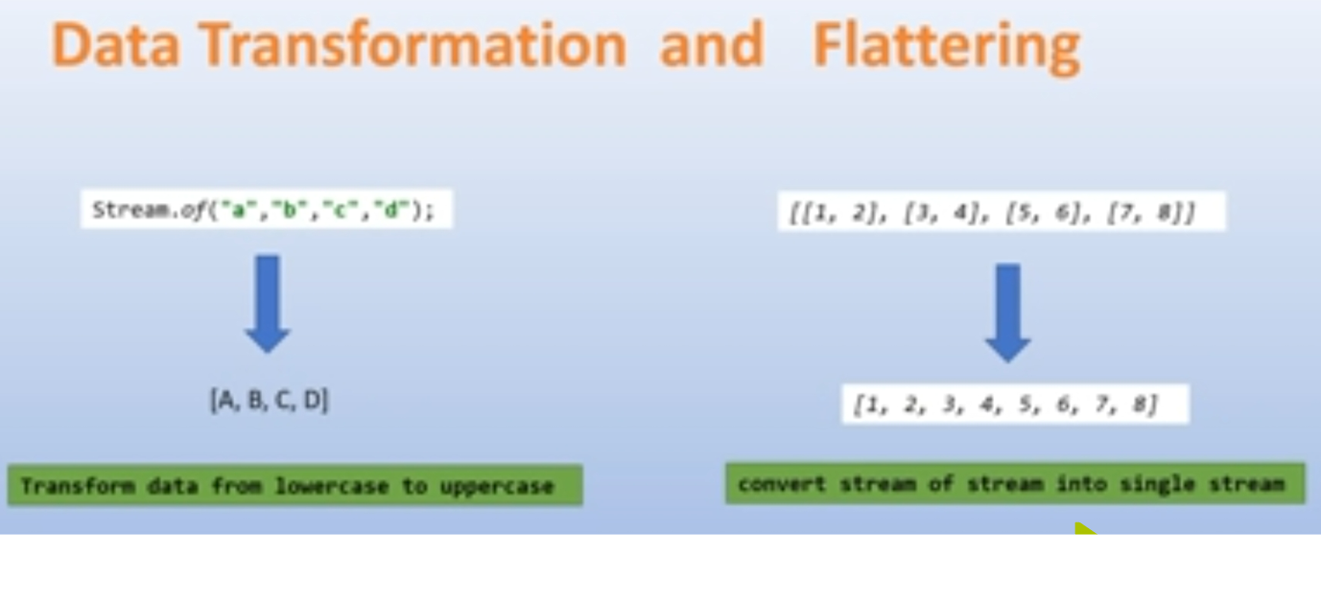• flatMap() → map() + flattering

**Real time examples**

Let's assume that we have a list of Employes and we need to get the list of cities where they have worked in past years.

Employee.java:-

**package** com.abc.entity;

**import** java.util.List;

@Data

**public** **class** Employee {

**private** Integer id;

**private** String name;

**private** List<String> city;

}

EmployeeDao.java:-

**package** com.abc.entity;

**import** java.util.List;

**public** **class** EmployeeDao {

**public** **static** List<Employee> getData(){

Employee employee1 = **new** Employee(1,"Rustam",List.*of*("Delhi","Banglore","Chennai"));

Employee employee2 = **new** Employee(2,"Saddam",List.*of*("Pune","Banglore","Kolkata"));

Employee employee3 = **new** Employee(3,"Atul",List.*of*("Delhi","Banglore","Noyda"));

**return** List.*of*(employee1,employee2,employee3);

}

}

MapFlatMap.java:-

**package** com.abc.entity;

**import** java.util.List;

**import** java.util.Set;

**import** java.util.stream.Collectors;

**public** **class** Map_FlatMap_Controller {

**public** **static** **void** main(String[] args) {

List<Employee> data = EmployeeDao.*getData*();

System.***out***.println(data);

// uses of map

List<Integer> id = data.stream()

.map(Employee::getId)

.collect(Collectors.*toList*());

System.***out***.println(id);

// uses of flatMap

Set<List<String>> city = data.stream()

.map(Employee::getCity)

.collect(Collectors.*toSet*());

System.***out***.println(city); // stream of stream we have to flat it.

// with flatMap

Set<String> cities = data.stream()

.flatMap(e -> e.getCity().stream())

.collect(Collectors.*toSet*());

System.***out***.println(cities);

}

}

Output:-

[

Employee [id=1, name=Rustam, city=[Delhi, Banglore, Chennai]],

Employee [id=2, name=Saddam, city=[Pune, Banglore, Kolkata]],

Employee [id=3, name=Atul, city=[Delhi, Banglore, Noyda]]

]

[1, 2, 3]

[[Delhi, Banglore, Noyda], [Delhi, Banglore, Chennai], [Pune, Banglore, Kolkata]]

[Delhi, Banglore, Chennai, Pune, Kolkata, Noyda]

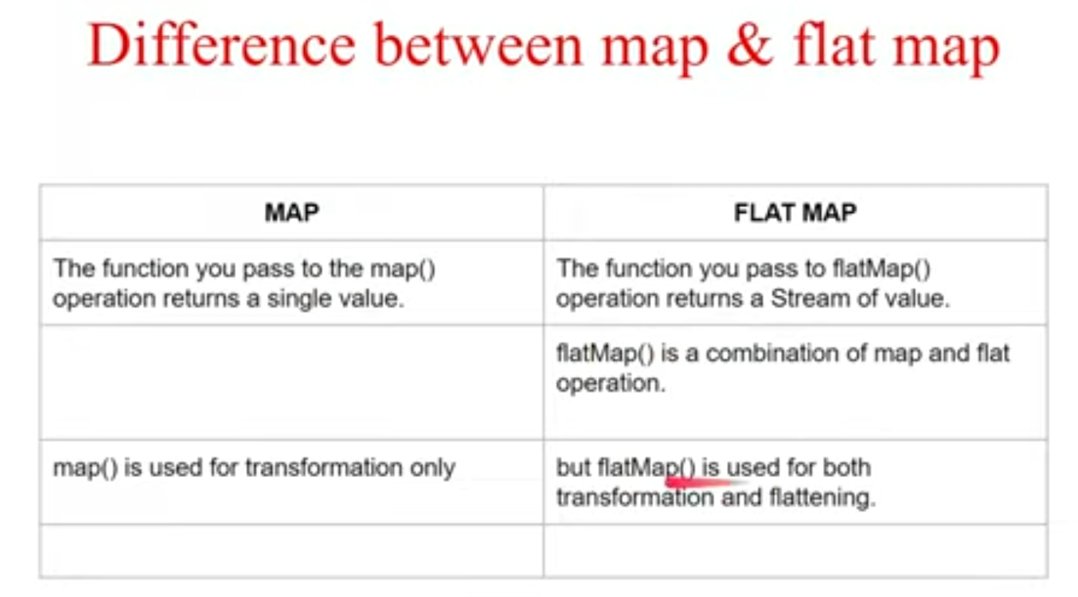

**10. What is immutable class . How to write customize immutable class .**

Immutable class in java means that once an object is created, we cannot change its content. In Java, all the [wrapper classes](https://www.geeksforgeeks.org/wrapper-classes-java/) (like Integer, Boolean, Byte, Short) and String class is immutable.

Following are the requirements:

* The class must be declared as final so that child classes can’t be inherited.
* Data members in the class must be declared **private and final** so that direct access is not allowed and can’t change the value of it after object creation.
* A parameterized constructor should initialize all the fields performing a deep copy so that data members can’t be modified with an object reference.
* Deep Copy of objects should be performed in the getter methods to return a copy rather than returning the actual object reference)
* Setter not be there in immutable class.

Ex:-

Depertment.java:-

**package** com.abc.immutable;

**public** **class** Depertment {

**private** String name;

**private** String location;

**public** Depertment() {

}

**public** Depertment(String name,String location) {

**this**.name=name;

**this**.location=location;

}

//using copy constructor

**public** Depertment(Depertment depertment) {

**this**(depertment.getName(),depertment.getLocation());

}

**public** String getName() {

**return** name;

}

**public** String getLocation() {

**return** location;

}

**public** **void** setLocation(String location) {

**this**.location = location;

}

**public** **void** setName(String name) {

**this**.name = name;

}

@Override

**public** String toString() {

**return** "Depertment [name=" + name + ", location=" + location + "]";

}

}

ImmutableEmployee.java:-

**package** com.abc.immutable;

**final** **public** **class** ImmutableEmployee {

**private** **final** Integer id;

**private** **final** String name;

**private** **final** Depertment dept;

**public** ImmutableEmployee() {

**this**.id = **null**;

**this**.name = "";

**this**.dept = **new** Depertment();

}

**public** ImmutableEmployee(Integer id, String name,Depertment dept) {

**super**();

**this**.id = id;

**this**.name = name;

**this**.dept = dept;

}

**public** Integer getId() {

**return** id;

}

**public** String getName() {

**return** name;

}

**public** Depertment getDept() {

// return dept; don't send actual object reference

// return new Depertment(dept.getName(),dept.getLocation());

**return** **new** Depertment(**this**.dept);

}

@Override

**public** String toString() {

**return** "ImmutableEmployee [id=" + id + ", name=" + name + ", dept=" + dept + "]";

}

}

Main.java:-

**package** com.abc.immutable;

**public** **class** Main {

**public** **static** **void** main(String[] args) {

Depertment depertment = **new** Depertment();

depertment.setName("tech");

depertment.setLocation("banglore");

ImmutableEmployee employee = **new** ImmutableEmployee(10,"rustam",depertment);

System.***out***.println(employee);

// employee.setName("Ali");

Depertment dept = employee.getDept();

System.***out***.println(dept);

System.***err***.println(depertment==dept);

dept.setName("HR"); //even we trying to change its not change

dept.setLocation("kolkata");

System.***err***.println(dept);

System.***out***.println(employee);

}

}

Output:-

ImmutableEmployee [id=10, name=rustam, dept=Depertment [name=tech, location=banglore]]

false

Depertment [name=HR, location=kolkata]

Depertment [name=tech, location=banglore]

ImmutableEmployee [id=10, name=rustam, dept=Depertment [name=tech, location=banglore]]

**11. What is Singleton. What are the ways to break singleton pattren. How to**

**write a code for single pattren .**

Singleton is a design pattern that ensures that a class can only have one object.

To create a singleton class, a class must implement the following properties:

* Create a **private constructor** of the class to restrict object creation outside of the class.
* Create a **private static attribute** of the class type that refers to the single object.
* Create a **public static method** that allows us to create and access the object we created. Inside the method, we will create a condition that restricts us from creating more than one object.

Syntax:-

class SingletonExample {

// private field that refers to the object

private static SingletonExample singleObject;

private SingletonExample() {

// constructor of the SingletonExample class

}

public static SingletonExample getInstance() {

// write code that allows us to create only one object

// access the object as per our need

}

}

Usage:-

Singletons can be used while working with databases. To make Connection .

There are two forms of singleton design patterns, which are:

**Early Instantiation:** The object creation takes place at the load time.

**Lazy Instantiation:** The object creation is done according to the requirement.

2.There are mainly 3 concepts that can break the singleton property of a class.

* **Through reflection Api.**
* **Through Serailzation and Deserailzation.**
* **Through Cloning.**
* **Through MultiThreading.**

**Way To create SingleTon Object:-**

LazySingleTon.java:-

**import** java.io.Serializable;

/**

Lazy initialization mean application will create instance when it is requested.

However, this can be used when you have non-thread-safe application.

**If used in multi threading it might break,Why?**

because your getinstance method if invoked by two thread at same time then!!!!

**\***

**When to use?**

Non thread safe and creating common resource like db connection.

*

*

*/

**public** **class** LazySingleton **implements** Serializable {

**private** **static** LazySingleton *instance* = **null**; //lazy loading

**private** LazySingleton() {

}

**public** **static** LazySingleton getInstance() {

**if**(*instance* == **null**){

*instance* = **new** LazySingleton();

}

**return** *instance*;

}

}

EagerSingleTon.java:-

/**

This is eager initialization concept where as soon as JVM start the object will be created irrespective whether it got accessed by any code in application or not.

**When to use :**

One possible usage can be let say your application has some static cache which is required to be loaded.

**Drawback :**

As mention consumes resource even if application does not use it.

*/

**public** **class** EagerSingleton {

**private** **static** **final** EagerSingleton ***instance*** = **new** EagerSingleton();

**private** EagerSingleton() {

// Do your init work here

}

**public** **static** EagerSingleton getInstance() {

**return** ***instance***;

}

}

**Way to handle to avoid to break SingleTon**

MultiThreadSingleTon.java:-

/**

As mentioned in Lazy Initialization if our get instance method invoked by two thread at the same time then there are chances that two objects created, and we violate singleton pattern.

* **To avoid we have two choices :**

* 1. Create getinstance synchronized so that only one instance can invoke

that method.

* **However, disadvantage is lets say**

there are 3 thread t1 is inside getinstance and t2,t3 waiting. Now t2 will get into method and simply return instance created by t1 and t3 still waiting. So it had lead to unnecessary of locks.

*

* 2. To avoid we have synchronized block which we will implement here.

*/

**public** **class** MultithreadSingleton {

**private** **static** MultithreadSingleton *instance* = **null**;

**private** MultithreadSingleton() {

}

**public** **static** MultithreadSingleton getInstance() {

**// Question arise why we have two null check here.**

// Reason for first null check is same as explained in method level

synchronization why create lock if our object is already

created.

**if**(*instance* == **null**) {

// Our method is static, so we have class level locking here

**synchronized** (MultithreadSingleton.**class**) {

//Reason for second null check is lets say two thread are

come inside first null at same time

// One call has taken lock and proceeds for creating object first time. Now once lock is released for t1 t2 should not create object because its already created and that's why we have second null check.

**if**(*instance* == **null**) {

*instance* = **new** MultithreadSingleton();

}

}

}

**return** *instance*;

}

}

SerializableSingleTon.java:-

**import** java.io.Serializable;

/**

**Let's say your singleton has implemented serialization. Now what will happen if you serialize object and deserialize.**

* During deserialization it will create the new object every time if we go

in traditional way.

* To resolve it **add readResolve method** which will ensure that during

deserialize we return same instance.

*

* Check Main class for violation example

*/

**public** **class** SerializableSingleton **implements** Serializable {

**private** **static** SerializableSingleton *instance* = **null**;

**private** SerializableSingleton() {

}

**public** **static** SerializableSingleton getInstance() {

**if**(*instance* == **null**) {

*instance* = **new** SerializableSingleton();

}

**return** *instance*;

}

/**

This is the key method which is responsible during deserialization process This method get invoked, and we are simply returning already created object

* **@return**

*/

**protected** Object readResolve() {

**return** *instance*;

}

}

EnumSingleTon.java:-

/**

* **Here we described creating singleton using enum but why?**

* Let's say in Lazy Init method you access constructor by reflection (Reason being you can access private constructor using reflection!!)

* and create the object which eventually creates the problem by having multiple instances.

*

**ENUM's constructor gets invoked by JVM not by User who is using so it is safe to use.**

Another advantage of using enum is , we don't need to worry about threads as it is thread safe.

It also solved the problem of Serialization as JVM takes care to return same object.

*

*/

**public** **enum** EnumSingleton {

***INSTANCE***;

**public** **void** doSomething() {

System.***out***.println("Cool");

}

}

Main.java:-

**import** java.io.*;

**import** java.lang.reflect.Constructor;

**import** java.lang.reflect.InvocationTargetException;

//Before jumping into pattern just explain what is lazy loading and eager loading

// Mainly this class used to show violations using serializable and reflection.

**public** **class** Main {

**public** **static** **void** main(String[] args) **throws** IOException, ClassNotFoundException, InvocationTargetException, InstantiationException, IllegalAccessException {

*exampleSerialization*();

*exampleReflection*();

}

**private** **static** **void** exampleSerialization() **throws** IOException, ClassNotFoundException {

LazySingleton lazySingleton = LazySingleton.*getInstance*();

LazySingleton lazySingleton2 = LazySingleton.*getInstance*(); //it will return same object ref

System.***out***.println("Object 1 :" + lazySingleton.hashCode()+" Object 2 :" + lazySingleton2.hashCode());

// due to serialization and deserialization object get changed

ObjectOutputStream objectOutputStream = **new** ObjectOutputStream(**new** FileOutputStream("object.obj"));

objectOutputStream.writeObject(lazySingleton);

objectOutputStream.close();

ObjectInputStream objectInputStream = **new** ObjectInputStream(**new** FileInputStream("object.obj"));

LazySingleton deserializedLazy = (LazySingleton) objectInputStream.readObject();

objectInputStream.close();

System.***out***.println("Object 1 :" + lazySingleton.hashCode());

System.***out***.println("Object 2 :" + deserializedLazy.hashCode());

//but here not changed because of override readResolve method because

during deserialized jvm will automatic call this method

SerializableSingleton serializableSingleton = SerializableSingleton.*getInstance*();

ObjectOutputStream objectOutputStream2 = **new** ObjectOutputStream(**new** FileOutputStream("object1.obj"));

objectOutputStream2.writeObject(serializableSingleton);

objectOutputStream2.close();

ObjectInputStream objectInputStream2 = **new** ObjectInputStream(**new** FileInputStream("object1.obj"));

SerializableSingleton deserializedInstance = (SerializableSingleton) objectInputStream2.readObject();

objectInputStream2.close();

System.***out***.println("SerializableSingleton Object 1 :" + serializableSingleton.hashCode());

System.***out***.println(" SerializableSingleton Object 2 :" + deserializedInstance.hashCode());

}

**private** **static** **void** exampleReflection() **throws** InvocationTargetException, InstantiationException, IllegalAccessException {

Constructor[] constructors = LazySingleton.**class**.getDeclaredConstructors();

//Knowing only one constructor taking it using index

Constructor constructor = constructors[0];

constructor.setAccessible(**true**);

LazySingleton lazySingleton = (LazySingleton) constructor.newInstance();

LazySingleton instance = LazySingleton.*getInstance*();

System.***out***.println("Reflected hashcode singleton :"+lazySingleton.hashCode());

System.***out***.println("Singleton instance : "+ instance.hashCode());

//Solution to this is go by enum

EnumSingleton.***INSTANCE***.doSomething();

}

}

Output:-

Object 1 :1365202186 Object 2 :1365202186

Object 1 :1365202186

Object 2 :1597462040

SerializableSingleton Object 1 :1576861390

SerializableSingleton Object 2 :1576861390

Reflected hashcode singleton :600746945

Singleton instance : 1365202186

Cool

**12. What is java refelction api.**

**Java Reflection** is a *process of examining or modifying the run time behavior of a class at run time*.

### **Pros and Cons of Reflection**

**Pros:** Inspection of interfaces, classes, methods, and fields during runtime is possible using reflection, even without using their names during the compile time. It is also possible to call methods, instantiate a clear or to set the value of fields using reflection. It helps in the creation of Visual Development Environments and class browsers which provides aid to the developers to write the correct code.

**Cons:** Using reflection, one can break the principles of encapsulation. It is possible to access the private methods and fields of a class using reflection. Thus, reflection may leak important data to the outside world, which is dangerous. For example, if one access the private members of a class and sets null value to it, then the other user of the same class can get the NullReferenceException, and this behaviour is not expected.

**13. What is concurrent hash map and how it works internally**

a. Traditional Collection Object like ArrayList,LinkedList,HashSet,HashMap is

accessed by Multiple Threads simultaneously and there may be a chance of "DataIncosistencyProblem". Since they are accessed by multiple threads simultaneously they are not "ThreadSafe".

b. Already Existed Collection Objects like a Vector,Hashtable ,synchronizedList()

,synchronizedSet(),synchronizedMap() are "ThreadSafe", but performance is

very low as the locking mechanism is not good.

c. In traditional collection if one thread iterates and other tries to modify **structural**

change then ConcurrentModificationException is thrown.

Becoz of the above mentioned problem,these collection objects are not suitable for "MultiThreadingEnvironment".To resolve this problem SUNMS introduced a new Set of Collection called "ConcurrentCollection" in JDK1.5.

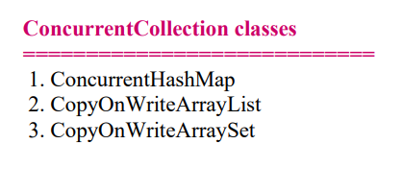

**ConcurrentHashMap**

**================**

• **Underlying datastructure =>** Hashtable

• **locking mechanism =>** not on the entire object, it is on part of object(bucket

level)

• **Read Operation =>** Mulitple threads can read no lock required

• **Update Operation =>** will be decided by bucket level/concurrency level.

**• DefaultConcurrency level =>** 16(can be changed as per user requirement).

• **null =>** not allowed as both key and value

**• ConcurrentModification =>** yes it is possible,no Excpetion

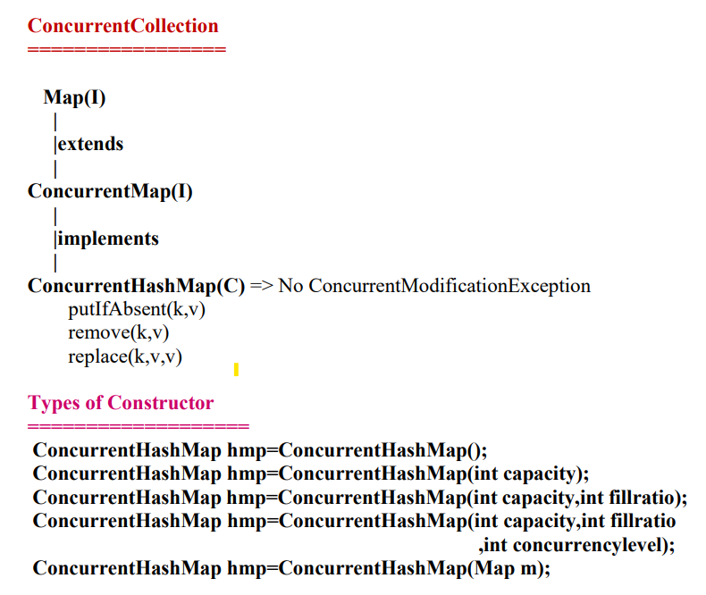

Ex:-

**package** com.fullcreative.staticprogram;

**import** java.util.HashMap;

**import** java.util.Iterator;

**public** **class** ConcurrentHashMapExample {

**public** **static** **void** main(String[] args) {

**HashMap<Integer, Integer> map = new HashMap<>();**

map.put(1, 1);

map.put(2, 2);

map.put(3, 3);

Iterator<Integer> it = map.keySet().iterator();

**while** (it.hasNext()) {

Integer key = it.next();

**if** (key.equals(2)) {

map.put(4, 4); //structure got changed

}

System.***out***.println("Map Value:" + map.get(key));

}

}

}

Output:-

Map Value:1

Map Value:2

Exception in thread "main" java.util.ConcurrentModificationException

at java.base/java.util.HashMap$HashIterator.nextNode(HashMap.java:1597)

at java.base/java.util.HashMap$KeyIterator.next(HashMap.java:1620)

at com.fullcreative.staticprogram.ConcurrentHashMapExample.main(ConcurrentHashMapExample.java:14)

Note:-

**if** (key.equals(2)) {

map.put(4, 4);

//if you give existing key then structure not get changed and it will not show error like **map.put(2,7);** here 2 is exits so its just update the value. structure will not change so no conncurrent modifiaction show .

in case of remove also its show conncurrent modifiaction Exception.

}

**The limitation of Traditional Collection is overcomed in ConcurrentCollections** 1. Concurrent collection is ThreadSafe.

2. Performance of ConurrentCollection is better than NormalCollection becoz of

different locking mechansim.

3. In case of ConcurrentCollection simultaneously read and update operation

can be performed so their is no "ConcurrentModificationException".

**Using ConcurrentHashMap :-**

**package** com.fullcreative.staticprogram;

**import** java.util.Iterator;

**import** java.util.concurrent.ConcurrentHashMap;

**public** **class** ConcurrentHashMapExample {

**public** **static** **void** main(String[] args) {

ConcurrentHashMap <Integer, Integer> map = **new** ConcurrentHashMap<>();

map.put(1, 1);

map.put(2, 2);

map.put(3, 3);

Iterator<Integer> it = map.keySet().iterator();

**while** (it.hasNext()) {

Integer key = it.next();

System.***out***.println("Map Value:" + map.get(key));

**if** (key.equals(2)) {

map.put(4, 4);

}

}

}

}

Output:-

Map Value:1

Map Value:2

Map Value:3

Map Value:4

Here Structure got change length of map now become 4.

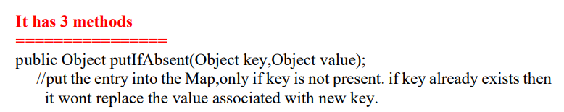

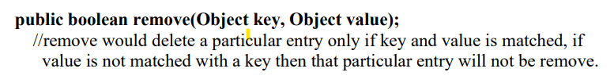

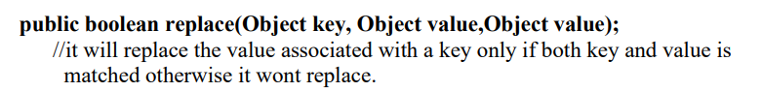

Ex:-

**import** java.util.concurrent.*;

**class** ConcurrentHashMapDemo {

**public** **static** **void** main(String[] args)

{

ConcurrentHashMap<Integer, String> m= **new** ConcurrentHashMap<>();

m.put(100, "Hello");

m.put(101, "Geeks");

m.put(102, "Geeks");

// Here we cant add Hello because 101 key

// is already present in ConcurrentHashMap object

m.putIfAbsent(101, "Hello");

// We can remove entry because 101 key

// is associated with For value

m.remove(101, "Geeks");

// Now we can add Hello

m.putIfAbsent(103, "Hello");

// We cant replace Hello with For

m.replace(101, "Hello", "For");

System.***out***.println(m);

}

}

**Output:-**

{100=Hello, 102=Geeks, 103=Hello}

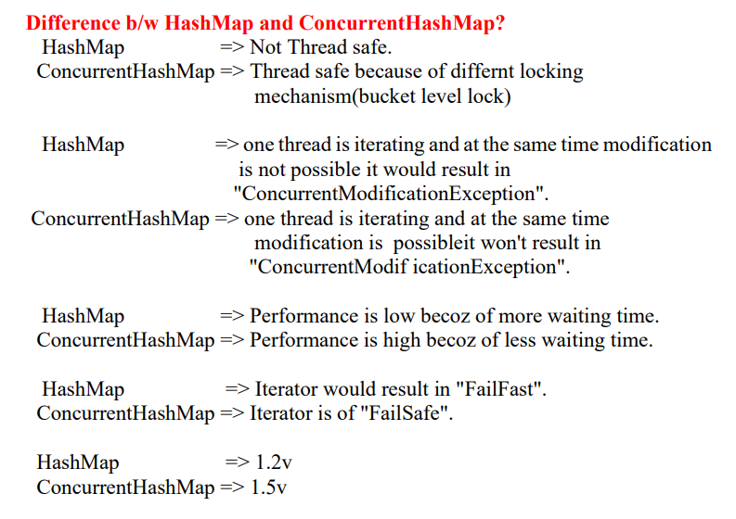

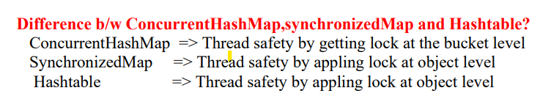

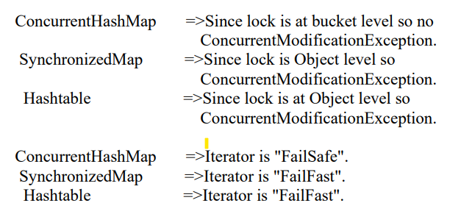

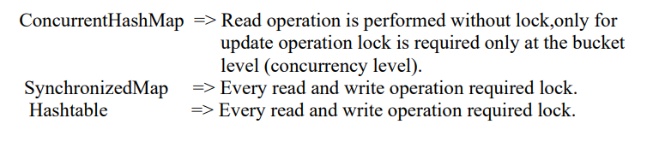

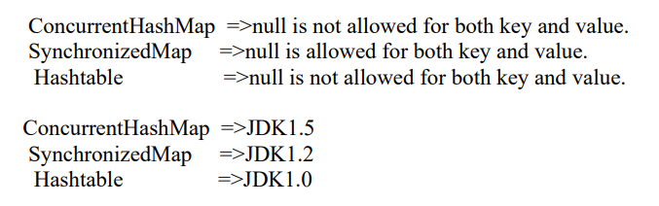

**14.Difference b/w Serialization and Externalization**

**Serialization**

1. It is meant for default Serialization

2. Here every thing takes care by JVM and programmer doesn't have any

control.

3. Here total object will be saved always and it is not possible to save part of

the object.

4. Serialization is the best choice if we want to save total object to the file.

5. relatively performence is low.

6. Serializable interface doesn't contain any method.

7. It is a marker interface.

8. Serializable class not required to contains public no-arg constructor.

9. transient keyword play role in serialization

**Externalization**

1. It is meant for Customized Serialization

2. Here every thing takes care by programmer and JVM does not have any

control.

3. Here based on our requirement we can save either total object or part of the

object.

4. Externalization is the best choice if we want to save part of the object.

5. relatively performence is high

6. Externalizable interface contains 2 methods :

1.writeExternal()

2. readExternal()

7. It is not a marker interface.   
8. Externalizable class should compulsory contains public no-arg constructor

otherwise we will get RuntimeException saying "InvalidClassException"

9. transient keyword don't play any role in Externalization.