An Alternative Perspective on the Process Bus:
Handling 1 million GOOSE and 1000 SV on Common Embedded Hardware

by Rustam Mustafin, 2025

Introduction

Initially, the process bus concept was introduced in Part 9.2 IEC 61850 standard in 2004. A few months later, in July 2004 the implementation guideline was published. During these 20 years there have been a few attempts to build full digital substations with a process bus under the hood. Unlike other parts of IEC 61850, which have become the de facto main standard, the process bus concept still has not been accepted by the industry.
First of all, let’s look at the market in general. According to [1] the global substation market reached 128.5 billion USD. The digital segment has reached 7.9 billion USD and significant growth is expected by 2030. For example, Hitachi Energy mentions [2] about 15000+ IEC 61850 substations and only 50+ of them using IEC 61850-9-2. This represents only 0.3% of their projects utilizing the Process Bus for full digitalization benefits. Even after two decades we are still discussing pilot-projects and reports in publications[3], [4]. Similarly, in Russia there are a few pilot projects but they haven’t become mainstream.
There are these major issues of the current Process Bus usage:
- High cost of devices that implement Process Bus such as Merging Units, Ethernet switches and Time synchronization units. Figure 1 illustrates the architecture of a digital substation.
- Cybersecurity issues especially with using Sampled Values and GOOSE protocols are not designed to secure or validate data (cryptographic features were added in IEC 62351-6).
- Figure 2 demonstrates the system complexity to maintain as a result.
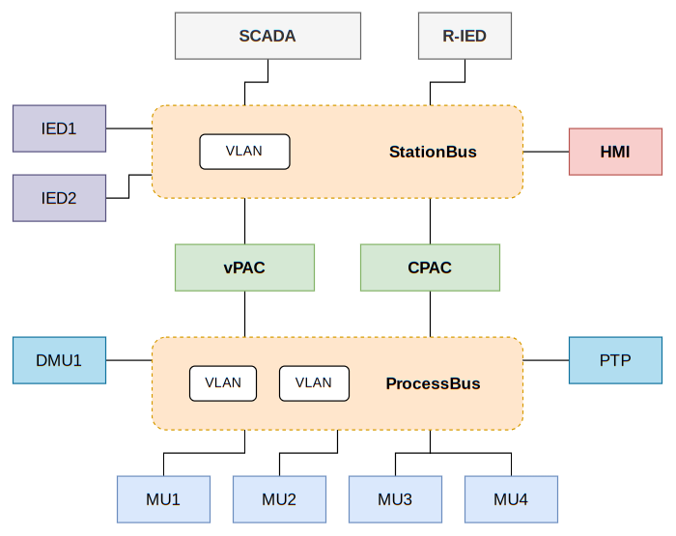
Figure 1. A high level scheme of a digital substation.
Ethernet is definitely a backbone for the IEC 61850 standard. As a means, it is also widely used in embedded systems and IoT. However, Ethernet is merely a tool and technology to implement concepts such as Process or Station Buses.

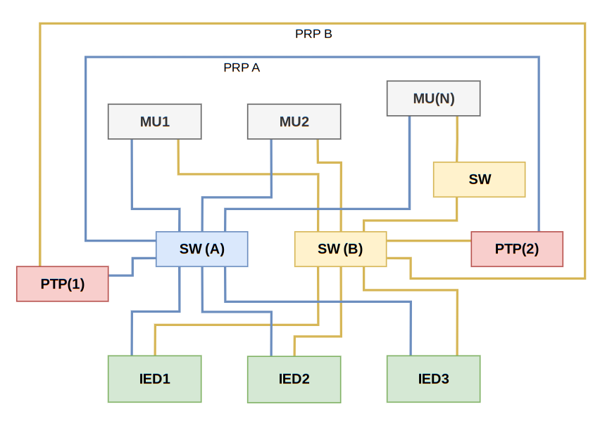
Figure 2. Complexity of the real communication on Process Bus

In the context of digital substations based on IEC 61850, SV and GOOSE communication mechanisms are often equated directly with Ethernet or Local Area Networks (LAN). This equivalence, although convenient for practical implementation, inadvertently obscures key differences and specific requirements originally intended by the concepts of the Process Bus and Station Bus. Mapping IEC 61850 to Ethernet Network is illustrated on Figure 3. It highlights the impact of Ethernet on the IEC 61850 services’ characteristics.
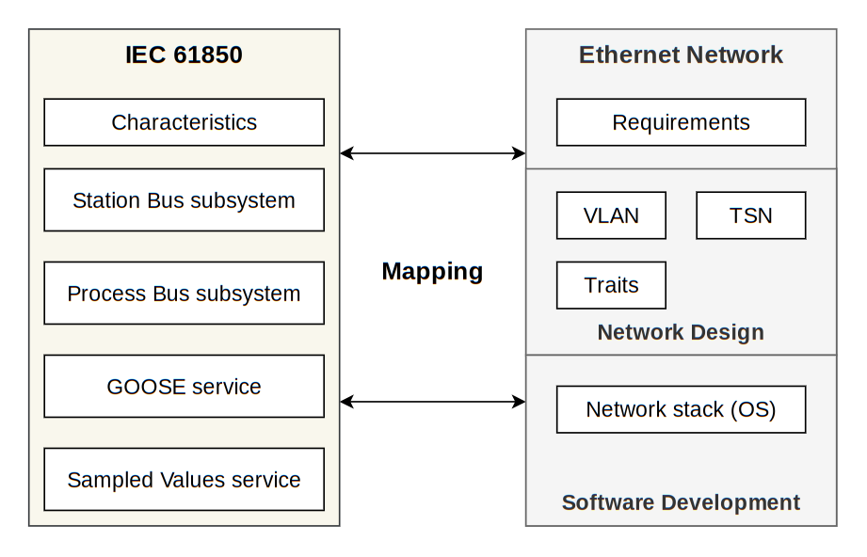
Figure 3. Mapping IEC 61850 concepts to Ethernet.

It is time to revise the core ideas of Process Bus and try to find a new solution.
An alternative perspective on Process Bus concept

Process Bus – defined in IEC 61850-1 as “the communication network which connects the IEDs at primary equipment level to other IEDs”[5]. Apostolov Alexander further elaborates this concept as the link between the high-voltage process equipment and protection/control IEDs, enabling digitalized signal exchange and reducing analog[6]. Importantly, while the standard maps this abstract bus onto Ethernet via SV and GOOSE, the underlying concept remains transport-agnostic.

Building a cost-efficient, reliable Process Bus requires a fresh perspective:
- Process Bus is a concept rather than Ethernet Network or LAN.
- Rethinking the Merging Unit concept and its characteristics.
- Fault tolerance for synchronization analogues signals.
- Removing switches in the Process Bus.
- Reduction of the IED devices by utilizing Virtual IEDs.

This way, I suggest two concepts to achieve these characteristics:
- Uber Merging Unit – multi-sensor aggregation unit, many SV streams, proprietary link instead of Ethernet for getting data from sensors.
- Virtual Process Bus – bus inside vIED servers, no Ethernet, DDS-style adaptive transport selection.

Uber Merging Unit

Basically, Merging unit concept is a means to reduce the copper connections and get some other benefits like observability and easier adding new IEDs for the same signals. It means we want to use optical fiber instead of copper to transfer signals from transformers to the relay and protection systems. An important requirement of relay & protection systems that all these signals must be synchronized between each other. This requirement is a key for rethinking merging unit concept. Working synchronously means that they are tightly coupled devices rather than independent units.
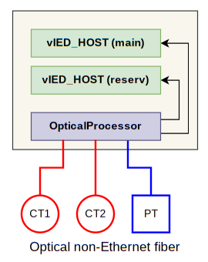
Figure 4. Profotech solution with optical transformers.
An interesting solution with utilizing optical fiber was presented by Profotech company[7]. In Profotech solution optical fiber isn’t an Ethernet transporter but a measurement tool that solves both tasks: getting measurements and transmit them. This approach is perfect because it doesn’t require a security system for monitoring communications like in Ethernet based solutions. The biggest problem is to follow the common Merging unit concept and combine their processing units to classical merging unit. It also doesn’t need an external synchronization system to measure simultaneously different phases and analogue signals. Let’s consider a generalization of this solution Figure 5.
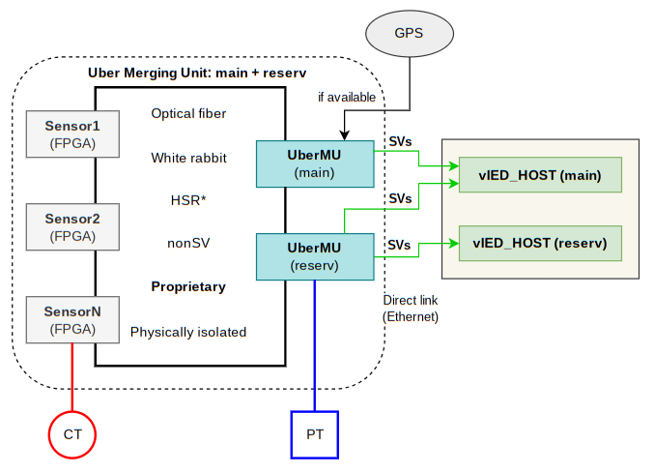
Figure 5. The Uber Merging Unit concept.

Ultimately, on the digital substation we will have optical transformers and processing units. All of them must work synchronously, therefore we can consider the whole system as a single Uber Merging Unit with proprietary optical transformers and sensors. This way we have a concept that is better to name a signal collector that utilizes optical fiber and non-Ethernet protocols to collect measurements in a secure way and synchronizes them in a hardware-reliable way.
This Merging Unit generalization includes:
- Simple sensors with only 1 function – measure and transfer data to a signal collector. As a result sensors are simple in their hardware and cheap.
- Optical fiber between sensors and a signal collector with direct links: sensor – collector or sensor – sensor for a ring topology.
- Signal collector can send all measurements in IEC 61850 SV protocol as a single Uber MU on a digital substation.
- Signal collector synchronizes all sensors using its internal clock.
- Signal collectors can be reserved and use the same sensors(according to their proprietary nature).
This way we have only main and reserved signal collectors that send their analogue signals in IEC 61850 SV protocol directly to vIED_HOST servers. Technically, the concept of Uber Merging Unit doesn’t break the existing requirements and presentation of MU as sources for SV streams. We just have a reliable system of signal collectors with remote sensors and IEC 61850-9-2 SV protocol as an interface for subscribers.
Some implementation details of Uber Merging Unit are mentioned on the Figure 5 however the full technical description of this concept is beyond the scope of this paper.

Virtual Process Bus and Virtual IEDs

The idea of having many virtual IED devices on the same physical server can significantly reduce the cost and improve maintainability of a digital substation. Virtual IED is actually an attempt to use the same physical connections and hardware that are more than enough nowadays[8]. Even in Embedded sphere there are many high-performance CPU and NICs that will become more powerful in the future. Although Virtual IED doesn’t automatically imply Virtualization there is a popular project – SeaPath that offers mapping physical devices to virtual machines and utilizing existing technologies[9]. In my opinion, this shift from many physical devices to one server should be adapted from an engineering perspective rather than direct using tools like different hypervisors.
For example, let’s consider direct move GOOSE communications from physical IEDs to VMs. Even though, our VMs are located on the same server we will have a waste of traffic such as retransmissions and increasing send periods. Only a few of modern NICs actually support redirection of traffic between VF without using physical cables. That means, we still have to use external switches and cables for inter-VM communication. Energy efficiency is another reason to avoid using Virtualization as is.
Having said that, the necessity of Virtual Process Bus becomes understandable.
Let’s consider the requirements for Virtual Process Bus:
- Reliability without need of retransmissions.
- Energy efficiency and low-latency.
- Based on a standard for easier implementation.

There are a few concepts to achieve these requirements:
- Using special NICs that offer “virtual” connections between NIC VFs. This solution is tightly connected to a manufacturer and won’t be considered.
- Using DPDK’s HugePages with shared rings between Containers or VMs. This way we have virtual software NICs in each vIED that are actually DPDK’s rings[10]. BusMaster is needed to manage packets between rings and physical NICs(possible in zero-copy mode). This way we still have Ethernet-based packet communications depicted on Figure 6.
- Using the Data-Distribution Service[11] with shared memory based transport for inter-containers and QEMU-based VMs communications. There is mapping of DDS to IEC 61850 [12]. This way, the BusMaster is still needed to convert DDS to IEC 61850 and vice versa. vIED with DDS can also find each other by utilizing DDS’s features without using BusMaster. Figure 7.

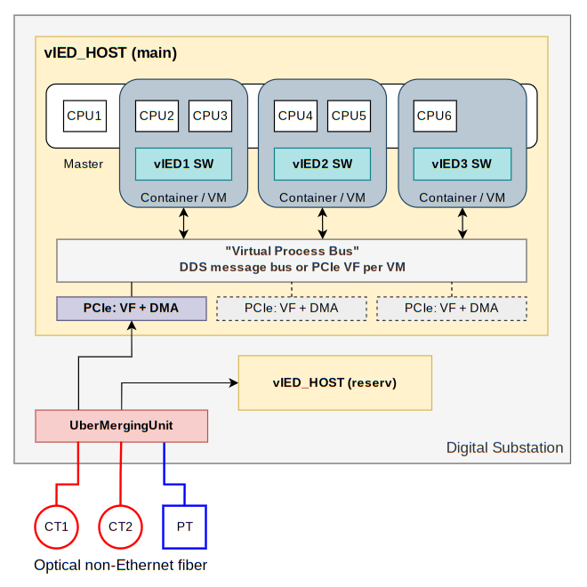
Figure 6. Virtual Process Bus with VF functions per VM

In my opinion, using DDS is the most interesting solution for inter vIED communications because there is mapping to IEC 61850[12] and it has mechanisms to ensure reliability. There is a significant issue with DDS in Network mode when Ethernet is used. In this mode, DDS uses TCP/IP stack to send/receive messages. The existing network stack in Linux has been implemented for completely different usage than Real-Time processing L2-multicast frames or UDP packets. This problem could be solved with using DPDK under the hood of CycloneDDS project.

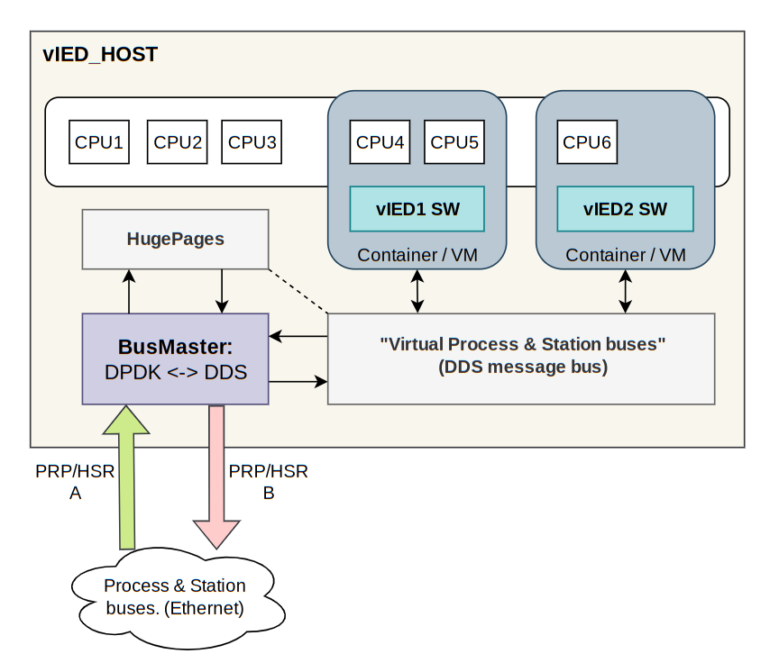
Figure 7. BusMaster and DDS translation

Ultimately, the alternative perspective on Process Bus is shown on Figure 8. This concept needs a proof of feasibility with handling massive traffic on common for embedded devices hardware without special high-performance CPU or NICs. By understanding of concept nature of Process Bus, we can treat the Ethernet as a means to transfer SV/GOOSE frames and get the direct access to frames with DPDK project[10].

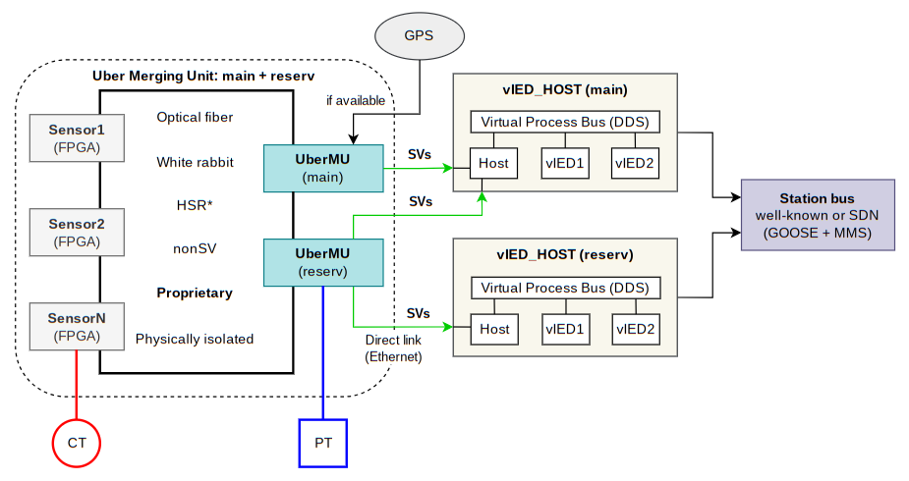
Figure 8. The alternative perspective on Process Bus.

Overview of DPDK in Digital substation context

DPDK[10] – is a well-known project for high-speed and low-latency processing Ethernet packets. Mostly, it could be found in Software Defined Network (SDN). Even though it is focused on handling IP-traffic it can also be used in IED devices to process data from Process & Station buses. There are many articles about using DPDK in SDN to build software routers and firewalls however they are mostly devoted to IP traffic processing.

Let’s consider the most important DPDK’s techniques for Digital Substations:
- DPDK offers direct access to NIC(Network interface card) from user space in Linux. It is crucial because we can handle Ethernet frames without copying between kernel and user space as well as context switching is not needed between kernel and application.
- Poll mode drivers offer IRQ-free processing with direct access to DMA by using memory mapped pages to an application space.
- Using huge-pages reduces latency during access to Ethernet frames.
- DPDK offers a unified API to a variety of NICs with their advanced features such as packet flows and Receive Side Scaling (RSS).

In my understanding, it is crucial to describe some peculiarities of modern NICs and how they work to understand limits and extreme situations that can cause Process & Station buses malfunction.
Modern NICs have several queues for receiving and transmitting Ethernet frames. Each queue has a preconfigured number of descriptors that are used to transfer ownership of frames from NIC to CPU during processing time. These settings are highly important because they set the number of frames that can be simultaneously processed on device.
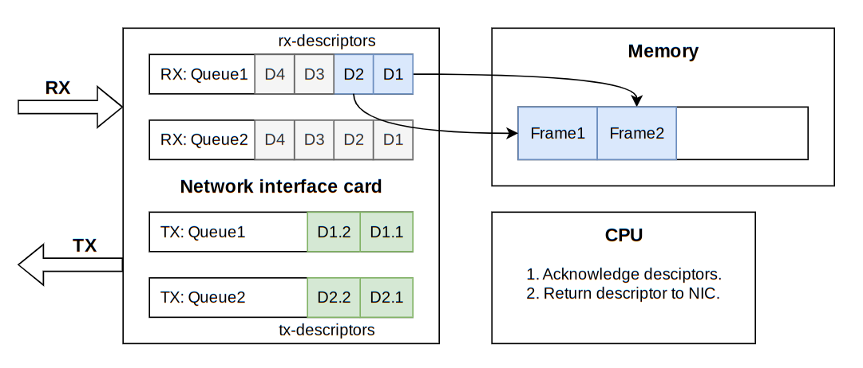
Figure 9. The core principles of modern NICs.

Unfortunately, most modern NICs oriented toward processing IP traffic and offer many offloads for IP traffic. For example, Receive Side Scaling mostly works only with IP fields such as source and destination IP-addresses and IP-ports. This hardware accelerated technology can distribute the traffic between different queues that can be handled on different CPU cores. Using software RSS with distribution between rx-rings is demonstrated in the ProcessBus project code. By using DPDK it becomes possible to directly work with Ethernet frames and treat it as a transfer channel rather than Local Network Area.

Ethernet based delays between IEDs in comparison with DDS

DDS offers shared memory transport for the exchange data on the same host. It means that just after writing a GOOSE message via DDS another IED can read it without any delays.
In order to understand the impact of Ethernet on time delivery GOOSE or SV frames it is important to measure the actual time that is needed to transfer a frame from one IED to another. This way, measurements should be done in an operating system rather than by MAC/PHY timestamps. It is important because we need some more time to transfer the whole packet from Ethernet to a RAM buffer. To measure the minimum and maximum time to transfer a packet between IED the application delay_measure has been created.
The logic of this application can be illustrated in a few steps:
- Create a pool of buffers and fill them with the static fields such as MAC, IP addresses and ports.
- TSC counter is used to measure the delays because it is most cost-effective method especially with Intel processors and disabled CPU frequency scaling. Each packet contains a field with TSC counter used to send it.
- After sending a bunch of packets the application waits up to 1ms for these packets on another Ethernet port but on the same CPU core.
- By measuring TSC clocks between sending and receiving the same packet we can actually find the delay is needed to transfer an L2-frame like GOOSE.

The principle scheme of testing environment is shown on Figure 10. The ports eth0-eth1 are used to generate and receive special UDP packets. The arrows are the physical connections between Ethernet ports.
Test description:
- Copper tests are conducted on eth2 - eth3 ports.
- SFP 10G tests are conducted on eth0 - eth1 ports.
- Two forwards are used: eth2 → eth3 and eth4 → eth5.

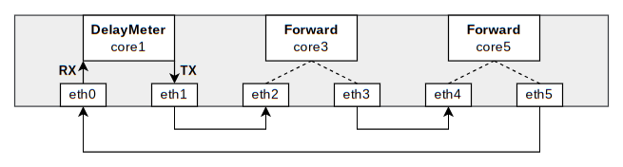
Figure 10. The stand to measure transfer delays between vIED
Table 1: Performance Results for 128-Byte packets

 | Min, us | Max, us | Avg, us
Copper 100M | 19.7 | 20.4 | 19.9
Copper 1G | 6.8 | 7.6 | 6.8
SFP 10G Fiber | 4.2 | 5.3 | 4.5
SFP 10G Copper | 6.6 | 8.1 | 6.8
SFP + 1 forward 2.5G | 18.3 | 20.2 | 18.7
SFP + 2 forwards 2.5G | 26.7 | 28.5 | 27.3
SFP 1G + 2 forwards 1G | 36.6 | 40.5 | 37.1

Table 2: Performance Results for 1500-Byte packets

 | Min, us | Max, us | Avg, us
Copper 100M | 135.3 | 136.2 | 135.5
Copper 1G | 23.8 | 24.5 | 24.0
SFP 10G Fiber | 7.1 | 8.2 | 7.3
SFP 10G Copper | 11.6 | 12.7 | 11.8
SFP + 1 forward 2.5G | 37.2 | 38.5 | 37.5
SFP + 2 forwards 2.5G | 55.8 | 59.5 | 56.6
SFP 1G + 2 forwards 1G | 119.7 | 122.1 | 120.4

This test demonstrates noticeable delay with using copper Ethernet 100M in comparison to Fiber optic and a shared memory based communication with DDS. It is worth mentioning the feasibility to use software-based data plane for Software Defined Networks in digital substations according to these delays.
Generating millions of GOOSE messages per second

There are many ways to generate N GOOSE messages per second with different characteristics like: minimum and maximum delay between messages and even these GOOSE messages can be sent from different IED devices emulated in the generating application.
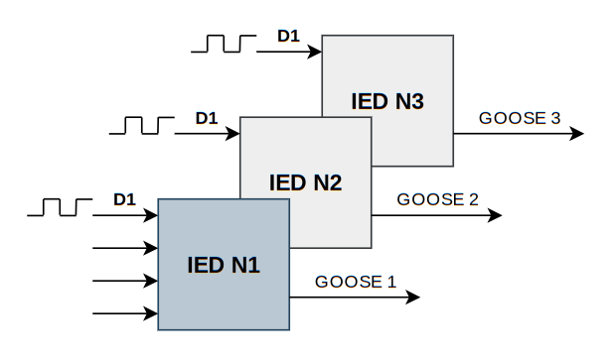
Figure 11. Imaginary IED devices with discrete inputs.

Let’s consider these different cases:
- There is only one IED with meander discrete signal on its discrete input. On each change the IED produces a new GOOSE message.
- There is another extreme case with 1 million IED devices. Each of them just sent 1 GOOSE message per second. There are limits in IEC 61850 standard for maximum number of unique GOOSE messages however we can still emulate them to stress Process & Station Buses and subscribers.
- Medium cases with legal number of unique IED with high frequency meander signals. For example, we can emulate 1000 IED devices with 1k Hz GOOSE messages from each. Figure 11.
Note: It is important that the implementation supports only sending GOOSE with changes in each message because my aim is generate huge GOOSE traffic whereas light modes with retransmissions. Otherwise, the libiec61850 library can be used.

Testing millions of GOOSE messages needs the generator that is able to produce this traffic. This application was created and all GOOSE have these parameters:
DMAC | 01:0C:CD:04:xx:xx
APPID | xxxx
IED name | IEDxxxxxxxx
LD name | LDName
GOID | GOIDxxxxxxxx
ConfRev | 1
x – is a placeholder for the IED number: 1, …
Generating thousands of SV-streams per second

There are two well-known SV types from the 9.2LE specification: SV with 80 points and 256 points on nominal period. To generate the configured number of SV80 or SV256 we need to fill all preallocated buffers and create the meta information for each stream with its state and configuration parameters to quickly amend SV frame buffer. These SV-streams have these parameters:

DMAC | 01:0C:CD:01:xx:xx
APPID | xxxx
SVID | SVIDxxxx
ConfRev | 1
x – is a placeholder for the IED number: 1, …

The proof-of-concept and test results

The concept of alternative perspective on Process Bus highly relies on the ability to receive and process massive traffic from an Uber Merging Unit on a common embedded device. This way, the generator and processing application of GOOSE and SV frames have been created and available on GitHub under GPL3 license: https://github.com/Rustam12345m/ProcessBus
A hardware platform with the following characteristics has been chosen for testing purposes:
CPU | Intel Atom C3808, 12 cores
RAM | 16 GB
Network card | Intel I226-V, 5xRJ45
Network card | Intel X553, 4xSFP
SFP | 2 x SFP-10G-T RJ45,  2 x SFP-10G/850nm/AOC/1m
Price | 400$

This hardware platform has many features that are important for vIED servers:
- 12 CPU cores make it possible to perform many vIED devices simultaneously.
- SFP ports with up to 10Gb/s connections are suitable for searching limits.
- Passive cooling system.
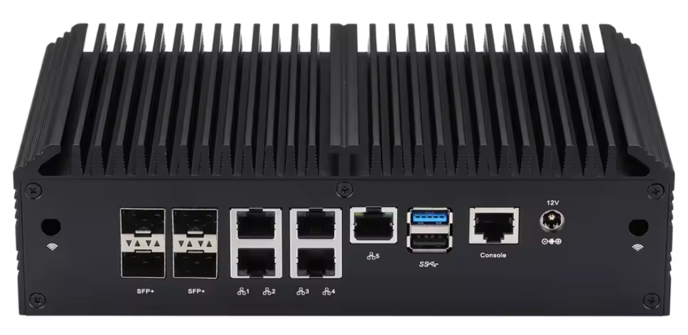
Figure 12. The hardware platform for tests
All the following tests were conducted on this device that performed both: generating and processing applications on different CPU cores. The SFP optical fiber 10Gb/s connection was used in all tests. Each test lasted for 5 minutes with control of sequence numbers in frames and had zero loss as a result. It is worth noting the need of further tests with R-SV and R-GOOSE that actually have many advantages such as support enhanced security features and better processing on modern NICs.

Table 3: GOOSE performance results

Gen-cores | Proc-cores | IEDs | Changes | PPS | Traffic | CPU load
1 | 1 | 1000 | 1000 | 1m | 1560 Mb/s | 35.1 %
1 | 1 | 2000 | 500 | 1m | 1560 Mb/s | 37.8 %
1 | 1 | 100 | 10000 | 1m | 1560 Mb/s | 35.5 %
1 | 1 | 150 | 10000 | 1.5m | 2340 Mb/s | 53.3 %
1 | 1 | 200 | 10000 | 2m | 3120 Mb/s | 72.1 %
1 | 1 + 2 | 300 | 10000 | 3m | 4680 Mb/s | 53-58-72 %
1 | 1 + 2 | 350 | 10000 | 3.5m | 5460 Mb/s | 39-74-90 %

Table 4: Sampled Values 80-Points performance results

Gen-cores | Proc-cores | SV80 | PPS | Traffic | CPU load
1 | 1 | 100 | 400k | 396.8 Mb/s | 6.7 %
1 | 1 | 200 | 800k | 793.5 Mb/s | 14 %
1 | 1 | 500 | 2m | 1984 Mb/s | 35 %
1 | 1 | 800 | 3.2m | 3174 Mb/s | 56 %
1 | 1 | 1000 | 4m | 3968 Mb/s | 70.2 %

Table 5: Sampled Values 256-Point performance results

Gen-cores | Proc-cores | SV256 | PPS | Traffic | CPU load
1 | 1 | 100 | 160k | 980 Mb/s | 7.6 %
1 | 1 | 200 | 320k | 1958 Mb/s | 15.6 %
1 | 1 | 500 | 800k | 4897 Mb/s | 39.8 %
1 | 1 | 800 | 1.28m | 7831 Mb/s | 64 %
1 | 1 | 900 | 1.44m | 8816 Mb/s | 73 %

Conclusion

The alternative perspective on Process Bus concept has been introduced in this paper. Rethinking Process Bus does not mean abandoning IEC 61850 — just decoupling the term “bus” from a single transport. This way, Uber Merging Unit concept has been described as well as the implementation details of Virtual Process Bus concept for vIED servers. The performance test results demonstrate the feasibility of the suggested Process Bus concept. Future work includes adding DPDK in CycloneDDS and conducting performance tests with R-SV and R-GOOSE packets.
References

- Substations Market Size - By Technology, By Component, By Application, By Connectivity, By Voltage Level, By End Use, By Category, By Insulation, By Application, Analysis, Share, & Forecast, 2025 - 2034
https://www.gminsights.com/industry-analysis/substation-market
- https://www.hitachienergy.com/us/en/products-and-solutions/digitalization/digital-substation#accelerating-the-way-towards-digital-substations
- Lessons Learned From Commissioning of IEC 61850-9-2 Process Bus-Based Busbar Protection System https://selinc.com/api/download/136293/
- Creating a Better Future: Innovative Substation Modernization in the Philippines https://selinc.com/highlights/davao-light/
- IEC 61850-1 2.0b clause 3.1.14
- IEC 61850 9-2 Process Bus: Basics, Applications and Benefits
Alexander Apostolov, Benton Vandiver https://wprcarchives.org/wp-content/uploads/2024/07/Apostolov_Alexander_IEC-61850-9-2-Process-Bus_-Basics-Applications-and-Benefits_2009.pdf
- ИЗМЕРИТЕЛЬНЫЕ ТРАНСФОРМАТОРЫ АО «ПРОФОТЕК»
https://profotech.ru/upload/Буклет%20Профотек.pdf
- Virtual Protection Relay White Paper
https://builders.intel.com/solutionslibrary/virtual-protection-relay-white-paper
- https://lfenergy.org/projects/seapath/
- Data Plane Development Kit https://www.dpdk.org/
- The OMG Data-Distribution Service for Real-Time Systems. https://www.omg.org/omg-dds-portal/
- Mapping of IEC 61850 to Data Distribute Service for digital substation communication https://ieeexplore.ieee.org/abstract/document/6672970?signout=success

