ASSIGNMENT # 2

Name: Rustam Chatha
Roll No: 23L-3041
Section: 6G

Submitted to: Ms. Mehroze Khan

SOFTWARE REQUIREMENTS SPECIFICATION

- Introduction
  - Purpose
This Software Requirements Specification (SRS) document describes in detail the functional and non-functional requirements of the web-based application BooksBridge.
BooksBridge is an interactive book trading platform designed to facilitate three primary modes of interaction:
- Selling books through a request-driven auction system.
- Exchanging books through direct barter.
- Performing blind swaps via a “Mystery Room” atomic exchange system.
The purpose of this document is to provide a clear and comprehensive description of the system’s behavior, constraints, interfaces, and architectural logic so that developers, testers, and stakeholders can implement and evaluate the system consistently.
This SRS defines system behavior prior to implementation and serves as a contract between the development process and final deployment.

1.2 Document Conventions
This document follows the IEEE Software Requirements Specification structure.
Requirement identifiers are categorized as follows:
- REQ-F-# → Functional Requirements
- REQ-NF-# → Nonfunctional Requirements
- REQ-SEC-# → Security Requirements
- REQ-BR-# → Business Rules

All diagrams including Use Case Diagrams, Class Diagram, and Data Flow Diagrams are included in Appendix B.

1.3 Intended Audience
This document is intended for:
- Software Developers responsible for implementation.
- Database Engineers designing the schema and relationships.
- UI/UX Designers developing Figma prototypes.
- Quality Assurance Engineers performing system testing.
- Academic Evaluators reviewing system completeness and modeling.
Readers unfamiliar with the system should begin with Section 2 (Overall Description) before proceeding to detailed requirements.

1.4 Product Scope
BooksBridge is a desktop-first, responsive web application developed using:
- Next.js
- Supabase
- Deployment on Vercel

The platform aims to create a structured, trust-based ecosystem for trading books without relying on traditional instant checkout mechanisms.
Unlike typical marketplaces, BooksBridge removes the “Buy Now” model and instead introduces a controlled request-based interaction mechanism. This ensures sellers retain decision authority while introducing competitive real-time engagement through rolling auctions.

1.5 References
The following documents and resources were consulted during the preparation of this Software Requirements Specification and the architectural planning of BooksBridge.

- Supabase Documentation
Supabase Inc. (2024). Supabase Documentation.
Available at: https://supabase.com/docs
Accessed: 2026.

- Next.js Documentation
Vercel Inc. (2024). Next.js Documentation.
Available at: https://nextjs.org/docs
Accessed: 2026.

- PostgreSQL Documentation
PostgreSQL Global Development Group. (2024). PostgreSQL 16 Documentation.
Available at: https://www.postgresql.org/docs/
Accessed: 2026.

- IEEE Software Requirements Specification Template
Wiegers, K. E. (1999). Software Requirements Specification Template.
Available at: https://ieeexplore.ieee.org/document/801671
Accessed: 2026.

- Unified Modeling Language (UML) Specification
Object Management Group (OMG). (2017). Unified Modeling Language (UML), Version 2.5.1.
Available at: https://www.omg.org/spec/UML/2.5.1/
Accessed: 2026.

- Vercel Platform Documentation
Vercel Inc. (2024). Vercel Documentation.
Available at: https://vercel.com/docs
Accessed: 2026.

2. Overall Description

2.1 Product Perspective
BooksBridge is a standalone cloud-based web application. It is not an extension of an existing system nor a replacement for legacy software.
The system architecture consists of:
- A frontend client built using Next.js.
- Backend services managed by Supabase (authentication, database, realtime communication, and storage).
- PostgreSQL relational database.
- Real-time auction engine using Supabase Realtime and Upstash Qstash.
The application does not process real financial transactions. Instead, it uses a simulated “Fake Card” verification step to establish user accountability.

2.2 Product Functions
The major functional capabilities of BooksBridge include:

- Secure user authentication and profile verification.
- Listing books under one of three trading categories.
- Request-based book purchasing.
- Real-time auction creation and participation.
- Direct barter exchange approval.
- Atomic mystery swaps with automatic ownership transfer.
- Seller dashboard for request management.

Each functional domain is modeled separately in Use Case Diagrams provided in the Appendix B.

- Level 0 DFD
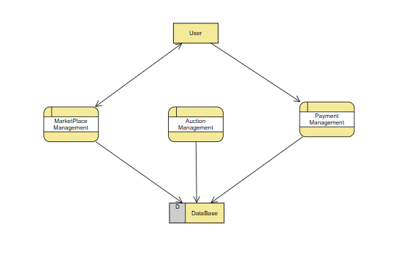

2.3 User Classes and Characteristics

Guest Users
Guests can browse listings across all three pillars but cannot perform transactions. They are not required to authenticate.
Verified Users
Users who complete fake card verification gain access to listing and request functionalities. Verification ensures accountability and prevents anonymous abuse of the system.
Sellers
Any verified user with an active listing is considered a seller. Sellers can manage requests, start auctions, and accept or reject exchanges.

2.4 Operating Environment
BooksBridge
Frontend Environment:
- Desktop-first responsive interface.
- Compatible with Chrome, Firefox, and Safari.
Backend Environment:
- Supabase managed PostgreSQL database.
- Realtime event triggering using Supabase Realtime and Upstash Qstash for auction updates.
Hosting Environment:
- Deployed on Vercel.

2.5 Design and Implementation Constraints
The system must adhere to the following constraints:
- Supabase Row Level Security (RLS) must be enabled.
- Auction logic must use real-time subscriptions.
- Auction timer resets to 30 seconds upon each valid bid.
- Free bid increments must be supported (no fixed increment).

- Mystery images must use CSS-based blur overlay.
- Atomic swaps must occur within a single database transaction.

2.6 User Documentation
No additional in-app documentation is included in the current version.

2.7 Assumptions and Dependencies
- Supabase services remain operational.
- No external payment gateway integration is required.

3. External Interface Requirements
3.1 User Interfaces
The user interface is designed as a desktop-first, grid-based layout with responsive scaling for mobile devices.
The main navigation consists of:
- Marketplace
- Exchange Zone
- Mystery Room
- Profile
- Seller Dashboard

Each feed displays book cards containing image, title, author, owner, and action buttons.
The Auction Room interface includes:
- Real-time countdown timer.
- Live bid history.
- Bid input field.
- Flame icon indicator when auction is active.
The Mystery Room displays blurred book covers using CSS filters until ownership transfer occurs.

FIGMA DESIGN

- Home

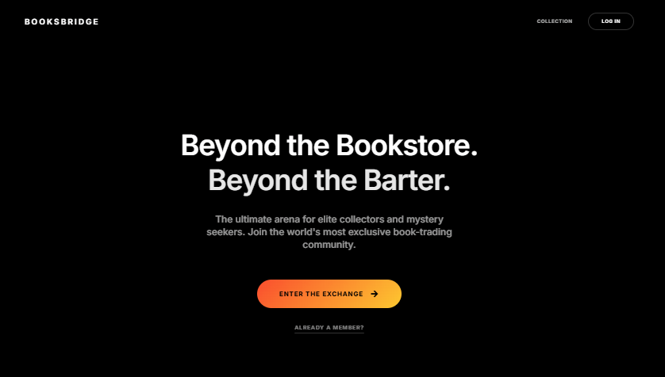

- Login

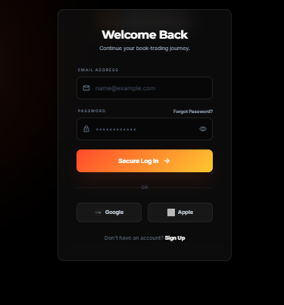

- Sign Up
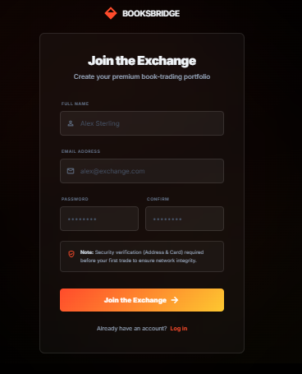

- User Profile
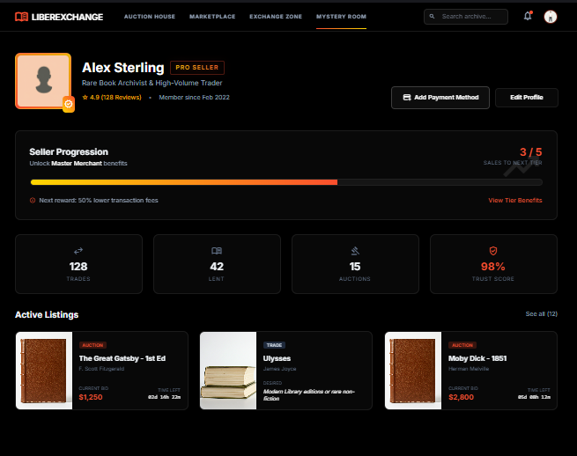

- User Details
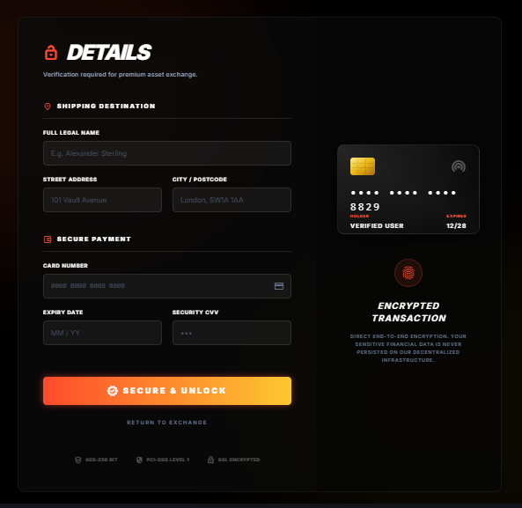

- Marketplace Screen

- Auction House

- Live Auction Screen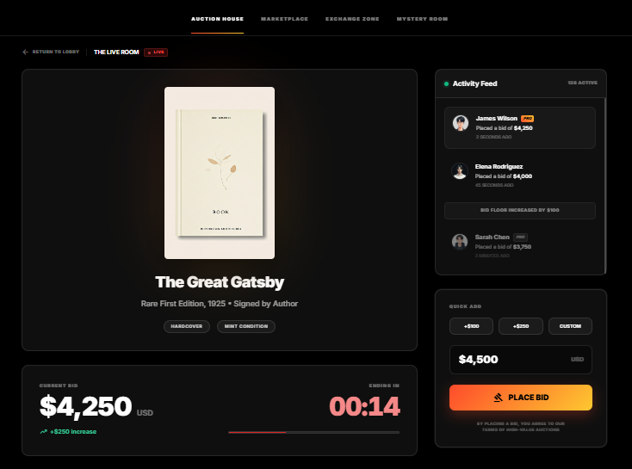

- Exchange Screen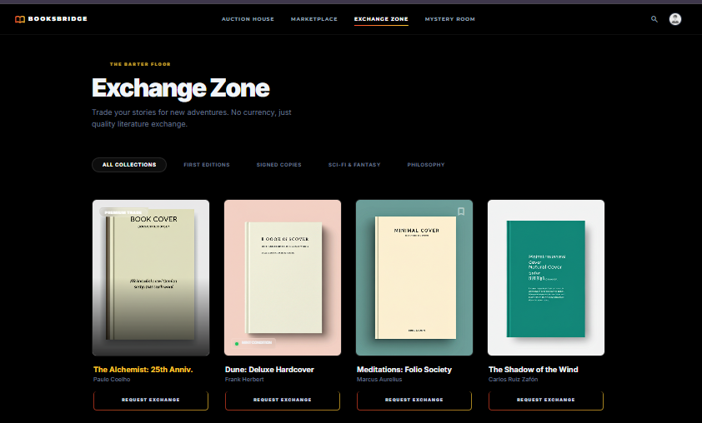

- Mystery Room Screen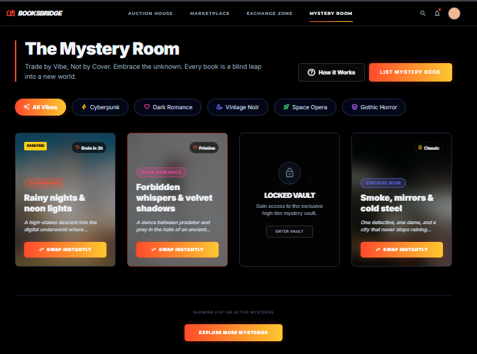

3.2 Hardware Interfaces
The system requires no specialized hardware beyond a device capable of running a modern web browser.

3.3 Software Interfaces
The system interfaces with:
- Supabase Authentication
- Supabase Storage
- Supabase Realtime & Upstash Qstash
- PostgreSQL database

3.4 Communications Interfaces
Communication occurs over HTTPS.
Realtime auction updates use secure WebSocket connections.

4. System Features
Each feature is elaborated below with contextual description and formal requirements.

4.1 Authentication & Verification
- REQ-F-1: The system shall allow users to register using email and password.
- REQ-F-2: The system shall allow registered users to log in using valid credentials.
- REQ-F-3: The system shall allow authenticated users to log out.
- REQ-F-5: The system shall require users to provide fake card information before sending a Request to Buy in the marketplace.
- REQ-F-7: The system shall allow users to update their profile information.

4.2 Marketplace (Sell System)
- REQ-F-8: The system shall allow verified users to list a book for sale.
- REQ-F-9: The system shall allow sellers to upload a clear book image.
- REQ-F-10: The system shall allow sellers to set a monetary price.
- REQ-F-11: The system shall not provide instant checkout functionality.
- REQ-F-12: The system shall allow verified users to send a “Request to Buy” for a listed book.
- REQ-F-14: The system shall allow sellers to view all incoming requests.
- REQ-F-15: The system shall allow sellers to accept one buy request directly.

- REQ-F-16: The system shall allow sellers to initiate an auction if two or more requests exist.

4.3 Auction System
- REQ-F-17: The system shall create an auction record when initiated by the seller.
- REQ-F-18: The system shall initialize the auction with a duration of one minute.
- REQ-F-19: The system shall allow verified users to place bids during an active auction.
- REQ-F-20: The system shall require that each new bid be greater than the current highest bid.
- REQ-F-21: The system shall allow free bid increments (no minimum increment constraint).
- REQ-F-22: The system shall reset the auction timer to 30 seconds upon each valid bid.
- REQ-F-23: The system shall display real-time bid updates to all participants.
- REQ-F-24: The system shall declare the highest bidder as winner when the timer reaches zero.
- REQ-F-25: The system shall automatically transfer ownership of the book to the winning bidder.
- REQ-F-26: The system shall increment transaction counts for both buyer and seller upon auction completion.

4.4 Exchange Zone
- REQ-F-27: The system shall allow users to list books for exchange.
- REQ-F-28: The system shall allow users to send exchange requests.
- REQ-F-29: The system shall allow sellers to accept exchange requests.
- REQ-F-30: The system shall allow sellers to reject exchange requests.
- REQ-F-31: The system shall transfer book ownership upon exchange acceptance.
- REQ-F-32: The system shall increment transaction counts after exchange completion.

4.5 Mystery Room
- REQ-F-33: The system shall allow users to list books under the Mystery category.
- REQ-F-34: The system shall automatically apply a blur overlay to mystery book images.
- REQ-F-35: The system shall require that a user have an active mystery listing before initiating a swap.

- REQ-F-36: The system shall perform ownership exchange in a single atomic database transaction.
- REQ-F-37: The system shall reveal the unblurred image to the new owner after swap completion.
- REQ-F-38: The system shall increment transaction counts after swap completion.

5. Other Nonfunctional Requirements
Performance, security and business requirements are formally defined below:

5.1 Security Requirements
REQ-SEC-1: The system shall authenticate users before allowing transactional actions.
REQ-SEC-2: Only authenticated users shall list books.
REQ-SEC-3: Users shall only modify data they own (Row Level Security enforced).
REQ-SEC-4: All bid validation shall occur server-side.

REQ-SEC-5: Atomic swap transactions shall roll back entirely if any failure occurs.
REQ-SEC-6: Service role keys shall never be exposed client-side.
REQ-SEC-7: Communication shall occur over HTTPS.
REQ-SEC-8: Passwords shall be handled by Supabase authentication service.

5.2 Business Rules

REQ-BR-1: A book may belong to only one trading category.
REQ-BR-2: Auction may only start if at least two requests exist.
REQ-BR-3: A bid must exceed the current highest bid.
REQ-BR-4: Mystery swaps are irreversible.
REQ-BR-5: Transaction count shall increase only after ownership transfer is confirmed.
REQ-BR-6: A user cannot request their own book.

5.3 Performance Requirements

REQ-NF-1: System shall load main feed within 3 seconds under normal load.
REQ-NF-2: Auction bid update latency shall not exceed 2 seconds.
REQ-NF-3: System shall support 100 concurrent bidders per auction.
REQ-NF-4: System shall support at least 1000 registered users.
Appendix A – Glossary
Document Conventions & Requirement Identifiers
The document categorizes requirements using these specific prefixes:
- REQ-F-#: Functional Requirements.
- REQ-NF-#: Nonfunctional Requirements.
- REQ-SEC-#: Security Requirements.
- REQ-BR-#: Business Rules.

Key Terms and Definitions
The document defines several core concepts and user classes for the platform:
- BooksBridge: An interactive web-based book trading platform facilitating auctions, direct barters, and blind swaps.
- Mystery Room: A system for performing "blind swaps" using atomic exchange logic where book covers are blurred until the transaction is complete.
- Exchange Zone: A dedicated area for users to list books for direct barter/exchange.
- Guest Users: Unauthenticated users who can browse listings but cannot perform transactions.
- Verified Users: Users who have provided fake card information, enabling them to send purchase requests in the marketplace.
- Sellers: Verified users with active book listings who manage requests and auctions.
- Atomic Swap: A transaction where book ownership is transferred in a single database operation that must either fully succeed or fail entirely.
- Fake Card: A simulated verification step used to establish user accountability without processing real financial transactions.

Appendix B – Analysis Models

B.1 Use Case Diagrams

- Authentication Use Case Diagram 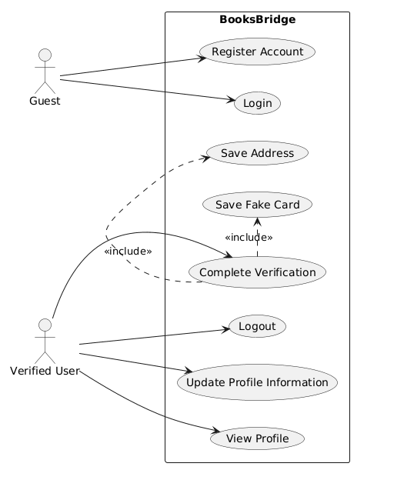

- Marketplace Use Case Diagram
- 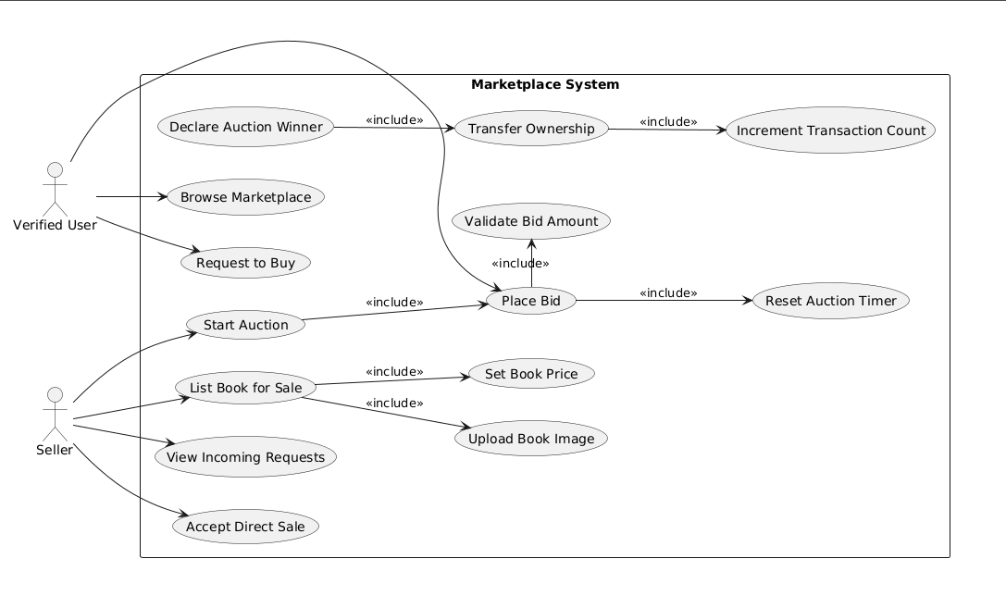

- Exchange Zone Use Case Diagram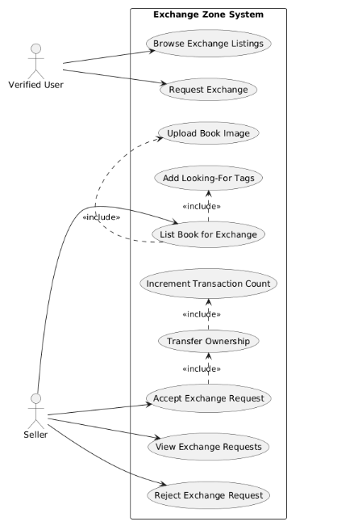

- Mystery Room Use Case Diagram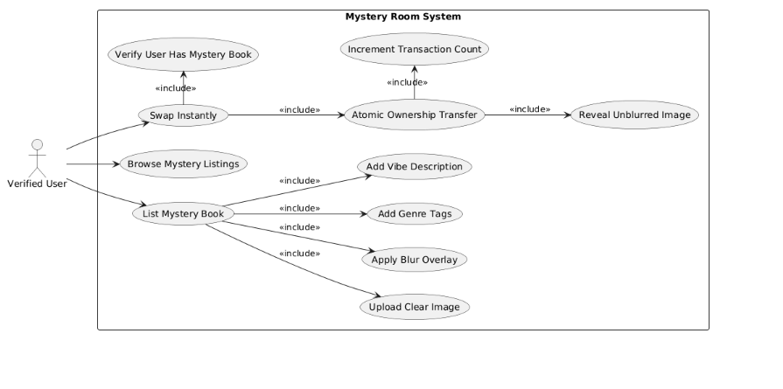

B.2 Class Diagram
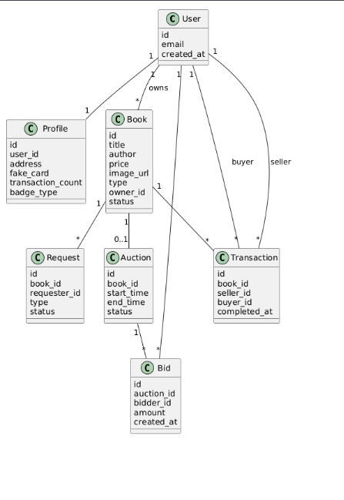

B.3 Data Flow Diagrams