# Deloitte Screens

## 000-Mobile Pre-Qualify Loader

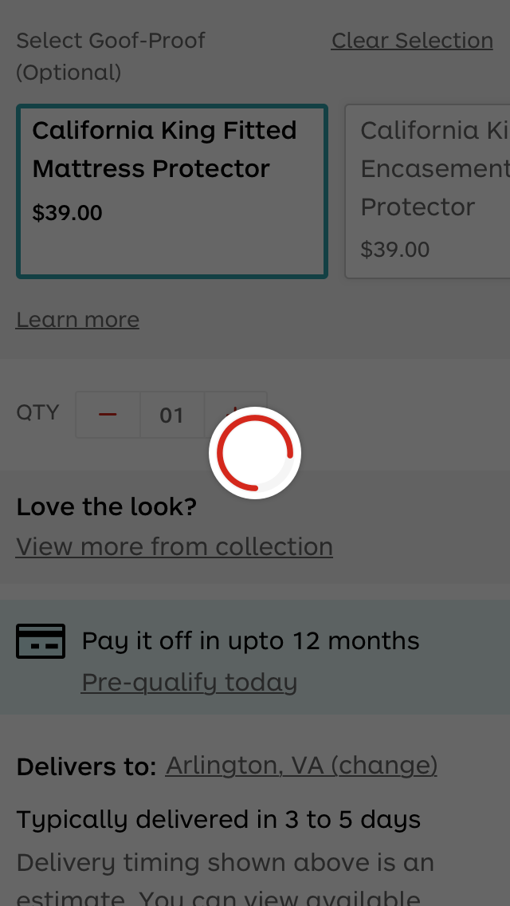

### Colors

#ffffff

#666666

#d4281c

#f5f5f5

#ceeef0

#000000

## 001-Mobile Pre-Qualify

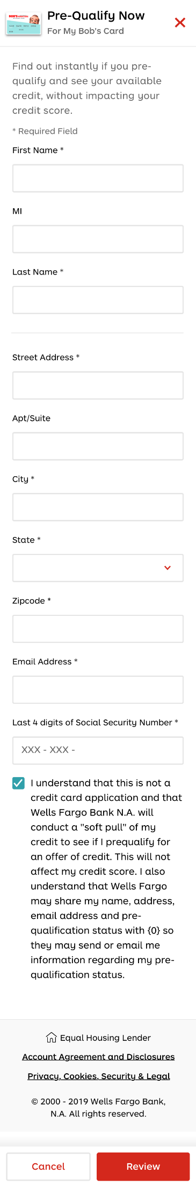

### Colors:

#ffffff

rgba(0, 0, 0, 0)

#000000

#d4281c

#666666

#31a0aa

#f9f9f9

#e8e8e8

### 002-Pre-Qualify Now

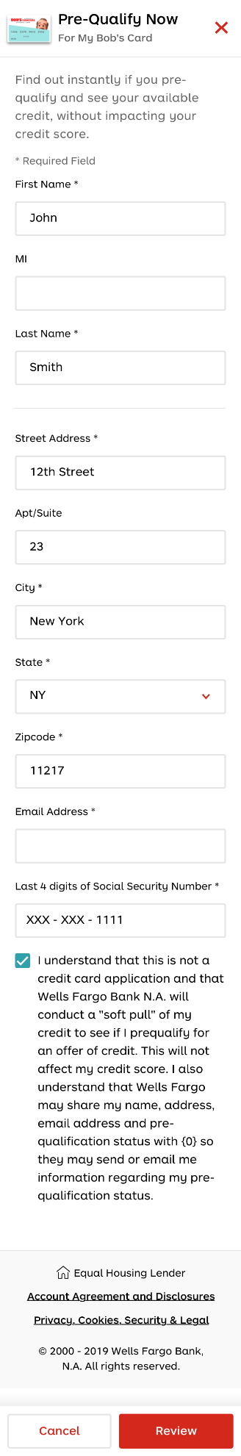

### Colors

#ffffff

rgba(0, 0, 0, 0)

#000000

#d4281c

#666666

#31a0aa

#f9f9f9

#e8e8e8

## 003-Mobile-Prequalify-formError

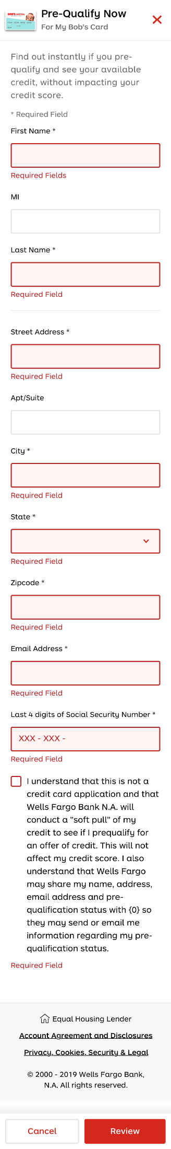

### Colors

#ffffff

rgba(0, 0, 0, 0)

#000000

#d4281c

#666666

#fef4f4

#b82323

#f9f9f9

#e8e8e8

### 004-Mobile-Prequalify-Review - Financing Options

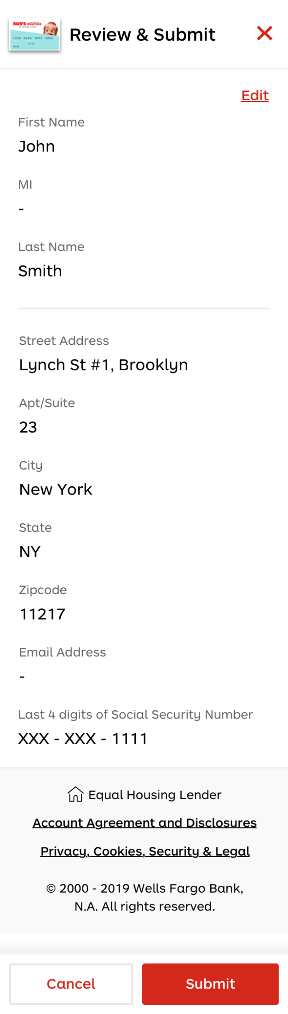

## 005-Prequalify Approved

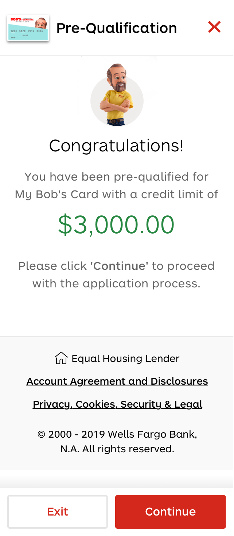

### Colors

#ffffff

rgba(0, 0, 0, 0)

#000000

#d4281c

#666666

#268740

#f9f9f9

#f0eeed

#e8e8e8

## 006-Desktop Prequalify Declined

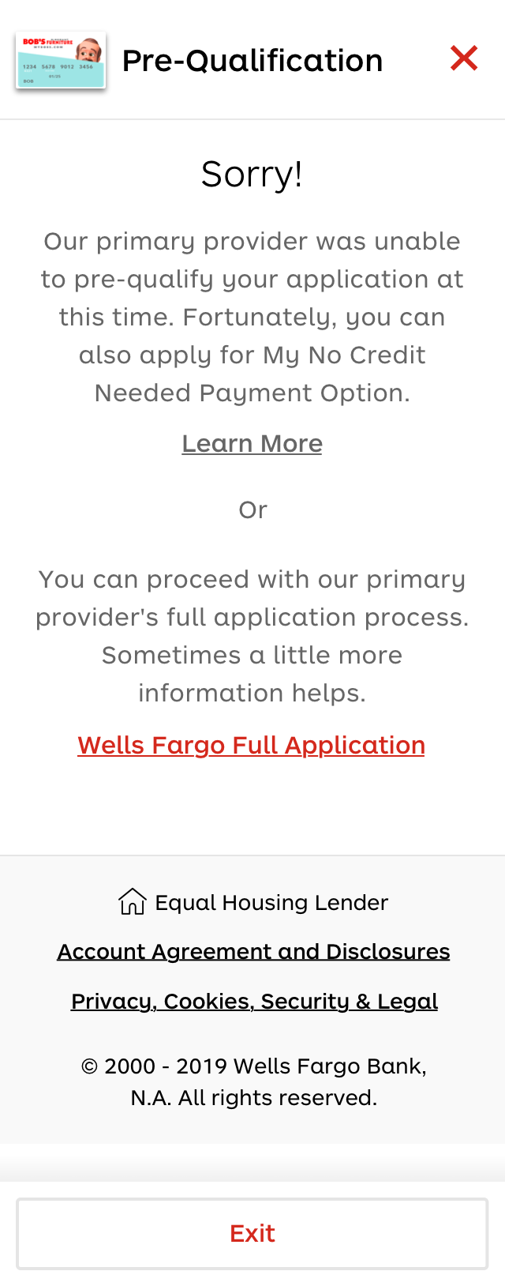

### Colors

#ffffff

#000000

#666666

#d4281c

#f9f9f9

rgba(0, 0, 0, 0)

#e8e8e8

## 000-Desktop Prequalify Loader

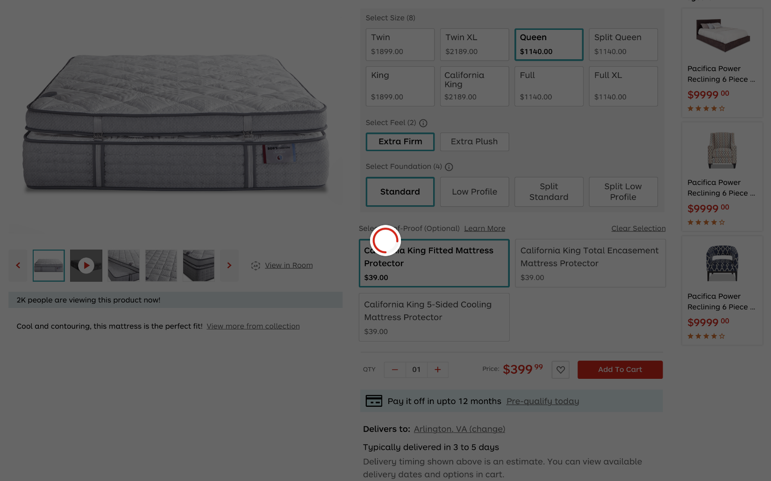

### Colors

#ffffff

#f5f5f5

#e1ebef

#000000

#d4281c

#666666

#414141

#d77735

#ceeef0

## 001-Desktop-Prequalify

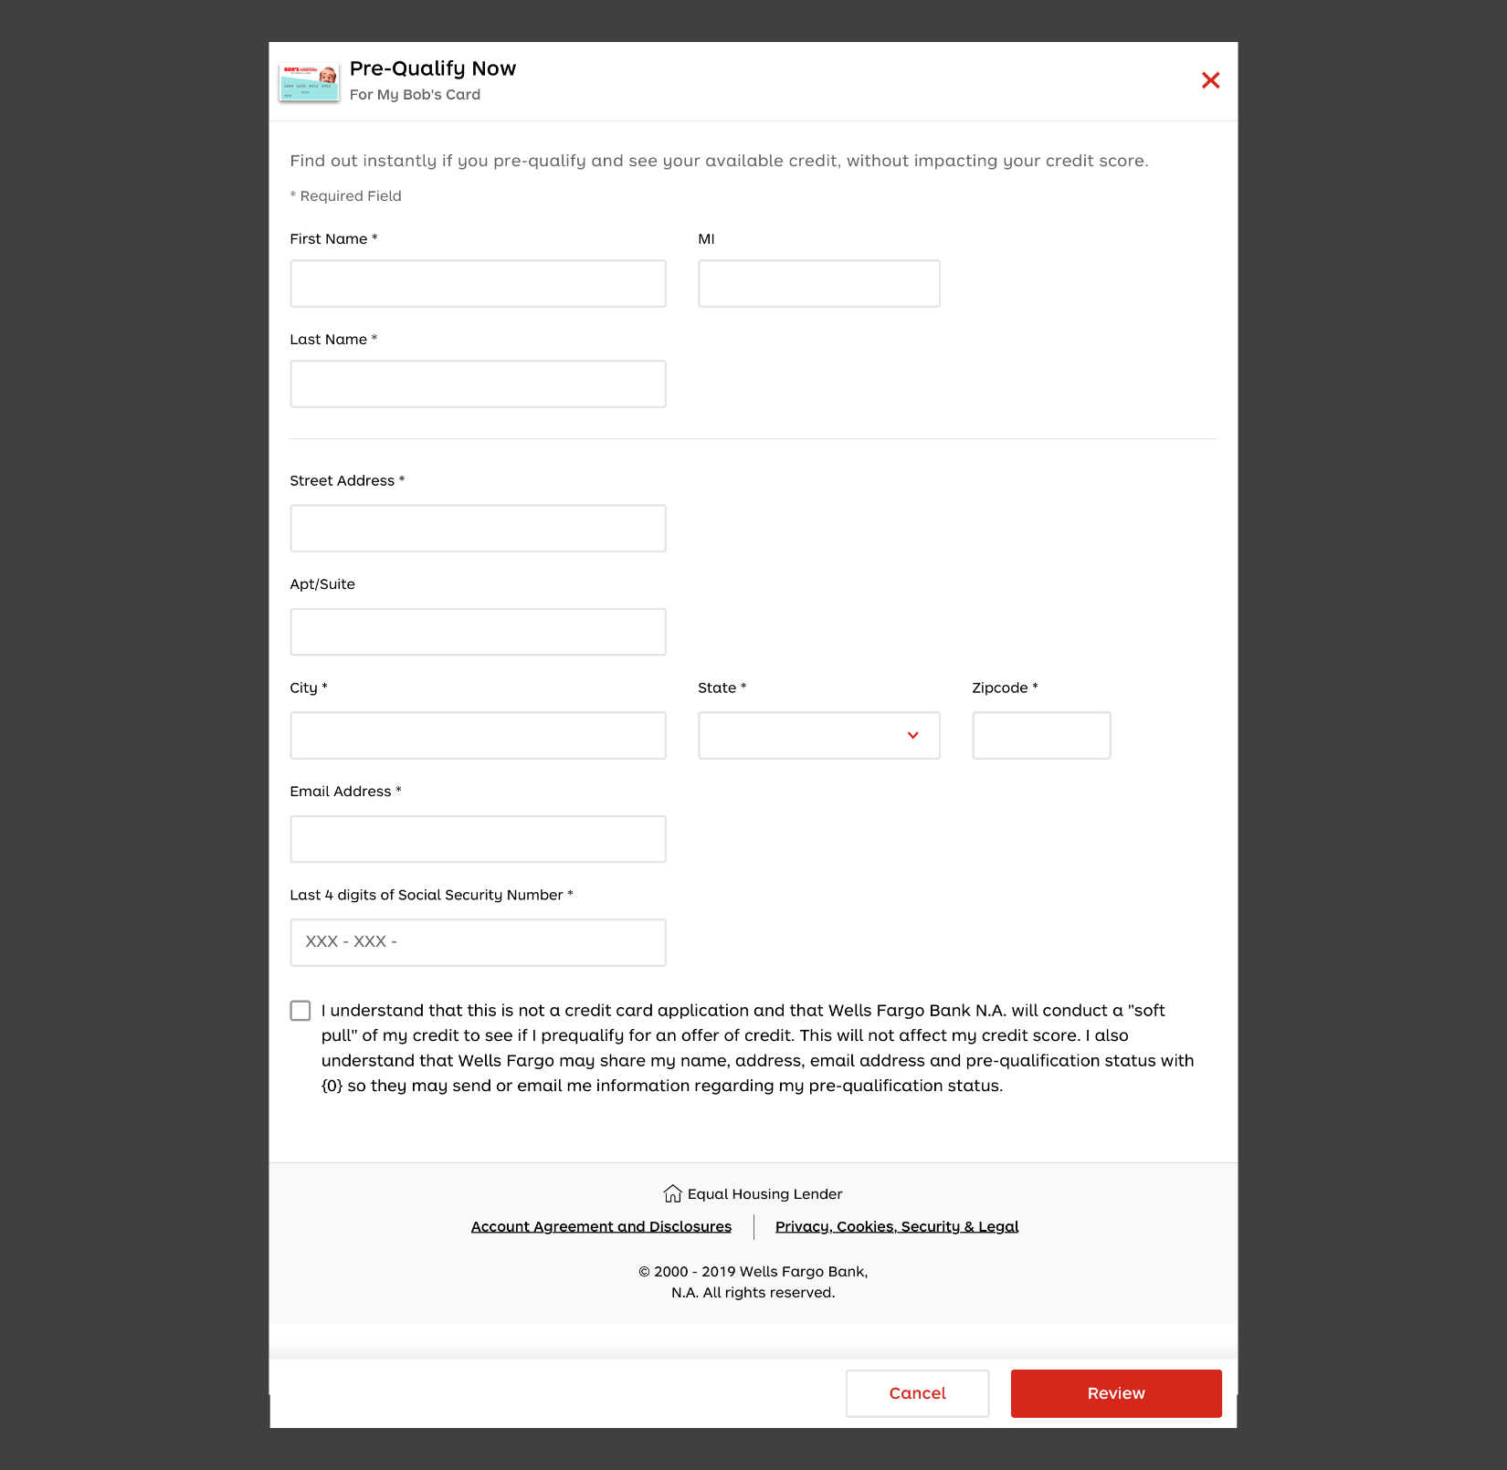

### Colors

#ffffff

#000000

#d4281c

#666666

#e8e8e8

rgba(0, 0, 0, 0)

#f9f9f9

## 002-Desktop-Prequalify

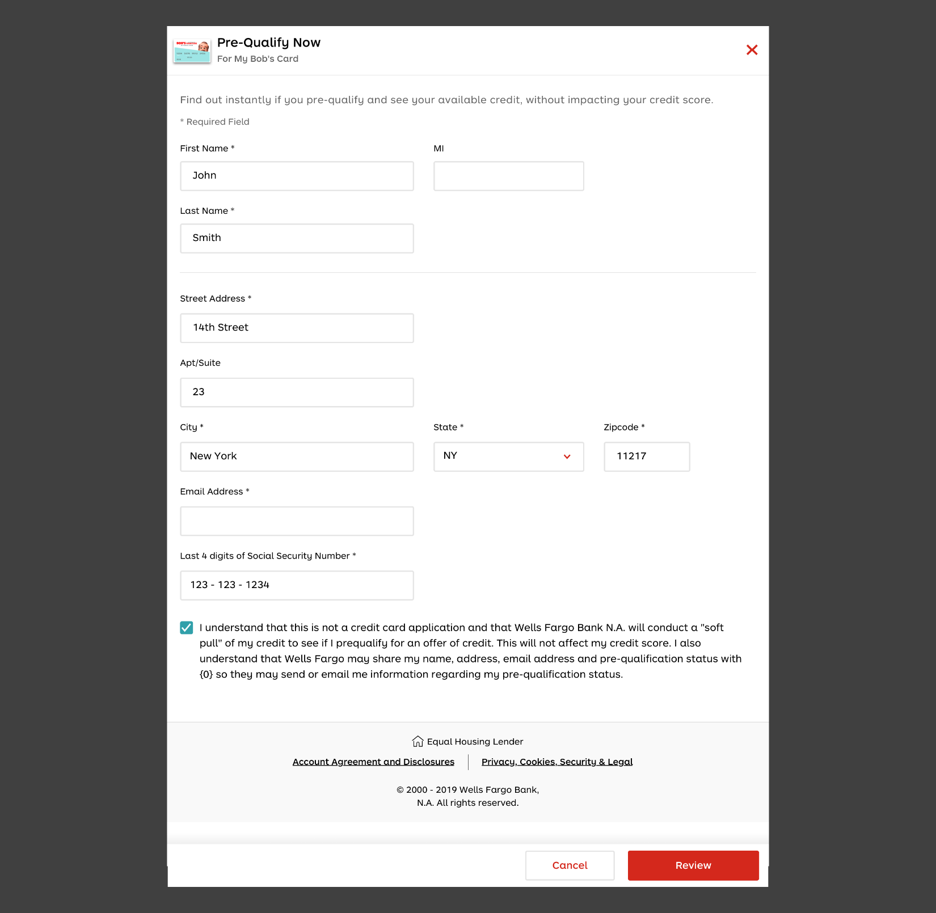

### Colors

#ffffff

#000000

#d4281c

#666666

#e8e8e8

rgba(0, 0, 0, 0)

#f9f9f9

#31a0aa

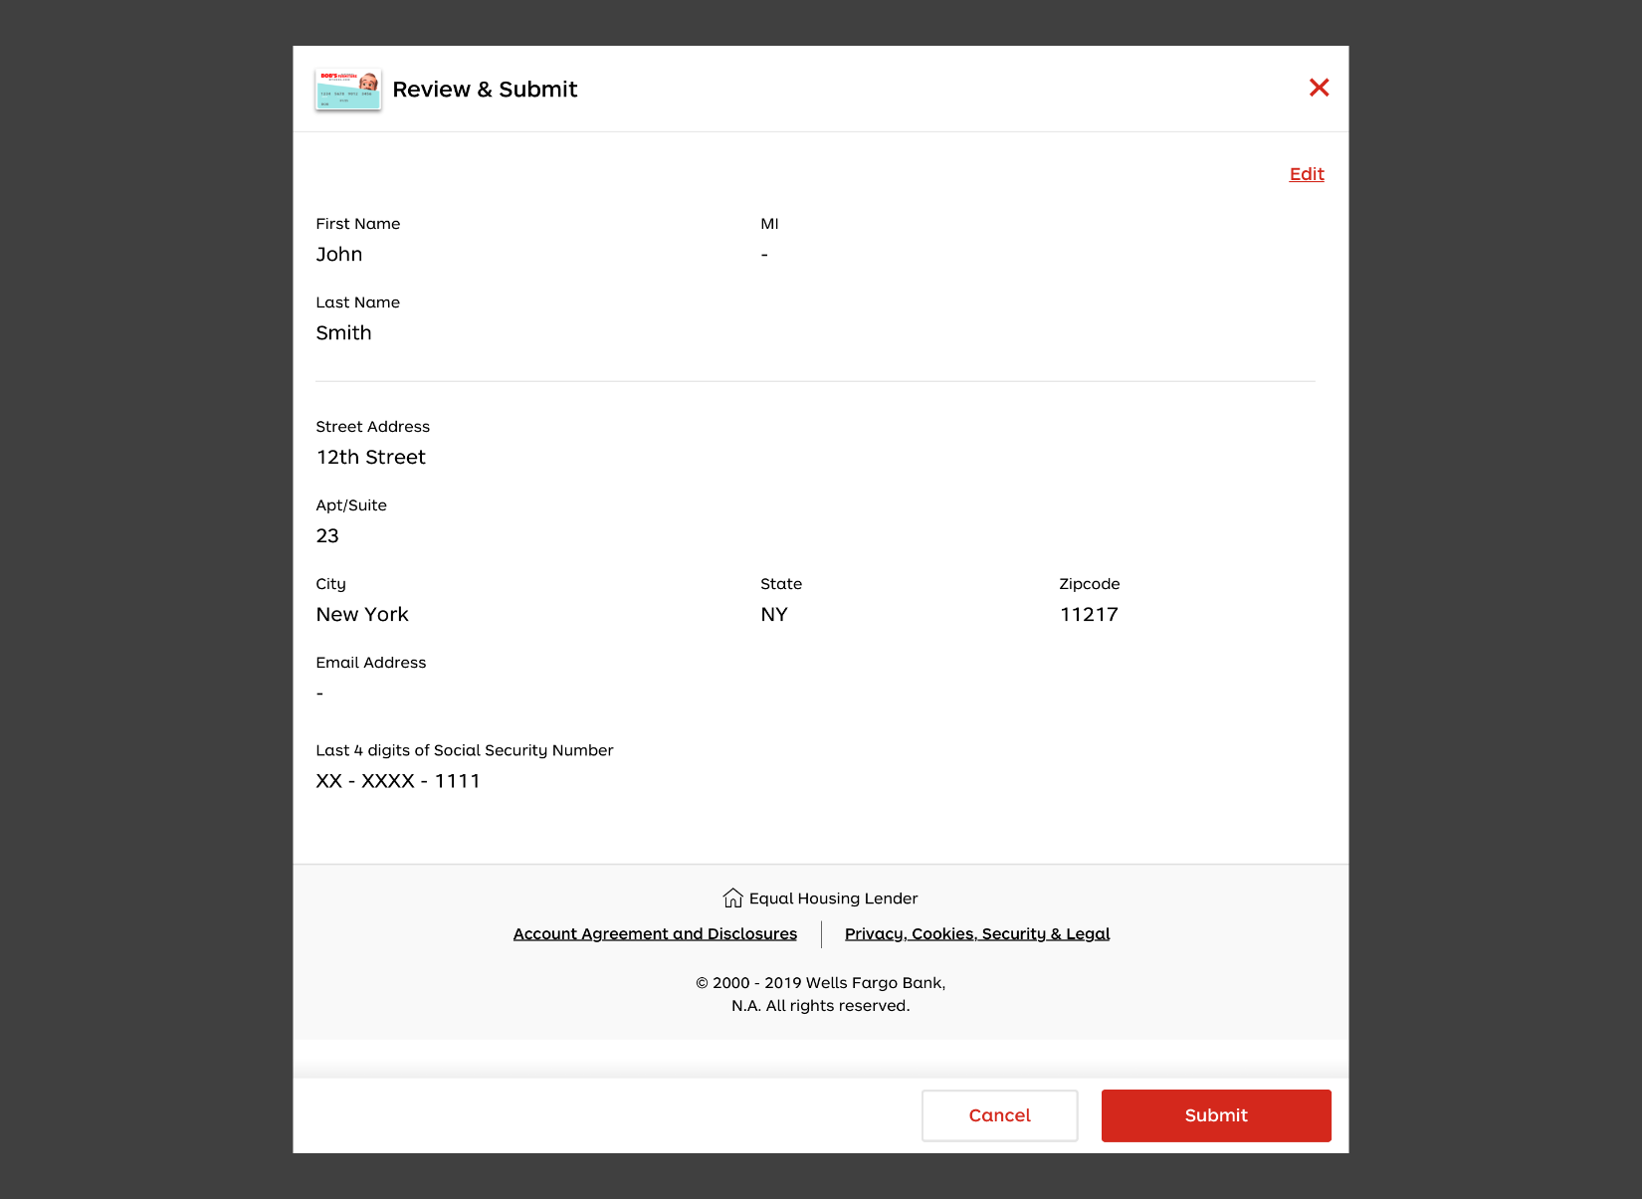

### Colors

#ffffff

#000000

#d4281c

#e8e8e8

#f9f9f9

#666666

rgba(0, 0, 0, 0)

## 004-Desktop-Prequalify Approved

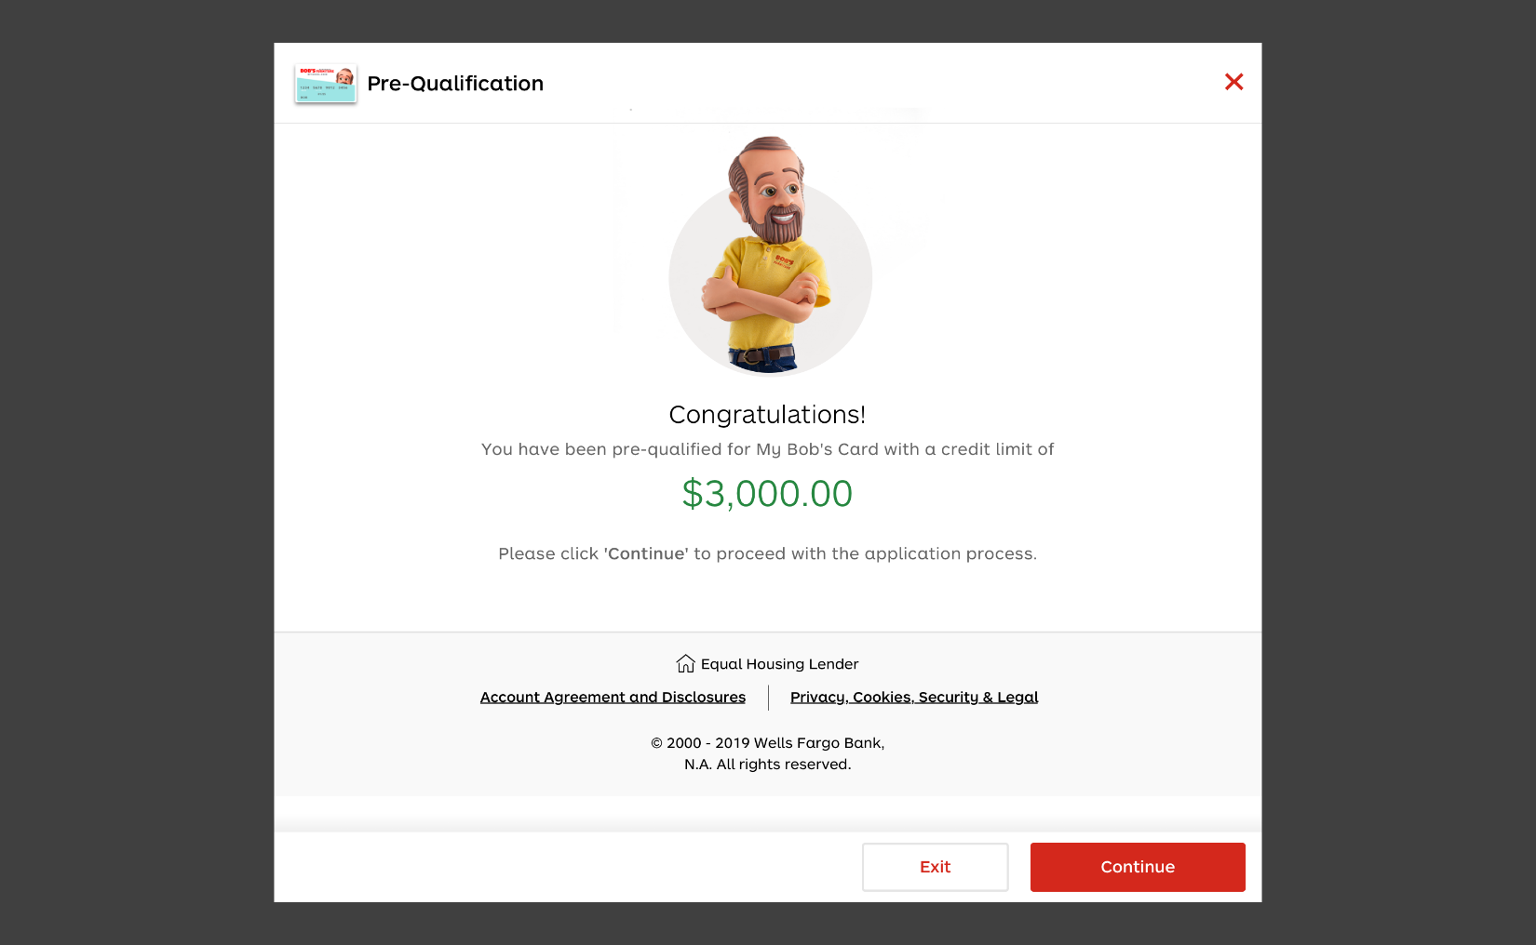

### Colors

#ffffff

#000000

#666666

#f9f9f9

#268740

#f0eeed

rgba(0, 0, 0, 0)

#d4281c

#e8e8e8

## 005-Desktop-Prequalify Declined

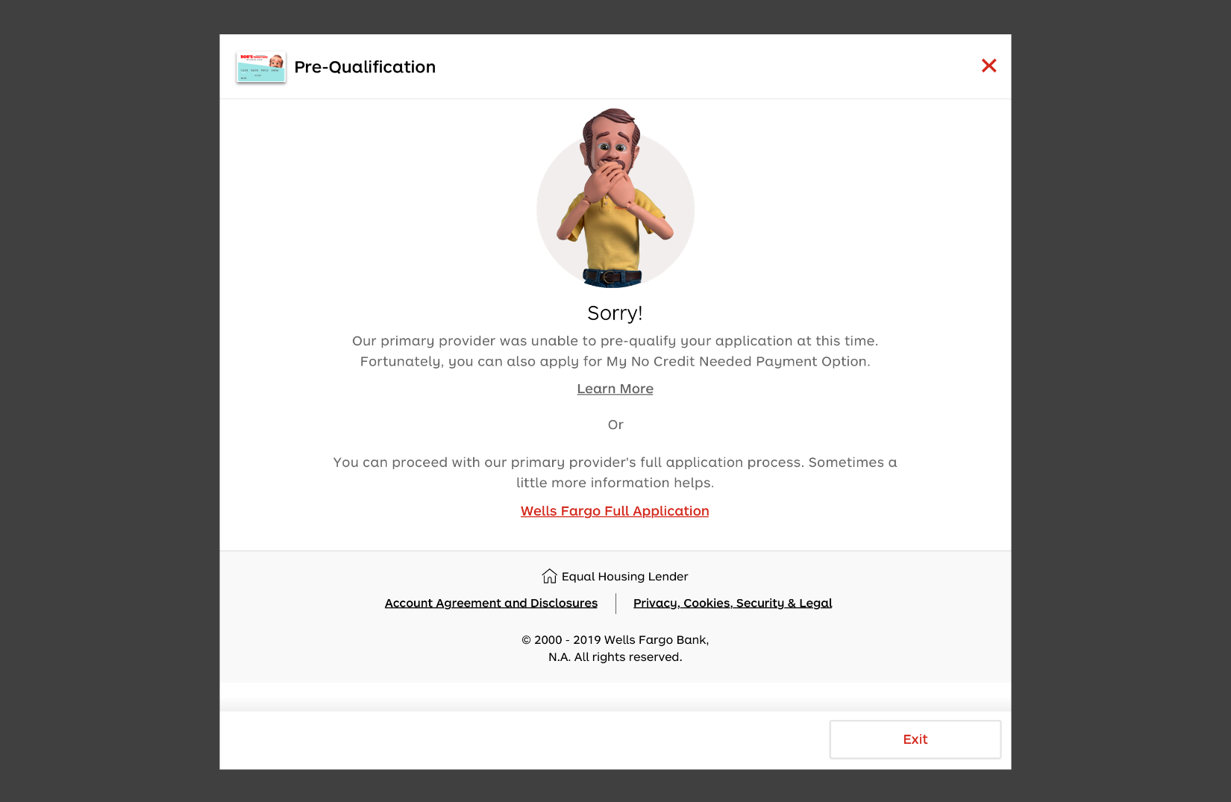

### Colors

#ffffff

#000000

#666666

#d4281c

#f9f9f9

rgba(0, 0, 0, 0)

#e8e8e8

## 002.1-Desktop-Prequalify-formError

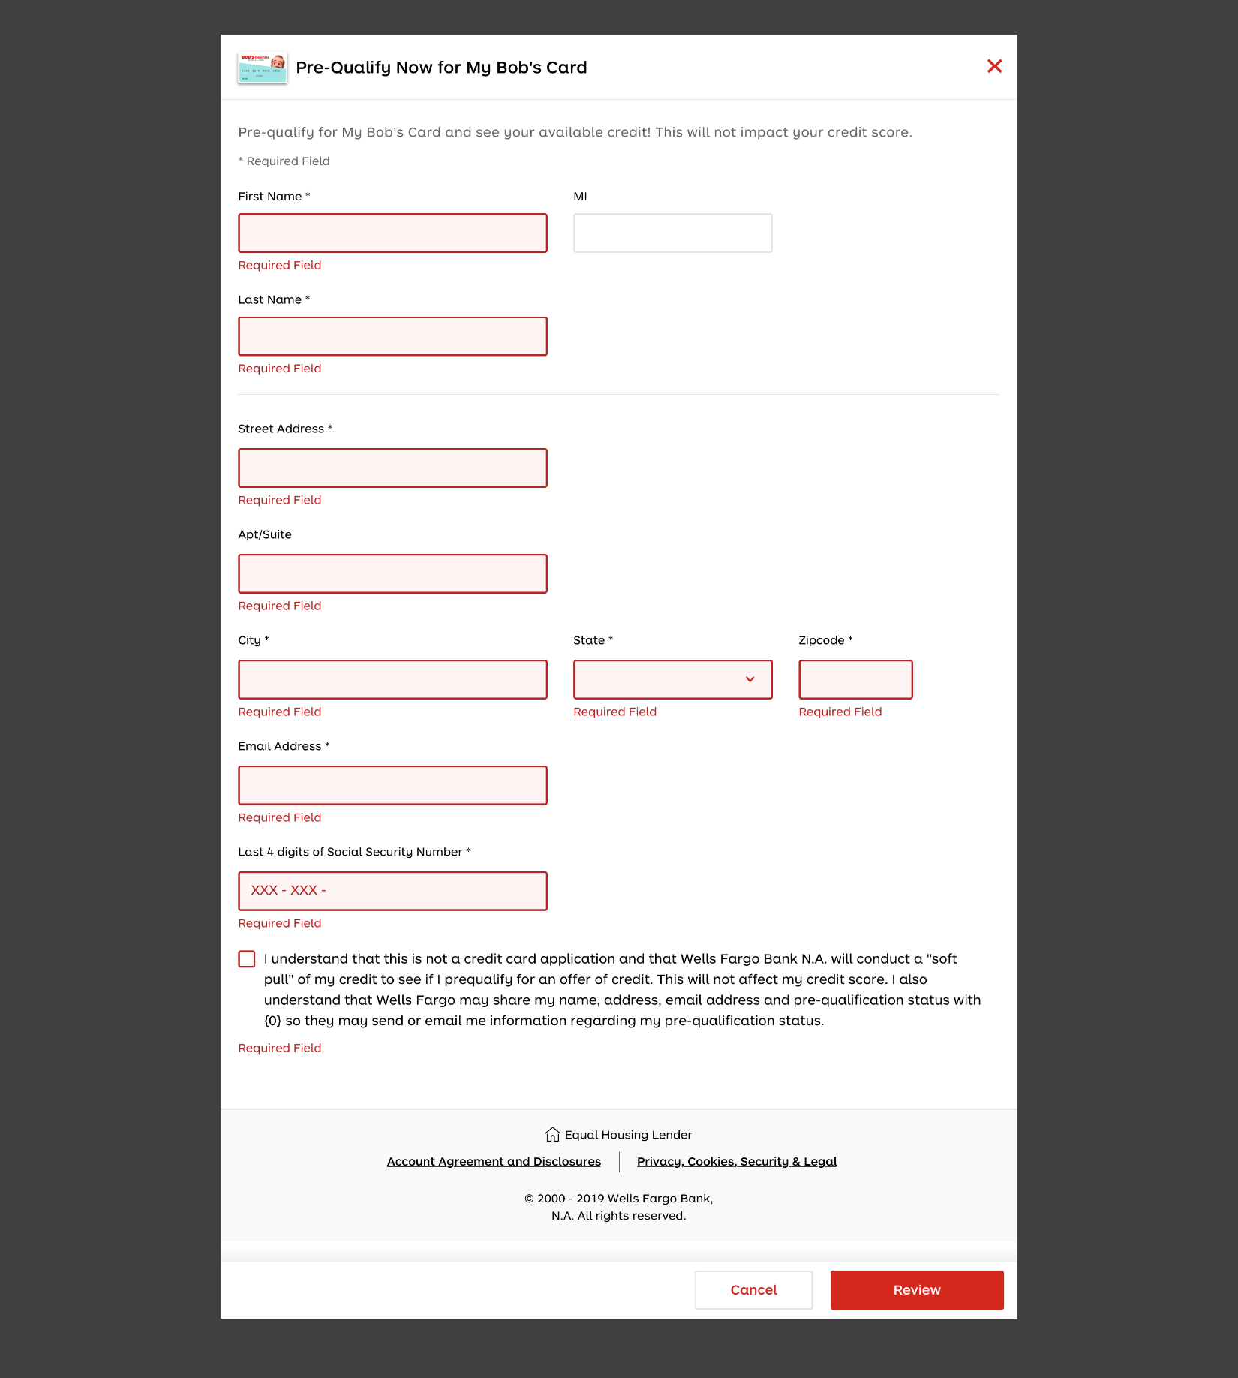

### Colors

#ffffff

#000000

#b82323

#f9f9f9

#666666

#fef4f4

rgba(0, 0, 0, 0)

#d4281c

#e8e8e8