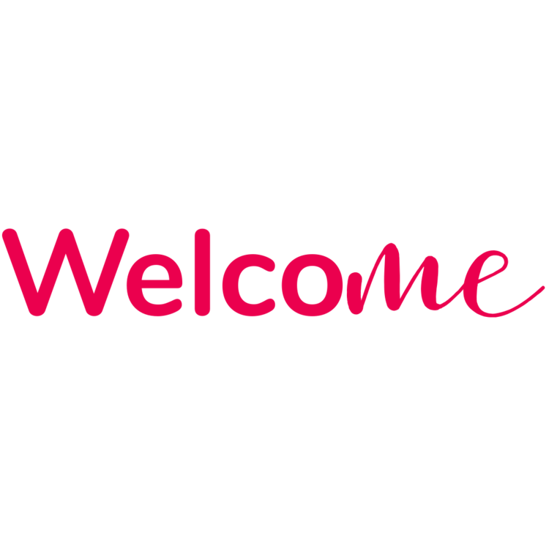

**helps to deliver excellent customer service to your disabled visitors**

[Try it now](https://www.wel-co.me/pricing)

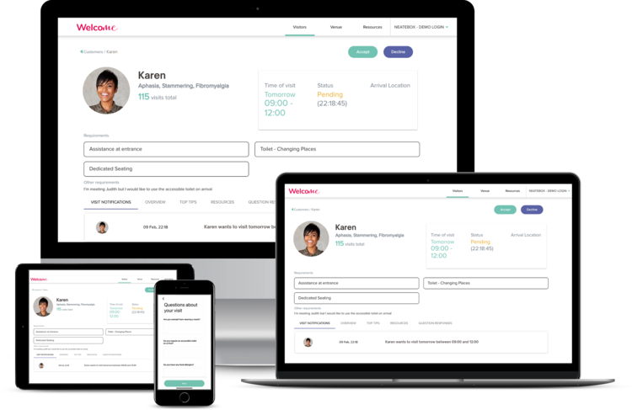

**The evolution of face-to-face communication**



**Cloud-Based Platform**

Welco*Me* is a cloud-based customer service platform solution that enables disabled visitors to plan assistance in advance of arriving at a venue.

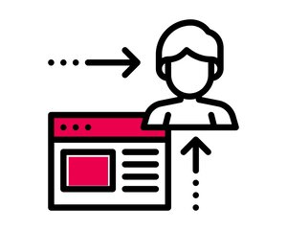

**Visitor Management**

Enables you to manage, understand and assist your disabled and vulnerable customers as per their requirements and needs.

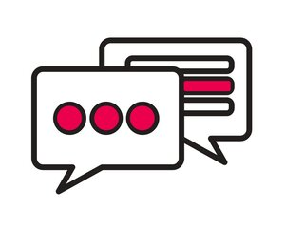

**Communication Tool**

Direct communication improving the relationship between the staff and the visitor and builds a foundation for a future visits.



**Inclusive Service**

Promotes inclusion and equality at its core and recognises that all parties need support and prepared for your visitor’s arrival.

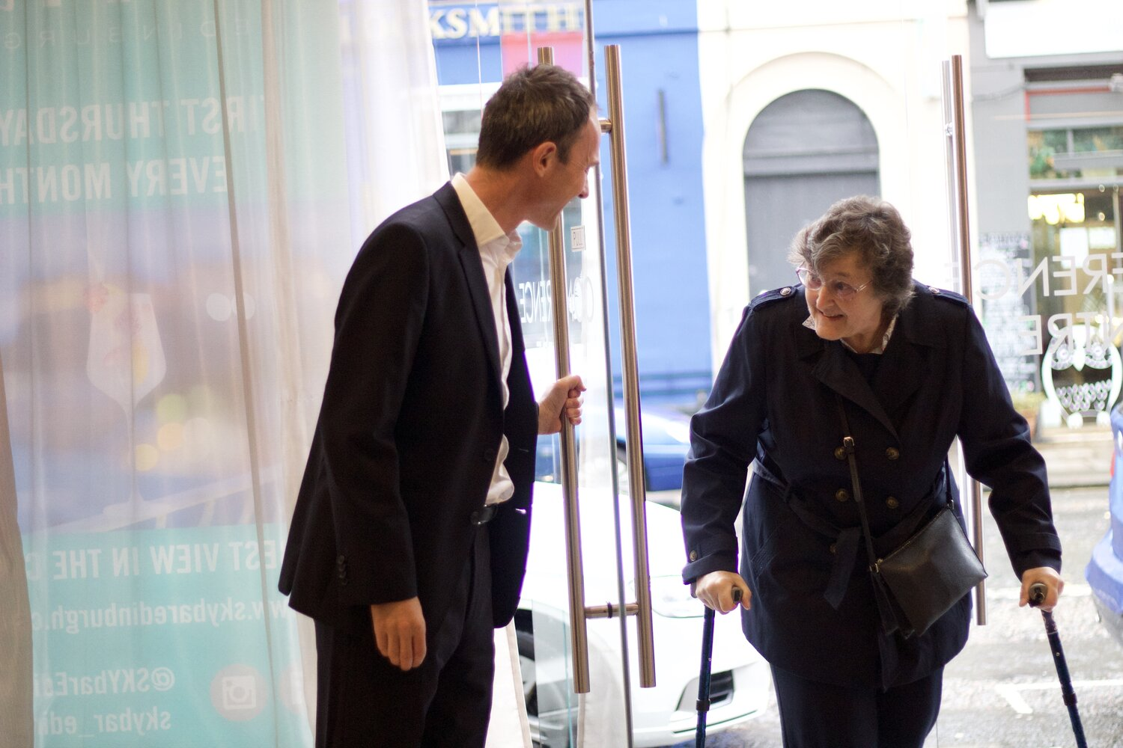

**Cement your position as a pioneer in the campaign for disabled people’s inclusion during COVID-19**

***“I have been using the WelcoMe App throughout lockdown, I love how confident it makes me feel - even in venues I haven’t visited before”***

**Elizabeth, East Lothian**

**How can Welco*Me* help?**

**Make your customer service exceptional**

WelcoMe improves the overall experience by enabling your disabled visitors to communicate their needs and requirements in advance of arriving at a venue.

**Raise your staff’s confidence around accessibility**

WelcoMe empowers your staff to deliver excellent customer service. The platform enables you to seamlessly manage, understand and assist your disabled customers.

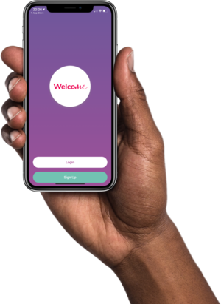

**Provide immediate training**

Welco*Me* provides in the moment accessibility training, hints and tips to your staff on how best to support your disabled visitors and customers.

**Know your customers before they walk through the door**

The platform is simple to use, helps you understand who your disabled visitors are and provides real-time support to your customer service staff before your visitors’ arrival.

**Watch the video or book a demo to learn more**

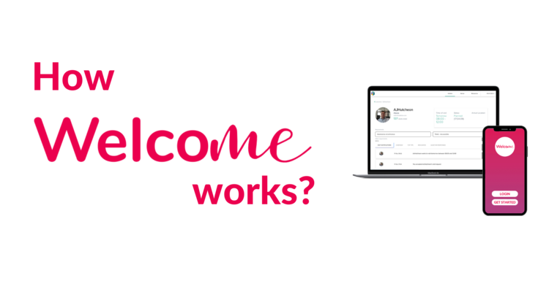

Book a demo

**Don’t let poor customer service ruin your reputation**

£30/mo

plus £49 Onboarding Fee

[More Info](https://www.wel-co.me/pricing)

[Try it Now](https://welcome.neatebox.com/venue-onboard/)

**Venues where you can find a warm Welco*Me***



**Scottish Parliament**

*“We are proud to be recognised as a five-star visitor attraction in Scotland and we are always looking at new ways to ensure that everyone, regardless of their needs, can visit Holyrood and have a positive experience. “Welcome” app which will enable us to respond quickly and effectively to the needs of our visitors who need additional assistance”*

**Ken Macintosh MSP** - Presiding Officer

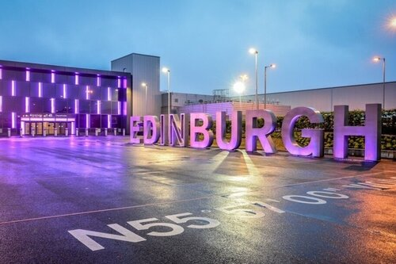

**Edinburgh Airport**

*“With over 80,000 people who could use this service travelling through Edinburgh Airport every year, many of them with “hidden” disabilities, we could not be in a better position to demonstrate this amazing service to the greatest number of people. We hope by doing so, we can promote Scotland as being the epicentre of this innovation”*

**GORDON DEWAR -** Chief Executive of Edinburgh Airport

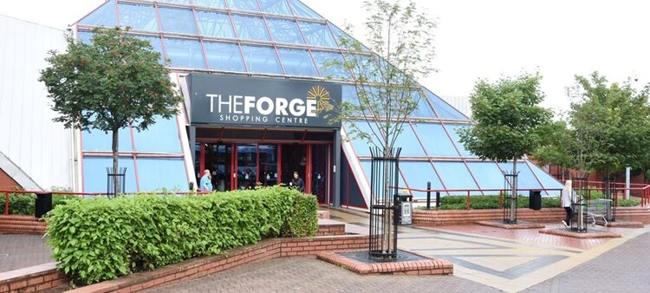

**The Forge**

*“We care about our customers, so we are delighted to announce that we the first shopping centre in the world on WelcoMe App, so we can provide even better customer service to all our disabled customers whether their condition is visible or hidden. Being inclusive and accessible is really important to us and it will help us give the best service possible”*

**PAUL WISHART -** Centre Manager

**Get started today**

**If you're ready to start providing a more accessible and inclusive customer service for all your visitors**