# Creating Accessible Microsoft Word Forms the DARS Way

Contents

Creating Accessible Microsoft Word Forms the DARS Way 1

Introduction 2

Form Specifications 2

File Type 2

Zoom Level 2

Display Spaces and Paragraph Marks 2

Form Margins 3

Table Layout 3

Borders 4

Row Height 5

Headers 6

Top Row 6

Section Headings and Subheadings 10

Footer 11

Instructions 11

Creating Form Inputs 12

Legacy Form Tools 12

Form Field Help Prompts 13

Steps in Creating Sample Form 14

Using Macros 20

Setting up Word for Macro Use 20

Macro: Do Spell Check on Help Text 22

Macro: Do Search and Replace on Help Text 25

Macro: Add Bookmarks to Help Text Fields 26

Clean up 26

Protecting the Form 26

Simple Form Test 27

Summary 27

## Introduction

This module covers how to create accessible Microsoft Word forms using DARS style and accessibility guidelines. The general strategy is to create a table and populate the form with logo, form name, and text inputs. After that, you need to add help text to the form field inputs. After designing the form, you must lock it, which will allow users to tab through the input fields. This method consistently works with all tested assistive technologies.

Cautionary notes to those who frequently create forms using Word:

* Form fields created using ActiveX Controls and Content Controls do not work properly with current assistive technology. Rely on Legacy Tool text form fields.
* ZoomText does not always track Word checkboxes.
* It can be difficult to design forms using columns where the tab order is correct.
* Radio buttons or other form elements may not work correctly with various assistive technologies. If these fields are needed, you may need to design the form as a PDF using Adobe LiveCycle Designer.

## Form Specifications

### File Type

DARS forms should have the “.doc” extension. By default, if you create a new document, it will be have a “.docx” extension. To get around this, create a new blank document and under File, Save As, choose “Word 97-2003 Document (*.doc).” This is to ensure the file is compatible with older versions of Microsoft Word. It is also important to remember that these forms will probably not be fillable or accessible for people using other word processing programs.

### Zoom Level

Set the magnification level to 100%. Microsoft Word will open the file at this zoom level if it is the last zoom level you used when you last worked on the document. This ensures a consistent experience for all users.

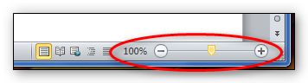

### Display Spaces and Paragraph Marks

As a visual design check, turn on the show spaces and paragraph marks by clicking on **Show All** on the **Productivity tab.**

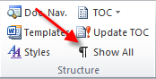

### Form Margins

From the **Page Layout Tab**, go to **Page Setup**, and select **Margins** or **Custom Margins,** then select **Narrow**. You may adjust Header and Footer margins if necessary.

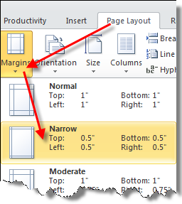

### Table Layout

From the **Productivity Tab**, select **Table**, and then choose **Insert Table** and select the row and column dimensions of the table you want. By default, start with a table that is 1 column wide by 16 rows deep. If the table does not open to the edge of the page margins, highlight the table’s rows, right click on them, then select **Autofit**, then **Autofit to Window**.

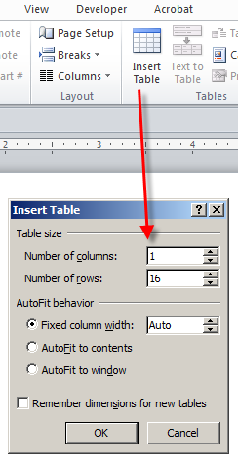

### Borders

By default, a table created using the instructions above should have a 1/2 point border, as will all the cells contained within it. This meets DARS style guidelines and is sufficient to distinguish the form’s rows. People who are partially sighted can use these borders as a visual queue. If for some reason, the form’s table doesn’t have borders, select the table or cells, right click, and select **Table Properties**, then **Borders and Shading**.

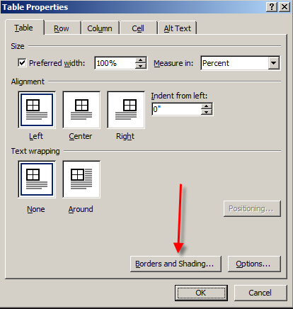

Under the **Borders tab**, select the following if they are not already set this way

* Setting: All
* Width: ½ point
* Apply to: Table

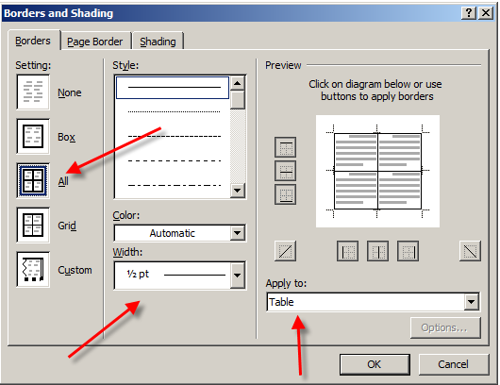

### Row Height

In **Table Properties**, select the **Row** tab. Set **Height** to **At Least**, to allow for row expansion when responses are entered.

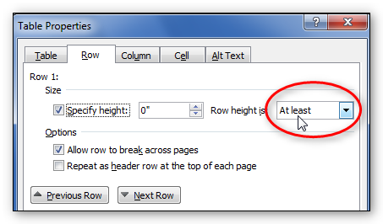

### Headers

Do not use page headers. It is difficult for screenreaders to read the content. When necessary, you may use repeating table headers.

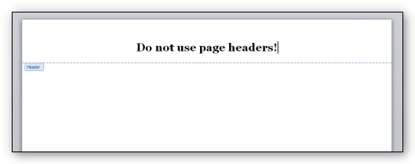

### Top Row

Start by splitting the top row into two columns. With cursor in the top row, right click, select **Split Cells**, then select 2 columns and 1 row. Define this top table row so there isn’t a border between these two columns. Highlight the first row, right click, and then select **Borders and Shading**. Under the **Borders** setting, select **Setting: None**, deselect the border between the columns, then under **Apply to: Cell**.

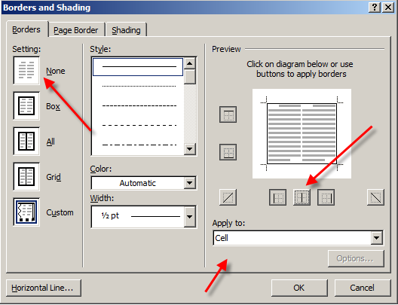

Place the DARS logo in the upper left column. You can copy it from an existing form or from the **Productivity tab**, click on **Picture icon** and navigate to the location of the logo picture. Enter the following as alternative text for the DARS logo: Logo, Texas Department of Assistive and Rehabilitative Services.

If the form is for the whole agency (DARS-wide), spell out the agency’s name on the first line of the right column, followed by the name of the form on the next line. If the form is for a specific division, spell out the division’s name on the first line of the right column, followed by the form title on the next line. Text on the first line of the right column is 12-point Arial Bold, and text on the second line is 16-point Arial Bold.



The logo should be aligned left and the text on both lines should be centered. Adjust the column width so that the name of the agency or the division fits on one line by selecting the column marker on the **Ruler tool**.

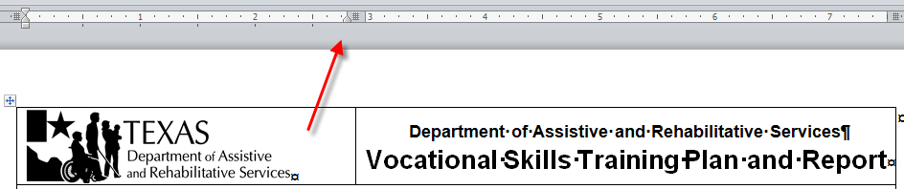

Don’t put an extra hard return between these lines for spacing purposes. Set the top line so there is 0 points before the top line and 3 points after it. Make these settings by going to the **Home tab**, then clicking on the arrow in the lower right corner of the **Paragraph settings** area.

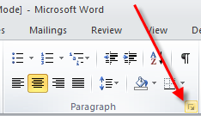

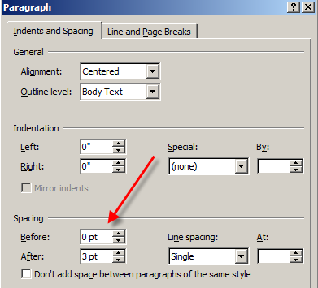Set the text in the cell to be center aligned by right clicking on the cell, selecting **Cell Alignment**, then select centered within the middle of the cell

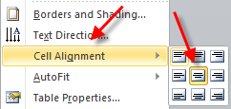

Although this clearly identifies the form to people who are sighted or partially sighted, this text will not be read aloud by a screenreader, therefore one more step is needed: Create a help text field a couple of spaces to the right of the last letter of the last word on the second line. From the **Productivity tab**, select **Text Form Field** and a gray rectangle will appear in the document before the cursor. 

Highlight the rectangle and from the **Home tab**, define it as 1-point Arial.

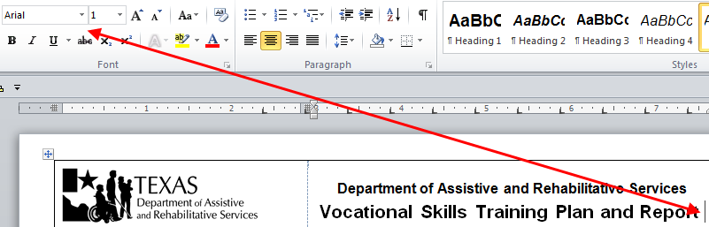

With the rectangle still selected, right click, and select **Properties** or press the F10 key. The default for **Maximum Length** says Unlimited. Change it to 1. With the **Properties** screen still visible, click **Add Help Text** button.

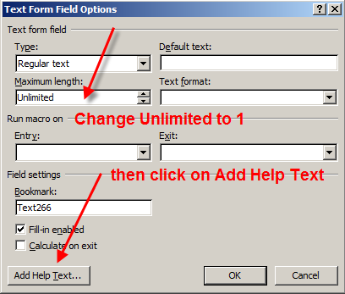

In the **Status Bar tab**, type in DARS and the form number, followed by a comma, then the name of form, then a period, then the last revision month and year, then a period. Note: There is a limit of 128 characters that can be entered into **Status Bar tab** and a limit of 256 characters that can be entered into the **Help Key (F1) tab**. More on that later.

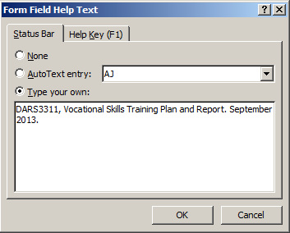

Click OK then OK. The rectangle should now change to a very thin gray line, which will hardly be noticeable as far as the form’s visual look.



### Section Headings and Subheadings

Use section headings to change subject content and to help low-vision users quickly find a particular section. When creating a section heading row, use:

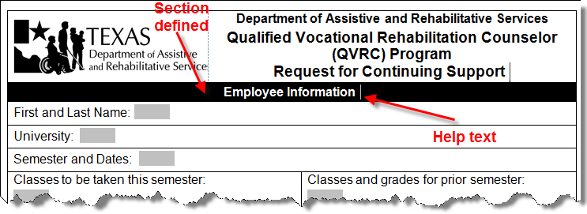

* A **single row.**
* **Black shading** that the row contains a header. This helps low-vision users identify the beginning and end of a form’s sections.
* **Bold text** that contrasts with the row shading. Text should be 12 point Arial Bold white text centered with 3-point spacing above and below the text. If necessary to save space, use 11 point Arial Regular or reduce the space before and after.
* If you number the sections, **use Arabic numbers** for easier navigation. Avoid Roman numerals.
* **Help text field** following the section name that reads: Info. Name of section. This helps a screenreader user recognize the help text as “For information only” as opposed to giving instructions for entering information. For the example above, the help text should read, “Info. Employee Information section.”

A section can be subdivided using subheadings with the following specifications:

* black border with no background fill that is 2¼ points thick
* boldface, 12-point Arial Bold that is left-aligned or centered (must be consistent within the document); and
* 3-point spacing above and below the text.

Example of subheading.

Example of subheading that says "Reviewer Information."

### Footer

The footer must include DARS, followed by the form number, abbreviated publication month and year in parenthesis, form title, and page number. The footer font is 10-point Arial regular. Position the text by adjusting the footer margins and using tabs. Do not use a table in footer.



### Instructions

DARS forms may (when needed or when the instructions are lengthy) have a separate instructions document, which follows a standard template and explains

* the purpose of the form,
* how to complete the form, and
* what to do with the form after completing it.

Lengthy instructions must be separate from the form because the form must be locked to be accessible (more on this later). Although it’s possible to include instructions in many hidden help text fields as described above, these require the user to tab repeatedly. Therefore, this might not always be the most effective way to communicate lengthy instructions.

A separate instructions document should be unlocked (unprotected) and in the same general format as the form itself. The header must match the header on the corresponding form. The revision date in the footer of the instructions document must match the revision date on the form, even if the most recent revision changed the form but not the instructions. The following picture illustrates the Form Instructions Template:

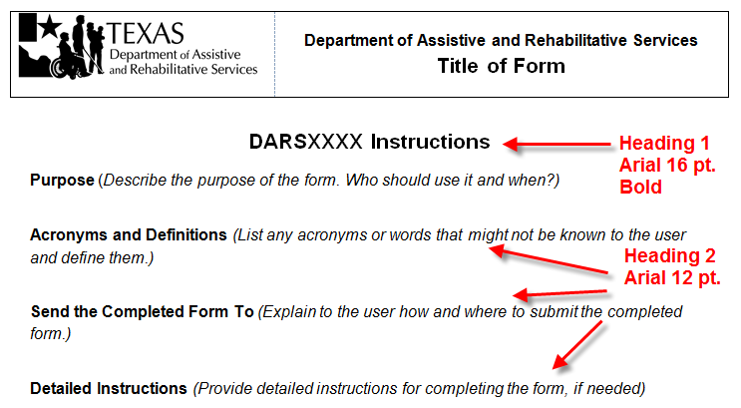

## Creating Form Inputs

### Legacy Form Tools

The **Legacy Form Tools,** located on the **Productivity** tab, are used to create **Text Form Fields**. Enter help text for each field in the **Status Bar**, which is limited to 128 characters or less. Otherwise, you can use the **Help** Key or **F1** edit boxes, which can contain up to 256 characters.

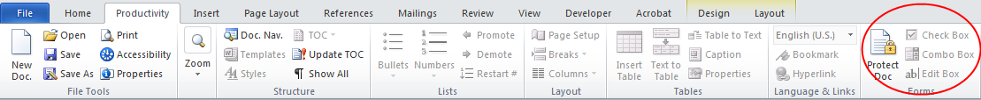

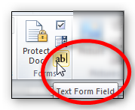

### Form Field Help Prompts

Form prompts let users know what information to enter. They should match the visual wording of the form.

If the prompt is too long to fit in the **Status** bar or **F1**, edit the prompt but maintain the meaning.

Acceptable methods for shortening input text include:

* Substituting symbols for words.
* Using Arabic numbers instead of written numbers.
* Shortening words with contractions.
* Using acronyms or abbreviations (use spaces between letters).

Select the form field you created in the cell with the text form field button.
1. Double-click in the form field.  The Text Form Field Options dialog box opens.
2. Click the Add Help Text button in the bottom left.  th eForm Field Help Text dialog box opens.
3. Add your message in the Status bar tab.
4. The Help Key tab allows for longer messages. 
Click OK twice to accept and close.

### Steps in Creating Sample Form

The following instructions illustrate the steps needed in building a sample form. First, begin building the form by entering in the text. In this case, the fields are name, address, office or location, and department ID.

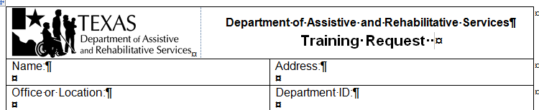

Next, create form fields using the **Legacy Form Tools** to create **Text Form Fields**. Note that there are hard returns between the text and the form fields. This may not apply in all situations, but if the text and the form fields are on the same line, there may not be enough room to fill out the fields. Place 3 points of space above and below each text area.

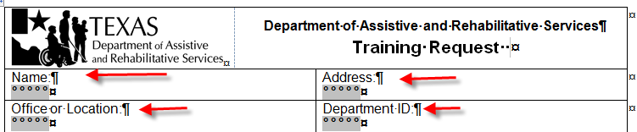

Now, define each of the form fields using the same text in each: Name, Address, Office or Location, Department ID. You must repeat the information because when the form is completed and locked, screenreaders will read the form fields, but not the text.

Double click on each form field, click on **Add Help Text**, then type in or copy the text for the **Status Bar**. Note: There is a space between the “I” and “D” of Department ID. This is to ensure a screenreader doesn’t read “id” (rhymes with “kid”), but instead says the abbreviation as separate letters. Some, but not all screenreaders have settings to spell out commonly used abbreviations. It is acceptable for some abbreviations like “DARS” to not have spaces between the letters because DARS (rhymes with “cars”) is acceptable in common usage (the agency is not known as “dee ay are es”).

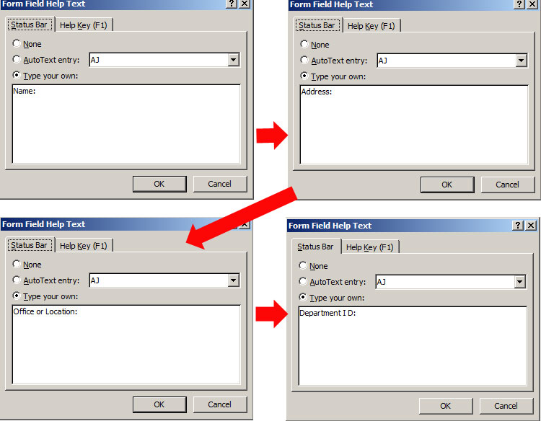

Add **section headings** in 12-point Arial Bold as visual queues, which helps both sighted people and people who have partial vision. From the **Paragraph section** of the **Home tab**, add 3 points of space before and after the section heading text. Define the cell to have a black background with white text that is centered. Add in help text field after the actual section heading text that is 1-point Arial and a maximum length of 1 character wide. In this case, the section is called “Training Information” and the help text field is defined as, “Info. Training Information section.”

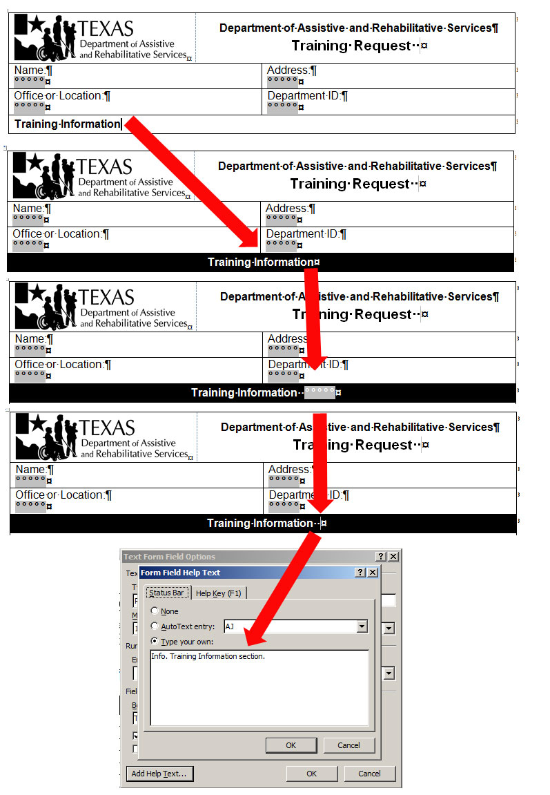

#### Working with Longer Text in Help Text Fields

When there are instructions that cannot fit in just the Status Bar section of the help text, split up the information between the **Status Bar** and **Help Key** tabs. The **Status Bar** can hold a maximum of 128 characters and the **Help Key** can hold a maximum of 256 characters. Try to split the text at a logical spot so that the phrasing will remain understandable when someone has to listen to it in two chunks. A screenreader user will first hear the text in the **Status Bar**, then be told that F1 help text is available. 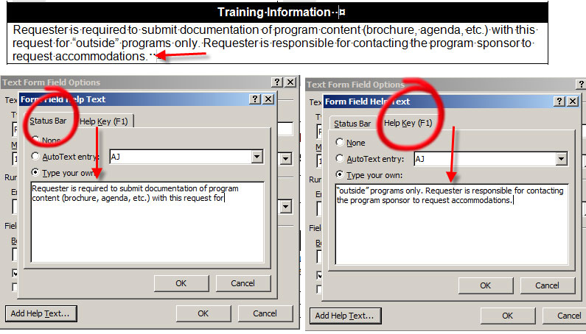

Large amounts of help text can be split between several help text fields that can be next to one another.

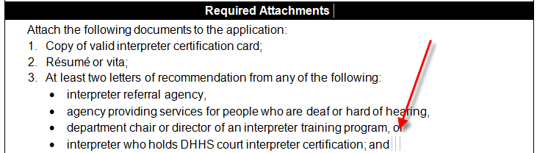

or split across the text area. Either way, a screenreader user will tab from one help text field to the other.

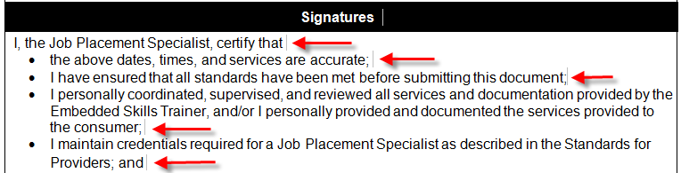

#### Writing Help Text that Explains Directions

In most cases, help text should match the same text that would be visible to a sighted user, but sometimes it is helpful to write help text in a manner that includes directions on what to do. There are several ways to word this, all of which would be correct as long as they explained the actions necessary to complete the field. In this example, a screenreader would say, “Registration. Colon. Dollar sign” if you wrote the help text exactly as seen. Therefore, explaining the field by saying “Enter registration amount in dollars” would be more helpful.

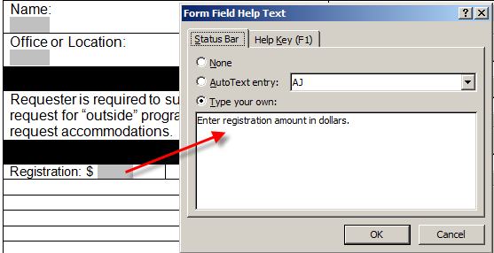

#### Additional Form Fields: Check Boxes and Signature Form Fields

As stated earlier, the only types of form fields used in DARS Microsoft Word forms are **Text Form Fields** from the **Legacy Form Tools,** located on the **Productivity** tab. Other form fields available in Microsoft Word create accessibility issues for users of assistive technology. Forms that require these fields should be created using Adobe LiveCycle Designer.

DARS has created a work around for checkboxes, however. They are simply **Text Form Fields** with a black border around them. To select them when completing the form, users type in the letter “X” into the field. To create such a field, insert a two-character **Text Form Field** and put a border on all edges. In this case, the help text could include the instructions to Enter X to select IL Independent Living.

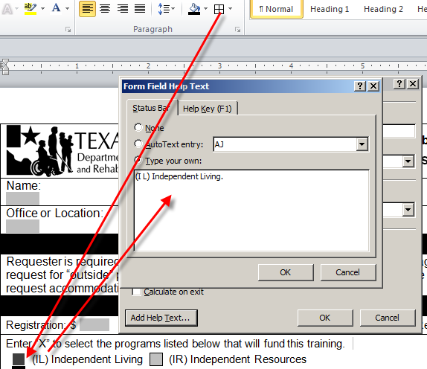

In cases with multiple choices, it’s not necessary to repeat instructions in the help text for each form field—in fact, that could be tedious to a screenreader user.

For forms that require signatures, the style is to include a 20-point Arial Bold capital letter X preceding the form field as a queue to help users with partial vision. Put two spaces after the X.



The last form field prompt should contain the words “end of form” to let users know they have reached the end of the form. Otherwise, after completing the final input, and pressing the tab key, they are returned to the top of the form.

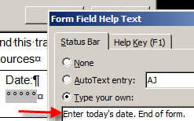

When you have entered in the last of the form, delete any blank rows that may still be left over from when you created the original table.

## Using Macros

While the form is unprotected, it is possible to further finalize it before it is published by using a series of macros described below. A macro is a saved sequence of commands or keyboard strokes that can be stored in a Word file and then recalled with a single command or keyboard stroke. While useful during the creation process, macros must be deleted from the file after being used (files cannot be published with macros still embedded in them).

### Setting up Word for Macro Use

By default, your computer may not be set up to create and use macros.

Open a Word form. Make sure the **Developer Tab** is visible somewhere along the top of your screen.

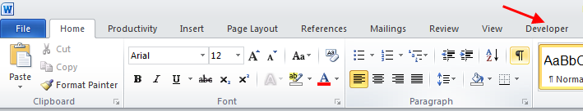

If it is not visible, go to File, then Options.

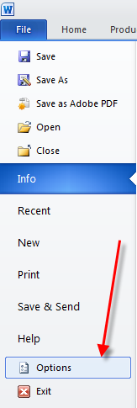

Go to **Customize Ribbon**, then make sure **Developer** is checked (note the number of items on the list on the right might look different from the picture below). When done, click OK. The **Developer tab** should be visible.

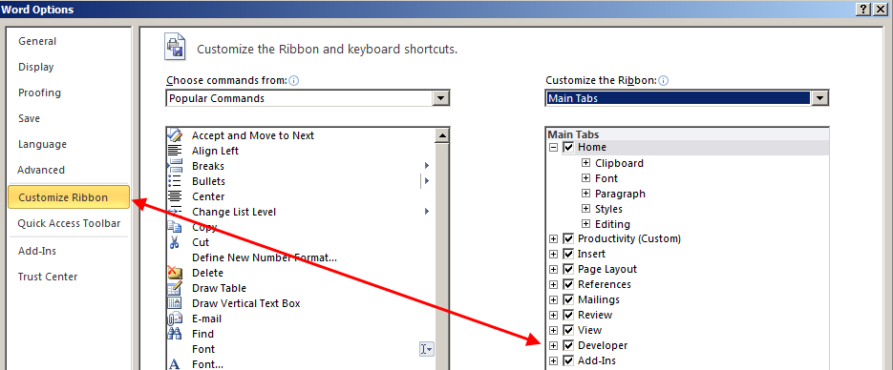

You should now see the Developer Tab.

### Macro: Do Spell Check on Help Text

Go to the **Developer tab** and click on **Macros** icon on the left. Then type in a word like “test” for macro name and click Create button.

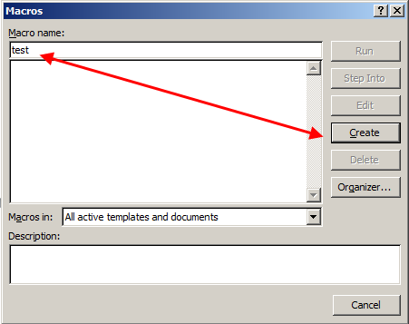

Control A, Control X to delete what is there.

1. 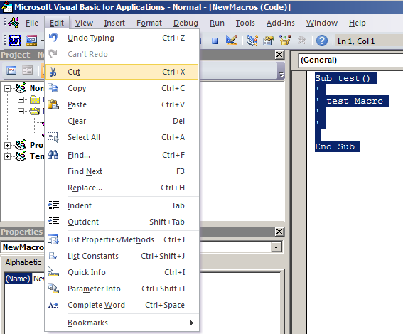

Select all of the text below and copy (Control C) , then paste (Control V) in its place:

Sub ListFormFields()

Dim ThisDoc As Document, NewDoc As Document

Dim NewTable As Table

Dim RowNum As Long

Dim ffld As FormField

Application.ScreenUpdating = False

Set ThisDoc = ActiveDocument

Set NewDoc = Documents.Add

Set NewTable = NewDoc.Tables.Add(NewDoc.Content, ThisDoc.Content.FormFields.Count + 1, 4)

RowNum = 1

NewTable.Cell(RowNum, 1).Range.Text = "Field"

NewTable.Cell(RowNum, 2).Range.Text = "Location"

NewTable.Cell(RowNum, 3).Range.Text = "StatusText"

NewTable.Cell(RowNum, 4).Range.Text = "HelpText"

NewTable.Rows(1).Range.Font.Bold = True

NewTable.Rows(1).HeadingFormat = True

For Each ffld In ThisDoc.Content.FormFields

RowNum = RowNum + 1

NewTable.Cell(RowNum, 1).Range.Text = ffld.Name

NewTable.Cell(RowNum, 2).Range.Text = _

"Page " & ThisDoc.Range(ffld.Range.Start, ffld.Range.Start).Information(wdActiveEndPageNumber) _

& ", Line " & ffld.Range.Information(wdFirstCharacterLineNumber)

NewTable.Cell(RowNum, 3).Range.Text = ffld.StatusText

NewTable.Cell(RowNum, 4).Range.Text = ffld.HelpText

Next ffld

Application.ScreenUpdating = True

Set NewTable = Nothing

Set NewDoc = Nothing

Set ThisDoc = Nothing

End Sub

Sub FixTerm()

Dim ThisDoc As Document

Dim frmfld As FormField

Set ThisDoc = ActiveDocument

For Each frmfld In ThisDoc.Content.FormFields

frmfld.StatusText = Replace(frmfld.StatusText, "SIGN", "tuber", , , vbTextCompare)

frmfld.HelpText = Replace(frmfld.HelpText, "SIGN", "tuber", , , vbTextCompare)

Next frmfld

End Sub

Sub GlobalRenameFormFields()

Dim oFrmFlds As FormFields

Dim pIndex As Long

Dim i As Long

Dim j As Long

Dim k As Long

Dim oVar As Variant

pIndex = 0

i = 0

j = 0

k = 0

If ActiveDocument.ProtectionType <> wdNoProtection Then

ActiveDocument.Unprotect

End If

Set oFrmFlds = ActiveDocument.FormFields

For pIndex = 1 To oFrmFlds.Count

oFrmFlds(pIndex).Select

Select Case oFrmFlds(pIndex).Type

Case wdFieldFormTextInput

oVar = oFrmFlds(pIndex).Result

i = i + 1

With Dialogs(wdDialogFormFieldOptions)

.Name = "Text" & i

.Execute

End With

oFrmFlds(pIndex).Result = oVar

Case wdFieldFormCheckBox

oVar = oFrmFlds(pIndex).CheckBox.Value

j = j + 1

With Dialogs(wdDialogFormFieldOptions)

.Name = "Check" & j

.Execute

End With

oFrmFlds(pIndex).CheckBox.Value = oVar

Case wdFieldFormDropDown

oVar = oFrmFlds(pIndex).DropDown.Value

k = k + 1

With Dialogs(wdDialogFormFieldOptions)

.Name = "DropDown" & k

.Execute

End With

oFrmFlds(pIndex).DropDown.Value = oVar

Case Else

'Do Nothing

End Select

Next pIndex

ActiveDocument.Protect Type:=wdAllowOnlyFormFields, NoReset:=True

End Sub

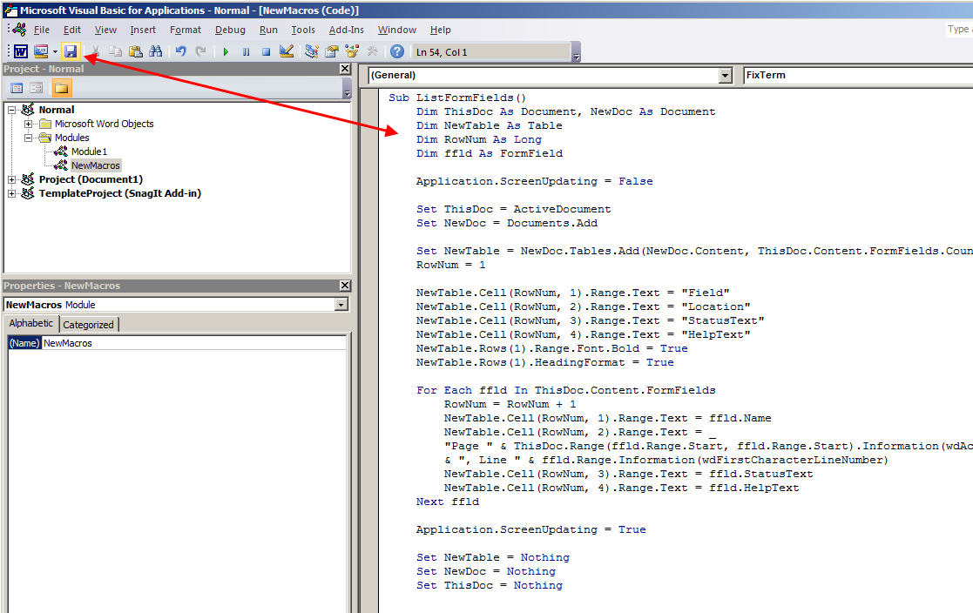

You have just entered in three macros. Click on the save icon (Control S) then close the window.

Now, go back to **Developer tab**. Click on **Macros** icon. This time you will see three choices. The last is called ListFormFields. Select it and click Run. Word should create a new document that lists all the help text in your form. Depending on the size of the form, it may take Word a while to generate. From here you can run a spellcheck on the newly created document to see if there are any typos in your help text. Then go back to the form and correct spelling errors in the corresponding help text.

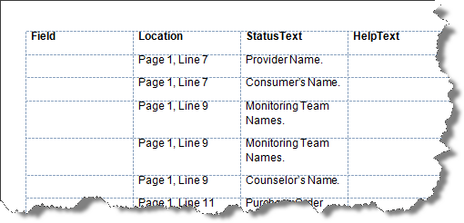

### Macro: Do Search and Replace on Help Text

The FixTerm macro will let you search and replace a word in all your form’s help text fields. The macro is a little more advanced because you will have to edit it. The search is case sensitive and the example will search for the word “SIGN” and replace it with “tuber.”

Go to the **Developer tab** and click on **Macros**. Then select FixTerm and click on Edit.

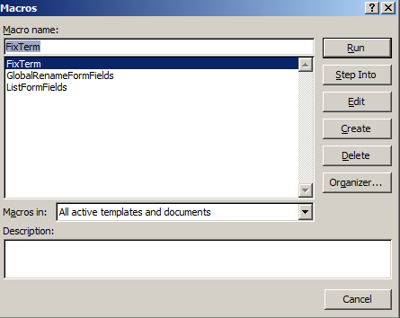

Word stores all the macros in one place. The macro you want to edit will be in the middle. Go to the macro and change the find word from “SIGN” to the word you want to find (you need to change it in two places highlighted in picture below). Then change the word “Tuber” to the word you want to replace (you will also need to change it in two places).

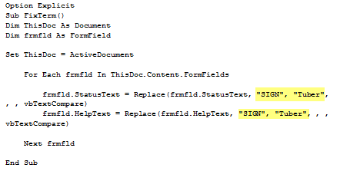

Then save and close the window.

To run this new Macro, go to the **Developer tab**, click on **Macros**, select FixTerm, then click on Run. The only way to confirm the changes is to click on the form field help text (or listen to it with screen reader).

### Macro: Add Bookmarks to Help Text Fields

It is necessary to run the GlobalRenameFormFields macro before submitting a Word form for translation. Go to the **Developer tab** and click on Macros. Then select GlobalRenameFormFields and click on Run. When the macro is finished running, you will be taken to the end of the file.

### Clean up

When you are done using your macros, you need to delete them from the file before you distribute it.

Go to **Developer tab** then Macros. Select each macro and click delete. Close out of Macros. Save file when done.

## Protecting the Form

When you have completed the form, lock the document to protect it. From the **Productivity** Ribbon, select **Protect Document**. Next, click the boxes “Allow only this type of editing in the document” and then“filling in form.” From **Start enforcement**, click “**Yes, Start Enforcing Protection**.” Finally, close and save the form. When prompted for entering password protection, leave the fields blank.

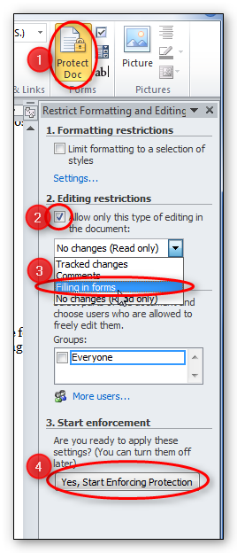

## Simple Form Test

Once the form is completed and protected, you can do a simple test to ensure the help text will work properly. Open the form and begin to hit the Tab button. Help text will be displayed in the lower left hand corner of the window. If there is F1 help text available, use the F1 key to review it. As you continue to press Tab, you will be advanced from field to field.

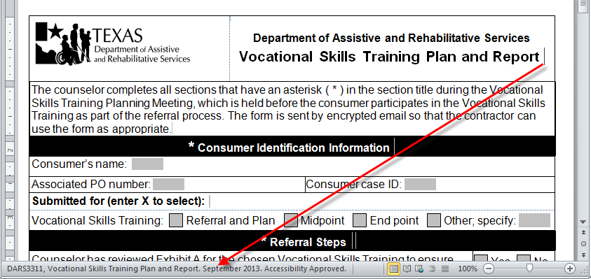

Hit Tab to advance to next field.

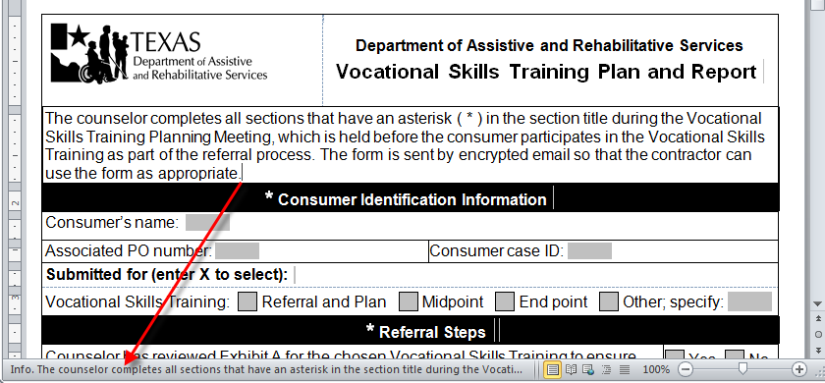

## Summary

This concludes our module on Creating Accessible Microsoft Word Forms the DARS Way. We’ve discussed creating the form from a table, and the specifications of forms, including borders and row height. We also discussed creating form inputs, including adding help text and prompts. Finally, we discussed protecting the form and using macros to spell check the help text, search and replace text in the help text, and add bookmarks to help text before the form is sent out for translation.