|  |
| --- |
| Bellabeat  Case Study, Data Analytics  Fitbit Tracker: A new opportunity that will provide update to your movement in motion. |
|  |



## Bellabeat - oversee your health by moving to your beat.

**Google Data Analytics Certificate**

This Capstone Project will use the Fitbit dataset from Kaggle: Ask, Prepare, Process, Analyze, Share are the steps that will be followed to for this project.

1. **ASK**

In this step, we define the business opportunity and how the case study be measured.

**Background of Company**

A manufacturing high tech company name Bellabeat provide health-focused products that is geared for women. These smart devices were made available around 2013 delivering knowledge to women that track their health and habits. Urška Sršen, the cofounder and Chief Creative Officer of Bellabeat, has assigned me the task of analyzing smart device fitness data that could help improve marketing strategies.

**Business Task**

Analyze Fitbit data to determine how consumers are using their Fitbit app and help develop a more efficient marketing strategy.

Deliverables

* A clear summary of the business task
* A description of all data sources used
* Documentation of any cleaning or manipulation of data
* A summary of the analysis
* Supporting visualizations and key findings
* High-level content recommendations based on the analysis

**Key Stakeholders**

Urška Sršen: Chief Creative Officer and Cofounder of Bellabeat

Sando Mur: Mathematician and Bellabeat co-founder, a key member of Bellabeat executive team

Bellabeat marketing analytics team: a team of data analytics responsible for Bellabeat’s marketing strategy.

**2. Prepare**

**Selected tables**

dailyActivity_merged.csv

dailyIntensities_merged.csv

dailysteps_merged.csv

heartrate_seconds_merged.csv

sleepDay_merged.csv

weightloginfo_merged.csv

hourlysteps_merged.csv

**Phase 3: Process Data**

1. View Data in Spreadsheet

2. Data cleaning for each table

2.1 Change all table name into lowercase

2.3 delete duplicate

2.4 delete extra space

2.5 Change date format

2.6 Add weekday column by TEXT function – TEXT(A1, “dddd”)

**Phase 4： Analysis in SQL**

**4.1** For Daily-level data analysis, code that will be used for example.

Select - determines which columns of the data to show in the results.

From – table name

Where – clause is used to filter records (rows) that match a certain condition.

Group BY - combine rows into groups

Order BY - used to sort the result set by a particular column either alphabetically or numerically.

The graphs will show that a different Market Strategy needs to be developed if Bellabeat want to increase their volume and profits.

5. ANALYZE & SHARE PHASE

SQL, Excel, and Python used (visualization part) for this project. In addition, the dataset was uploaded to SSMS, Jupyter Notebook for calculating and analyzing.

The dataset from 4.1 below was uploaded to SSMS. It was used to count the number of distinct Ids.

**The queries below are used to view the total number of users per table.**

SELECT Count (Distinct Id)

From ..dailyactivity_merged_df = 33

SELECT Count (Distinct Id)

From ..dailycalories_merged_df = 33

SELECT Count (Distinct Id)

From ..weightloginfo_merged_df = 8

SELECT Count (Distinct Id)

From ..sleepday_merged_df = 24

Here are the number of IDs that are unique for 4 datasets. In addition, there are 33 participants which no demographics is known.

**Regression Analysis**

SELECT VeryActiveMinutes, Calories FROM ..dailyactivity_merged_df ). In addition, all the graphs were plotted in Python.

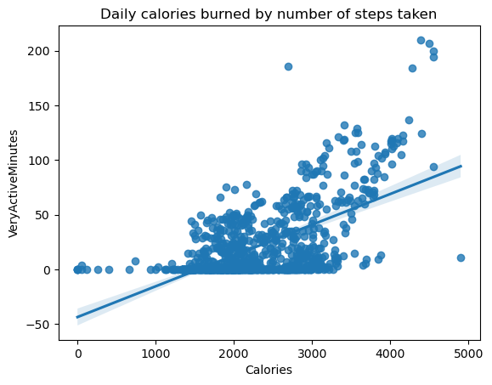

e

Per

SELECT

Id,

COUNT(Id) AS Movement,

CASE

WHEN COUNT(Id) BETWEEN 25 AND 31 THEN 'Sedentary Minutes'

WHEN COUNT(Id) BETWEEN 15 AND 24 THEN 'Very Active Minutes'

WHEN COUNT(Id) BETWEEN 8 AND 14 THEN 'Fairly Active Minutes'

WHEN COUNT(Id) BETWEEN 0 and 7 THEN 'Lightly Active Minutes'

END Trackerusage

FROM

..dailyactivity_merged_df

GROUP BY Id

Percentage of Total Activity is shown in the Pie Chart above. Sedentary minutes plays a role in physical activity not being achieved.

heatmap_df=mm_da[["TotalSteps","TotalDistance","Calories","SedentaryMinutes"]]

heatmap_df

| **TotalSteps** | **TotalDistance** | **Calories** | **SedentaryMinutes** |
| --- | --- | --- | --- |
| **0** | 13162 | 8.500000 | 1985 | 728 |
| **1** | 10735 | 6.970000 | 1797 | 776 |
| **2** | 10460 | 6.740000 | 1776 | 1218 |
| **3** | 9762 | 6.280000 | 1745 | 726 |
| **4** | 12669 | 8.160000 | 1863 | 773 |
| **...** | ... | ... | ... | ... |
| **935** | 10686 | 8.110000 | 2847 | 1174 |
| **936** | 20226 | 18.250000 | 3710 | 1131 |
| **937** | 10733 | 8.150000 | 2832 | 1187 |
| **938** | 21420 | 19.559999 | 3832 | 1127 |
| **939** | 8064 | 6.120000 | 1849 | 770 |

940 rows × 4 columns

Day of the Week – Bar Chart

Select Day, count (*) AS DayoftheWeek

From ..dailyactivity_merged_df

Group BY Day, Day

Order BY 3 DESC

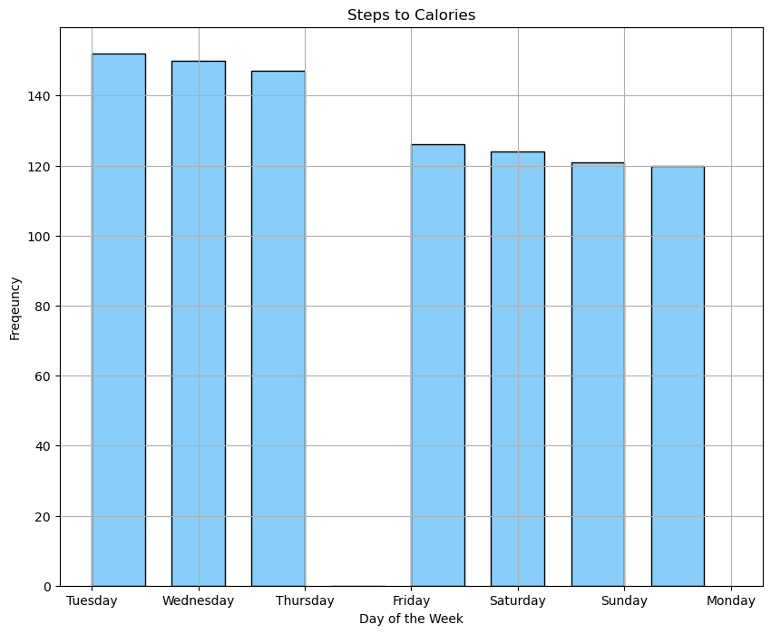

**Calories**

* Based on a woman body type plays into the number of calories that they can burn off. Fitness and personal health goals are very important to reach the objective.
* The figure displays the relationship between days of the week taken and frequency to reach the calories goal base on steps.

the

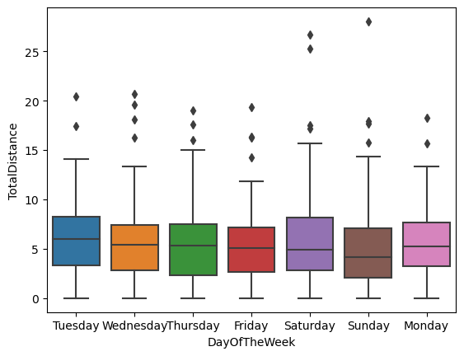

**R:**

**Recommendations for Bellabeat app:**

1. Create team challenges and provide prizes to the winners.
2. Create a joint venture with a health provider which they can provide

insight into wellness tips.

1. Find an alternative way to have individuals use the tracker.

Calories

• Participants didn’t burn more calories on days that they worked vs. days they didn’t.

• If users want to burn calories, they’re best off doing so by being very active and/or increasing their daily step count.