# ESOF 322: Software Engineering I DUE Date: August 25, 2020

**Instructions:**

* Do all exercises
* Clearly print your name in the first page of your assignment
* No hand-written answers allowed
* Absolutely no late assignments
* Your assignment should be turned in to D2L
* You **must provide references** to any sources used

# Exercise 1 (4 pts)

1. What is polymorphism? Provide an example using source code
   1. Polymorphism, as defined by Pressman, is the characteristic that greatly reduces the effort needed to extend the functionality of an existing object-oriented system.
   2. 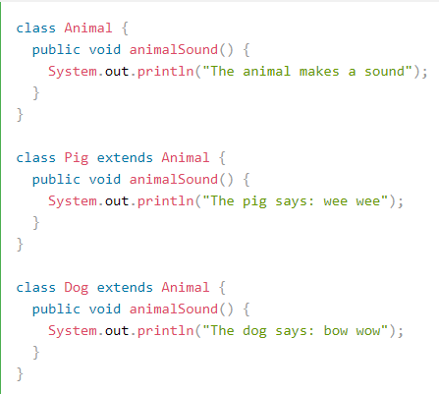
2. What is inheritance? Describe the differences between public vs private inheritance
   1. Inheritance is defined as a subclass inherits all of the attributes and operations associated with this superclass. This means that all of the data structures and algorithms associated with the parent are available to child. The difference between public and private inheritance is the classification of the members of the derived class. Public members of base class with become public members of the derived class. However, if deriving from a private class the public members become private in the derived class
3. What is encapsulation?
   1. Data and the processes that should be packages as a cohesive unit. All of this information is packaged under one name and can be reused as one specification or program component.
4. What is the difference between static vs dynamic binding?
   1. Static binding happens during compile time, observes private, static, and final methods. Dynamic binding happens during run time and observes instance methods.

# Exercise 1 (8 pts)

1. Provide a definition for a prescribed lifecycle, and name two types of prescribed lifecycles
   1. An orderly approach to software engineering such as the waterfall model or the V model.
2. For each type provide an example (i.e. a use case)

We used the Waterfall method for Customer Relationship Management system I worked on this summer at an internship.

The V Model is very popular when designing medical equipment.

# Research Question (3 pts)

What does low coupling and high cohesion mean?

Low coupling and high cohesion are a desirable traits for your object oriented code to have. The low coupling means that each module should be as separate from the others as possible. The goal is to be able to change one module without effecting the others. High cohesion refers to keeping code blocks with related functionality close together. It should be easy to jump to once section of the code file and work on a specific part of the project.

# Works Cited

<https://www.w3schools.com/java/java_polymorphism.asp>

<https://www.tutorialspoint.com/cplusplus/cpp_inheritance.htm>

<https://www.tutorialspoint.com/what-are-differences-between-static-binding-and-dynamic-binding-in-java>

<https://medium.com/clarityhub/low-coupling-high-cohesion-3610e35ac4a6>

<https://airbrake.io/blog/sdlc/v-model>

*Software Engineering: A Practitioner’s Approach by Roger S. Pressman*