Outline of paper.
Working title: Simulating the effects of habitat loss on multi-trophic hybrid communities.

Context

This can be largely taken from my thesis intro chapter, which Jason passed as setting the context for the study (and others to follow).

Hypotheses

In our analysis we consider the following five metrics, which capture different properties of the simulated communities.

- Links
- Predators
- IS
- Area
- CV

Below we justify the choice of each metric, and predict how it will respond under HL (random and contiguous). The five metrics are chosen for simplicity or analysis and interpretation, from the plethora of potential community descriptors.

1. Links. The number of links in the network is a fundamental topological property. Since we are controlling for species richness in these experiments, Links scales linearly with connectance. Network topology can change without changes in Links via re-wiring. Still, we argue that Links is a suitable low level metric, and that changes in Links indicate potential changes in other network properties. We expect Links to decrease with HL. This has been documented in nature [citations]. (Does the number of links ever increase in nature, e.g. spatial compression?)

2. Predators. The relative abundance of top predators captures the trophic distribution of biomass. Generally species in higher trophic levels are most effected by HL [citations]. Therefore we should expect our model to reproduce this effect, and show a decrease in Predators.

3. IS captures the mean interaction strength between species. Modelling suggests [citations] that interaction strengths are a key determinant of dynamic stability: strong interactions lead to high variability. Previous studies also indicate that HL, both fragmentation [citation] and area loss [citation], may lead to changes in IS. However, this effect is currently only speculative. We predict that random and contiguous HL may have different effects on IS. Contiguous HL is similar to spatial-compression [McCann] and therefore should increase IS. Whereas random HL may in fact reduce IS because the fragmented landscape makes it harder for individuals to find each other in interact.

The final two metrics Area and CV capture different aspects of community stability. In general we predict that both types of HL will destabilise community dynamics, increasing both these metrics. (Why do we predict this?)

4. Area is a measure of the mean temporal variability in the size of species spatial range. It is therefore a measure of community stability in space. If species were homogeneously distributed in space, we would expect no change in Area, only changes in density. However, we know that these communities display some spatial aggregation [Lurgi et al]. Therefore, we know that changes in Area are meaningful.

5. CV is the mean temporal variability in species abundances. This is commonly used to capture community stability [citations]. We predict that this metrics will increase in both case (but perhaps more under contiguous?).

Further predictions:

Based on previous modelling [many citations] we anticipate that random HL will be more detrimental than contiguous HL. The reason given for this previously was that contiguous HL leaves larger areas of pristine landscape in tact, which are able to support higher species richness. Random HL, on the other hand, results in patchiness at the landscape level and can present barriers to the motion of individuals.

We expect total abundance to decrease in both scenarios. We do not expect extinctions, because we are controlling for species richness by using a high immigration rate.

Finally, there are studies suggesting that mutualism can play a stabilising role in hybrid communities [citations]. Do high MAI communities have greater robustness to HL?

Causal structure of the SEM:

Crucially we must hypothesise a causal structure for the SEMs, and make arguements each relationship. (This can possibly be done after the initial bivariate results are presented? For now I include it here..)

We hypothesise the following causal relationships between the variables:

HL → all 5 variables (direct links not mediated by other effects, or mediated by effects not measured. Direction of effects hypothesised above).

Links → Predators : If the connectance of the network decreases, it may be harder for energy to transfer up the food chains. Meaning lower availability of food for top predators. (Any citations supporting this link?)

Links → IS : Changing number of links can change the interaction strength distribution (e.g. weaker links are lost) – still not sure about how to justify this. Think Miguel had a good argument?

Links → Area : not sure? Link with May 1972. Connectance and stability?

Links → CV : as above?

Predators → IS : predation is the main interaction in the community. If predators become less abundant, IS should decrease. (citations supporting this?)

Predators → Area : less predation pressure should reduce variability in space [McCann]

Predators → CV : less predation pressure should reduce variability in abundance [McCann]

IS → Area : same as justification for CV? (below)

IS → CV : strong theoretical justification here

Area → CV : if species ranges become more variable this drives variability in abundance?

Main results

No extinctions. Abundance decreases in both cases. MAI ratio has no or little effect qualitatively on community responses (what is the best way to show this convincingly?).

Links decrease under both scenarios. Predators decreases only under random, constant under contiguous.

IS, Area and CV respond in different ways under the two scenarios. Unexpectedly, random HL reduces Area and CV.

Mobility experiment demonstrates the differential responses of the motion of individuals to the different types of HL – we can use this to explain of lot of the differences between the two cases.

SEMs: reveals different pathways of influence under the two types of HL.

Random SEM: Most relationships are as expected. Strongest pathway is HL → Predators → IS → Area → CV. Effect of Links on Area is confusing. Also I don't understand effect of Links on IS.

Contiguous SEM: Strongest pathway (ending in CV) is HL → IS → CV. Strongest overall pathway is HL → IS → Area. Links has a very strong effect on CV. Two relationships change sign compared to random case: HL → IS and HL → Predators. The fact that contiguous HL is benefitial to predators is interesting.

(Note: SEMs are affected by choice of threshold. May be better to look at all MAI?)
Figures to present in the main text

Possibly also include figures to show: how Links and Predators change under both HL scenarios.
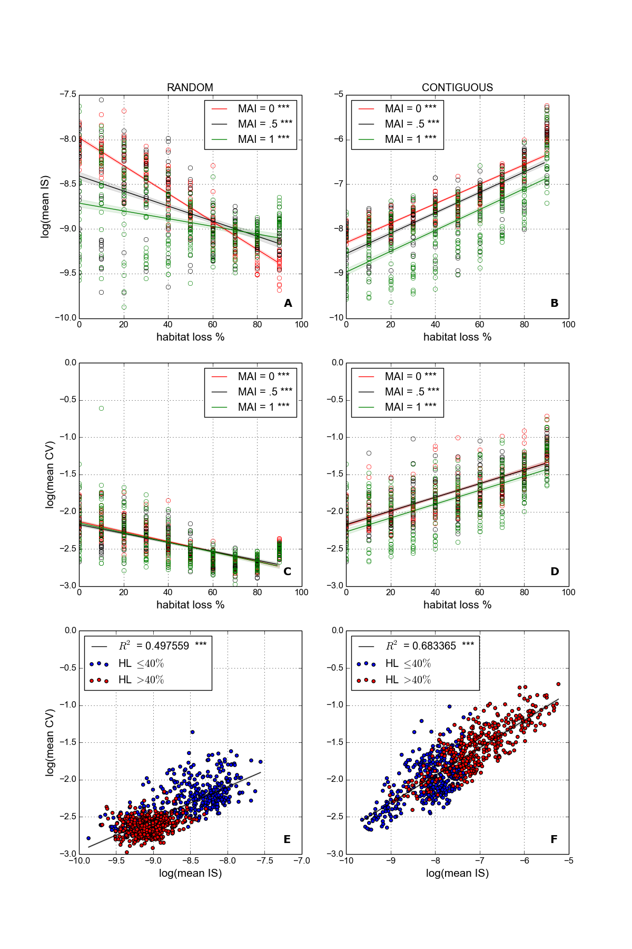Illustration 1: Interaction strengths and temporal variability. Both natural log-transformed to linearise trends. Panels A-B: Interaction strength metric IS averaged over all interactions in realised network. Panels C-D: mean CV, coefficient of variation in species abundances averaged over all species. Panels E-F: IS as a linear predictor for mean CV, with low and high HL communities indicated by blue and red circle respectively. All communities for MAI = 0.0, 0.5, 1.0 shown. Linear fits and p-value as in other plots.

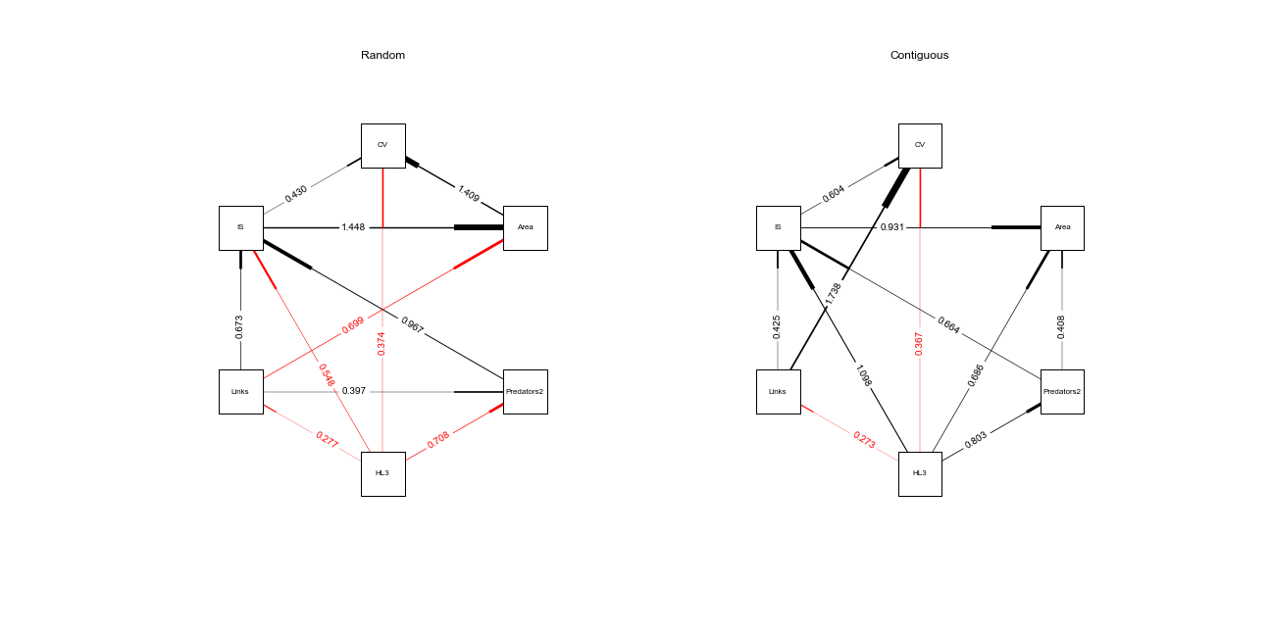Illustration 2: Structural equations models (SEM) for random and contiguous habitat loss. SEMs are calculated individually for each of the 11 eleven MAI ratios. Links are only included in the plot if they are significant in at least 66% of cases. Coefficient values given are averaged over all models in which the link is significant. Positive effects are shown in black, negative effects in red.

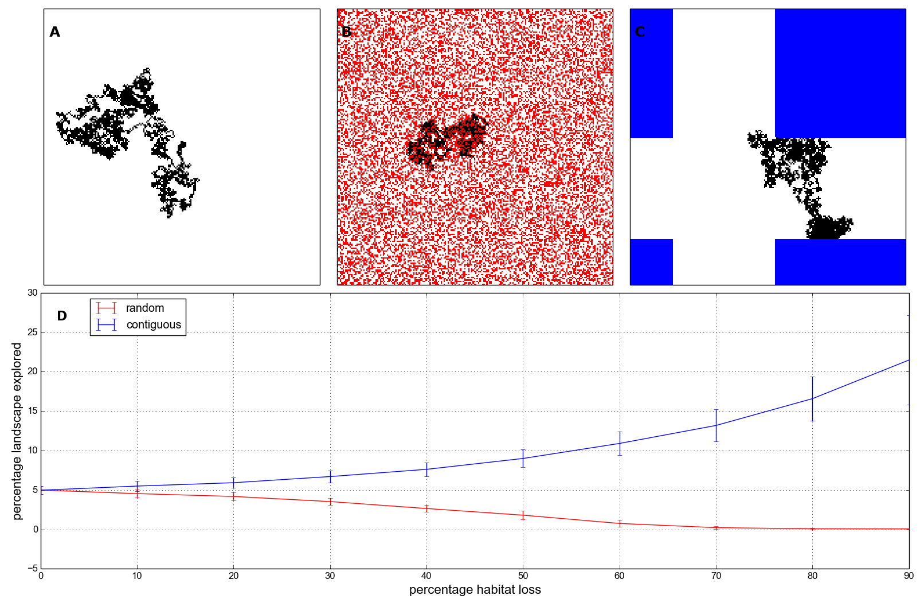Illustration 3: The mobility of an individual in three different landscapes: A) No HL, B) 40% random HL, C) 40% contiguous HL. D) The change in mobility with increasing HL of both kinds. Mobility measured as the percentage of non-destroyed cells visited by an individual during 5000 time steps. Solid lines show mean over 100 replicates, error bars show one standard deviation.
Ideas for discussion

Main finding – difference between how communities respond to random and contiguous HL. One reduces variability, and increases it. The SEMs reveal the pathways of influence leading to these differential responses.
Figures to present in SI

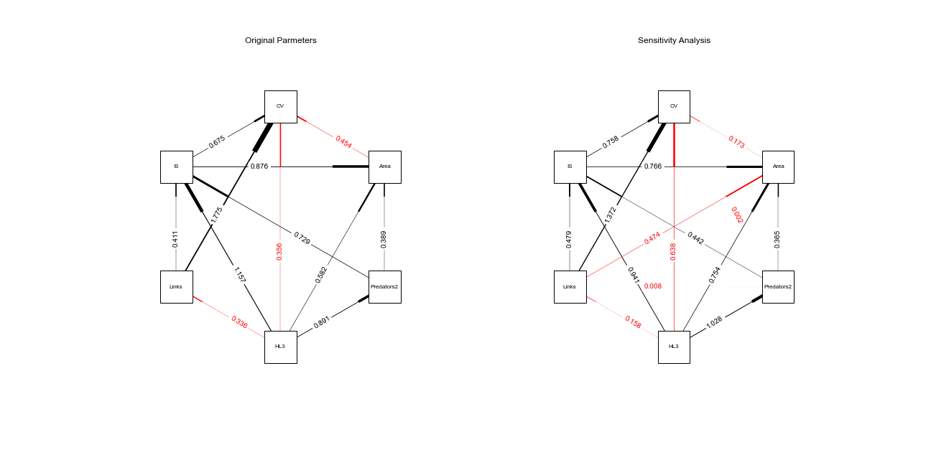Illustration 4: Contiguous HL. Comparing SEMs for the original parameter set, and for the sensitivity ensemble, averaged over three MAI ratios (0,0.5,1). Links are included if they are significant in at least two MAI ratios.

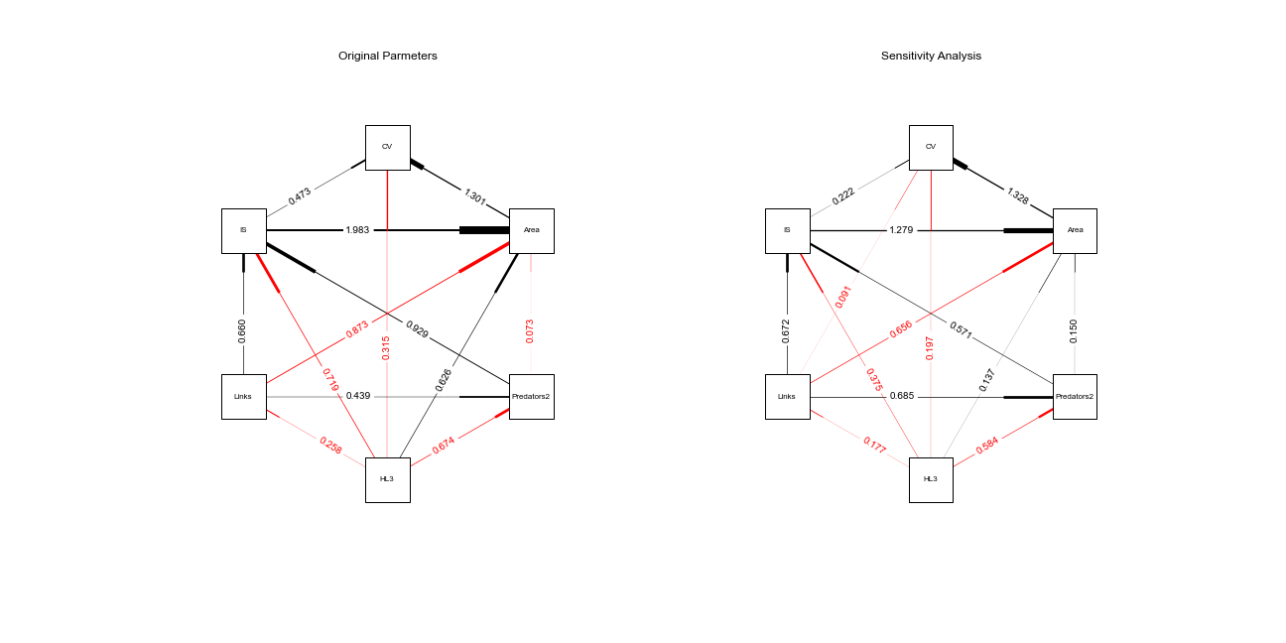Illustration 5: As figure 3, but for random HL.
Possibly also include figure showing “dependence on immigration” (fraction of new individuals coming from immigration, compared to local reproduction).

