Part 1 - M07

| case | test 1 score | test 2 score | test 3 score | total score | average | prediction |
| --- | --- | --- | --- | --- | --- | --- |
| 1 | 85 | 10 | 95 | 190 | 63 | the program will run normally |
| 2 | 150 | 22 | 34 | 206 | 69 | the program will have an error but run |
| 3 | 77 | 99 | 77 | 253 | 84 | the program will run normally |

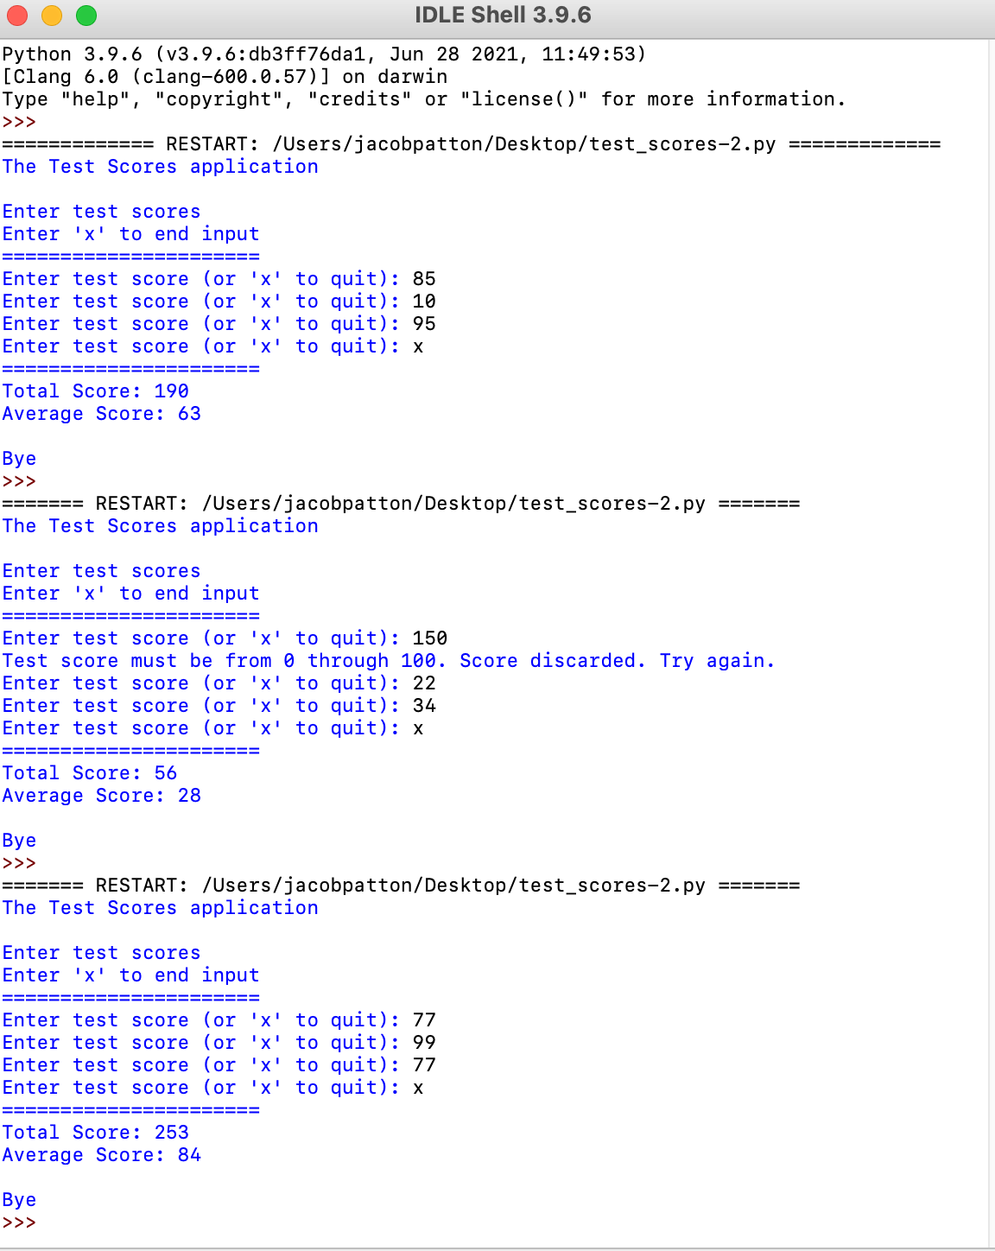

Part 2 - M07

