User manual for alea

First the main window is started:
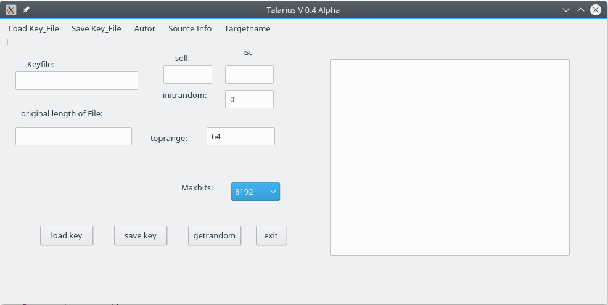

With Maxbits you first choose the encryption depth.
Then click on theertrandom button with the mouse. At „ist“ then the cross sum of the permuted number series appears. At „soll:“ on the other hand the control number. Both must match, otherwise an error has occurred while permuting the series of numbers. The selected encryption depth appears for initrandom and toprange. If everything worked, then you choose in the main menu
„Save-Key_File“.
There you choose the name of the key file. You can&#39;t enter 8192 int variables by hand!This is only saved when the button „save key“ is pressed. The completed work sequence is then saved in the text window on the right.
In order to determine whether everything was done correctly, please now with„exit“ exit the program and start new. With „load Key_File“ first select the name of the key file and click on the button “load key“ load the file. A message should appear that this file is still without an attachment, otherwise this file has already been used for encryption and can only be used for decryption.
Then the name that the encrypted file should have must be specified under “Targetname”.
Only now can you click on „Source Info“ the name of the file to be encrypted must be specified. The second window appears automatically:
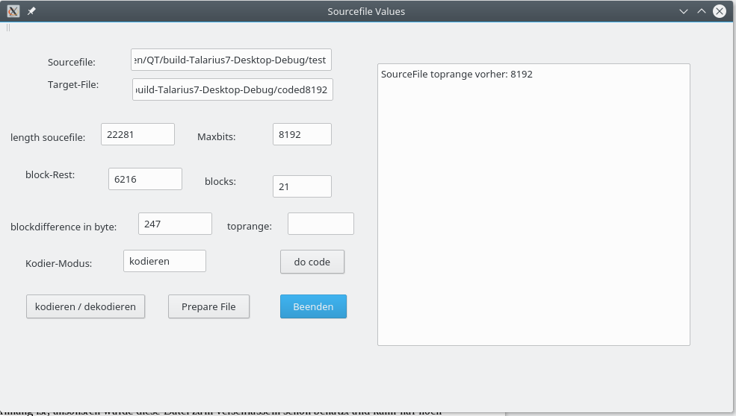

With a click on encode / decode you choose whether to encrypt or decrypt. Coding is preset.
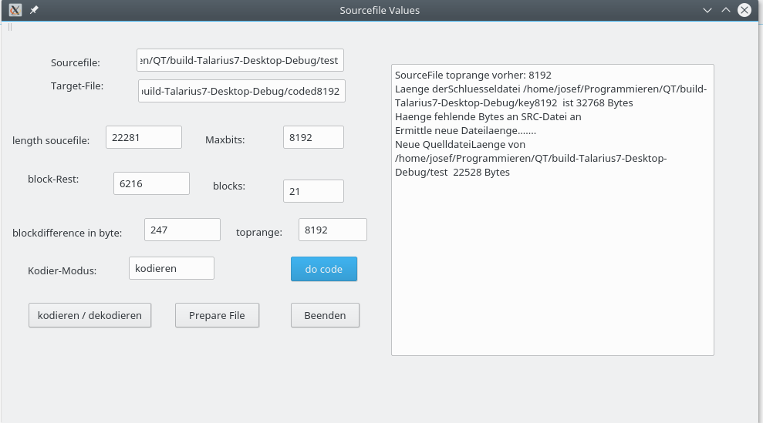
Dthen click on the button <Prepare File>. The file to be encrypted must first be processed in order to enable the permutations of the bits. Because the length of the file must be divisible by the length of the key, here in the example 8192. The original length of the source file was therefore saved in the key file by entering a Byte-int -value appended at the end:

The encryption process is now complete. We click on <Beenden> and <exit>.
JIt is now being deciphered. We restart the program. The skin window appears.
With load Key_File you specify the name of the key file and with the button <load key> this
file will be loaded.
With <Targetname>The name of the decrypted file is set in the main menu.
Now with <Source Info> the name of the decoded file is set. The second window appears. With one click on <kodieren/dekodieren> switch to decoding!
Now aclci on <do code>. The decryption process is now complete and both windows are now closed.
Please practice decoding a few times.
After encoding, the source file should actually be restored to its original length.
But still only work with copies, as the program is still in the alpha stage.
Übrigens:
No Warranty!

No liability for any damage.

Author:
Fitje Weshoms (Name as an anagram, correctly ordered the name of the author)
District upper palatinate
Pinetreeway 7
Cockreed (Adresse kodiert)

