Week 2 Unit 1

Using a remote service with aggregation binding

Please perform the exercises below in your app project as shown in the video.

Table of Contents

1 Verify your destination to backend system ES5 2

2 USE the Service in your app 4

3 (Optional) Use mock server if you have a slow internet connection 9

## Preview

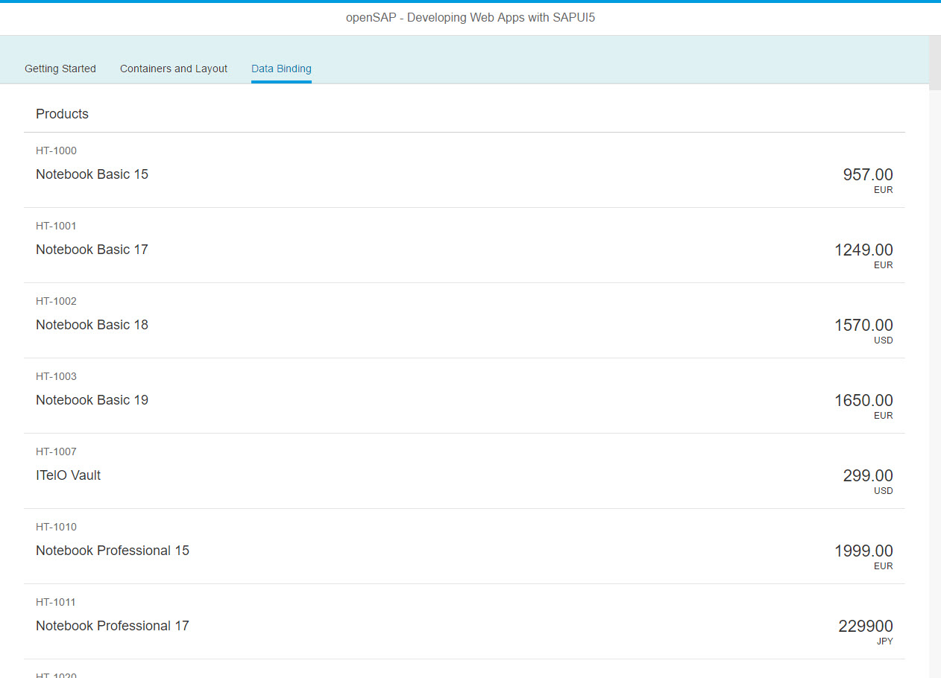

Figure 1 - Preview of the app after doing this unit’s exercises

# **Verify your destination to backend system ES5**

In this step we will verify the backend connection that you set up in week 0 unit 1.

### Check User Access to the Service on System ES5

| Explanation | **Screenshot** |
| --- | --- |
| 1. Navigate to the following URL and log in with the user/pw create in week 0 unit 1:   <https://sapes5.sapdevcenter.com/sap/opu/odata/IWBEP/GWSAMPLE_BASIC/$metadata>  **User:** <P…> (Same as your SAP Hana Cloud Platform Developer Account)  **PW:** <…>  You should see an XML document defining the service metadata that we will use throughout this course  **Note:** If you cannot access the metadata document or forgot your username/password you need to follow the sign up procedure from week 0 unit 1 – 2 CONNECT TO THE DEMO SYSTEM ES5. You will not be able to do the exercises for the remaining weeks of the course otherwise. |  |

### Check Destination to System ES5

| Explanation | **Screenshot** |
| --- | --- |
| 1. Go to destinations page of the SAP HCP Cockpit by opening the following URL and pressing the menu item “Destinations”:   <https://account.hanatrial.ondemand.com/cockpit> |  |
| 1. Make sure that there is a destination “ES5” created and click on the check icon on the right side. Verify that the connection test is successful.   **Note:** If there is no destination ES5 in your developer account you need to follow the sign up procedure from week 0 unit 1 – 2 CONNECT TO THE DEMO SYSTEM ES5. You will not be able to do the exercises for the remaining weeks of the course otherwise. |  |

# **USE the Service in your app**

In this step we will add a new tab “Data Binding” to our app and display a list of products from the ES5 backend service.

### Preview

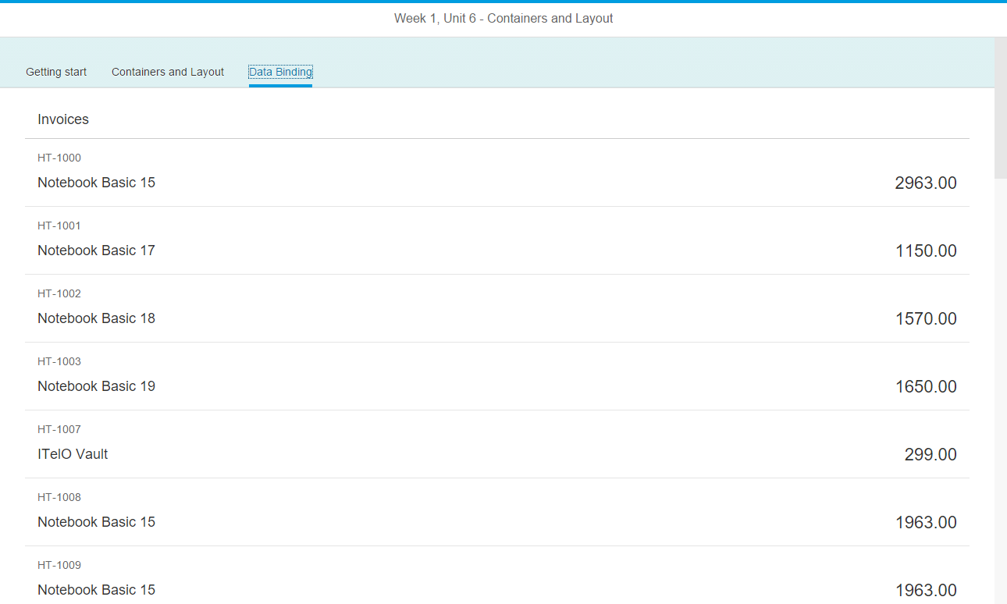

Figure 2 - A list of products from the backend service

### Create a neo-app.json file

| Explanation | **Screenshot** |
| --- | --- |
| 1. Open SAP Web IDE and right click on your project folder “myApp”. Select “New > HTML5 Application Descriptor”.   **Note:** The menu option will only appear if the project folder is directly located below the root node “Workspace”. |  |
| 1. Open the newly created file neo-app.json. It contains a JSON configuration file for your project with resource definitions. The default configuration will make sure SAPUI5 is registered under the path “/resources”. |  |

### neo-app.json

{

welcomeFile: "index.html",

routes: [

{

…

}**,**

**{**

**"path": "/destinations/ES5",**

**"target": {**

**"type": "destination",**

**"name": "ES5"**

**},**

**"description": "ES5 Demo Service"**

**}**

]

}

Add the destination “ES5” to the neo-app.json  configuration file. It contains all project settings for SAP Web IDE and is created in the root folder of your project. It is a JSON format file consisting of multiple configuration keys. The most important setting for you to configure is the path where the OpenUI5 runtime is located when starting the app.

Below “routes”, add a new configuration entry for the destination ES5. The destination itself is configured inside the SAP HANA Cloud Platform Cockpit. With this configuration entry in the neo-app.json file you are able to use it inside your application project.

### webapp/manifest.json

{

"_version": "1.1.0",

"sap.app": {

…

"applicationVersion": {

"version": "1.0.0"

}**,**

**"dataSources": {**

**"ES5": {**

**"uri": "/destinations/ES5/sap/opu/odata/IWBEP/GWSAMPLE_BASIC/",**

**"type": "OData",**

**"settings": {**

**"odataVersion": "2.0"**

**}**

**}**

**}**

},

"sap.ui": {

…

},

"sap.ui5": {

…

"models": {

…

"helloPanel": {

"type": "sap.ui.model.json.JSONModel",

"uri": "model/HelloPanel.json"

}**,**

**"" : {**

**"dataSource": "ES5"**

**}**

}

}

Create a Model Configuration in the App Descriptor. In the sap.app section we add the data source configuration for the OData service. With the key ES5 we specify a configuration object that allows automatic instantiation of this model. We specify the URI by combining the name of the destination we configured in the neo-app.json file above with the path to the service. So /destinations/ES5 references the destination that we have configured in the SAP HANA Cloud Cockpit and /sap/opu/odata/IWBEP/GWSAMPLE_BASIC/ is the path to the service endpoint. In addition, we specify the type of the service (OData) and the model version (2.0).

The complete URI at run time looks like this: <https://sapes5.sapdevcenter.com/sap/opu/odata/IWBEP/GWSAMPLE_BASIC/>

In the models section under sap.ui5, we add a second entry with an empty key. The value ES5 is a reference to the data source section that we specified above. This configuration allows the component to retrieve the technical information for this model during the start-up of the app.

Our component will then automatically create an instance of sap.ui.model.odata.v2.ODataModel according to the settings we specified above, and make it available as the default model on the component.

### webapp/view/App.view.xml

…

<Page title="OpenSAP – Developing with SAPUI5">

<IconTabBar

id="idTopLevelIconTabBar"

**selectedKey="db"**

…>

<items>

…

**<IconTabFilter**

**text="{i18n>dataBindingFilter}" key="db">**

**<content>**

**<List**

**headerText="{i18n>productListTitle}"**

**items="{/ProductSet}">**

**<items>**

**<ObjectListItem**

**title="{Name}"**

**number="{Price}"**

**intro="{ProductID}" />**

**</items>**

**</List>**

**</content>**

**</IconTabFilter>**

</items>

</IconTabBar>

</Page>

…

We add a new IconTabFilter with the key db and the translated text dataBindingFilter to the view of our app. additionally, we set the selectedkey property on the IconTabBar control to db so that this tab is opened by default when we start the app.

The content of the IconTabFilter is a list control with a custom header text. The item aggregation of the list is bound to the root path ProductSet of the OData service. And since we defined a default model, we do not have to prefix the binding definitions with a model name and can just write the path.

In the items aggregation, we define the template for the list that will be automatically repeated for each product of our service data. More precisely, we use an ObjectListItem to create a control for each aggregated child of the items aggregation. The title property of the list item is bound to properties of a single product. This is achieved by defining a relative path (without / in the beginning). This works because we have bound the items aggregation absolutely via items={/ProductSet} to the collection of products.

### webapp/i18n/i18n.properties

**…**

**# Tabs**

**dataBindingFilter = Data Binding**

**…**

**# Data Binding Content**

**productListTitle = Products**

Add the new translation texts to your resource bundle file.

**You should now see a list of products fetched from the ES5 backend system in your app!**

# (Optional) Use mock server if you have a slow internet connection

**Note:**If the service connection is too slow for you during these exercises, you can manually switch to a mock server and simulate the backend requests by doing the following changes in your project. This is a workaround that will create random test data in your app. The MockServer will be explained later in the course in more detail and would be set up a bit differently in a real project.

### webapp/index.html

…

<script>

sap.ui.getCore().attachInit(function () {

**// workaround begin: start a mock server**

**jQuery.sap.require("sap.ui.core.util.MockServer");**

**var oMockServer = new sap.ui.core.util.MockServer({**

**rootUri: "/destinations/ES5/sap/opu/odata/IWBEP/GWSAMPLE_BASIC/"**

**});**

**oMockServer.simulate("./mockdata/metadata.xml", {**

**sMockdataBaseUrl: "./mockdata",**

**bGenerateMissingMockData: true**

**});**

**oMockServer.start();**

**// workaround end**

new sap.ui.core.ComponentContainer({

name: "sap.ui.demo.wt"

}).placeAt("content");

});

</script>

…

Add the code above to your index file to start a local mock server that will intercept and simulate requests to your backend service. Don’t worry, we will explain it later in the course. This is just a workaround for now.

**webapp/mockdata/ProductSet.json**(get it from here: https://github.com/SAP/openSAP-ui5-course/tree/ui51/mockdata)

**[**

**{**

**"ProductID": "HT-1001",**

**"TypeCode": "PR",**

**"Category": "Notebooks",**

**"Name": "Notebook Basic 17",**

**"NameLanguage": "EN",**

**"Description": "Notebook Basic 17 with 2,80 GHz quad core, 17\" LCD, 4 GB DDR3 RAM, 500 GB Hard Disc, Windows 8 Pro",**

**"DescriptionLanguage": "EN",**

**"SupplierID": "0100000001",**

**"SupplierName": "Becker Berlin",**

**"TaxTarifCode": 1,**

**"MeasureUnit": "EA",**

**"WeightMeasure": "4.500",**

**"WeightUnit": "KG",**

**"CurrencyCode": "EUR",**

**"Price": "1249.00",**

**"Width": "29.000",**

**"Depth": "17.000",**

**"Height": "3.100",**

**"DimUnit": "CM",**

**"CreatedAt": "/Date(1458513044000)/",**

**"ChangedAt": "/Date(1458513044000)/",**

**"ToSupplier": {**

**"__deferred": {**

**"uri": "https://SAPES5.SAPDEVCENTER.COM:443/sap/opu/odata/IWBEP/GWSAMPLE_BASIC/ProductSet('HT-1001')/ToSupplier"**

**}**

**}**

**},**

**...**

### webapp/mockdata/metadata.xml (NEW)

**<?xml version="1.0" encoding="utf-8"?>**

**<edmx:Edmx Version="1.0"**

**xmlns:edmx="http://schemas.microsoft.com/ado/2007/06/edmx"**

**xmlns:m="http://schemas.microsoft.com/ado/2007/08/dataservices/metadata"**

**xmlns:sap="http://www.sap.com/Protocols/SAPData">**

**<edmx:DataServices m:DataServiceVersion="2.0">**

**<Schema**

**xmlns="http://schemas.microsoft.com/ado/2008/09/edm"**

**Namespace="/IWBEP/GWSAMPLE_BASIC"**

**xml:lang="en"**

**sap:schema-version="1">**

**<EntityType Name="Product">**

**<Key>**

**<PropertyRef Name="ProductID"/>**

**</Key>**

**<Property Name="ProductID" Type="Edm.String" Nullable="false" MaxLength="10"/>**

**<Property Name="TypeCode" Type="Edm.String" Nullable="false" MaxLength="2"/>**

**<Property Name="Category" Type="Edm.String" Nullable="false" MaxLength="40"/>**

**<Property Name="Name" Type="Edm.String" Nullable="false" MaxLength="255"/>**

**<Property Name="NameLanguage" Type="Edm.String" MaxLength="2"/>**

**<Property Name="Description" Type="Edm.String" MaxLength="255"/>**

**<Property Name="DescriptionLanguage" Type="Edm.String" MaxLength="2"/>**

**<Property Name="SupplierID" Type="Edm.String" Nullable="false" MaxLength="10"/>**

**<Property Name="SupplierName" Type="Edm.String" MaxLength="80"/>**

**<Property Name="TaxTarifCode" Type="Edm.Byte" Nullable="false"/>**

**<Property Name="MeasureUnit" Type="Edm.String" Nullable="false" MaxLength="3"/>**

**<Property Name="WeightMeasure" Type="Edm.Decimal" Precision="13" Scale="3"/>**

**<Property Name="WeightUnit" Type="Edm.String" MaxLength="3"/>**

**<Property Name="CurrencyCode" Type="Edm.String" Nullable="false" MaxLength="5"/>**

**<Property Name="Price" Type="Edm.Decimal" Precision="16" Scale="3"/>**

**<Property Name="Width" Type="Edm.Decimal" Precision="13" Scale="3"/>**

**<Property Name="Depth" Type="Edm.Decimal" Precision="13" Scale="3"/>**

**<Property Name="Height" Type="Edm.Decimal" Precision="13" Scale="3"/>**

**<Property Name="DimUnit" Type="Edm.String" MaxLength="3" sap:label="Dimension Unit"/>**

**<Property Name="CreatedAt" Type="Edm.DateTime" Precision="7"/>**

**<Property Name="ChangedAt" Type="Edm.DateTime" Precision="7" ConcurrencyMode="Fixed"/>**

**</EntityType>**

**<EntityContainer Name="/IWBEP/GWSAMPLE_BASIC_Entities" m:IsDefaultEntityContainer="true">**

**<EntitySet Name="ProductSet" EntityType="/IWBEP/GWSAMPLE_BASIC.Product"/>**

**</EntityContainer>**

**</Schema>**

**</edmx:DataServices>**

**</edmx:Edmx>**

Add the file metadata.xml that contains the service interface with the product entity to be mocked.

### Related Information

[Walkthrough Tutorial - Step 26: Remote OData Service](https://sapui5.hana.ondemand.com/" \l "docs/guide/44062441f3bd4c67a4f665ae362d1109.html)