Web Development:

WEB DEVELOPMENT

CORE PHP | WORDPRESS | MAGENTO | LARAVEL | SHOPIFY | ZENCART | CODEIGNITER | OPENCART

We offer a complete range of bespoke web development services right from Requirement Analysis, Conceptualization, Development, Implementation, Testing, to Maintenance and support. Whether you require a simple web application to be developed from ground up or a custom one with complex integrations – we do it all. We are having expert advisers, who can consult the client based on their needs and budget, whether to go for fresh development, or it can be developed based on available open-source solutions.
PHP Development:
PHP Hypertext Processor, that’s extensively called PHP, is designed in particular for server-side programming. It is considered to be one of the first-rate alternatives whilst seeking out an awesome exceptional functional website. PHP surely allows you to build interactive and innovative websites. With its capacity to guide numerous structures, PHP has been extensively used by professionals and users from around the globe. TechnoAdviser Technologies offers dynamic PHP web development services and solutions. The experienced team of PHP developers at TechnoAdviser Technologies has the potential to deliver the first-rate to the desk at the same time, dealing with the latest technologies, user interface & methodologies.
CORE PHP DEVELOPMENT
We have the capability to start any project from scratch using CORE PHP
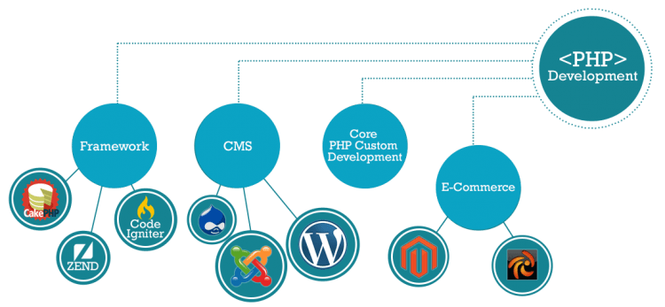

Exceptional websites and web applications:
PHP web application development can be the appropriate choice if you are looking for a top-notch quality functional website. As PHP supports multiple platforms, it is a trusted choice of most developers and end-users globally.

PHP platform to help your business grow:
TechnoAdviser provides dynamic and functional web application development services and solutions. With several years of experience in the industry, we have delivered multiple projects with very strict quality standards. Our experienced and skilled PHP developers have in-depth knowledge and expertise in the latest technologies & development platform and they are well-versed with the User interface, methodologies, servers, complexity and much more. The best thing about us is, we believe in complete transparency with our valuable clients.

Why choose PHP application development?
PHP is a robust platform used for building feature-rich websites and dynamic websites with database access. Interactive and innovative websites can be built by using PHP. The expert techno-professionals engaged with us have excellent database skills, ensuring that the data is stored and retrieved in an efficient and secure manner. The experts have a keen knowledge of front end technologies like HTML, CSS and Javascript also.
- Cost-effective solution
- PHP supports many frameworks
- Scalable and robust solutions
- Large technological support available
- Several open-source CMS available to run on LAMP
- Frequent up-gradation of language for high performance
We have several years of experience in PHP software development solutions, we have the required capability and skills to deliver the best PHP solutions that help you achieve the long term business goals.

WORDPRESS DEVELOPMENT
DYNAMIC – FLEXIBLE – COST-EFFECTIVE – SECURED – USER FRIENDLY

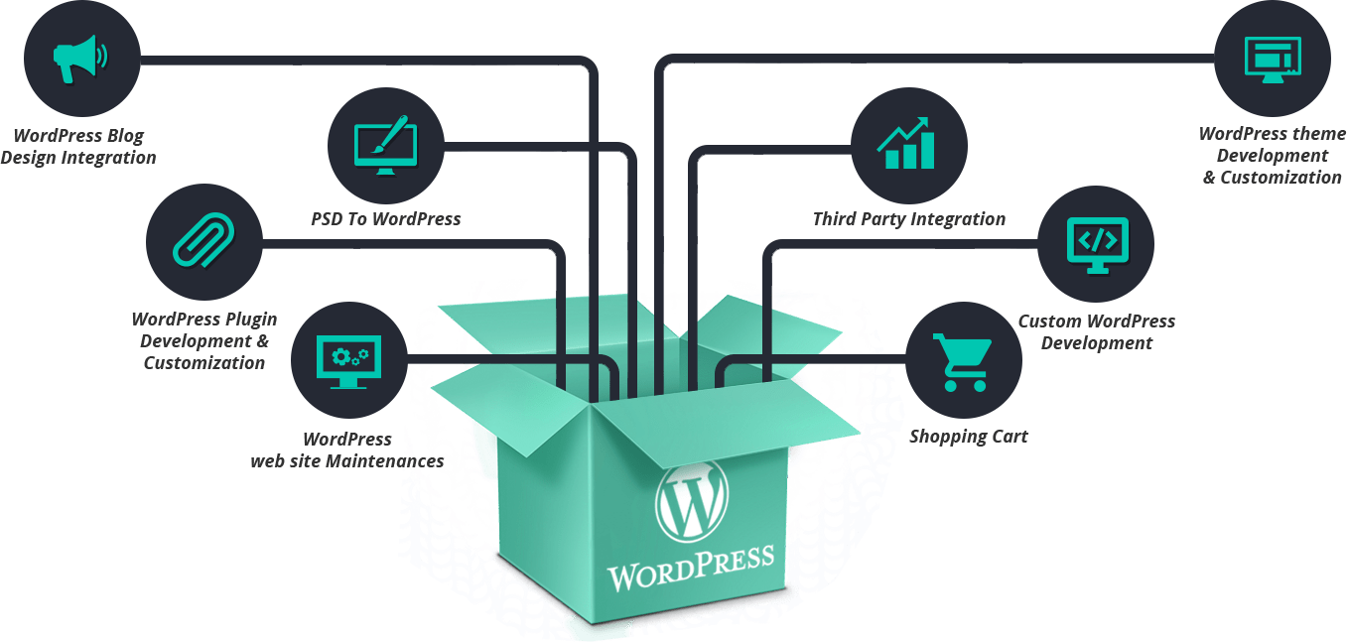

WordPress is a user-friendly content management system (CMS) based on MySQL and PHP, which functions on Web Hosting service. WordPress is a free and open-source blogging tool with numerous of features that make it preferred for creating rich and robust blogs and corporate websites. Additionally, the platform supports to get the website with high search rankings because of its SEO-friendly core capability. With its simplicity and host of plugins and templates it offers, WordPress CMS Development site to deliver a great user experience and keep the business revenues has emerged as a much in demand service for most size and types of businesses.
TechnoAdviser Technologies Pvt. Ltd. has years of experience in developing business websites and offers a wide range of Custom WordPress Development Services that suffice all the needs of your business requirements. From developing high end, responsive websites, multi-sites or even creating simple blogs, we are capable of fulfilling all your requirements. We also help you in modifying your existing WordPress website, Templates or plugin to ensure that you get what exactly you need. For us, client satisfaction matters the most as successful and timely delivery of the project to our valuable customers.

Our Expertise With WordPress!
+ Installation & Configuration
Our expert developers provide immediate assistance for the latest WordPress installation, upgrade and configuration.
+ Custom WordPress Development
We create custom WordPress websites by using the most updated versions with the latest features and functions.
+ Multisite Development
We are experts with multisite, multi-lingual, Multi-currency network setup & management, customization, bug fixing, security, updates, and adding themes & plugins.
+ WordPress API Integration
We can integrate any kind of third-party APIs like Google, PayPal, Stripe, LinkedIn, IDX, MLS, Amazon, sprout, Bill-desk, Paytm, etc to a site. We code APIs to make them functional & compatible with the site.
+ WordPress Migration Service
We offer hassle-free and quick WordPress migration service. This helps you transfer your website to a new host without losing any data.
+ WordPress Plug-in Development
With our custom WordPress plugin development service, we enhance the existing functionality of your website.
+ Support & Maintenance
We provide assistance for all your WordPress queries, issues, & hassles and offer instant maintenance service for your website.
+ PSD to WordPress Conversion
We take your PSD file and convert it into a WordPress theme. We are experts with various design formats like PSD, Adobe XD, PNG, Sketch AI, EPS, etc.
+ Many More Module & Solution By WordPress
Nowadays, WordPress provider many more advanced modules, which can serve various professions and Industries. We support solutions like eCommerce(woo-commerce), ERP, CRM, Affiliate Module, MLM, EMR and other advanced modules within the structure of WordPress & Core PHP.
+ WordPress with Woocommerce
WooCommerce is the leading eCommerce plugin for working with WordPress with all required features. WooCommerce is designed to integrate seamlessly with the WordPress platform, making it the obvious eCommerce choice for thousands of online shop owners.

LARAVEL DEVELOPMENT

A platform for high-quality web applications with modular programming and stress-free coding.
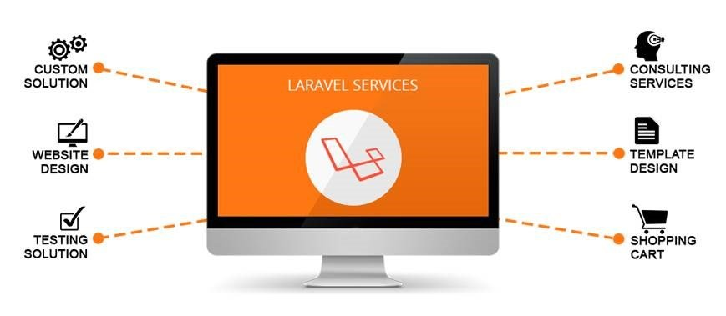
Laravel framework is among the best PHP-based web and app framework. Laravel is free and open-source. Its quick development approach and MVC architectural pattern make it more powerful. This framework works well in the development of high-quality web portals, Websites and web applications. It supports developers with a strength of free coding and modular programming.
TechnoAdviser Technologies have adept Laravel developers who develop Laravel PHP Framework suiting all kinds of small, medium and large-scale projects.
What our technical experts committed with Laravel
Laravel Custom web development
Experts at TechnoAdviser Technologies Pvt. Ltd. offers you customized, business-centric Laravel web solutions that meet the exact requirements of your business. We have experienced and skilled Laravel developers to accept any kind of complicated challenges.
Laravel CMS development
Our experts are capable to provide you with powerful Laravel CMS solutions that have an intriguing and explicit interface.
Laravel E-Commerce development
We provided a highly featured E-commerce portal with laravel to provide an amazing shopping experience for your users.
Backend Development for Mobile Applications
Due to the structure of Laravel framework, it provides lots of flexibility to offer lightweight and free development tools to support mobile application admin control. Backend development of mobile apps with Laravel to be able to offer exceptional features like big data connectivity.
Other Services for Laravel Framework
Experts of TechnoAdviser provide various services for Laravel Framework, which involved laravel theme design and integration, Site maintenance, Migration, third party API and plugin integration and custom portal developments

CODEIGNITER DEVELOPMENT

Rapid development web framework, for use in building dynamic web sites with PHP

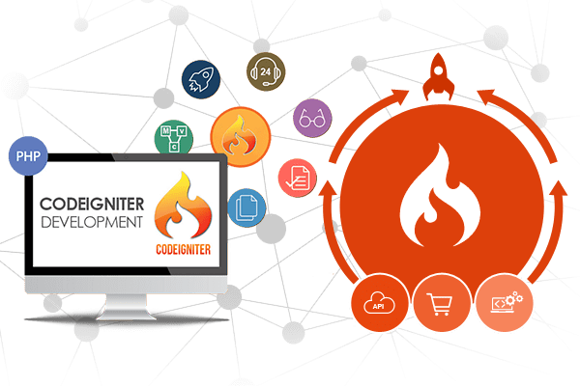
CodeIgniter is a advance PHP framework with a small footprint, built for PHP developers who need a simple and elegant development tool to create full-featured web applications.
CodeIgniter is an Application Development Framework – an advance toolkit – for users who build web sites using PHP. Its goal is to enable you to develop solutions much faster than you could if you were coding from scratch, by providing a rich set of libraries for commonly needed tasks, as well as a simple interface and logical structure to access these libraries. CodeIgniter lets you creatively focus on your project by minimizing the amount of code needed for a given task and saving your efforts and time.
It is one of the best PHP framework in web Application Development. If you are looking for develop the web application in a best way, then the one of good option is web development framework. As compared to the other web development frameworks, Codeigniter Development is fast, reliable and speed wise significant platform.

Why Codeigniter?
+ General Feature of Codeigniter
- Codeigniter is available with inbuilt library classes for numbers of complicated functionalities. Lets summaries some features of CodeIgniter
- It is MVC (Model-View-Controller) Based System
- By size, it is extremely Light Weight
- Available with full-featured database classes with support for multiple platforms.
- It offers Active Record Database Support with Form and Data Validation
- It includes security & XSS Filtering, advance session management
- For Mailing, it provides Email Sending Class. Supports Attachments, HTML/Text email, multiple protocols (Sendmail, SMTP, and Mail) and more.
- Codeigniter includes Image Manipulation Library (cropping, resizing, rotating, etc.), File Uploading Class, FTP Class
- Other features can be listed as Localization, Data Encryption, Pagination, Benchmarking, Full Page Caching, Error Logging, Calendaring Class, Application Profiling, User-Agent Class, Zip Encoding Class, Template Engine Class, Trackback Class
- The platform supports Search-engine Friendly URLs, Flexible URI Routing
- Technically it supports for Hooks and Class Extensions
- It is also available with a large library of “helper” functions
+ Security Feature
- Remote code execution:
This feature ensures that the PHP file is not accessible directly by manipulating or running a script, which would compromise the system.
- SQL injection:
A SQL injection occurs when an attacker/hacker exploits the front-end and the post data to retrieve secure data from the backend(database). This type of attack is common on the web platform. According to CodeIgniter, it becomes evident that your web application is automatically safe from such attacks. This fact has been proving by CodeIgniter User Manual excerpt: “Beyond simplicity, a major benefit to using the Active Record features is that it allows you to create database-independent applications since the query syntax is generated by each database adapter. It also allows for safer queries, since the values are escaped automatically by the system.”
- XSS Attacks:
An XSS or Cross-Site scripting attack is unarguably the common reason for the demise of web applications. An XSS attack works by a hacker crafting a malicious URL into the browser in order to compromise the security of the application. CodeIgniter has a built-in XSS filter which is initialized automatically. In order to double-check the security threats against XSS attacks, a Firefox add-on called XXS Me (download here) can be used to test the sample application against 96 different types of attacks. The results are shown in the image below. It shows that all form input fields were not found unencoded, which means the XSS filter within CodeIgniter did its job.
- Other security features:
Other then above, there are a few other security features that developers can apply. Make sure your web application does not allow any two different user groups to access each other’s accounts in the same session. This is possible by having the session data encoded with user id and user type so it can be used to determine if the account belongs to the user whose user data is in the active session. When it comes to storing passwords, the MD5 algorithm should be used to encrypt passwords. Also, if you are using file uploads, make sure the file names are encoded with a random 32-bit string so that private or sensitive information is anonymous. In addition, CodeIgniter’s form validation library can prove to be very useful. Form validation ensures that invalid information is not entered into the database. To provide a double layer of security, the SQL structure can be as such that each field conforms to the incoming form data by a) type and b) length.
+ Benefits
- Codeigniter web development platform is fast, reliable, lightweight and more capable.
- PHP framework is an easy debug that allows you easily to get out of the errors in your development. Codeigniter Development can extend your PHP coding to get specific functions through frameworks.
- In web Development, many features are almost the same so that you can describe the same code in a different way.
- Codeigniter PHP Development is the easiest way to utilize modular programs.
- Codeigniter PHP Development is compatible with most web servers, numerous operating systems and platforms.
- For many relational database management systems, PHP can be used.
- In worldwide, PHP developers are located and without any difficulty, with Codeigniter PHP development you can find an enormous amount of support through forums and blogs.
- Codeigniter has an outstanding performance as well as presentation.
- While configuring the PHP framework, Codeigniter is famous among developers because of effort investment.

MOBILE APPLICATION DEVELOPMENT

ANDROID | IOS | WINDOW | ANDROID WEB-VIEW

Everybody wants their mobile to be with uninterrupted and uncompromised speed. That is what our techno professionals deal with every day. Team TechnoAdviser helps to accelerate your mobile app development with the right experts working on it, appropriate process and the latest technology. TechnoAdviser is one of the highly recommended mobile application development company in India to serve clients all over the world.
We create apps that have result-driven, user-centric and have a high impact on your business. TechnoAdviser harnesses the advance and updated tools, latest frameworks and more to create tailored mobile apps for Android, iPhone, iPad, & tablets.
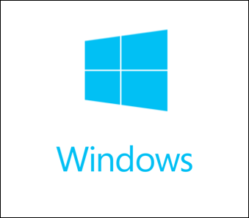

Our custom mobile application development services build mobile apps for your business that delivers everything in a single experience. As we can see, smartphone users are increasing day by day all over the globe, we are inserting more energies to study the latest trends, advanced technology and tactics to develop an app that performs with complete utility. At team TechnoAdviser, we develop a mobile app that allows you to manage your operations anytime and anywhere by everyone.
Our skilled and highly experienced mobile developers enlist all your enterprise features that outmatch your user needs. We have a big pool of mobile app technology experts who have good command over the latest technology, current trends and UX/UI concepts. We follow a dynamic process for our mobile app development services that go through an app strategy, impressive and trending designing, development and proper quality checks.

+Mobile App UI/UX Design
The interface is the most important feature of your mobile application and we make it countable while we start working on it for you. Our mobile app development services comprise high-end UX and UI that makes your mobile application interactive, engaging, user friendly with the great end-user experience. We develop impressive designs with high-end usability and rich features.

+Mobile Application Development
At TechnoAdviser, our experts strategize the process application development keeping your business requirements and goals in mind. Our custom mobile application development services cycle include various self-evaluation, comparison, detailed planning and security & quality checks. Such process of development empowers your mobile app and make it crash proof and gives great experience to your end users.

+Cross Platform Development
Now its time for step beyond the native apps and develop an app that works for all platform. At TechnoAdviser, We develop cross platform apps that run across all the major mobile operating system and helps you to take the best of it. we builds apps that work flawlessly and with effectiveness.

+Third party application Integration with mobile app
Mobile applications are not limited to few features and modules or even it is not necessary to develop everything from scretch. There are many third party APIs, Solutions and services may be required to integrate with your app to give it advance functioning. We at TechnoAdviser serve you to identify such third party services and integrate with your mobile applications.

+Website/eCommerce Portal to Mobile App conversation/integration.

Do you already have website or eCommerce portal and looking to serve with mobile application to your end-users. Are you worried about how you can manage both? Your search ends here. Experts at TechnoAdviser are having capabilities to run your website and mobile application both with a single admin panel. Our expertise will allow your both platforms to synchronise with each and it will serve your client on any platforms which can be Window, IOS, Linux, Ipad, IOS phone, Android Phone, Tablets etc.

+Mobile Application Maintenance
With several years of experience in web and mobile application development, we are equipped with all the resources and skills to maintain and support your mobile application. So, if you are looking for a mobile app development company to maintain your app, TechnoAdviser Technologies is the best choice for you.

SEO & DIGITAL MARKETING

“I have a BEAUTIFUL WEBSITE – Vs. – I have a WEBSITE with ONGOING TRAFFIC”



TechnoAdviser Technologies Private Limited is a digital marketing company with a long history of delivering great results for our clients. We take a personalized approach to each of our customer projects. In some cases, we may focus more on SEO, while in others we’ll dig more into PPC, social media, or conversion optimization. It’s often best to get a totally clean start where TechnoAdviser will work with your team to restructure your entire online strategy and web design from the ground up, leading to a higher customer conversion rate and additional sales. We offer the right combination of digital marketing services to deliver the very best results.
Our Digital Marketing Services
So, what exactly is digital marketing, and what are the different types of digital marketing? We’re glad you asked. Digital marketing is any type of promotional activity done via the website. This includes anything in our list of marketing services.
Search Engine Optimization (SEO)
Smart companies seeking that elusive competitive advantage online to see the greatest successes with a strategy that employs optimization best practices. SEO takes into consideration search engines, social network and online news media preferences while catering to your customer’s needs. Increase your online visibility and put your brand in front of the right audience, on the right channel, at the right point in their purchasing journey with our SEO services. READ MORE
Social Media Marketing
Understanding your audience is key to your brand’s success in social media. The B2B buying journey, from discovery to conversion, may extend over weeks or months of information gathering, consumption and for the good stuff, sharing. Put our pioneering combination of traditional marketing, search marketing and social media to work for your brand, to improve direct website traffic, brand buzz and search engine rankings.​
Pay-Per-Click Advertising
To support solid and effective SEO campaign strategies, Pay-Per-Click has emerged as a fundamental Internet Marketing channel utilized by every business from sole proprietorship’s too immense corporations in order to drive immediate results. Consult TechnoAdviser to determine how a selective and closely monitored PPC campaign can jump-start the results your online business requires.​
Content Marketing
Content marketing is found on social media, websites, blogs, emails, and more. Developing helpful, useful, and interesting content helps strengthen your business’ story and gets your story heard by the right people. It gives your potential customers a reason to engage with your business beyond a quick visit to your website, and your current customers a reason to stick around.
Position your business above your competitors by educating and entertaining your audience to become advocates of your brand with our content marketing services.
Branding and Creative Services
No matter your business size, industry, or location, a strong, effective, and cohesive brand strategy and design help to convey your company’s quality, credibility, value, and experience. When it comes to marketing your products and services, those that have a strong brand hold an enormous competitive advantage.
Conversion Rate Optimization
A solid Conversion Rate Optimization strategy will help your business to increase sales, form submissions, blog or newsletter subscriptions, requests for additional information, and appointment scheduling. Conversion rates can be optimized across all digital channels and results can and should be revisited often and adjusted as necessary.
WHY TECHNOADVISER?
We, at TechnoAdviser, bring a complete package of digital marketing solutions to help your business to extend its reach on a global scale. There is more than one reason why you should choose us as your digital partner.
End-to-End Solutions
We are a one-stop destination as we cover all dimensions of online marketing services, from SEO to SEM, PPC, content marketing, mobile app optimization, and more.
Client-Centric Perspective
We follow a client-centric perspective and create customized solutions that match their requirement to perfection. We understand their needs and are available round the clock for communication.
Unmatched Experience
Our unmatched experience of more than a decade makes us a pioneer in the field of digital marketing. We have an impressive list of satisfied clients in India and across the globe.
Dedicated Team Of Experts
At TechnoAdviser, we have a dedicated team of certified online marketers who have expertise in various aspects of digital strategies. Their proven expertise comes with certifications in Google Adwords, Analytics, Customer Acquisition, and more.
Progressive Approach
We have a progressive approach as we always endeavor to follow the changing trends and make them a part of our digital strategies. We make sure that your business avails maximum traffic and revenues with these services.
Process for Success
Our expert marketers follow a process that is tailor-made for success. We begin with developing a strategy that guarantees online success, works to bring more traffic to your website, and drive the leads to conversion.

HIRE DEDICATED TEAM

NO RECRUITMENT HEADACHE | NO HR COST | EXTENSIVE TEAM SUPPORT | COST EFFECTIVE

If you’re searching for dedicated techno professionals who can grow beyond capabilities and build custom web and mobile applications, then our dedicated software development team can be an ideal solution for you. TechnoAdviser Technologies offers dedicated development teams for a wide array of industry verticals catering to all kinds of start-ups, mid and large scale businesses.
Cut The Overhead, Our dedicated development model is designed to reduce your overhead, while ensuring high-quality, timely deliverables for each project milestone.
- No Recruiting Costs any more
- No Need To Pay For Vacations
- No Office Rental Cost
- No Operational Overhead
- No Hardware Cost
- No hiring – firing tension
- Easy assistance from senior resource
- Easily replaceable if not suitable

