

**ASSIGNMENT#3**

**GROUP MEMBERS:**

RUTABA HAYAT FA23-BSE-220

ASNA AQEEL SP24-BSE-016

MUHIBBA FATIMA SP24-BSE-138

**Home Page**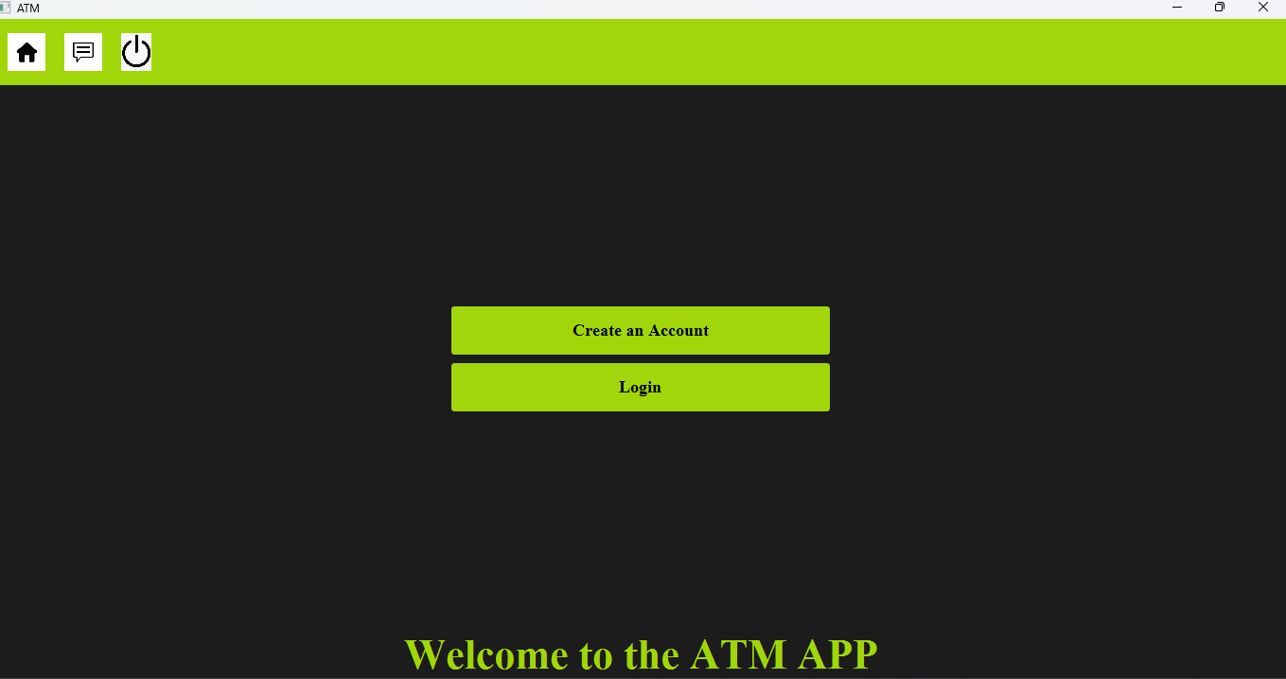

**Account Creation**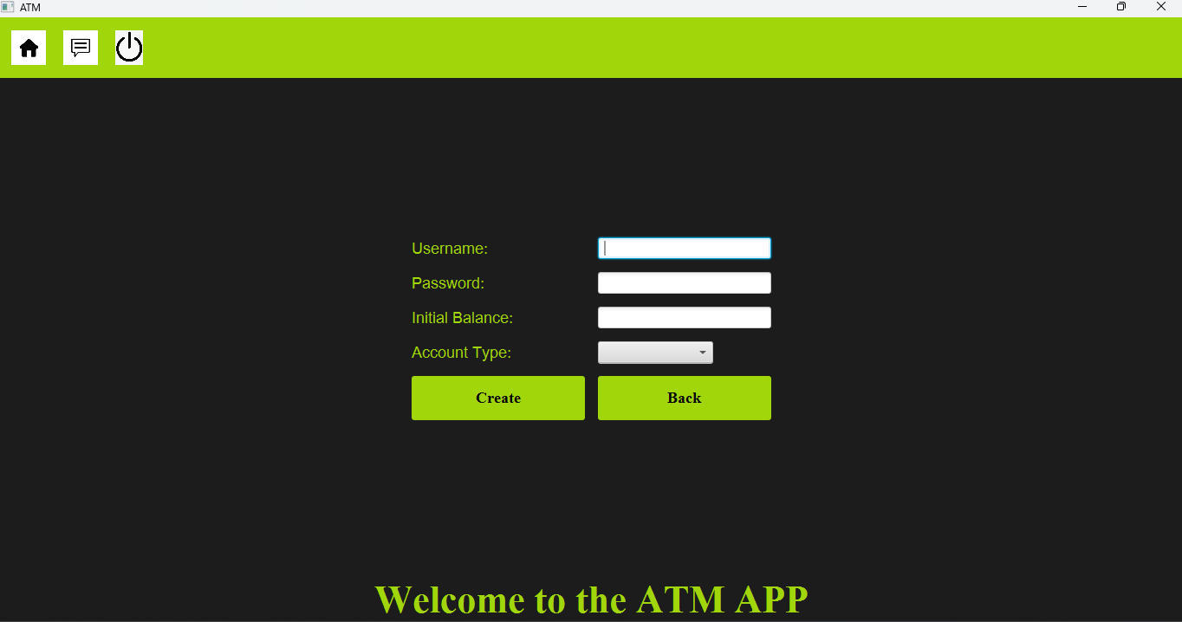

**Login page**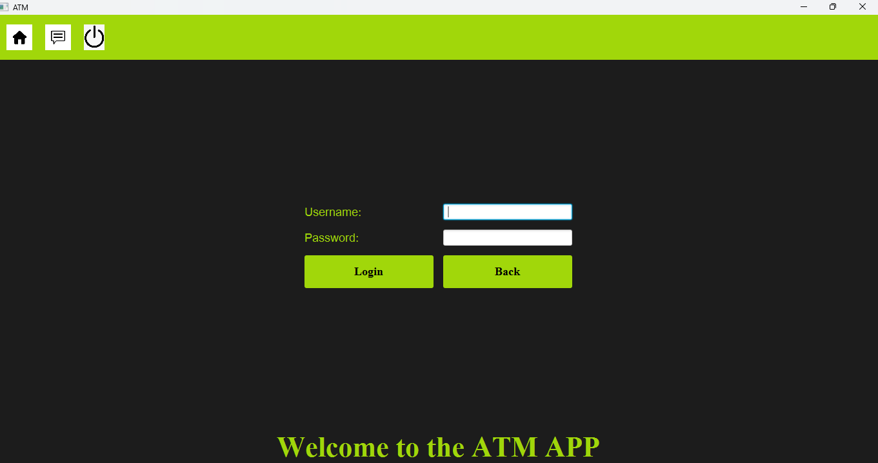

**Main Menu**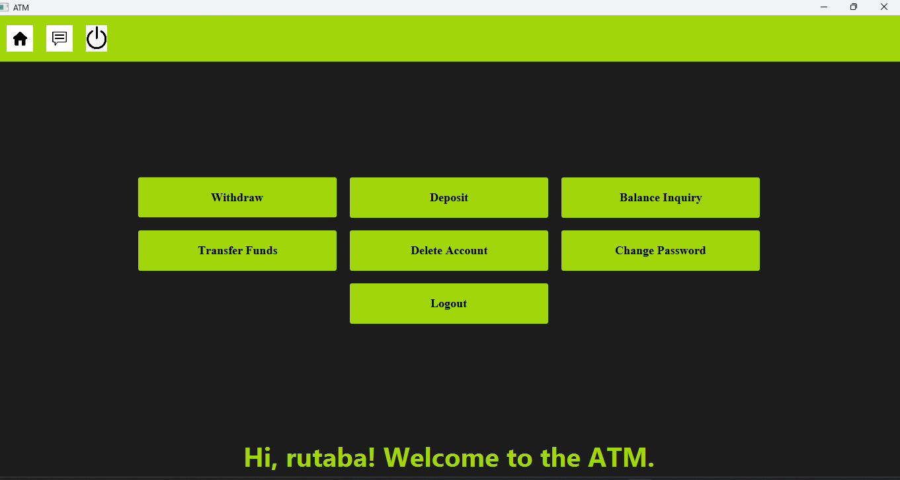

**Withdraw**

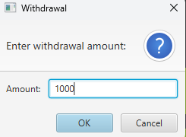

**Deposit**

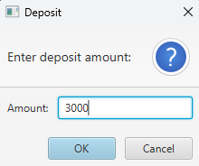

**Balance Inquiry**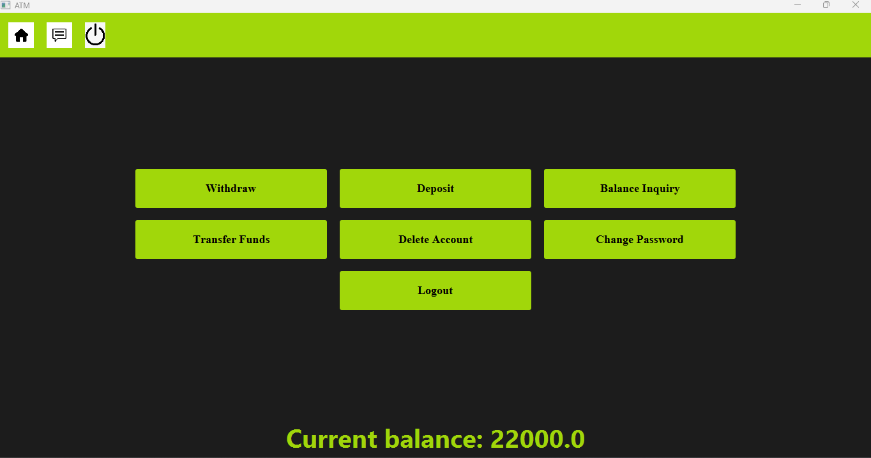

**Account Deletion**

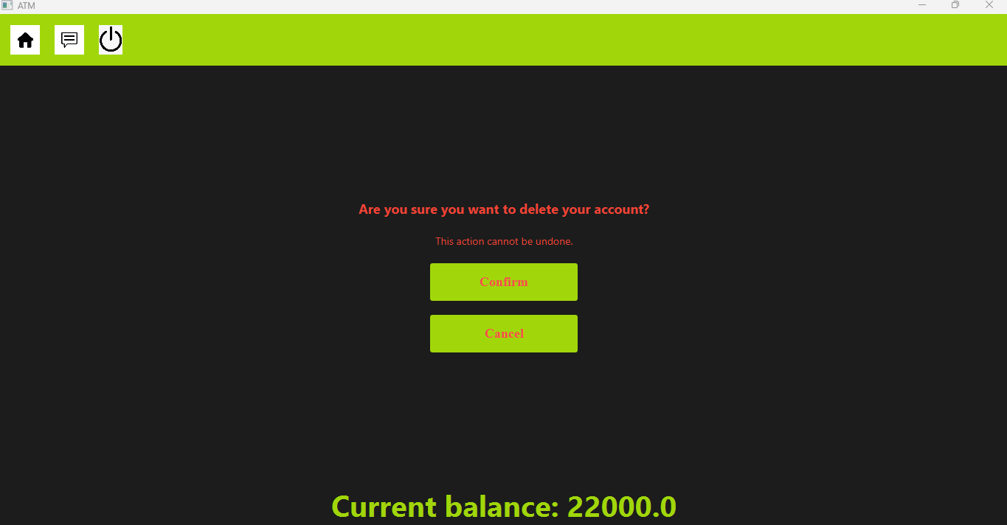

**Change Password**

