**A Report on Blood Bank Management System**

**(Project 1- using C language)**

**Course Code: SWE 231**

**By**

**Rubaiyat Tasnia Husain**

**ID: 153-35-1367**

**Department of Software Engineering**

**Daffodil International University**

**Under the supervision of**

**Dr. Md. Ashraf Ali**

**Associate Professor**

**Department of Software Engineering**

**Daffodil International University**



**Table of Contents**

1. Acknowledgement…………………………………………………………………………… 3
2. Introduction .……………………………………………………………… ………………… 4
   1. Overview………………………………………………………………………………… 4
   2. Background & Motivation……………………………………………………………… 4
   3. Objectives……………………………………………………………………………… 4
3. Features at a glance …………………………………………………………………………5
4. Use-case diagram of Blood Bank Management System………………………………………5
5. Data flow diagram……………………………………………………………………………6
6. Project description……………………………………………………………………………7
   1. Main menu………………………………………………………………………………7
      1. Admin panel…………………………………………………………………….7
         1. Add donor……………………………………………………………….7
         2. View donor ……………………………………………………………….7
         3. Delete donor……………………………………………………………….7
         4. Log out…………………………………………………………………….8
         5. Exit……………………………………………………………………….8
      2. Guest Panel……………………………………………………………………….8
         1. View donor……………………………………………………………….8
         2. About blood donation………………………………………………….8
         3. Contact us……………………………………………………………….8
   2. Implementation …………………………………………………………………………9
   3. Features of product……………………………………………………………………39
7. Upcoming features…………………………………………………………………………45
8. Conclusion …………………………………………………………………………………45
9. References …………………………………………………………………………………45
10. **Acknowledgement**

The Author expresses her indebtedness and heartfelt thanks to her project supervisor Dr. Ashraf Ali for his valuable guidance, constructive criticism and constant help during the course of the project work and in preparation of this manuscript.

Without his help , the completion of this report would not be possible.

The author expresses her sincere thanks to Mr. Imran Mahmud , Assistant professor of department of software engineering , for providing necessary help.

Thanks are due to Mr. Imran Hadid for his help in work as well as many other ways.

**Rubaiyat Tasnia Husain**

**ID: 153-35-1367**

**Department of Software Engineering**

**Daffodil International University**

1. **Introduction**
   1. **Overview**

This report discusses why this product was important & how does it work, & what I have learnt from building this software. What are the specifications of this software, what are the objectives, methods & which operating system will support this software.

Also this report will present some screenshots of the product with description along with the code.

Here I have described the limitations of the software & what are the future plan of this,& which management should be taken while this product will be updated.

* 1. **Background & Motivation**

In 2014, while my Father was under an operation for his sickness, he needed blood for it. That time I found that find a donor in time is very difficult.

Till now every time I need blood for him I have to contact many people & it becomes very hard to find a donor of his blood group when needed. I know a lot of people who face this problem on critical times.

So in that aspect I decided to make a project on **Blood Bank Management System**, to organize the database of donor, blood group & related information.

As it will make to find & reach a donor very easy & quickly.

* 1. **Objectives**

By using graphics on screen interface, it will be easier to add donors information in blood group wise along with the address & contact information.

1. **Features of the product at glance**

~ Strong Security

Everywhere security is the most important thing. For this purpose I have made the security of this product as best as I can make it. In the admin log in panel there is a password protection for the admin so that any other person could not bring any change in this product. This ensures the security of the product very well.

~Clock

On the main menu page there is a clock which shows the time & date.

~Admin panel & Guest panel

On admin panel an admin can log in in this software using the password. A guest can use the product without any password.

1. **The use case diagram**

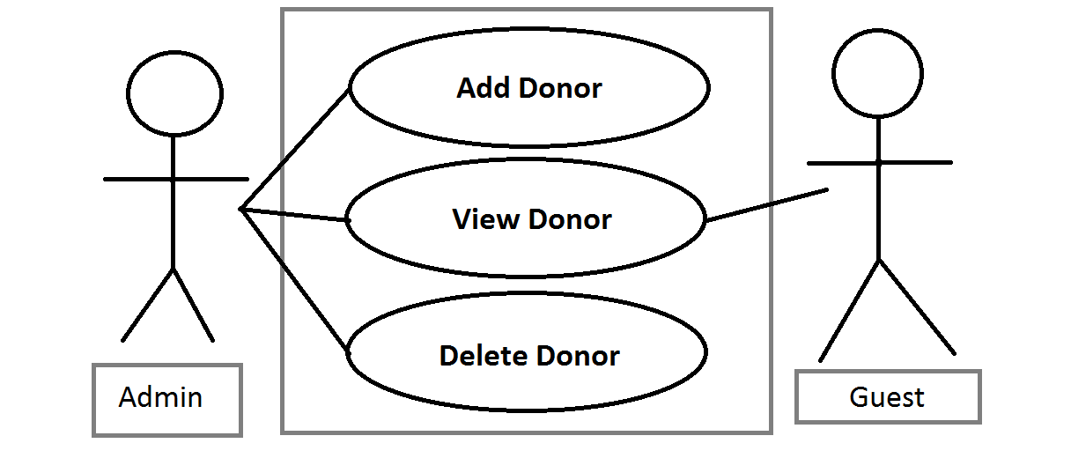

1. **The Data flow Diagram**

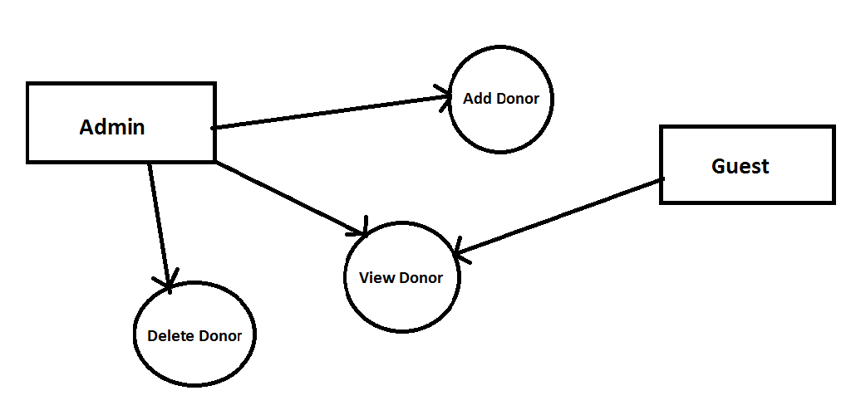

1. **Product description**
   1. **Main menu**

After opening the software, there is a welcome message which says “Welcome to DIU blood bank”. Underneath the message, there are two options, one is for admin and another one is for guest.

* + 1. **Admin panel**

This panel is for admin. The admin can log in with a password. After giving the right password, there will be a message showing “log in successful”. If the password is wrong, it will show “incorrect password, please try again”. After logging in, there are some options called,

1. Add donor
2. View donor
3. Delete donor
4. Log out
5. Exit
   * + 1. **Add donor**

This option is for adding a new donor with information. Like, name of donor, blood group, address & contact information.

* + - 1. **View donor**

This option is to view the added donor list.

* + - 1. **Delete Donor**

This is to delete a donor’s all information.

* + - 1. **Log out**

This is to log out from admin panel. After choosing this option admin will return to the first page.

* + - 1. **Exit**

This is used to close the software.

* + 1. **Guest panel**

* + - 1. **View donor**

This option helps to find a donor very easy & quickly.

* + - 1. **About blood donation**

Here, the user will able to get information about blood donation & other things related to donation. As,

1. About donation
2. Eligibility
3. Types of donation
   * + 1. **Contact us**

Here, the mailing address of admin is given. So that if there is any suggestion or complain about the feature, the user can send his/her opinion to the admin.

* 1. **Implementation**

#include<stdio.h>

#include<windows.h>

#include<conio.h>

#include<string.h>

#include<time.h>

#define speed 3

voidadmin_mainmenu(void);

voidfirstPage();

void login(int);

voidadmin_design();

voidnewdonor();

voidviewdonor();

voiddeletedonor();

voidsearchdonor();

voidguest_mainmenu();

voidguest_design();

void contact();

void about();

voidblood_donation();

voidblood_detailed();

voidblood_type();

voidprint_admin();

voidprint_load_slow();

intgetdata();

voidprint_guest();

voiddonorlist();

voidprint_slow(char per[1000]);

void date();

intcheckid(int);

char password[10] = "1";

char catagories[][25]={"A+", "A-", "B+", "B-", "AB+", "AB-", "O+", "O-"};

struct blood{

char name[30];

char address[20];

char email[20];

int phone;

intdonor_id;

char *cat;

char *sr;

};

struct blood donor;

FILE *fp, *fpp;

COORD coord = {0,0};

int s, b, u;

voidgotoxy(int x, int y){

coord.X = x;

coord.Y = y;

SetConsoleCursorPosition(GetStdHandle(STD_OUTPUT_HANDLE), coord);

}

int main(void){

firstPage();

return 0;

}

voidfirstPage(){

system("cls");

system("mode 150");

system("COLOR F0");

charch;

gotoxy(124,0);

date();

gotoxy(50,6);

printf("\xB2\xB2\xB2\xB2\xB2\xB2\xB2\xB2\xB2\xB2\xB2\xB2\xB2\xB2 Welcome to the DIU Blood Bank \xB2\xB2\xB2\xB2\xB2\xB2\xB2\xB2\xB2\xB2\xB2\xB2\xB2\xB2");

gotoxy(65,11);

printf("Thanks for using our software.");

gotoxy(65,16);

printf("Press 1 if you want to go to Admin Panel.");

gotoxy(65,18);

printf("Press 2 for Guest.");

InputOptions:

gotoxy(65,21);

printf("Enter your choice : ");

ch = getch();

switch(ch){

case '1':

login(1);

break;

case '2':

guest_design();

break;

default:

{

gotoxy(65,23);

printf("\aWrong Entry!!Please re-enter the correct output");

gotoInputOptions;

}

}

}

void login(intFirstTime){

system("cls");

system("COLOR F0");

system("mode 150");

gotoxy(124,0);

date();

if(FirstTime == 0)

{

gotoxy(75,15);

printf("Password Incorrect.");

}

char d[16]=" Login Panel ";

charch,pass[10];

inti=0,j;

gotoxy(60,4);

for(j=0;j<15;j++)

{

printf("\xB2");

}

for(j=0;j<3;j++){

printf("=");

}

for(j=0;j<12;j++)

{

printf("%c",d[j]);

}

for(j=0;j<3;j++){

printf("=");

}

for(j=0;j<15;j++)

{

printf("\xB2");

}

gotoxy(75,7);

printf("Enter Password:");

while(ch!=13)

{

ch=getch();

if(ch!=13 &&ch!=8)

{

putch('*');

pass[i] = ch;

i++;

}

}

pass[i] = '\0';

if(strcmp(pass,password)==0)

{

gotoxy(75,12);

printf("Login Successful");

gotoxy(75,15);

printf("Press any key to go to main menu");

if(getch())

{

admin_design();

}

}

else

{

login(0);

}

}

voidadmin_design(){

system("cls");

system("COLOR F0");

system("mode 150");

inti;

gotoxy(50,12);

print_load_slow();

Sleep(2000);

for(i=0; i<3; i++)

{

system("cls");

gotoxy(50,12);

printf("Admin Panel......\n\n\n");

Sleep(500);

gotoxy(50,15);

print_admin();

Sleep(500);

}

admin_mainmenu();

}

voidadmin_mainmenu(){

char c;

system("cls");

system("COLOR F0");

system("mode 150");

gotoxy(124,0);

date();

gotoxy(50,3);

printf("\xB2\xB2\xB2\xB2\xB2\xB2\xB2\xB2\xB2\xB2\xB2\xB2\xB2\xB2\xB2\xB2\xB2\xB2\xB2\xB2\xB2\xB2 MAIN MENU \xB2\xB2\xB2\xB2\xB2\xB2\xB2\xB2\xB2\xB2\xB2\xB2\xB2\xB2\xB2\xB2\xB2\xB2\xB2\xB2\xB2\xB2");

gotoxy(50,4);

printf("\xB2\t\t\t\t\t\t\t\xB2");

gotoxy(50,5);

printf("\xB2\t\t1. Add New Donor\t\t\t\xB2");

gotoxy(50,6);

printf("\xB2\t\t2. View Blood Donor\t\t\t\xB2");

gotoxy(50,7);

printf("\xB2\t\t3. Delete Donor\t\t\t\t\xB2");

gotoxy(50,8);

printf("\xB2\t\t4. Logout\t\t\t\t\xB2");

gotoxy(50,9);

printf("\xB2\t\t5. Exit\t\t\t\t\t\xB2");

gotoxy(50,10);

printf("\xB2\t\t\t\t\t\t\t\xB2");

gotoxy(50,11);

printf("\xB2\xB2\xB2\xB2\xB2\xB2\xB2\xB2\xB2\xB2\xB2\xB2\xB2\xB2\xB2\xB2\xB2\xB2\xB2\xB2\xB2\xB2\xB2\xB2\xB2\xB2\xB2\xB2\xB2\xB2\xB2\xB2\xB2\xB2\xB2\xB2\xB2\xB2\xB2\xB2\xB2\xB2\xB2\xB2\xB2\xB2\xB2\xB2\xB2\xB2\xB2\xB2\xB2\xB2\xB2");

InputOptions:

gotoxy(60,15);

printf("Enter your choice: ");

c = getch();

switch(c)

{

case '1':

newdonor();

break;

case '2':

viewdonor();

break;

case '3':

deletedonor();

break;

case '4':

firstPage();

break;

case '5':

system("cls");

exit(0);

default:

{

gotoxy(60,18);

printf("\aWrong Entry!!Please re-enter the correct output");

gotoInputOptions;

}

}

}

voidnewdonor(){

char c;

system("cls");

system("COLOR F0");

system("mode 150");

gotoxy(124,0);

date();

gotoxy(50,3);

printf("******************** Add New Blood Donor ********************");

gotoxy(68,5);

printf("1. A+");

gotoxy(68,6);

printf("2. A-");

gotoxy(68,7);

printf("3. B+");

gotoxy(68,8);

printf("4. B-");

gotoxy(68,9);

printf("5. AB+");

gotoxy(68,10);

printf("6. AB-");

gotoxy(68,11);

printf("7. O+");

gotoxy(68,12);

printf("8. O-");

gotoxy(50,14);

printf("**************************************************************");

gotoxy(58,16);

printf("Choose your category to add Donor: ");

scanf("%d", &s);

fp=fopen("donor.dat","ab+");

if(getdata()==1)

{

donor.cat=catagories[s-1];

fseek(fp,0,SEEK_END);

fwrite(&donor,sizeof(donor),1,fp);

fclose(fp);

gotoxy(58,18);

printf("Account Created successfully!");

gotoxy(58,20);

printf("Enter 1 to go to the Main menu OR 0 for Exit");

scanf("%d", &b);

if (b==1)

admin_mainmenu();

else

system("cls");

exit(0);

}

}

intgetdata(){

system("cls");

system("COLOR F0");

system("mode 150");

gotoxy(124,0);

date();

int b, t;

gotoxy(55,5);printf("Enter the Information Below");

gotoxy(50,6);

printf("********************************************");

gotoxy(50,16);

printf("********************************************");

gotoxy(65,8);

printf("Category:");

gotoxy(75,8);

printf("%s",catagories[s-1]);

InputData:

gotoxy(58,10);

printf("Enter Donor ID number: ");

scanf("%d",&t);

if (checkid(t)==0){

gotoxy(58,20);

printf("This ID already exists. Input again!");

gotoInputData;

return 0;

}

donor.donor_id=t;

gotoxy(58,11);

printf("Enter Donor Name: ");

scanf("%s", donor.name);

gotoxy(58,12);

printf("Enter Donor Address: ");

scanf("%s", donor.address);

gotoxy(58,13);

printf("Enter Donor Phone Number: ");

scanf("%d", &donor.phone);

gotoxy(58,14);

printf("Enter Donor Email: ");

scanf("%s", donor.email);

return 1;

}

intcheckid(int t){

rewind(fp);

while(fread(&donor,sizeof(donor),1,fp)==1)

if(donor.donor_id == t)

return 0; //returns 0 if user exits

return 1;

}

voidviewdonor(){

inti=0,j, z = 10;

system("cls");

system("COLOR F0");

system("mode 150");

gotoxy(40,3);

printf("*********************************Donor List*****************************");

gotoxy(40,5);

printf(" ID TYPE NAME CONTACT Address EMAIL ");

j=6;

fp=fopen("donor.dat","rb");

while(fread(&donor,sizeof(donor),1,fp)==1)

{

gotoxy(42,j);

printf("%d",donor.donor_id);

gotoxy(53,j);

printf("%s", donor.cat);

gotoxy(64,j);

printf("%s",donor.name);

gotoxy(78,j);

printf("%d", donor.phone);

gotoxy(95,j);

printf("%s",donor.address);

gotoxy(110,j);

printf("%s",donor.email);

printf("\n\n");

j++;

}

fclose(fp);

z = z + j;

gotoxy(52,z);

printf("Press any key to return to main menu");

if(getch())

admin_mainmenu();

}

voiddeletedonor(){

intfindonor;

system("cls");

system("COLOR F0");

system("mode 150");

gotoxy(124,0);

date();

int d, j = 16;

char name[30];

char another='y';

while(another=='y')

{

system("cls");

gotoxy(50,4);

printf("Enter the Information Below");

gotoxy(38,6);

printf("\xB2\xB2\xB2\xB2\xB2\xB2\xB2\xB2\xB2\xB2\xB2\xB2\xB2\xB2\xB2\xB2\xB2\xB2\xB2\xB2\xB2\xB2\xB2\xB2\xB2\xB2\xB2\xB2\xB2\xB2\xB2\xB2\xB2\xB2\xB2\xB2\xB2\xB2\xB2\xB2\xB2\xB2\xB2\xB2\xB2\xB2\xB2\xB2\xB2\xB2\xB2\xB2\xB2\xB2");

gotoxy(38,10);

printf("\xB2\xB2\xB2\xB2\xB2\xB2\xB2\xB2\xB2\xB2\xB2\xB2\xB2\xB2\xB2\xB2\xB2\xB2\xB2\xB2\xB2\xB2\xB2\xB2\xB2\xB2\xB2\xB2\xB2\xB2\xB2\xB2\xB2\xB2\xB2\xB2\xB2\xB2\xB2\xB2\xB2\xB2\xB2\xB2\xB2\xB2\xB2\xB2\xB2\xB2\xB2\xB2\xB2\xB2");

gotoxy(50,8);

printf("Enter the Donor ID for delete:");

scanf("%d",&d);

fp=fopen("donor.dat","rb");

rewind(fp);

while(fread(&donor,sizeof(donor),1,fp)==1)

{

if(donor.donor_id==d)

{

gotoxy(55,13);

printf("Donor record is available");

gotoxy(38,15);

printf("TYPE NAME Address EMAIL PHONE NUMBER");

gotoxy(38,j);

printf("%s",donor.cat);

gotoxy(46,j);

printf("%s",donor.name);

gotoxy(58,j);

printf("%s", donor.address);

gotoxy(73,j);

printf("%s", donor.email);

gotoxy(82,j);

printf("%d",donor.phone);

findonor=0;

break;

}

}

if(findonor==0 )

{

gotoxy(50,18);

printf("Do you want to delete it?(Y/N):");

if(getch()=='y')

{

fpp=fopen("blood.dat","wb");

rewind(fp);

while(fread(&donor,sizeof(donor),1,fp)==1)

{

if(donor.donor_id!=d)

{

fseek(fpp,0,SEEK_CUR);

fwrite(&donor,sizeof(donor),1,fpp);

}

}

fclose(fpp);

fclose(fp);

int a=1;

a=remove("donor.dat");

rename("blood.dat","donor.dat");

if(a==0)

{

gotoxy(50,20);

printf("This account is successfully deleted");

gotoxy(50,22);

printf("Delete another Account?(Y/N)");

}

}

else

admin_mainmenu();

fflush(stdin);

another=getch();

}

else

{

gotoxy(50,18);

printf("No record is found.");

if(getch())

admin_mainmenu();

}

}

admin_mainmenu();

}

voidguest_design(){

system("cls");

system("COLOR F0");

system("mode 150");

gotoxy(124,0);

date();

inti;

gotoxy(50,12);

print_load_slow();

Sleep(2000);

for(i=0; i<3; i++)

{

system("cls");

gotoxy(50,12);

printf("Welcome Guest......\n\n\n");

Sleep(500);

gotoxy(50,15);

print_admin();

Sleep(500);

}

guest_mainmenu();

}

voidguest_mainmenu(){

char c;

system("cls");

system("COLOR F0");

system("mode 150");

gotoxy(124,0);

date();

gotoxy(50,3);

printf("\xB2\xB2\xB2\xB2\xB2\xB2\xB2\xB2\xB2\xB2\xB2\xB2\xB2\xB2\xB2 Guest Menu \xB2\xB2\xB2\xB2\xB2\xB2\xB2\xB2\xB2\xB2\xB2\xB2\xB2\xB2\xB2");

gotoxy(50,11);

printf("\xB2\xB2\xB2\xB2\xB2\xB2\xB2\xB2\xB2\xB2\xB2\xB2\xB2\xB2\xB2\xB2\xB2\xB2\xB2\xB2\xB2\xB2\xB2\xB2\xB2\xB2\xB2\xB2\xB2\xB2\xB2\xB2\xB2\xB2\xB2\xB2\xB2\xB2\xB2\xB2\xB2\xB2");

gotoxy(50,4);

printf("\xB2\t\t\t\t\t \xB2");

gotoxy(50,10);

printf("\xB2\t\t\t\t\t \xB2");

gotoxy(50,5);

printf("\xB2\t\t1. View Donor\t\t \xB2");

gotoxy(50,6);

printf("\xB2\t\t2. Contact us\t\t \xB2");

gotoxy(50,7);

printf("\xB2\t\t3. About\t\t \xB2");

gotoxy(50,8);

printf("\xB2\t\t4. Back\t\t\t \xB2");

gotoxy(50,9);

printf("\xB2\t\t5. Exit\t\t\t \xB2");

gotoxy(58,13);

printf("Select Choice : ");

scanf("%d", &u);

if(u == 1){

searchdonor();

}else if(u == 2){

contact();

}else if(u == 3){

about();

}else if (u == 4){

firstPage();

}else if (u == 5){

system("cls");

exit(0);

}else{

guest_mainmenu();

}

}

void contact(){

system("cls");

system("COLOR F0");

system("mode 150");

gotoxy(124,0);

date();

gotoxy(50,3);

printf("\xB2\xB2\xB2\xB2\xB2\xB2\xB2\xB2\xB2\xB2\xB2\xB2\xB2\xB2\xB2 Admin Contact \xB2\xB2\xB2\xB2\xB2\xB2\xB2\xB2\xB2\xB2\xB2\xB2\xB2\xB2\xB2");

gotoxy(50,8);

printf("\xB2\xB2\xB2\xB2\xB2\xB2\xB2\xB2\xB2\xB2\xB2\xB2\xB2\xB2\xB2\xB2\xB2\xB2\xB2\xB2\xB2\xB2\xB2\xB2\xB2\xB2\xB2\xB2\xB2\xB2\xB2\xB2\xB2\xB2\xB2\xB2\xB2\xB2\xB2\xB2\xB2\xB2\xB2\xB2\xB2");

gotoxy(50,4);

printf("\xB2 \t\t\t\t\t \xB2");

gotoxy(50,7);

printf("\xB2\t\t\t\t\t \xB2");

gotoxy(50,5);

printf("\xB2\tName : Rubaiyat Tasnia Husain\t \xB2");

gotoxy(50,6);

printf("\xB2\tEmail : rubaiyat229@gmail.com\t \xB2");

gotoxy(55,25);

printf("Press any key to return to main menu");

if(getch())

guest_mainmenu();

}

void about(){

system("cls");

system("mode 150");

system("COLOR F0");

gotoxy(124,0);

date();

charch;

gotoxy(50,6);

printf("\xB2\xB2\xB2\xB2\xB2\xB2\xB2\xB2\xB2\xB2\xB2\xB2\xB2\xB2\xB2\xB2\xB2\xB2\xB2\xB2 About \xB2\xB2\xB2\xB2\xB2\xB2\xB2\xB2\xB2\xB2\xB2\xB2\xB2\xB2\xB2\xB2\xB2\xB2\xB2\xB2");

gotoxy(50,14);

printf("\xB2\xB2\xB2\xB2\xB2\xB2\xB2\xB2\xB2\xB2\xB2\xB2\xB2\xB2\xB2\xB2\xB2\xB2\xB2\xB2\xB2\xB2\xB2\xB2\xB2\xB2\xB2\xB2\xB2\xB2\xB2\xB2\xB2\xB2\xB2\xB2\xB2\xB2\xB2\xB2\xB2\xB2\xB2\xB2\xB2\xB2\xB2\n\n\n");

gotoxy(50,7);

printf("\xB2\t\t\t\t\t\t\xB2");

gotoxy(50,13);

printf("\xB2\t\t\t\t\t\t\xB2");

gotoxy(50,8);

printf("\xB2\t\t1. About donation\t\t\xB2");

gotoxy(50,9);

printf("\xB2\t\t2. Eligibility\t\t\t\xB2");

gotoxy(50,10);

printf("\xB2\t\t3. Types of donation\t\t\xB2");

gotoxy(50,11);

printf("\xB2\t\t4. Back\t\t\t\t\xB2");

gotoxy(50,12);

printf("\xB2\t\t5. Exit\t\t\t\t\xB2");

gotoxy(65,16);

InputOptions:

printf("Enter your choice : ");

ch = getch();

switch(ch)

{

case '1':

blood_donation();

break;

case '2':

blood_detailed();

break;

case '3':

blood_type();

break;

case '4':

guest_mainmenu();

break;

case '5':

system("cls");

exit(0);

default:

{

system("cls");

gotoxy(65,18);

printf("\aWrong Entry!!Please re-enter the correct output");

gotoInputOptions;

}

}

}

voidblood_donation(){

system("cls");

system("mode 150");

system("COLOR F0");

gotoxy(124,0);

date();

gotoxy(50,6);

printf("\xB2\xB2\xB2\xB2\xB2\xB2\xB2\xB2\xB2\xB2\xB2\xB2\xB2\xB2\xB2\xB2\xB2\xB2\xB2\xB2 Blood Donation \xB2\xB2\xB2\xB2\xB2\xB2\xB2\xB2\xB2\xB2\xB2\xB2\xB2\xB2\xB2\xB2\xB2\xB2\xB2\xB2");

gotoxy(35,8);

printf("A blood donation occurs when a person voluntarily has blood drawn and used for transfusions \n\t\t\tand/or made into biopharmaceutical medications by a process called fractionation (separation of \n\t\t\twhole-blood components). Donation may be of whole blood (WB), or of specific components directly\n\t\t\t (the latter called apheresis). Blood banks often participate in the collection process as well \n\t\t\tas the procedures that follow it.");

gotoxy(55,25);

printf("Press any key to return to main menu");

if(getch())

about();

}

voidblood_detailed(){

system("cls");

system("mode 150");

system("COLOR F0");

gotoxy(124,0);

date();

gotoxy(50,6);

printf("\xB2\xB2\xB2\xB2\xB2\xB2\xB2\xB2\xB2\xB2\xB2\xB2\xB2\xB2\xB2\xB2\xB2\xB2\xB2\xB2 Detailed eligibility \xB2\xB2\xB2\xB2\xB2\xB2\xB2\xB2\xB2\xB2\xB2\xB2\xB2\xB2\xB2\xB2\xB2\xB2\xB2\xB2");

gotoxy(65,9);

printf("If you are female, you must:");

gotoxy(65,10);

printf("1) Be healthy and feeling well");

gotoxy(65,11);

printf("2) Be at least 17 years old in most states");

gotoxy(65,12);

printf("3) Be at least 5'1\"");

gotoxy(65,13);

printf("4) Weigh at least 130 lbs.");

gotoxy(65,15);

printf("If you are male, you must:");

gotoxy(65,17);

printf("1) Be healthy and feeling well");

gotoxy(65,18);

printf("2) Be at least 17 years old in most states");

gotoxy(65,19);

printf("3) Be at least 5'5\"");

gotoxy(65,20);

printf("4) Weigh at least 150 lbs.");

gotoxy(55,25);

printf("Press any key to return to main menu");

if(getch())

about();

}

voidblood_type(){

system("cls");

system("mode 150");

system("COLOR F0");

gotoxy(124,0);

date();

gotoxy(50,6);

printf("\xB2\xB2\xB2\xB2\xB2\xB2\xB2\xB2\xB2\xB2\xB2\xB2\xB2\xB2\xB2\xB2\xB2\xB2\xB2\xB2 Types of donation \xB2\xB2\xB2\xB2\xB2\xB2\xB2\xB2\xB2\xB2\xB2\xB2\xB2\xB2\xB2\xB2\xB2\xB2\xB2\xB2");

gotoxy(35,9);

printf("Blood donations are divided into groups based on who will receive the collected blood. An 'allogeneic'\n\t\t (also called 'homologous') donation is when a donor gives blood for storage at a blood bank for transfusion to an\n\t\t unknown recipient. A 'directed' donation is when a person, often a family member, donates blood for transfusion to\n\t\t a specific individual. Directed donations are relatively rare when an established supply exists. A 'replacement donor'\n\t\t donation is a hybrid of the two and is common in developing countries such as Ghana. In this case, a friend or family\n\t\t member of the recipient donates blood to replace the stored blood used in a transfusion, ensuring a consistent supply.\n\t\t When a person has blood stored that will be transfused back to the donor at a later date, usually after surgery, that\n\t\t is called an 'autologous' donation. Blood that is used to make medications can be made from allogeneic donations or\n\t\t from donations exclusively used for manufacturing.");

gotoxy(55,25);

printf("Press any key to return to main menu");

if(getch())

about();

}

voidsearchdonor(){

inti=0,j, z=1, x = 10;

system("cls");

system("COLOR F0");

system("mode 150");

gotoxy(40,3);

printf("\xB2\xB2\xB2\xB2\xB2\xB2\xB2\xB2\xB2\xB2\xB2\xB2\xB2\xB2\xB2\xB2\xB2\xB2\xB2\xB2\xB2\xB2\xB2\xB2\xB2\xB2\xB2\xB2 Donor List \xB2\xB2\xB2\xB2\xB2\xB2\xB2\xB2\xB2\xB2\xB2\xB2\xB2\xB2\xB2\xB2\xB2\xB2\xB2\xB2\xB2\xB2\xB2\xB2\xB2\xB2\xB2\xB2");

gotoxy(40,5);

printf(" Donor TYPE NAME CONTACT Address EMAIL ");

j=6;

fp=fopen("donor.dat","rb");

while(fread(&donor,sizeof(donor),1,fp)==1)

{

gotoxy(41,j);

printf("%d",z);

gotoxy(50,j);

printf("%s", donor.cat);

gotoxy(58,j);

printf("%s",donor.name);

gotoxy(70,j);

printf("%d", donor.phone);

gotoxy(85,j);

printf("%s",donor.address);

gotoxy(100,j);

printf("%s",donor.email);

printf("\n\n");

j++;

z++;

}

fclose(fp);

x = x + j;

gotoxy(55,x);

printf("Press any key to return to main menu");

if(getch())

guest_mainmenu();

}

voidprint_load_slow(){

system("COLOR F0");

system("mode 150");

gotoxy(25,5);

printf("Loading......\n\n\n");

}

voidprint_admin(){

system("COLOR F0");

printf("...");

}

void date(){

time_tcurrent_time;

char* c_time_string;

current_time=time(NULL);

c_time_string=ctime(&current_time);

print_slow(c_time_string);

}

voidprint_slow(char per[1000]){

intm,n;

n=strlen(per);

for(m=0; m<n; m++)

{

if(per[m]==' ')

{

printf("%c", per[m]);

continue;

}

else

{

Sleep(speed);

printf("%c", per[m]);

}

}

}

* 1. **Features of product**

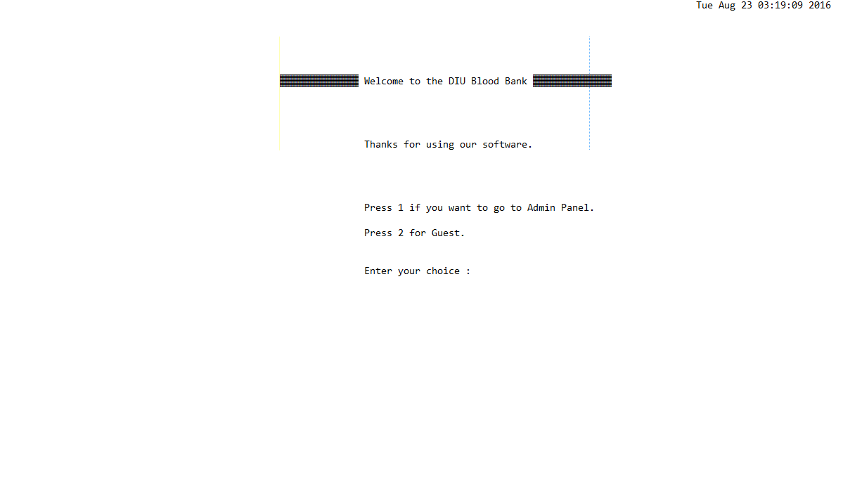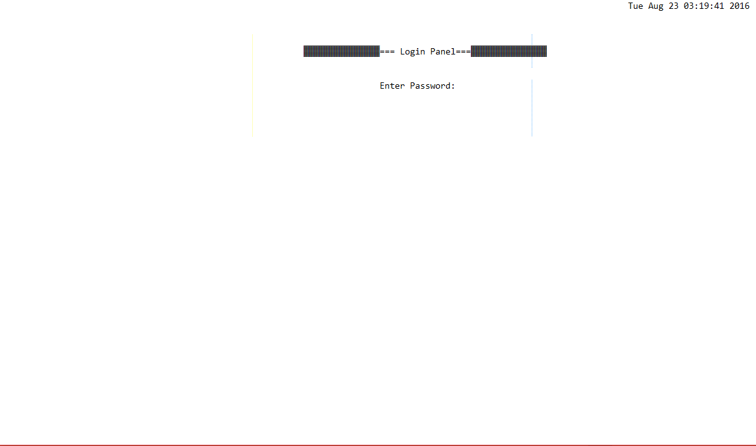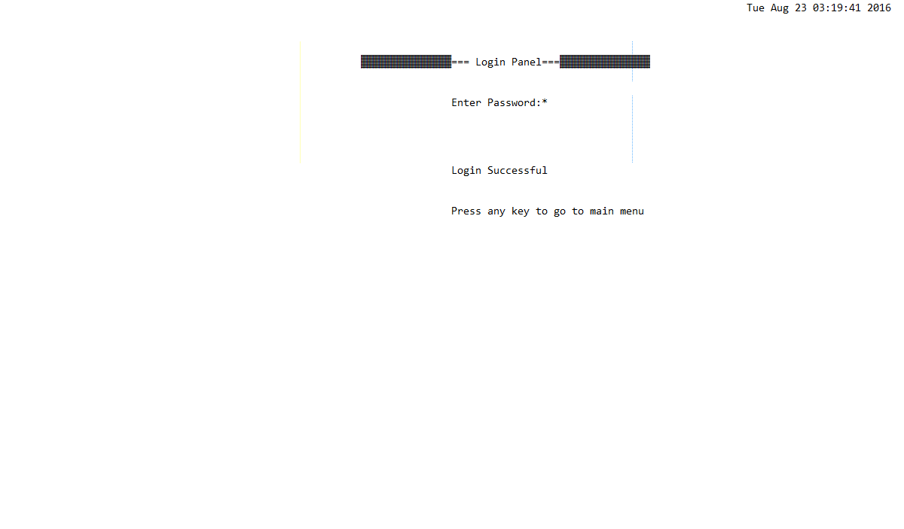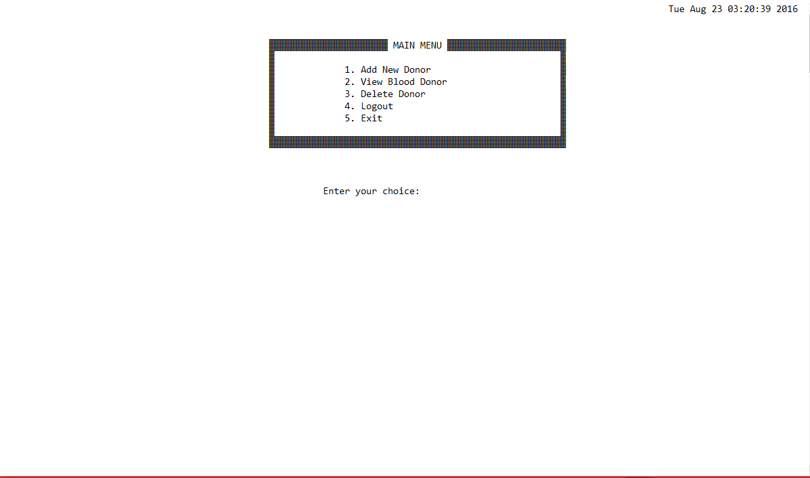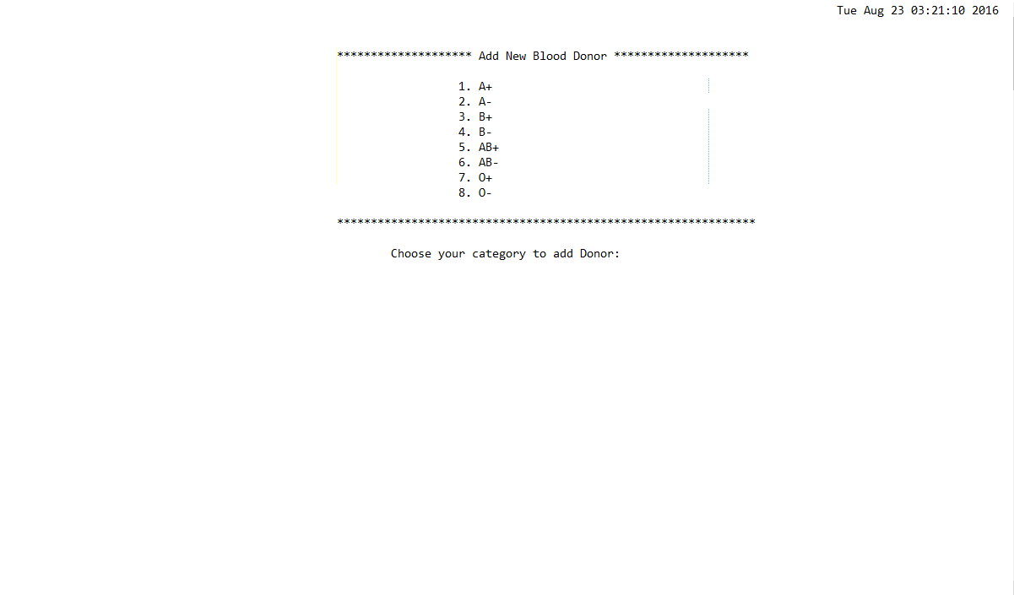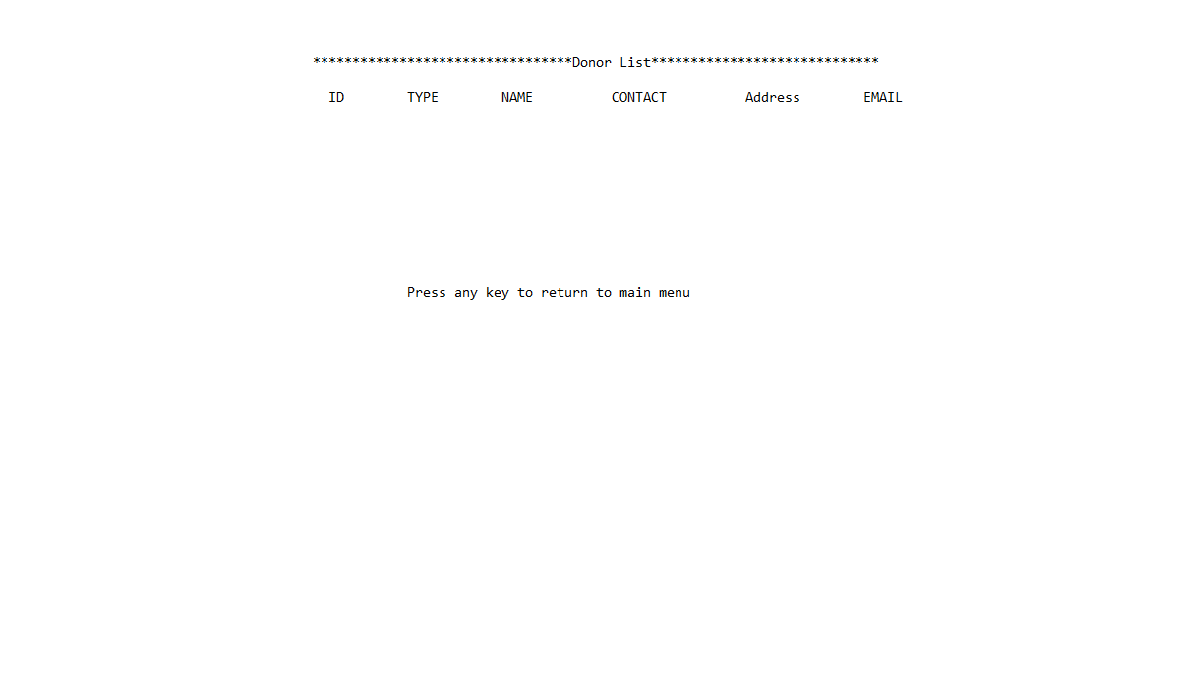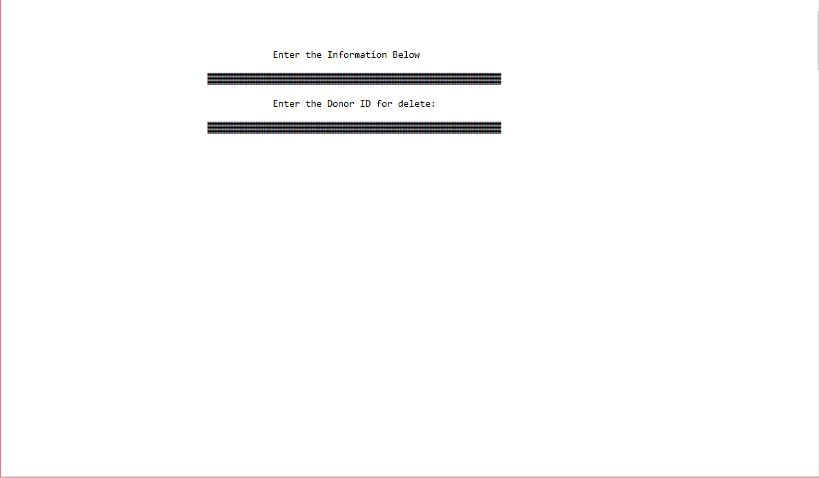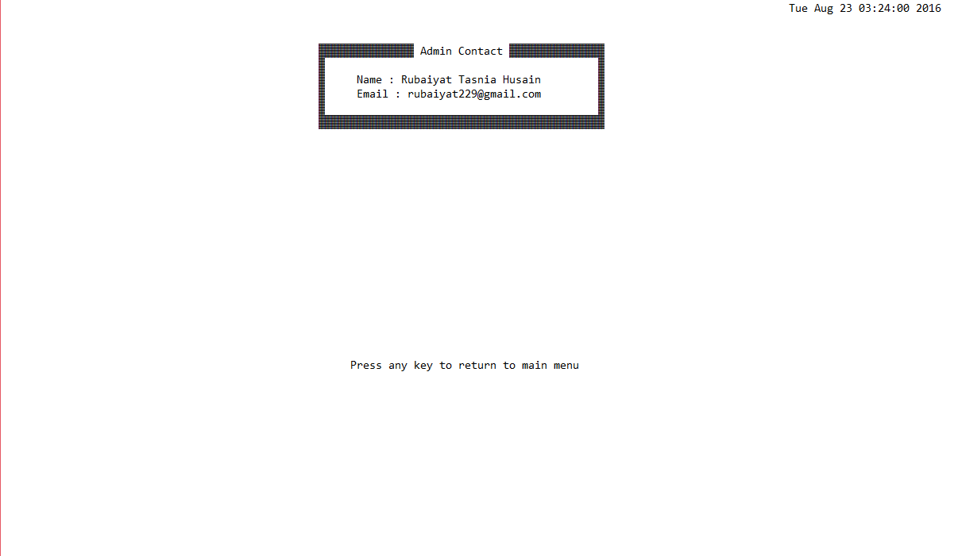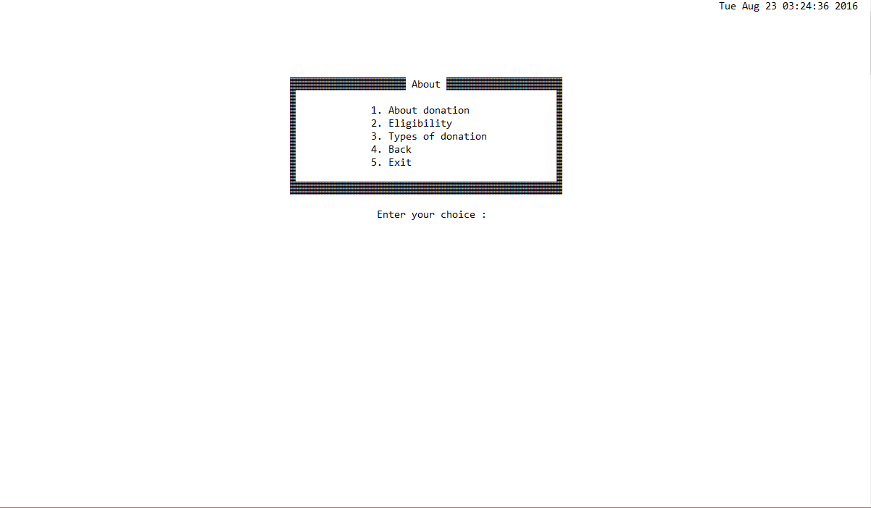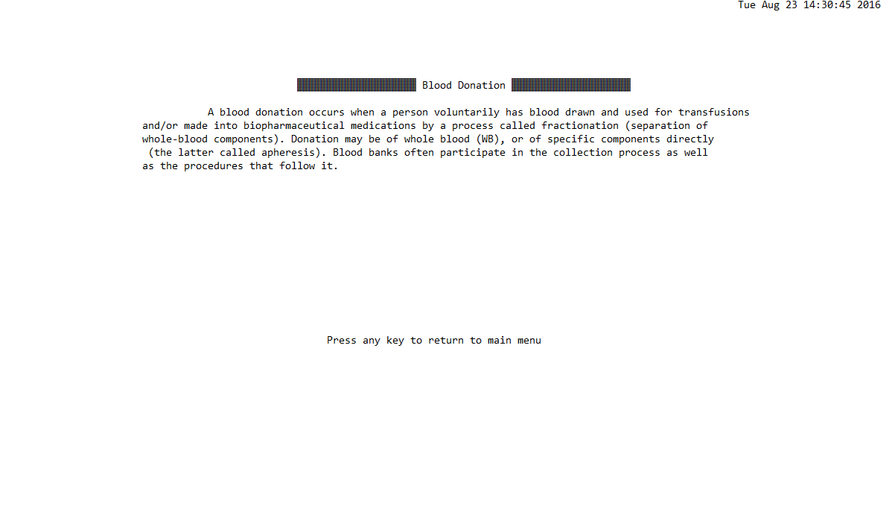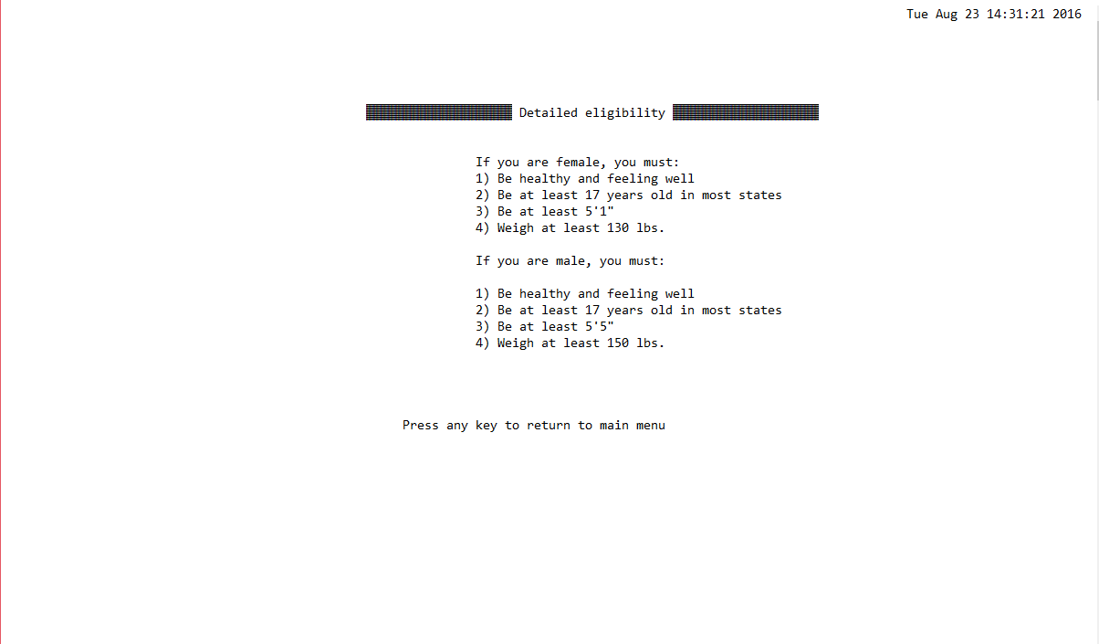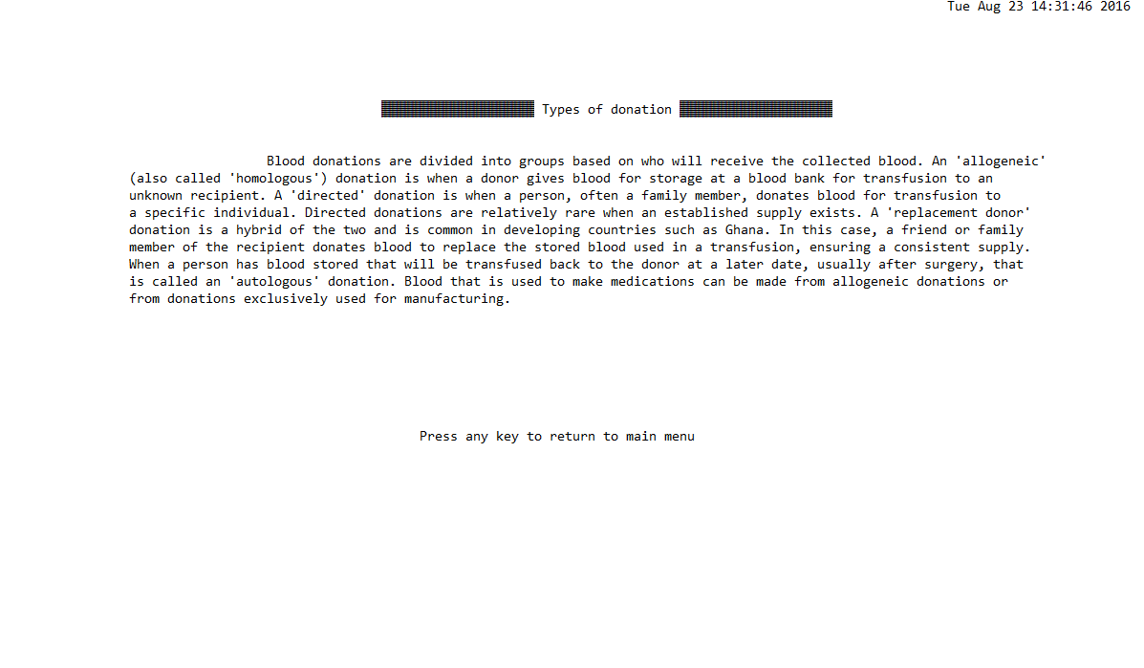

1. **Upcoming features**

There is plan to update this software in a wide range. If updated, some features will be added in this product. For example,

1. We can add the date of last donation in another column.
2. As a donor can’t donate blood 2 times within three months, a feature can be added which will hide the specific donor’s information for next three months.
3. If updated, user could be able to open an account to add him/herself to be a voluntary donor.
4. In any case if a donor is having some disease or under medication for which he/she would not be able to donate blood for a certain time, donor will be able to hide the ID for that time. After the time span comes over, the account will be unhidden automatically.
5. There is a plan to make this product for android application in future.
6. **Conclusion**

This software satisfies all the requirements. Here I have used very easy language for prompting, so that anyone can understand how to use this product. It is also very helpful to save time.

1. **Reference**
2. C Programming (basic and advance). Mohammad Moktar Hossain
3. Ansi C (5th edition). Balaguruswamy
4. Teach yourself C (3rd edition). Herbert Schidt