MQ-DATAMIND Workshop

Proteomics and mental health: using large-scale population-based plasma proteomic data to examine causal mechanisms and blood-based biomarkers for mental health conditions

**Using our Posit Cloud workspace or installing R, RStudio, and R packages on your computer**

## **Posit Cloud**

It is easiest to run R practical within our Posit Cloud space (what used to be called RStudio Cloud), which by default will have the correct R version and packages installed. To join our Posit Cloud, please go to the following link: [Posit Cloud](https://posit.cloud/spaces/232842/join?access_code=VsT9IA2ou_hXs3nQr9UY3WrVdCuLqiUnMQmT8d7l), where you will be prompted to create an account at the sign in screen.

How to use the Posit Cloud

* Graphical user interface, application

  Description automatically generatedOnce you have clicked the link above, if you do not already have a Posit Cloud account, click on the right-hand tab (“*Sign Up*”) to create an account
* Fill in your details and you’ll see the following message

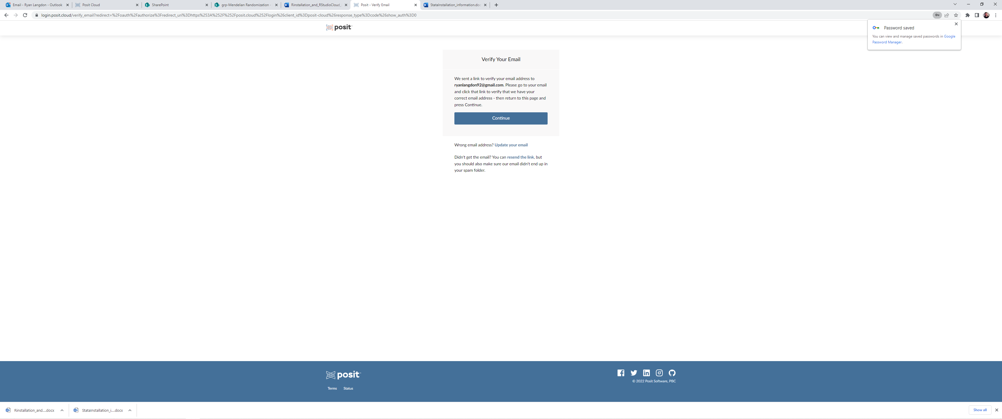

* Open a new tab, go to your email inbox and click on the verify email address link
* Go back to the browser tab with the “*Verify Your Email*” message above and click “Continue”.
* **Click the link** ([Proteomics_Workshop_Practical_1 - Posit Cloud](https://posit.cloud/content/10981075)) to access practical materials in the Posit Could. Alternatively, copy this URL into your browser address bar <https://posit.cloud/content/10981075>
* Once link is open and materials loaded, on the right-hand side click on “*Save a Permanent Copy*” to download the practical materials into “*Your workspace*”.

* On the left-hand side, click on *“Your Workspace”,* then on the Content tab click on the practical session. You should find that RStudio opens within your browser window.

* Within the practical session you can see in the Files pane (on the bottom right-hand side) all the files required for the practical.

* + Open either the .R or .Rmd file depending upon your preference
  + You can now run and edit the code in these files as you wish
  + Note if you do not have R packages installed required in this session, you will need to uncomment the install.packages() function calls.
  + After editing the files, your changes will be automatically saved in the permanent copy of the practical under “Your Workspace” in personal RStudio Cloud account

## **Installing R, RStudio, and R packages on your own computer**

**Installing R and RStudio**

If you are intending to use R offline for the proteomics workshop practical (even if you haven’t used it before), please make sure that R and RStudio are installed on your computer (the following website has very helpful instructions: <https://www.datacamp.com/community/tutorials/installing-R-windows-mac-ubuntu>).

You will need to download and run the R installation file for your operating system from CRAN  
<https://cran.r-project.org/>

And the free version of RStudio Desktop from the RStudio website  
<https://www.rstudio.com/products/rstudio/download/#download>

**Installing R packages**

Please make sure the following packages are installed in R on your own computer **before the workshop** by copying, pasting and running the following single line of R code:

install.packages( c("rmarkdown", "dplyr", "ggplot2"), dependencies = T)

We will explain what these packages do during the course. Each time you open a new R session, you will not need to re-install these packages, as they will have been saved within your R installation.

In each new R session (i.e., each time you open R), load a package into the R environment with

library(package) (e.g. library(dplyr))

**Click the link** ([rutamargelyte/proteomics_workshop_session_1](https://github.com/rutamargelyte/proteomics_workshop_session_1)) to access ALL materials for the first session of proteomics workshop. Alternatively, copy this URL into your browser address bar <https://github.com/rutamargelyte/proteomics_workshop_session_1>

**Any problems**

If you have any problems installing the required packages, or if you have any unusual problems with your computer, installing R, or installing RStudio please do not hesitate to get in contact with Ruta Margelyte ([ruta.margelyte@bristol.ac.uk](mailto:ruta.margelyte@bristol.ac.uk)) before the workshop begins.