|  |  |  |  |  |  |  |
| --- | --- | --- | --- | --- | --- | --- |
| Accident | N | N | N | N | N | N |
| Age | **Y** | **Y** | **Y** | **N** | **N** | **N** |
| Experience | **0** | **1 to 9** | **>9** | **0** | **1 to 9** | **>9** |
| Insurance | **Y** | **Y** | **Y** | **Y** | **Y** | **Y** |
| Amount | **$2,000** | **$1,000** | **$500** | **$2,000** | **$1,000** | **$500** |
| Reduction Rate (%) | **-** | **15** | **15** | **-** | **-** | **-** |
| Final Amount | **$2,000** | **$850** | **$425** | **$2,000** | **$1,000** | **$500** |

**PART - 1**

**2nd Iteration**

|  |  |  |  |  |  |  |
| --- | --- | --- | --- | --- | --- | --- |
| Accident |  |  |  |  |  |  |
| Age |  |  |  |  |  |  |
| Experience |  |  |  |  |  |  |
| Insurance |  |  |  |  |  |  |
| Amount |  |  |  |  |  |  |
| Reduction Rate (%) |  |  |  |  |  |  |
| Final Amount |  |  |  |  |  |  |

**3rd Iteration**

**PART – 2**

1. Index.html

Code:

<html>

<head>

<title>Home</title>

<link rel="stylesheet" href="https://maxcdn.bootstrapcdn.com/bootstrap/4.1.0/css/bootstrap.min.css">

</head>

<body onload="SellerDisplay();">

<nav class="navbar navbar-expand-lg navbar-light bg-light">

<a class="navbar-brand" href="#">Assignment 4</a>

<button class="navbar-toggler" type="button" data-toggle="collapse" data-target="#navbarSupportedContent"

aria-controls="navbarSupportedContent" aria-expanded="false" aria-label="Toggle navigation">

<span class="navbar-toggler-icon"></span>

</button>

<div class="collapse navbar-collapse" id="navbarSupportedContent">

<ul class="navbar-nav mr-auto">

<li class="nav-item active">

<a class="nav-link" href="index.html">Home <span class="sr-only">(current)</span></a>

</li>

<li class="nav-item">

<a class="nav-link" href="sellerpage.html">Seller</a>

</li>

</ul>

<div class="form-inline my-2 my-lg-0">

<input class="form-control mr-sm-2" type="text" id="SellerSearch" placeholder="Search" aria-label="Search">

<button class="btn btn-outline-success my-2 my-sm-0" type="submit" data-toggle="modal" data-target="#exampleModal"

onclick="SellerSearch()">Search</button>

</div>

</div>

</nav>

<!-- Modal -->

<div class="modal fade" id="exampleModal" tabindex="-1" role="dialog" aria-labelledby="exampleModalLabel" aria-hidden="true">

<div class="modal-dialog" role="document">

<div class="modal-content">

<div class="modal-header">

<h5 class="modal-title" id="exampleModalLabel">Searched Seller List</h5>

<button type="button" class="close" data-dismiss="modal" aria-label="Close">

<span aria-hidden="true">&times;</span>

</button>

</div>

<div id="searchSellerList" class="modal-body">

</div>

<div class="modal-footer">

<button type="button" class="btn btn-secondary" data-dismiss="modal">Close</button>

</div>

</div>

</div>

</div>

<div class="container" id="SellerDisplay">

</div>

<script src="https://code.jquery.com/jquery-3.3.1.slim.min.js" integrity="sha384-q8i/X+965DzO0rT7abK41JStQIAqVgRVzpbzo5smXKp4YfRvH+8abtTE1Pi6jizo"

crossorigin="anonymous"></script>

<script src="https://cdnjs.cloudflare.com/ajax/libs/popper.js/1.14.3/umd/popper.min.js" integrity="sha384-ZMP7rVo3mIykV+2+9J3UJ46jBk0WLaUAdn689aCwoqbBJiSnjAK/l8WvCWPIPm49"

crossorigin="anonymous"></script>

<script src="https://stackpath.bootstrapcdn.com/bootstrap/4.1.3/js/bootstrap.min.js" integrity="sha384-ChfqqxuZUCnJSK3+MXmPNIyE6ZbWh2IMqE241rYiqJxyMiZ6OW/JmZQ5stwEULTy"

crossorigin="anonymous"></script>

<script src="js/javascript.js"></script>

</body>

</html>

1. Sellerpage.html

Code:

<html>

<head>

<title>QA</title>

<!-- Load Bootstrap CSS -->

<link rel="stylesheet" href="https://maxcdn.bootstrapcdn.com/bootstrap/4.1.0/css/bootstrap.min.css">

<!-- Load Stylesheet -->

<link rel="stylesheet" href="css/style.css">

</head>

<body>

<nav class="navbar navbar-expand-lg navbar-light bg-light">

<a class="navbar-brand" href="index.html">Assignment 4</a>

<button class="navbar-toggler" type="button" data-toggle="collapse" data-target="#navbarSupportedContent"

aria-controls="navbarSupportedContent" aria-expanded="false" aria-label="Toggle navigation">

<span class="navbar-toggler-icon"></span>

</button>

<div class="collapse navbar-collapse" id="navbarSupportedContent">

<ul class="navbar-nav mr-auto">

<li class="nav-item active">

<a class="nav-link" href="index.html">Home <span class="sr-only">(current)</span></a>

</li>

<li class="nav-item">

<a class="nav-link" href="sellerpage.html">Seller</a>

</li>

</ul>

</div>

</nav>

<div class="form_wrapper">

<div class="form_container">

<div class="title_container">

<h2>New Seller</h2>

</div>

<div class="row clearfix">

<div class="">

<form>

<div class="row clearfix">

<div class="col_half">

<div class="input_field">

<input type="text" name="name" id="firstName" minlength="2" placeholder="First Name"

required />

<div id="firstNameMsg">

<p></p>

</div>

</div>

</div>

<div class="col_half">

<div class="input_field">

<input type="text" name="name" id="lastName" minlength="2" placeholder="Last Name"

required />

<div id="lastNameMsg">

<p></p>

</div>

</div>

</div>

</div>

<div class="input_field">

<input type="text" name="Address" id="Address" minlength="2" placeholder="Address" required />

<div id="AddressMsg">

<p></p>

</div>

</div>

<div class="input_field">

<input type="text" name="City" id="City" minlength="2" placeholder="City" required />

<div id="CityMsg">

<p></p>

</div>

</div>

<div class="input_field">

<input type="tel" pattern="((\(\d{3}\) ?)|(\d{3}-))?\d{3}-\d{4}" minlength="12" maxlength="15"

name="PhoneNumber" id="phoneNumber" placeholder="Phone Number xxx-xxx-xxxx" onkeypress="ValidatePhone(this.value)" onblur="ValidatePhone(this.value)" required />

<div id="PhoneNumberMsg">

<p></p>

</div>

</div>

<div class="input_field">

<input type="email" name="email" minlength="2" pattern="^[\w]{1,}[\w.+-]{0,}@[\w-]{2,}([.][a-zA-Z]{2,}|[.][\w-]{2,}[.][a-zA-Z]{2,})$"

id="email" placeholder="Email" onkeypress="ValidateEmail(this.value)" onblur="ValidateEmail(this.value)" required />

<div id="EmailMsg">

<p></p>

</div>

</div>

<div class="input_field">

<input type="text" name="VehicalMake" minlength="2" id="vehicalMake" placeholder="Vehical Make"

required />

<div id="VehicalMakeMsg">

<p></p>

</div>

</div>

<div class="row clearfix">

<div class="col_half">

<div class="input_field">

<input type="text" name="Model" minlength="2" id="model" placeholder="Model"

required />

<div id="ModelMsg">

<p></p>

</div>

</div>

</div>

<div class="col_half">

<div class="input_field">

<input type="text" name="Year" minlength="2" id="year" placeholder="Year" required />

<div id="YearMsg">

<p></p>

</div>

</div>

</div>

</div>

<input class="button" type="submit" value="Submit" onclick="Validation();"/>

</form>

</div>

</div>

</div>

</div>

<p class="credit"></p>

<!-- Loaded JQuery -->

<!-- <script src="https://ajax.googleapis.com/ajax/libs/jquery/3.3.1/jquery.min.js"></script> -->

<!-- Loaded Chart JS for Chart -->

<!-- <script src="https://cdnjs.cloudflare.com/ajax/libs/Chart.js/2.7.2/Chart.bundle.js"></script> -->

<!-- Loaded Notify JS for Alert -->

<!-- <script type="text/javascript" src="js/javascript.js"></script> -->

<!-- Loaded Bootstrap JS for -->

<!-- <script src="https://maxcdn.bootstrapcdn.com/bootstrap/4.1.0/js/bootstrap.min.js"></script> -->

<!-- Load Application Javascript -->

<script src="js/javascript.js"></script>

</body>

</html>

Javascript.js

var validnumber = false;

var validemail = false

function Validation() {

var isValid = true;

var firstName = document.getElementById("firstName");

var lastName = document.getElementById("lastName");

var Address = document.getElementById("Address");

var City = document.getElementById("City");

var PhoneNumber = document.getElementById("phoneNumber");

var SellerEmail = document.getElementById("email");

var VehicalMake = document.getElementById("vehicalMake");

var Model = document.getElementById("model");

var Year = document.getElementById("year");

document.getElementById("firstNameMsg").innerHTML = "";

if (firstName.value.length <= 1) {

document.getElementById("firstNameMsg").innerHTML = "*Enter First Name";

document.getElementById("firstNameMsg").style.color = "Red";

isValid = false;

}

document.getElementById("lastNameMsg").innerHTML = "";

if (lastName.value.length <= 1) {

document.getElementById("lastNameMsg").innerHTML = "*Enter Last Name";

document.getElementById("lastNameMsg").style.color = "Red";

isValid = false;

}

document.getElementById("AddressMsg").innerHTML = "";

if (Address.value.length <= 1) {

document.getElementById("AddressMsg").innerHTML = "*Enter Address ";

document.getElementById("AddressMsg").style.color = "Red";

isValid = false;

}

document.getElementById("CityMsg").innerHTML = "";

if (City.value.length <= 1) {

document.getElementById("CityMsg").innerHTML = "*Enter City ";

document.getElementById("CityMsg").style.color = "Red";

isValid = false;

}

document.getElementById("PhoneNumberMsg").innerHTML = "";

if (PhoneNumber.value.length < 10 || !validnumber) {

document.getElementById("PhoneNumberMsg").innerHTML = "*Enter Phone Number ";

document.getElementById("PhoneNumberMsg").style.color = "Red";

isValid = false;

}

document.getElementById("EmailMsg").innerHTML = "";

if (SellerEmail.value.length <= 1 || !validemail) {

document.getElementById("EmailMsg").innerHTML = "*Enter Email ";

document.getElementById("EmailMsg").style.color = "Red";

isValid = false;

}

document.getElementById("VehicalMakeMsg").innerHTML = "";

if (VehicalMake.value.length <= 1) {

document.getElementById("VehicalMakeMsg").innerHTML = "*Enter Vehical Make ";

document.getElementById("VehicalMakeMsg").style.color = "Red";

isValid = false;

}

document.getElementById("ModelMsg").innerHTML = "";

if (Model.value.length <= 1) {

document.getElementById("ModelMsg").innerHTML = "*Enter Model";

document.getElementById("ModelMsg").style.color = "Red";

isValid = false;

}

document.getElementById("YearMsg").innerHTML = "";

if (Year.value.length <= 1) {

document.getElementById("YearMsg").innerHTML = "*Enter Year Make";

document.getElementById("YearMsg").style.color = "Red";

isValid = false;

}

if (isValid) {

let data = { firstName: firstName.value, lastName: lastName.value, Address: Address.value, City: City.value, PhoneNumber: PhoneNumber.value, SellerEmail: SellerEmail.value, VehicalMake: VehicalMake.value, Model: Model.value, Year: Year.value };

let dataArray = localStorage.getItem('sellerDetails') ? JSON.parse(localStorage.getItem('sellerDetails')) : [];

localStorage.setItem('sellerDetails', JSON.stringify(dataArray));

dataArray.push(data);

localStorage.setItem('sellerDetails', JSON.stringify(dataArray));

}

}

function SellerDisplay() {

let storedValues = JSON.parse(localStorage.getItem('sellerDetails'));

var details = '';

var divSellerList = document.getElementById('SellerDisplay');

if (storedValues.length > 0) {

if (divSellerList) {

for (let i = storedValues.length - 1; i >= 0; i--) {

let sellerName = storedValues[i].firstName + ` (Phone Number: ` + storedValues[i].PhoneNumber + ` OR Email: ` + storedValues[i].SellerEmail + `)`;

let address = storedValues[i].Address + `, ` + storedValues[i].City;

let vehichleDetail = storedValues[i].VehicalMake + ` ` + storedValues[i].Model + ` ` + storedValues[i].Year;

let link = `https://www.jdpower.com/Cars/` + storedValues[i].VehicalMake + `/` + storedValues[i].Model + `/` + storedValues[i].Year;

details += `<div class="card text-white bg-info mb-3" style="margin: 10px;"> <div class="card-body"> <h5 class="card-title">` + vehichleDetail + `</h5> <h6 class="card-subtitle mb-2 text-muted">` + address + `</h6> <p class="card-text">` + sellerName + `</p> <a href="` + link + `" class="btn btn-info">` + link + `</a> </div> </div>`;

}

console.log(details);

divSellerList.innerHTML = details;

}

else if (divSellerList) {

divSellerList.innerHTML = `<h4 class="card-title productTitle" id="productTitle"> There are no Seller information availbale currently to display.</h4>`;

}

}

}

function SellerSearch() {

let values = JSON.parse(localStorage.getItem('sellerDetails'));

var SellerSearch = document.getElementById('SellerSearch');

var details = "";

var result = [];

var DisplayResult = document.getElementById('searchSellerList');

if (values && values.length > 0) {

if (SellerSearch.value && SellerSearch.value.length > 0) {

for (let index = values.length - 1; index >= 0; index--) {

if (values.find(name => values[index].firstName.toLowerCase().trim() === SellerSearch.value.toLowerCase().trim() || values[index].VehicalMake.toLowerCase().trim() == SellerSearch.value.toLowerCase().trim() || values[index].Model.toLowerCase().trim() == SellerSearch.value.toLowerCase().trim() || values[index].Year.toLowerCase().trim() == SellerSearch.value.toLowerCase().trim()))

result.push(values[index]);

}

if (DisplayResult && result.length > 0) {

for (let index = result.length - 1; index >= 0; index--) {

let sellerName = result[index].firstName + ` (Contact: ` + result[index].PhoneNumber + ` OR Email: ` + result[index].email + `)`;

let address = result[index].Address + `, ` + result[index].City;

let vehichleDetail = result[index].VehicalMake + ` ` + result[index].Model + ` ` + result[index].Year;

let link = `https://www.jdpower.com/Cars/` + result[index].VehicalMake + `/` + result[index].Model + `/` + result[index].Year;

details += `<div class="card" style="margin: 10px;"> <div class="card-body"> <h5 class="card-title">` + vehichleDetail + `</h5> <h6 class="card-subtitle mb-2 text-muted">` + address + `</h6> <p class="card-text">` + sellerName + `</p> <a href="` + link + `" class="btn btn-info">` + link + `</a> </div> </div>`;

}

DisplayResult.innerHTML = details;

}

else {

DisplayResult.innerHTML = `<h6 class="card-title productTitle" id="productTitle"> No result found for '` + SellerSearch.value + `' </h6>`;

}

}

else {

DisplayResult.innerHTML = `<h6 class="card-title productTitle" id="productTitle"> Enter Vehicle Make OR Year OR Model OR Seller Name to search.</h6>`;

}

}

else {

DisplayResult.innerHTML = `<h6 class="card-title productTitle" id="productTitle"> No Sellers found on website. Please add sellers.</h6>`;

}

SellerSearch.value = "";

}

function ValidatePhone(number) {

var error = document.getElementById('PhoneNumberMsg');

var RegEx = /^((\(\d{3}\) ?)|(\d{3}-))?\d{3}-\d{4}$/;

error.innerText = '';

if (number.length < 12) {

error.innerText = "Enterd number is not proper.";

error.style.color = "red";

validnumber = false;

return false;

}

if ((number != "") && (!RegEx.test(number))) {

error.innerText = "Please check the supported format";

error.style.color = "red";

validnumber = false;

return false;

}

error.innerText = '';

validnumber = true;

return true;

}

function ValidateEmail(email) {

var error = document.getElementById('EmailMsg');

var RegEx = /^[\w]{1,}[\w.+-]{0,}@[\w-]{2,}([.][a-zA-Z]{2,}|[.][\w-]{2,}[.][a-zA-Z]{2,})$/;

error.innerText = '';

if (!email) {

error.innerText = "Please enter proper email address. (ex. test@gmail.com, test@gb.co.in)";

error.style.color = "red";

validemail = false;

return false;

}

if ((email != "") && (!RegEx.test(email))) {

error.innerText = "Please enter proper email address. (ex. jdpower@yahoo.com, jdp@jdp.org)";

error.style.color = "red";

validemail = false;

return false;

}

error.innerText = '';

validemail = true;

return true;

}

Style.css

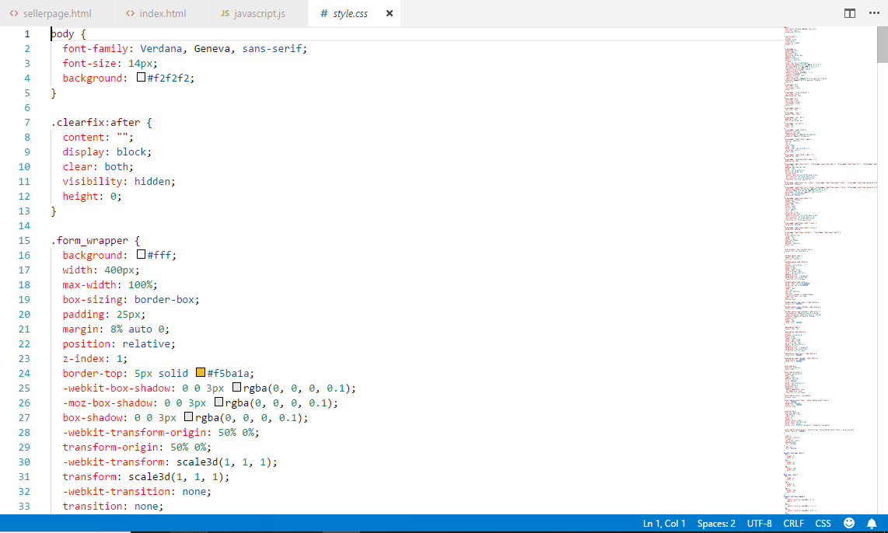

Website url:

<http://localhost/QA_ASS_4/>

Screenshot of web application

Index.html

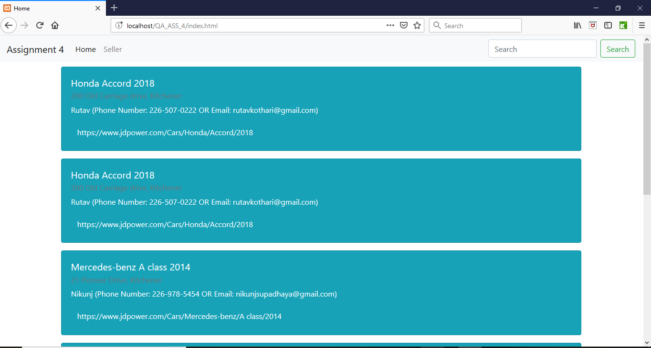

Sellerpage.html

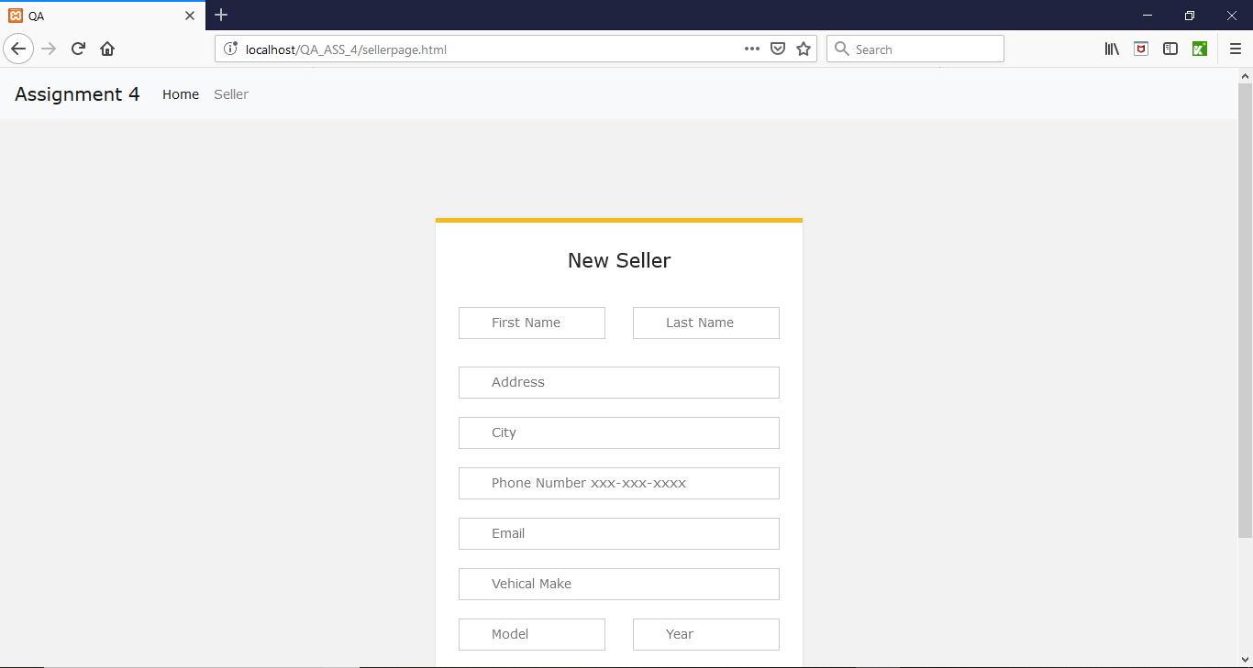

Search seller

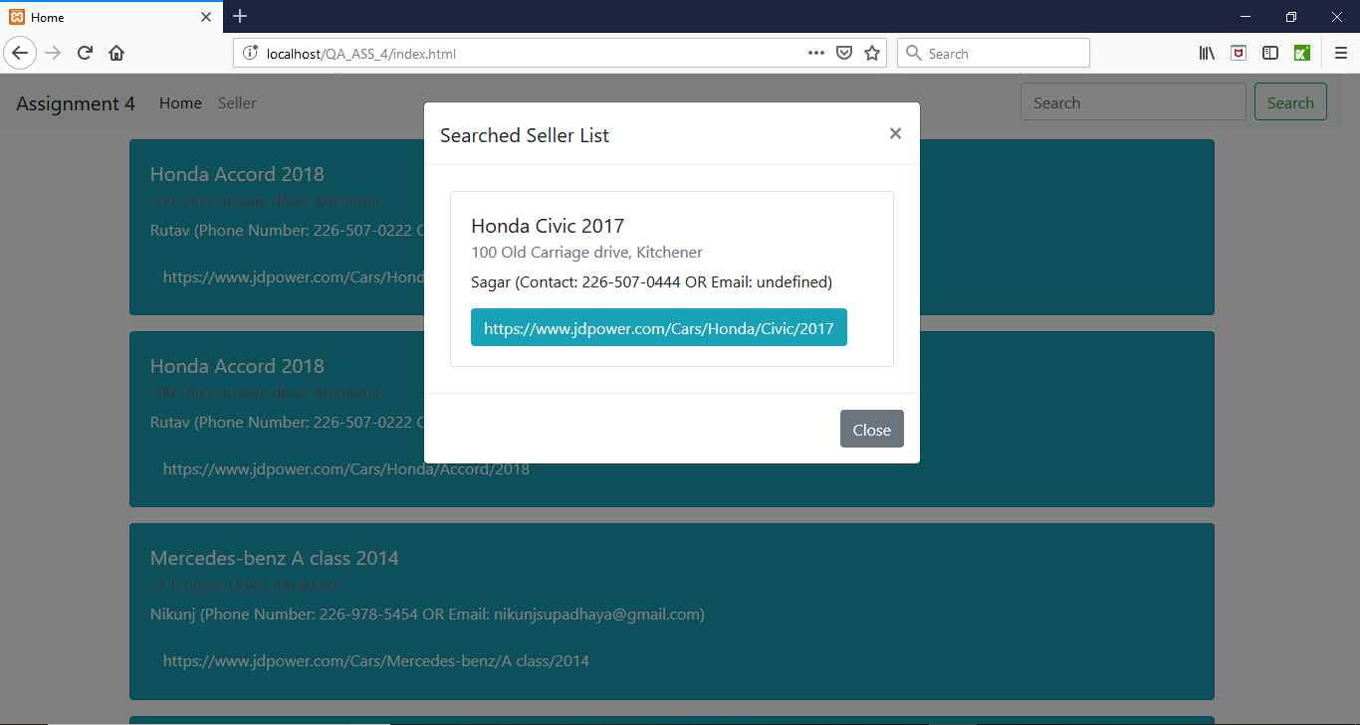

Testcase solution

1. SearchTestCases.cs

using NUnit.Framework;

using OpenQA.Selenium;

using OpenQA.Selenium.Firefox;

using OpenQA.Selenium.Support.UI;

using System;

using System.Collections.Generic;

using System.Linq;

using System.Text;

using System.Threading.Tasks;

namespace Assignment_4_Test_Cases

{

[TestFixture]

public class SearchTestCases

{

private IWebDriver driver;

private StringBuilder verificationErrors;

private string baseURL;

private bool acceptNextAlert = true;

[SetUp]

public void SetupTest()

{

driver = new FirefoxDriver();

baseURL = "http://localhost/QA_ASS_4/index.html";

verificationErrors = new StringBuilder();

}

[TearDown]

public void TeardownTest()

{

try

{

driver.Quit();

}

catch (Exception)

{

// Ignore errors if unable to close the browser

}

Assert.AreEqual("", verificationErrors.ToString());

}

[Test]

public void SearchTestCase_InputTest_ExpectedNoResultFound()

{

driver.Navigate().GoToUrl(baseURL);

driver.FindElement(By.Id("SellerSearch")).Click();

driver.FindElement(By.Id("SellerSearch")).Clear();

driver.FindElement(By.Id("SellerSearch")).SendKeys("test");

WebDriverWait waitForElementToFind = new WebDriverWait(driver, TimeSpan.FromSeconds(10));

waitForElementToFind.Until(r => r.FindElement(By.XPath("(.//*[normalize-space(text()) and normalize-space(.)='Seller'])[1]/following::button[1]")));

driver.FindElement(By.XPath("(.//*[normalize-space(text()) and normalize-space(.)='Seller'])[1]/following::button[1]")).Click();

Assert.AreEqual("No Sellers found on website. Please add sellers.", driver.FindElement(By.XPath("//*[@id=\"productTitle\"]")).Text);

}

private bool IsElementPresent(By by)

{

try

{

driver.FindElement(by);

return true;

}

catch (NoSuchElementException)

{

return false;

}

}

private bool IsAlertPresent()

{

try

{

driver.SwitchTo().Alert();

return true;

}

catch (NoAlertPresentException)

{

return false;

}

}

private string CloseAlertAndGetItsText()

{

try

{

IAlert alert = driver.SwitchTo().Alert();

string alertText = alert.Text;

if (acceptNextAlert)

{

alert.Accept();

}

else

{

alert.Dismiss();

}

return alertText;

}

finally

{

acceptNextAlert = true;

}

}

}

}

1. InvalidformTestCases.cs

using NUnit.Framework;

using OpenQA.Selenium;

using OpenQA.Selenium.Firefox;

using System;

using System.Collections.Generic;

using System.Linq;

using System.Text;

using System.Threading.Tasks;

namespace Assignment_4_Test_Cases

{

[TestFixture]

class InvalidFormTestCase

{

private IWebDriver driver;

private StringBuilder verificationErrors;

private string baseURL;

private bool acceptNextAlert = true;

[SetUp]

public void SetupTest()

{

driver = new FirefoxDriver();

baseURL = "http://localhost/QA_ASS_4/sellerpage.html";

verificationErrors = new StringBuilder();

}

[TearDown]

public void TeardownTest()

{

try

{

driver.Quit();

}

catch (Exception)

{

// Ignore errors if unable to close the browser

}

Assert.AreEqual("", verificationErrors.ToString());

}

[Test]

public void TheInvalidFormTestCaseTest_InputNewSellerDetails_AND_Expect_ErrorMessage_NoResult()

{

driver.Navigate().GoToUrl(baseURL);

//driver.FindElement(By.LinkText("Home (current)")).Click();

driver.FindElement(By.LinkText("Seller")).Click();

driver.FindElement(By.XPath("(.//*[normalize-space(text()) and normalize-space(.)='New Seller'])[1]/following::input[10]")).Click();

Assert.AreEqual(string.Empty, driver.FindElement(By.XPath("//*[@id=\"firstNameMsg\"]")).Text);

Assert.AreEqual(string.Empty, driver.FindElement(By.XPath("//*[@id=\"lastNameMsg\"]")).Text);

Assert.AreEqual(string.Empty, driver.FindElement(By.XPath("//*[@id=\"AddressMsg\"]")).Text);

Assert.AreEqual(string.Empty, driver.FindElement(By.XPath("//*[@id=\"CityMsg\"]")).Text);

Assert.AreEqual(string.Empty, driver.FindElement(By.XPath("//*[@id=\"PhoneNumberMsg\"]")).Text);

Assert.AreEqual(string.Empty, driver.FindElement(By.XPath("//*[@id=\"EmailMsg\"]")).Text);

Assert.AreEqual(string.Empty, driver.FindElement(By.XPath("//*[@id=\"VehicalMakeMsg\"]")).Text);

Assert.AreEqual(string.Empty, driver.FindElement(By.XPath("//*[@id=\"ModelMsg\"]")).Text);

Assert.AreEqual(string.Empty, driver.FindElement(By.XPath("//*[@id=\"YearMsg\"]")).Text);

}

private bool IsElementPresent(By by)

{

try

{

driver.FindElement(by);

return true;

}

catch (NoSuchElementException)

{

return false;

}

}

private bool IsAlertPresent()

{

try

{

driver.SwitchTo().Alert();

return true;

}

catch (NoAlertPresentException)

{

return false;

}

}

private string CloseAlertAndGetItsText()

{

try

{

IAlert alert = driver.SwitchTo().Alert();

string alertText = alert.Text;

if (acceptNextAlert)

{

alert.Accept();

}

else

{

alert.Dismiss();

}

return alertText;

}

finally

{

acceptNextAlert = true;

}

}

}

}

1. ValidFormTestCases.cs

using NUnit.Framework;

using OpenQA.Selenium;

using OpenQA.Selenium.Firefox;

using System;

using System.Collections.Generic;

using System.Linq;

using System.Text;

using System.Threading.Tasks;

namespace Assignment_4_Test_Cases

{

[TestFixture]

class ValidFormTestCase

{

private IWebDriver driver;

private StringBuilder verificationErrors;

private string baseURL;

private bool acceptNextAlert = true;

[SetUp]

public void SetupTest()

{

driver = new FirefoxDriver();

baseURL = "http://localhost/QA_ASS_4/index.html";

verificationErrors = new StringBuilder();

}

[TearDown]

public void TeardownTest()

{

try

{

driver.Quit();

}

catch (Exception)

{

// Ignore errors if unable to close the browser

}

Assert.AreEqual("", verificationErrors.ToString());

}

[Test]

public void ValidFormTestCaseTest_InputNewSellerValue_AND_Expect_Information_Generated()

{

driver.Navigate().GoToUrl(baseURL);

driver.FindElement(By.LinkText("Seller")).Click();

driver.FindElement(By.Id("firstName")).Click();

driver.FindElement(By.Id("firstName")).Clear();

driver.FindElement(By.Id("firstName")).SendKeys("Rutav");

driver.FindElement(By.Id("lastName")).Clear();

driver.FindElement(By.Id("lastName")).SendKeys("Kothari");

driver.FindElement(By.Id("Address")).Clear();

driver.FindElement(By.Id("Address")).SendKeys("200 Old Carriage drive");

driver.FindElement(By.Id("City")).Clear();

driver.FindElement(By.Id("City")).SendKeys("Kitchener");

driver.FindElement(By.Id("phoneNumber")).Clear();

driver.FindElement(By.Id("phoneNumber")).SendKeys("226-507-0222");

driver.FindElement(By.Id("email")).Clear();

driver.FindElement(By.Id("email")).SendKeys("rutavkothari@gmail.com");

driver.FindElement(By.Id("vehicalMake")).Clear();

driver.FindElement(By.Id("vehicalMake")).SendKeys("Honda");

driver.FindElement(By.Id("model")).Clear();

driver.FindElement(By.Id("model")).SendKeys("Accord");

driver.FindElement(By.Id("year")).Clear();

driver.FindElement(By.Id("year")).SendKeys("2018");

driver.FindElement(By.XPath("(.//*[normalize-space(text()) and normalize-space(.)='New Seller'])[1]/following::input[10]")).Click();

Assert.AreEqual("", driver.FindElement(By.XPath("//*[@id=\"firstName\"]")).GetAttribute("value"));

Assert.AreEqual("", driver.FindElement(By.XPath("//*[@id=\"lastName\"]")).GetAttribute("value"));

Assert.AreEqual("", driver.FindElement(By.XPath("//*[@id=\"Address\"]")).GetAttribute("value"));

Assert.AreEqual("", driver.FindElement(By.XPath("//*[@id=\"City\"]")).GetAttribute("value"));

Assert.AreEqual("", driver.FindElement(By.XPath("//*[@id=\"phoneNumber\"]")).GetAttribute("value"));

Assert.AreEqual("", driver.FindElement(By.XPath("//*[@id=\"email\"]")).GetAttribute("value"));

Assert.AreEqual("", driver.FindElement(By.XPath("//*[@id=\"vehicalMake\"]")).GetAttribute("value"));

Assert.AreEqual("", driver.FindElement(By.XPath("//*[@id=\"vehicalMake\"]")).GetAttribute("value"));

Assert.AreEqual("", driver.FindElement(By.XPath("//*[@id=\"year\"]")).GetAttribute("value"));

}

private bool IsElementPresent(By by)

{

try

{

driver.FindElement(by);

return true;

}

catch (NoSuchElementException)

{

return false;

}

}

private bool IsAlertPresent()

{

try

{

driver.SwitchTo().Alert();

return true;

}

catch (NoAlertPresentException)

{

return false;

}

}

private string CloseAlertAndGetItsText()

{

try

{

IAlert alert = driver.SwitchTo().Alert();

string alertText = alert.Text;

if (acceptNextAlert)

{

alert.Accept();

}

else

{

alert.Dismiss();

}

return alertText;

}

finally

{

acceptNextAlert = true;

}

}

}

}

1. PhoneNumberTestCase.cs

using NUnit.Framework;

using OpenQA.Selenium;

using OpenQA.Selenium.Firefox;

using System;

using System.Collections.Generic;

using System.Linq;

using System.Text;

using System.Threading.Tasks;

namespace Assignment_4_Test_Cases

{

[TestFixture]

class PhoneNumberTestCase

{

private IWebDriver driver;

private StringBuilder verificationErrors;

private string baseURL;

private bool acceptNextAlert = true;

[SetUp]

public void SetupTest()

{

driver = new FirefoxDriver();

baseURL = "http://localhost/QA_ASS_4/index.html";

verificationErrors = new StringBuilder();

}

[TearDown]

public void TeardownTest()

{

try

{

driver.Quit();

}

catch (Exception)

{

// Ignore errors if unable to close the browser

}

Assert.AreEqual("", verificationErrors.ToString());

}

[Test]

public void PhoneNumberTestCase_Input_PhoneNumber_AND_Expect_ErrorMessage()

{

driver.Navigate().GoToUrl(baseURL);

driver.FindElement(By.LinkText("Seller")).Click();

driver.FindElement(By.Id("firstName")).Click();

driver.FindElement(By.Id("firstName")).Clear();

driver.FindElement(By.Id("firstName")).SendKeys("Hetal");

driver.FindElement(By.Id("lastName")).Clear();

driver.FindElement(By.Id("lastName")).SendKeys("Thumar");

driver.FindElement(By.Id("Address")).Clear();

driver.FindElement(By.Id("Address")).SendKeys("425 wilson Ave");

driver.FindElement(By.Id("City")).Clear();

driver.FindElement(By.Id("City")).SendKeys("Kitchener");

driver.FindElement(By.Id("phoneNumber")).Clear();

driver.FindElement(By.Id("phoneNumber")).SendKeys("2267898589");

driver.FindElement(By.Id("email")).Clear();

driver.FindElement(By.Id("email")).SendKeys("gihm.13.008@gmail.com");

driver.FindElement(By.Id("vehicalMake")).Clear();

driver.FindElement(By.Id("vehicalMake")).SendKeys("mazda");

driver.FindElement(By.Id("model")).Clear();

driver.FindElement(By.Id("model")).SendKeys("mazda 3");

driver.FindElement(By.Id("year")).Clear();

driver.FindElement(By.Id("year")).SendKeys("2018");

driver.FindElement(By.XPath("(.//*[normalize-space(text()) and normalize-space(.)='Enterd number is not proper.'])[1]/following::input[5]")).Click();

Assert.AreEqual("*Enter Phone Number", driver.FindElement(By.XPath("//*[@id=\"PhoneNumberMsg\"]")).Text);

}

private bool IsElementPresent(By by)

{

try

{

driver.FindElement(by);

return true;

}

catch (NoSuchElementException)

{

return false;

}

}

private bool IsAlertPresent()

{

try

{

driver.SwitchTo().Alert();

return true;

}

catch (NoAlertPresentException)

{

return false;

}

}

private string CloseAlertAndGetItsText()

{

try

{

IAlert alert = driver.SwitchTo().Alert();

string alertText = alert.Text;

if (acceptNextAlert)

{

alert.Accept();

}

else

{

alert.Dismiss();

}

return alertText;

}

finally

{

acceptNextAlert = true;

}

}

}

}

1. InvalidEmailTestCase.cs

using NUnit.Framework;

using OpenQA.Selenium;

using OpenQA.Selenium.Firefox;

using System;

using System.Collections.Generic;

using System.Linq;

using System.Text;

using System.Threading.Tasks;

namespace Assignment_4_Test_Cases

{

[TestFixture]

class InvalidEmailTestCase

{

private IWebDriver driver;

private StringBuilder verificationErrors;

private string baseURL;

private bool acceptNextAlert = true;

[SetUp]

public void SetupTest()

{

driver = new FirefoxDriver();

baseURL = "http://localhost/QA_ASS_4/index.html";

verificationErrors = new StringBuilder();

}

[TearDown]

public void TeardownTest()

{

try

{

driver.Quit();

}

catch (Exception)

{

// Ignore errors if unable to close the browser

}

Assert.AreEqual("", verificationErrors.ToString());

}

[Test]

public void InvalidEmailTestCase_InputInvalidEmaildID_AND_Expect_ErrorMessage()

{

driver.Navigate().GoToUrl(baseURL);

driver.FindElement(By.LinkText("Seller")).Click();

driver.FindElement(By.Id("firstName")).Click();

driver.FindElement(By.Id("firstName")).Clear();

driver.FindElement(By.Id("firstName")).SendKeys("Kush");

driver.FindElement(By.Id("lastName")).Clear();

driver.FindElement(By.Id("lastName")).SendKeys("Gilitwala");

driver.FindElement(By.Id("Address")).Clear();

driver.FindElement(By.Id("Address")).SendKeys("200 Old carriage drive");

driver.FindElement(By.Id("City")).Clear();

driver.FindElement(By.Id("City")).SendKeys("kitchener");

driver.FindElement(By.Id("phoneNumber")).Clear();

driver.FindElement(By.Id("phoneNumber")).SendKeys("226-987-9632");

driver.FindElement(By.Id("email")).Clear();

driver.FindElement(By.Id("email")).SendKeys("kushgilitwalagmail.com");

driver.FindElement(By.Id("vehicalMake")).Clear();

driver.FindElement(By.Id("vehicalMake")).SendKeys("Toyota");

driver.FindElement(By.Id("model")).Clear();

driver.FindElement(By.Id("model")).SendKeys("Camrry");

driver.FindElement(By.Id("year")).Clear();

driver.FindElement(By.Id("year")).SendKeys("2017");

driver.FindElement(By.XPath("(.//*[normalize-space(text()) and normalize-space(.)='Please enter proper email address. (ex. jdpower@yahoo.com, jdp@jdp.org)'])[1]/following::input[4]")).Click();

Assert.AreEqual("*Enter Email", driver.FindElement(By.XPath("//*[@id=\"EmailMsg\"]")).Text);

}

private bool IsElementPresent(By by)

{

try

{

driver.FindElement(by);

return true;

}

catch (NoSuchElementException)

{

return false;

}

}

private bool IsAlertPresent()

{

try

{

driver.SwitchTo().Alert();

return true;

}

catch (NoAlertPresentException)

{

return false;

}

}

private string CloseAlertAndGetItsText()

{

try

{

IAlert alert = driver.SwitchTo().Alert();

string alertText = alert.Text;

if (acceptNextAlert)

{

alert.Accept();

}

else

{

alert.Dismiss();

}

return alertText;

}

finally

{

acceptNextAlert = true;

}

}

}

}

NUnit test case

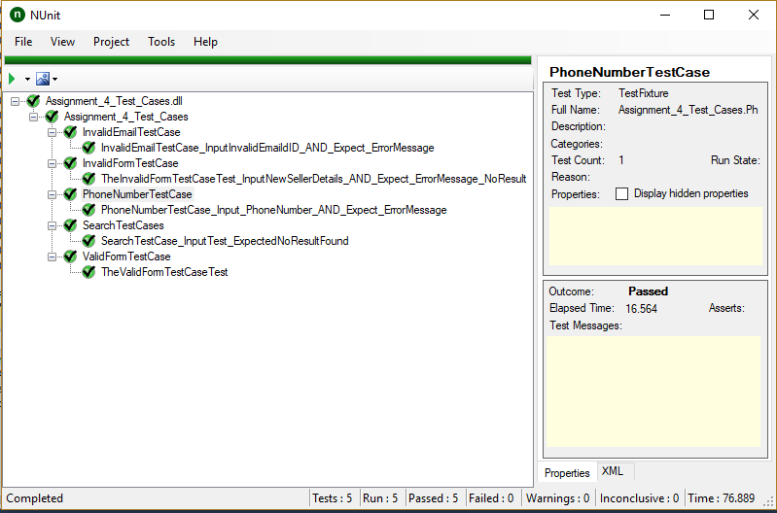

Git Status: