**Three Phase LV CT Postpaid Metering Unit**

**MU33 Metering Unit**

**Brief Introduction**

MU33 Series metering unit is specially designed for the large power user and can achieve the postpaid function. It is equipped with high precision smart energy meter, which has a plug and play communication module for remote reading and controlling; current transformers and Box for outdoor usage. It is a ideal product for Utilities and Distribution company to reduce energy loss and revenue protection. It is suitable to be used for villa, commercial and industrial projects.

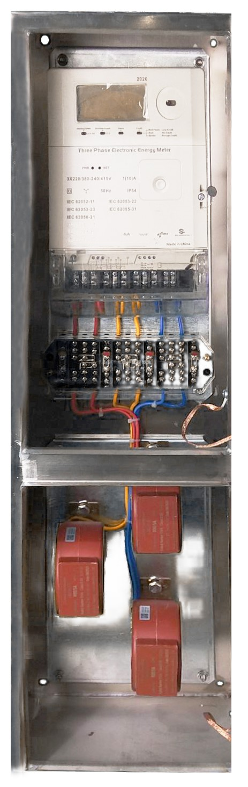

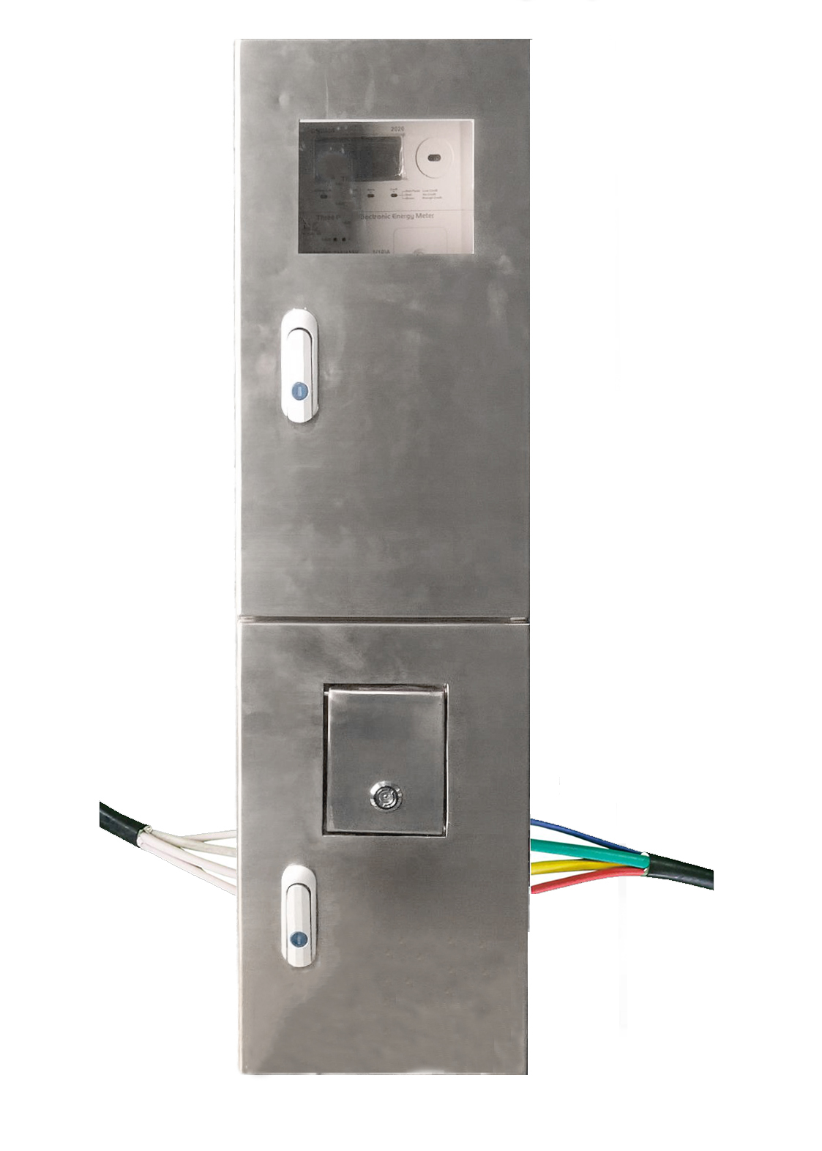

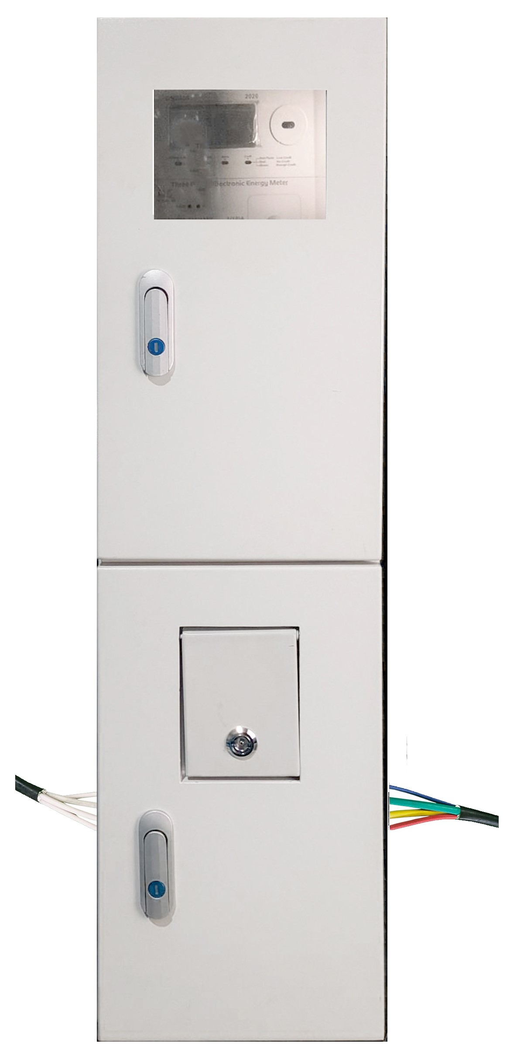

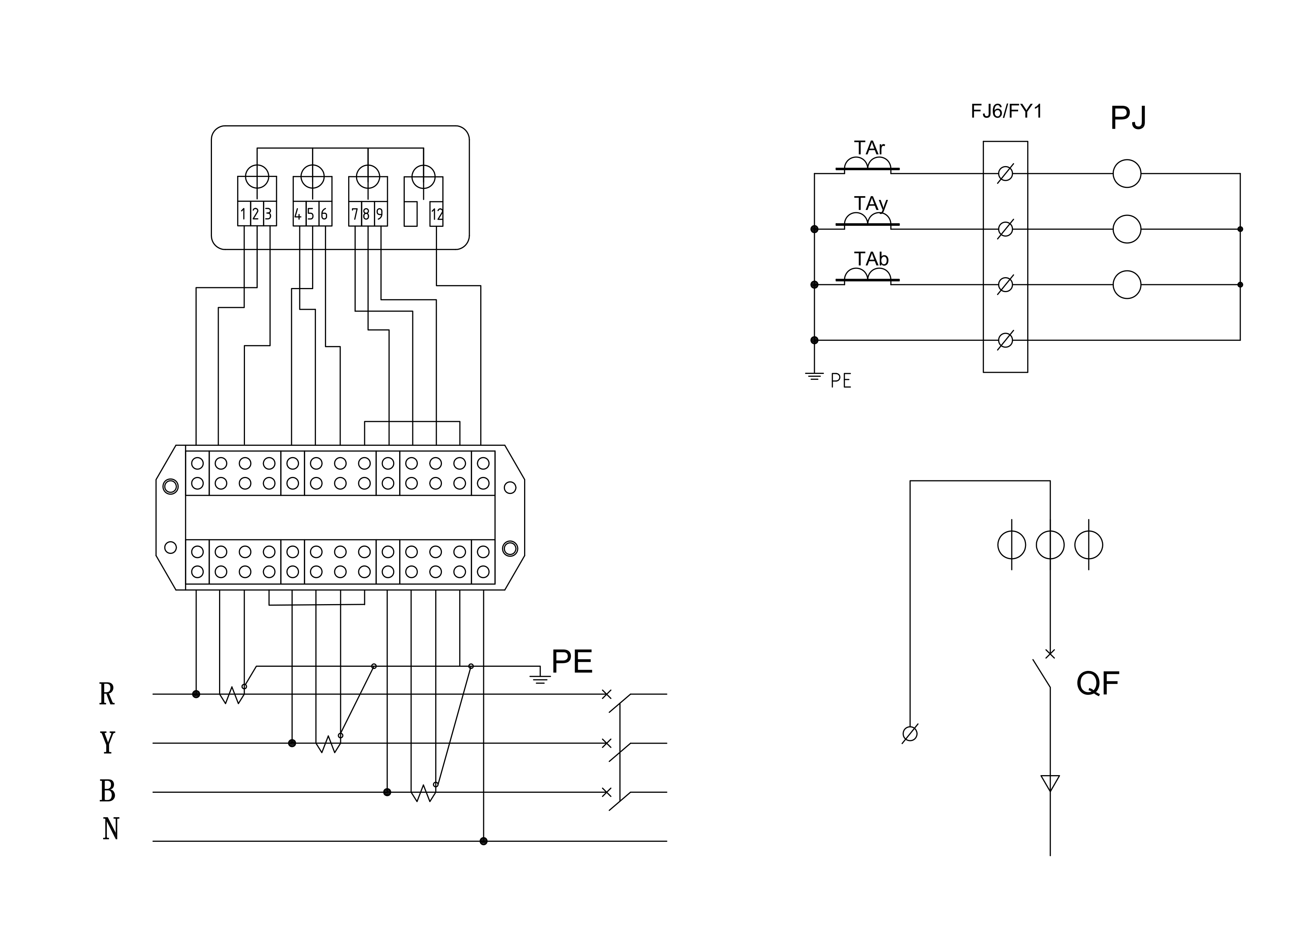

**Connection Diagram**

**Feature**

Separate Chamber for meter and CT

Plug and play communication module

High accuracy class

Maximum demand

Outdoor usage

Sealable and lockable

Anti-tamper

**OUTLINE DRAWING**

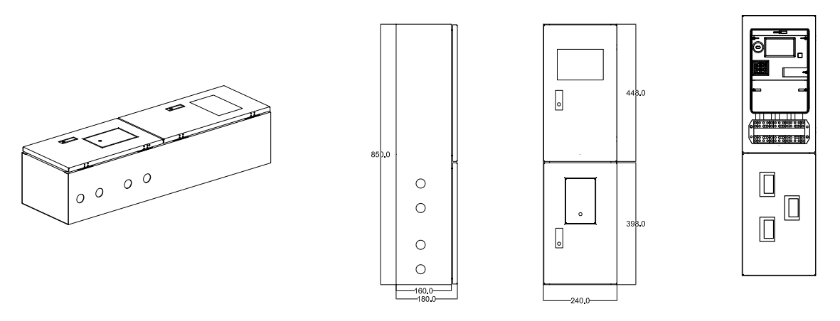

|  |  |  |  |  |  |  |
| --- | --- | --- | --- | --- | --- | --- |
| **SPECIFICATIONS ON METER** | | | | |  | |
|  | | | | |  | |
| **DESCRIPTION** | | **PARAMETER** | |  | |
| Accuracy | | Active class 0.5s, reactive class 2.0 | |  | |
| Rated Voltage | | 3x230/400V.3X240/415V | |  | |
| Operation voltage range | | 0.7Un-1.2ur | |  | |
| Current | | 200-800/5A | |  | |
| Power consumption | | Voltage circuit (Un): 2W/5VA  Current circuit (in): 0.5VA | |  | |
| Protection class | | IP54 | |  | |
| RTC | | <is/day (in 23℃) | |  | |
|  | | | | |  | |
| **SPECIFICATIONS ON METERING UNIT** | | | | |  | |
|  | | | | |  | |
| **200A metering unit** | | **500A metering unit** | |  | |
| CT ratio | 200/5 | CT ratio | 500/5 |  | |
| Box dimension | 850mmx240mmx160mm | Box dimension | 850mmx240mmx180mm |  | |
| Weight | Approx. 14kg | Weight | Approx. 18kg |  | |
| Box material | Stainless steel 201, cold steel | Box material | Stainless steel 201, cold steel |  | |
| IP protection class | 54 | IP protection class | 54 |  | |
| **300A metering unit** | | **800A metering unit** | |  | |
| CT ratio | 300/5 | CT ratio | 800/5 |  | |
| Box dimension | 850mmx240mmx160mm | Box dimension | 850mmx240mmx180mm |  | |
| Weight | Approx. 15kg | Weight | Approx. 19kg |  | |
| Box material | Stainless steel 201, cold steel | Box material | Stainless steel 201, cold steel |  | |
| IP protection class | 54 | IP protection class | 54 |  | |
|  |  |  |  |  | |