Bank Stability Analysis

This project analyzes and prepares data to predict bank stability. The main goal is to identify differences between banks that failed and those that remained stable. These insights help recognize at-risk banks early and improve overall financial stability.

Dataset Summary
- Rows: 5,000
- Columns: 11

Important Metrics:
- Capital Adequacy Ratio (CAR) (%): Indicates a bank’s capital strength (minimum recommended: 8%).
- Non-Performing Loans Ratio (NPL) (%): Percentage of loans in default (lower is better).
- Loan-to-Deposit Ratio (LDR) (%): Shows balance between loans and deposits (ideal range: 75–85%).
- Net Interest Margin (NIM) (%): Profitability from lending (higher is better).

Observations:The dataset includes both numerical and categorical columns.
- Missing Values: The "Went_Defunct" column has 25 missing entries.

Library Usage:

Libraries like Pandas, Numpy, Matplotlib, and Seaborn were used for data manipulation and visualization.

Steps Taken

1. Data Loading and Exploration
- Purpose: Load the dataset and understand its structure.
- Key Findings:
  - The dataset includes financial metrics like CAR, NPL, and LDR.
  - Missing values were identified in the "Went_Defunct" column.

2. Data Cleaning

Handling Missing Values:
- Issue: Missing entries in "Went_Defunct".
- Action Taken:
  - Imputed missing values with the mode value ("No").
  - Verified no remaining missing values using .isnull().sum().

Removing Duplicates:Ensured no duplicate rows existed.

Handling Outliers:
- Issue: Extreme values in numerical columns (e.g., CAR, NPL).
- Action Taken:
  - Used Z-score analysis to filter outliers beyond ±3 standard deviations.
  - Dataset reduced from 5,000 to ~4,777 rows while preserving quality.

3. Data Transformation
- Label Encoding: Converted "Went_Defunct" into numerical values (1 for "Yes," 0 for "No").
- Outlier Removal: Applied Z-score-based filtering to improve model reliability.

4. Exploratory Data Analysis (EDA)

Methods:
- Heatmap: Displayed correlations between features to check for multicollinearity.
- Boxplots and Pairplots: Visualized feature distributions and outliers.

Key Insights:
- Lower CAR and higher NPL values are more common in defunct banks.
- Stable banks tend to have higher LCR values, ensuring liquidity for short-term obligations.

5. Machine Learning

Target Variable:
- Went_Defunct: 1 = Defunct, 0 = Stable.

Feature Selection:Dropped "Went_Defunct" from the feature set for training models.

Models and Accuracy:
- Random Forest Classifier
  - Accuracy: Achieved 99% accuracy.
  - Purpose: Captures complex relationships and ranks feature importance.
- Logistic Regression
  - Accuracy: Achieved 97% accuracy.
  - Purpose: Provides a simple and interpretable baseline for comparison.

Deliverables
- Saved Models:
  - random_forest_model.pkl: Random Forest Classifier.
  - logistic_model.pkl: Logistic Regression Model.

Conclusion
This project successfully identifies the key metrics that significantly influence bank stability, providing valuable insights into factors associated with financial resilience or failure. The developed models and tools enable effective risk assessment and early identification of at-risk banks.
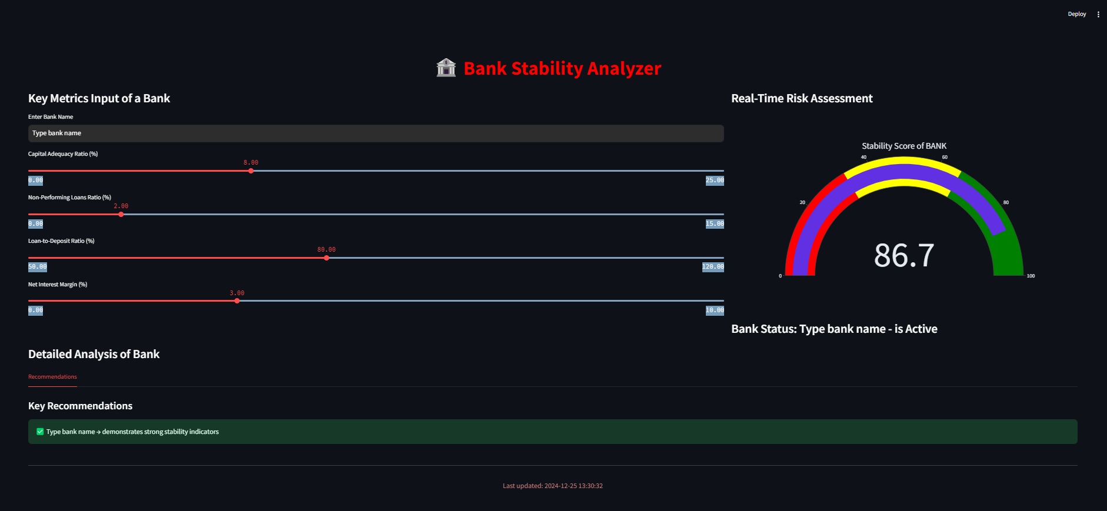
screenshots of the streamlit app
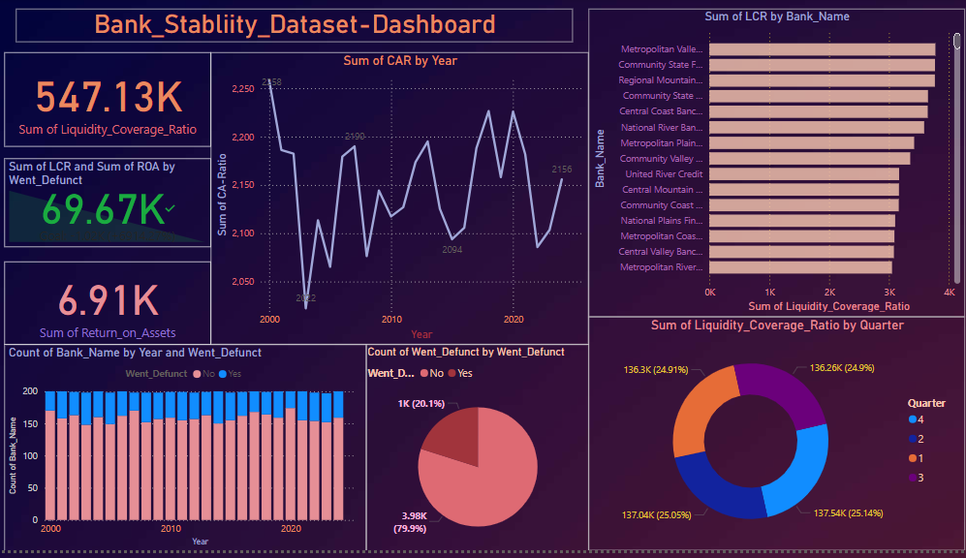
screenshots of the Power BI file

