Use Case Diagram and Descriptions- Dublin Walking Tour App

Use Case Diagram

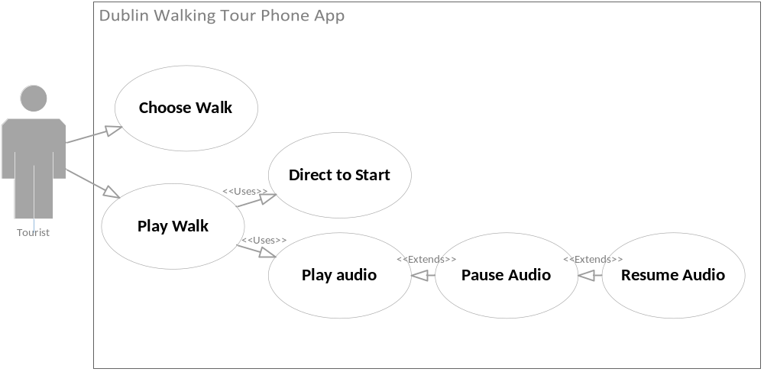

Use Case Descriptions

Dublin Walking App
Use Case: | Choose Walk
Actor (s): | Tourist
Goal: | The tourist wants to choose what walk to do.
Overview:
Type
Pre-Conditions | No preconditions
Post-Conditions | The walk is selected.
Special Requirements
Successful Scenario: | Step 1. The tourist opens the walk application by tapping on the live tile on the windows phone.
 | Step 2. The main screen shows a list of possible walks. Each walk will have a button to show a description of the walk and a button to start the walk.
 | Step 3. The user presses the button to start the walk.
Alternative Scenario (s) | Alternative step 3.The tourist opens the walk description and reads the description of the walk. The description also shows the location of the start of the walk. The tourist can either go back to the main menu and step 2 or choose to start the walk and go to step 3.

Dublin Walking App
Use Case: | Play Walk
Actor (s): | Tourist
Goal: | To do a selected audio walk
Overview: | The tourist does a walk from the app.
Type
Pre-Conditions | The walk is selected
Post-Conditions | The walk has been walked and the information listened to.
Special Requirements
Successful Scenario: | Step 1. Once the walk is selected the app directs the tourist to the starting location of the walk.
 | Step 2. Once at the starting location the tourist presses play to start the audio information for that location.
 | Step 3. Once the audio is complete the app directs the tourist to the next location of the walk.
 | Step 4. Once at the location the audio information for that location is played automatically.
 | Step 5. Steps 3 and 4 are repeated until the walk is finished.
 | Step 6. Once the walk is finished the app goes back to the main page and the tourist can choose another walk
Alternative Scenario (s) | Alternative step 3. The audio can be paused at any time. When paused and the tourist goes out of the app, the app is resumed at the paused page when the tourist comes back to the app.

Class Diagram
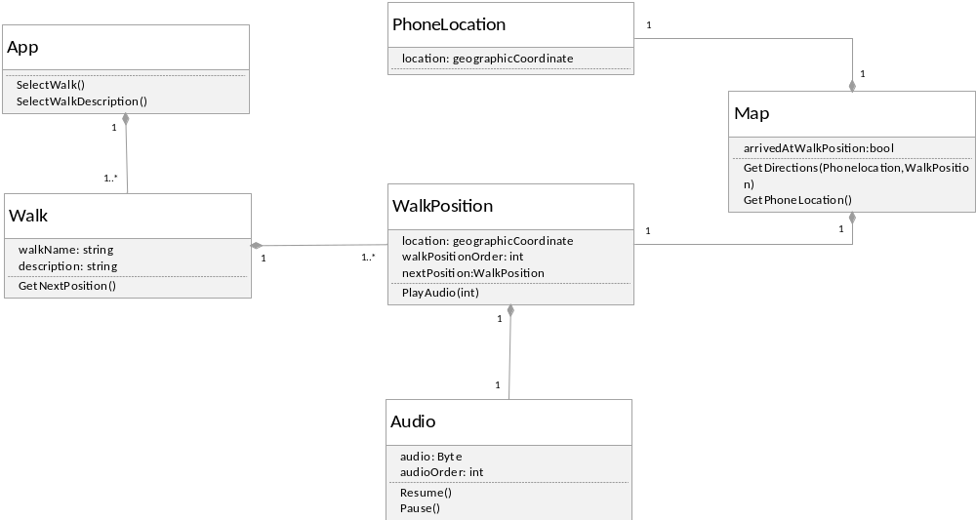

Sequence Diagram
