Sustainable data analysis with Snakemake (https://f1000research.com/articles/10-33/v1)

Types of bioinformatic workflow management systems
- systems like Galaxy⁴ and KNIME⁵ offer graphical user interfaces for composition and execution of workflows.
  - advantage is the shallow learning curve
- systems like Anduril⁶, Balsam⁷, Hyperloom⁸, Jug⁹, Pwrake¹⁰, Ruffus¹¹, SciPipe¹², SCOOP¹³, and COMPSs¹⁴ workflows are specified using a set of classes and functions for generic programming languages like Python, Scala, and others.
  - advantage that they can be used without a graphical interface (e.g. in a server environment), and that workflows can be straightforwardly managed with version control systems like Git
- systems like Nextflow¹⁵, Snakemake¹⁶, BioQueue¹⁷, Bpipe¹⁸, ClusterFlow¹⁹, Cylc²⁰, and BigDataScript²¹, workflows are specified using a domain specific language (DSL).
  - advantages of the second niche are shared, while adding the additional benefit of improved readability
  - For Nextflow and Snakemake, since the DSL is implemented as an extension to a generic programming language (Groovy and Python, respectively), access to the full power of the underlying programming language is maintained (e.g. for implementing conditional execution and handling configuration).
- systems like Popper²², workflow specification happens in a purely declarative way, via configuration file formats like YAML²³.
  - declarative systems share the concision and clarity of the third niche
  - workflow specification can be particularly readable for non-developers
  - by disallowing imperative or functional programming, these workflow systems can be more restrictive in the processes that can expressed
- system-independent workflow specification languages like CWL²⁴ and WDL²⁵. These define a declarative syntax for specifying workflows, which can be parsed and executed by arbitrary executors, e.g. Cromwell (https://cromwell.readthedocs.io), Toil²⁶, and Tibanna²⁷.
  - Similar to the fourth niche, a downside is that imperative or functional programming is not or less integrated into the specification language
  - advantage is that the same workflow definition can be executed on various specialized execution backends, thereby promising scalability to virtually any computing platform
Today, several of the above mentioned approaches support full in silico reproducibility of data analyses (e.g. Galaxy, Nextflow, Snakemake, WDL, CWL), by allowing the definition and scalable execution of each involved step, including deployment of the software stack needed for each step (e.g. via the Conda package manager, https://docs.conda.io, Docker, https://www.docker.com, or Singularity²⁸ containers).

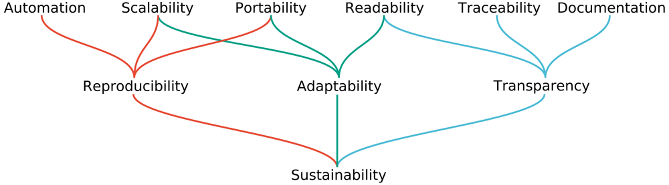

Snakemake (https://snakemake.github.io)
- Since its original publication in 2012, Snakemake has seen hundreds of releases and contributions
- one of the most widely used workflow management systems in science
- We will thereby introduce relevant features of both:
  - the workflow definition language
  - the execution environment
Automation:
- Central idea: workflows are specified through decomposition into steps represented as rules
  - Each rule describes how to obtain a set of output files from a set of input files
  - via a shell command, a block of Python code, an external script (Python, R, or Julia), a Jupyter notebook (https://jupyter.org), or a so-called wrapper
  - input and output files are either stored on disk, or in a remote storage (e.g. FTP, Amazon S3, Google Storage, Microsoft Azure Blob Storage, etc.)
- Wildcards – Generic rules:
  - Ex.: function select_by_country in Figure 3a (line 20) can be applied to generate any output file of the form results/by-country/{country}.csv, with {country} being a wildcard that can be replaced with any non-empty string
- Example workflow:
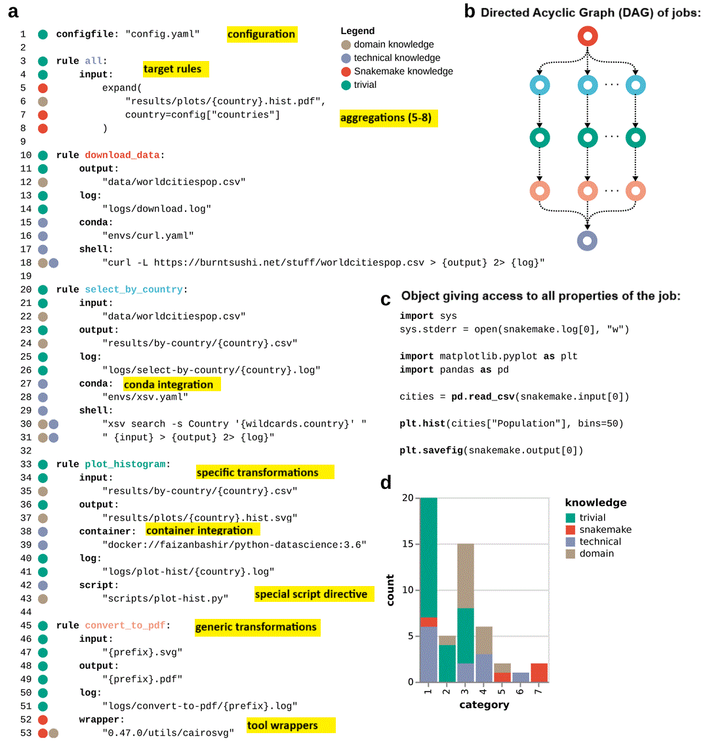
Figure 3. Example Snakemake workflow.
(a) workflow definition; hypothesized knowledge requirement for line readability is color-coded on the left next to the line numbers. (b) directed acyclic graph (DAG) of jobs, representing the automatically derived execution plan from the example workflow; job node colors reflect rule colors in the workflow definition. (c) content of script plot-hist.py referred from rule plot_histogram. (d) knowledge requirements for readability by statement category (see subsection 3.2). The example workflow downloads data, plots histograms of city populations within a given list of countries, and converts these from SVG to PDF format. Note that this is solely meant as a short yet comprehensive demonstration of the Snakemake syntax.
  - Figure 3a illustrates all major design patterns needed to define workflows with Snakemake:
    - workflow configuration (line 1),
    - aggregations (line 5–8),
    - specific (line 33–43) and generic (line 45–53) transformations,
    - target rules (line 3–8),
    - log file definition, software stack definition, as well as shell command, script, and wrapper integration
  - When using script integration instead of shell commands, Snakemake automatically inserts an object giving access to all properties of the job (e.g. snakemake.output [0], see Figure 3c)
  - By replacing wildcards with concrete values, Snakemake turns any rule into a job which will be executed
  - Snakemake obtains a directed acyclic graph of jobs (DAG, see Figure 3b), conferring runtime speed
  - Unit tests (concept from software development):
    - When maintaining and developing a production workflow, it is important to test each contained step, ideally upon every change to the workflow code
    - Snakemake can automatically generate a suite of unit tests, which can be executed via the Pytest framework (https://pytest.org)
    - It is advisable to keep the input datasets of the source workflow small in order to ensure that unit tests finish quickly

Readability:
- for each written statement, we can judge whether it:
  - needs domain knowledge (from the field analyzed in the given workflow),
  - needs technical knowledge (e.g. about Unix-style shell commands or Python),
  - needs Snakemake knowledge,
  - is trivial (i.e., it should be understandable for everybody).
- only five lines need Snakemake-specific knowledge (Figure 3d) (for a very simple example)
  - the ratio of lines requiring Snakemake knowledge, and lines that are trivial or readable with domain or technical knowledge can be expected to stay roughly the same
- Modularization:
  - Used to hide more technical parts of the workflow definition (e.g. helper functions or variables), in order to not distract the reader from understanding the main steps of the data analysis
  - Snakemake provides the ability to deposit and use tool wrappers (see Figure 3a, line 52–53) in/from a central repository (https://snakemake-wrappers.readthedocs.io)
    - each wrapper provides a Conda environment defining the required software stack, including tool and library versions
    - sub-workflows for common tasks (called meta-wrappers)
    - All wrappers are automatically tested to run without errors prior to inclusion in the repository, and upon each committed change
  - Integrating a script works via a special script directive (see Figure 3a, line 42)
  - Via the command line interface or browser, it is possible to instruct Snakemake to open a Jupyter notebook server for editing a notebook in the context of a specific job derived from the rule that refers to the notebook
- Standardized code linting and formatting:
  - Snakemake provides automatic code formatting (via the tool snakefmt) of workflows, together with any contained Python code
  - Snakemake has a built in code linter that detects code violating best practices (e.g. missing directives, indentation issues, missing environment variables, etc.) and provides suggestions on how to improve the code

Portability:
- Snakemake itself is easily deployable via the Conda package manager (https://conda.io), as a Python package (https://pypi.io), or a Docker container (https://hub.docker.com/r/snakemake/snakemake). Instructions and further information can be found at https://snakemake.github.io.
- Management of software stacks complementary mechanisms:
  - Conda integration (Figure 3a, line 15):
    - Each environment is described by a lightweight YAML file used by conda to install constituent software
    - software defined in the environment takes precedence over the same software in the operating system, and is isolated and independent from the same software in other Conda environments
  - Container integration (Figure 3a, line 38):
    - possible to define a container for each rule via container directive
    - Snakemake will pull the requested container image and run a job inside that container using Singularity²⁸
    - advantage of using containers is that the execution environment can be controlled down to the system libraries, and becomes portable across operating systems, thereby further increasing reproducibility³²
    - downside of using containers is that generating and modifying container images requires additional effort, as well as storage, since the image has to be uploaded to a container registry
- A sweet spot between containers and Conda can be exploited by combining container and conda directives. In that case, Snakemake will generate the requested Conda environment inside of the container, providing the flexibility of Conda together with the additional reproducibility guarantees of containers.

Traceability and documentation:
- Snakemake tracks input files, output files, parameters, software, and code of each executed job
- After completion, this information can be made available via self-contained, interactive, HTML based reports
- In the future, Snakemake reports will be extended to additionally follow the RO-crate standard, which will make them machine-readable and allow an integration with web services like https://workflowhub.eu

Scalability:
- Snakemake allows workflow execution to scale to various computational platforms, ranging from single workstations to large compute servers, any common cluster middleware, grid computing, and cloud computing (with native support for Kubernetes, the Google Cloud Life Sciences API, Amazon AWS, TES (https://www.ga4gh.org), and Microsoft Azure, the latter two in an upcoming release)
- Via configuration profiles, it is possible to persist and share the command line setup of Snakemake for any computing platform (https://github.com/snakemake-profiles/doc)
- Job scheduling:
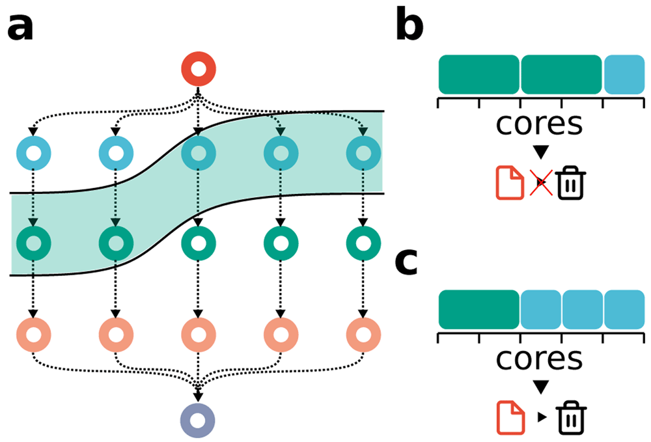
Figure 4. Snakemake scheduling problem.
(a) Example workflow DAG. The greenish area depicts the jobs that are ready for scheduling (because all input files are present) at a given time during the workflow execution. We assume that the red job at the root generates a temporary file, which may be deleted once all blue jobs are finished. (b) Suboptimal scheduling solution: two green jobs are scheduled, such that only one blue job can be scheduled and the temporary file generated by the red job has to remain on disk until all blue jobs are finished in a subsequent scheduling step. (c) Optimal scheduling solution: the three blue jobs are scheduled, such that the temporary file generated by the red job can be deleted afterwards.

- Caching between workflows: While data analyses usually entail the handling of multiple datasets or samples that are specific to a particular project, they often also rely on retrieval and post-processing of common datasets
  - For example, in the life sciences, such datasets include reference genomes and corresponding annotations
  - Historically, the solution in practice was to compile shared resources with post-processed datasets that could be referred to from the workflow definition (e.g. Illumina iGenomes resource, GATK resource bundle)
  - to provide a more flexible way of selection and retrieval for such shared resources, so-called “reference management” systems have been published, like Go Get Data (https://gogetdata.github.io) and RefGenie (http://refgenie.databio.org)
    - but transparency of the data analysis is hampered since the steps taken to obtain the used resources are hidden and less accessible for the reader of the data analysis
  - Snakemake provides a new, generic approach to the problem which does not have this downside (see Figure 5) – blockchain hashing (similar to used for cryptocurrency)
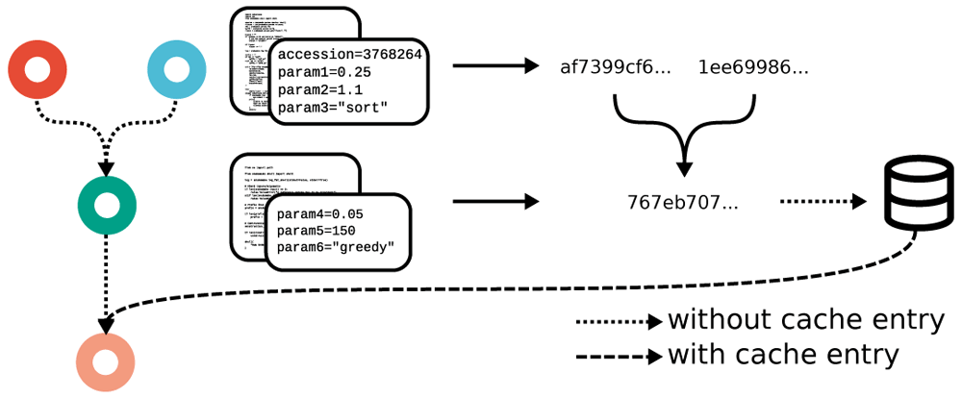
Figure 5. Blockchain-hashing based between workflow caching scheme of Snakemake.
If a job is eligible for caching, its code, parameters, raw input files, software environment and the hashes of its dependencies are used to calculate a SHA-256 hash value, under which the output files are stored in a central cache. Subsequent runs of the same job (with the same dependencies) in other workflows can skip the execution and directly take the output files from the cache.

- Graph partitioning:
  - When executing a Snakemake workflow in a cluster or cloud setting, by default, every job will be submitted separately to the underlying queuing system. For short-running jobs, this can result in a considerable overhead, as jobs wait in a queue, and may also incur additional delays or cost when accessing files from remote storage or network file systems.
  - To minimize such overhead, Snakemake offers the ability to partition the DAG of jobs into subgraphs that will be submitted together, as a single cluster or cloud job
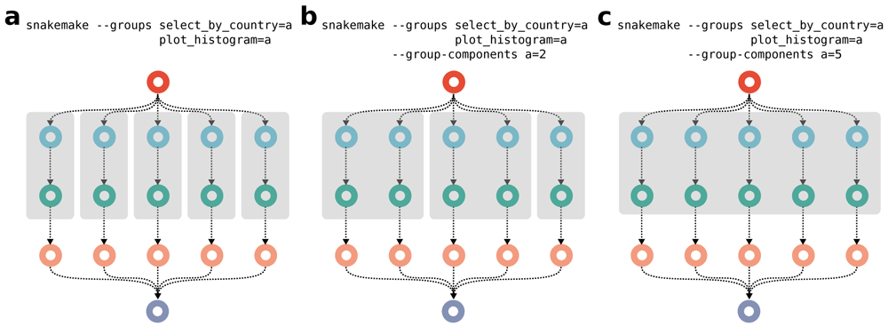
Figure 6. Job graph partitioning by assigning rules to groups.
Two rules of the example workflow (Figure 3a) are grouped together, (a) spanning one connected component, (b) spanning two connected components, and (c) spanning five connected components. Resulting submitted group jobs are represented as grey boxes.

- Streaming:
  - Sometimes, intermediate results of a data analysis can be huge, but not important enough to store persistently on disk
  - Apart from the option to mark such files as temporary so that Snakemake will automatically delete them once no longer needed, it is also possible to instruct Snakemake to never store them on disk at all by directly streaming their content from the producing job to to the consuming job
    - This requires the producing and consuming jobs to run at the same time on the same computing node
    - Snakemake ensures this by submitting producer and consumer as a group job

Further considerations:
- Advanced workflow design patterns:
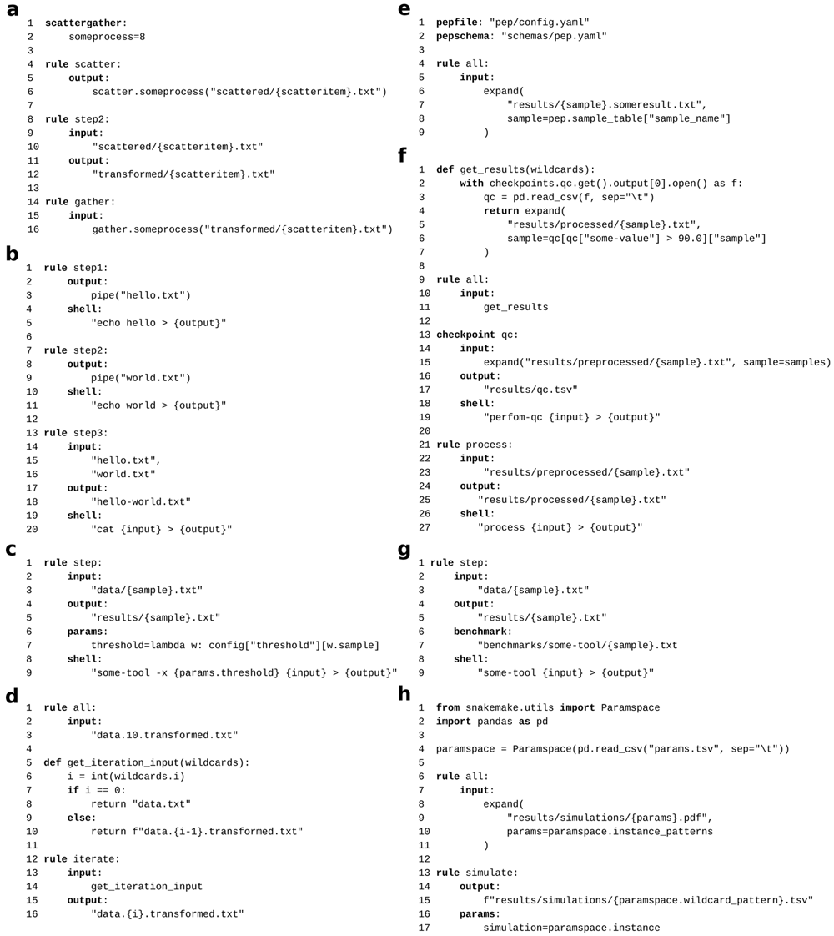
For brevity only rule properties that are necessary to understand each example are shown (e.g. omitting log directives and shell commands or script directives). (a) scatter/gather process, (b) streaming, (c) non-file parameters, (d) iteration, (e) sample sheet based configuration, (f) conditional execution, (g) benchmarking, (h) parameter space exploration. See subsection 3.1 for details.

