Input files format: .csv

The input files names CANNOT contain spaces and mathematical symbols (e.g.: +, -)

Input model:

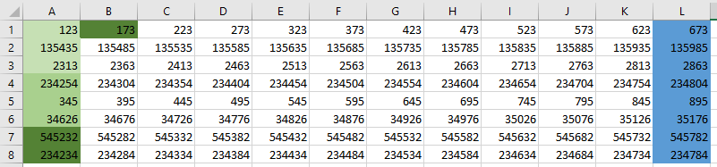

* In different shades of green: sample triplicates (they have to be ordered in the vertical)
* In blue: blank values column

To run the R code:

1. Open the code in R studio
2. Change “setwd” path to the folder that contains all your input files
3. Select the whole code and press “Run”
4. The output file with all the results for all the plates in the folder will be stored in the same folder, under the name “results.txt”

To check the results:

1. Open the .txt output in excel. Sample:

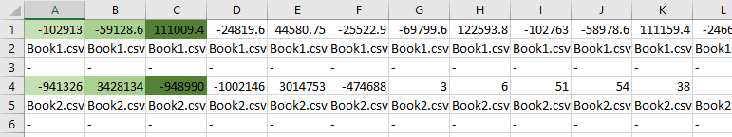

1. The first line will contain results from the first table in the folder. The name of the input file is written below (in this case, Book1.csv). The third line will contain results from the second table (Book2.csv), and so on.
2. The average from the first three triplicates in the plate will be in the first cell of the results line, the average from the second three triplicates in the plate will be in the second cell of the results line, and so on.