**DRUGPRED 2.0 TRAINING/TEST SETS 3 REPORTS**

PDB files have been removed, DrugPred2.0 descriptors, fsasa not included because it is skewed.

PDB code 1x70 has been included for DPP-IV

**Without haa, dsasa**

Training Set

|  |  |
| --- | --- |
| **Accuracy** | 0.906667 |
| **DRUGGABLE** | |
| **precision** | 0.9 |
| **recall** | 0.957447 |
| **NONDRUGGABLE** | |
| **precision** | 0.92 |
| **recall** | 0.821429 |

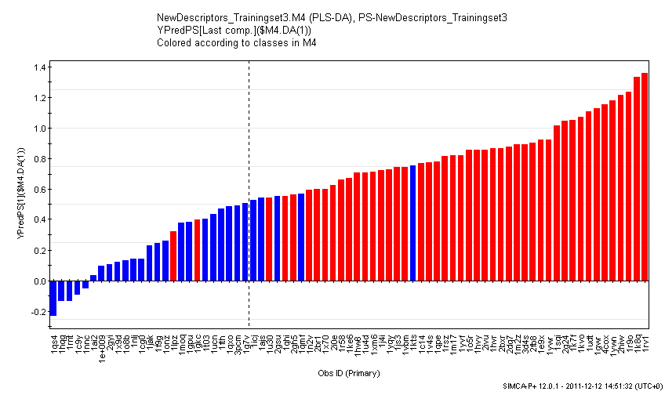

Test set

|  |  |
| --- | --- |
| **Accuracy** | 0.864865 |
| **DRUGGABLE** | |
| **precision** | 0.9 |
| **recall** | 0.857143 |
| **NONDRUGGABLE** | |
| **precision** | 0.823529 |
| **recall** | 0.875 |

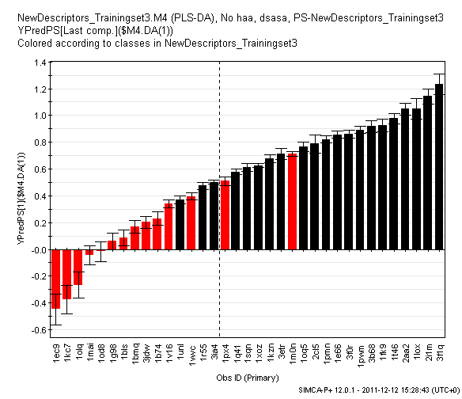

**With haa**

Training set

|  |  |
| --- | --- |
| **Accuracy** | 0.906667 |
| **DRUGGABLE** | |
| **precision** | 0.916667 |
| **recall** | 0.93617 |
| **NONDRUGGABLE** | |
| **precision** | 0.888889 |
| **recall** | 0.857143 |

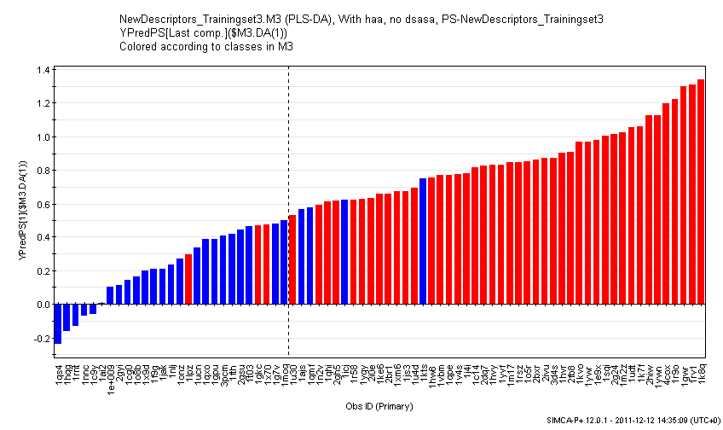

Test set

|  |  |
| --- | --- |
| **Accuracy** | 0.942857 |
| **DRUGGABLE** | |
| **precision** | 0.952381 |
| **recall** | 0.952381 |
| **NONDRUGGABLE** | |
| **precision** | 0.928571 |
| **recall** | 0.928571 |

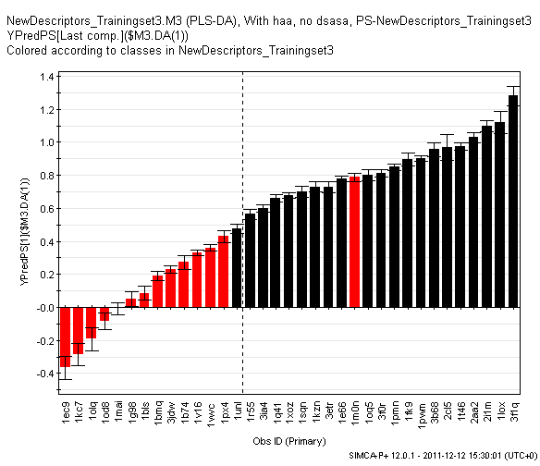

**With dsasa**

Training set

|  |  |
| --- | --- |
| **Accuracy** | 0.92 |
| **DRUGGABLE** | |
| **precision** | 0.918367 |
| **recall** | 0.957447 |
| **NONDRUGGABLE** | |
| **precision** | 0.923077 |
| **recall** | 0.857143 |

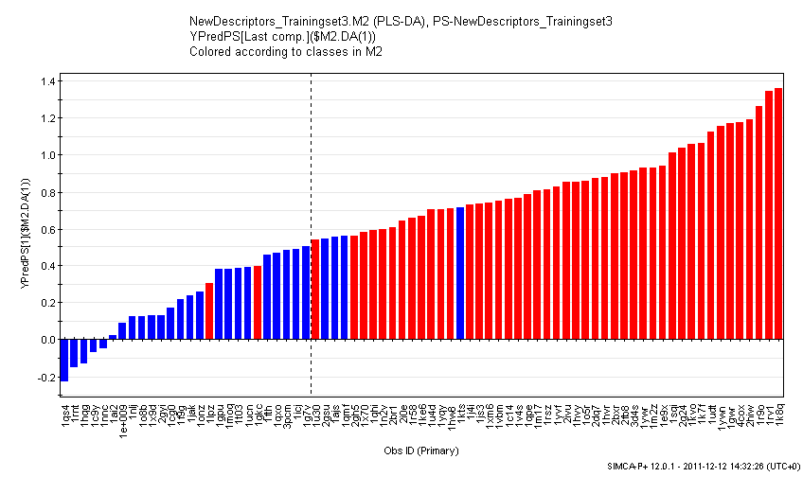

Test set

|  |  |
| --- | --- |
| **Accuracy** | 0.885714 |
| **DRUGGABLE** | |
| **precision** | 0.947368 |
| **recall** | 0.857143 |
| **NONDRUGGABLE** | |
| **precision** | 0.8125 |
| **recall** | 0.928571 |

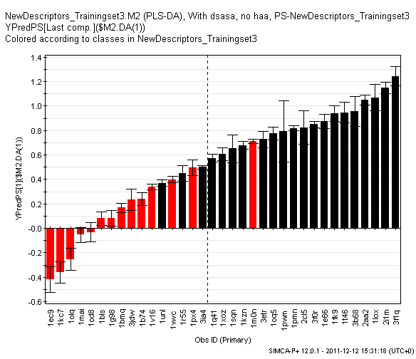

**With dsasa, haa**

Training set

|  |  |
| --- | --- |
| **Accuracy** | 0.906667 |
| **DRUGGABLE** | |
| **precision** | 0.916667 |
| **recall** | 0.93617 |
| **NONDRUGGABLE** | |
| **precision** | 0.888889 |
| **recall** | 0.857143 |

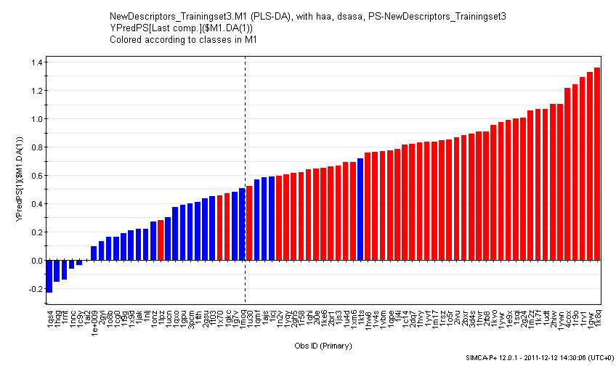

Test set

|  |  |
| --- | --- |
| **Accuracy** | 0.942857 |
| **DRUGGABLE** | |
| **precision** | 0.952381 |
| **recall** | 0.952381 |
| **NONDRUGGABLE** | |
| **precision** | 0.928571 |
| **recall** | 0.928571 |

