PID=5630, var=88
Fri Feb 26 14:00:34 CST 2016
Child process is done, var = 88, status=0

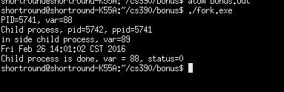

Screenshot from second run.

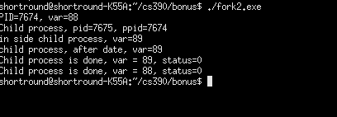

Screenshot from third run.

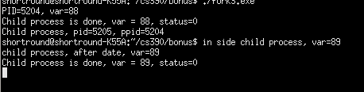

Screenshot from fourth run.

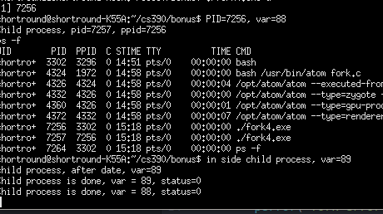

Screenshot from fifth run.

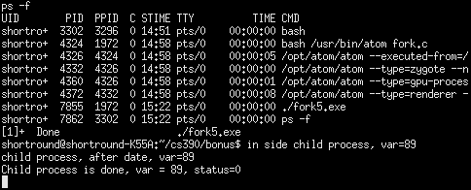

Sixth run.

