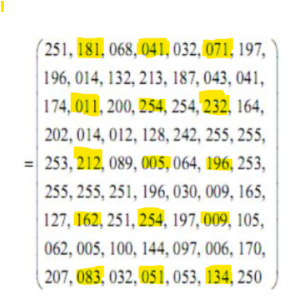

לפני הקטנת התמונה כדאי לבצע החלקה עליה.

2.

|  |  |  |  |  |  |
| --- | --- | --- | --- | --- | --- |
| 71 | 71 | 41 | 41 | 181 | 181 |
| 71 | 71 | 41 | 41 | 181 | 181 |
| 232 | 232 | 254 | 254 | 11 | 11 |
| 232 | 232 | 254 | 254 | 11 | 11 |
| 196 | 196 | 5 | 5 | 212 | 212 |
| 196 | 196 | 5 | 5 | 212 | 212 |
| 9 | 9 | 254 | 254 | 162 | 162 |
| 9 | 9 | 254 | 254 | 162 | 162 |
| 134 | 134 | 51 | 51 | 83 | 83 |
| 134 | 134 | 51 | 51 | 83 | 83 |

3.בשאלות 3 ו4 עשינו דוגמית קטנה. כל שאר המטריצה ממולאת כך.

|  |  |  |  |  |  |  |
| --- | --- | --- | --- | --- | --- | --- |
|  |  |  |  |  |  |  |
|  |  |  |  | 123 | 136 |  |
|  |  |  |  |  |  |  |
|  |  |  |  |  |  |  |
|  |  |  |  |  |  |  |
|  |  |  |  |  |  |  |
|  |  |  |  |  |  |  |
|  |  |  |  |  |  |  |
|  |  |  |  |  |  |  |

4.

|  |  |  |  |  |  |  |
| --- | --- | --- | --- | --- | --- | --- |
|  |  |  |  |  |  |  |
|  |  |  |  | 68 | 132 |  |
|  |  |  |  |  |  |  |
|  |  |  |  |  |  |  |
|  |  |  |  |  |  |  |
|  |  |  |  |  |  |  |
|  |  |  |  |  |  |  |
|  |  |  |  |  |  |  |
|  |  |  |  |  |  |  |