SOFTWARE DEVELOPMENT PROJECT MANAGEMENT SYSTEM
A DBMS Capstone Project Report submitted in partial fulfillment of the requirements for the award of the degree of
BACHELOR OF TECHNOLOGY
in
ARTIFICIAL INTELLIGENCE AND MACHINE LEARNING

Submitted By
T. Ruthika TriNayani – 25B11AIC02
A. Keerthi – 25B11AI025
G.K L S Shravya – 25B11AI319
K. Devi Saranya – 25B11AI623

Under the esteemed guidance of
Mr. T. Srinivasulu, M.Tech, (Ph.D.)
Assistant Professor



DEPARTMENT OF ARTIFICIAL INTELLIGENCE AND MACHINE LEARNING
ADITYA UNIVERSITY
(Formerly Aditya Engineering College (A))
Aditya Nagar, ADB Road, Surampalem, Andhra Pradesh, India
2026 – 2027

Aditya Nagar, ADB Road, Surampalem, Andhra Pradesh, India
DEPARTMENT OF ARTIFICIAL INTELLIGENCE AND MACHINE LEARNING
CERTIFICATE
This is to certify that the DBMS Capstone Project report entitled “SOFTWARE DEVELOPMENT PROJECT MANAGEMENT SYSTEM” is being submitted by T. Ruthika TriNayani (Roll No. 25B11AIC02), A. Keerthi (Roll No. 25B11AI025), G.K L S Shravya (Roll No. 25B11AI319) and K. Devi Saranya (Roll No. 25B11AI623) in partial fulfillment of the requirements for the award of the B.Tech. degree in Artificial Intelligence and Machine Learning. The work documented in this report was carried out as part of the Capstone Project for the course Database Management Systems (2501IT05) during the academic year 2026–2027, and records the database design, implementation, and documentation undertaken by the team.

Project Guide Head of the Department
Mr. T. Srinivasulu, M. Tech, (Ph.D.) Dr. K. Naga Bhargavi, M. Tech, Ph.D. Associate professor Associate Professor & HOD

External Examiner

DECLARATION
We hereby declare that the DBMS Capstone Project entitled “SOFTWARE DEVELOPMENT PROJECT MANAGEMENT SYSTEM” is a genuine work carried out by us. The database design, SQL implementation, queries and documentation presented in this report are our own work, completed under the guidance of Mr. T. Srinivasulu, M.Tech, (Ph.D.), Department of Artificial Intelligence and Machine Learning, Aditya University, Surampalem. We further declare that this work has not been submitted, in full or in part, for the award of any degree of this or any other educational institution.

Project Associates
T. Ruthika TriNayani (25B11AIC02)
A. Keerthi (25B11AI025)
G.K L S Shravya (25B11AI319)
K. Devi Saranya (25B11AI623)

Date: ____________
Place: Surampalem

ACKNOWLEDGEMENT
It is with immense pleasure that we express our indebted gratitude to our project guide Mr. T. Srinivasulu, M.Tech, (Ph.D.), Department of Artificial Intelligence and Machine Learning, who guided us throughout the capstone project. We are thankful for the constant encouragement and valuable suggestions received at every review stage.
We are grateful to Dr. K. Naga Bhargavi, M.Tech, Ph.D., Head of the Department, for inspiring us and for arranging the facilities and resources needed for this project.
We extend our sincere thanks to the Management, Dr. M. Sreenivasa Reddy, Deputy Pro-Chancellor, Dr. M. B. Srinivas, Vice-Chancellor, and Dr. A. Ramesh, Pro Vice-Chancellor (Engineering & Sciences), for providing an excellent academic environment.
Not to forget, we thank the Teaching and Non-Teaching Staff, our parents and our friends, who have directly or indirectly supported us in completing this project on time.

Project Associates
T. Ruthika TriNayani 25B11AIC02
A. Keerthi 25B11AI025
G.K L S Shravya 25B11AI319
K. Devi Saranya 25B11AI623

ABSTRACT
Software companies run many client projects at the same time, and every project generates client, team, developer, module, task and bug data that must stay consistent and quickly retrievable. When this information is kept in disconnected spreadsheets, effort is duplicated, deadlines are missed and bug reports are lost, because nothing links a client’s project to its modules, tasks, developers and bugs. The Software Development Project Management System addresses this by consolidating the data of a software team into a single normalized relational database. Seven entities were identified — Client, Project, Team, Developer, Module, Task and Bug — connected by one-to-many and one-to-one relationships, so that every task and bug can be traced back to the client project it belongs to. The conceptual design was drawn as an ER diagram, converted into a relational schema with seven foreign keys and normalized up to the Third Normal Form. The database was implemented in PostgreSQL with primary keys, foreign keys, NOT NULL, UNIQUE, CHECK and DEFAULT constraints, and populated with sample data across all seven tables. Eleven SQL operations were executed, covering DDL and DML statements, data retrieval, joins, aggregate functions with GROUP BY and a reusable view for developer workload, and each constraint was verified by deliberately inserting invalid data. The resulting database tracks task progress and bug status from assignment to resolution, enforces referential integrity automatically, and answers reporting questions such as developer workload and open bugs per module with a single query.

INDEX
Chapter | Title | Page No.
 | Certificate | i
 | Declaration | ii
 | Acknowledgement | iii
 | Abstract | iv
 | List of Figures | v
 | List of Tables | vi
1 | Introduction | 9
 | 1.1 Introduction to the Domain | 9
 | 1.2 Problem Statement | 9
 | 1.3 Motivation and Need for a Database | 9
 | 1.4 Objectives of the Project | 10
 | 1.5 Scope of the Project | 10
 | 1.6 Organization of the Report | 10
2 | System Study and Tools | 11
 | 2.1 Existing System and Its Limitations | 11
 | 2.2 Proposed Database System | 11
 | 2.3 Tools and Technologies Used | 12
 | 2.4 Software and Hardware Requirements | 12
3 | Database Design (Review – I) | 13
 | 3.1 Identified Entities | 13
 | 3.2 Entity Attributes and Attribute Types | 13
 | 3.3 ER Diagram | 14
 | 3.4 Relationships and Cardinality | 15
 | 3.5 Relational Database Schema | 16
 | 3.6 Primary Keys and Foreign Keys | 17
 | 3.7 Normalization up to 3NF | 17
4 | Database Implementation (Review – II) | 19
 | 4.1 Database and Table Creation – DDL | 19
 | 4.2 Sample Data Insertion – DML | 20
 | 4.3 Constraints and Data Integrity | 22
 | 4.4 Data Validation Rules | 22
5 | SQL Operations and Queries | 26
 | 5.1 DQL – Basic Retrieval Queries | 26
 | 5.2 Join Operations | 26
 | 5.3 Aggregate Functions and GROUP BY | 27
 | 5.4 Views | 27
 | 5.5 DDL and DML Modification Operations | 28
6 | Modules and Functionalities | 29
7 | Results – Sample Outputs and Screenshots | 30
8 | Testing and Data Validation | 34
9 | GitHub Repository and Team Contribution | 35
10 | Conclusion and Future Enhancements | 36
 | References | 37
 | Appendix A – Complete SQL Script | 38

LIST OF FIGURES
Figure No. | Title of the Figure | Page No.
3.1 | ER Diagram of the Software Development Project Management System | 15
3.2 | Relational Schema Diagram showing Primary Key – Foreign Key links | 17
4.1 | Successful Creation of Tables — seven tables created in the pms_db database | 20
4.2 | Record counts confirming sample data in all seven tables | 21
4.3 | PRIMARY KEY constraints defined on the seven tables | 23
4.4 | FOREIGN KEY constraints defined on the tables | 23
4.5 | NOT NULL constraint rejecting a missing Client.name | 24
4.6 | UNIQUE constraint rejecting a duplicate client e-mail | 24
4.7 | CHECK constraint rejecting an invalid Project.status value | 24
4.8 | DEFAULT value applied when Project.status is omitted | 25
7.1 | Database and table creation in PostgreSQL / pgAdmin | 30
7.2 | Sample data inserted — record counts of the seven tables | 30
7.3 | Details of the Project table (SELECT * FROM Project) | 31
7.4 | Tasks assigned to each developer (JOIN) | 31
7.5 | Task count per developer (LEFT JOIN + GROUP BY) | 32
7.6 | Open bugs per module | 32
7.7 | Bugs grouped by severity | 32
7.8 | DeveloperWorkload view — example output | 33

LIST OF TABLES
Table No. | Title of the Table | Page No.
2.1 | Tools and Technologies Used | 12
2.2 | Software and Hardware Requirements | 12
3.1 | List of Entities | 13
3.2 | Entity Attributes and Attribute Types | 13
3.3 | Relationships and Cardinality | 15
3.4 | Relational Database Schema | 16
3.5 | Primary Keys and Foreign Keys | 17
3.6 | Normalization up to 3NF | 18
4.1 | Sample Data Insertion Summary | 21
4.2 | Constraints and Data Integrity | 22
5.1 | DDL and DML Modification Operations | 28
6.1 | Modules and Their Functionalities | 29
8.1 | Test Cases and Results | 34
9.1 | Team Responsibilities | 35
9.2 | Review-wise Progress Record | 35

CHAPTER 1: INTRODUCTION

1.1 Introduction to the Domain
Software development is organised around projects. A software company is commissioned by a client to build a product; a team of developers is assigned to the project; the product is divided into functional modules; each module is broken down into tasks that are given to individual developers; and, as the work is tested, bugs are reported against the tasks. Every one of these activities produces data, and the data items are strongly related to one another: a project belongs to one client, a module belongs to one project, a task belongs to one module and is assigned to one developer, a developer belongs to a team, and a bug is reported against a task.
The Software Development Project Management System is a relational database designed to hold this data for a software development team. It covers the clients who commission projects, the projects and the team assigned to each, the developers in each team, the functional modules of every project, the tasks within each module together with their deadlines and status, and the bugs reported against those tasks together with their severity and status.

1.2 Problem Statement
Development teams commonly track projects, tasks and bugs in disconnected spreadsheets. This arrangement causes several recurring problems.
Duplicated effort — the same client, project and developer details are typed into several sheets, and each copy has to be updated separately whenever something changes.
Missed deadlines — task deadlines and statuses are scattered across files, so a task that is falling behind is noticed only when the deadline has already passed.
Lost bug reports — a bug noted in one sheet is not linked to the task it was found in, so it is easily forgotten or reported twice.
Difficult reporting — a question such as “how many tasks does each developer hold” or “which module has the most open bugs” has to be compiled by hand, because there is no single source of truth linking a client’s project to its modules, tasks, developers and bugs.
The proposed system stores each fact exactly once in a normalized table, links the tables through foreign keys so that every task and bug can be traced back to the client project it belongs to, and answers the above questions with a single SQL statement.

1.3 Motivation and Need for a Database
A spreadsheet can store rows, but it cannot enforce relationships. It will happily accept a task assigned to a developer who does not exist, a bug reported against a deleted task, a project status of “Active” when only three statuses are valid, or two clients sharing the same e-mail address. A database management system enforces these rules at the point of insertion through PRIMARY KEY, FOREIGN KEY, NOT NULL, UNIQUE, CHECK and DEFAULT constraints, so invalid data never enters the system in the first place. A DBMS also allows project managers, developers and testers to work on the same data concurrently, and provides a query language in which reporting questions — developer workload, project status, open bugs per module — are expressed declaratively rather than compiled by hand.

1.4 Objectives of the Project
- To design a normalized relational database for clients, projects, teams, developers, modules, tasks and bugs of a software development organisation, with a minimum of six entities.
- To model the relationships between projects, teams, tasks and bugs with correct cardinalities using a clear ER diagram, and to convert the design into a relational schema normalized up to the Third Normal Form.
- To track task progress from assignment to completion and bug status from report to resolution, using constrained status columns with sensible default values.
- To support reports such as developer workload, project status and open bugs per module through JOIN and GROUP BY queries and a reusable view.
- To ensure data integrity through well-defined primary and foreign keys together with NOT NULL, UNIQUE, CHECK and DEFAULT constraints, and to verify that the database rejects duplicate keys, invalid values and missing data.

1.5 Scope of the Project
The database covers the project-management side of a software development organisation: client onboarding, project registration, the team assigned to each project and its developers, the functional modules of each project, the tasks within each module and the developer who owns each one, and the bugs reported against tasks from the time they are reported until they are resolved.
The following are outside the scope of the present work: user login and role-based access, automated deadline notifications, time-tracking and billing, integration with a source-code repository, and any graphical front-end application. The project is a database design and implementation exercise, and all interaction is through SQL.

1.6 Organization of the Report
This report is organized into ten chapters. Chapter 2 presents the system study and the tools used. Chapter 3 covers the complete database design including the ER diagram, relational schema and normalization. Chapter 4 describes the database implementation with DDL, sample data and constraint validation. Chapter 5 presents the SQL operations and queries executed. Chapter 6 explains the modules and functionalities. Chapter 7 presents the results with sample outputs. Chapter 8 covers testing and data validation. Chapter 9 details the GitHub repository and the contribution of each team member. Chapter 10 concludes the report and outlines future enhancements.

CHAPTER 2: SYSTEM STUDY AND TOOLS

2.1 Existing System and Its Limitations
The existing arrangement in a small development team is file based. Client details, project plans, task lists and bug reports are kept in separate spreadsheets that are updated independently by different people. During the study of the present system the following limitations were observed.
The same client, project and developer names are re-typed in several sheets, so a change has to be applied in more than one place and is often applied only once.
There is no automatic link between a task and the module, project and client it belongs to; the connection exists only in the minds of the team members.
Bug reports are not tied to the task in which the bug was found, so bugs are lost, duplicated or left unresolved without anyone noticing.
Status values are typed as free text, so the same status is written in different ways (“Done”, “Completed”, “finished”) and cannot be counted reliably.
Summary reports such as developer workload, project status or open bugs per module must be prepared manually for every request.

2.2 Proposed Database System
The proposed system is a single relational database in which each fact is stored once. Client, Project, Team, Developer, Module, Task and Bug details are held in their own tables and linked through foreign keys, which makes orphan records impossible: a task cannot exist without a module and a developer, and a bug cannot exist without a task. CHECK constraints restrict project, task and bug statuses and bug severity to a defined set of values, DEFAULT values fill in a sensible starting status when none is supplied, and UNIQUE constraints prevent duplicate client and developer e-mail addresses. Reports that were previously manual — developer workload, open bugs per module, bugs by severity — are obtained by a single SELECT statement, and the workload report is stored as a view.

2.3 Tools and Technologies Used
Table 2.1: Tools and Technologies Used
Category | Tool / Technology Used | Version / Remarks
Database Server | PostgreSQL | Relational DBMS used for implementation
Query / Admin Tool | pgAdmin / DB Fiddle | Script execution, output capture and independent verification of queries
Front-end | None | All interaction is through SQL
Operating System | Windows | Development platform
Version Control | GitHub | Team repository for the SQL script
Documentation | Microsoft Word | Report preparation

2.4 Software and Hardware Requirements
Table 2.2: Software and Hardware Requirements
Requirement Type | Specification
Operating System | Windows 10 / 11 (64-bit)
Database Server | PostgreSQL 14 or above
Client Tool | pgAdmin 4, or the DB Fiddle online SQL editor
Processor | Intel Core i3 or above
RAM | 4 GB minimum, 8 GB recommended
Disk Space | 2 GB free (server, sample data and documentation)

CHAPTER 3: DATABASE DESIGN

3.1 Identified Entities
Seven entities were identified from the study of the domain. Every relationship between them is one-to-many or one-to-one, so no associative table was required.
Table 3.1: List of Entities
S.No | Entity Name | Description
1 | Client | A client who commissions software projects (name, e-mail, phone, address).
2 | Project | A project commissioned by a client, with its title, start and end dates and status.
3 | Team | The single team assigned to a project.
4 | Developer | A developer who belongs to a team, with e-mail and role.
5 | Module | A functional module that makes up a project.
6 | Task | A unit of work within a module, assigned to a developer, with a deadline and status.
7 | Bug | A defect reported against a task, with severity, status and report date.

3.2 Entity Attributes and Attribute Types
The attributes of each entity are listed below with the data type, the key role and the attribute classification. The classification follows the ER model: an attribute is Simple if it cannot be divided further, Composite if it is made up of smaller attributes, Multi-valued if one entity instance may hold several values, and Derived if its value is computed from other stored attributes.
Table 3.2: Entity Attributes and Attribute Types
Entity | Attribute | Data Type | Key (PK / FK / —) | Attribute Type
Client | client_id | INT | PK | Simple
 | name | VARCHAR(100) | NOT NULL | Simple
 | email | VARCHAR(100) | UNIQUE, NOT NULL | Simple
 | phone | VARCHAR(15) | --- | Simple
 | address | VARCHAR(200) | --- | Composite (stored as one text value)
Project | project_id | INT | PK | Simple
 | title | VARCHAR(100) | NOT NULL | Simple
 | client_id | INT | FK → Client, NOT NULL | Simple
 | start_date / end_date | DATE | --- | Simple
 | status | VARCHAR(20) | DEFAULT ‘Ongoing’, CHECK IN (3 values) | Simple
Team | team_id | INT | PK | Simple
 | team_name | VARCHAR(100) | NOT NULL | Simple
 | project_id | INT | FK → Project, NOT NULL | Simple
Developer | developer_id | INT | PK | Simple
 | name | VARCHAR(100) | NOT NULL | Simple
 | email | VARCHAR(100) | UNIQUE, NOT NULL | Simple
 | role | VARCHAR(50) | --- | Simple
 | team_id | INT | FK → Team, NOT NULL | Simple
Module | module_id | INT | PK | Simple
 | module_name | VARCHAR(100) | NOT NULL | Simple
 | description | VARCHAR(200) | --- | Simple
 | project_id | INT | FK → Project, NOT NULL | Simple
Task | task_id | INT | PK | Simple
 | title | VARCHAR(100) | NOT NULL | Simple
 | deadline | DATE | --- | Simple
 | status | VARCHAR(20) | DEFAULT ‘Pending’, CHECK IN (3 values) | Simple
 | module_id | INT | FK → Module, NOT NULL | Simple
 | developer_id | INT | FK → Developer, NOT NULL | Simple
Bug | bug_id | INT | PK | Simple
 | description | VARCHAR(200) | NOT NULL | Simple
 | severity | VARCHAR(10) | CHECK IN (Low, Medium, High) | Simple
 | status | VARCHAR(20) | DEFAULT ‘Open’, CHECK IN (Open, Resolved) | Simple
 | reported_date | DATE | --- | Simple
 | task_id | INT | FK → Task, NOT NULL | Simple

3.3 ER Diagram
The ER diagram below shows the seven entities as rectangles, their attributes as ellipses with the primary key (PK) and foreign key (FK) attributes marked, and the relationships as named diamonds connecting the entities.
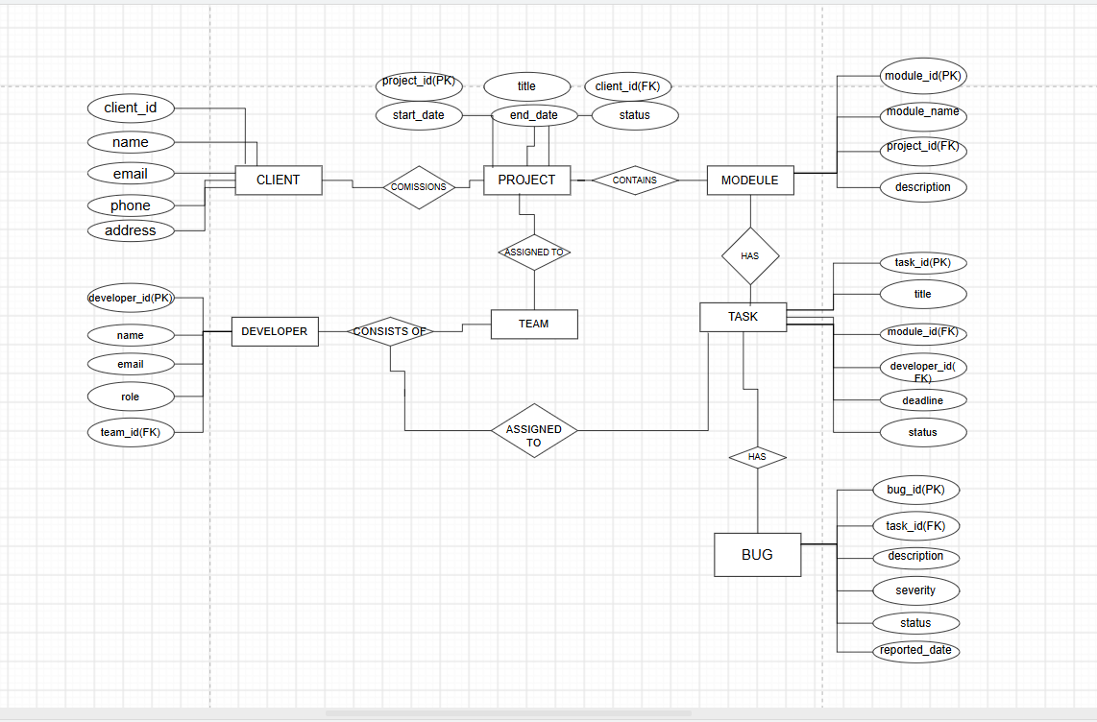
Fig. 3.1: ER Diagram of the Software Development Project Management System

3.4 Relationships and Cardinality
Table 3.3: Relationships and Cardinality
Entity 1 | Relationship | Entity 2 | Cardinality (1:1 / 1:N / M:N) | Participation
Client | commissions | Project | 1 : M | Total on Project
Project | has / contains | Module | 1 : M | Total on Module
Project | assigned to | Team | 1 : 1 | Total on Team
Team | consists of | Developer | 1 : M | Total on Developer
Module | contains | Task | 1 : M | Total on Task
Developer | assigned to | Task | 1 : M | Total on Task
Task | has / reports | Bug | 1 : M | Total on Bug
Every relationship is implemented by placing the foreign key on the many side: Project.client_id, Module.project_id, Team.project_id, Developer.team_id, Task.module_id, Task.developer_id and Bug.task_id. The participation of the many side is total because each of these foreign key columns is declared NOT NULL — a project must have a client, a module must belong to a project, a task must have both a module and a developer, and a bug must be reported against a task. The relationship between Project and Team is 1 : 1 as designed: each project is served by a single team.

3.5 Relational Database Schema
The ER design was converted into the following relational schema. Each entity became a table, and each relationship was implemented by placing the foreign key on the many side.
Table 3.4: Relational Database Schema
Table Name | Column Name | Data Type | Key (PK / FK / —) | Constraints
Client | client_id | INT | PK | PRIMARY KEY
 | name | VARCHAR(100) | --- | NOT NULL
 | email | VARCHAR(100) | --- | NOT NULL, UNIQUE
 | phone | VARCHAR(15) | --- | ---
 | address | VARCHAR(200) | --- | ---
Project | project_id | INT | PK | PRIMARY KEY
 | title | VARCHAR(100) | --- | NOT NULL
 | client_id | INT | FK | NOT NULL, REFERENCES Client
 | start_date, end_date | DATE | --- | ---
 | status | VARCHAR(20) | --- | DEFAULT ‘Ongoing’, CHECK IN (Ongoing, Completed, On Hold)
Team | team_id | INT | PK | PRIMARY KEY
 | team_name | VARCHAR(100) | --- | NOT NULL
 | project_id | INT | FK | NOT NULL, REFERENCES Project
Developer | developer_id | INT | PK | PRIMARY KEY
 | name | VARCHAR(100) | --- | NOT NULL
 | email | VARCHAR(100) | --- | NOT NULL, UNIQUE
 | role | VARCHAR(50) | --- | ---
 | team_id | INT | FK | NOT NULL, REFERENCES Team
Module | module_id | INT | PK | PRIMARY KEY
 | module_name | VARCHAR(100) | --- | NOT NULL
 | description | VARCHAR(200) | --- | ---
 | project_id | INT | FK | NOT NULL, REFERENCES Project
Task | task_id | INT | PK | PRIMARY KEY
 | title | VARCHAR(100) | --- | NOT NULL
 | deadline | DATE | --- | ---
 | status | VARCHAR(20) | --- | DEFAULT ‘Pending’, CHECK IN (Pending, In Progress, Completed)
 | module_id | INT | FK | NOT NULL, REFERENCES Module
 | developer_id | INT | FK | NOT NULL, REFERENCES Developer
Bug | bug_id | INT | PK | PRIMARY KEY
 | description | VARCHAR(200) | --- | NOT NULL
 | severity | VARCHAR(10) | --- | CHECK IN (Low, Medium, High)
 | status | VARCHAR(20) | --- | DEFAULT ‘Open’, CHECK IN (Open, Resolved)
 | reported_date | DATE | --- | ---
 | task_id | INT | FK | NOT NULL, REFERENCES Task

Schema Diagram
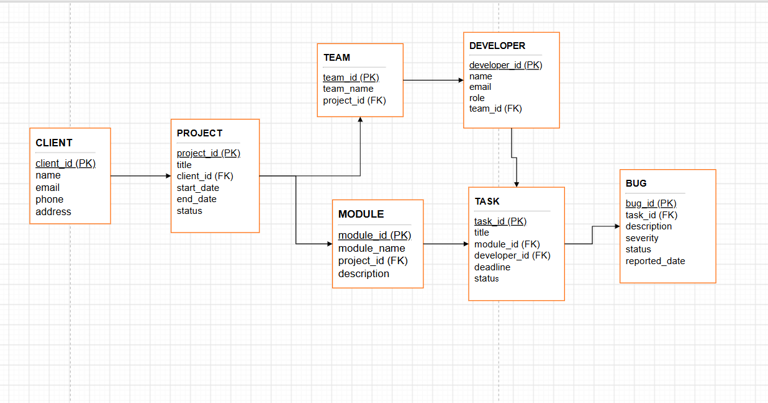
Fig. 3.2: Relational Schema Diagram showing Primary Key – Foreign Key links

3.6 Primary Keys and Foreign Keys
Table 3.5: Primary Keys and Foreign Keys
Table | Primary Key | Foreign Key | References (Table.Column)
Client | client_id | --- | ---
Project | project_id | client_id | Client(client_id)
Team | team_id | project_id | Project(project_id)
Developer | developer_id | team_id | Team(team_id)
Module | module_id | project_id | Project(project_id)
Task | task_id | module_id / developer_id | Module(module_id) / Developer(developer_id)
Bug | bug_id | task_id | Task(task_id)
Seven tables carry seven foreign keys in all, and every table has a single-column primary key.

3.7 Normalization up to 3NF
The initial design held all project information in a single unnormalized relation of the form shown below, in which one row described a client and project together with every developer, module, task and bug connected with it.
PROJECT_DETAIL ( project_id, project_title, client_name, client_email, client_phone, client_address, start_date, end_date, project_status, team_name, developer_name, developer_email, developer_role, module_name, task_title, task_deadline, task_status, bug_description, bug_severity, bug_status, reported_date )

First Normal Form (1NF)
A project has several developers, modules, tasks and bugs, so one project row carried repeating groups of values, which violates 1NF. 1NF requires every attribute to hold a single, atomic value and every row to be unique. The repeating groups were therefore moved into separate tables — Developer, Module, Task and Bug — each row holding one developer, one module, one task or one bug and linked back by a key.

Second Normal Form (2NF)
After 1NF, attributes such as client_name and project_title depended only on the project, while developer_name depended only on the developer and task_title only on the task. These are partial dependencies on part of a combined key, which 2NF forbids. After the decomposition every table has a single-column primary key (client_id, project_id, team_id, developer_id, module_id, task_id, bug_id), so every non-key attribute depends on the whole key of its own table and 2NF holds by construction.

Third Normal Form (3NF)
A transitive dependency still remained: client_name, client_email and client_phone depended on client_id, which in turn depended on project_id, and team_name depended on a team that in turn depended on the project. Since these attributes were determined by non-key attributes, the Client and Team tables were separated out and only client_id and project_id were retained as foreign keys. Likewise a developer’s team_id is stored once on Developer and not repeated on every Task. In the final design every non-key attribute depends only on the primary key of its own table.
Table 3.6: Normalization up to 3NF
Normal Form | Condition Satisfied | Anomaly Removed | Resulting Tables
1NF | All attributes atomic; no repeating groups | Several developers, modules, tasks and bugs packed into one project record | Developer, Module, Task, Bug
2NF | No partial dependency on part of a key | Client, developer and task details repeated for every row of the combined record | Project, Developer, Task (single-column keys)
3NF | No transitive dependency on a non-key attribute | Client and team details repeated across project, developer and task rows | Client, Project, Team, Developer, Module, Task, Bug

CHAPTER 4: DATABASE IMPLEMENTATION

4.1 Database and Table Creation – DDL
The schema was implemented in PostgreSQL. The tables are created in dependency order so that every referenced table exists before the foreign key referring to it is defined.
CREATE DATABASE pms_db;

-- connect to the new database before creating tables
-- (psql: \c pms_db; pgAdmin: select pms_db from the browser)

/* Creating the Client table */
CREATE TABLE Client
(
client_id INT PRIMARY KEY,
name VARCHAR(100) NOT NULL,
email VARCHAR(100) NOT NULL UNIQUE,
phone VARCHAR(15),
address VARCHAR(200)
);

/* Creating the Project table */
CREATE TABLE Project
(
project_id INT PRIMARY KEY,
title VARCHAR(100) NOT NULL,
client_id INT NOT NULL,
start_date DATE,
end_date DATE,
status VARCHAR(20) DEFAULT 'Ongoing'
CHECK (status IN ('Ongoing','Completed','On Hold')),
FOREIGN KEY (client_id) REFERENCES Client(client_id)
);

/* Creating the Team table */
CREATE TABLE Team
(
team_id INT PRIMARY KEY,
team_name VARCHAR(100) NOT NULL,
project_id INT NOT NULL,
FOREIGN KEY (project_id) REFERENCES Project(project_id)
);

/* Creating the Developer table */
CREATE TABLE Developer
(
developer_id INT PRIMARY KEY,
name VARCHAR(100) NOT NULL,
email VARCHAR(100) NOT NULL UNIQUE,
role VARCHAR(50),
team_id INT NOT NULL,
FOREIGN KEY (team_id) REFERENCES Team(team_id)
);

/* Creating the Module table */
CREATE TABLE Module
(
module_id INT PRIMARY KEY,
module_name VARCHAR(100) NOT NULL,
description VARCHAR(200),
project_id INT NOT NULL,
FOREIGN KEY (project_id) REFERENCES Project(project_id)
);

/* Creating the Task table */
CREATE TABLE Task
(
task_id INT PRIMARY KEY,
title VARCHAR(100) NOT NULL,
deadline DATE,
status VARCHAR(20) DEFAULT 'Pending'
CHECK (status IN ('Pending','In Progress','Completed')),
module_id INT NOT NULL,
developer_id INT NOT NULL,
FOREIGN KEY (module_id) REFERENCES Module(module_id),
FOREIGN KEY (developer_id) REFERENCES Developer(developer_id)
);

/* Creating the Bug table */
CREATE TABLE Bug
(
bug_id INT PRIMARY KEY,
description VARCHAR(200) NOT NULL,
severity VARCHAR(10) CHECK (severity IN ('Low','Medium','High')),
status VARCHAR(20) DEFAULT 'Open'
CHECK (status IN ('Open','Resolved')),
reported_date DATE,
task_id INT NOT NULL,
FOREIGN KEY (task_id) REFERENCES Task(task_id)
);

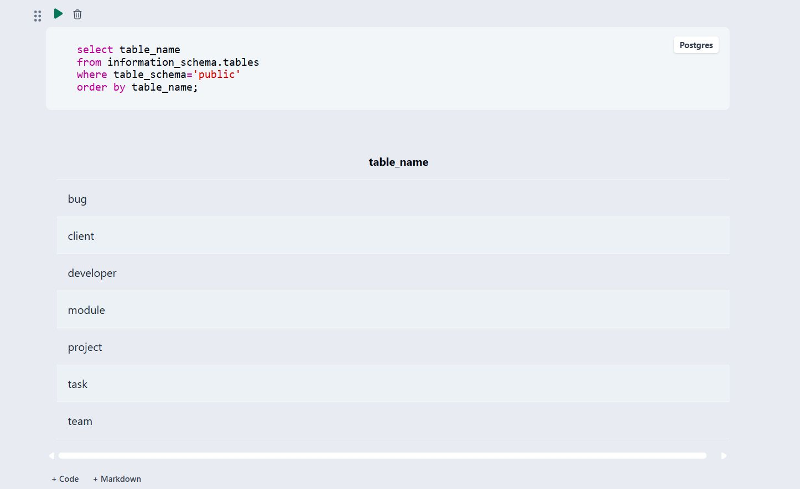
Fig. 4.1: Successful Creation of Tables — seven tables created in the pms_db database
The script executed without errors and created all seven tables listed above.

4.2 Sample Data Insertion – DML
Sample data was inserted into all seven tables, chosen so that every relationship and constraint is exercised: every project references an existing client, every developer belongs to an existing team, every task references an existing module and developer, and every bug is reported against an existing task.
Table 4.1: Sample Data Insertion Summary
S.No | Table Name | No. of Records Inserted | Remarks
1 | Client | 4 | Each client carries a unique e-mail address
2 | Project | 4 | Status Ongoing; each project references a client
3 | Team | 1 | Team assigned to a project
4 | Developer | 5 | Each developer belongs to a team
5 | Module | 1 | Stock Management module of a project
6 | Task | 5 | Linked to a module and a developer
7 | Bug | 1 | High-severity open bug linked to a task

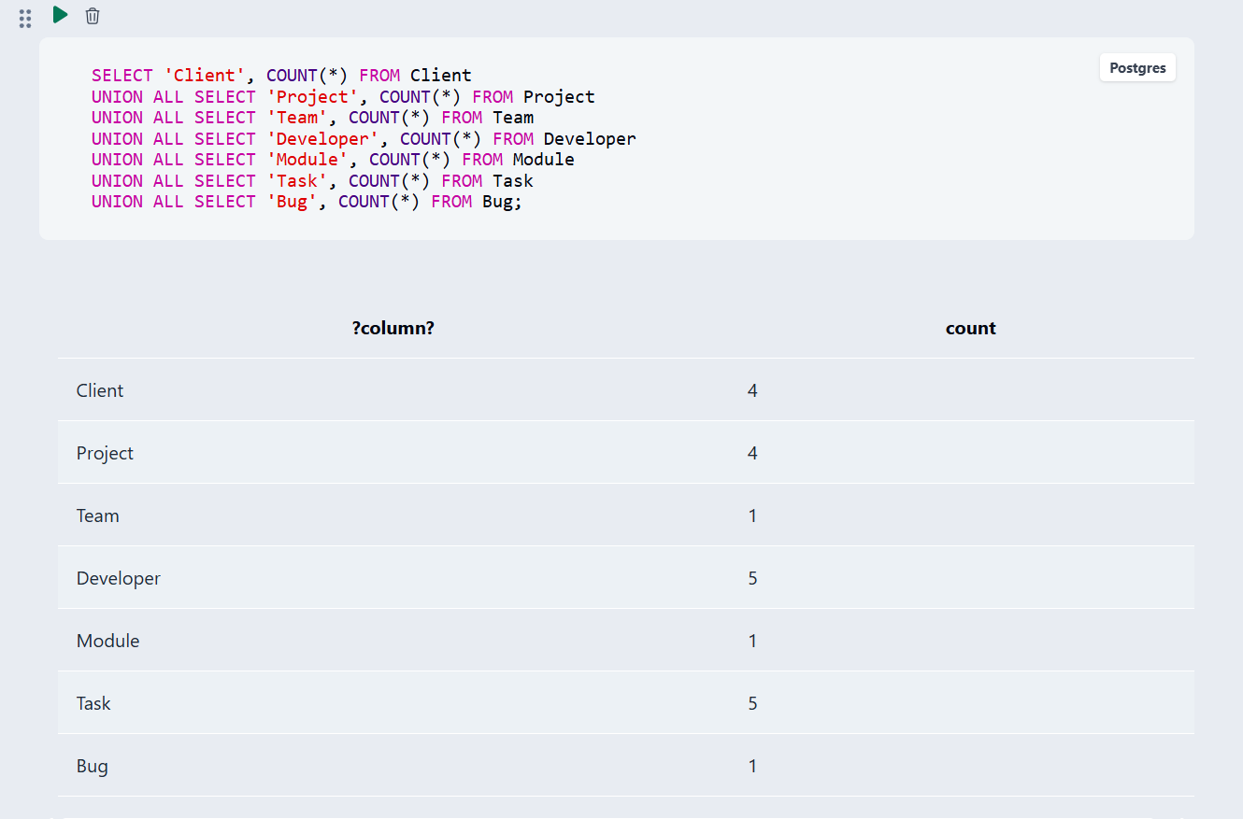
Fig. 4.2: Record counts confirming sample data in all seven tables
Sample INSERT statements (a Task and the Bug reported against it):
INSERT INTO Task
(task_id, title, module_id, developer_id, deadline, status)
VALUES
(502, 'Build stock update API', 401, 301, '2026-02-15', 'In Progress');

INSERT INTO Bug
(bug_id, task_id, description, severity, status, reported_date)
VALUES
(601, 502, 'Stock count goes negative on bulk update',
'High', 'Open', '2026-02-18');

4.3 Constraints and Data Integrity
The following constraints were applied to keep project-management data accurate and consistent.
Table 4.2: Constraints and Data Integrity
Constraint / Validation | Applied On (Table.Column) | Purpose | Evidence / Screenshot Ref.
PRIMARY KEY | All seven tables (*_id columns) | Uniquely identifies each row; prevents duplicate IDs | Fig. 4.3
FOREIGN KEY | Project.client_id, Team.project_id, Developer.team_id, Module.project_id, Task.module_id, Task.developer_id, Bug.task_id | Prevents orphan records and maintains referential integrity (seven foreign keys) | Fig. 4.4
NOT NULL | name, title, description and all foreign key columns | Ensures mandatory information is always supplied | Fig. 4.5
UNIQUE | Client.email, Developer.email | Prevents two clients or developers sharing an e-mail address | Fig. 4.6
CHECK | Project.status, Task.status, Bug.severity, Bug.status | Restricts values to a valid, predefined set | Fig. 4.7
DEFAULT | Project.status, Task.status, Bug.status | Auto-fills a sensible status (Ongoing / Pending / Open) when none is supplied | Fig. 4.8

4.4 Data Validation Rules
To confirm that the constraints actually work, each constraint was exercised against the populated database. The two key constraints were checked by querying the system catalog, and the NOT NULL, UNIQUE, CHECK and DEFAULT constraints were checked by executing statements that deliberately break the rule. In each case of violation PostgreSQL rejected the statement and no row was written.
(a) PRIMARY KEY — one primary key on each of the seven tables:
SELECT table_name, constraint_name, constraint_type FROM information_schema.table_constraints WHERE constraint_type = 'PRIMARY KEY' AND table_schema = 'public' AND table_name IN ('client','project','team','developer','module','task','bug') ORDER BY table_name;
Seven rows returned — bug_pkey, client_pkey, developer_pkey, module_pkey, project_pkey, task_pkey and team_pkey.
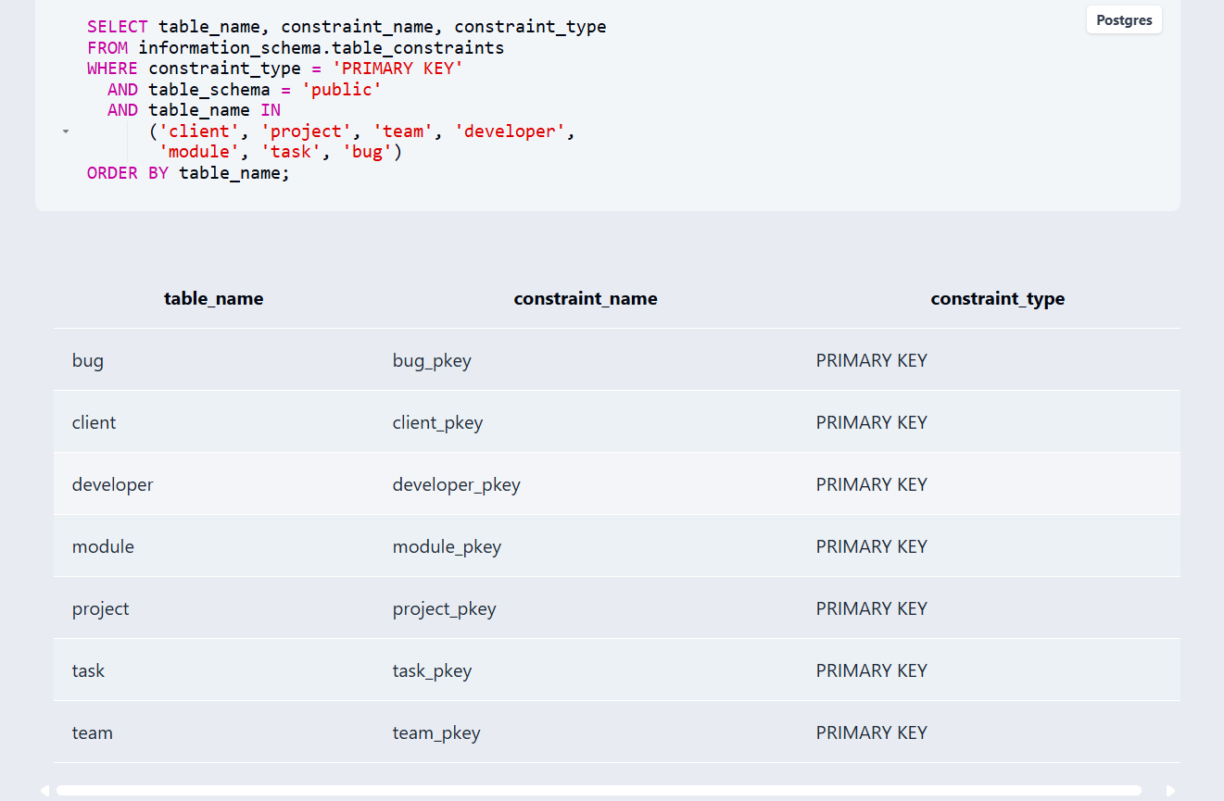
Fig. 4.3: PRIMARY KEY constraints defined on the seven tables
(b) FOREIGN KEY — the seven referential links between the tables:
SELECT table_name, constraint_name, constraint_type FROM information_schema.table_constraints WHERE constraint_type = 'FOREIGN KEY' AND table_schema = 'public' AND table_name IN ('client','project','team','developer','module','task','bug') ORDER BY table_name;
Seven rows returned — bug_task_id_fkey, developer_team_id_fkey, module_project_id_fkey, project_client_id_fkey, task_module_id_fkey, task_developer_id_fkey and team_project_id_fkey.
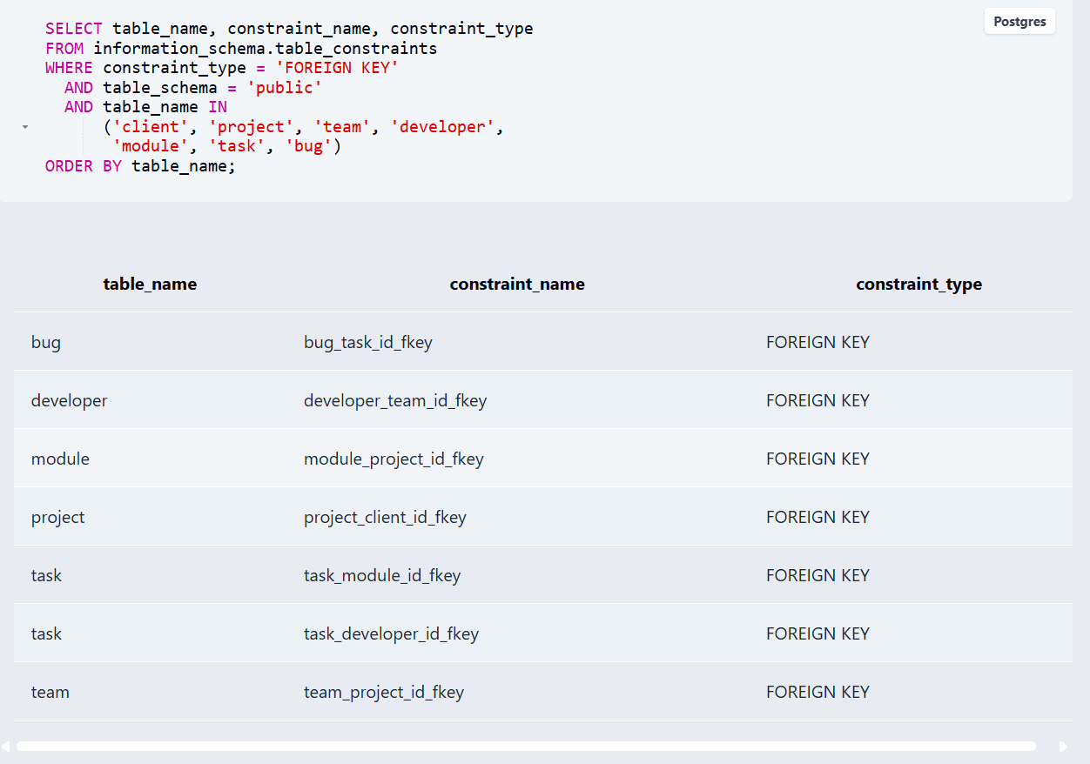
Fig. 4.4: FOREIGN KEY constraints defined on the tables
(c) NOT NULL constraint — a client inserted without a name:
INSERT INTO Client (client_id, email, phone, address) VALUES (4, 'hnish@gmail.com', '9099999', 'Nuzvid');
Error: null value in column "name" of relation "client" — insert rejected.
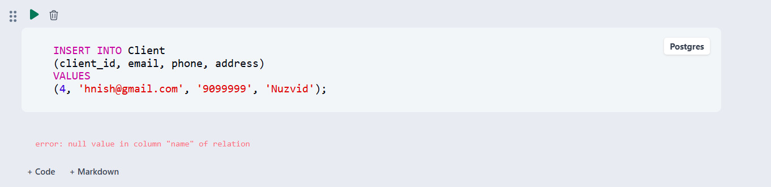
Fig. 4.5: NOT NULL constraint rejecting a missing Client.name
(d) UNIQUE constraint — a client inserted with an e-mail address that already exists:
INSERT INTO Client (client_id, name, email, phone, address) VALUES (3, 'hani', 'hani@gmail.com', '9033443', 'Mylavaram');
Error: duplicate key value violates unique constraint — insert rejected.
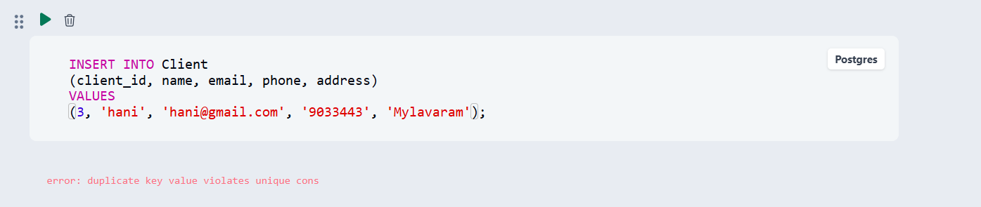
Fig. 4.6: UNIQUE constraint rejecting a duplicate client e-mail
(e) CHECK constraint — a project inserted with an invalid status:
INSERT INTO Project (project_id, title, client_id, start_date, end_date, status) VALUES (3, 'Test Project', 1, '2026-06-01', '2026-07-01', 'Active');
Error: new row for relation "project" violates check constraint — insert rejected, because only Ongoing, Completed and On Hold are valid statuses.
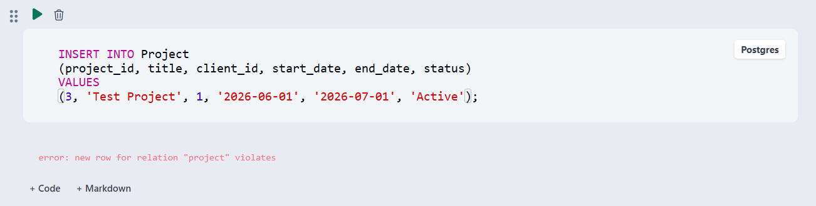
Fig. 4.7: CHECK constraint rejecting an invalid Project.status value
(f) DEFAULT constraint — a project inserted without a status:
INSERT INTO Project (project_id, title, client_id, start_date) VALUES (102, 'Support Portal', 1, '2026-03-10'); SELECT project_id, title, status FROM Project WHERE project_id = 2;
1 row affected — the project row is stored with status Ongoing, which was never supplied in the INSERT.
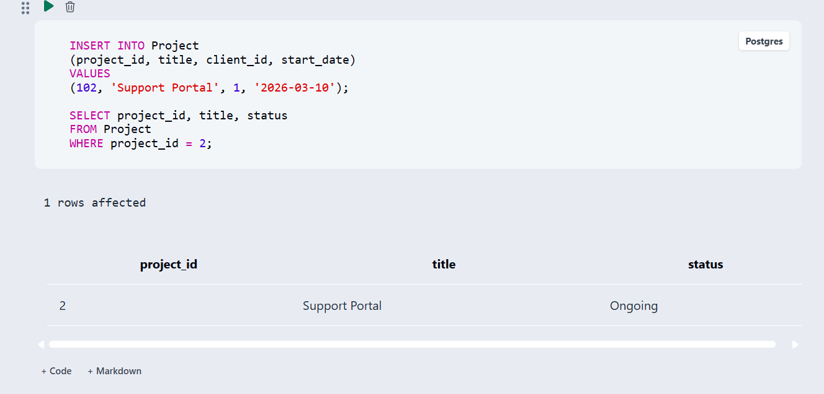
Fig. 4.8: DEFAULT value applied when Project.status is omitted
These results confirm that invalid data is rejected by the database engine itself and does not depend on the application or on the person entering the data.

CHAPTER 5: SQL OPERATIONS AND QUERIES
Eleven SQL operations were executed against the populated database: retrieval queries, a join, aggregate queries with GROUP BY, a view, and four structure- and data-modification statements. The outputs are shown as returned by PostgreSQL; the corresponding screenshots are collected in Chapter 7.

5.1 DQL – Basic Retrieval Queries
Q1. List the tasks that are not yet completed.
SQL:
SELECT title, status FROM Task WHERE status <> 'Completed';
Output:
title | status
Build stock update API | In Progress
Test login API | Pending
Build login API | Pending
Build stock module | Pending
Test stock module | Pending
(5 rows returned)
Q2. Display the details of all projects.
SQL:
SELECT * FROM Project;
Output:
project_id | title | client_id | start_date | end_date | status
101 | Software Project | 1 | 2026-01-01 | 2026-12-31 | Ongoing
204 | Support Portal | 1 | 2026-03-10 | NULL | Ongoing
2 | Support Portal | 1 | 2026-03-10 | NULL | Ongoing
102 | Support Portal | 1 | 2026-03-10 | NULL | Ongoing
(4 rows returned)

5.2 Join Operations
A join combines rows of two tables on a matching key, so that each task is displayed together with the developer who owns it.
Q3. INNER JOIN — tasks assigned to each developer.
SQL:
SELECT d.name, t.title, t.status FROM Developer d JOIN Task t ON d.developer_id = t.developer_id ORDER BY d.name;
Output:
name | title | status
John | Build stock update API | In Progress
Priya | Test login API | Pending
Ravi | Build login API | Pending
Ruthika | Build stock module | Pending
shravya | Test stock module | Pending
(5 rows returned)

5.3 Aggregate Functions and GROUP BY
Q4. LEFT JOIN with GROUP BY — number of tasks held by each developer (workload).
SQL:
SELECT d.name, COUNT(t.task_id) AS total_tasks FROM Developer d LEFT JOIN Task t ON d.developer_id = t.developer_id GROUP BY d.name ORDER BY d.name;
Output:
name | total_tasks
John | 1
Priya | 1
Ravi | 1
Ruthika | 1
shravya | 1
The LEFT JOIN keeps every developer in the result, including any developer who has no task yet (count 0).
Q5. GROUP BY — open bugs per module.
SQL:
SELECT m.module_name, COUNT(b.bug_id) AS open_bugs FROM Module m JOIN Task t ON m.module_id = t.module_id JOIN Bug b ON t.task_id = b.task_id WHERE b.status = 'Open' GROUP BY m.module_name;
Output:
module_name | open_bugs
Stock Management | 1
Q6. GROUP BY — bugs grouped by severity.
SQL:
SELECT severity, COUNT(*) AS bug_count FROM Bug GROUP BY severity ORDER BY bug_count DESC;
Output:
severity | bug_count
High | 1

5.4 Views
A view stores a frequently used query under a name, so that the report can be obtained with a simple SELECT. The DeveloperWorkload view counts the tasks of each developer that are not yet completed.
Q7. Create and query the view DeveloperWorkload.
SQL:
CREATE VIEW DeveloperWorkload AS SELECT d.name, COUNT(t.task_id) AS active_tasks FROM Developer d JOIN Task t ON d.developer_id = t.developer_id WHERE t.status <> 'Completed' GROUP BY d.name;
SELECT * FROM DeveloperWorkload;
Output:
name | active_tasks
shravya | 1
Ravi | 1
Ruthika | 1
John | 1
Priya | 1

5.5 DDL and DML Modification Operations
DDL statements change the structure of a table, while DML statements change the data it stores. The following four statements complete the set of operations. They were executed after the queries above, so that the outputs shown in Q1 to Q7 are not affected by them.
Table 5.1: DDL and DML Modification Operations
S.No | Operation | Purpose | SQL Query
Q8 | DDL — ALTER TABLE | Adds a new column to Developer | ALTER TABLE Developer ADD COLUMN phone VARCHAR(15);
Q9 | DDL — DROP TABLE | Removes a temporary table | DROP TABLE IF EXISTS TempLog;
Q10 | DML — UPDATE | Marks a task as completed | UPDATE Task SET status = 'Completed' WHERE task_id = 502;
Q11 | DML — DELETE | Removes a resolved bug | DELETE FROM Bug WHERE bug_id = 604;
DDL changes table structure, DML changes stored data, and DQL retrieves data without modifying it. The JOIN links Developer and Task on developer_id so that each task shows its owner; the GROUP BY queries aggregate the results into project-management insights (workload, open bugs per module, severity breakdown); and the view packages the workload report as a reusable, named query.

CHAPTER 6: MODULES AND FUNCTIONALITIES
The database is organized into seven functional modules, one for each entity of the design.
Table 6.1: Modules and Their Functionalities
S.No | Module Name | Functionality | Tables Involved
1 | Client Management | Stores and manages client details such as client ID, name, e-mail, phone and address. | Client
2 | Project Management | Maintains project information including project ID, title, client, start and end dates and status. | Project
3 | Team Management | Manages the team assigned to each project (team ID, team name, project). | Team
4 | Developer Management | Stores developer information including developer ID, name, e-mail, role and team. | Developer
5 | Module Management | Manages the functional modules of a project (module ID, name, description, project). | Module
6 | Task Management | Records tasks within a module, their deadline and status, and the developer assigned. | Task
7 | Bug Management | Tracks bugs reported against a task, including severity, status and report date. | Bug

Client and Project Management underpin every other module: a client is registered first, and every project, module, task and bug is eventually traceable back to a client through the chain of foreign keys.
Team and Developer Management record who does the work. Each project has one team and each developer belongs to a team, so the workload of every developer can be read from the tasks assigned to him or her.
Module and Task Management break a project down into manageable pieces. A task carries a deadline and a status that moves from Pending to In Progress to Completed, and is owned by exactly one developer.
Bug Management closes the loop. A bug is reported against a task with a severity of Low, Medium or High, starts with the status Open and is marked Resolved when fixed, which makes reports such as open bugs per module possible.

CHAPTER 7: RESULTS – SAMPLE OUTPUTS AND SCREENSHOTS
This chapter collects the screenshots of the database creation, the sample data and the query outputs described in the previous chapters.
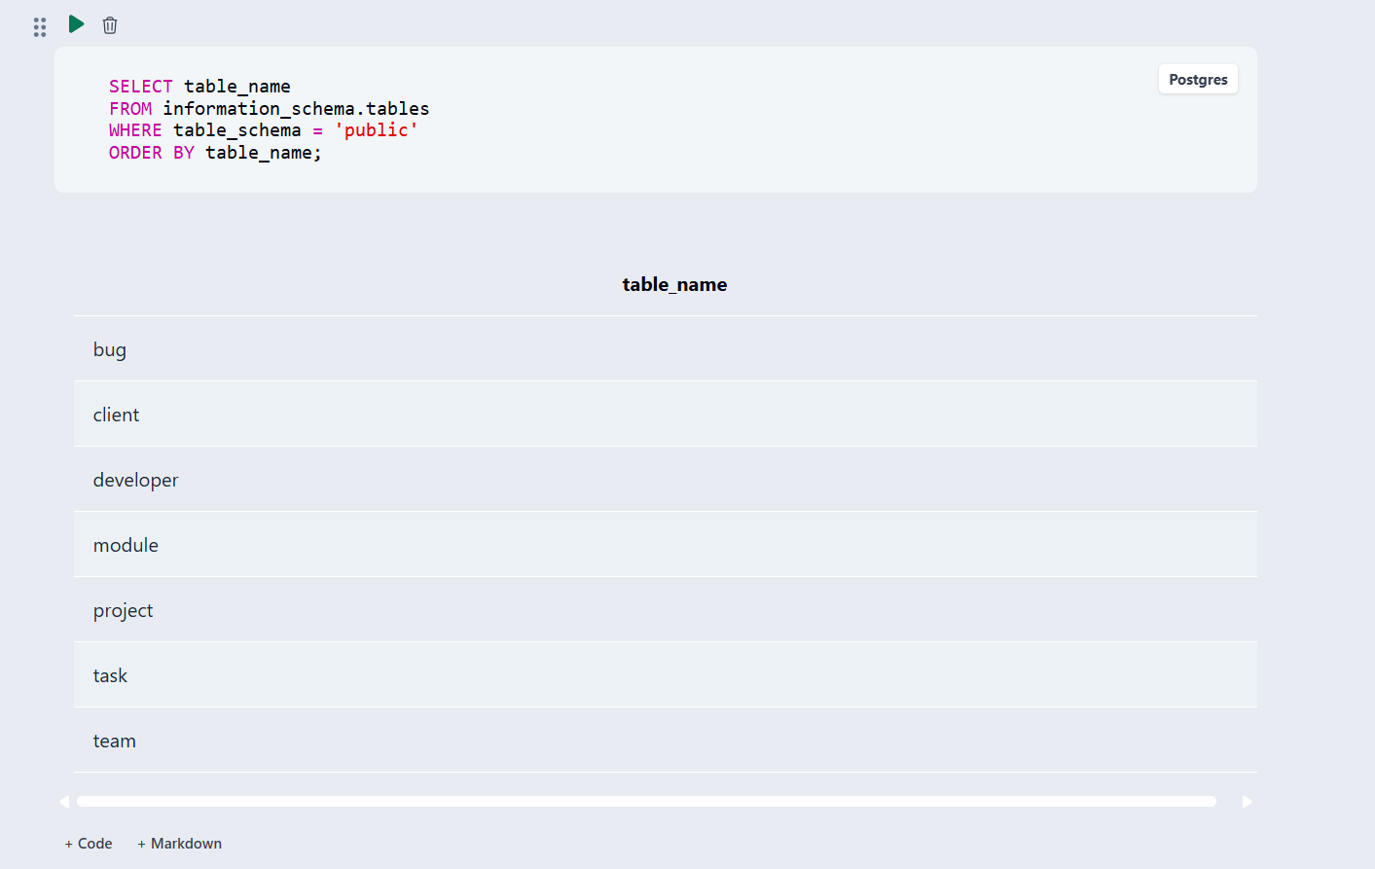
Fig. 7.1: Database and table creation in PostgreSQL / pgAdmin
Fig. 7.2: Sample data inserted — record counts of the seven tables
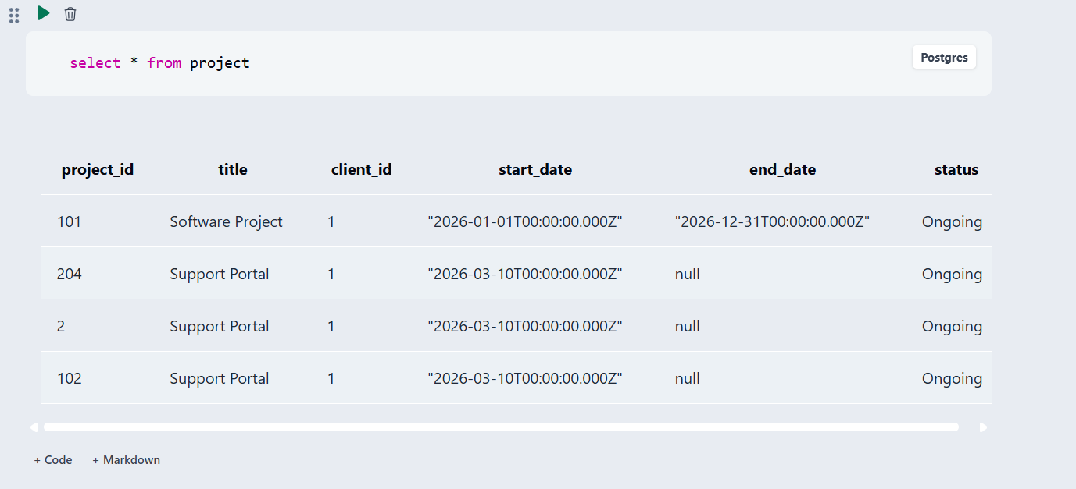
Fig. 7.3: Details of the Project table (SELECT * FROM Project)
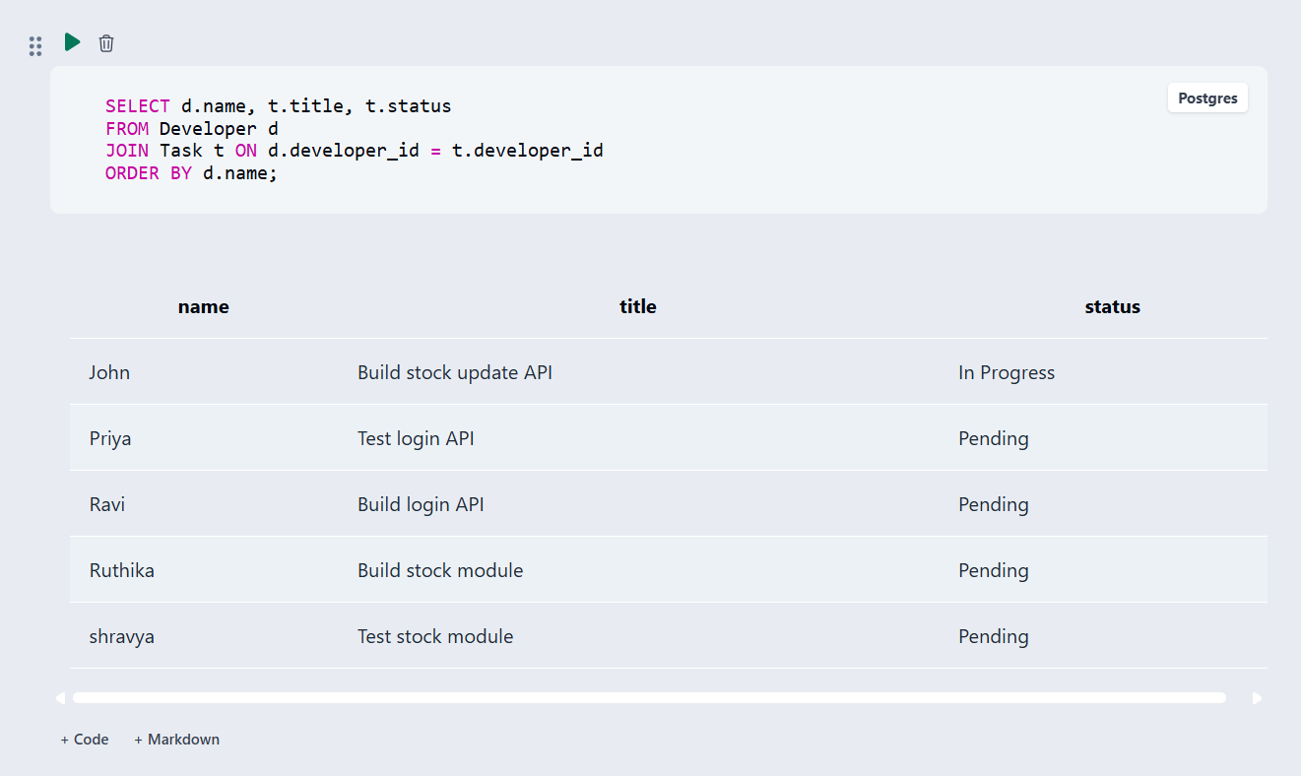
Fig. 7.4: Tasks assigned to each developer (JOIN)
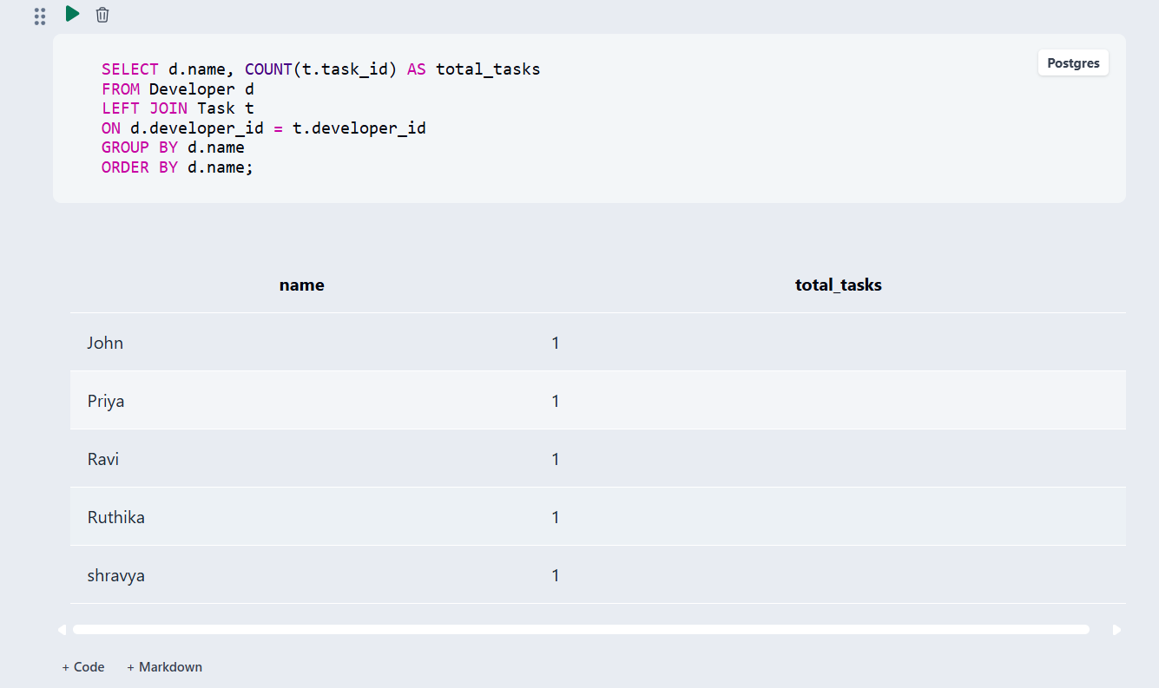
Fig. 7.5: Task count per developer (LEFT JOIN + GROUP BY)
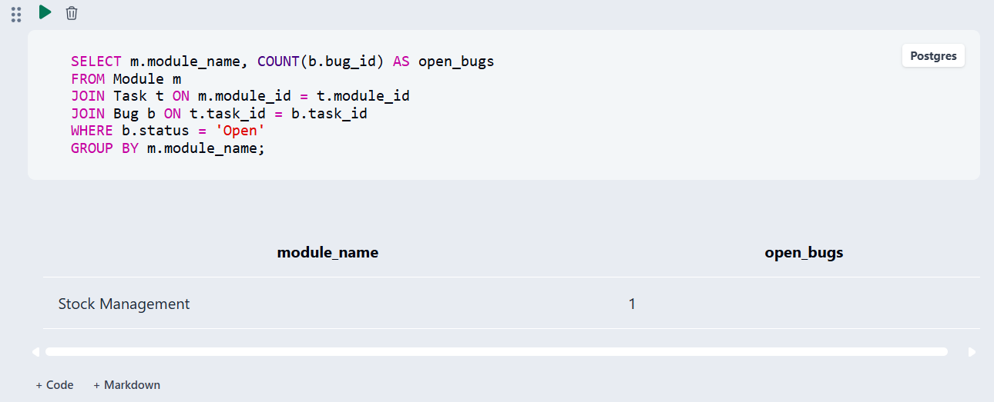
Fig. 7.6: Open bugs per module
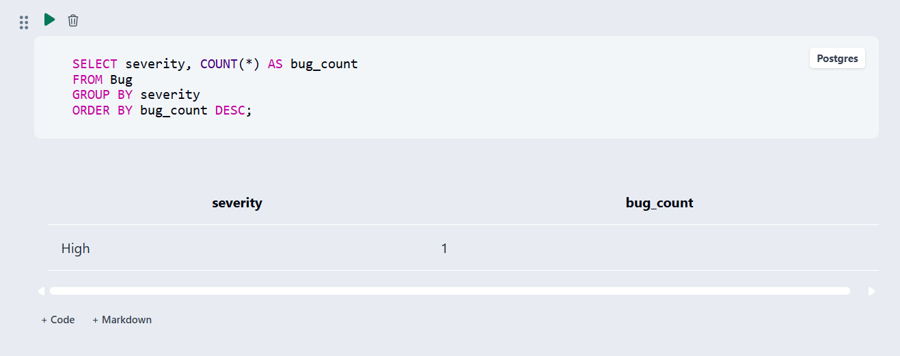
Fig. 7.7: Bugs grouped by severity
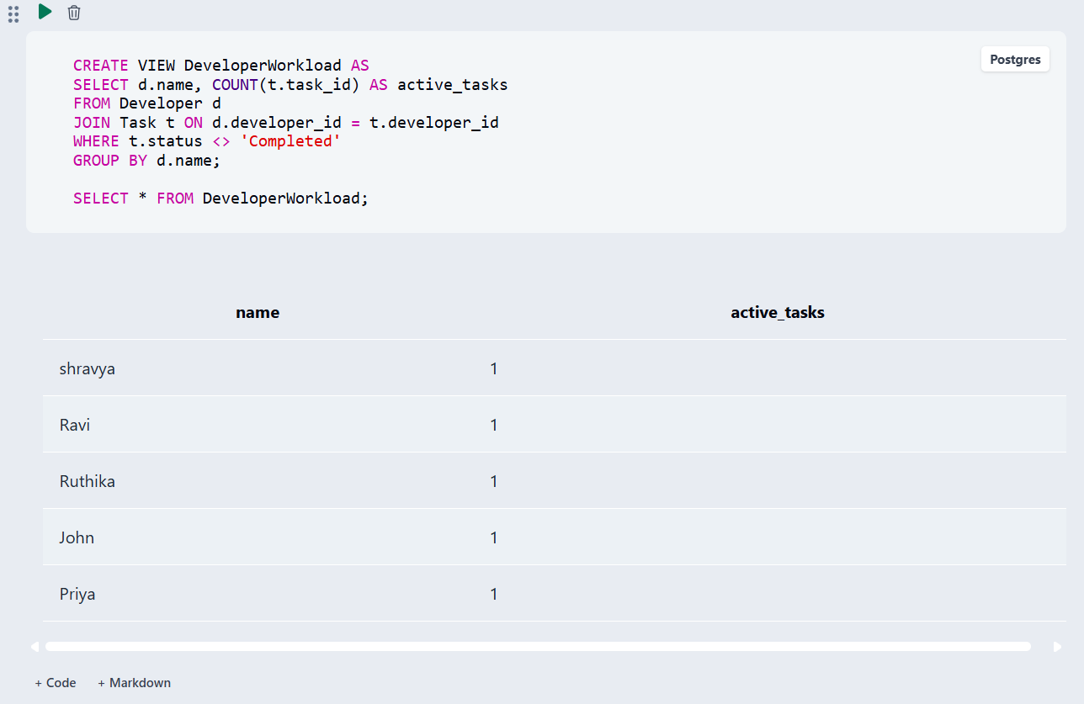
Fig. 7.8: DeveloperWorkload view — example output

CHAPTER 8: TESTING AND DATA VALIDATION
Ten test cases were run against the populated database to verify that the constraints reject invalid data and that the queries return the expected results. All ten passed.
Table 8.1: Test Cases and Results
TC No. | Test Case Description | Input / Action | Expected Result | Actual Result | Status
TC-01 | PRIMARY KEY on all tables | Query the catalog for PRIMARY KEY constraints on the seven tables | One primary key per table | Seven PRIMARY KEY constraints listed (Fig. 4.3) | Pass
TC-02 | FOREIGN KEY relationships | Query the catalog for FOREIGN KEY constraints | Seven foreign keys | Seven FOREIGN KEY constraints listed (Fig. 4.4) | Pass
TC-03 | NOT NULL constraint | Insert Client without a name | Insert rejected | Rejected — NOT NULL violation on name | Pass
TC-04 | UNIQUE constraint on e-mail | Insert Client with an existing e-mail | Insert rejected | Rejected — unique constraint violation | Pass
TC-05 | CHECK constraint on status | Insert Project with status ‘Active’ | Insert rejected | Rejected — CHECK violation | Pass
TC-06 | DEFAULT constraint on status | Insert Project without a status | Status set to Ongoing | Row stored with status Ongoing | Pass
TC-07 | JOIN of Developer and Task | Q3 — tasks per developer | Each task with its owner | Five rows returned | Pass
TC-08 | Workload by GROUP BY | Q4 — task count per developer | One count per developer | Five developers, one task each | Pass
TC-09 | Open bugs per module | Q5 — open bugs grouped by module | Count of open bugs per module | Stock Management — 1 | Pass
TC-10 | View DeveloperWorkload | SELECT * FROM DeveloperWorkload | Active tasks per developer | Five rows, one active task each | Pass

CHAPTER 9: GITHUB REPOSITORY AND TEAM CONTRIBUTION

9.1 Repository Details
GitHub Repository Link: https://github.com/ruthikathota024/software-management-system

9.2 Team Responsibilities and Contribution
Table 9.1: Team Responsibilities
S.No | Student Name | Roll Number | Role / Responsibility | Modules Contributed
1 | T. Ruthika TriNayani | 25B11AIC02 | ER diagram, relational schema and screenshots | Database design (Ch. 3) and result screenshots (Ch. 7)
2 | K. Devi Saranya | 25B11AI623 | DDL, tables, keys and constraints | Table creation and constraints (Ch. 4)
3 | A. Keerthi | 25B11AI025 | DML and SQL queries | Sample data and queries (Ch. 4, 5)
4 | G.K L S Shravya | 25B11AI319 | Documentation | Report preparation (Ch. 1–10)

9.3 Review-wise Progress
Table 9.2: Review-wise Progress Record
Review | Date | Deliverables Presented | Remarks of the Guide
Review-1 | (update with actual date) | Problem statement, ER diagram, relational schema and normalization up to 3NF | (update with guide’s remarks)
Review-2 | (update with actual date) | DDL script, sample data and constraint testing | (update with guide’s remarks)
Final Review | (update with actual date) | Complete SQL script, all queries, view and the final report | (update with guide’s remarks)

CHAPTER 10: CONCLUSION AND FUTURE ENHANCEMENTS

10.1 Conclusion
The Software Development Project Management System provides a centralized database for managing client projects, teams, developers, modules, tasks and bugs in an organized manner. The database design was finalized with seven entities, seven relationships and a normalized relational schema in Third Normal Form, with seven foreign keys across the seven tables.
The SQL implementation was completed in PostgreSQL with DDL, DML and DQL across all tables, and sample data was inserted and validated with consistent foreign keys. JOIN and GROUP BY queries, a reusable view and the DDL and DML modification statements were successfully demonstrated. Data integrity is maintained through primary keys, foreign keys and CHECK, UNIQUE, NOT NULL and DEFAULT constraints, which together prevent duplicate records, invalid values, missing required data and broken relationships between tables.
The key learning of the project was translating an ER model into a working, query-ready relational database.

10.2 Limitations of the Present Work
The project is limited to the database layer: there is no user interface, login or role-based access. The relationship between Project and Team is 1 : 1 by design but is not enforced by a UNIQUE constraint on Team.project_id, so a project could in principle be given more than one team row. Statuses are held as constrained text values rather than in separate lookup tables.

10.3 Future Enhancements
The system can be further enhanced to improve usability, security and reporting. The following improvements are planned:
• Role-Based Access — separate login and permissions for clients, developers and project managers.
• Deadline Notifications — automated reminders for approaching task deadlines and unresolved bugs.
• Reporting Dashboard — a visual dashboard summarizing project status, developer workload and open bugs.
• User Interface Integration — a web-based interface so that clients and developers can access the system directly.
• Performance Improvements — indexing and query optimization as the number of projects and tasks grows.
• Scalability — support for multiple teams per project and multi-level task dependencies.
REFERENCES
PostgreSQL Global Development Group, “PostgreSQL Documentation”, https://www.postgresql.org/docs/
PostgreSQL Global Development Group, “SQL Commands”, https://www.postgresql.org/docs/current/sql.html
pgAdmin Development Team, “pgAdmin Documentation”, https://www.pgadmin.org/docs/
DB Fiddle, online SQL editor, https://www.dbfiddle.uk/
Abraham Silberschatz, Henry F. Korth and S. Sudarshan, “Database System Concepts”, McGraw-Hill Education.
Ramez Elmasri and Shamkant B. Navathe, “Fundamentals of Database Systems”, Pearson.

APPENDIX A – COMPLETE SQL SCRIPT
The SQL script — covering database and table creation (DDL), the sample data insertion shown in Chapter 4 (DML), and all queries, the view and the modification statements from Chapter 5 — is reproduced below in the order it is executed.
CREATE DATABASE pms_db;

-- connect to the new database before creating tables
-- (psql: \c pms_db; pgAdmin: select pms_db from the browser)

/* Creating the Client table */
CREATE TABLE Client
(
client_id INT PRIMARY KEY,
name VARCHAR(100) NOT NULL,
email VARCHAR(100) NOT NULL UNIQUE,
phone VARCHAR(15),
address VARCHAR(200)
);

/* Creating the Project table */
CREATE TABLE Project
(
project_id INT PRIMARY KEY,
title VARCHAR(100) NOT NULL,
client_id INT NOT NULL,
start_date DATE,
end_date DATE,
status VARCHAR(20) DEFAULT 'Ongoing'
CHECK (status IN ('Ongoing','Completed','On Hold')),
FOREIGN KEY (client_id) REFERENCES Client(client_id)
);

/* Creating the Team table */
CREATE TABLE Team
(
team_id INT PRIMARY KEY,
team_name VARCHAR(100) NOT NULL,
project_id INT NOT NULL,
FOREIGN KEY (project_id) REFERENCES Project(project_id)
);

/* Creating the Developer table */
CREATE TABLE Developer
(
developer_id INT PRIMARY KEY,
name VARCHAR(100) NOT NULL,
email VARCHAR(100) NOT NULL UNIQUE,
role VARCHAR(50),
team_id INT NOT NULL,
FOREIGN KEY (team_id) REFERENCES Team(team_id)
);

/* Creating the Module table */
CREATE TABLE Module
(
module_id INT PRIMARY KEY,
module_name VARCHAR(100) NOT NULL,
description VARCHAR(200),
project_id INT NOT NULL,
FOREIGN KEY (project_id) REFERENCES Project(project_id)
);

/* Creating the Task table */
CREATE TABLE Task
(
task_id INT PRIMARY KEY,
title VARCHAR(100) NOT NULL,
deadline DATE,
status VARCHAR(20) DEFAULT 'Pending'
CHECK (status IN ('Pending','In Progress','Completed')),
module_id INT NOT NULL,
developer_id INT NOT NULL,
FOREIGN KEY (module_id) REFERENCES Module(module_id),
FOREIGN KEY (developer_id) REFERENCES Developer(developer_id)
);

/* Creating the Bug table */
CREATE TABLE Bug
(
bug_id INT PRIMARY KEY,
description VARCHAR(200) NOT NULL,
severity VARCHAR(10) CHECK (severity IN ('Low','Medium','High')),
status VARCHAR(20) DEFAULT 'Open'
CHECK (status IN ('Open','Resolved')),
reported_date DATE,
task_id INT NOT NULL,
FOREIGN KEY (task_id) REFERENCES Task(task_id)
);

/* Sample data insertion (Task and its linked Bug) */
INSERT INTO Task
(task_id, title, module_id, developer_id, deadline, status)
VALUES
(502, 'Build stock update API', 401, 301, '2026-02-15', 'In Progress');

INSERT INTO Bug
(bug_id, task_id, description, severity, status, reported_date)
VALUES
(601, 502, 'Stock count goes negative on bulk update',
'High', 'Open', '2026-02-18');

/* DQL */
SELECT title, status FROM Task WHERE status <> 'Completed';
SELECT * FROM Project;

/* JOIN */
SELECT d.name, t.title, t.status
FROM Developer d JOIN Task t ON d.developer_id = t.developer_id
ORDER BY d.name;

/* Aggregate - GROUP BY */
SELECT d.name, COUNT(t.task_id) AS total_tasks
FROM Developer d LEFT JOIN Task t ON d.developer_id = t.developer_id
GROUP BY d.name ORDER BY d.name;

SELECT m.module_name, COUNT(b.bug_id) AS open_bugs
FROM Module m JOIN Task t ON m.module_id = t.module_id
JOIN Bug b ON t.task_id = b.task_id
WHERE b.status = 'Open' GROUP BY m.module_name;

SELECT severity, COUNT(*) AS bug_count
FROM Bug GROUP BY severity ORDER BY bug_count DESC;

/* VIEW */
CREATE VIEW DeveloperWorkload AS
SELECT d.name, COUNT(t.task_id) AS active_tasks
FROM Developer d JOIN Task t ON d.developer_id = t.developer_id
WHERE t.status <> 'Completed' GROUP BY d.name;

SELECT * FROM DeveloperWorkload;

/* DDL and DML modification operations */
ALTER TABLE Developer ADD COLUMN phone VARCHAR(15);
DROP TABLE IF EXISTS TempLog;
UPDATE Task SET status = 'Completed' WHERE task_id = 502;
DELETE FROM Bug WHERE bug_id = 604;

