Monthly Development Report: Yegara Modernization

1. Project Overview
This report provides a detailed analysis of the modernization of the Yegara Trading Share Company digital ecosystem. We have transitioned from a static, template-based website to a custom-built, cinematic platform that prioritizes interactive data representation and premium user experience.

2. Page-by-Page Detailed Comparison

A. Home Page: From Information to Experience
The original home page was a standard informational portal. The new version is a cinematic entry point designed to establish immediate corporate authority.

Original Hero Visual (Static):
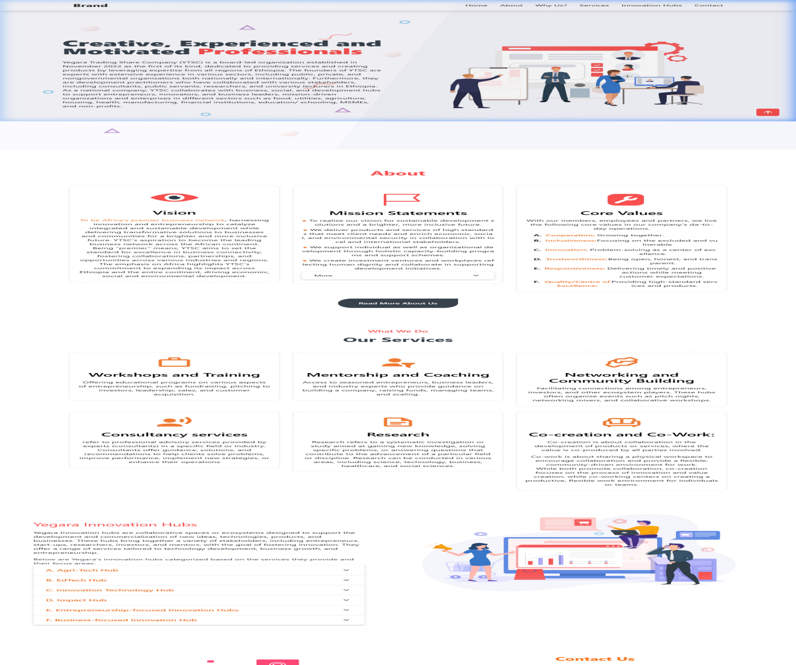

New Cinematic Hero Visual (Dynamic Video Background):


B. Portfolio: Interactive Data Representation
We replaced static text descriptions with interactive, live-data dashboards. The Geographic Scope Map features a high-resolution, interactive map of Ethiopia where each region triggers a specific data dashboard.

New Interactive Map Dashboard:
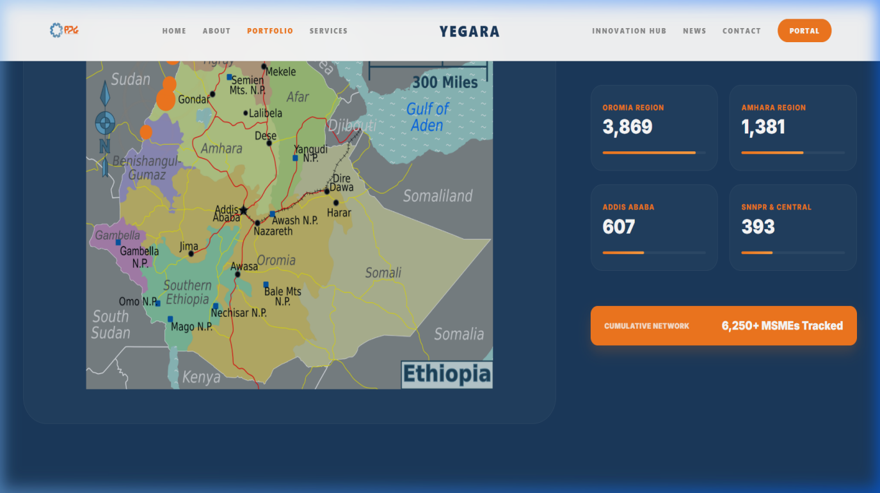

C. Our Services: Specialized Pillar Cards
We transitioned from generic icon grids to specialized 'Pillar Cards' that provide depth and context for each service category.

Original Services Grid (Static):
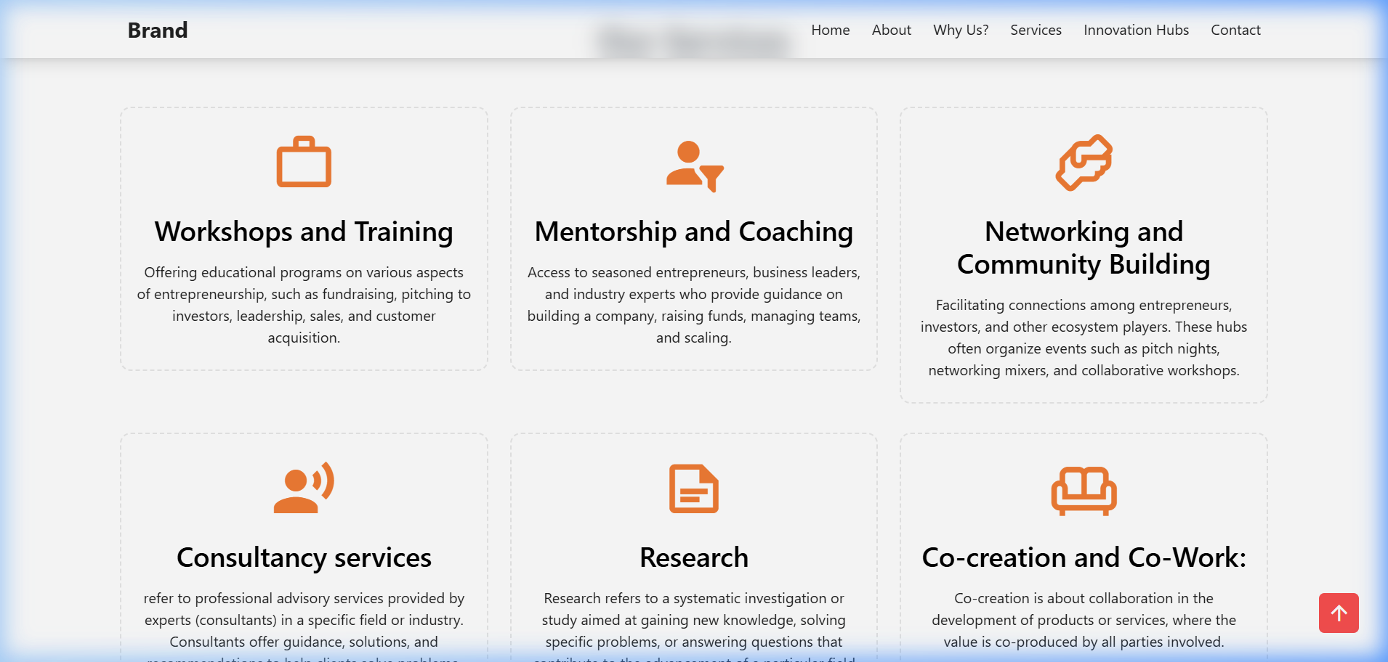

New Service Pillar Card UI:
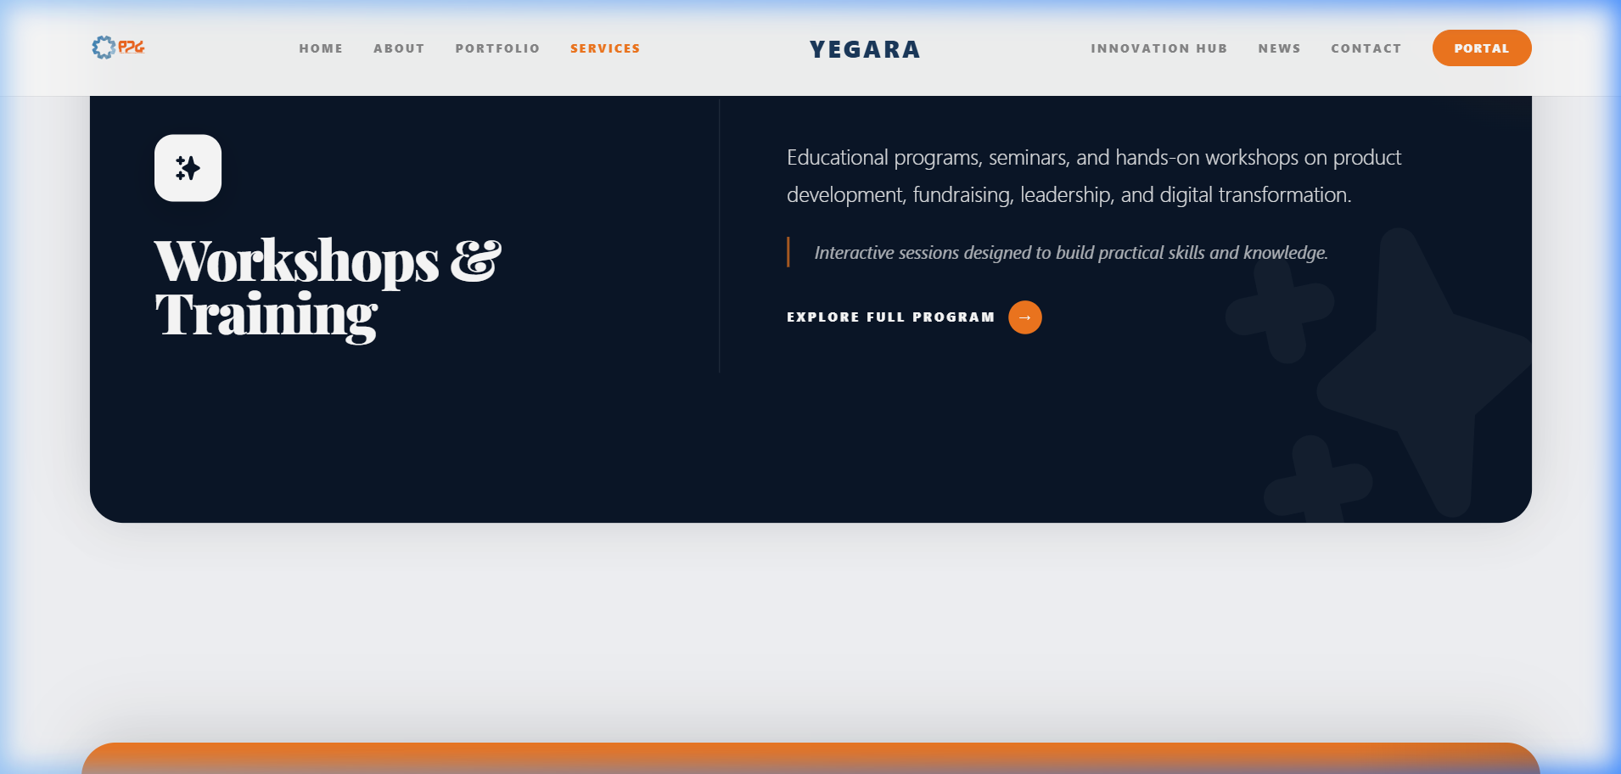

D. Innovation Hub: The Ecosystem Matrix
The original Innovation Hubs were presented as a simple accordion list. We have reimagined this as an Ecosystem Matrix.

Original Hubs Accordion:
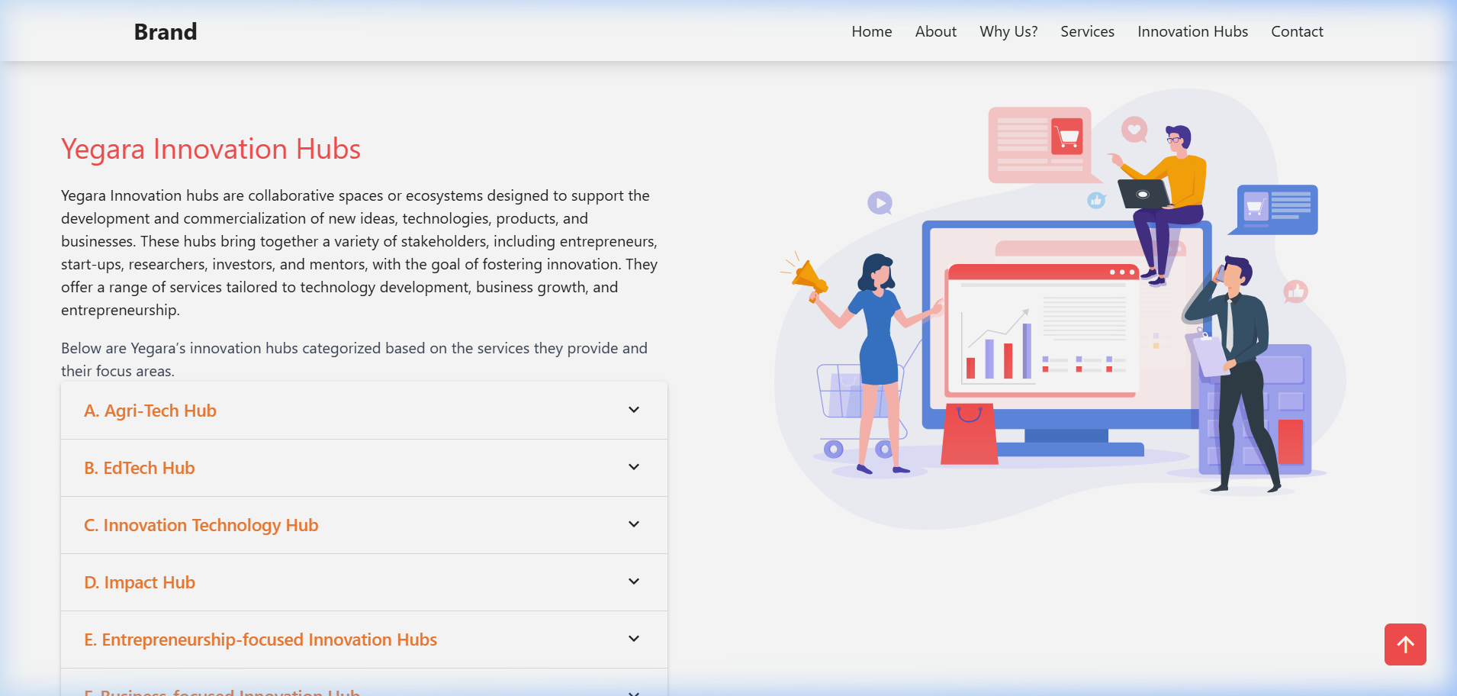

New Ecosystem Matrix Dashboard:
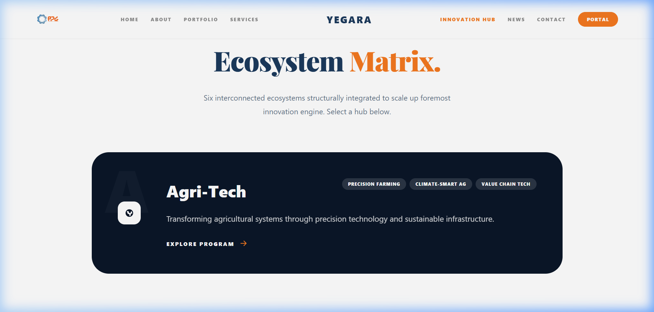

3. Technical Implementation Details
• Cinematic UI: Implemented using custom CSS3 transitions and Framer Motion.
• Data Architecture: Built a scalable JSON-based data layer feeding the interactive map.
• Responsive Engineering: Flawless performance on both desktop and mobile devices.

4. Conclusion
The development work this month has fundamentally transformed how Yegara communicates its impact. The platform now provides a professional experience that matches the scale of the company's regional operations.

