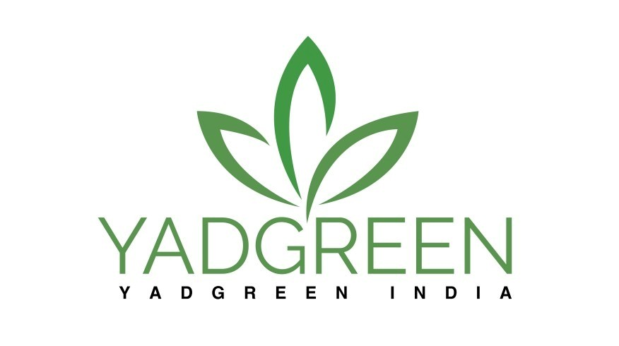
Dear Ruthra Moorthi V,
We are pleased to formally acknowledge the successful completion of your internship as an Data Science Intern at YADGREEN INDIA. Your dedication and contributions from 14-09-2025 to 14-11-2025 have been greatly appreciated.
During your time with us, you demonstrated a strong understanding of Data Science and Machine Learning and also a commitment towards learning and collaboration. Your efforts have contributed positively to our projects, and we commend your growth throughout this experience.
Sincerely,

For Yadgreen India

