RAJALAKSHMI ENGINEERING COLLEGE
B.TECH COMPUTER SCIENCE AND ENGINEERING
CYBERSECURITY
LABORATORY MANUAL
COMPUTER NETWORKS
CS23532
ACADEMIC YEAR 2026–2027
NAME | RUTHRESH KANNA S
ROLL NO. | 251901140
BRANCH | CYBERSECURITY

DEPARTMENT OF COMPUTER SCIENCE AND ENGINEERING – CYBERSECURITY

CONTENTS
Experiments listed in the supplied reference manual.
EXPERIMENT | TITLE | SIGNATURE / DATE
1a | Basic Networking Commands in Linux Operating System
1b | Basic Networking Commands in Windows Operating System
2 | Study of Socket Programming in Python
3 | Customized Ping Command to Test Server Connectivity
4 | Packet Sniffing Using Raw Sockets in Python
5 | Simple Calculator Using XML-RPC
6 | Nmap Live Host Discovery
7 | Anonymous FTP Scanner
8 | Reverse Shell Using TCP Sockets
9 | Design a Simple Topology Using Cisco Packet Tracer
10 | Customize Switch with Network Modules Using Cisco Packet Tracer
11 | Examining Network Address Translation (NAT) Using Cisco Packet Tracer
12 | Capture, Save, and Analyze Network Traffic Using Wireshark
13 | Network Forensics Using PcapXray Tool
14 | Learning and Assignment of IP Address Manually to Computers
15 | Analyze Different Types of Servers Using Webalizer Tool

EXPERIMENT 1a
BASIC NETWORKING COMMANDS IN LINUX OPERATING SYSTEM

Aim
To study and execute basic networking commands in linux operating system.
1. ls
NAME: ls - list directory contents
SYNOPSIS: ls [OPTION]... [FILE]...
DESCRIPTION: List information about the FILEs (the current directory by
default).

OUTPUT
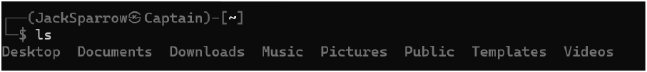
a) ls -a : do not ignore entries starting with .

OUTPUT
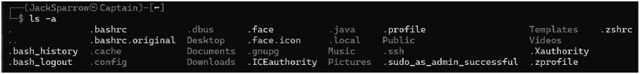
b) ls -l : use a long listing format

OUTPUT
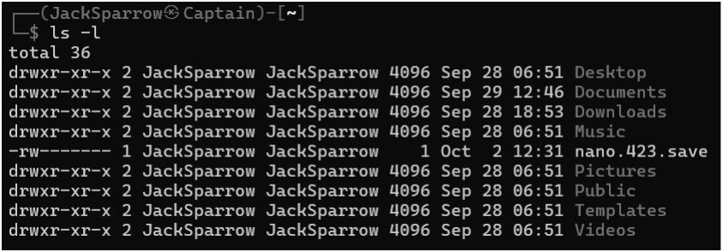
2. echo
NAME: echo - display a line of text
SYNOPSIS: echo [SHORT-OPTION]... [STRING]...
echo LONG-OPTION
DESCRIPTION: Echo the STRING(s) to standard output.

OUTPUT
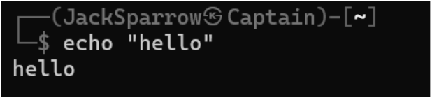
3.ps
NAME: ps - report a snapshot of the current processes.
SYNOPSIS: ps [options]
DESCRIPTION: ps displays information about a selection of the active
processes.

OUTPUT
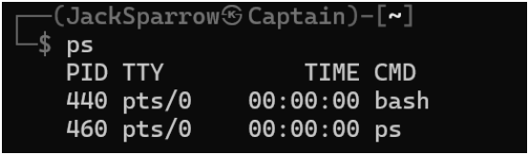
a) ps -e: See all current running processes in the system.

OUTPUT
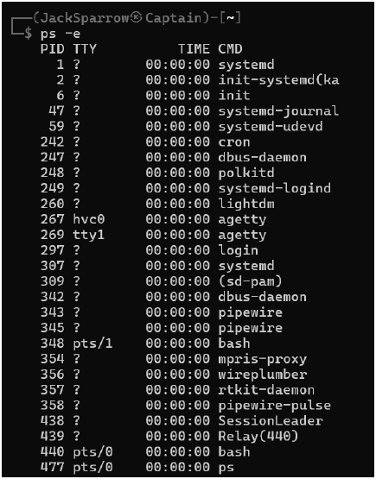
4. cat
NAME: cat - concatenate files and print on the standard output
SYNOPSIS: cat [OPTION]... [FILE]...
DESCRIPTION: Concatenate FILE(s) to standard output.

OUTPUT
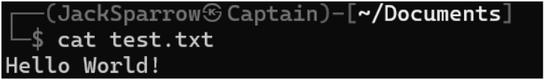
5. free
NAME: free - Display amount of free and used memory in the system
SYNOPSIS: free [options]
DESCRIPTION: free displays the total amount of free and used physical and
swap memory in the system, as well as the buffers and caches used by the
kernel.

OUTPUT
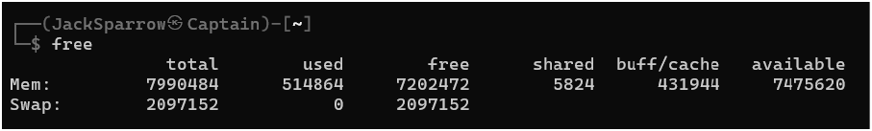
6. rm
NAME: rm - remove files or directories
SYNOPSIS: rm [OPTION]... [FILE]...
DESCRIPTION: rm removes each specified file.

OUTPUT
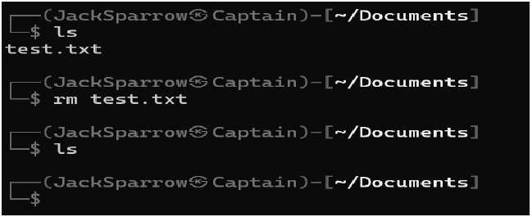
7. top
NAME: top - display Linux processes
SYNOPSIS: top [options]
DESCRIPTION: The top program provides a dynamic real-time view of a
running system.

OUTPUT
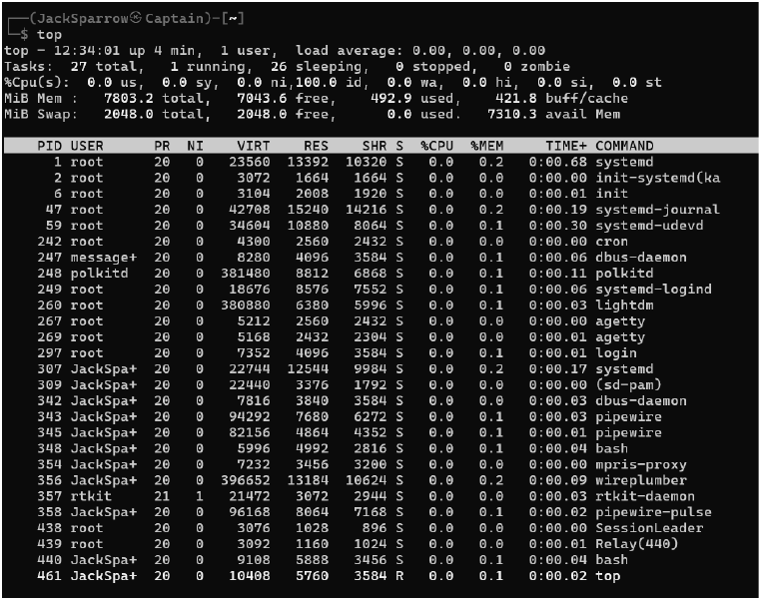
8. vmstat
NAME: vmstat - Report virtual memory statistics
SYNOPSIS: vmstat [options] [delay [count]]
DESCRIPTION: vmstat reports information about processes, memory, paging,
block IO, traps, disks and cpu activity

OUTPUT
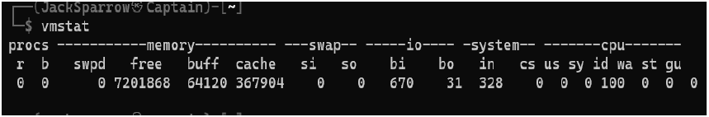
9. ping
NAME: ping - send ICMP ECHO_REQUEST to network hosts
SYNOPSIS: ping [-aAbBdCDfhHLnOqrRUvV346] [-c count]
[-e identifier] [-F flowlabel] [-i interval]
[-I interface] [-l preload] [-m mark]
[-M pmtudisc_option] [-N nodeinfo_option]
[-w deadline] [-W timeout] [-p pattern] [-Q tos]
[-s packetsize] [-S sndbuf] [-t ttl]
[-T timestamp option] [hop...] {destination}
DESCRIPTION: ping uses the ICMP protocol's mandatory
ECHO_REQUEST datagram to elicit an ICMP ECHO_RESPONSE from a host
or gateway.

OUTPUT
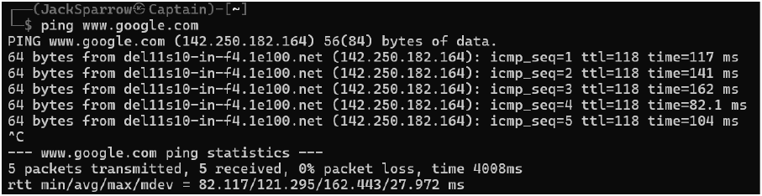
10. ifconfig
NAME: ifconfig - configure a network interface
SYNOPSIS: ifconfig [-v] [-a] [-s] [interface]
ifconfig [-v] interface [aftype] options | address ...
DESCRIPTION: Ifconfig is used to configure the kernel-resident network
interfaces.

OUTPUT
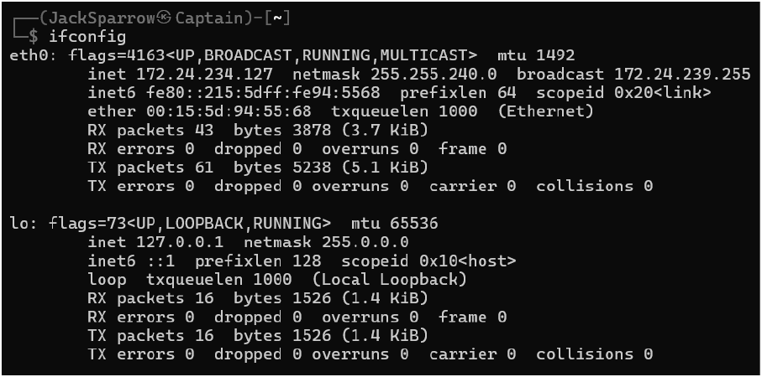

Result
Thus the above linux commands were executed.

EXPERIMENT 1b
BASIC NETWORKING COMMANDS IN WINDOWS OPERATING SYSTEM

Aim
To study and execute basic networking commands in Windows operating system.
1. cd
SYNOPSIS: CD [/D] [drive:][path]
CD [..]
DESCRIPTION: Displays the name of or changes the current directory.

OUTPUT
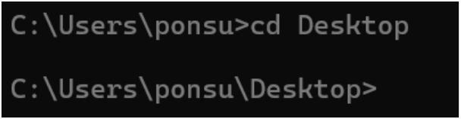
2. cls
SYNOPSIS: cls
DESCRIPTION: Clears the screen.

OUTPUT
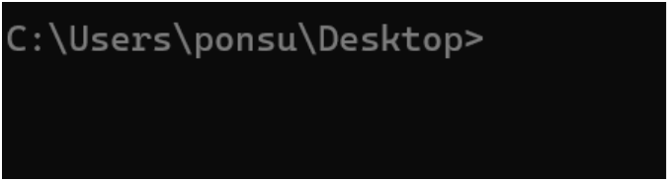
3. ipconfig
SYNOPSIS: ipconfig [/allcompartments]
DESCRIPTION: The default is to display only the IP address, subnet mask
and default gateway for each adapter bound to TCP/IP.

OUTPUT
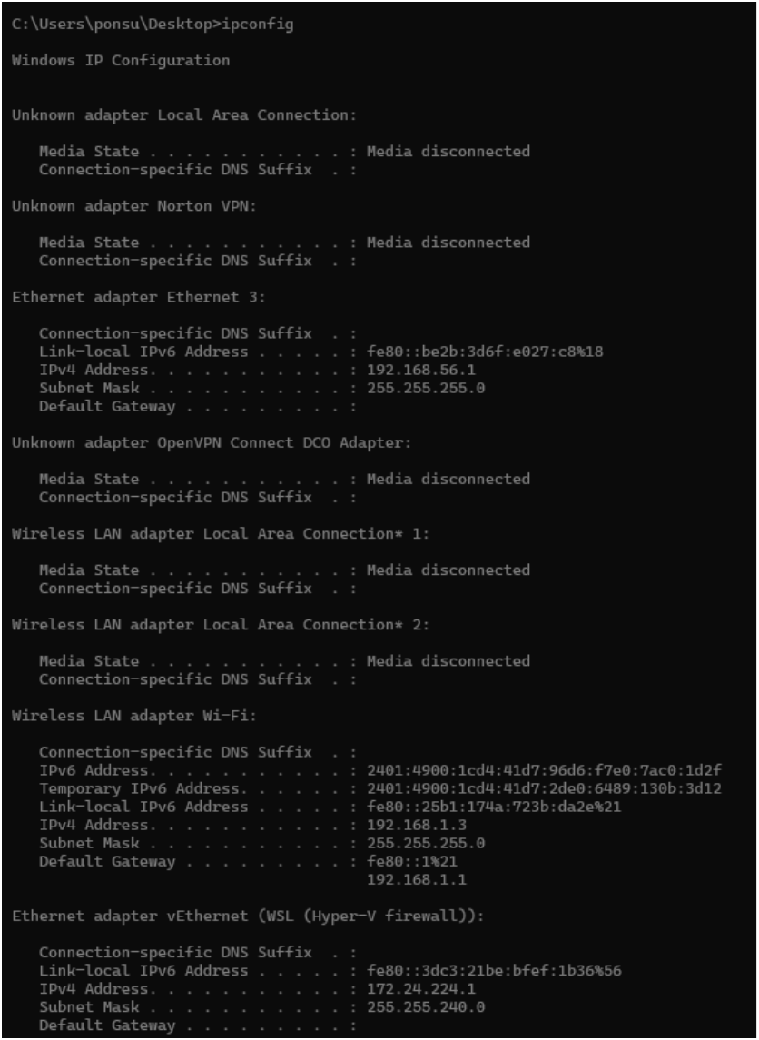
4. echo
SYNOPSIS: ECHO [ON | OFF]
ECHO [message]
DESCRIPTION: Displays messages, or turns command-echoing on or off.

OUTPUT
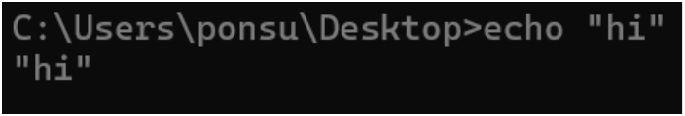
5. del
SYNOPSIS: DEL [/P] [/F] [/S] [/Q] [/A[[:]attributes]] names
ERASE [/P] [/F] [/S] [/Q] [/A[[:]attributes]] names
DESCRIPTION: Deletes one or more files.

OUTPUT
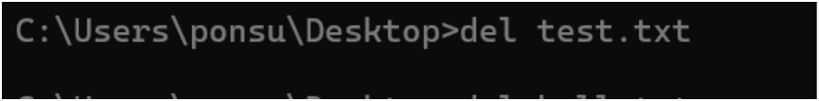
6. find
SYNOPSIS: FIND [/V] [/C] [/N] [/I] [/OFF[LINE]] "string"
[[drive:][path]filename[ ...]]
DESCRIPTION: Searches for a text string in a file or files.

OUTPUT
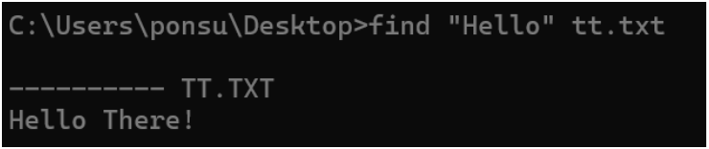
7. tasklist
SYNOPSIS: TASKLIST [/S system [/U username [/P [password]]]]
[/M [module] | /SVC | /V] [/FI filter] [/FO format] [/NH]
DESCRIPTION: This tool displays a list of currently running processes on
either a local or remote machine.

OUTPUT
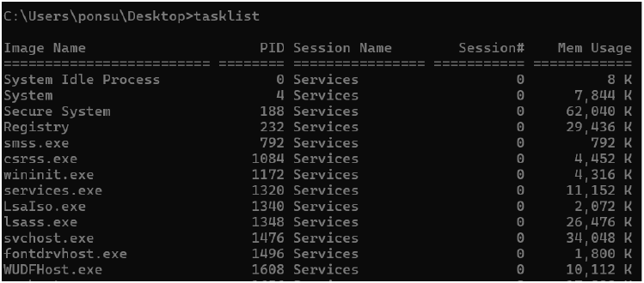
8. systeminfo
SYNOPSIS: SYSTEMINFO [/S system [/U username [/P [password]]]] [/FO
format] [/NH]
DESCRIPTION: This tool displays operating system configuration
information for a local or remote machine, including service pack levels.

OUTPUT
9. tracert
SYNOPSIS: tracert [-d] [-h maximum_hops] [-j host-list] [-w timeout]
[-R] [-S srcaddr] [-4] [-6] target_name
DESCRIPTION: Traces the route packets take to a destination, showing each
hop and its response time to diagnose network issues.

OUTPUT
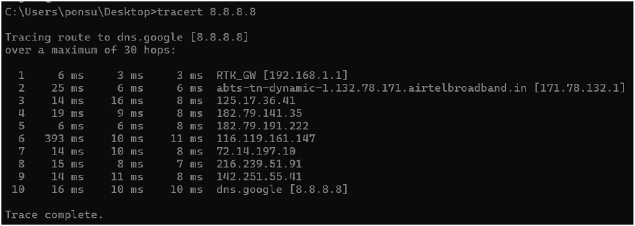
10. ping
SYNOPSIS: ping [-t] [-a] [-n count] [-l size] [-f] [-i TTL] [-v TOS]
[-r count] [-s count] [[-j host-list] | [-k host-list]]
[-w timeout] [-R] [-S srcaddr] [-c compartment] [-p]
[-4] [-6] target_name
DESCRIPTION: Ping tests network connectivity and measures response time
between two devices.

OUTPUT
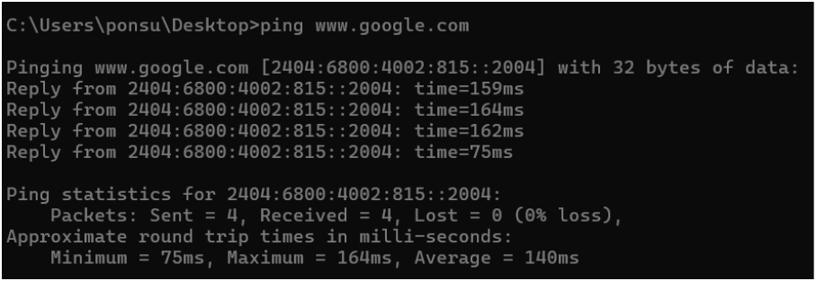

Result
Thus the above windows commands were executed.

Viva Questions
1. What is the purpose of the ping command?
Answer: It checks whether a host or server is reachable on the network.
2. What does the ipconfig command do in Windows?
Answer: It displays the IP configuration of the computer.
3. Which command is used in Linux to display network interfaces?
Answer: ifconfig or ip addr.
4. What is the use of the tracert or traceroute command?
Answer: It shows the path taken by packets to reach a destination.
5. What is the purpose of the netstat command?
Answer: It displays active network connections and listening ports.

EXPERIMENT 2
STUDY OF SOCKET PROGRAMMING IN PYTHON
STUDY OF SOCKET PROGAMMING IN PYTHON

Aim
To study the concepts of socket programming in python.

Introduction
Socket definition:
A network socket is an endpoint of a two-way communication link
between two programs or processes - client and server in our case - which are
running on the network. This can be on the same computer as well as on
different systems which are connected via the network. Both client/server
communicate with each other by writing to or reading from the network socket.
The technical equivalent in reality is a telephone communication between two
participants. The network socket represents the corresponding number of the
telephone line, or a contract in case of cell phones.
Socket programming in python
- Python's core networking library is Socket Module.
- Python's socket module has both class-based and instances-based
methods.
- Class-based method is an intuitive approach which doesn't need an
instance of a
- socket object.
- For example, in order to print a machine's IP address, you don't
need a socket
- object. Instead, just call the socket's class-based methods.
- In instance-based method, if some data needed to be sent to a
server application,
- it is more intuitive to create a socket object to perform that explicit
operation.
- This module has everything you need to build socket servers and
clients.
TCP Client-Server Communication Using Socket programming in python:

Algorithm
Server:
1. Create a TCP socket using `socket.socket(AF_INET,
SOCK_STREAM)`.
2. Bind the socket to `'localhost'` and a specific port using `bind()`.
3. Listen for incoming client connections using `listen()`.
4. Accept a connection, receive the client’s message using `recv()`, and
send a reply using `send()`.
5. Ask the user whether to continue; if not, close the socket using
`close()`.
Client:
1. Create a TCP socket using `socket.socket(AF_INET,
SOCK_STREAM)`.
2. Connect the socket to the server using `connect((‘localhost’, 55555))`.
3. Send a message to the server using `send()`.
4. Receive the reply from the server using `recv()` and display it.
5. Close the socket connection using `close()`.

Program Code

Server
import socket

sockfd = socket.socket(socket.AF_INET, socket.SOCK_STREAM)
print('Socket Created')
sockfd.bind(('localhost', 55555))
sockfd.listen(3)
print('Waiting for connections')

while True:
clientfd, addr = sockfd.accept()
received_msg = clientfd.recv(1024).decode()
print('Connected with', addr)
print('Message Received from Client:', received_msg)
clientfd.send(received_msg.encode('utf-8'))
print('Message reply sent to Client!')
choice = input('Do you want to continue (y/n): ')
if choice.lower() == 'n':
clientfd.close()
break

sockfd.close()

Client
import socket

clientfd = socket.socket(socket.AF_INET, socket.SOCK_STREAM)
clientfd.connect(('localhost', 55555))
name = input('Enter your message: ')
clientfd.send(name.encode('utf-8'))
reply = clientfd.recv(1024).decode()
print('Message Received from Server:', reply)
clientfd.close()

OUTPUT
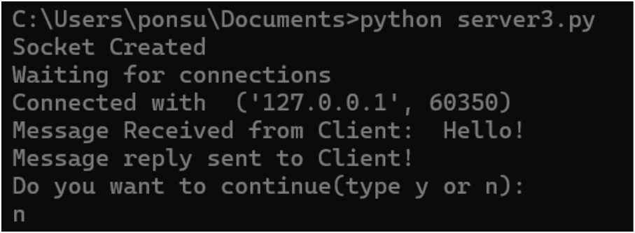
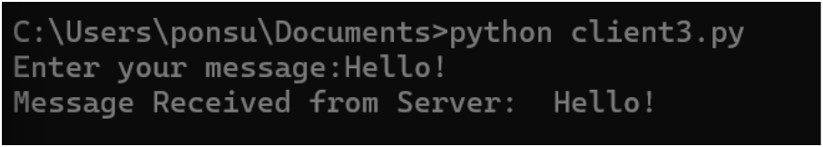
Server:
Client:
UDP Client-Server Communication Using Socket programming in python:

Algorithm
Server:
1. Create a UDP socket using socket.socket(AF_INET,
SOCK_DGRAM).
2. Bind the socket to 'localhost' and a specific port using bind().
3. Wait to receive a message from a client using recvfrom().
4. Display the received message and send it back using sendto().
5. Ask the user whether to continue or close the socket using close().
Client:
1. Create a UDP socket using `socket.socket(AF_INET,
SOCK_DGRAM)`.
2. Enter the message to send to the server.
3. Send the message using `sendto()` with the server’s address and port.
4. Receive the server’s reply using `recvfrom()` and display it.
5. Ask the user whether to continue or close the socket using `close()`.

Program Code

Server
import socket

sockfd = socket.socket(socket.AF_INET, socket.SOCK_DGRAM)
print('UDP Socket Created')
sockfd.bind(('localhost', 8000))
print('Waiting for messages...')

while True:
data, addr = sockfd.recvfrom(1024)
print('Message Received from Client:', data.decode())
sockfd.sendto(data, addr)
print('Message reply sent to Client!')
choice = input('Do you want to continue (y/n): ')
if choice.lower() == 'n':
break

sockfd.close()

Client
import socket

clientfd = socket.socket(socket.AF_INET, socket.SOCK_DGRAM)
while True:
msg = input('Enter message to send: ')
clientfd.sendto(msg.encode(), ('localhost', 8000))
data, addr = clientfd.recvfrom(1024)
print('Message from Server:', data.decode())
choice = input('Do you want to continue (y/n): ')
if choice.lower() == 'n':
break

clientfd.close()

OUTPUT
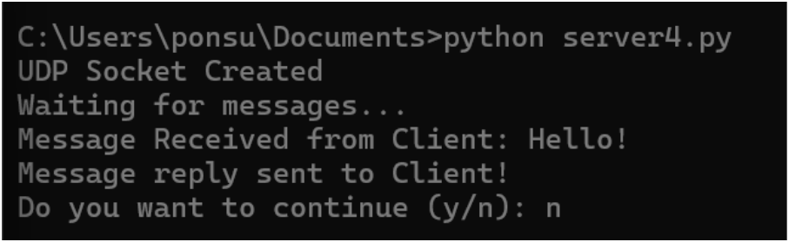
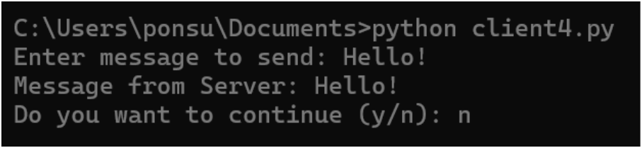
Server:
Client:

Result
Thus concepts of socket programming in python were studied.

Viva Questions
1. What is a socket in computer networks?
Answer:
A socket is an endpoint for sending and receiving data between two computers
over a network.
2. What are the two main types of sockets?
Answer:
The two main types are:
- TCP Socket (SOCK_STREAM): Connection-oriented and reliable.
- UDP Socket (SOCK_DGRAM): Connectionless and faster but less
reliable.
3. What is the difference between TCP and UDP sockets?
Answer:
TCP provides reliable, ordered, and error-checked communication, whereas
UDP provides faster communication without guaranteeing delivery or order of
packets.
4. Which Python module is commonly used for socket programming?
Answer:
The socket module is used in Python for creating and managing network
sockets.
Example:
import socket
5. What is the role of a server socket and a client socket?
Answer:
A server socket listens for incoming connection requests, while a client socket
initiates a connection to the server.

EXPERIMENT 3
CUSTOMIZED PING COMMAND TO TEST SERVER CONNECTIVITY
CUSTOMIZED PING COMMAND TO TEST THE SERVER
CONNECTIVITY

Aim
To develop a customized ping command to test the server connectivity.

Introduction
Ping:
The ping command sends ICMP echo request packets to a host and waits
for echo replies. It measures reachability and reports RTT statistics (min, max,
avg, packet loss).

Algorithm
1. Set host, port, and number of pings.
2. Create an empty list to store RTT values.
3. Repeat for the given number of pings.
4. Start a timer.
5. Attempt to connect to host on the given port.
6. Stop the timer if connection is successful.
7. Calculate RTT and save it in the list.
8. If connection fails, print timeout.
9. After all attempts, find minimum, maximum, and average RTT.
10. Display the results.

Program Code

Customized ping command
import socket
import time

host = 'google.com'
port = 80
count = 4

for _ in range(count):
try:
with socket.socket(socket.AF_INET, socket.SOCK_STREAM) as sock:
start = time.time()
sock.connect((host, port))
end = time.time()
elapsed_ms = (end - start) * 1000
print(f'Reply from {host}: time={elapsed_ms:.2f} ms')
except OSError:
print('Request timed out')

OUTPUT
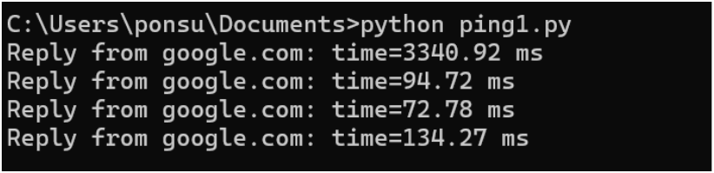

Program Code

RTT statistics
import socket
import time

host = 'google.com'
port = 80
count = 4
times = []

for _ in range(count):
try:
with socket.socket(socket.AF_INET, socket.SOCK_STREAM) as sock:
start = time.time()
sock.connect((host, port))
end = time.time()
rtt = (end - start) * 1000
times.append(rtt)
print(f'Reply from {host}: time={rtt:.2f} ms')
except OSError:
print('Request timed out')

if times:
print('\nMin RTT =', min(times), 'ms')
print('Max RTT =', max(times), 'ms')
print('Avg RTT =', sum(times) / len(times), 'ms')

OUTPUT
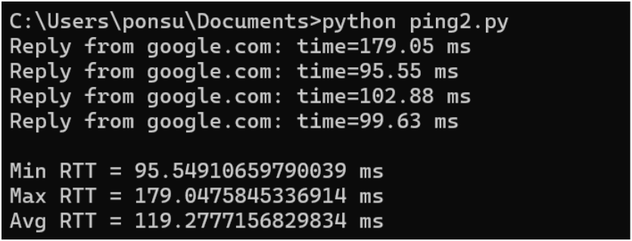

Result
Thus the server connectivity is tested using ping command.

Viva Questions
1. What is the purpose of the ping command?
Answer:
The ping command is used to check whether a host or server is reachable over a
network and to measure the response time.
2. Which protocol is used by the ping command?
Answer:
Ping uses the Internet Control Message Protocol (ICMP), specifically ICMP
Echo Request and Echo Reply messages.
3. What is an ICMP Echo Request?
Answer:
An ICMP Echo Request is a message sent by a computer to another device to
check whether it is active and reachable.
4. What is meant by latency in a ping operation?
Answer:
Latency is the time taken for a packet to travel from the source to the
destination and back, usually measured in milliseconds (ms).
5. What does packet loss indicate in a ping test?
Answer:
Packet loss indicates that some packets failed to reach the destination or return
to the sender, which may be due to network congestion or failures.

EXPERIMENT 4
PACKET SNIFFING USING RAW SOCKETS IN PYTHON

Aim
To implement packet sniffing using raw sockets in python that captures Ethernet frames and displays source/destination MACs and protocol info for network analysis and troubleshooting.

Introduction
Packet Sniffing:
Packet sniffing is the process of intercepting and analyzing network
packets traveling over a network to monitor or troubleshoot traffic.

Algorithm
1. Get the local host IP address.
2. Create a raw IPv4 socket.
3. Bind the socket to the host IP.
4. Set socket to include IP headers.
5. Enable promiscuous mode to capture all packets.
6. Enter an infinite loop to receive data.
7. Receive raw packet bytes from the socket.
8. Parse the Ethernet frame into dest MAC, src MAC, protocol, and payload.
9. Format MAC addresses and protocol for display.
10. Print the extracted fields and loop to continue sniffing.

Program Code

Packet-sniffing program
import binascii
import socket
import struct

def get_mac_addr(bytes_addr):
return ':'.join(f'{byte:02x}' for byte in bytes_addr).upper()

def get_protocol(bytes_proto):
return binascii.hexlify(bytes_proto).decode().upper()

def ethernet_frame(data):
dest_mac, src_mac, proto = struct.unpack('!6s6s2s', data[:14])
return (
get_mac_addr(dest_mac),
get_mac_addr(src_mac),
get_protocol(proto),
data[14:],
)

def main():
host = socket.gethostbyname(socket.gethostname())
print(f'IP: {host}')
conn = socket.socket(socket.AF_INET, socket.SOCK_RAW, socket.IPPROTO_IP)
conn.bind((host, 0))
conn.setsockopt(socket.IPPROTO_IP, socket.IP_HDRINCL, 1)
conn.ioctl(socket.SIO_RCVALL, socket.RCVALL_ON)

while True:
raw_data, addr = conn.recvfrom(65536)
dest_mac, src_mac, eth_proto, payload = ethernet_frame(raw_data)
print('\nEthernet Frame:')
print(f'Destination MAC: {dest_mac}')
print(f'Source MAC: {src_mac}')
print(f'Protocol: {eth_proto}')

if __name__ == '__main__':
main()

OUTPUT
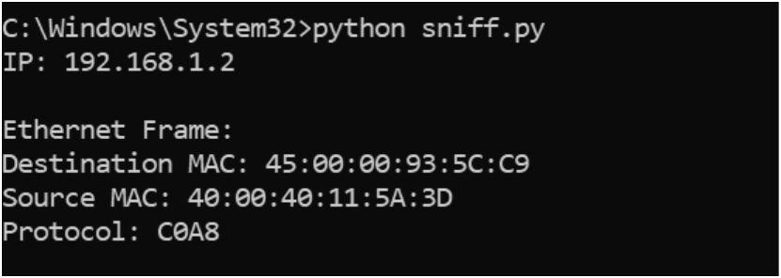

Result
Thus packet sniffing was implemented using raw sockets in python.

Viva Questions
1. What is packet sniffing?
Answer:
Packet sniffing is the process of capturing and analyzing data packets that travel
through a computer network.
2. What is a raw socket?
Answer:
A raw socket is a type of socket that provides direct access to network packets,
allowing programmers to read and manipulate packet headers and data.
3. Why are administrator or root privileges required for raw sockets?
Answer:
Administrator privileges are required because raw sockets provide low-level
access to network traffic, which can affect system security and privacy.
4. Which Python module is used for implementing raw sockets?
Answer:
The socket module in Python is used to create and work with raw sockets.
Example:
import socket
5. What is the main purpose of packet sniffing?
Answer:
Packet sniffing is used for network monitoring, troubleshooting, performance
analysis, and security investigations.

EXPERIMENT 5
SIMPLE CALCULATOR USING XML-RPC
SIMPLE CALCULATOR USING XMLRPC

Aim
To develop a simple calculator using xmlrpc in python. Introduction: XML-RPC: XML-RPC is a protocol that uses XML to encode remote procedure calls (RPC) and HTTP as a transport mechanism, allowing a client to call functions on a remote server over a network.

Algorithm
Client:
1. Import xmlrpc.client and create a ServerProxy for
http://localhost:8000/.
2. Loop a fixed number of times (e.g., 5).
3. Prompt the user to input two numbers (a and b).
4. Call server functions (add, sub, mul, div, mod) via the proxy.
5. Receive results from the server for each operation.
6. Print the results to the user.
Server:
1. Import SimpleXMLRPCServer from xmlrpc.server.
2. Define arithmetic functions: add, sub, mul, div, mod.
3. Create an XMLRPCServer object bound to localhost on port 8000.
4. Register each function with the server.
5. Print a message indicating the server is listening.
6. Start the server using serve_forever() to handle incoming client
requests.

Program Code

Client
import xmlrpc.client

proxy = xmlrpc.client.ServerProxy('http://localhost:8000/')
for _ in range(5):
a = int(input('Enter a number: '))
b = int(input('Enter another number: '))
print('Addition:', proxy.add(a, b))
print('Subtraction:', proxy.sub(a, b))
print('Multiplication:', proxy.mul(a, b))
print('Division:', proxy.div(a, b))
print('Modulus:', proxy.mod(a, b))

Server
from xmlrpc.server import SimpleXMLRPCServer

def add(a, b):
return a + b

def sub(a, b):
return a - b

def mul(a, b):
return a * b

def div(a, b):
return a / b

def mod(a, b):
return a % b

server = SimpleXMLRPCServer(('localhost', 8000))
print('Listening on port 8000...')
for function in (add, sub, mul, div, mod):
server.register_function(function, function.__name__)
server.serve_forever()

OUTPUT
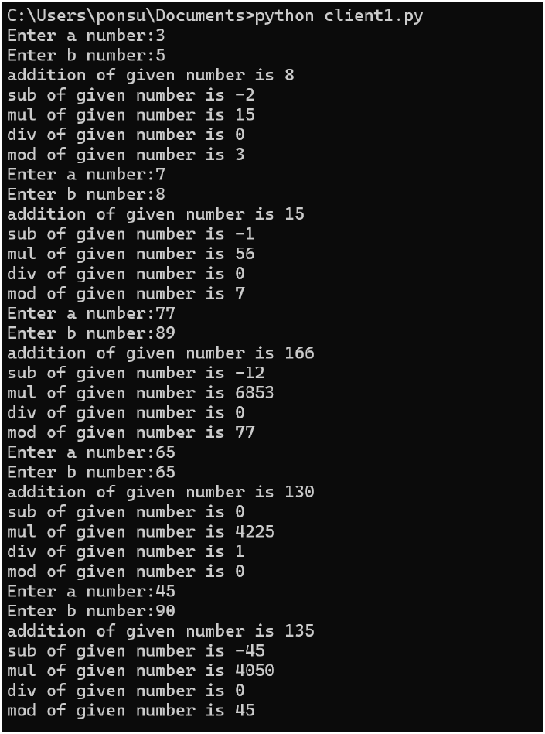
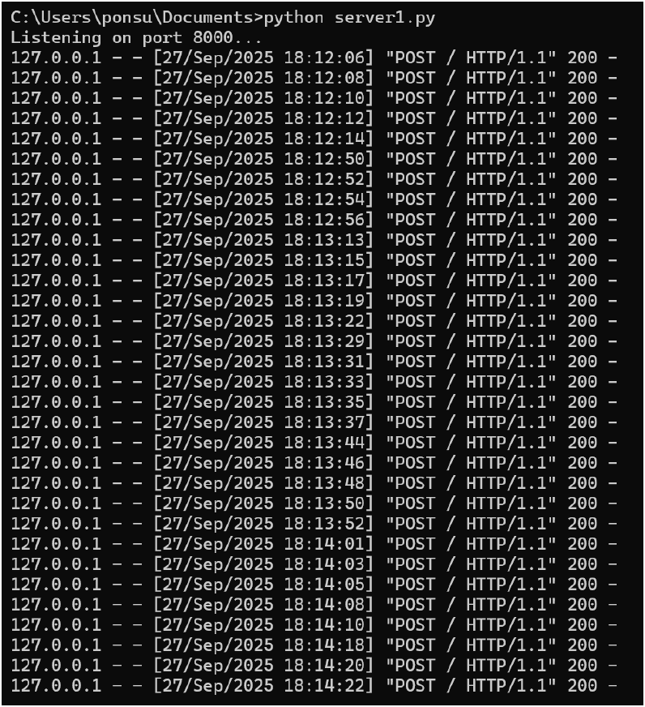
Client:
Server:

Result
Thus a simple calculator was developed using xmlrpc in python

Viva Questions
1. What is XML-RPC?
Answer:
XML-RPC (XML Remote Procedure Call) is a protocol that allows a program
to call functions on another computer using XML for data exchange over a
network.
2. What is the client-server model in XML-RPC?
Answer:
In the client-server model, the client sends a request to perform an operation,
and the server processes the request and returns the result.
3. Which Python modules are used for XML-RPC programming?
Answer:
Python provides the following modules:
- xmlrpc.server for creating the server
- xmlrpc.client for creating the client
4. Why is XML used in XML-RPC?
Answer:
XML is used because it is a standard, platform-independent format for
exchanging structured data between systems.
5. What is a remote procedure call (RPC)?
Answer:
A remote procedure call is a technique that allows a program to execute a
function or method on another computer as if it were a local function.

EXPERIMENT 6
NMAP LIVE HOST DISCOVERY

Aim
To use Nmap to discover live hosts using ARP scan, ICMP scan, and TCP/UDP ping scan in TryHackMe platform.

Introduction
Nmap is a network scanning tool that finds hosts, open ports, and
services.
Task 1: Introduction
Task 2: Subnetworks
Task 3: Enumerating Targets
Task 4: Discovering Live Hosts
Task 5: Nmap Host Discovery Using ARP
Task 7: Nmap Host Discovery Using TCP and UDP
Task 8: Using Reverse-DNS Lookup

Summary

Result
Thus Nmap was used to discover live hosts using ARP scan, ICMP scan, and TCP/UDP ping scan in TryHackMe platform.

Viva Questions
1. What is Nmap?
Answer:
Nmap (Network Mapper) is an open-source tool used for network discovery,
host identification, and security auditing.
2. What is live host discovery in Nmap?
Answer:
Live host discovery is the process of identifying active devices (hosts) on a
network without performing a complete port scan.
3. Which Nmap option is used only for host discovery?
Answer:
The -sn option is used for host discovery without scanning ports.
Example:
nmap -sn 192.168.1.0/24
4. What protocols are commonly used by Nmap for host discovery?
Answer:
Nmap commonly uses:
- ICMP Echo Requests (Ping)
- ARP Requests
- TCP SYN Ping
- TCP ACK Ping
- UDP Ping
5. What is an ARP scan in Nmap?
Answer:
An ARP scan sends Address Resolution Protocol requests to discover active
devices on a local network and is very effective in LAN environments.

OUTPUT
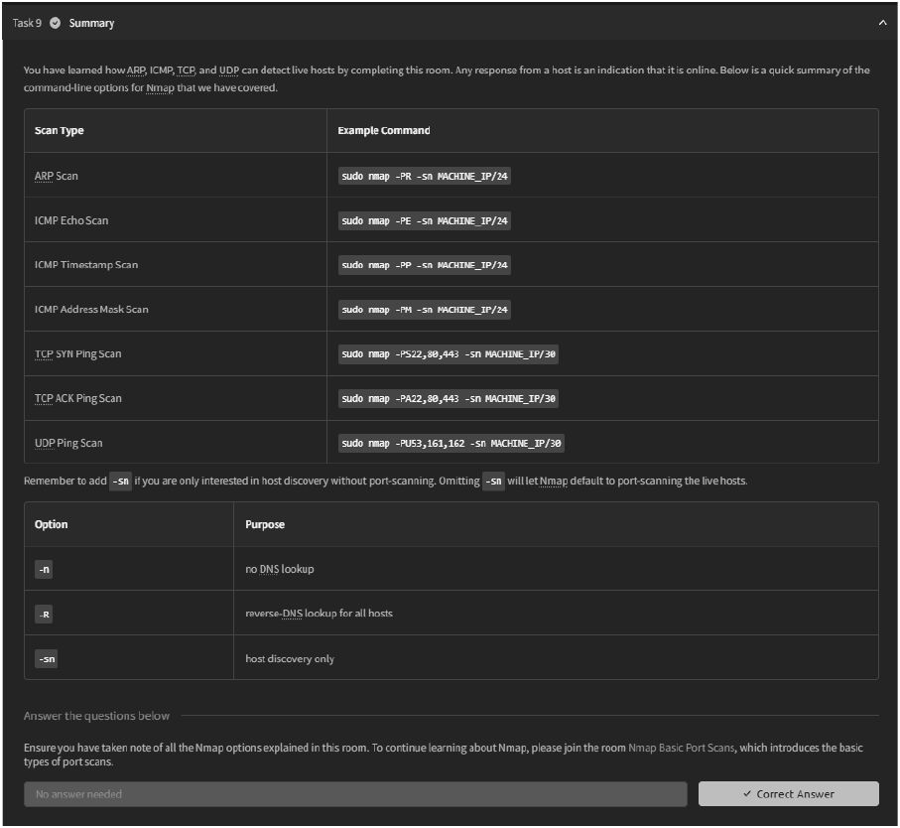

EXPERIMENT 7
ANONYMOUS FTP SCANNER

Aim
To build an anonymous ftp scanner using ftplib module in python.

Introduction
FTP Scanner:
A tool that automatically scans IPs/hosts for active FTP servers. It tests
connectivity and credentials, reporting successful logins and vulnerabilities.
ftplib:
A built in Python library for working with the File Transfer Protocol
(FTP). It allows connecting to FTP servers, logging in, listing directories, and
transferring files.

Algorithm
1. Import the `ftplib` module.
2. Define a function that accepts a hostname.
3. Inside the function, create an FTP connection to the hostname.
4. Attempt to log in with username `"anonymous"` and password
`"anonymous"`.
5. Store the server’s response from the login attempt.
6. If the response contains `"230 Anonymous access granted"`, proceed.
7. Print a success message with the hostname.
8. Display the server’s welcome message and directory listing.
9. If an exception occurs, print the error and a failure message.
10. Call the function with the desired hostname or IP address.

Program Code

Anonymous FTP login
import ftplib

def anonymous_login(hostname):
try:
with ftplib.FTP(hostname) as ftp:
response = ftp.login('anonymous', 'anonymous')
print(response)
if '230 Anonymous access granted' in response:
print(f'\n[*] {hostname} FTP anonymous login succeeded.')
print(ftp.getwelcome())
ftp.dir()
except Exception as error:
print(str(error))
print(f'\n[-] {hostname} FTP anonymous login failed.')

hostname = 'ftp.be.debian.org'
anonymous_login(hostname)

OUTPUT
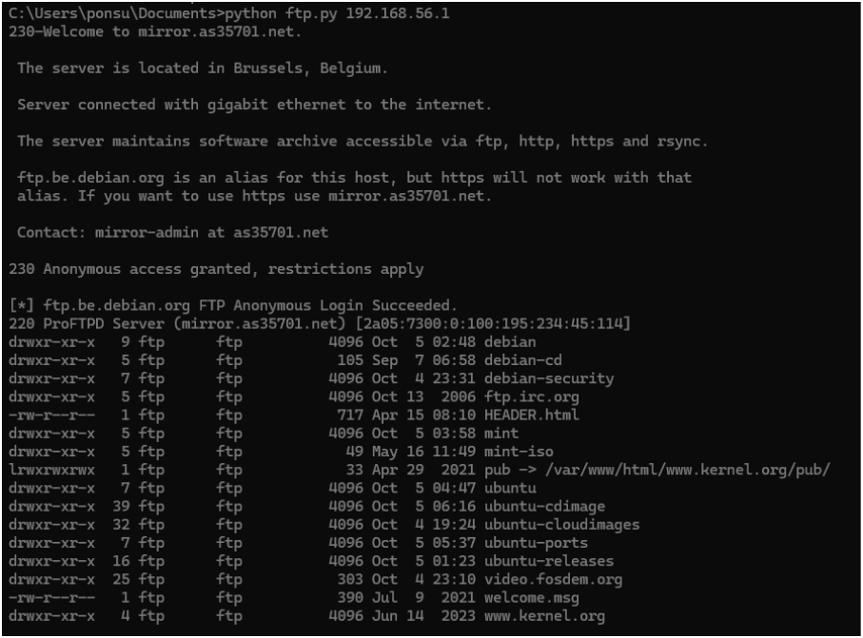

Result
Thus an anonymous ftp scanner using ftplib module was built and executed

Viva Questions
1. What is FTP?
Answer:
FTP (File Transfer Protocol) is a network protocol used to transfer files between
a client and a server over the Internet or a local network.
2. What is anonymous FTP login?
Answer:
Anonymous FTP login allows users to access an FTP server without a personal
username and password, usually using "anonymous" as the username.
3. What is the purpose of an anonymous FTP scanner?
Answer:
An anonymous FTP scanner checks whether a server permits anonymous login
access, which can help identify security risks.
4. Which port is commonly used by FTP?
Answer:
FTP uses port 21 as its default control port for communication between the
client and the server.
5. Which Python module is used to implement an FTP scanner?
Answer:
The ftplib module in Python is used to connect to and interact with FTP servers.
Example:
from ftplib import FTP

EXPERIMENT 8
REVERSE SHELL USING TCP SOCKETS

Aim
To develop a program to reverse shell using TCP Sockets.

Introduction
Reverse Shell:
A reverse shell is a TCP connection where a target machine connects
back to a controller, allowing remote command execution.
TCP Sockets:
TCP sockets are endpoints for a reliable, connection-based
communication channel between two machines over the Internet or a network.
They ensure ordered, error-checked data delivery.

Algorithm
Server:
1. Create a socket and bind it to host and port.
2. Start listening for incoming client connections.
3. Accept a connection when a client connects.
4. Send user-entered commands to the connected client.
5. Receive and display the client’s output; close on `quit`.
Client:
1. Create a socket and connect to the server.
2. Wait to receive a command from the server.
3. If the command is `cd`, change the directory; if `quit`, close connection.
4. Execute other commands using subprocess.
5. Send the command output and current directory back to the server.

Program Code

Server flow (safety summary)
# The source exercise creates a TCP listener and accepts a client.
# It then exchanges text commands and results over the connection.
# For safety, the remote command-execution implementation is omitted.
# Use only an instructor-provided, isolated lab environment.

Client flow (safety summary)
# The source exercise connects to the lab server and receives text commands.
# It returns results over the connection.
# For safety, process-launching and remote command-execution code is omitted.
# Use only an instructor-provided, isolated lab environment.

output = f"Changed directory to {os.getcwd()}"
except Exception as e:
output = str(e)
else:
process = subprocess.Popen(command, shell=True,
stdout=subprocess.PIPE, stderr=subprocess.PIPE,
stdin=subprocess.PIPE)
output = process.stdout.read() + process.stderr.read()
output = output.decode()
current_dir = os.getcwd() + "> "
client.send((output + "\n" + current_dir).encode())
except Exception as e:
client.send(str(e).encode())
break
client.close()
if __name__ == "__main__":
connect_to_server()

OUTPUT
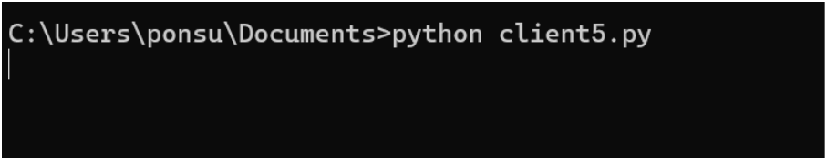
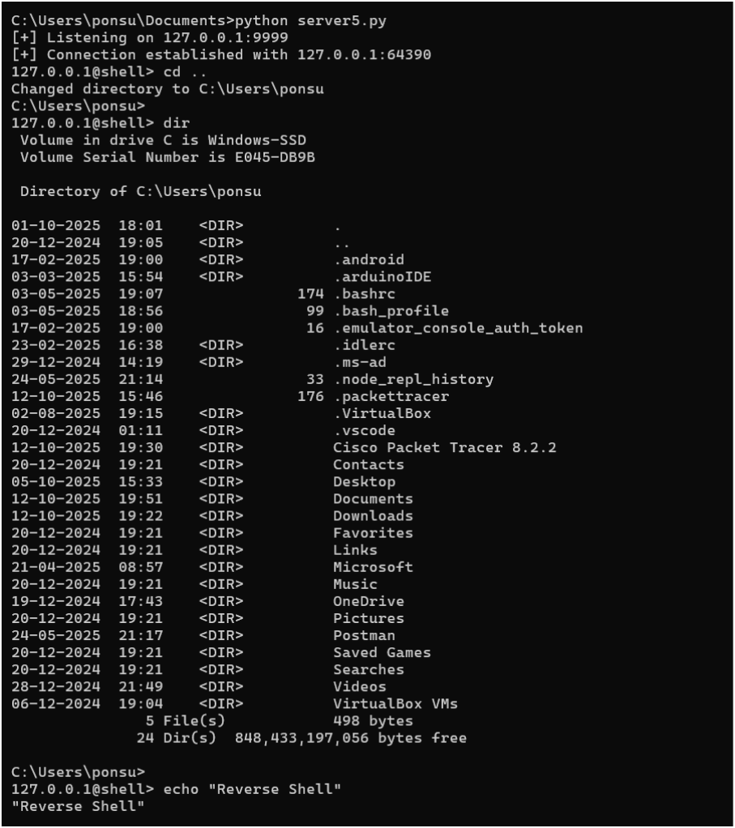
Client:
Server:

Result
Thus a program was developed and executed to reverse shell using TCP Sockets.

Viva Questions
1. What is a TCP socket?
Answer:
A TCP socket is an endpoint used for reliable, connection-oriented
communication between two devices over a network using the TCP protocol.
2. What is a reverse shell?
Answer:
A reverse shell is a program in which a client system initiates a connection to a
server, allowing remote command execution. It should be used only in
authorized lab environments for educational purposes.
3. Which Python module is used for TCP socket programming?
Answer:
The socket module is used in Python to create and manage TCP sockets.
Example:
import socket
4. What is the difference between a client and a server in socket programming?
Answer:
A server waits for incoming connections, while a client initiates a connection to
the server.
5. Why is TCP preferred for remote communication applications?
Answer:
TCP provides reliable, ordered, and error-checked delivery of data, ensuring
that information reaches the destination correctly.

EXPERIMENT 9
DESIGN A SIMPLE TOPOLOGY USING CISCO PACKET TRACER

Aim
To design and configure a simple network topology with one router, two switches, and four PCs in Cisco Packet Tracer for successful inter-network communication.

Procedure
1. Launch Cisco Packet Tracer
- Open Cisco Packet Tracer on your system.
- Ensure the workspace and device categories (Routers, Switches, End
Devices, etc.) are visible.
2. Add Network Devices
- From the Routers section, drag one router onto the workspace.
- From the Switches section, drag two 2960 switches.
- From the End Devices section, drag four PCs (PC1, PC2, PC3, PC4).
- Rename the devices.
3. Connect the Devices
Use Copper Straight-Through cables to connect:
- PC1 to Switch1 using port FastEthernet0/1.
- PC2 to Switch1 using port FastEthernet0/2.
- PC3 to Switch2 using port FastEthernet0/1.
- PC4 to Switch2 using port FastEthernet0/2.
- Switch1 to the router using Switch1 port GigabitEthernet0/1 and Router
port GigabitEthernet0/0/0.
- Switch2 to the router using Switch2 port GigabitEthernet0/1 and Router
port GigabitEthernet0/0/1.
4. Assign IP Addresses:
- Network 1 (Switch1 side): 192.168.1.0/24
- Network 2 (Switch2 side): 192.168.2.0/24
For each PC (PC1 to PC4):
1. Click the PC → go to Desktop → IP Configuration.
2. Select Static and manually enter the IP address, subnet mask, and default
gateway
- PC1 → IP 192.168.1.2 / 255.255.255.0, Gateway 192.168.1.1
- PC2 → IP 192.168.1.3 / 255.255.255.0, Gateway 192.168.1.1
- PC3 → IP 192.168.2.2 / 255.255.255.0, Gateway 192.168.2.1
- PC4 → IP 192.168.2.3 / 255.255.255.0, Gateway 192.168.2.1
For Router:
- Router interface GigabitEthernet0/0/0 → 192.168.1.1 / 255.255.255.0
- Router interface GigabitEthernet0/0/1 → 192.168.2.1 / 255.255.255.0
Click on Router, go to the CLI tab, and enter the following commands:
5. Test Connectivity
These test the router and cross-network connectivity.
- On PC1, open the Command Prompt and type:
- On PC3, open the Command Prompt and type:
Successful replies confirm that inter-network communication is functioning
correctly.

Result
Thus, a simple network topology with one router, two switches, and four PCs was successfully designed and configured in Cisco Packet Tracer. Successful ping replies verified proper connectivity between all devices in both networks.
1. What is Cisco Packet Tracer?
Answer:
Cisco Packet Tracer is a network simulation tool used to design, configure, and
test computer networks virtually.
2. What is network topology?
Answer:
Network topology is the physical or logical arrangement of devices and
connections in a computer network.
3. What are the basic devices used in a simple network topology?
Answer:
The basic devices include:
- PCs (Personal Computers)
- Switches
- Routers
- Network cables
4. What is the function of a switch in a network?
Answer:
A switch connects multiple devices within the same local area network (LAN)
and forwards data to the correct destination.
5. What is the role of a router in a network?
Answer:
A router connects different networks and routes data packets between them.

OUTPUT
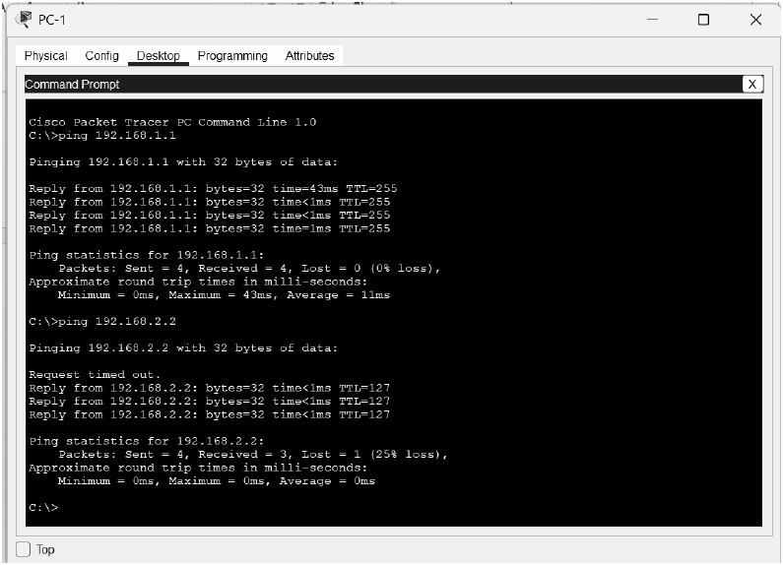
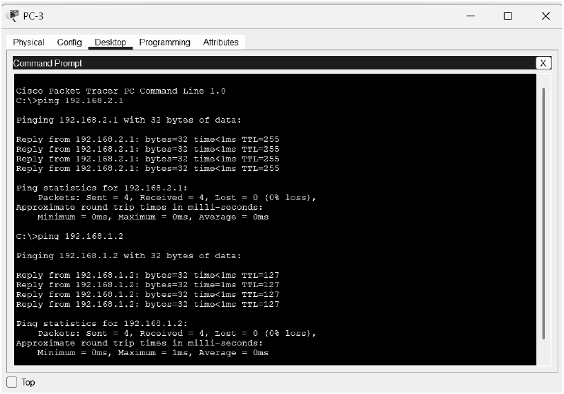

EXPERIMENT 10
CUSTOMIZE SWITCH WITH NETWORK MODULES USING CISCO PACKET TRACER
PACKET TRACER

Aim
To Customize Switch with Network Modules using Cisco Packet Tracer.

Procedure
1. Open Cisco Packet Tracer
- Launch Cisco Packet Tracer on your computer.
2. Add a Switch to Your Workspace
- In the device toolbar (usually on the left side of the screen), locate
the "Switches" section.
- Drag and drop a switch model onto the workspace.
3. Access the Switch's Physical Layout
- Click on the switch in the workspace to open its configuration
window.
- Navigate to the "Physical" tab to see the switch's physical layout
and modules.
4. Add Network Modules
- In the "Physical" tab, you might see options to add or modify
network modules.
- Click on the slot where you want to add a module.
- Drag the module from the list of available modules and drop it into
the slot on the switch.
5. Configure the Modules and save the configuration
- After adding the module, switch to the "CLI" tab in the switch's
configuration window.
- Here, you can configure the ports provided by the module. For
example, you can set IP addresses, VLAN configurations, and
other settings for the new interfaces.
CONFIG THE HOSTNAME OF THE SWITCH:
SET THE MESSAGE OF THE DAY(MOTD) BANNER FOR THE
SWITCH:
CONFIG THE LINE CONSOLE PASSWORD AND ENABLE SECRET
PASSWORD:
SHOW THE VLAN:
NAMING THE VLAN:
ASSIGN INTERFACE TO VLAN:
ASSIGN IP ADDRESS TO VLAN

Result
Thus successfully configured and customize switch with network modules using cisco packet tracer has been verified.
1. What is Cisco Packet Tracer?
Answer:
Cisco Packet Tracer is a network simulation software used to design, configure,
and test network topologies virtually.
2. What is a network module in a switch?
Answer:
A network module is a hardware component that can be added to a switch to
provide extra ports or additional functionalities.
3. Why do we customize switches with network modules?
Answer:
We customize switches to increase the number of ports, support different
network technologies, and meet specific network requirements.
4. What is the function of a switch in a computer network?
Answer:
A switch connects multiple devices in a Local Area Network (LAN) and
forwards data to the correct destination using MAC addresses.
5. How can you add a network module to a switch in Cisco Packet
Tracer?
Answer:
First, turn off the switch, drag and drop the required module into the empty slot,
and then turn the switch back on.

OUTPUT
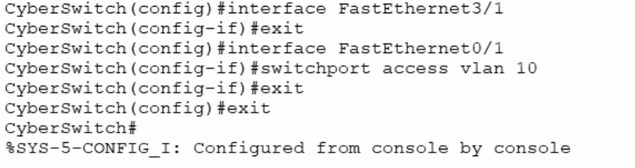
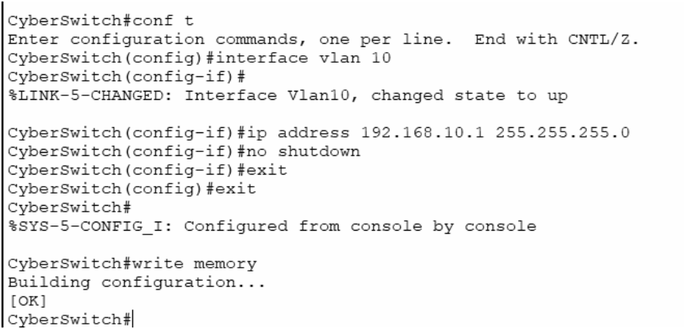

EXPERIMENT 11
EXAMINING NETWORK ADDRESS TRANSLATION (NAT) USING CISCO PACKET TRACER
CISCO PACKET TRACER

Aim
To Examine Network Address Translation (NAT) using Cisco Packet Tracer.
1. Setting Up the Network Topology
Devices Required:
- 2 Routers (R1, R2)
- 2 Switches (S1, S2)
- 3 PCs (PC1, PC2, PC3)
- 1 Server
- Serial and Ethernet cables
Cable the devices:
- PC1 → FastEthernet0 → Switch S1.
- PC2 → FastEthernet0 → Switch S1.
- Switch S1 → GigabitEthernet0/0 → Router R1.
- Server → FastEthernet0 → Switch S2.
- Switch S2 → GigabitEthernet0/0 → Router R2.
- Router R1 Serial0/0/0 ↔ Serial0/0/0 Router R2 (serial cable).
2.Assign IP Addresses to PC and Server:
1. Open the PC.
2. Go to Desktop → IP Configuration.
3. Enter the details:
1. Open the Server.
2. Go to Desktop → IP Configuration.
3. Enter the details:
1.Go to services tab,edit index.html
2.Change the heading.
3.Open browser in PC1 and type the following url. Notice the Change in
heading.
3.Configure the routers
- Click on the router,go to config tab.
- Under interface,select the port connected . Mark the tick box “on”. Fill
the ip address and subnet mask.
- Repeat for all the ports in both the routers.
Static NAT Mapping on Router1:
- Open R1 → CLI
- Enter:
Static Routing on Router2:
- Open Router2 → Config tab → Static.
- Fill the fields: Network,Subnet Mask,Next Hop
- Click Add
4.Test Connectivity Using PDU and Ping
PDU Test:
- Select the Add Simple PDU tool from the main toolbar.
- Source: PC3 → Destination: PC2.
- Send the PDU.
- The PDU suceeds because the private IP can traverse the public network.
- Select the Add Simple PDU tool from the main toolbar.
- Source: PC2 → Destination: PC3.
- Send the PDU.
- The PDU fails because the public IP cannot traverse the private network.
Ping test:
- Open command prompt in PC3 and ping PC2.
- Ping successful.
- Open command terminal in PC2 and ping PC3.
- Ping Failed.

Result
Thus Network Address Translation (NAT) was examined using Cisco Packet Tracer.
1. What is Network Address Translation (NAT)?
Answer:
Network Address Translation (NAT) is a technique that converts private IP
addresses into public IP addresses, allowing devices in a local network to
communicate with the Internet.
2. Why is NAT used in computer networks?
Answer:
NAT is used to conserve public IP addresses and provide an additional layer of
security by hiding internal network addresses from external networks.
3. What is the difference between a private IP address and a public IP address?
Answer:
A private IP address is used within a local network and cannot be accessed
directly from the Internet, while a public IP address is globally unique and used
for Internet communication.
4. Which device commonly performs NAT?
Answer:
A router commonly performs Network Address Translation between internal
and external networks.
5. What is PAT (Port Address Translation)?
Answer:
PAT, also called NAT Overload, allows multiple devices in a private network to
share a single public IP address by using different port numbers.

OUTPUT
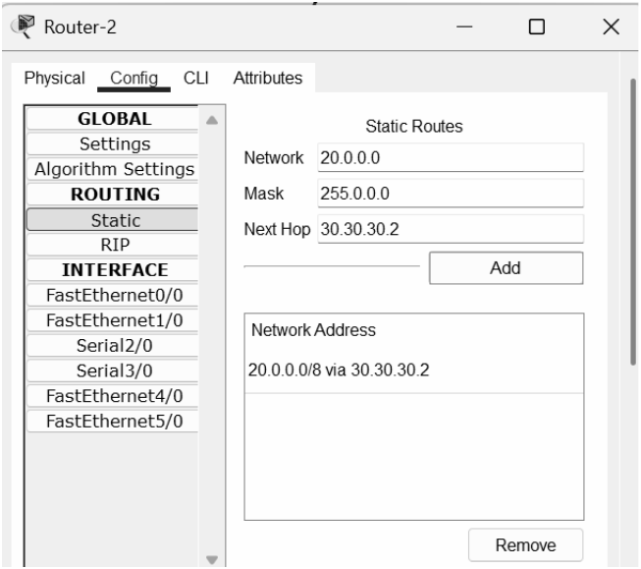
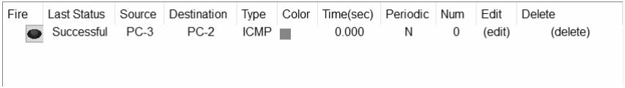
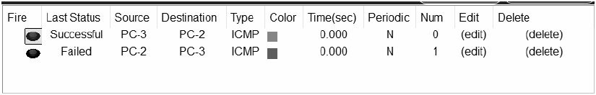
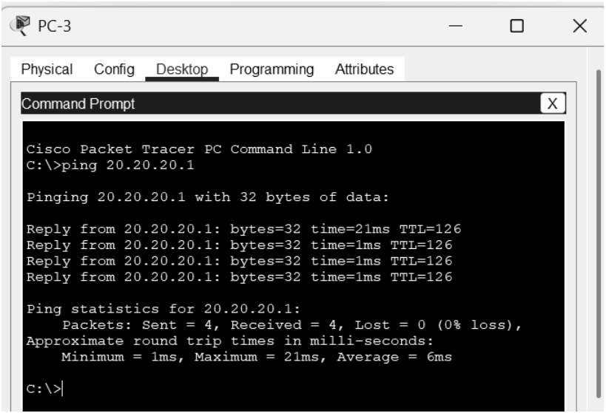

EXPERIMENT 12
CAPTURE, SAVE, AND ANALYZE NETWORK TRAFFIC USING WIRESHARK
TO CAPTURE, SAVE, AND ANALYZE NETWORK TRAFFIC USING
WIRESHARK TOOL

Aim
To capture, save, and analyze network traffic on
TCP/UDP/IP/HTTP/ARP/DHCP/ICMP /DNS using Wireshark Tool.

Procedure
1. Install Wireshark
- Download and install Wireshark from https://www.wireshark.org/
- Make sure to install the required packet capture drivers (e.g., WinPcap or
Npcap on Windows).
2. Start Capturing Traffic
- Open Wireshark.
- Select the correct network interface for capturing (Wi-Fi, Ethernet, etc.).
- Click on the interface to start live capture.
3. Apply Capture Filters
To reduce the amount of data captured, you can apply capture filters.
Example filters for protocols:
- TCP only: tcp
- UDP only: udp
- ARP only: arp
- ICMP only: icmp
- DHCP (uses UDP ports 67 and 68): udp port 67 or udp port 68
- DNS (uses UDP or TCP port 53): port 53
4. Save Captured Traffic
- When done capturing, go to File > Save As.
- Save the capture file in .pcapng or .pcap format for later analysis
5. Analyze Captured Traffic
Wireshark provides powerful tools to filter and analyze packets:
Display Filters:
You can filter displayed packets without limiting the saved capture.
Examples:
- TCP: tcp
- UDP: udp
- IP: ip
- HTTP: http
- ARP: arp
- DHCP: bootp (DHCP is part of the BOOTP protocol)
- ICMP: icmp
- DNS: dns
Follow Streams:
For TCP or UDP conversations, right-click a packet and select Follow > TCP
Stream or Follow > UDP Stream to see the conversation in readable form.
Protocol Hierarchy:
Use Statistics > Protocol Hierarchy to get an overview of protocols present.
Packet Details:
Select any packet and expand protocol layers in the middle pane to analyze
headers and payload details.
Conversations:
Use Statistics > Conversations to analyze communication between source and
destination hosts.
Endpoints:
Go to Statistics > Endpoints to list all active IP/MAC addresses involved in the
capture.
I/O Graphs:
Use Statistics > I/O Graphs to visualize traffic rate and identify spikes or drops
over time.
Expert Information:
Open Analyze > Expert Information to detect errors, warnings, and
retransmissions.

Result
Thus network traffic on TCP/UDP/IP/HTTP/ARP/DHCP/ICMP /DNS were
analyzed using Wireshark Tool.
1. What is Wireshark?
Answer:
Wireshark is a network protocol analyzer used to capture, monitor, and analyze
network traffic in real time.
2. What is a packet in a computer network?
Answer:
A packet is a small unit of data transmitted from one device to another over a
network.
3. What is the purpose of capturing network traffic?
Answer:
Capturing network traffic helps in troubleshooting network problems,
monitoring performance, and investigating security incidents.
4. What is a capture filter in Wireshark?
Answer:
A capture filter is used to capture only specific types of network traffic during
packet collection.
Example:
host 192.168.1.1
5. What is a display filter in Wireshark?
Answer:
A display filter is used to view specific packets from the captured data without
affecting the original capture.
Example:
http

OUTPUT
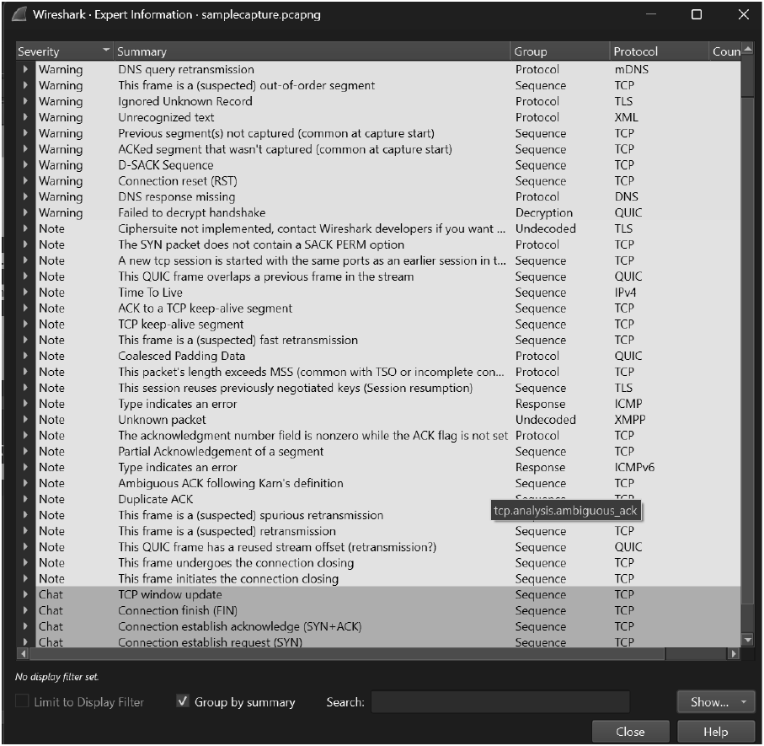

EXPERIMENT 13
NETWORK FORENSICS USING PCAPXRAY TOOL

Aim
To analyze a PCAP file using PcapXray and visualize network activity for basic network forensic investigation.

Algorithm
1. Install PcapXray dependencies using: sudo pip3 install -r requirements.txt
2. Launch the tool with: sudo python3 PcapXray.py
3. Open the web interface and upload the given PCAP file.
4. Click Analyze to process the packet data.
5. View the generated network topology and communication graph.
6. Examine hosts, protocols, and suspicious connections.
7. Save the generated report and diagrams for documentation.

OUTPUT
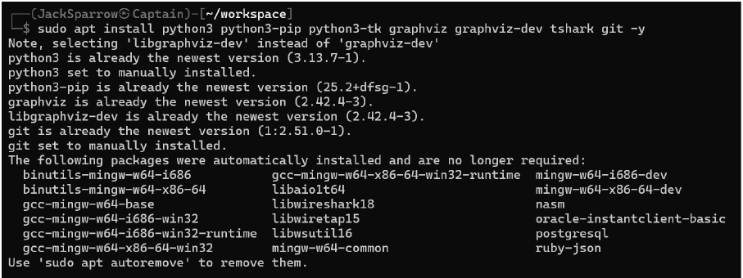
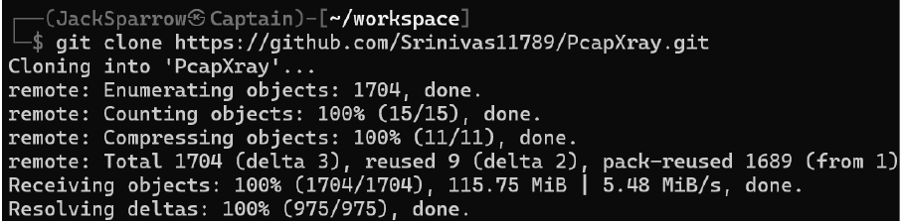
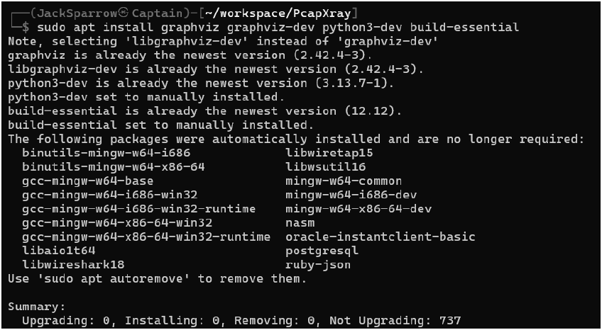
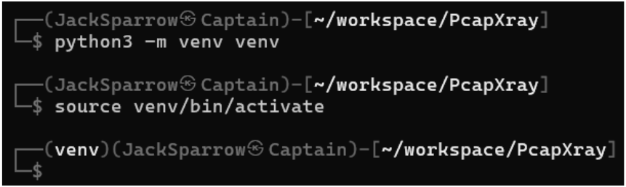
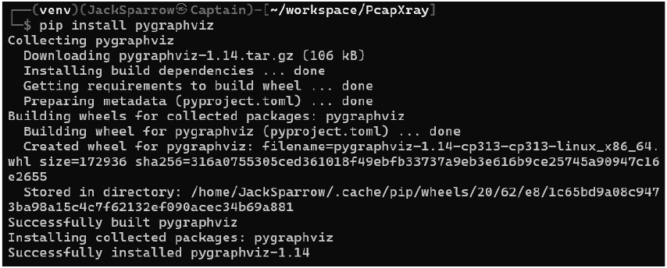
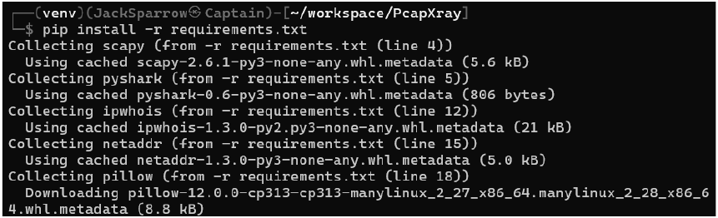
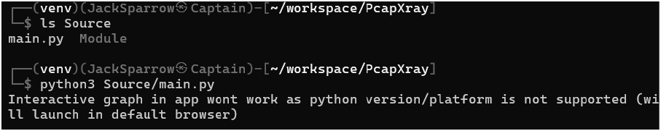
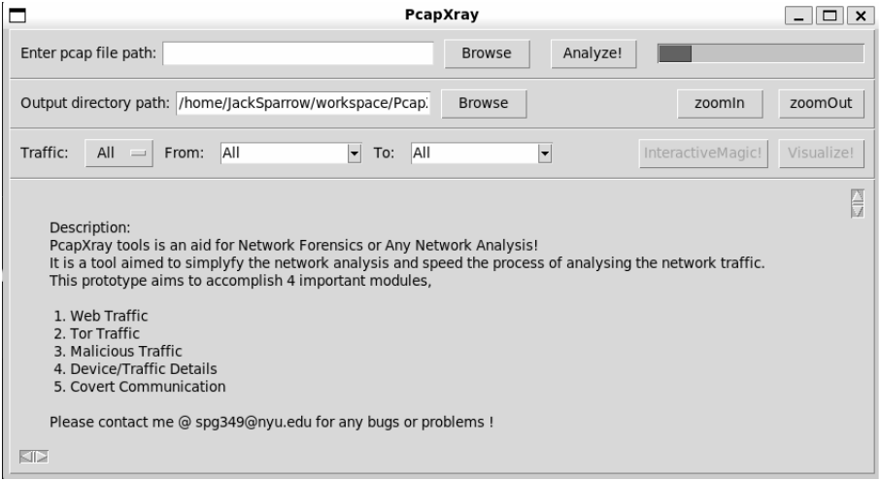

Result
Network forensics was successfully carried out using PcapXray, and the tool visualized hosts, protocols, and communication flows from the provided PCAP file.
1. What is network forensics?
Answer:
Network forensics is the process of capturing, monitoring, and analyzing
network traffic to investigate security incidents and collect digital evidence.
2. What is PcapXray?
Answer:
PcapXray is a network forensic tool used to visualize and analyze packet
capture (PCAP) files to understand network activities and detect suspicious
behavior.
3. What is a PCAP file?
Answer:
A PCAP (Packet Capture) file stores network packets captured from a network
interface for later analysis.
4. Why is network traffic analysis important in digital forensics?
Answer:
Network traffic analysis helps investigators identify cyberattacks, trace
malicious activities, recover evidence, and understand communication between
systems.
5. What information can be obtained from a PCAP file?
Answer:
A PCAP file can provide information such as source and destination IP
addresses, protocols used, timestamps, ports, and transmitted data.

EXPERIMENT 14
LEARNING AND ASSIGNMENT OF IP ADDRESS MANUALLY TO COMPUTERS
COMPUTERS

Aim
To manually assign a static IPv4 address to a computer and verify network connectivity using subnet mask, default gateway, and DNS configuration.

Introduction
In a computer network, devices can obtain IP addresses either
automatically through DHCP or manually through static assignment.Static IP
assignment is used in labs, servers, and controlled networks where fixed
addressing is required.By configuring the IP address, subnet mask, default
gateway, and DNS manually, we ensure the system correctly communicates
within the LAN and accesses external networks.

Algorithm
1. Open Control Panel → Network and Sharing Center.
2. Click Change adapter settings.
3. Right-click the active network adapter → Properties.
4. Select Internet Protocol Version 4 (TCP/IPv4) → Properties.
5. Choose Use the following IP address. Enter:
- IP Address: 172.16.36.100
- Subnet Mask: 255.255.0.0
- Default Gateway: 172.16.36.1
6.Choose Use the following DNS server addresses.Enter:
- Preferred DNS: 172.16.36.1
- Alternate DNS: 8.8.8.8
7.Click OK to save the settings.
8.Open Command Prompt and verify configuration using: ipconfig.

OUTPUT
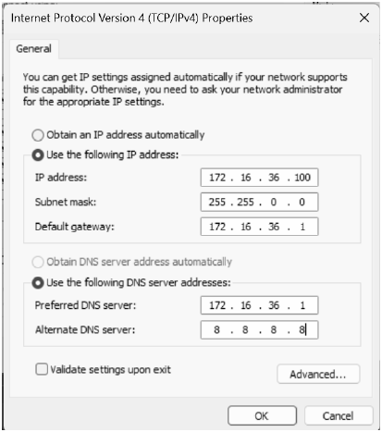
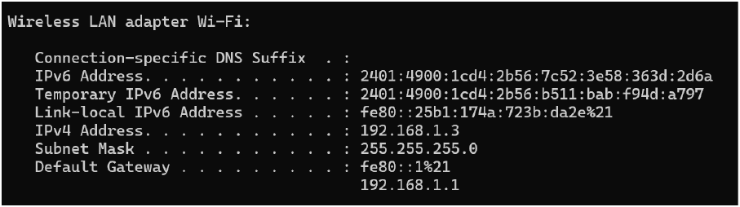
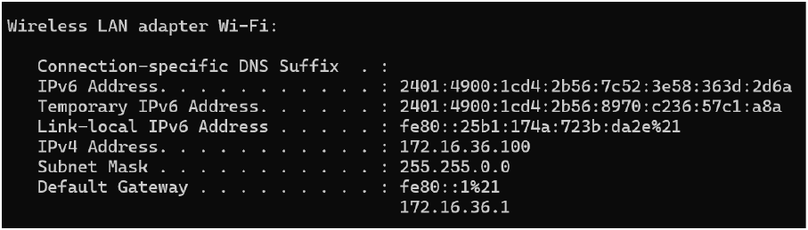
BEFORE:
AFTER:

Result
Thus, the manual IP assignment was completed and validated.
1. What is an IP address?
Answer:
An IP (Internet Protocol) address is a unique numerical identifier assigned to a
device so that it can communicate with other devices on a network.
2. What is the difference between a static IP address and a dynamic IP address?
Answer:
A static IP address is assigned manually and remains fixed, whereas a dynamic
IP address is assigned automatically by a DHCP server and may change over
time.
3. What is a subnet mask?
Answer:
A subnet mask is used to divide an IP address into network and host portions,
helping devices determine whether another device is in the same network.
4. What is the purpose of a default gateway?
Answer:
A default gateway allows a computer to communicate with devices that are
outside its local network, such as the Internet.
5. What happens if two computers are assigned the same IP address?
Answer:
An IP address conflict occurs, causing communication problems and preventing
proper network connectivity.

EXPERIMENT 15
ANALYZE DIFFERENT TYPES OF SERVERS USING WEBALIZER TOOL
TO ANALYZE THE DIFFERENT TYPES OF SERVERS USING
WEBALIZER TOOL

Aim
To install Webalizer and analyze server log files to study server activity and traffic patterns.

Introduction
Webalizer is a web log analysis tool used to generate graphical reports
from server log files. It helps in understanding server activity such as hits, visits,
requested URLs, and client usage. In this experiment, Webalizer is used to
analyze logs from a web server and study how different types of server requests
are handled.

Procedure
1. Update the system using sudo apt update.
2. Install Apache server using sudo apt install apache2 -y.
3. Start Apache with sudo systemctl start apache2.
4. Install Webalizer using sudo apt install webalizer -y.
5. Generate traffic by accessing http://localhost/ or using curl.
6. Create Webalizer output directory:
7. sudo mkdir -p /var/www/html/webalizer
8. Run Webalizer on Apache logs:
sudo webalizer -o /var/www/html/webalizer /var/log/apache2/access.log
9.Open the browser and view the report at: http://localhost/webalizer/

OUTPUT
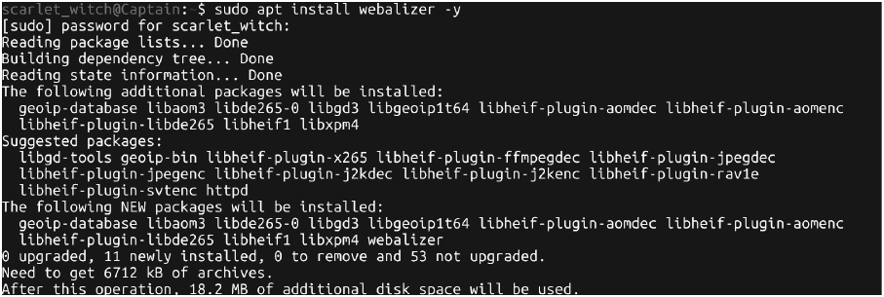
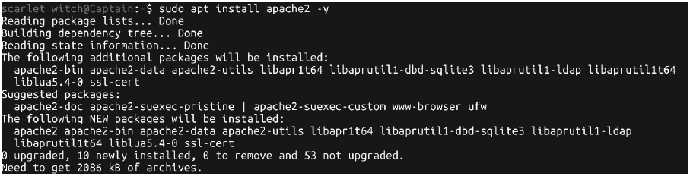
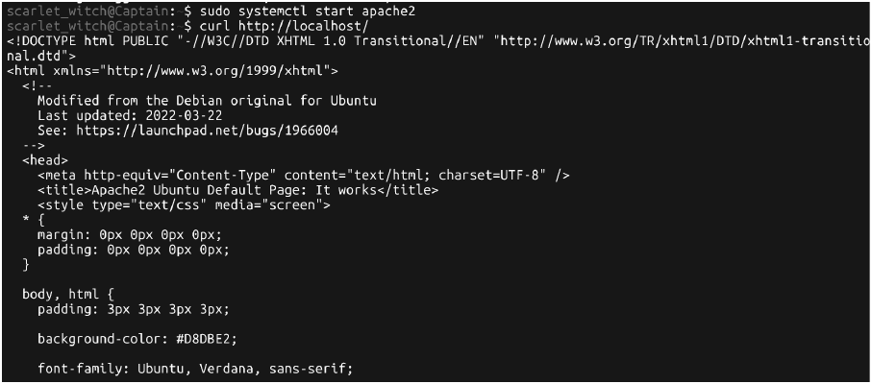
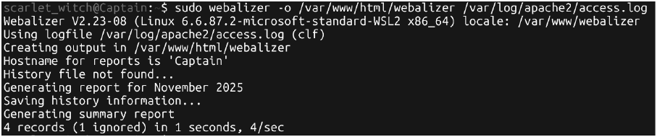
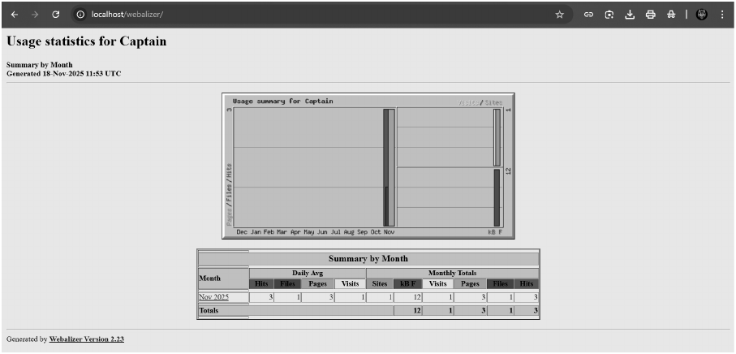
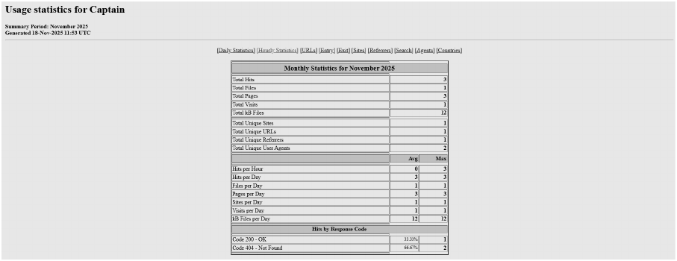
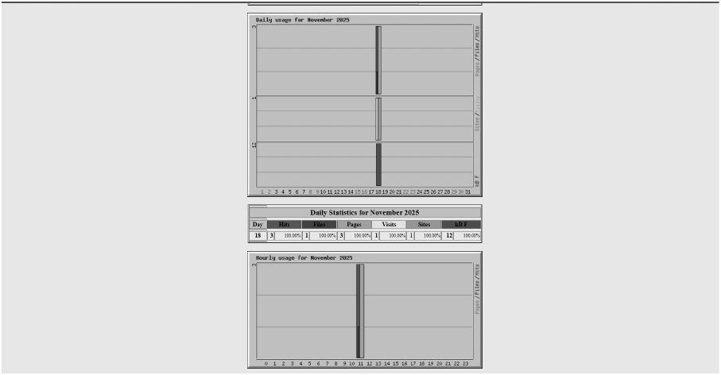
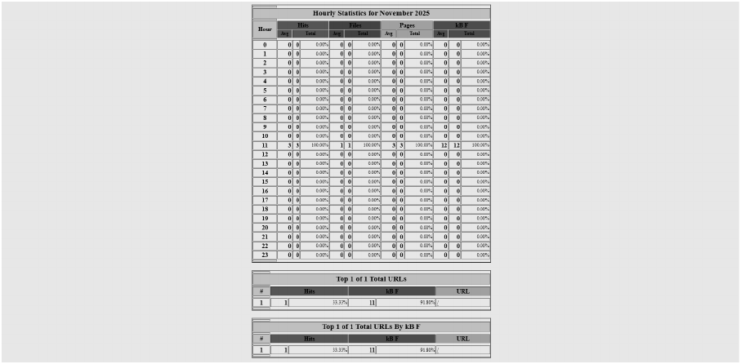
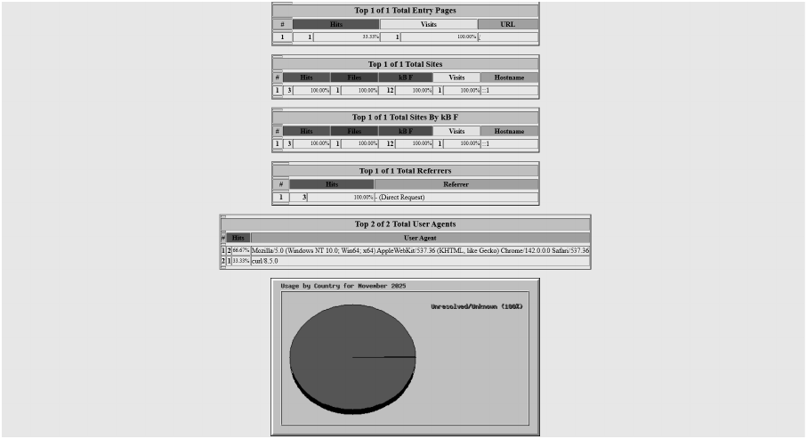

Result
Webalizer was successfully installed and used to analyze the server logs. The generated reports displayed traffic details, server usage, and request statistics.
1. What is Webalizer?
Answer:
Webalizer is a web server log analysis tool that generates graphical and
statistical reports from server log files.
2. What is a server?
Answer:
A server is a computer or software that provides services, resources, or data to
other computers called clients over a network.
3. What is a log file?
Answer:
A log file is a file that records events, activities, and requests occurring on a
server or application.
4. Why is Webalizer used?
Answer:
Webalizer is used to analyze server logs and generate reports about website
traffic, visitors, page views, and resource usage.
5. Name some common types of servers.
Answer:
Some common types of servers are:
- Web Server
- File Server
- Mail Server
- Database Server
- Application Server
- DNS Server

