

YENEPOYA INSTITUTE OF ARTS, SCIENCE, COMMERCE AND MANAGEMENT
YENEPOYA (DEEMED TO BE UNIVERSITY)
BALMATTA, MANGALORE

AN PROJECT REPORT ON
“FINANCIAL TRANSACTION DATA ANALYSIS AND VISUALISATION”

SUBMITTED BY
RUTH SARA SHAJAN
III BCA (Cyber Forensic, Data Analytics and Cyber Security)
22BCACDC60

UNDER THE GUIDANCE OF
Ms. PRATHIKSHA
DEPARTMENT OF COMPUTER SCIENCE

IN PARTIAL FULLFILLMENT OF THE REQUIREMENT FOR THE AWARD OF THE DEGREE OF
BACHELORS IN COMPUTER APPLICATION

April 2025`

CERTIFICATE

This is to certify that the project entitled “Financial Transaction Data Analysis and Visualization” has been successfully carried out in the Graduate Studies and Research in Computer Science by Ruth Sara Shajan (Reg No: 22BCACDC60), student of III BCA (Cyber Forensic, Data Analytics and Cyber Security with IBM), under the supervision and guidance of Ms. Prathiskha.

Internal Guide: Ms. Prathiskha Chairperson:

Internal Examiner: External Examiner:

PRINCIPAL
Prof (Dr.) Arun A.Bhagawath
The Yenepoya Institute of Arts, Science, Commerce and Management
(Deemed to be University)

Submitted for the viva-voice Place: Mangalore



DECLARATION

I RUTH SARA SHAJAN bearing Reg. No. 22BCACDC60 hereby declare that this project report entitled “FINANCIAL TRANSACTION DATA ANALYSIS AND VISUALIZATION” had been prepared by me towards the partial fulfilment of the requirement for the award of the Bachelor of Computer Application at Yenepoya (Deemed to be University) under the guidance of Ms. PRATHISKHA, Department of Computer Science, Yenepoya Institute of Arts, Science, Commerce and Management.

I also declare that this field study report is the result of my own effort and that it has not been submitted to any university for the award of any degree or diploma.

Place: Mangalore Ruth Sara Shajan
Date: III BCA (CF, DA, CS)
22BCACDC60

ACKNOWLDEGMENT

I would like to express my heartfelt gratitude to all those who have contributed to the successful completion of this project.

First and foremost, I extend my sincere thanks to Prof. Dr. Arun Bhagawath, Principal and Dean of Science, for providing me with the opportunity and resources to undertake this project. Your guidance and encouragement have been invaluable throughout this journey.

I am deeply grateful to Dr. Shareena P, Vice Principal, Dr. Jeevan Raj, and Mr. Narayana Sukumar, for their continuous support and motivation, which have inspired me to strive for excellence in my work.

I would also like to express my profound appreciation to Dr. Rathnakar Shetty, Head of the Department of Computer Science, for his insightful suggestions, encouragement, and for fostering an environment conducive to learning and growth.

A special note of gratitude goes to my Internal Guide, Ms. Prathiskha, whose invaluable guidance, constructive feedback, and unwavering support have played a crucial role in the successful completion of this project. Your mentorship has been a source of inspiration throughout this endeavor.

Finally, I thank my family, friends, and peers for their constant encouragement and support, which motivated me to persevere and complete this project to the best of my abilities.

To Internal Guide Ms. Prathiskha

Place: Mangalore
Date: RUTH SARA SHAJAN
III BCA (CF, DA, CS)
22BCACDC60
TABLE OF CONTENTS
SL NO. | TOPIC | PAGE NO.
1. | INTRODUCTION | 8
 | 1.1. OVERVIEW OF THE PROJECT | 8
 | 1.2. OBJECTIVE OF THE PROJECT | 8
 | 1.3. PROJECT CATEGORY | 8
 | 1.4. TOOLS AND PLATFORM TO BE USED | 9
 | 1.5. OVERVIEW OF THE TECHNOLOGIES USED | 9
 | 1.5.1. Hardware Requirements | 9
 | 1.5.2. Software Requirements | 9
 | 1.5.3. Programming Languages | 10
 | 1.6. ORGANIZATION PROFILE | 10
 | 1.7. STRUCTURE OF THE PROGRAM | 10
 | 1.8. STATEMENT OF THE PROBLEM | 11
2. | SOFTWARE REQUIREMENTS SPECIFICATION | 12
 | 2.1. INTRODUCTION | 12
 | 2.1.1. Purpose | 12
 | 2.1.2. Scope Of the Project | 12
 | 2.1.3. Intended Audience and Reading Suggestions | 13
 | 2.1.4. Definitions, Acronyms, And Abbreviations | 13
 | 2.1.5. References | 14
 | 2.1.6. Overview | 14
 | 2.2. OVERALL DESCRIPTION | 14
 | 2.2.1. Product Perspective | 14
 | 2.2.2. Product Features | 15
 | 2.2.3. User Characteristics | 16
 | 2.3. OPERATING ENVIRONMENT | 16
 | 2.3.1. Design And Implementation Constraints | 16
 | 2.3.2. General Constraints | 16
 | 2.3.3. Assumptions And Dependencies | 17
 | 2.4. SPECIFIC REQUIREMENTS | 19
 | 2.4.1. External Interface Requirements | 19
 | 2.4.1.1. User Interface | 19
 | 2.4.1.2. Hardware Interface | 20
 | 2.4.1.3. Software Interface | 21
 | 2.4.1.4. Communication Interface | 22
 | 2.4.2. Functional Requirements | 22
 | 2.4.3. Performance Requirements | 23
 | 2.4.4. Design Constraints | 23
 | 2.4.5. Other Requirements | 24
3. | SYSTEM ANALYSIS AND DESIGN | 25
 | 3.1. INTRODUCTION | 25
 | 3.2. DATA FLOW DIAGRAM | 25
 | 3.3. DATABASE DESIGN | 25
 | 3.3.1. Entity-Relationship Diagram | 25
 | 3.3.2. Table Relationships | 26
 | 3.3.3. Table Descriptions | 26
 | 3.4. SYSTEM DESIGN IMPLEMENTATION | 27
 | 3.4.1. Use Case | 27
 | 3.4.2. Class Diagram | 29
 | 3.4.3. Activity Diagram | 30
 | 3.4.4. Sequence Diagram | 31
 | 3.5. USER INTERFACE DESIGN | 31
4. | TESTING | 33
 | 4.1. INTRODUCTION | 33
 | 4.2. TESTING OBJECTIVE | 33
 | 4.3. TEST CASES | 34
 | 4.3.1. Data Sampling | 34
 | 4.3.2. Data Loading and Preprocessing | 35
 | 4.3.3. Exploratory Data Analysis (EDA) | 35
 | 4.3.8. Visualization Testing | 36
 | 4.3.9. Performance Testing | 36
5. | SYSTEM SECURITY | 38
 | 5.1. INTRODUCTION | 38
 | 5.2. SOFTWARE SECURITY | 38
 | 5.2.1. Secure Data Storage | 38
 | 5.2.2. Access Control | 38
 | 5.2.3. Data Preprocessing Security | 39
 | 5.2.4. Secure Visualisation and Reporting | 39
 | 5.2.5. Vulnerability Management | 39
6. | CONCLUSION | 40
7. | FUTURE ENHANCEMENT | 41
8. | WEEKLY PROGRESS REPORTS | 43
9. | BIBLIOGRAPHY | 53
10. | APPENDIX | 54

LIST OF CHARTS
SL. NO. | CHART | PAGE NO.
1. | Transaction Amounts – Outlier Detection | 50
2. | Total Amount by Transaction Type | 54
3. | Transaction Amount Distribution | 54
4. | Total Transaction Amount Over Time | 55
5. | Average Transaction Amount Over Time | 55
6. | Fraud Rate by Transaction Type | 55
7. | Transaction Volume Over Time | 56
8. | Fraud Rate Over Time | 56
9. | Power BI Dashboard | 56

- INTRODUCTION

  - OVERVIEW OF THE PROJECT
The project titled “Financial Transaction Data Analysis and Visualization” involves a detailed study of mobile money transactions, focusing on detecting anomalies and identifying financial behaviour patterns using Exploratory Data Analysis (EDA). Using a large-scale synthetic dataset from Kaggle (PaySim), this project simulates real-world transaction behaviour. By applying Python-based analysis and interactive visualization techniques, the project aids in uncovering trends, transaction types, and outliers. The product is a comprehensive Power BI dashboard that presents data in an intuitive and interactive way for financial analysts.

  - OBJECTIVE OF THE PROJECT
The main objectives of this project are:
- To conduct in-depth analysis on mobile money transaction data to identify key behavioural patterns among users.
- To detect irregular transaction behaviors that could indicate potential fraud or system misuse.
- To represent transaction metrics visually to facilitate intuitive understanding of financial trends.
- To deliver an interactive Power BI dashboard for dynamic filtering and data exploration by stakeholders.

  - PROJECT CATEGORY
This project is categorized under the Data Analytics domain, with a primary focus on analysing and visualizing financial transaction data. It integrates key concepts from data preprocessing, data exploration, and data visualization to deliver actionable insights. By leveraging these techniques, the project aims to uncover spending trends, detect anomalies, and identify fraudulent activities within financial transaction datasets.

  - TOOLS AND PLATFORM TO BE USED
The project leverages the following tools and platforms to achieve its objectives:
- Data Storage:
AWS S3: Used for storing and managing datasets efficiently.
- Programming Language:
Python: Employed for data processing, exploratory data analysis (EDA), machine learning, and feature engineering.
- Libraries and Frameworks:
- Pandas and NumPy: For efficient data manipulation and preprocessing.
- Seaborn and Plotly: For generating meaningful and interactive data visualizations.
- Visualization Tool:
Power BI: Used to create interactive dashboards for presenting insights to stakeholders.
- Dataset Source:
Kaggle: Datasets sourced from Kaggle.

  - OVERVIEW OF THE TECHNOLOGIES USED
    - HARDWARE REQUIREMENTS
- A machine with a standard processor (e.g., Intel i5 or higher) and at least 8GB of RAM.
- Adequate storage capacity for datasets, requiring approximately 2GB or more.

    - SOFTWARE REQUIREMENTS
- Python 3.x environment: Includes tools like Anaconda or a standalone Python installation for development.
- AWS CLI: Used for seamless interaction with AWS S3 for data storage and retrieval.
- Power BI Desktop: Required for creating interactive dashboards and visualizations.
- Visual Studio Code (VS Code): Used as the primary IDE for development, testing, and experimentation.

    - FRONT-END AND BACK-END PROGRAMMING LANGUAGES
- Front-End:
Power BI is utilized for creating dynamic and interactive visualizations to represent data-driven insights effectively.
- Back-End:
Python is employed for data preprocessing, EDA, and preparing datasets to support visualization efforts.

  - ORGANIZATION PROFILE
This project is a personal/academic initiative and is not affiliated with any specific organization. However, its objectives and methodologies closely align with the operational needs of financial institutions and fintech companies. By focusing on fraud detection and anomaly analysis, the project aims to strengthen financial security and provide valuable insights to mitigate risks associated with financial transactions.

  - STRUCTURE OF THE PROGRAM
- Data Loading and Preprocessing
- Efficiently handle large datasets by sampling to make them manageable for processing.
- Merge multiple datasets into a unified structure for seamless analysis.
- Save the pre-processed data securely to AWS S3, ensuring accessibility and scalability.
- Exploratory Data Analysis (EDA)
- Perform initial EDA on the pre-processed dataset to gain insights into the data.
- Generate meaningful visualizations to explore:
- Spending distributions.
- Transaction volumes.
- Account behaviours and patterns.
- Visualization
- Design interactive dashboards using Power BI to represent insights derived from Exploratory Data Analysis
- Enable stakeholders to understand and interact with trends, anomalies, and fraud predictions visually.
- Final Reports and Deliverables
- Generate comprehensive reports that cover:
- Exploratory Data Analysis (EDA).
- Upload final processed data and visualizations to AWS S3 for easy access and sharing.

  - STATEMENT OF THE PROBLEM
Financial institutions process large volumes of transactions daily, making it increasingly difficult to detect fraudulent activities, identify anomalies, and analyse spending patterns. Traditional methods often struggle to handle such massive and complex datasets efficiently.
This project seeks to overcome these challenges by:
- Leveraging machine learning models: Enhancing fraud detection and anomaly analysis capabilities through advanced algorithms.
- Creating detailed visualizations: Empowering financial analysts to better understand and interpret transaction data through insightful, interactive dashboards.
- Utilizing scalable storage solutions: Employing AWS S3 to efficiently store and manage large-scale datasets, ensuring accessibility and reliability.
By combining these approaches, the project aims to improve financial security and streamline data analysis in high-volume transaction environments.

- SOFTWARE REQUIREMENTS SPECIFICATION

  - INTRODUCTION
    - PURPOSE
This document serves to define the software requirements for the Financial Transaction Data Analysis and Visualization project. It outlines the system's functionalities, constraints, and performance specifications, ensuring that the requirements are well-documented and aligned with the project’s objectives. By providing this clarity, the document ensures all stakeholders are on the same page regarding the scope and purpose of the project.

    - SCOPE OF THE PROJECT
This project focuses on the analysis and visualization of mobile financial transaction data using exploratory data techniques. The aim is to uncover meaningful trends, anomalies, and fraud indicators without employing machine learning models. The following key areas are included in the project scope:
- Data Sampling: Random selection of 10,000 records from a large dataset of over 6 million transactions to make analysis feasible and efficient.
- Data Preprocessing: Cleaning the dataset by removing duplicates, handling missing values using appropriate strategies (median/mode), converting data types, encoding categorical variables, and eliminating personally identifiable information such as user IDs.
- Exploratory Data Analysis (EDA): Conducting detailed analysis on transaction attributes such as transaction type, time, and amount to uncover patterns and potential irregularities using descriptive statistics and visual methods.
- Visualization with Plotly: Generating dynamic and interactive visualizations such as time-based trends, transaction breakdowns, and fraud flags using Python libraries.
- Dashboard Development: Creating a comprehensive and interactive dashboard using Power BI, enabling users to filter data by transaction type, amount range, time step, and fraud status for easy exploration.
The project’s deliverables are designed to support analysts and stakeholders in visualizing and understanding financial patterns, thereby aiding in identifying potential fraud scenarios and making data-driven decisions.

    - INTENDED AUDIENCE AND READING SUGGESTIONS
Audience:
- Financial Analysts and Domain Experts: Professionals interested in using visual insights to understand transaction behaviour and identify potential anomalies without relying on complex models.
- Academic Evaluators and Faculty: Reviewers who assess analytical skills and technical understanding of data visualization and processing.
- Students and Beginner Analysts: Individuals seeking practical exposure to EDA techniques, AWS integration, and Power BI dashboarding in the context of financial datasets.
Reading Suggestions:
- Section 2.2: Provides an overview of the product features and user characteristics.
- Section 2.4: Contains detailed information on specific requirements and technical aspects of the project.

    - DEFINITIONS, ACRONYMS, AND ABBREVIATIONS
EDA | Exploratory Data Analysis
AWS S3 | Amazon Web Services Simple Storage Service
CSV | Comma-Separated Values
KPI | Key Performance Indicator
Power BI | A business analytics tool used for data visualization.

    - REFERENCES
- Kaggle Dataset: PaySim Dataset
- AWS Documentation: Amazon S3
- Python Libraries: Pandas, Seaborn, Plotly.

    - OVERVIEW
This document provides a comprehensive outline of the project, detailing its purpose, scope, and technical requirements. It includes the following key aspects:
- Functional, performance, and design constraints: Clearly defining the limitations and expectations of the system.
- System architecture: Offering a detailed description of the system’s structure and components.
- Operating environment: Specifying the platforms and conditions under which the system will function.
By addressing these elements, this document serves as a guide for stakeholders to understand the project’s objectives and implementation framework.

  - OVERALL DESCRIPTION
    - PRODUCT PERSPECTIVE
The system is designed as a standalone data analytics tool focused on performing in-depth exploratory data analysis on financial transactions. It provides a complete pipeline from data ingestion to dashboard delivery, without depending on third-party modelling tools or machine learning libraries. The goal is to help users detect trends and possible irregularities purely through visual exploration and descriptive analytics. Key components include:
- Data Sampling: Efficiently handling massive datasets by extracting a manageable, statistically representative subset.
- Data Preprocessing: Cleaning, formatting, encoding, and ensuring privacy by removing identifiers.
- EDA with Python: Using tools like Plotly and Pandas to generate interactive visual insights.
- Dashboard Development: Summarizing insights using a Power BI interface for ease of interpretation by end-users.
This comprehensive structure enables financial analysts to extract meaningful patterns from transactional data with minimal technical overhead.

    - PRODUCT FEATURES
- Data Loading and Preprocessing:
Seamless data loading from CSV files, followed by preprocessing steps such as null handling, duplicate removal, encoding categorical variables, and dropping sensitive fields like user IDs.
- Exploratory Data Analysis (EDA):
Deep dive into trends in transaction types, hourly activity (step feature), transaction amounts, and fraud labels. Statistical summaries and visual plots are used to highlight abnormalities.
- Visualization using Plotly:
Interactive HTML-based plots (line, scatter, bar) created using Plotly for flexible, detailed visual exploration.
- Data Upload to AWS S3:
Ensures secure access and remote sharing of processed data and visual reports using AWS cloud storage.
- Interactive Dashboards in Power BI:
A final user-facing dashboard that enables filtering by transaction type, time, amount, and fraud flag status, allowing stakeholders to interact with the dataset dynamically and spot critical insights efficiently. Product Features:
- Efficient handling and sampling of large CSV datasets.
- Data cleaning: Duplicate removal, null value treatment, and type conversion.
- Conversion of categorical transaction types to encoded form for analysis.
- Trend and distribution plots that expose irregular patterns.
- Upload of processed data and visualizations to AWS S3 for easy access and sharing.
- Interactive filtering options on Power BI for real-time data exploration.

    - USER CHARACTERISTICS
- Basic Knowledge of Financial Data Analysis:
Users should have a foundational understanding of financial concepts and transaction data to effectively interpret insights.
- Familiarity with Data Visualization Tools:
Experience with tools like Power BI can enhance the user experience but is not mandatory.
- No Advanced Programming Skills Needed:
The final deliverables, such as dashboards, are designed to be user-friendly and do not require technical coding expertise.

  - OPERATING ENVIRONMENT
    - DESIGN AND IMPLEMENTATION CONSTRAINTS
- Efficient Handling of Large Datasets:
The system must be capable of processing datasets exceeding 1GB in size while maintaining high performance and low latency.
- Python 3.x Compatibility:
All data processing scripts must adhere to Python 3.x standards to ensure compatibility, scalability, and ease of maintenance.
- Interactive and Intuitive Visualizations:
Visual outputs should be designed using Power BI, ensuring they are interactive, user-friendly, and easy to interpret for financial analysts.

    - GENERAL CONSTRAINTS
- Internet Connectivity:
- The system requires a stable internet connection to access external services such as AWS S3 for data storage and retrieval, as well as Power BI for generating and displaying interactive dashboards.
- Limited or unreliable connectivity may result in delays or restricted functionality.

- Hardware Requirements:
- The system is designed to operate on commonly available hardware with the following minimum specifications:
- 8GB RAM to ensure smooth data processing and model execution.
- A multi-core processor (e.g., Intel i5 or equivalent) to handle computational tasks efficiently.
- At least 50GB of free disk space to store datasets, intermediate files, and logs.
- While the system can run on lower specifications, performance might degrade with larger datasets or complex computations.
- Software Dependencies:
- The system relies on a modern operating system supporting Python 3.x and associated libraries for data processing and machine learning.
- Users must install specific software tools, such as Power BI Desktop, to fully utilize the visualization features.
- Scalability Limitations:
- The system is optimized for datasets up to 1GB in size. Larger datasets may require additional hardware resources or modifications to the pipeline for optimal performance.
- User Environment:
- The system assumes that users are working in a controlled environment with access to the required software, hardware, and permissions for external services like AWS and Power BI.

    - ASSUMPTIONS AND DEPENDENCIES
- Input Data Format:
- The system assumes that all input datasets are provided in either CSV or JSON format. Other formats may require pre-processing or conversion before being used in the system.
- AWS S3 Availability:
- The system relies on AWS S3 for data storage and retrieval.
- Proper permissions and credentials must be configured to ensure seamless access.
- Network disruptions or S3 service outages may impact system functionality.
- Power BI Desktop Requirement:
- Power BI Desktop must be installed and available to create, view, and interact with the dashboards.
- Users must ensure that Power BI is updated to the latest version for compatibility.
- For sharing dashboards, access to Power BI Service may be required.
- Operating System Compatibility:
- The system is designed to run on major operating systems such as Windows, macOS, and Linux.
- Users should ensure that their operating system is up-to-date and compatible with the required software dependencies.
- Python Environment:
- A properly configured Python 3.x environment is essential for running data processing scripts.
- Key libraries such as pandas, NumPy, seaborn and Plotly must be installed.
- A virtual environment is recommended to avoid dependency conflicts.
- Security and Privacy:
- All data transmitted between the system and AWS S3 must be encrypted to protect sensitive information.
- Users should ensure compliance with data privacy regulations, such as GDPR or CCPA, depending on their region.
- Hardware Requirements:
- While the system is optimized for commonly available hardware with 8GB RAM, better performance can be achieved with higher specifications such as 16GB RAM and SSD storage.

- Scalability:
- The system assumes datasets up to 1GB in size. For larger datasets, additional resources or distributed processing frameworks like Apache Spark may be required.
- User Training and Knowledge:
- Users are expected to have a basic understanding of financial data analysis and familiarity with visualization tools like Power BI.
- No advanced programming skills are required to interact with the final deliverables.
- External Dependencies:
- The system depends on reliable internet connectivity for accessing AWS S3 and Power BI services.
- Any interruptions in these services may impact the availability and functionality of the system.

  - SPECIFIC REQUIREMENTS
    - EXTERNAL INTERFACE REQUIREMENTS
      - USER INTERFACE
The user interface is centred around Power BI dashboards, designed to provide an intuitive and interactive experience for users:
- Key Features:
- Visualization of Trends: Dashboards will display key financial and operational trends over time to help users identify patterns and make informed decisions.
- Anomaly Detection Insights: Highlight irregularities in datasets, enabling users to quickly identify outliers or unusual behaviours
- Fraud Detection Results: Provide clear and actionable insights into potentially fraudulent activities, with supporting data for further investigation.
- Interactivity:
- Users can interact with visuals through filtering, sorting, and drill-down capabilities to explore data at various levels of granularity.
- Dashboards will support real-time updates for dynamic data exploration.
- Ease of Use:
- Designed with a clean and user-friendly layout, ensuring that users without technical expertise can easily interpret and use the visualizations.
- Tooltips, legends, and labels will enhance usability by offering additional context for the displayed data.
- Customization:
- Users can customize views and filters to suit their specific analytical needs.
- Options to export data or visuals for reporting purposes will also be available.

      - HARDWARE INTERFACE
The system is designed to operate efficiently on standard computing hardware. The recommended specifications are as follows:
- Memory (RAM):
- A minimum of 8GB RAM is required to handle data processing tasks effectively.
- For enhanced performance, particularly with larger datasets, 16GB RAM or more is recommended.
- Storage:
- Adequate storage is necessary to accommodate datasets, intermediate files, and visualization outputs.
- It is recommended to have at least 50GB of free disk space for smooth operation, with SSD storage preferred for faster read/write speeds.
- Processor:
- A multi-core processor (e.g., Intel i5 or equivalent) is recommended for efficient task execution.
- Higher-end processors may further improve performance, especially for compute-intensive operations.
- Graphics (Optional):
- While not mandatory, systems with a dedicated GPU may benefit from faster data visualization and computational tasks, especially when working with large datasets or advanced visualizations.
- Connectivity:
- A stable internet connection is required for accessing external services such as AWS S3 and Power BI.
- Compatibility:
- The system is compatible with major operating systems, including Windows, macOS, and Linux.

      - SOFTWARE INTERFACE
The system requires the following software components to function effectively:
- Python 3.x Environment:
- A properly configured Python 3.x environment is essential.
- The following libraries must be installed:
- Pandas: For data manipulation and analysis.
- NumPy: For numerical computations.
- Additional libraries may include Matplotlib, Seaborn, Plotly for visualization and advanced analytics.
- AWS CLI (Command Line Interface):
- The system relies on AWS CLI to interact with AWS S3 for data storage and retrieval.
- Proper configuration of AWS credentials is required to ensure seamless access to S3 buckets.
- Power BI Desktop:
- Power BI Desktop must be installed to create, view, and interact with dashboards.
- Users should ensure that Power BI is updated to the latest version for compatibility and optimal performance.
- Optional Tools:
- Jupyter Notebook or VS Code: For easier script development and testing.
- Anaconda: For managing the Python environment and dependencies conveniently.

      - COMMUNICATION INTERFACE
The system communicates with AWS S3 to upload and download datasets, utilizing either the AWS CLI or Python libraries such as boto3 for secure and efficient data transfer.

    - FUNCTIONAL REQUIREMENTS
- Data Sampling and Preprocessing
- The system should perform random sampling from large datasets to ensure manageable processing time while maintaining data representativeness.
- It must clean the data by removing duplicates, filling missing values using appropriate strategies, and converting data types for consistency.
- Sensitive columns such as anonymized user identifiers (e.g., nameOrig, nameDest) must be dropped to ensure privacy.
- The cleaned dataset should be securely stored back in AWS S3.
- Exploratory Data Analysis (EDA) Visualizations
- The system should generate meaningful and visually appealing EDA charts using Plotly and Seaborn. These charts include time series plots, bar graphs, and distribution plots.
- Key features to analyse include transaction amount, step (hour), transaction type, and fraud flag.
- All EDA plots must be exported as standalone HTML files and uploaded to AWS S3 for remote access and sharing.
- Interactive Dashboard Development
- A Power BI dashboard must be created using the cleaned dataset to allow users to explore data interactively.
- The dashboard should feature filters for transaction type, amount, fraud status, and step range.
- It should include KPIs such as total transactions, fraudulent transaction count, and total volume processed.
- Secure Data Management
- All files including raw, cleaned, and visualizations must be encrypted and stored in AWS S3 with restricted access.
- Scripts must be version-controlled and documented for reproducibility and future updates.

    - PERFORMANCE REQUIREMENTS
- Data Preprocessing
- The system must preprocess datasets efficiently, completing the task within a reasonable timeframe.
- For datasets under 1GB, preprocessing should take no longer than 5 minutes under normal operating conditions.
- Visualization Rendering
- Visualizations, including EDA outputs and dashboards, should render quickly without noticeable delays.
- The system should ensure smooth user interaction, with most visualizations loading in under 2 seconds for typical datasets.

    - DESIGN CONSTRAINTS
- Modular Design
- The system architecture must follow a modular approach, with separate scripts or components for each critical function:
- Sampling and Preprocessing Module: For cleaning and preparing raw datasets.
- EDA Module: For generating exploratory data analysis visualizations.
- Visualization Export Module: For exporting and managing HTML plot files.
- Dashboard Module: For building and publishing dashboards using Power BI.
- This design structure ensures the maintainability, scalability, and ease of debugging throughout the development lifecycle.
- User-Friendly Dashboards
- The final Power BI dashboards must be intuitive and accessible, designed with both technical and non-technical users in mind.
- Users should be able to interpret key metrics and filter the data interactively without prior training.
- Clear visualizations, concise labels, and a structured layout must be used to enhance readability and navigation.

    - OTHER REQUIREMENTS
- Data Integrity
- The system must ensure the integrity of the original datasets and avoid any unintentional modifications.
- Raw datasets should remain untouched and be stored securely, with changes applied only to copies used for preprocessing and analysis.
- Documentation
- Comprehensive documentation should be provided for all scripts, processes, and workflows.
- This documentation should include clear instructions, code explanations, and usage guidelines, enabling easy understanding and reproducibility for users.

- SYSTEM ANALYSIS AND DESIGN

  - INTRODUCTION
This section provides a comprehensive overview of the system's analysis and design, focusing on the Python-based implementation of financial transaction data analysis. The system is designed to efficiently handle large transaction datasets, detect anomalies, and analyse spending patterns using advanced machine learning models and feature engineering techniques. The design emphasizes scalability to support growing data volumes and adaptability to accommodate diverse dataset formats and structures, ensuring robust and reliable performance.

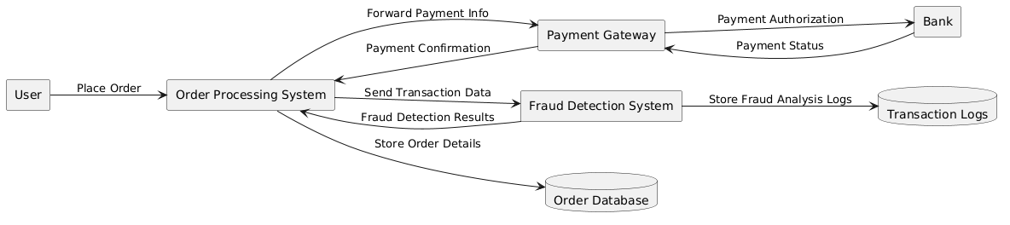
  - DATA FLOW DIAGRAM

  - DATABASE DESIGN
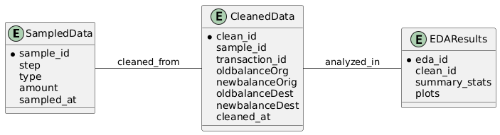
    - ENTITY-RELATIONSHIP DIAGRAM

    - TABLE RELATIONSHIPS
The system's database follows a flat, single-table structure derived from the cleaned dataset (data_cleaned.csv). As such, it does not contain explicit relational mappings like foreign keys, but the following conceptual associations can be inferred:
- Transactions Table:
- Primary Key: Each transaction is uniquely identified by the combination of features such as step, amount, and account balances.
- Includes all relevant transactional data including fraud indicators, transaction amount, balances, and one-hot encoded transaction types.
- Internal Associations:
- The type of column in the raw dataset is one-hot encoded into binary features (type_CASH_OUT, type_DEBIT, etc.) during preprocessing.
- isFraud and isFlaggedFraud columns provide binary classification labels for fraud detection.
- Removed Identifiers:
- Columns nameOrig and nameDest were dropped during data cleaning to ensure privacy and simplify analysis.
- Data Preparation and Visualization Integration:
- Cleaned data serves as input for both EDA and Power BI dashboards.
- Fields like step, amount, isFraud, and type_* are used to generate insights and KPIs in the dashboard.

    - TABLE DESCRIPTIONS
Each table is described below with its attributes:
- Transactions Table (Sampled):
This is the original raw dataset sampled from the PaySim dataset.
- step (int): Represents the hour of the transaction.
- type (object): Transaction type — e.g., CASH_IN, CASH_OUT, TRANSFER.
- amount (float): Monetary value of the transaction.
- nameOrig (object): Anonymized sender account.
- oldbalanceOrg (float): Balance of the sender before the transaction.
- newbalanceOrig (float): Balance of the sender after the transaction.
- nameDest (object): Anonymized receiver account.
- oldbalanceDest (float): Balance of the receiver before the transaction.
- newbalanceDest (float): Balance of the receiver after the transaction.
- isFraud (int): 1 if the transaction was fraudulent.
- isFlaggedFraud (int): 1 if flagged by the system.
- Cleaned Transactions Table:
This is the transformed version after preprocessing.
- step (int): Hour of the transaction.
- amount (float): Monetary value of the transaction.
- oldbalanceOrg / newbalanceOrig: Sender balance before/after.
- oldbalanceDest / newbalanceDest: Receiver balance before/after.
- isFraud / isFlaggedFraud: Fraud labels.
- type_CASH_OUT, type_DEBIT, type_PAYMENT, type_TRANSFER (bool): One-hot encoded columns for transaction type.

  - SYSTEM DESIGN IMPLEMENTATION
    - USE CASE
The Use Case Diagram highlights the key interactions between the User, System, and Administrator. It emphasizes the functionalities provided and how these actors interact with the system to achieve its goals.
- Actors and Their Use Cases
- User
The User is the primary actor and interacts with the system to:
- Upload transaction data (e.g., CSV files).
- Trigger data preprocessing and feature engineering.
- Explore spending trends through visual reports and insights.
- Review detected anomalies in transaction data.
- Evaluate fraud detection outcomes and model performance (e.g., precision, recall, ROC curve).
- System
The System is the primary processor and automates the following tasks:
- Process and clean uploaded transaction data.
- Normalize and analyse spending patterns over time.
- Provide actionable visualizations and reports for user insights.
- Administrator
The Administrator ensures smooth and secure system operations by:
- Monitoring system logs and addressing issues.
- Maintaining data integrity and security throughout the data processing pipeline.
- System Goals
The system is designed to:
- Provide actionable insights into financial transactions.
- Help users efficiently identify anomalies and potential fraud.
- Deliver clear and intuitive visualizations and reports to enhance decision-making.

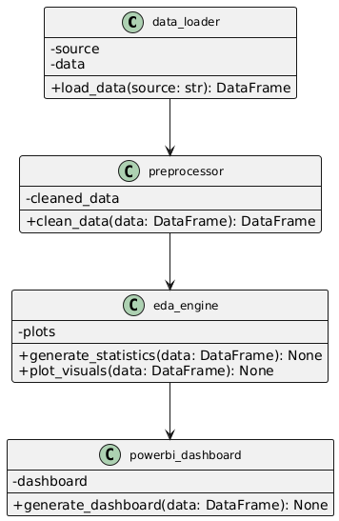
    - CLASS DIAGRAM

    - ACTIVITY DIAGRAM
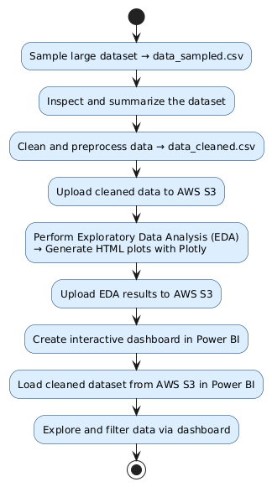

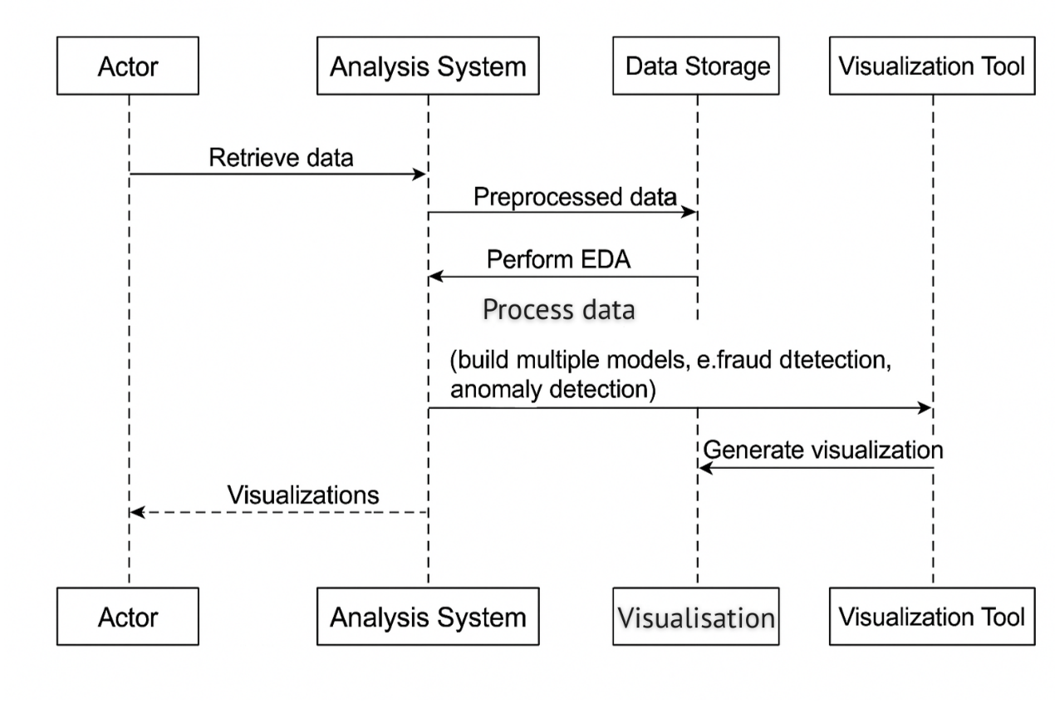
    - SEQUENCE DIAGRAM

  - USER INTERFACE DESIGN
The User Interface (UI) is designed to simplify the exploration of financial transaction data through dynamic and easy-to-use visualizations. Interactive tools were developed using Python (Plotly) for initial EDA and Power BI for comprehensive dashboard presentation. The UI elements focus on fraud analysis, transaction trends, and filtering capabilities.
- Transaction Amounts – Outlier Detection
- Visualization Type: Box/Strip Plot
- Purpose: Identify outliers in transaction amounts to detect unusually high values, which may indicate errors or suspicious activity.
- Total Amount by Transaction Type
- Visualization Type: Bar Chart
- Purpose: Compare the total monetary volume for each transaction type to see which types handle the largest amounts.
- Transaction Amount Distribution: Fraud vs Non-Fraud
- Visualization Type: Histogram (Grouped by Fraud Status)
- Purpose: Visualize how transaction amounts differ between fraudulent and non-fraudulent transactions, helping to identify patterns.
- Total Transaction Amount Over Time
- Visualization Type: Line Chart
- Purpose: Track the sum of all transaction amounts at each time step to spot spikes or unusual activity.
- Average Transaction Amount Over Time
- Visualization Type: Line Chart
- Purpose: Show how the average transaction amount fluctuates over time, potentially revealing changes in user behaviour or fraudulent periods.
- Fraud Rate by Transaction Type
- Visualization Type: Bar Chart
- Purpose: Display the proportion of fraudulent transactions per transaction type, highlighting more vulnerable types.
- Transaction Volume Over Time
- Visualization Type: Line Chart
- Purpose: Monitor the number of transactions per time step to identify periods of high or low activity.
- Fraud Rate Over Time
- Visualization Type: Line Chart
- Purpose: Observe how the rate of fraud changes over time to detect unusual spikes or trends.
- Power BI Dashboard Features
- Filters: Select step range, transaction type, amount range, and fraud/suspicion status for custom views.
- KPIs: Total transactions, total amount, fraud transactions, and flagged suspicious transactions.
- Trends & Patterns:
- Transaction amounts over time by type
- Distribution of amounts by type and fraud status
- Transaction counts and fraud rates by type
- Summary Table: Key figures for transaction types and fraud cases.
- TESTING

  - INTRODUCTION
The testing phase was a critical step in validating the functionality, performance, and usability of the system. Rigorous testing methodologies were employed, including unit testing, integration testing, and end-to-end testing, to ensure that all components function as intended and work together seamlessly. This phase focused on:
- Data Accuracy: Verifying the correctness of data preprocessing, feature engineering, and machine learning model outputs.
- System Integration: Ensuring smooth interaction between AWS S3 for data storage, Python scripts for processing and modelling, and Power BI dashboards for visualization.
- Error Resolution: Detecting and addressing any errors or inconsistencies in data handling and model performance.
By addressing these key focus areas, the system aims to deliver reliable and actionable insights while maintaining high standards of efficiency and user experience.

  - TESTING OBJECTIVE
The testing phase was guided by the following key objectives:
- Data Integrity:
- Ensure that datasets loaded from AWS S3 (and locally) are processed and saved without corruption, inconsistency, or loss of information.
- Data Cleaning Validation:
- Verify that data cleaning steps (removal of duplicates, handling of missing values, correct data types, encoding of categorical variables, and dropping sensitive columns) were performed accurately and consistently.
- EDA Output Verification:
- Confirm that summary statistics, distributions, and other descriptive analyses (counts, means, etc.) accurately reflect the underlying data after preprocessing.
- Visualization Accuracy:
- Ensure that all visualizations (line charts, bar charts, histograms, etc.) correctly represent the cleaned dataset, accurately display trends, distributions, and patterns, and are free from errors or misleading representations.
- Dashboard Functionality:
- Test the Power BI dashboard to verify that interactive filters, KPIs, charts, and tables update correctly and provide accurate, actionable insights for users.
- System Scalability (Sampling):
- Validate that the sampling approach used enables efficient analysis and visualization, while maintaining the representativeness of the data and ensuring responsiveness of scripts and dashboards.

  - TEST CASES
    - DATA SAMPLING
- Objective:
Verify that the large PaySim dataset (data.csv) is correctly sampled, reducing size for analysis without significant loss of information.
- Test Steps:
- Load the original dataset (data.csv).
- Apply random sampling to select 10,000 rows and save as data_sampled.csv.
- Compare summary statistics (mean, median, variance, distributions) for key variables (e.g., amount, isFraud) between original and sampled datasets.
- Expected Results:
The sampled dataset should retain similar overall statistical properties as the full dataset.
- Actual Results:
Test Passed – Sampled dataset closely matched the original in key statistics and distribution patterns.

    - DATA LOADING AND PREPROCESSING
- Objective:
Ensure the sampled dataset is correctly loaded, cleaned, and pre-processed for analysis.
- Test Steps:
- Load data_sampled.csv from AWS S3.
- Perform data cleaning and preprocessing:
  - Remove duplicates
  - Handle missing values (median for numeric, mode for categorical)
  - Correct data types
  - One-hot encode 'type' column
  - Drop sensitive columns (nameOrig, nameDest)
- Save the cleaned data as data_cleaned.csv (locally and in S3).
- Expected Results:
Cleaned dataset should have no missing values or duplicates, correct data types, and all sensitive columns removed.
- Actual Results:
Test Passed – Data was cleaned successfully, all requirements met.

    - EXPLORATORY DATA ANALYSIS (EDA)
- Objective:
Validate that EDA scripts generate accurate and insightful visualizations.
- Test Steps:
- Load data_cleaned.csv from AWS S3.
- Generate a series of interactive visualizations using Plotly, including:
  - Transaction volume over time
  - Total and average transaction amount over time
  - Transaction type distribution
  - Fraud rate by type and over time
- Save plots locally and upload to S3.

- Expected Results:
Visualizations should accurately reflect trends and distributions in the cleaned data.
- Actual Results:
Test Passed – Visualizations were accurate, interpretable, and matched data expectations.

    - VISUALIZATION TESTING
- Objective:
Ensure that Power BI dashboards accurately reflect the processed datasets and provide meaningful, interactive insights.
- Test Steps:
- Load data_cleaned.csv into Power BI.
- Build dashboard elements:
- KPI cards for total transactions, amount, fraud count
- Filters for step, transaction type, amount, and fraud
- Charts for trends, distributions, and fraud rates
- Summary table
- Verify interactivity and accuracy by cross-checking with source data.
- Expected Results:
Dashboard should be fully interactive and accurately display all key insights.
- Actual Results:
Test Passed – Dashboard was interactive, and all metrics/charts accurately reflected the underlying dataset.

    - PERFORMANCE TESTING
- Objective:
Ensure the workflow remains efficient and responsive even with large datasets by using sampling.
- Test Steps:
- Attempt to load and analyse a large subset of the original data (prior to sampling).
- Measure script execution time and system responsiveness before and after sampling.
- Confirm that analysis and visualization remain feasible after sampling.
- Expected Results:
System should handle sampled data efficiently; sampling should resolve any performance bottlenecks.
- Actual Results:
Test Passed – Sampling enabled efficient analysis and visualization, with no performance issues encountered.

- SYSTEM SECURITY

  - INTRODUCTION
In this project, system security is essential for ensuring the integrity and confidentiality of financial transaction data throughout its lifecycle. From sourcing the dataset to performing analysis and uploading processed results to AWS S3, protecting sensitive information is critical in preventing unauthorized access, data breaches, and potential misuse.
The security measures implemented in this project focus on safeguarding data at every stage, including storage, preprocessing, analysis, and visualization. These measures ensure compliance with best practices while enabling secure collaboration and scalable data processing.

  - SOFTWARE SECURITY
To ensure the secure handling of data and software components throughout the project, several key measures were implemented. These measures focus on safeguarding sensitive data, maintaining system integrity, and mitigating potential vulnerabilities at every stage of the pipeline

    - SECURE DATA STORAGE
- All datasets, including raw, processed, and feature-engineered files, are securely stored in an AWS S3 bucket with access control policies to restrict unauthorized access.
- Data is encrypted both in transit (using HTTPS) and at rest (using AWS S3 server-side encryption).

    - ACCESS CONTROL
- Role-based access control (RBAC) is implemented in AWS to ensure that only authorized users can access or modify the datasets.
- Temporary access tokens are used for secure and time-limited access during data processing workflows.

    - DATA PREPROCESSING SECURITY
- During preprocessing, the data is sampled and merged securely using tools like Pandas and Python scripts stored in a version-controlled repository.
- Sensitive data attributes are anonymized or masked as necessary to prevent potential misuse.

    - SECURE VISUALISATION AND REPORTING
- EDA visualizations and model outputs are saved securely in the project directory and uploaded to AWS S3 for controlled access.
- Final interactive dashboards are hosted on Power BI, with access restricted to financial analysts through secure sharing mechanisms.

    - VULNERABILITY MANAGEMENT
- Regular updates to Python libraries such as Pandas, Scikit-learn, and Plotly are applied to mitigate known vulnerabilities.
- Dependencies are scanned for vulnerabilities using tools like pip-audit.

- CONCLUSION

This project successfully demonstrates a complete data analytics pipeline for financial transaction data using industry-standard tools and best practices in data analysis and visualization. By leveraging AWS S3 for scalable data storage, thorough data cleaning and sampling, and interactive visualization with both Python (Plotly) and Power BI, the analysis uncovers key insights into transaction patterns, trends, and fraud occurrences.
The project showcases the effectiveness of exploratory data analysis (EDA) in revealing important behavioural and risk patterns within financial datasets. The Power BI dashboard provides an accessible, user-friendly interface for exploring critical metrics, trends, and anomalies, supporting data-driven decision making for financial analysts and stakeholders.
Key takeaways include the importance of careful data preparation, the value of visual analytics for uncovering hidden patterns, and the necessity of efficient workflows (such as sampling) when working with large-scale datasets. Future work could involve integrating real-time data sources or expanding the set of interactive dashboard features to further enhance usability and insight discovery.
This work establishes a strong foundation for ongoing financial analytics and supports the ongoing goal of improving transparency, risk detection, and operational efficiency within financial transaction systems.

- FUTURE ENHANCEMENT

Although the project has successfully achieved its primary objectives, there is significant potential to enhance its functionality, scalability, and impact. The following enhancements are proposed to further improve the system:
- REAL-TIME ANALYSIS
- Real-Time Data Streaming: Incorporate tools such as Apache Kafka or AWS Kinesis to enable real-time data ingestion and processing, allowing for immediate detection of anomalies and fraud.
- Live Monitoring: Implement live dashboards that refresh automatically, providing up-to-date insights into financial transactions.

- ADVANCED FRAUD DETECTION
- Deep Learning Models: Integrate sequential models like Long Short-Term Memory (LSTM) networks to better analyse patterns in transaction sequences and improve fraud detection accuracy.
- External Data Integration: Use additional datasets, such as demographic or geolocation data, to enhance the robustness and contextual understanding of the fraud detection models.

- INTEGRATION WITH BANKING SYSTEMS
- API Development: Create secure Application Programming Interfaces (APIs) to connect the system with core banking platforms, enabling seamless fraud alerts and anomaly notifications.
- Real-Time Alerts: Develop alert systems that notify banking personnel of suspicious transactions as they occur.

- ENHANCED DASHBOARDS
- Predictive Analytics: Add predictive analytics capabilities to Power BI dashboards to forecast transaction trends and potential fraud risks.
- Improved Interactivity: Include dynamic filtering and drill-down capabilities to allow financial analysts to explore data more effectively.

- USER BEHAVIOUR ANALYSIS
- Customer Segmentation: Use clustering algorithms to segment customers based on their spending patterns and behaviour, enabling targeted marketing and risk profiling.
- Behavioural Anomaly Detection: Identify unusual account activities by comparing user behaviour against historical patterns.

- DATA PRIVACY AND SECURITY
- Advanced Encryption: Implement cutting-edge encryption techniques for both data storage and transmission to ensure maximum security.
- Regulatory Compliance: Adapt the system to comply with data protection regulations such as GDPR, HIPAA, and CCPA.

- SCALABIILITY
- Data Lake Architecture: Transition to a data lake architecture to support the storage and analysis of larger datasets.
- Distributed Computing: Leverage distributed frameworks like Apache Spark or Dask to accelerate data processing and improve scalability for growing datasets.

- CROSS – DOMAIN APPLICATIONS
- Healthcare and Insurance: Adapt the system for use cases such as healthcare fraud detection or insurance claims analysis.
- E-Commerce: Extend anomaly detection capabilities to detect fraudulent activities in e-commerce transactions, such as fake reviews or payment fraud.

- WEEKLY PROGRESS REPORTS

WEEKLY PROJECT PROGRESS REPORT (WPPR)– 1
For week commencing 3 March 2025
Programme: BCA(Cyber Forensic, Data Analytics & Cyber Security)
Student Name: Ruth Sara Shajan Register Number: 22BCACDC60
WPPR: 1
Internal Guide’s Name: Ms. Prathiskha
MAJOR PROJECT Title:
Financial Transaction Data Analysis and Visualization
Targets set for the current week:
- Define project objectives and understand requirements.
- Set up project structure and environment.
- Source and download the PaySim dataset from Kaggle.
- Set up AWS S3 for data storage.
- Perform initial data exploration (review columns, data size, and attribute meanings).

Progress/Achievements for the current week:
- Project objectives and requirements clarified.
- Local project folder and Python environment created.
- PaySim dataset successfully downloaded from Kaggle.
- AWS S3 bucket set up and verified for data storage.
- Initial dataset inspection completed; column names and data types recorded.

Future Work Plans (for the upcoming week):
- Perform data sampling to create a manageable working dataset.
- Begin data cleaning (remove duplicates, handle missing values).
- Save sampled and cleaned datasets both locally and to AWS S3.

Implementation shown: Yes No

Remarks by the Internal Guide:

Signature of the student Signature of the Internal Guide
(with date) (with date)

WEEKLY PROJECT PROGRESS REPORT (WPPR)– 2
For week commencing 10 March 2025
Programme: BCA(Cyber Forensic, Data Analytics & Cyber Security)
Student Name: Ruth Sara Shajan Register Number: 22BCACDC60
WPPR: 2
Internal Guide’s Name: Ms. Prathiskha
MAJOR PROJECT Title:
Financial Transaction Data Analysis and Visualization
Targets set for the current week:
- Sample a manageable subset (10,000 rows) from the original PaySim dataset.
- Inspect the sampled data for data types, missing values, and summary statistics.
- Begin data cleaning: remove duplicates and handle missing values.

Progress/Achievements for the current week:
- Successfully sampled 10,000 rows and saved as data_sampled.csv.
- Inspected the sampled data, noted column types, missing values, and key statistics.
- Removed duplicate records and addressed missing values using appropriate methods (median/mode).
- Uploaded the cleaned sampled data to AWS S3.

Future Work Plans (for the upcoming week):
- Complete data preprocessing: encode categorical variables, drop sensitive columns, and finalize data types.
- Save the fully cleaned dataset as data_cleaned.csv and upload to S3.
- Begin exploratory data analysis (EDA) on the cleaned dataset.

Implementation shown: Yes No

Remarks by the Internal Guide:

Signature of the student Signature of the Internal Guide
(with date) (with date)

WEEKLY PROJECT PROGRESS REPORT (WPPR)– 3
For week commencing 17 March 2025
Programme: BCA(Cyber Forensic, Data Analytics & Cyber Security)
Student Name: Ruth Sara Shajan Register Number: 22BCACDC60
WPPR: 3
Internal Guide’s Name: Ms. Prathiskha
MAJOR PROJECT Title:
Financial Transaction Data Analysis and Visualization

Targets set for the current week:
- Conduct EDA on the cleaned dataset.
- Generate visualizations for transaction trends, distributions, and fraud analysis using Python (Plotly).
- Save and document EDA findings.

Progress/Achievements for the current week:
- Loaded data_cleaned.csv and performed detailed EDA.
- Created multiple interactive visualizations: transaction amounts over time, fraud rates by type, transaction type distributions, etc.
- Saved EDA plots locally and, where required, to AWS S3.
- Documented key patterns and insights from the data.

Future Work Plans (for the upcoming week):
- Import cleaned data and insights into Power BI.
- Design and build an interactive dashboard for financial transaction analysis.
- Ensure dashboard reflects the EDA findings and supports interactivity.

Implementation shown: Yes No

Remarks by the Internal Guide:

Signature of the student Signature of the Internal Guide
(with date) (with date)

WEEKLY PROJECT PROGRESS REPORT (WPPR)– 4
For week commencing 24 March 2025
Programme: BCA(Cyber Forensic, Data Analytics & Cyber Security)
Student Name: Ruth Sara Shajan Register Number: 22BCACDC60
WPPR: 4
Internal Guide’s Name: Ms. Prathiskha
MAJOR PROJECT Title:
Financial Transaction Data Analysis and Visualization
Targets set for the current week:
- Import the cleaned financial transaction data into Power BI.
- Design and develop a Power BI dashboard with interactive KPIs, filters, charts, and summary tables.
- Test dashboard interactivity and accuracy.

Progress/Achievements for the current week:
- Successfully imported data_cleaned.csv into Power BI.
- Designed and built a dashboard with filters (step, type, amount, fraud), KPI widgets, trend charts, and summary tables.
- Validated the dashboard’s interactivity and accuracy against the processed data.

Future Work Plans (for the upcoming week):
- Compile and organize all reports, EDA visuals, and dashboard screenshots.
- Write the final project report, including methodology, results, and conclusion.
- Prepare and finalize weekly progress and project documentation for submission.

Implementation shown: Yes No

Remarks by the Internal Guide:

Signature of the student Signature of the Internal Guide
(with date) (with date)

WEEKLY PROJECT PROGRESS REPORT (WPPR)– 5
For week commencing 30 March 2025
Programme: BCA(Cyber Forensic, Data Analytics & Cyber Security)
Student Name: Ruth Sara Shajan Register Number: 22BCACDC60
WPPR: 5
Internal Guide’s Name: Ms. Prathiskha
MAJOR PROJECT Title:
Financial Transaction Data Analysis and Visualization
Targets set for the current week:
- Compile all analysis results, EDA plots, and dashboard screenshots.
- Write the final report: methodology, findings, visualizations, and conclusion.
- Complete all project documentation and weekly progress reports.

Progress/Achievements for the current week:
- Organized and compiled all project outputs (Python scripts, EDA plots, Power BI screenshots).
- Drafted and finalized the comprehensive project report and supporting documentation.
- Ensured all files are ready for review and submission.

Future Work Plans (for the upcoming week):
- Submit the final project and documentation.
- Address any feedback or requested revisions from the internal guide or evaluation panel.

Implementation shown: Yes No

Remarks by the Internal Guide:

Signature of the student Signature of the Internal Guide
(with date) (with date)

- BIBLIOGRAPHY

- Kaggle. Transactions Fraud Datasets. Retrieved from Kaggle: https://www.kaggle.com/datasets/computingvictor/transactions-fraud-datasets?resource=download
- AWS. Amazon S3 Documentation. Retrieved from AWS Documentation: https://docs.aws.amazon.com/s3/
- Data Cleaning Techniques in Python. Retrieved from: https://realpython.com/python-data-cleaning-numpy-pandas/
- Plotly Interactive Data Visualization. Retrieved from Plotly Documentation: https://plotly.com/
- Seaborn: Statistical Data Visualization. Retrieved from: https://seaborn.pydata.org/
- Power BI Business Intelligence Tools. Retrieved from Microsoft Power BI.: https://www.microsoft.com/en-gb/power-platform/products/power-bi/
- McKinney, W. (2010). Data Structures for Statistical Computing in Python. Proceedings of the 9th Python in Science Conference, 51-56. (Pandas Library) Retrieved from: https://pandas.pydata.org/

- APPENDIX

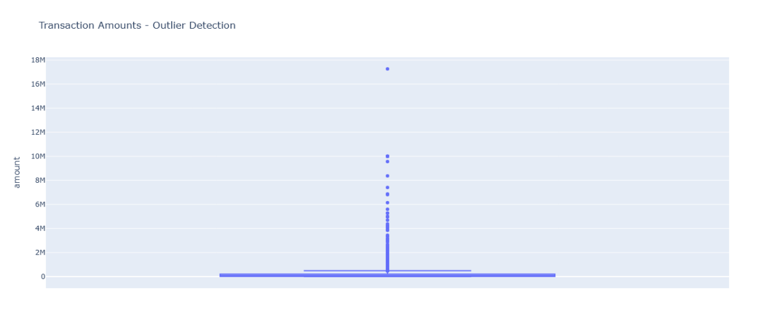
- Transaction Amounts – Outlier Detection
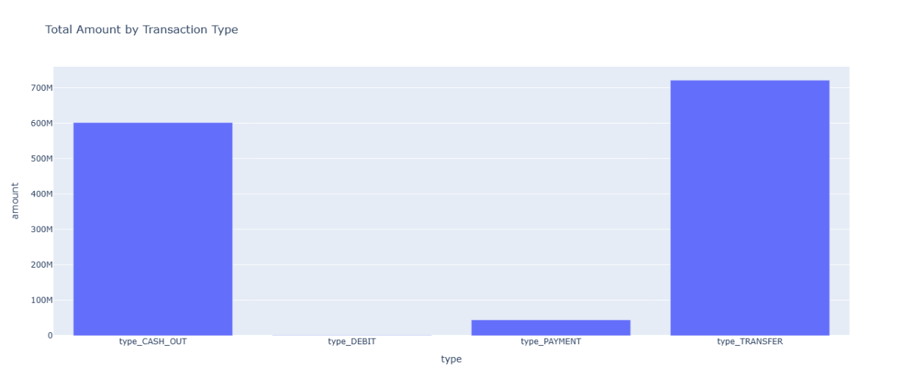
- Total Amount by Transaction Type
- Transaction Amount Distribution
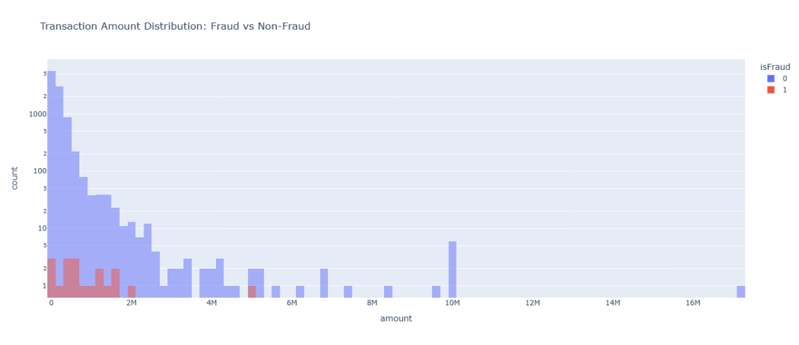

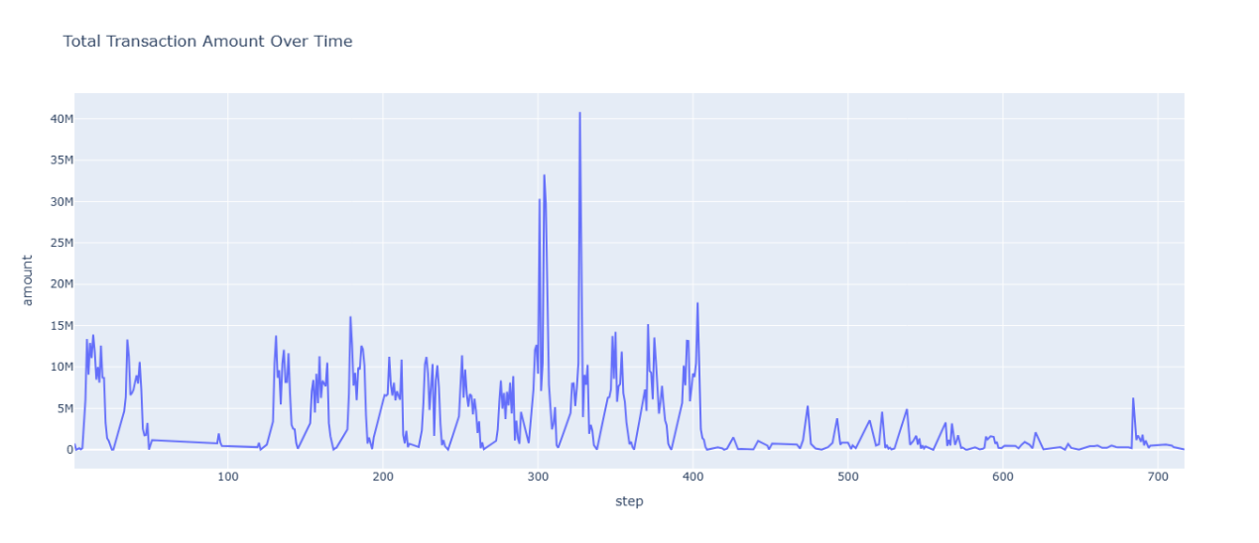
- Total Transaction Amount Over Time
- Average Transaction Amount Over Time
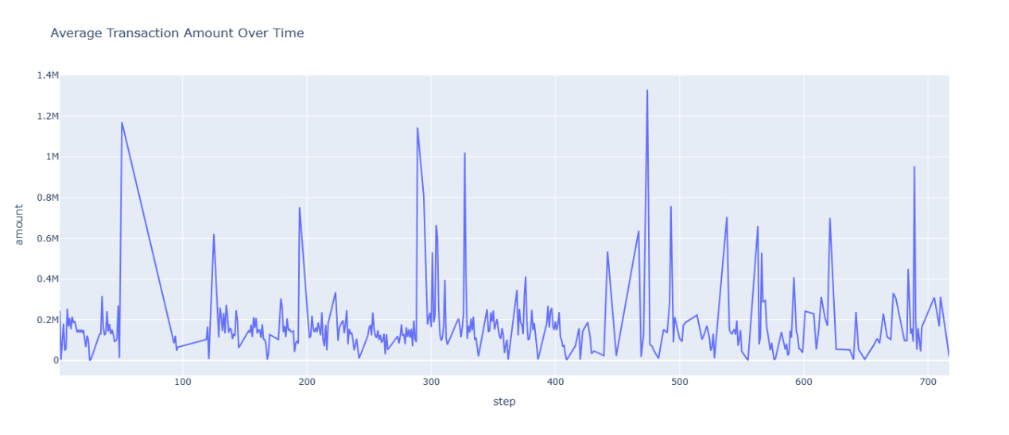
- Fraud Rate by Transaction Type
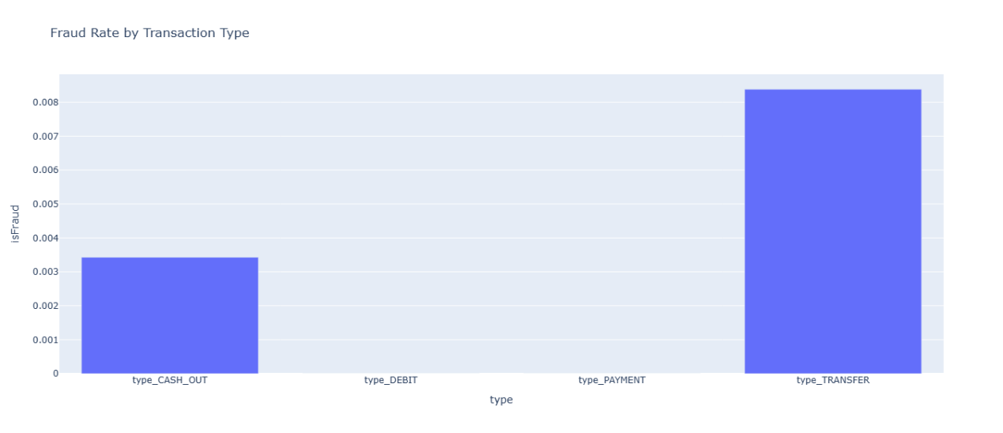
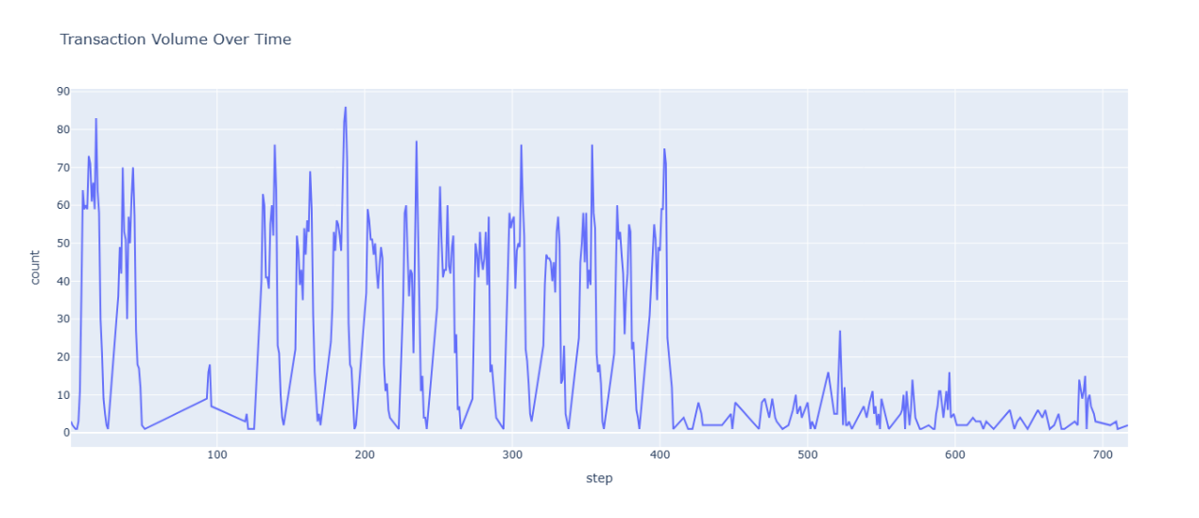
- Transaction Volume Over Time
- Fraud Rate Over Time
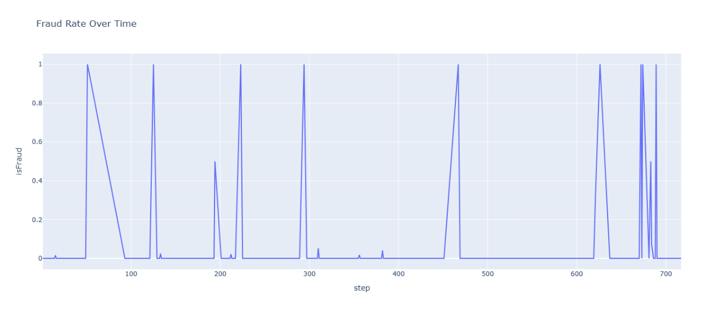
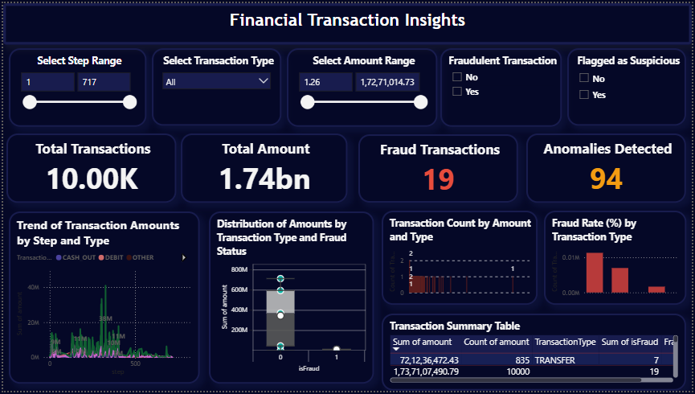
- Power BI Dashboard

