

MSc FINAL PROJECT REPORT

Design and Evaluation of a Secure Web-Based Access Control and Tamper-Evident Audit Logging Framework for Simulated Electronic Health Records

Name: Ruth Sara Shajan
Banner ID: B01828711

Thesis Project for the partial fulfilment
of the requirements for the Master’s Degree
in Advanced Computer Security

University of the West of Scotland
School of Computing, Engineering and Physical Sciences
Date of Submission: 14th August 2026


DECLARATION OF ORIGINALITY

I declare that this is an original study based on my own
work and that I have not submitted it for any other
course or degree.

Signature Ruth Sara Shajan



Library Form to Accompany MSc Project

To be completed in full

Surname: Shajan

First Name: Ruth Sara Initials: N/A

Banner No: B01828711

Course Code: COMP11024

Course Title: Advanced Computer Security

Project Supervisor: Dr. Raman Singh

Project Title: Design and Evaluation of a Secure Web-Based Access Control and Tamper-Evident Audit Logging Framework for Simulated Electronic Health Records

Session: 2025/2026 Date of Submission: 14/08/2026

Signature: Ruth Sara Shajan

Please ensure that a copy of this form is included with your project before submission.

DEDICATION

To God first and foremost, for his grace and guidance, and to my family, for their constant love and support throughout this whole journey. Thank you for everything.

ACKNOWLEDGEMENT

I would like to express my sincere gratitude to my supervisor, Dr Raman Singh, for his guidance and feedback throughout this project

ABSTRACT

Electronic Health Record (EHR) Systems contains sensitive personal and clinical information, which makes accountability and integrity important. This project constructed and implemented a local simulated HER security prototype using Python, Flask and SQLite with fictional patient data. The prototype provided authenticated access for administrator, patients, doctors, nurses and general practitioner roles. Role-based access controls were used to strengthen by record-level authorisation, which allowed patients to keep their own records and clinicians to assigned patients. The website-based administrative workflow involved account creation, assigning clinicians and GP registration.
Security-related activities were also recorded in a detailed log which was protected by SHA-256 hash algorithm chain. A secondary experiment was conducted during this project which compared SHA-256 to ML-DSA-44, a post quantum digital-signature standard, for execution time, storage overhead, and detecting changes in the data. This manual functionality and security testing was conducted to verify authentication, role separation and record isolation, clinician assignments, audit logging, chain verification and session protection.
The evaluation concluded that the prototype had achieved its main objectives and that there were significant trade-offs between regular hashing and post-quantum signatures. However, this prototype is still a local academic prototype and not a clinical implementation and ML-DSA-44 was only experimentally evaluated.

Keywords: electronic health record, EHR security, role-based access control, audit logs, SHA-256, ML-DSA, post-quantum cryptography, Flask.

TABLE OF CONTENTS
Declaration of Originality ii
Library Form iii
Dedication iv
Acknowledgement v
Abstract vi
Table of Contents vii
List of Figures ix
List of Tables x
CHAPTER 1: INTRODUCTION 1
Project Context 1
Problem Statement 1
Research Question and Evaluation 2
Aim of the Project 3
Objectives 3
Project Scope 3
Report Structure 4
CHAPTER 2: BACKGROUND AND LITERATURE REVIEW 6
EHR Security Requirements 6
From Principles to Requirements 6
Authentication and Password Security 7
Role-Based and Record-Level Access 8
Limitations of RBAC 9
Audit Logging and Accountability 10
SHA-256 Audit Chains 11
Integrity and Trust Boundaries 11
ML-DSA-44 Digital Signatures 12
ML-DSA Key Management 12
Literature Synthesis 13
Comparing SHA-256 and ML-DSA-44 14
CHAPTER 3: METHODOLOGY AND SYSTEM DESIGN 14
Development Approach 15
Evidence Traceability 15
Tools, Technologies and Libraries 16
System Architecture 17
Database Design 18
Access Control Design 19
Administration and GP Registration 20
Audit Chain Design 21
Experimental Design 21
Measurement and Analysis 21
Experimental Validity 22
Ethics and Data 24
CHAPTER 4: IMPLEMENTATION AND TESTING 25
Authentication and Dashboards 25
Record Level Access 25
Administrator Functions 26
Audit Interface 26
Development Challenges 27
Manual Security Testing 28
Test Interpretation 29
CHAPTER 5: RESULTS AND DISCUSSION 30
Security Test Results 30
Cryptographic Performance Results 31
Run-to-Run Variation 34
Storage Overhead 35
Tamper Detection 37
Audit Chain Evaluation: Entry 97 39
Evaluation of Objectives 40
Discussion of Findings 42
Hybrid Audit Design 44
Limitations and Validity 44
CHAPTER 6: CONCLUSION AND FUTURE WORK 46
Conclusion 46
Future Work 47
CHAPTER 7: CRITICAL SELF EVALUATION 49
Personal Performance 48
Strengths 49
Areas for Improvement 50
Lessons Learned 50
Overall Reflection 51
REFERENCES 52
APPENDIX A: DETAILED MANUAL TEST RECORD 55
APPENDIX B: CRYPTOGRAPHIC EXPERIMENT RECORD 58
APPENDIX C: SELECTED PROTOTYPE SOURCE CODE 60
APPENDIX D: PROJECT PROCESS DOCUMENTATION, PROJECT SPECIFICATION & GITHUB LINKS 63
LIST OF FIGURES
Figure 1: High-level prototype architecture 18
Figure 2: Administrator patient and clinician assignment workflow 20
Figure 3: Example clinician dashboard showing an assigned patient 25
Figure 6: Mean SHA-256 and ML-DSA-44 operation times 31
Figure 7: ML-DSA-44 performance over ten saved runs 34
Figure 8: Cryptographic storage requirements 36
Figure 9: Detection of changed data across ten runs 38
Figure A.1: Login page after authentication failure or logout 55
Figure A.2: Administrator accessing protected functions 55
Figure A.3: Non-administrator access rejected 56
Figure A.4: Authorised access to a fictional patient record 56
Figure A.5: Authorised and denied access in the audit log 57
Figure A.6: Successful SHA-256 audit-chain verification 57
LIST OF TABLES
Table 1: Project objectives and evidence 3
Table 2: User roles and their permitted actions 9
Table 3: Core database entities 18
Table 4: Manual functional and security test results 28
Table 5: Final cryptographic timing results 32
Table 6: Cryptographic output sizes 35
Table 7: Critical assessment of objective achievement 42
Table B.1: Raw results from ten saved comparison runs 58
CHAPTER 1: INTRODUCTION

  - Project Context

Electronic Health Record (EHR) systems allow for the storage, update and sharing of clinical information efficiently, but given the sensitive nature of health data security has become a central design concern. A single application can be used by patients, clinicians and administrators whose responsibilities are far more distinct. Because of this, authentication is just not enough. Even after a user is in the system, it must decide what records and functions the user is able to access. And it needs to keep evidence of major events so that inappropriate behaviour and unauthorised changes can be investigated. The Confidentiality, Integrity and Availability (CIA) model is a perfect starting ground for this. Confidentiality requires information to be shared only with authorised users. Integrity requires data and security records to be accurate and to disclose unauthorised modifications.
Availability requires authorised users to access the information they require. In this project, we focus primarily on confidentiality, authorisation, accountability and integrity and consider that production availability, disaster recovery and clinical safety are not something the small local prototype can do. This project also looks at the transition towards post-quantum cryptography. SHA-256 and digital signatures perform different functions. SHA-256 generates a fixed digest size that is useful for integrity checking and hash linking but nothing more than an unkeyed digest can tell us who has generated the data. ML-DSA creates and verifies digital signatures using a public/private key pair and is designed to resist attacks from both conventional and sufficiently capable quantum computers (NIST, 2024). Consequently, we treat the two mechanisms as complementary controls and not as competitors.

  - Problem Statement

The simple EHR application may look as secure as it has login page but might be vulnerable if server-side routes trust identifiers in URLs or display records without checking ownership and clinical relationships. Other weaknesses arise if work is done by changing the source code, as the real users need to be controlled in the application. Finally, a database audit table can be changed by a user who has access to the database unless additional integrity checks are used. The challenge of this project is to demonstrate in a transparent educational prototype that a combination of:
- Authenticated , role- specific access.
- Record-level checks for patients and assigned clinicians.
- Web-based administration of users and assignments.
- Details about the successful and denied actions of the audit entries.
- Tamper-evident linking of audit entries.
- An empirical testing of the lightweight hashing and post-quantum signing.

    - Research Question and Evaluation

The research question is:
To what extent can a small web-based EHR prototype demonstrate role and record-level access control, accountable audit logging and tamper-evident integrity, and what practical trade-offs arise when SHA-256 is compared with ML-DSA-44?
This research question deliberately put two parts in the same sentence that are connected, but not so much at the same time. The first part of the question is to see whether the application is making the security decisions. The second part is to figure out the cost and security of two cryptographic mechanisms. A successful benchmark fails for that reason, and successful access-control tests are not the proof of the application’s security.
The application question was assessed through observable behaviour. A feature was not counted as successful just because a dashboard had a link in it. The protected route must reject a user who did not take an authorised user could do the task and negative tests were able to cross the same line, changing a URL or visiting an administrator route. Audit entries were then reviewed to see whether important successful and denied actions were recorded. This combination connected the design claim, the user-visible result, and the accountability record.
The cryptographic question was empirically evaluated rather than arguing that it is stronger than the stronger claim of security. This experiment recorded the time, output size, and results of the controlled changed message check. The Hash algorithm SHA-256 and post-quantum cryptography method ML-DSA-44 were not assumed as substitutes. SHA-256 was considered as a compact integrity primitive to connect audit events and ML-DSA-44 as a post-quantum digital signature mechanism that could be user to provided public key verification if the key is managed correctly. The beneficial comparison would be that the additional computation, storage and key management responsibility for the stringer claim of verifiable origin would be significantly higher for the stringer claim.
This evaluation logic also sets out what the project cannot achieve. Ten manual scenarios cannot show that every access control defect is absent. Ten saved benchmark runs cannot predict performance on every computer or under a production workload. A changed message check shows that the tested mechanisms have responded to that deliberate change and does not establish a universal probability of detecting all forms of tampering. These qualifications are part of the analysis rather than the weaknesses to be hidden.

  - Aim of the Project

The aim of the project is to design, implement and evaluate a secure simulated EHR prototype that shows practical access control and audit integrity, while investigating the performance and storage implications of SHA-256 and ML-DSA-44.

  - Objectives

Objective | Evidence produced
Review relevant EHR security, access control, auditing and post-quantum concepts. | Background and literature review in Chapter 2.
Develop a role-based Flask prototype for administrator, patient, doctor, nurse and GP users. | Working dashboards and protected routes.
Enforce patient ownership and clinical assignment rules on the server. | Authorised and denied manual tests in Chapter 4.
Provide usable website workflows for account creation, GP registration and clinical assignment. | Administrator and patient workflows described in Chapters 3 and 4.
Record detailed security events and protect their ordering with a SHA-256 hash chain. | Audit interface and successful chain verification.
Benchmark SHA-256 and ML-DSA-44 for execution time, storage and controlled tamper detection. | Ten run experiment and graphs in Chapter 5.
Critically evaluate the prototype, results and limitations. | From Chapters 5 to 7.
Table 1: Project objectives and evidence.

  - Project Scope

The project scope was to create, implement and localise a simulated EHR security prototype that was built with Python, Flask, SQLite, HTML and CSS. The application was based on five user roles: administrator, patient, doctor, nurse and GP. The functionality on the website includes authentication, role specific dashboards, patient self-access, assignment based clinician access, GP registration requests, fictious patient and staff accounts, patient clinician assignments, detailed audit logging, and administrator verification of a SHA-256 audit chain. The scope was not only the interface presentation but also the server decisions and the database relationships that determine of a record is returned.
The cryptographic work was split into two parts. SHA-256 was added to the live prototype to ensure that subsequent audit records are linked and verified in the sequence of record stored in the system. ML-DSA-44 was evaluated with companion experiments that measure key generation, signing, verification, storage overhead and response to controlled message change. ML-DS-44 did not sign every live audit entry no public key infrastructure was implemented. This is important because the experimental results support a possible future authenticity control but do not provide evidence that the current Flask audit is authentic or not.
The evaluation used only fictional data, a small number of local accounts and records, 10 structured manual tests and 10 saved cryptographic comparison run. It did not include any real patient data, clinical decision making, NHS deployment, professional penetration testing, formal information governance approval, large scale or concurrent testing, automated testing, HTTPS/TLS deployment or interoperability with any external EHR standards.

  - Report Structure

This report had been organised into 7 chapters in which each chapter explains the process done to complete the project in a systematic way. Chapter 2 reviews the literature and technical background needed to justify the prototype, it considers EHR security, authentication, role-based and relationship aware authorisation, least privilege security logging, SHA-256 hash chains and ML-DSA-44. The chapter also distinguishes between the integrity evidence provided by hashing and the origin assurance provided by digital signatures.
Chapter 3 explains the methodology and system design of the project. It connects the objectives to the development approach, system architecture, database relationships, route level authorisation rules, administrative workflows, audit-chain construction and experimental procedure. Chapter 4 describes how these designs were implemented and presents the manual functional and security testing, including both authorised actions and deliberate attempts to cross access boundaries.
Chapter 5 presents the functional results and the ten run SHA-256 and ML-DSA-44 comparison using tables and reserved figure locations. It interprets performance, storage and changed data detection results discusses the entry-97 serialisation defect and evaluates achievement of the objectives and threats to validity.. Chapter 6 answers the research question and summarises the conclusion of the project and proposes future work, while Chapter 7 provides a critical self-evaluation of the development process, learning areas for improvement. Supporting tests, experiment details and process documentation are included in the appendices.

CHAPTER 2: BACKGROUND AND LITERATURE REVIEW

  - EHR Security Requirements

Health information is very sensitive because disclosure can affect privacy, dignity and trust and wrong information can affect treatment decisions. Article 32 of the General Data Protection Regulation requires security measures appropriate to risk, including controls on confidentiality, integrity, availability and resilience (European Union, 2016). Similarly, the Information Commissioner’s Office treats security as an organisational and technical responsibility and not simply a product feature (UK Information Commissioner’s Office, 2023). these higher-level requirements should become explicit software checks and not policy statements alone.
Data reviews in the EHR security literature are highly sensitive to privacy, authentication, access control, storage, sharing and accountability and not one control that protects the whole record system (Fernández-Alemán et al., 2013; Shojaei, Vlahu-Gjorgievska and Chow, 2024) Recent work on EHR access control solutions also indicates the problem is about identifying and combining what is required to meet clinical requirements and what is needed to change (Cobrado et al., 2024). This supports a defence-in-depth view of the project: authentication, authorisation, logging and integrity checking are all critical components in the project.
Access should be constrained according to legitimate duties and relationships. Anderson’s (1996) healthcare security policy model presented the different responsibilities and roles that medical systems have for everyone, and so can be explained as to why a generic logged in/logged-out boundary is not enough. A doctor may need to see an assigned patient but not every patient in the database. A patient should be able to see their own record without access to another record by changing a numeric URL. The administrator needs account and assignment functions but does not automatically require unlimited clinical editing. These examples demonstrate that EHR access is both role-based and object-specific. The NHS Data Security and Protection Toolkit serves as a further practical reminder that health and care organisations need to address security via a wider range of controls and evidence, and the prototype demonstrates some technical controls but does not claim Toolkit compliance (NHS England, 2025).

    - From Principles to Requirements

The confidentiality, integrity and availability model is useful only when the broad goals of the approach are translated into decisions that software can help enforce. For this prototype, confidentiality became a set of questions asked on every protected request: is a user authenticated, is the user allowed to use this route, and does this user own or have an assignment to the requested patient record. Integrity was two related requirements: stored passwords should not be recoverable as plaintext, and the sequence of security audit events should show inconsistent changes, Availability was understood more narrowly through working role dashboards and in website administrative process, resilient hosting, recovery objectives and continuous service were outside the scope of the local prototype.
This translation reveals an important distinction between policy and mechanism. A statement that “doctors may see their patients” is a policy intention. The mechanism requires a stable user identity, a doctor role, a patient identifier an assignment record joining the doctor and patient, a server-side query and a denial path if the relationship is absent. If none of these ate present, the interface shown is correct when the route is too lax. This prototype therefore thinks of the database relationship and route check as security relevant design elements and not just as navigation features.
Accountability also comes from healthcare information. Confidentiality controls aim to avoid unauthorised disclosure, but an operational system must also record enough information to investigate what really happened. All this is a balance: logs need the actor, action, target and the outcome but it should not copy passwords or unnecessary sensitive clinical information. The prototype records fictional identifiers and readable event details because we want to demonstrate the structure of accountable logging without real patient information. The resulting log can show both permitted activity and attempted boundary violations.
This project, therefore, adopts defence in depth at a small scale. Authentication, role checks, object-level checks, filtered dashboards and audit records overlap but do not have the same purpose. A filtered dashboard helps an authorised user to find the correct record, but the route check remains necessary is an identifier is entered manually. An access denied response stops the request and the audit record keeps evidence of the attempt. The SHA-256 chain does not prevent the initial event from being written incorrectly, but it does provide a later consistency check over the sequence that was sorted. Each mechanism has its own failure mode, and the evaluation involves their combined behaviour.

  - Authentication and Password Security

Authentication establishes the identity of a request. In the prototype, the users submit their username and password and login to a server aware session with identity and role information. The session is saved against the password and encrypted. Passwords are stored as hashes and not a plaintext. This is in line with the more general principle that authentication information should not be extraction from the account (Temoshok et al., 2024).
Sessions improve usability, but they introduce state that must be invalidated. The logout function eliminates the session, and a manual test showed that a protected administrator URL was redirected to login after it was done. This is important, as hiding as a link is not a security control: every protected route must be explicitly enforced.
Authentication and authorisation need to be conceptually separate. A correct password indicates which local account is making a request, it does not establish that the account can do everything. The role and assignment checks are done only after authentication and may still not be able to make a request. This separation is also apparent in the design of the tests: invalid login tests are authentication test, while patient, doctor, nurse and GP URL tests are authorisation tests which use accounts that have been logged in.
Session data is convenient because the application does not need to request credentials on every page. But the server must treat values obtained from the session as security relevant. This prototype stores the logged-in identity and role and uses them when making route decisions. It does not depend on a role value provided in a form or URL by the browser. The logout test does not provide sufficient evidence that session termination worked for the tested route, although a production evaluation would also look at cookie flags, session expiry, fixation resistance, concurrent sessions and secret management. These areas a re recommendations and not claims.

  - Role-Based and Record-Level Access

Role-based access control (RBAC) associates permissions with organisational roles and assigns users to those roles. The initial RBAC model described by Ferraiolo and Kuhn (1992) and the family of models introduced by Sandhu et al. (1996) established clear separation between users, roles and permissions. The latter has been discussed in detail for the use of model as a general access control approach and its application to web systems (Sandhu, 1998; Barkley et al., 1997), whereas the proposed NIST model further confirmed key and hierarchical aspects of RBAC (Ferraiolo et al., 2001). RBAC facilitates separation of responsibilities and is easier to work with than a single list of permissions for everyone. This prototype has five roles: administrator, patient, doctor, nurse and GP.
RBAC alone is not precise for clinical records. Healthcare authorisation research distinguishes organisational roles from contextual relationships involving a certain task and patient (Blobel, 2004; Motta and Furuie, 2003). Two users may play the role of doctor, but only one person is responsible for treating a specific patient. Rizvi et al. (2015) point to this as a limitation of conventional RBAC in medical records: role membership can restrict access to doctors in general but cannot limit access to clinicians who have a relationship with the patient. The prototype therefore supplements RBAC with record-level authorisation. Patients are restricted to their own linked records, and doctors, nurses and GPs check against the patient-assignment table before being able to access them. This is applied to least privilege more precisely, but the relationship between patients and doctors is static and does not account for time, location, emergency access or changing clinical responsibilities.

Role | Permitted prototype actions
Administrator | View users and roles, create patient and staff accounts, assign GPs, doctors and nurses, review audit logs, verify audit chain.
Patient | View their own record, view GP registration status, request for a GP registration if not registered.
Doctor | View only patients assigned to that doctor.
Nurse | View only patients assigned to that nurse.
GP | View only patients assigned to that GP.
Table 2: User roles and their permitted actions.

The authorisation decision is on the server. Numeric record identifiers still appear in prototype URLs, but having an identifier does not permit access. The manual tests show that changing the identifier gives the answer that it is not accessible when the user does not have access or has the assignment to that record.

    - Limitations of RBAC

Role-based access control simplifies granting permissions by grouping permissions according to organisational roles. However, in an EHR system, a role specifies the general category of a user but does not necessarily establish whether that user has a legitimate relationship with the specific patient whose record has been requested. Motta and Furuie (2003) thus extended RBAC with contextual information, including the relationship between the user and the patient, because role membership alone cannot cover every clinical access condition.
Rizvi et al. (2015) also found a similar issue in the OpenMRS medical record system. Traditional RBAC could restrict access to users in the doctor role, but it could not fully distinguish between a clinician treating a particular patient and other clinicians with the same role. This shows why broad role membership needs to be balanced with record-level or relationship-based checks. It also supports the approach to the design of this project where the prototype does a role check and then a patient-ownership check and clinician-assignment check.
RBAC can also create administrative challenges. Roles must be defined at the right level of detail and reviewed for any change in roles. Too wide a role may provide more access as well as too narrow and administrative complexity and “role explosion” are created. Zhang et al. (2011) examined three months of EHR audit data with around 8,000 users and 140 roles. Their findings highlight the difficulty in ensuring that the roles assigned to users are consistent with their actual access behaviour. Role engineering should therefore be viewed as a continuous process with monitoring and audit analysis.
A healthcare-focused review done by de Carvalho Junior and Bandiera-Paiva (2018) also highlights challenges in the context of authorisation, emergency access, delegation, inter-organisational access and fine-grained permissions. The prototype addresses one of the major RBAC limitations through patient ownership and clinician-assignment relationships. However, its code is largely static. It does not consider time, location or clinical emergencies, and the prototype does not have a break-glass mechanism, field-level restrictions, dynamic patient consent, automated role review or a formal role revocation lifecycle. So, the implementation should be considered as a controlled demonstration of role and relationship aware authorisation rather than a complete healthcare access-control model.

  - Audit Logging and Accountability

Security logs should record events that support monitoring and investigation, such as authentication results, access denials and significant administrative actions (Kent and Souppaya, 2006). EHR logging research highlights accountability and the importance of access records (King and Williams, 2012; Rostad and Edsberg, 2006). The NIST log-management model treats the generation, storage, analysis and protection of data as one life cycle and not as separate database writes (Kent and Souppaya, 2006). In healthcare, ISO 27789 sets out the required audit trail parameters for EHRs, and HL7 FHIR AuditEvent provides a standardised model to describe security-related incidents (International Organization for Standardization, 2021; HL7 International, 2023). The prototype has a timestamp, username, role, action, target, outcome, IP address and human-readable details field. Examples include login success or failure, log out, viewing a patient record, being denied record access, creation of staff account and clinician assignment.
Details help an administrator to understand the log. For example, the action CLINICIAN_ASSIGNED is also accompanied by the name of the fictional patient, the clinician, and role. Passwords and other authentication secrets are not recorded. The prototype does not use an audit-based access control system where later log analysis grants or removes access, as done by Dekker et al. (2007), but instead it pre-emptively checks the route and records its results. This distinction keeps the claim in the functionality.
If the audit log is complete and interpretable, it is useful. Recording a generic message like “page opened” would make it difficult to identify who had acted, which object was affected and whether the action succeeded or not. The separate actor, role, action, target, outcome and details fields of the prototype allow for filtering and human review, which is in line with the broader focus of ISO 27789 and HL7 AuditEvent on identifiable participants, actions and outcomes (International Organization for Standardization, 2021; HL7 International, 2023). The implementation of the claims cannot fit the two standards, but the comparison shows why structured fields are more valuable than an undifferentiated text file.
In practice, completeness and correctness are important things to know. A well-crafted log entry may contain the wrong target, and a correctly implemented event type may never be called on an unusual failure path. The manual review showed that certain successful logins, failed logins, views, denials, assignments and administrative actions were identified as being present in the audit interface. It did not instrument all lines of code, nor reconcile all database changes to an expected number of events. The result therefore provides scenario-based evidence of audit coverage rather than evidence that there has been full mediation. The following integration tests could strengthen this evidence by asserting both the HTTP response and the exact audit event produced for each protected route.

  - SHA-256 Audit Chains

SHA-256 is defined by NIST as part of the Secure Hash Standard and produces a 256-bit (32-byte) digest (NIST, 2015). A cryptographic hash maps arbitrary input to fixed-length output. A small change to the input results in a different digest and this digest is used for integrity checks.
The audit design hashes a canonical representation of each event together with the previous entry's hash. Linking subsequent values follows the larger tamper-evident principle that later evidence should depend cryptographically on earlier history (Haber and Stornetta, 1991; Schneier and Kelsey, 1999). If the old entry has been changed, the new hash of that entry is no longer the same as the original and so the current one must be linked to the previous one as well. This approach is tamper-evident rather than the tamper-proof approach. Someone with access to the database can still edit or delete rows in the old entry, but verification shows that the recorded chain is no longer consistent. It also does not identify a trusted signer because SHA-256 is not a digital-signature algorithm.

    - Integrity and Trust Boundaries

A hash chain derives value from order. If an entry ‘n’ contains the digest of entry ‘n-1’, the verifier can go back and check where exactly the stored representation and the expected digest diverge. This is more informative than hashing isolated rows because the attacker cannot change an earlier row without invalidating the links that follow it. This design is therefore suited to showing internal inconsistency in an ordered audit history.
But the trust boundary really matters. The audit events, previous hashes and current hashes are all stored in the same SQLite database. A person who can change one row may be able to change many rows and, if they could also run equivalent hashing code, they could also rebuild a consistent alternative chain. The chain therefore helps to guard against unnoticed inconsistent changes relative to the current trusted history; it doesn't make the database physically immutable. Research on forward-secure and tamper-evident logging thus considers protected authentication values, efficient verification structures and trusted external evidence instead of assuming a local chain is immutable (Schneier and Kelsey, 1999; Waters et al., 2004; Crosby and Wallach, 2009). Stronger designs would put a trusted chain head outside the database, use append-only storage or digitally sign checkpoints.
Canonical representation is part of this trust calculation. Cryptographic hashes work on bytes and not on the human meaning of a value. The text value 97 and the integer value 97 can describe the same identifier to the developer but can produce different serialised bytes. A writer and verifier must apply the same field order, delimiters, data types, character encoding, and handling of absent values.
The repair record also impacts how to interpret the result. Repairing the damaged links restored consistency after the canonicalization issue was corrected and an AUDIT_CHAIN_REPAIRED event documented the maintenance action. It’s better than just rewriting the chain, but that would rely on trust in the documentation and evidence. The episode points to a need for more controlled maintenance processes, secure external checkpoints and separation of operational and verification authority in any stronger implementation.

  - ML-DSA-44 Digital Signatures

NIST FIPS 204 standardises ML-DSA as a module-lattice-based digital signature algorithm based on CRYSTALS-Dilithium (NIST, 2024). Digital signatures provide the origin of authentication and integrity if private keys are controlled properly and public keys are trusted. ML-DSA-44 is the lowest of the standardised ML-DSA parameter sets and is a good balance between security and resource efficiency. In contrast to SHA-256, ML-DSA requires key generation and thus produces a comparatively large signature. Because of this, the experiment measured key generation, signing and verification time as well as public key, secret key and signature size. The comparison is not intended to decide which algorithm is universally better. Hashing is a good choice for fast digest calculation and internal chaining, while signatures provide verifiable authorship and post-quantum assurance at a higher computational and storage cost.

    - ML-DSA Key Management

ML-DSA does not just change the operational model, as it introduces asymmetric keys. A private key is used to form a signature and must remain under the control of the authorised signer. A corresponding public key allows another party to verify that signature, but the verifier also needs a trustworthy way to link the public key with the claimed signer. FIPS 204 defines the ML-DSA key generation, signing and verification operations, but implementing them into a credible system still requires the application to protect the private key and establish which public key is trusted (NIST, 2024). Therefore, generating a key pair is only the beginning of a usable signature system. Secure storage, access control, backup, rotation, revocation and public-key distribution are implementation requirements for future work and have not been considered in this project.
This lifecycle helps explain why the experiment reports key generation time separately. Key generation would usually happen during provisioning or rotation, but not for every audit event. Signing is the most significant operation in generating a signed event or checkpoint, and verification is done by the party checking it. If these three timings are added together for every record of this study, then that would be a misrepresentation of the architecture. Instead, the operations should measure at the time in the lifecycle where they would happen.
The post-quantum relevance of ML-DSA is also narrower than a general claim that an application is "quantum secure." NIST standardisation means that the signature algorithm must be used in environments where the attacker with conventional quantum computers is not able to perform the attacks (NIST, 2024). It does not automatically protect passwords, sessions, database queries, browser connections or the confidentiality of stored clinical data. A system using ML-DSA can still have ordinary access-control and key management failures. The report therefore describes ML-DSA-44 as a post-quantum signature mechanism evaluated by the experiment, not as a complete post-quantum security solution for the Flask application.
A selective checkpoint design follows from these characteristics. Signing every audit entry would provide frequent public key verified evidence but would incur a 2,420-byte signature and a measured signing operation for every event. Signing a periodic chain head would retain lightweight SHA-256 links between events and apply ML-DSA at selected intervals. Such a design would reduce overhead but make up for the history between trusted checkpoints. The appropriate timing would depend on the volume of events, the time that could be detected, the need to verify the information, and the ability of the key management. This is a reasonable future recommendation and not work in the present prototype.

  - Literature Synthesis

The reviewed principles outlined four key requirements: deny-by-default route protection, relationship aware record checks, sufficient audit events and verifiable integrity of the event history. Some EHR research has examined blockchain-based records and permission management to build trust and establish provenance (Azaria et al., 2016; Mayer, da Costa and Righi, 2020). The designs are good and all, but a blockchain was neither needed nor implemented in our local prototype. The project is about what one can prove with server-side authorisation, SQLite audit and then post-quantum signature experiment. Its other contribution is a reproducible comparison over ten runs that makes the resource trade-off between SHA-256 and ML-DSA-44 visible. The project doesn't introduce a new cryptographic algorithm; the value lies in applied design, integration, testing and critical evaluation.

    - Comparing SHA-256 and ML-DSA-44

SHA-256 and ML-DSA-44 are similar in one aspect: when the tested message was changed, the original digest or signature no longer validated the data in the changed message. Their security claims are different. SHA-256 is an unkeyed one-way function. A party that gets a message and the trusted original digest can check the validity of the first one, but a party can calculate a new digest for the second one. ML-DSA uses possession of the private key to create a signature that can be checked with the public key. With trusted key ownership and implementation, the signature could also support an origin claim that an unkeyed digest cannot.
These mechanisms also fail differently. A SHA-256 chain may lose its evidential value if an attacker can replace the history and every trusted copy of the chain head. An ML-DSA design may lose its origin assurance if the private key is stolen or the verifier accepts an attacker's replacement public key. Hashing therefore requires protection of trusted reference values, whereas digital signatures require protection of key identity and private signing capability. Neither mechanism removes access control, monitoring, and operational governance.
The above comparison justifies the decision not to rank the algorithms by speed alone. SHA-256 is expected to be much faster and smaller because it has a simpler and different function. The experimental value is in quantifying the scale of the resource difference on the test computer and connecting it with architecture. If the only requirement is fast internal linkage, the digest is appropriate. If an independent verifier must check who authorised a checkpoint, a signature may justify the additional cost. A hybrid design uses each mechanism for the claim it is suited to make.

CHAPTER 3: METHODOLOGY AND SYSTEM DESIGN

  - Development Approach

An iterative prototyping process was used for this project. The work started with a simple role-based Flask application and expanded on it by iterative testing, browser testing and evaluation. New features were added gradually: database-based login, role dashboards, patient records, assignment checks, audit logging, audit-chain verification, in-website account creation, clinician assignment and GP registration. The problems discovered during testing were outlined in the project journal and used to guide the next iteration.
This approach was suitable because security behaviour could be seen immediately. For example, an access control rule was tested not only through the expected dashboard link but also by manually changing a protected URL. Administrative workflows were tested from the user interface to ensure that the system could be operated without editing Python or SQL source code.
The project involved an evidence-based iteration. Each increment would be connected to something that would later be useful in the report: a route and template, a schema relation, an audit event, a browser screenshot, a manual test or an experimental CSV row. The journal recorded implementation problems and decisions, so the final account did not rely only on memory. This was particularly important for the audit-chain representation defect because the final successful verification alone would not be a sufficient explanation of why an earlier failure occurred, or what was learned from it.
Iteration was also applied to minimize developer involvement. Such initial demonstrations might rely on static data or database changes, but this would not do justice to an administrative workflow. The later account-creation and assignment forms allowed the authorised administrator to create fictitious patients and staff, assign clinicians and register GP registration via the website. Testing then went along the same path that users would follow. That also supported functional validity because the evaluated behaviour included the interface, route logic, database update and dashboard state.
The method was not a formal secure software development lifecycle. There was no independent threat modelling workshop, code review team, continuous integration test gate or professional penetration test. Requirements also changed once the scope was expanded to include the comparison between SHA-256 and ML-DSA-44. The iterative approach was feasible for a time-limited individual project, but it increased the risk that documentation and automated testing would follow implementation rather than guide it from the beginning. This restriction informs the self-evaluation and future work recommendations.

    - Evidence Traceability

Traceability was maintained by linking each objective to an observable artefact. The five-role objective was demonstrated by account roles, dashboards and protected routes. The record level objective was demonstrated by ownership and assignment queries or by authorised and denied URL tests. The administrative-workflow objective was represented by web forms, database state changes, dashboard changes and audit events. The audit integrity objective was represented by stored chain fields, verification function and the displayed verification result. The objective of the experiment is also shown by the final CSV, analysis output and four graphs were generated.
This map does not treat a list of codes as proof. Code from the source can show that a conditional check was performed, but a browser test will show if the deployed route worked as expected in each case. A screenshot can show the result, but the database or audit data would indicate what is happening. The report therefore uses several types of evidence when making its most important claims. Where there is only manual evidence to provide, the limitation is shown instead of an assumption of full correctness.
The evidence was also separated by scope. The screenshots and audit-chain verification are related to the live Flask prototype. CSV rows and cryptographic graphs are related to the standalone comparison scripts. Keeping these evidence streams separate prevents the ML-DSA results from being presented as if signatures were attached to the live audit records. The connection between them appears in the discussion as a potential future checkpoint design.

  - Tools, Technologies and Libraries

The tools and techniques used for this project are as follows:
- Python: Application and experiment implementation.
- Flask: Routing, templates, sessions and request handling.
- SQLite: Local relational storage for accounts, fictional patient records, assignments and audit events.
- HTML and CSS: Accessible, consistent user interfaces.
- Werkzeug Password Utilities: Password hashing and verification within the Flask application.
- SHA-256: Audit-chain hashing and verification and comparison experiment.
- ML-DSA-44 Library Implementation: Post-quantum signing experiment.
- Matplotlib: Create repeatable report graphs from the experiment CSV.
- GitHub: Project codes stored and managed for version control.
The technology choices are in line with the purpose of an educational local prototype. Flask provides clear routes and requests, so authentication and authorisation decisions can be clearly explained; its own documentation also indicates the development server is in good hands (Pallets Projects, 2026). SQLite supports relational joins between accounts, patients, assignments and audit events without a separate database server. Server-rendered HTML keeps the interaction model simple, and security remains a server-side concern. These choices make for more transparency and faster development speed, but not the deployment hardening, scalability or operational resilience required of a production health system.
Werkzeug’s password utilities were used to store password hashes instead of plaintext passwords. This greatly reduces the danger of casual database disclosure but does not build a complete authentication architecture. Password policy, reset, change in first-login, multi-factor authentication, throttling and account lockout remain to be implemented. Similarly, Matplotlib allows for reproducible presentation of the CSV results, but the validity of the graphs depends on the measurements and units provided by the experiment rather than on the plotting library itself.

  - System Architecture

The application follows a simple three-layer structure:
- HTML forms, role dashboards and report tables are shown in the browser.
- Flask routes act as authentication channels for requests, role and record-level rules are applied, workflows are run and audit events are written.
- SQLite stores users, patients, assignments and the audit chain.
The browser is considered an untrusted presentation layer. It can submit identifiers and form values, but those values do not determine whether access is allowed or not. Flask retrieves the current session, validates the permitted role and, where a patient record is involved, checks ownership or an assignment before querying or displaying the protected information. This boundary is significant because a user can change a URL or submit an unexpected form value regardless of which links are shown on a page. The application layer also centralises audit creation. Security-relevant routes write structured events after successful or denied actions so that the actor, target, outcome and explanation can be reviewed together. The hash-chain function uses the previous stored digest when creating the next event. As a result, the audit record is both an operational history and an input to the integrity verifier. This coupling is useful for demonstration but creates the trust-boundary limitation discussed later because the events and their hashes reside in the same database.
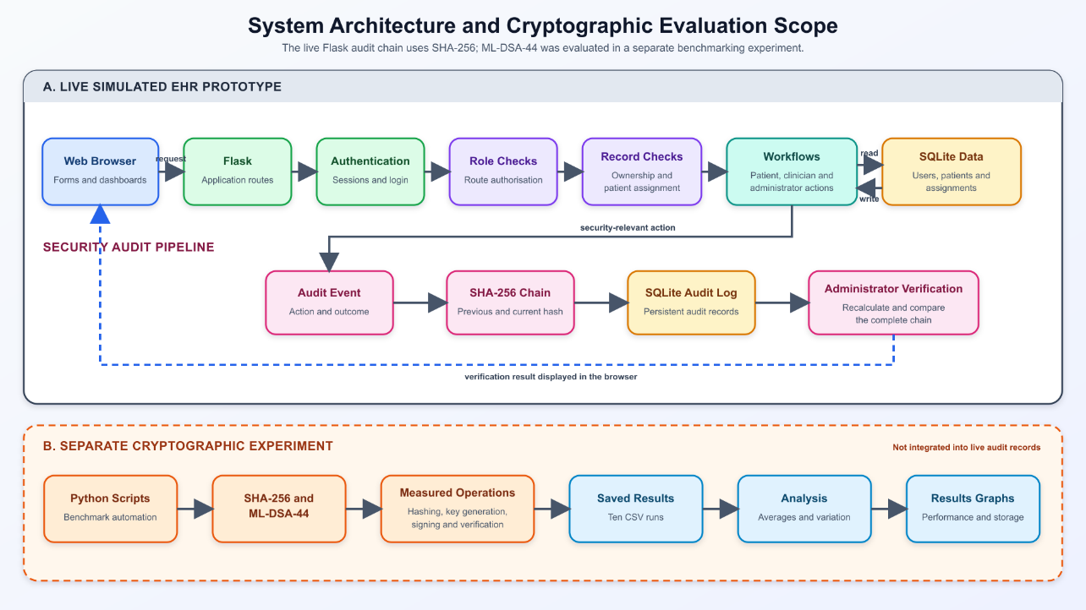
Figure 1: High-level prototype architecture.

All security decisions are made on the server. Templates display data supplied after the checks; they are not relied upon to prevent access.

  - Database Design

Entity | Purpose and important fields
Users | Account identifier, username, password hash, full name, role and active status.
Patients | Fictional patient identity, date of birth and simulated clinical fields linked to a patient user account.
Patient assignments | Links a patient to a clinician and records the assignment type (GP, doctor or nurse)
Audit logs | Timestamp, actor, role, action, target, outcome, IP address, details, previous hash and current hash.
Table 3: Core database entities.

Relational joins are used to show meaningful names in administrator and clinician interfaces. Server-side queries select only the assigned or owned records required by a route.
The schema separates account identity from fictional patient information. The user record holds authentication and role data, and the patient record contains the simulated clinical fields and can be linked to a patient account. This avoids storing authentication secrets in the clinical record and allows staff accounts that do not require patient data to be connected to that of the patient. The assignment table is a many-to-many style relationship in which a patient can be connected to different types of clinicians. This relationship can be queried both to populate a clinician dashboard and to validate a direct record request.
The audit table is intentionally richer than a single message column. Structured fields allow filtering and interpretation, and the details field provides a readable explanation. The previous_hash and entry_hash fields represent the chain. A production schema would need to be developed for indexing, retention, time synchronisation, immutable storage, data classification and volume, but the implemented fields are enough to show how security decisions can leave a trace that is later verified.
Data integrity in the application is more than the cryptographic chain. Account creation should result in a usable login and for a patient the correct connected patient record. An assignment must join existing records and have a type that the dashboards and route checks are able to interpret consistently. The administrator forms therefore reduce free-text identifier entry through controlled selections, but the server still validates the submitted records. These relational constraints and checks help prevent inconsistent application state, although comprehensive database constraints were not the subject of the final evaluation.

  - Access Control Design

Authorisation is done in stages:
- If the session has no authenticated username, redirect to login.
- Check the session role is allowed to use the route.
- For a patient role, compare the requested patient record with the account-linked record.
- For doctor, nurse or GP roles, search the assignment table for the requested patient and logged-in clinician.
- If no relationship exists, deny the request and write an ACCESS_DENIED audit event.
- If access is allowed, return the record and write a VIEW_PATIENT_RECORD event.
This method mitigates the threat of insecure direct object reference. The identifier is not considered as an authorisation token.
The order of the checks is deliberate. Authentication is performed before role or relationship as an anonymous request has no trusted application identity. Role checking then stops a user from entering a workflow which is irrelevant to their work. Ownership or assignment is evaluated at the time a specific patient object is requested. If no relationship is present, the application will deny access and write an event and not provide the record and instead will hide it through the interface.
The two uses of assignment data are complementary. By filtering a dashboard, a clinician can avoid selecting the wrong patient and the interface reflects the user's workload. Route-level checking is about deliberate or accidental requests that don't navigate that way. If only the dashboard query existed, manually entering another identifier could expose data. If only the route check existed, the clinician would find confusing links that repeatedly led to denial. Both work to make us use and enforce without confusing one in the same way as the other.
Denial handling is purposefully straightforward in the prototype. Plain text responses make the result clear in testing, but they are not an ideal user experience and may not be consistent. A production design would have the central error handling, not provide unnecessary information disclosure, maintain an appropriate HTTP status and provide a styled message. The security is however managed by the server, so presentation quality does not determine whether the record is disclosed.

  - Administration and GP Registration

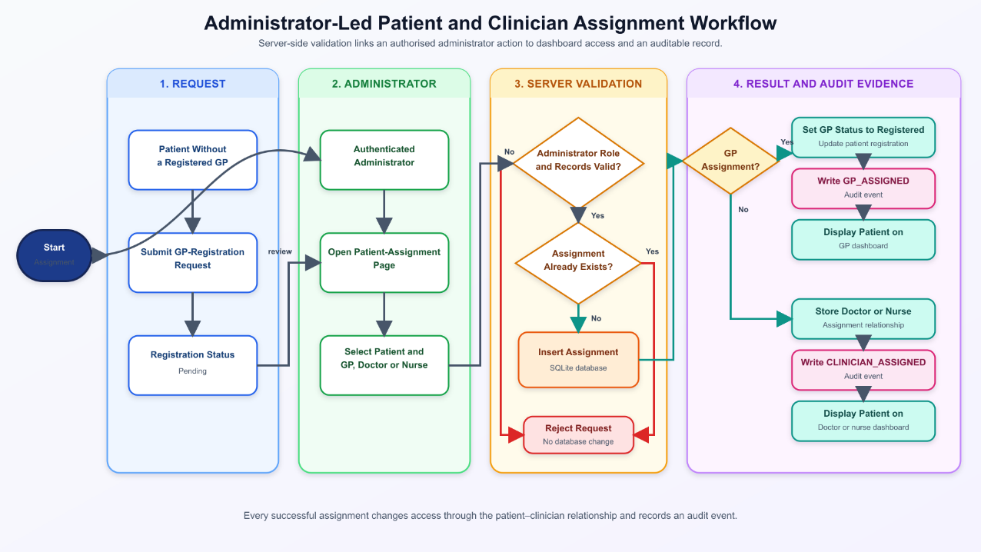
The last prototype supports operational tasks on the website. An administrator can create patient accounts and their fictitious records, create staff accounts for doctors, nurses and GPs, and assign clinicians to patients. A patient with no GP can request registration and the patient is then visible to the administrator. Involving a GP in the process changes the patient’s status to registered and the patient appears on the GP dashboard.
Figure 2: Administrator patient and clinician assignment workflow.

These workflows turned the prototype from a static demonstration to an application in which authorised users can perform the intended tasks without direct source-code or database modification.

  - Audit Chain Design

When a security event occurs, the application gets the previous audit hash, serialises new event fields in the same order and combines them with the previous hash and calculates a new SHA-256 digest. Both the previous and current values are stored. Verification walks through the entries in order and recalculates each expected digest. If there's a mismatch the first inconsistent entry is detected.
A representation mismatch was discovered during development, as HTML form values were initially hashed as text but stored by SQLite as integers. While the meaning of the event was unchanged, the different representation caused verification to fail. The cause was investigated, the canonical representation was corrected, and the chain was rebuilt with a maintenance event recording the repair. This shows why deterministic serialisation is so important in hash-chain systems.

  - Experimental Design

The final comparison was made from 10 saved runs. Each run performed 30 measured ML-DSA operations and recorded the average key generation, signing and verification time. SHA-256 timing was recorded separately in milliseconds and its size (32 bytes). ML-DSA public-key, secret-key and signature sizes were also recorded. A changed-message test was also conducted to determine if the SHA digest and the ML-DSA signature failed to be verified after message modification.
The CSV file was used as the main record of the experiments. A Python analysis script calculated overall means and a graph generation script produced PNG figures. Running several saved experiments rather than reporting one observation reduced the potential for drawing conclusions from only one anomalous time, although ten runs are still a small sample.

    - Measurement and Analysis

The final dataset contains 10 saved comparison runs, each of which was set to 30 internal tests. In a SHA-256 internal test, the fixed 29-byte simulated audit message was hashed repeatedly and the elapsed duration was divided to estimate average time per hash. One digest operation is too short to time reliably with a coarse single measurement. The ML-DSA section took key generation, signing and verification as separate operations.
The average of the saved run performances was used for summarising typical performance. Sample standard deviation was also estimated in the ten saved runs and kept the minimum and maximum run averages. The standard deviation is relevant here, as the mean is not representative of all run averages but of background processes, scheduling and interpreter behaviour. However, ten run averages are not enough to provide a stable distribution of performance and no confidence interval should be interpreted as hardware dependent. The graphs thus are visualizations of the data rather than benchmarks.
Units were chosen to make the results more understandable. The SHA-256 overall result is shown to be around 1.724 microseconds, and the ML-DSA operations are shown in milliseconds. Showing all four values on one linear millisecond axis would make the SHA-256 bar almost invisible. The unit labels in the graph are explicit so that the visual scale is not confused with the same purpose.
The changed message check used the same controlled idea for both mechanisms but examined different validation processes. For SHA-256, the digest of the changed message was different from the original digest. For ML-DSA-44, the signature of the original message failed to be verified against the changed message. By recording one outcome per saved run, 10/10 detections were produced for each. The tested test did not simulate stolen keys, new trusted digests, malicious code or database-wide history reconstruction, so it is only able to conclude by deliberately modifying the tested message.

    - Experimental Validity

Reliability was improved through scripts, a fixed message, repeated internal tests and a saved CSV rather than manually copying stopwatch results. The analysis and graph scripts make the transformation from raw run records to means and figures repeatable. Reproducibility will depend on preserving the exact Python environment, ML-DSA package version, parameters and hardware description. [AUTHOR TO INSERT EXACT PYTHON VERSION, ML-DSA PACKAGE/VERSION AND TEST-COMPUTER SPECIFICATION.]
Internal validity is strongest for the fact that in this environment and implementation, SHA-256 hashing was much faster and smaller than the measured ML-DSA operations and artefacts. It is weaker for any end-to-end application claim, since this benchmark excluded database writes, network transfers, key retrieval and concurrent requests. External validity is limited by one computer, one short message, one parameter set and a very small sample. Construct validity also must be taken into account: execution time and size are overhead, but for the changed message rejection it is chosen integrity behaviour; none of these measures alone represent total security.
No experiment values were changed during the preparation of the report. Any saved or archived CSVs are kept separately, and the final graphs are the final ten-run comparison. This allows for a trace from the data to be saved. Future work should also include environment capture, automated seeds or configuration if necessary, multiple message sizes and warm-up periods, confidence intervals and throughput under concurrent workloads.
The reliability of the comparison relies on what constitutes one observation. Each saved CSV row is already an average over repeated internal operations. The ten values analysed across runs are run-level averages, rather than thousands of raw timing observations. This reduces the impact of a very short individual call but also means that the sample standard deviation is representative for any variation between saved runs. This should not be taken as the distribution of every hash, signature or verification process. The graphs show that interpretation by plotting run averages and stating that their error bars show sample standard deviation across the 10 saved runs.
Measurement resolution is especially important for SHA-256. Just one hash of the short test message runs too quickly for a coarse timing method to be able to measure reasonably accurately, so the script repeats hashing and divides the time. This yields a useful estimate for comparison but loop control, interpreter overhead and timer resolution are still part of the measurement environment. The result is reported to appropriate units, about 1.724 microseconds, and not in the way that all displayed decimal places are independent in precision. ML-DSA operations are long enough to be measured separately in milliseconds, but it is still affected by interpreter state, memory allocation and other local processes.
The changed-message test is a very common but not identical one. In the case of SHA-256, the script hashes the changed message and compares the new digest with the original one. In the case of ML-DSA, it tries to verify the original signature against the changed message. Both reject the changed message but the reason for the rejection is different: digest inequality in the first case as well as failure of signature verification with public key in the second. The binary results as a common number of tamper detection are worth presenting given the different security scenarios in the report.
The experimental fairness does not mean forcing the algorithms to perform the same thing. It means using the same fixed message and deliberate modification, recording the relevant time and artefact sizes of each mechanism and interpreting the outputs according to their intended purpose. SHA-256 does not have key generation, signing or public key verification, and ML-DSA does not produce a 32-byte digest for an unkeyed audit-chain digest. The different timing categories make it clear that there is a difference. A benchmark that only compares the fastest operation from each mechanism would be easier to use and less informative because it would hide all the additional functionality and lifecycle that digital signatures have brought.
The approach also separates empirical observation from design extrapolation. The CSV directly supports statements about the recorded means, variation, sizes and changed-message results. The proposed signed-checkpoint architecture is an inference based on those measurements and on the trust limitation of a locally stored chain. It was not benchmarked end to end. That distinction prevents the report from presenting a future design as an implemented result and helps to demonstrate which conclusions could be repeated from the supplied scripts.

  - Ethics and Data

No real patient data was used. Names, dates and clinical descriptions in the prototype are fictional and only for demonstration. [AUTHOR TO CONFIRM THE FORMAL ETHICS CLASSIFICATION/APPROVAL AND INSERT THE CORRECT STATEMENT FROM THE PROJECT SPECIFICATION.] The prototype should not be presented as suitable for real clinical decisions.

CHAPTER 4: IMPLEMENTATION AND TESTING

  - Authentication and Dashboards

The login route retrieves the account by username and checks the submitted password against the stored hash. Successful login puts the username, role and user identifier in the session, writes a LOGIN_SUCCESS event and sends the user to the relevant dashboard. Failed login does not indicate whether the username or password is wrong; they write a LOGIN_FAILURE event. Dashboards are organized by role and only show the functions relevant to the logged-in user.

  - Record Level Access

The patient dashboards link to the current account record. The record page shows fictional name, date of birth, allergy, medication, diagnosis and treatment-plan fields. If a patient manually requests another identifier, the server turns down the request and records the attempt. This prevents horizontal privilege escalation between the patient accounts.
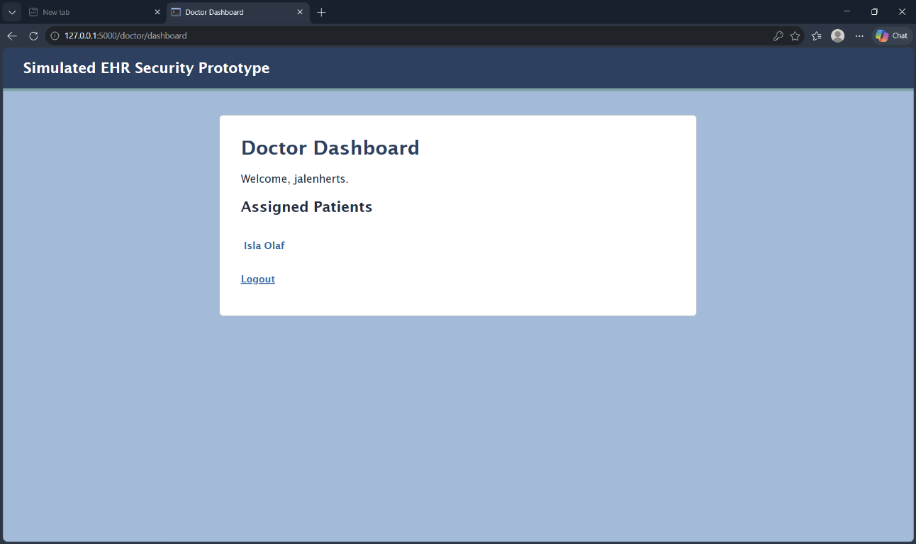
Clinician dashboards are populated with assignment queries. A doctor or nurse sees only patients assigned to that account; a GP sees registered or assigned patients. A name marked as a patient still triggers a server-side check on the record route. The filtered navigation and independent route validation are stronger than either measure alone.
Figure 3: An example clinician dashboard showing an assigned patient.

  - Administrator Functions

The administrator dashboard provides links to system users, role descriptions, patient assignments, audit logs and chain verification. Later versions added forms for making patient and staff accounts on the site. Submitted account passwords are hashed prior to entering. Patient creation adds the login account and a fictitious patient record to a user's account, and staff creation takes care of selecting the employee to have a specific role which corresponds to the person's job type. Successful creation is recorded with the account's name and description. The assignment page has separate controls for GP registration and doctor/nurse assignments. Drop-down lists reduce identifier entry errors, and the server checks the chosen records before writing an assignment. The result is shown immediately on the clinician dashboard.

  - Audit Interface

The audit interface contains structured columns and an additional detail row. The actor, role, action, target, outcome and IP address are stored to filter or investigate, and details are described in natural language. For example, the assignment of a clinician to a fictional patient tells which administrator assigned that fictional patient to which clinician. Denied record requests are reported with a denied outcome.

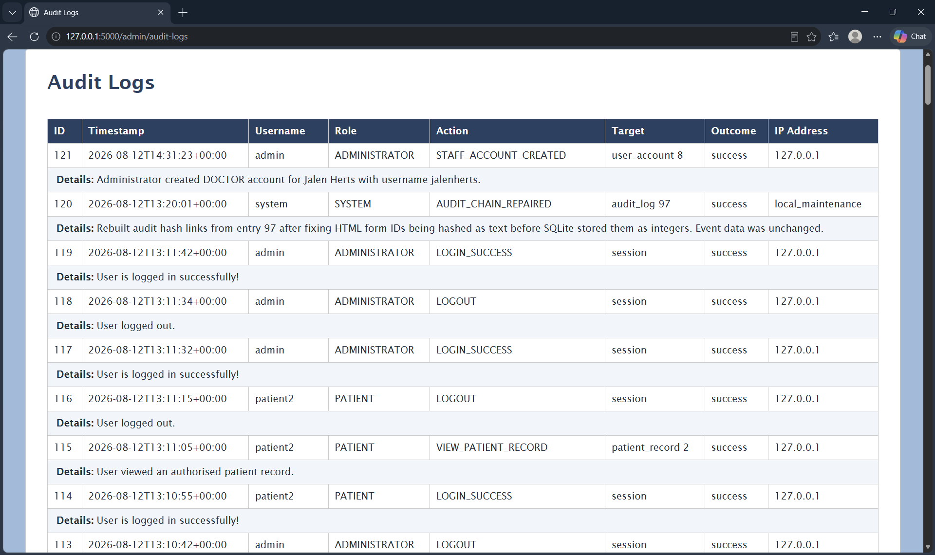
Figure 4: Detailed audit-log interface for staff-account creation and the documented chain-repair event.

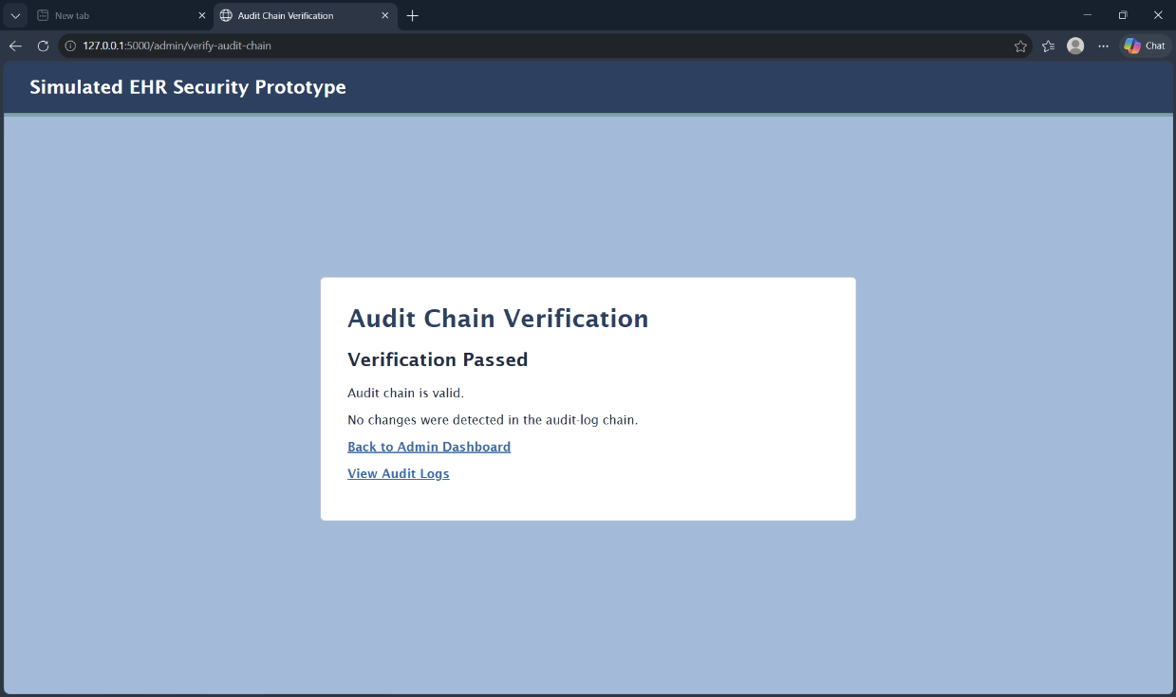
Figure 5: Successful verification of the SHA-256 audit chain.
  - Development Challenges

Some practical issues influenced the final implementation:
- Python indentation and route structure: the wrong way to write the database statements had kept the Flask application from restarting. The affected route was redesigned in a consistent four-space format, and the syntax was checked before testing on the browser.
- HTTP 405 Method Not Allowed: the assignment form was sent as POST to the route that only accepted GET. The route was set up for both methods, and the POST branch was then set up before the display queries.
- Database state vs. static pages: early user and role pages were static. Database queries and web forms were added so new accounts and assignments were reflected without editing code.
- Record-level access: role checks only allowed for too broad logic. Patient ownership and clinician assignment queries were added to the record route.
- Audit-chain canonicalization: string form identifiers and stored integer identifiers were not equal. Values were normalized before hashing and the corrective maintenance process was documented.
- Wide audit table: the initial fixed-width card caused table overflow. The audit layout was widened and adjusted for readable columns and detail rows.
- Experiment reproducibility: the early results were just a few rows. The final comparison was repeated ten times and analysis/graph scripts were used to calculate and visualise consistent results.

  - Manual Security Testing

Ten end-to-end tests were done in a browser. The results below represent screenshots and audit evidence that was retained in the last testing.

Test | Procedure | Expected Result | Result
1 | Submit an invalid username/password | Login rejected with generic error, failure logged. | Pass
2 | Log in as administrator and open the user list | Administrator page displayed. | Pass
3 | Log in as a patient and request /admin/users. | Access denied. | Pass
4 | As patient2, open own record then requests patient1. | Own record displayed, other record denied. | Pass
5 | As a doctor assigned to patient2, open patient2 then request patient1. | Assigned record displayed, unassigned record denied. | Pass
6 | As a nurse, open assigned records and request and unassigned record. | Assigned records displayed, unassigned record denied. | Pass
7 | As the GP, view the registered patient list and open a registered record. | Registered patients displayed and accessible. | Pass
8 | Review the administrator audit log after the preceding actions. | Success, failures and denials shown with details. | Pass
9 | Run audit chain verification after normal activity. | Verification reports a valid chain. | Pass
10 | Log out, then manually request an administrator URL. | Redirect to the login page. | Pass

The test set gives evidence for the principal access control scenarios, both positive and negative paths. It is not a full penetration test. Automated unit, integration and security scanning would be needed for stronger assurance.

    - Test Interpretation

The ten tests were chosen to cover the central security boundaries and not to cover 10 variations of the same successful workflow. The invalid-login and post-logout tests are about authentication and session protection. The administrator test confirms an intended privileged path and GP-to-administrator tests are about role separation. The patient, doctor and nurse record tests take a positive view and ask for a record that should not be available. Then, audit and chain tests are applied to determine whether the previous activity left reviewable evidence and whether the recorded sequence remained internally consistent.
Positive and negative paths answer different questions. A doctor opening an assigned patient record shows that the assignment model does not prevent legitimate work. The same doctor being denied an unassigned record shows that the role alone is insufficient to cross the boundary. Both observations are important: A system that denies everything would appear secure in negative testing but fail its purpose, while a system that displays every intended page might still be over-permissive. Pairing the paths provides a more balanced functional security evaluation.
The tests also involve state transitions. A newly created doctor sees no patients at first, the administrator sets up an assignment and then the doctor looks at the clinician dashboard. GP registration is not registered but pending and then registered after the administrative process. These sequences show that authorisation depends on the current relational data, not hard-coded names. They also link to other components: form management changes the database, the dashboard query reflects the new relationship, and the record route ensures it.
Manual execution was good to observe the full interface at the end of the project but was not perfect. The tester knows the solution and may be unconsciously avoiding unexpected input and data input in some cases. Screenshots show certain results rather than all the different requests and database changes. Repetition after later changes is slower and can be inconsistent. A better test suite would automate route requests for each role and create isolated fixtures, assert response codes and audit events, regression cases of missing sessions, inactive accounts, malformed identifiers, duplicate assignments and unsupported form values.
The results were described as “10/10 passed” as scenario coverage and not as a security score. It means the ten end-to-end scenarios reported produced the expected results during final testing. It doesn’t mean the prototype is 100% secure or all code paths are tested or that a professional adversary cannot find another weakness. This distinction is especially important for a security project because an evidently perfect percentage may overstate assurance if the denominator is a small, selected set.

CHAPTER 5: RESULTS AND DISCUSSION

  - Security Test Results

The final evaluation consisted of ten structured manual tests on authentication, role separation, record-level authorisation, audit logging, audit-chain verification, and session termination. All the tests showed the expected result. Table 4 in Section 4.6 provides the procedure, expected outcome and result for each test. The screenshots also show the list of administrator users without password hashes, the GP not being able to get a path to an administrator and the detailed audit events and Verification Passed result.
The positive tests show that authorised users could perform the functions we are testing. The negative tests are more important for assessing access control since they attempt to cross a security boundary. For example, changing /patient/2 to /patient/1 tested if the server independently checked ownership or assignment. A design that relied on hiding links would have failed this test. The denial thus provides evidence that the server-side decision was made on the tested request.
The results also show that a role name alone did not give a clinician access to every patient. Doctor, nurse and GP dashboards were generated using assignment data and a second check was conducted when a record URL was requested. The new doctor account was not populated at the start and only allowed access after an administrator created an assignment. This is better than dashboard-only filtering because the record route was still used to maintain the relationship when an identifier was entered manually.
The administrative workflow results demonstrate functional integration between account creation, patient records, assignments, dashboards, and audit events. A fictional patient or staff account could be created on the website, an administrator could make the appropriate assignment, and the change appeared on the relevant clinician dashboard. This removed the need to edit seed data or the SQLite database to demonstrate a workflow.
It also illustrates why administration is security relevant. Account creation, role allocation and assignment creation determine who can access protected records. With this feature integrated on the website, we improve usability and testability but also give more control over the administrator role. The current interface authenticates and checks that role but does not add re-authentication, dual approval or fine-grained administrative permissions. The feature is a successful prototype workflow and a production limitation.
Audit evidence increases confidence in the observed workflows because it records the actor, target and outcome after the event. For example, a clinician assignment can be connected to the administrator who created it, while a denied record view can be connected to the user and target identifier. This is stronger than a screenshot of the final dashboard alone. It still depends on the completeness and correctness of the logging calls; the manual review did not prove that every exceptional code path records an event.
However, a result of 10/10 must be interpreted narrowly. The tests were manually performed with a small number of local fictional accounts and known routes. They do not represent full path coverage, automated regression testing, concurrent access, professional penetration testing or testing by clinical users. The result is therefore evidence that the scenarios that have been described behave as expected but is not evidence that every request or attack would be handled securely.

  - Cryptographic Performance Results
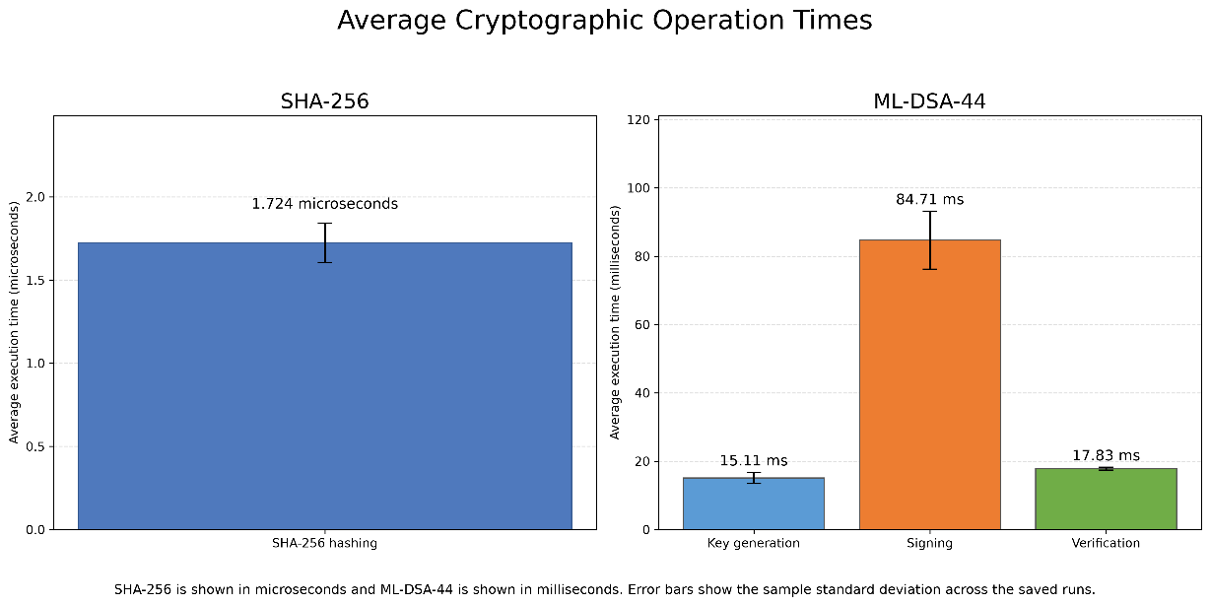
Figure 6: Mean SHA-256 hashing and ML-DSA-44 operation times across ten saved runs; error bars represent the sample standard deviation. Source: Author’s own experimental results.
The final cryptographic dataset contained 10 saved comparison runs. Each run included 30 internal tests of the SHA-256 operations and the ML-DSA-44 steps. In each SHA-256 internal test, the same short, simulated audit message was hashed 10,000 times and the time spent was divided by 10,000 to get an average for each hash. Each ML-DSA internal test measured the key generation, signing and verification separately. The average of the 10 saved run averages was then calculated. The error bars in Figure 6 represent the sample standard deviation over those ten saved averages.
The fixed experimental message was the 29-byte value Simulated EHR audit log entry. A fixed input made the ten runs comparable, but it also limits the conclusion: the results describe the tested message, implementation and computer instead of every possible record size or deployment environment.
The aggregation method needs to be clearly explained. Each saved row already contains averages over internal operations, and the overall numbers are a function of those 10 saved run averages. This reduces the effect of a very short timing observation but also the statistical unit in the graph is a run average rather than every cryptographic call. Error bars thus describe the variability between saved run averages. They should not be described as a confidence interval or as the distribution of any underlying operation.
The relative scale of this dataset can be seen clearly in the data. The SHA-256 result is measured in microseconds while key generation, signing and verification are measured in milliseconds. Converting the units shows that the ML-DSA means are thousands of times slower than the hash calculation. This difference is expected from their different work and should not be taken as a flaw in ML-DSA. The digital signature operations create or verify a public key authentication object, and the SHA-256 calculates an unkeyed digest. The performance question is to do with the added property being needed often enough to justify the cost.

Operation | Overall mean | Sample standard deviation | Minimum run average | Maximum run average
SHA-256 hashing | 1.724 µs | 0.119 µs | 1.610 µs | 1.964 µs
ML-DSA-44 key generation | 15.115 ms | 1.646 ms | 13.832 ms | 19.601 ms
ML-DSA-44 signing | 84.711 ms | 8.511 ms | 74.911 ms | 100.911 ms
ML-DSA-44 verification | 17.826 ms | 0.421 ms | 17.300 ms | 18.540 ms
Table 5: Final cryptographic timing results across ten saved runs.

Figure add here.

In Figure 6, SHA-256 is shown in microseconds and ML-DSA in milliseconds. Separate axes and units were needed because the SHA-256 bar on the same linear millisecond scale would be almost invisible. The SHA-256 mean of 0.001724 milliseconds is approximately 1.724 microseconds.
The timing difference should not be presented as proof that SHA-256 is better than ML-DSA. The operations answer different security questions. SHA-256 produces an unkeyed digest that can reveal a change when a trusted digest is available (NIST, 2015). ML-DSA uses a private key to create a signature that can be checked using the corresponding public key (NIST, 2024). It can provide evidence about origin as well as integrity if the private key, public key association and verification process are properly handled.
Among the measured ML-DSA operations, signing had the largest mean latency. It was about 5.60 times the key-generation mean and 4.75 times the verification mean. This is an architectural feature. Key generation would be a provisioning or rotation process, not an operation that would be repeated for every audit. Signing cost would be incurred each time the design decided to create a signature. The verification cost would be if a verifier checked that signature. The measured key-generation time should not be added to every hypothetical signed audit entry.
The average signing time of 84.71 milliseconds indicates that signing synchronously for every high-volume application event could be noticeable, particularly if coupled with database, network and key-service overhead that was not measured in the experiment. It does not mean that such a design would be unusable - event rates, batching and concurrency would determine the user-visible effect. It motivates measuring the full workload before choosing a signature strategy for each event.
Verification took around 17.83 milliseconds and was the most stable of the three ML-DSA operations in the saved runs. If verification is mainly done for audit review and not every user request, then the cost of verification is not too high in most designs. However, a large historical audit might have many checkpoints or signatures, and verification time would increase with the number of checks that have been made. Although the experiment measured one operation at a time, it cannot predict audit-review latency completely.
Key generation took about 15.11 milliseconds, but the key generation takes its most operational caution because the private key is a sensitive long-lived asset. A fast key generation result is not a fast key management result. Generating all the keys too frequently can be difficult to trust, retain and revoke them. If you keep one of the private keys for too long the compromise becomes more likely. The performance measurement is what determines the technical cost but not the governance decision.

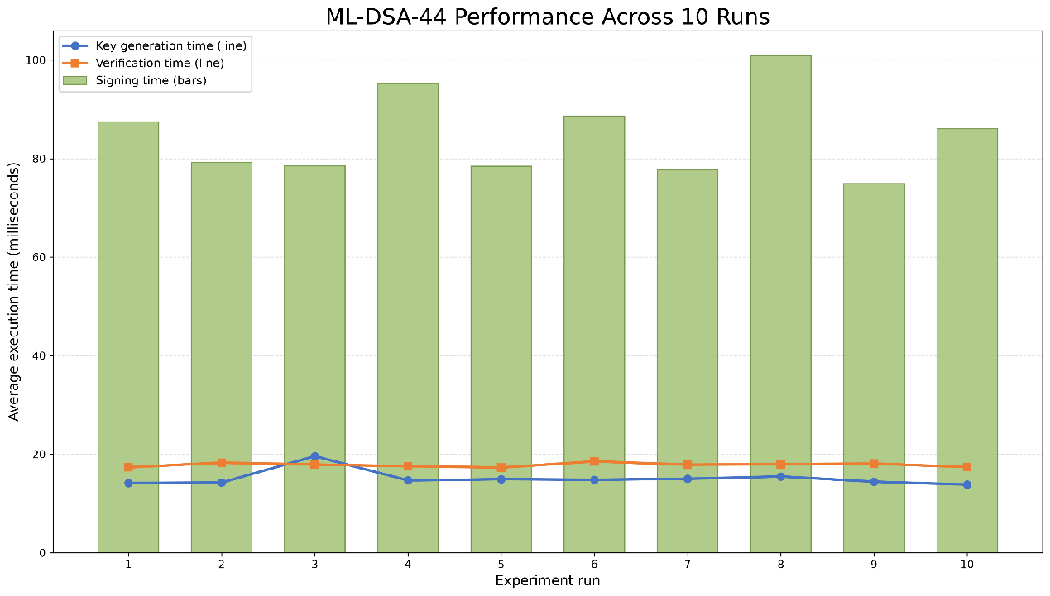
  - Run-to-Run Variation
Figure 7: ML-DSA-44 key-generation, signing and verification performance over ten saved runs.

Figure 7 captures the individual run averages rather than only the overall average. Verification was the most stable ML-DSA operation in terms of consistency and the average run times were 17.300 to 18.540 ms and the standard deviation of the sample was 0.421 ms. This is roughly 2.36% of the verification mean. Signing was more granular from 74.911 to 100.911 ms and there was an average of 8.511 ms, or 10.05% of the verification mean. Key generation had similar variation of about 10.89% in the mean but with 19.601 ms average in run 3 (which was the minimum of our sample). SHA-256 run averages had a relative variation of approximately 6.92%.
The graph thus supports two results. First, signing was the slowest ML-DSA operation, although the exact time varies between runs. Second, verification was faster than signing and more closely clustered on this dataset. These patterns are more useful than the fastest run, since to develop an audit mechanism to be able to account for any variation in the process it would have to consider the best case and not the worst case.
The experiment did not investigate the cause of each fluctuation. The measurements were collected sequentially on a general-purpose local computer without a controlled operating system workload, processor isolation or warm-up phase. Background scheduling, interpreter activity and other local processes may have influenced the results. The value of 10 saved runs is sufficient to show visible variation but too small to give a general performance distribution. A more robust future study would record full hardware and software versions, control background load, use larger samples, report confidence intervals, test multiple message sizes and measure concurrent application workloads.
The experiment also measured library-level operations rather than end-to-end web request latency. It did not include database access, network transfer, key retrieval, certificate processing or protected-key storage. Therefore, the results should be viewed as a comparison of cryptographic overhead on the test computer and not as a prediction of total response time on the production system.
The variation was largest in relative terms for key generation and signing, while verification was more closely grouped. One possibility is that the local machine was just doing regular background work, but the experiment did not extract processor usage and scheduler data and cannot determine the cause. It would be wrong to attribute a particular slow run to the operating system without any evidence. The key point is that the local timing is variable and one run could have concealed that variation.
The maximum signing run average of about 100.91 milliseconds is also relevant to capacity thinking. Designing only around the overall mean could underestimate occasional latency in the tested environment. On the other hand, assuming the maximum of ten runs is a guaranteed worst case would also be unjustified. A larger benchmark should report percentiles over many individual operations, control warm-up and background load, and separate cold key initialization from steady-state work.

  - Storage Overhead

Cryptographic item | Recorded size | Ratio to the 32-byte digest
SHA-256 digest | 32 bytes | 1.000
ML-DSA-44 public key | 1,312 bytes | 41.000
ML-DSA-44 secret key | 2,560 bytes | 80.000
ML-DSA-44 signature | 2,420 bytes | 75.625
Table 6: Cryptographic output sizes recorded by the experiment.

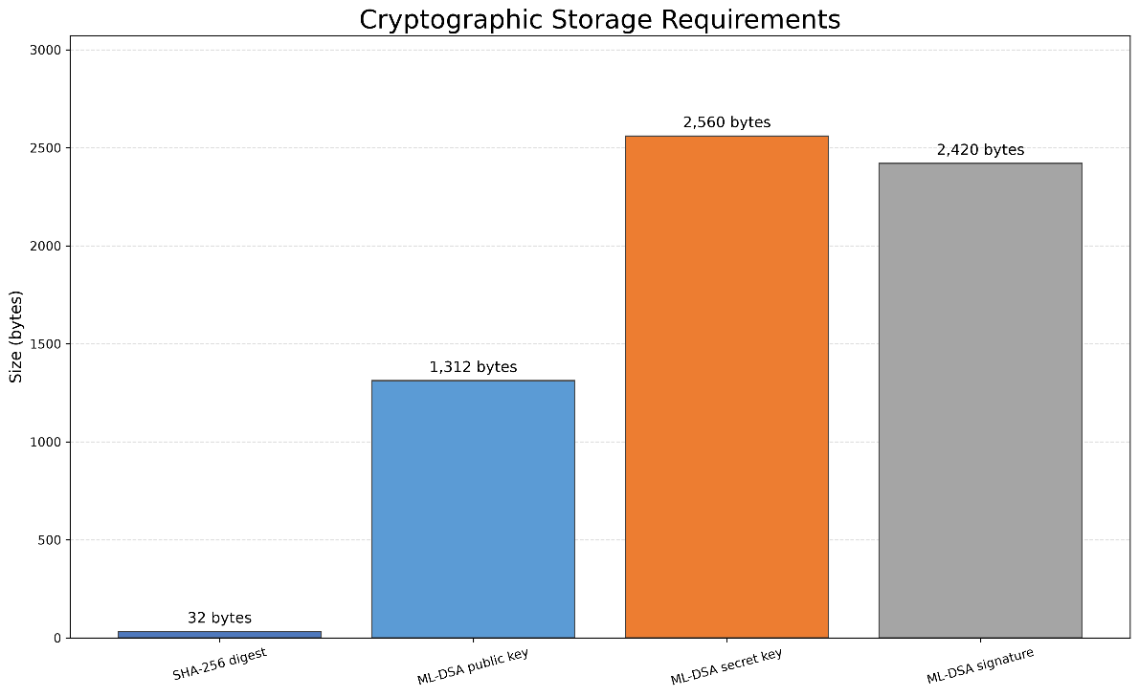

Figure 8: Raw cryptographic storage requirements for SHA-256 and ML-DSA-44.

The most relevant comparison per record is between the 32-byte digest and the 2,420-byte signature. A design that added one ML-DSA-44 signature to every audit entry would add a cryptographic object about 75.6 times the raw size of one SHA-256 digest, before database encoding and metadata were considered. This shows a significant storage and transfer trade-off.
The key sizes can be interpreted differently. A public key and secret key would normally be associated with a signer or deployment context and not copied into every audit record. The 2,560-byte secret key is particularly sensitive since it provides the signing capability defined by ML-DSA (NIST, 2024). Accordingly, protected storage, access control, rotation and recovery arrangements would need to be implemented in a future operational design. Those key-management controls were not done in the experiment and were not implemented in the Flask prototype.
Table 6 shows the raw cryptographic sizes returned by the experiment. The live SQLite audit table stores previous_hash and entry_hash as 64-character hexadecimal strings rather than raw 32-byte values. The graph is thus a comparison of cryptographic artefact sizes, not a measurement of the full database row or file size. A production storage analysis would need to include encoding, column types, indexes, record metadata, public-key identifiers and signature containers.
Storage overhead becomes more pronounced when the number of events is high. One 2,420-byte signature is small in isolation, but signing every entry increases the cost by the number of events and may add database and transport encoding. In comparison to a 32-byte raw digest, the prototype's hexadecimal scale is more compact, and the raw digest can be stored and shown in hexadecimal. Our test supports a qualitative scaling result: per event ML-DSA signatures add more storage than per event SHA-256 digests, and the exact cost of database storage would have to be measured in the system.
Public and private keys should not be counted once per event. A signer could reuse a key pair across many signatures for an approved period, with records carrying a key identifier instead of another complete key copy. The 1,312-byte public key and 2,560-byte secret key describe artefact sizes and key distribution requirements, not necessarily per-row overhead. The private key should usually be in protected key storage instead of the audit database. Any storage model that simply places it beside the signed records would undermine the authenticity control.
Selective signing changes the calculation. If one checkpoint was a batch of audit entries, the signature cost would be amortised over the batch. Larger batches reduce storage and signing frequency but leave a longer interval whose integrity depends on the local chain before the next externally trusted checkpoint. Smaller batches provide more frequent external evidence at greater cost. The current experiment provides the primitive measurements needed to discuss this trade-off but does not identify an optimal interval.
The results indicate the possibility of a selective hybrid approach, but such a hybrid approach has not been implemented in this project. SHA-256 chaining could be used as a lightweight per-event mechanism, while an ML-DSA signature could be applied to selected chain-head values or batch values. This would reduce the number of signatures compared to signing every event. The appropriate interval would depend on threat assumptions, acceptable verification delay, event volume and key-management arrangements. It cannot be selected from timing results alone.

  - Tamper Detection

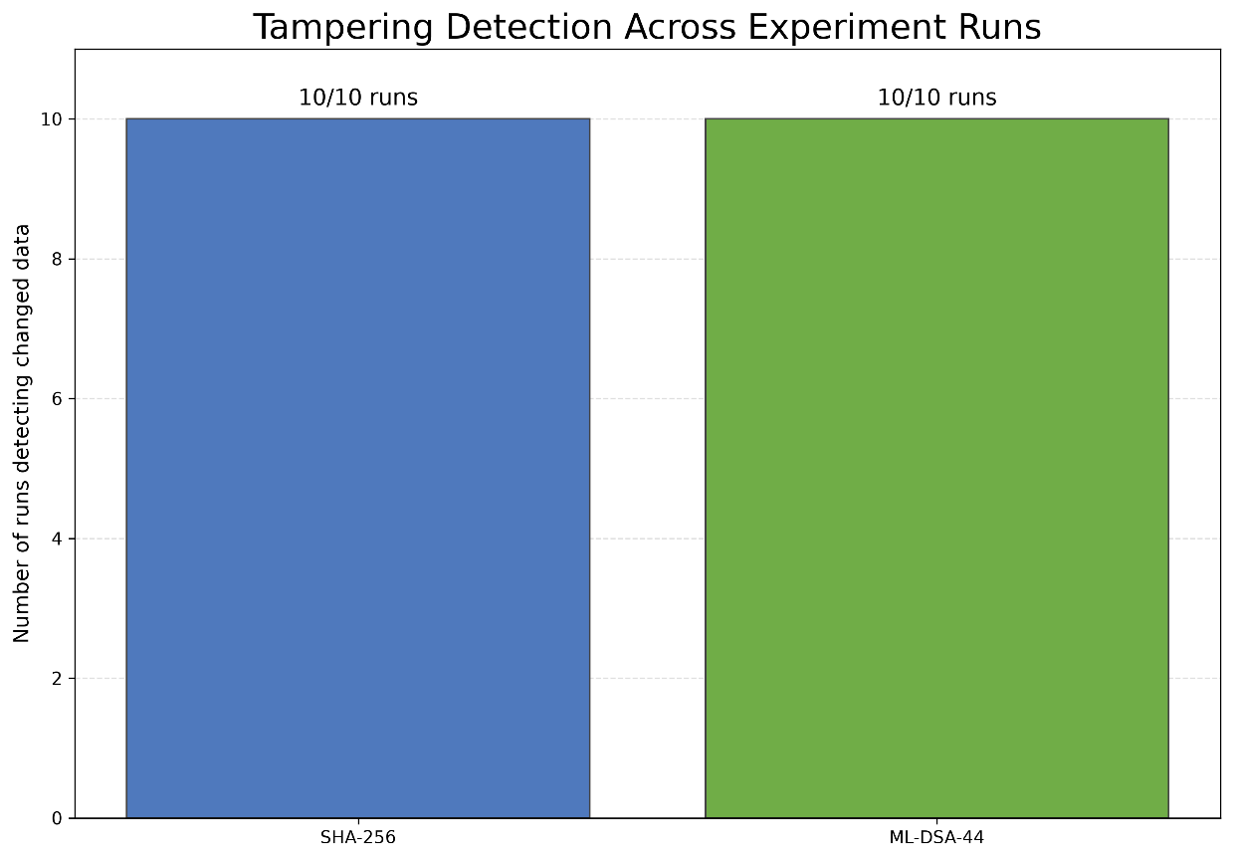
Figure 9: Detection of changed data over the ten saved experiment runs.

One changed-message check was performed in each saved comparison run. For SHA-256, the digest of the changed message is different from the digest of the original message. For ML-DSA-44, the signature created for the original message fails to be verified when compared with the changed message. Both mechanisms detect the change intentionally in all ten saved runs.
The common 10/10 result does not make these mechanisms interchangeable. SHA-256 comparison depends on the verifier having a trusted original digest or trusted chain head. If an attacker can change both the data and every unprotected digest used to validate it, an unkeyed hash alone does not establish who produced the replacement values. ML-DSA verification uses a public key, and a valid signature is generated using the corresponding private key (NIST, 2024), but the resulting origin claim still depends on the private key being protected and the verifier trusting the association between the public key and the signer.
The 100% result is an experimental success rate, not a universal security probability. The test used one known original message, and one deliberately changed message. It did not test stolen keys, replacing a trusted public key, compromised endpoints, implementation defects or manipulation of external checkpoints. It also did not empirically test every form of audit-log deletion or reordering. These scenarios would require a broader adversarial test design.
The changed-message test also assumes that the verifier holds a trusted reference. In the SHA-256 case, comparison has meaning only if the original digest or chain head has not been replaced along with the data. In the ML-DSA case, verification has meaning only if the public key is really associated with the intended signer and the private key was not available to an attacker. The test isolates message modification and holds these trust assumptions unchanged. This makes it repeatable but intentionally narrower than a full attack simulation.
Deletion and reordering of the chain are different for the live audit. Removing an internal event would disrupt the relationship with the previous hash unless all links were rebuilt. Removing entries from the end may be harder to see if no trusted external copy of the latest chain head or expected number of events exists. Maybe there is a checkpoint exported to an independent verifier that would make truncation more visible.
This is also one of the reasons why we suggest an external trust anchor rather than claiming that local chaining alone can prevent tampering.

  - Audit Chain Evaluation: Entry 97

The audit log of the application and the comparison experiment generated two different but related kinds of evidence. The live Flask application used the SHA-256 chaining for its audit records. The comparison script compared a SHA-256 digest and ML-DSA-44 signatures on a fixed simulated message. We did not use ML-DSA to sign the live audit entries.
At the time of the final evidence review, the live database was filled with 161 audit records and the complete chain verified successfully. Each record had the previous entry hash, and verification recalculated every entry in ID order. The final manual test also showed Verification Passed through the administrator interface.
An earlier failure at entry 97 is a more important test of the design. The first GP-assignment form provided identifiers as text. The hash was initially calculated as the string representation, but SQLite returned the stored identifier as an integer. When the verifier serialised the retrieved data, the JSON representation was different from the representation that was hashed. The event had the same practical meaning, but SHA-256 produced a different digest because the input bytes were different.
This was a development flaw in canonical data representation, not malicious change. However, it illustrates a key property of cryptographic integrity controls: deterministic serialisation is part of the security design. Values need to be normalised before hashing so that the writer and verifier construct the same byte sequence. The form handling was improved by converting identifiers to integers before database and audit processing.
This repair was done intentionally. A database backup containing 119 entries is kept, and independent read-only verification for that backup finds entry 97 as the first mismatch. The repair utility refuses to proceed unless entry 97 is the first invalid entry, calculating only previous_hash and entry_hash from entries 97 to 119 and leaving the event fields unchanged. It then adds an AUDIT_CHAIN_REPAIRED maintenance event that explains why it was done. Twenty-three hash link records of the problem are recalculated, and the maintenance event is now entry 120.
The successful repair restores internal consistency but also exposes a limitation of a hash chain stored entirely in the same database. A sufficiently privileged person who can change the database and execute the same code can rebuild the later hashes. The chain is therefore tamper-evident relative to a trusted previous hash or chain head. This does not make modification physically impossible. Evidence and structures for secure and tamper-evident logs are available to defend against re-writes of history (Schneier and Kelsey, 1999; Waters et al., 2004; Crosby and Wallach, 2009). So, it might be better to export some values of the protected chain-head or sign certain checkpoints and therefore provide a stronger external trust reference.
This is because we have a real connection between the live SHA-256 implementation and the separate ML-DSA experiment. The experiment shows the cost and artefact size of a candidate post-quantum signature mechanism, while the entry-97 case shows how a trusted signed checkpoint could benefit. It would still be false to say that the current application has such checkpoints.
The entry-97 episode is also useful as a negative result. If the report only mentioned the final passing chain it would hide a cryptographic property that is critical to cryptographic integrity. The false mismatch showed verification can detect inconsistency without knowing if the cause is malicious. Investigation is still needed to find an attack, corruption, migration issue or serialisation defect. A verifier is therefore an alarm mechanism rather than an automatic judgement about intent.
The limited repair process minimized the risk of rewriting unrelated data. The backup identified entry 97 as the first mismatch, the repair was carried out on the hash-link range, and the maintenance event recorded the reason. Any tool capable of rebuilding a chain is security sensitive. In a better design it should have explicit authorisation, preserve immutable before-and-after evidence, record who approved the repair and prevent the same operator from unilaterally replacing the external trust anchor.
The last chain of 161 records passing verification is proof that the current stored sequence and verifier agreed at the time of review. It is not retrospective proof that all the events were complete or truthful when written. A logging function could skip one event or write an error in the target and still have a mathematically consistent chain. Integrity verification must be combined with coverage testing, log review and controls over the code that generates events.

  - Evaluation of Objectives

Objective | Assessment | Evidence and qualification
Review EHR security, access control, auditing and post-quantum concepts. | Substantially achieved final citation audit required. | Chapter 2 addresses the intended subjects, but all academic references must be verified, and the final discussion must use a sufficient range of credible sources.
Develop a five-role Flask prototype. | Achieved within prototype scope. | Administrator, patient, doctor, nurse and GP users authenticate and receive role-specific functions or dashboards.
Enforce patient ownership and clinician assignments on the server. | Achieved for the tested scenarios. | Positive and negative URL tests confirmed patient ownership and assignment checks. Coverage remains manual and limited to the selected accounts and routes.
Provide website workflows for account creation, GP registration and clinician assignment. | Achieved | The administrator created fictional patient and staff accounts and assigned GPs, doctors and nurses through website forms; assignment changes affected dashboards.
Record detailed events and protect their ordering using a SHA-256 chain. | Achieved as a local prototype. | The audit interface recorded successful and denied events, the final 161-entry chain verified, and a representation mismatch was detected. There is no external trust anchor.
Compare SHA-256 and ML-DSA-44 time, storage and controlled tamper detection | Achieved experimentally | Ten saved runs measured the specified operations and sizes. ML-DSA remained separate from the live audit chain, and results are specific to one local environment and parameter set.
Critically evaluate the prototype and its limitations. | In progress until the report is finalised. | This chapter identifies security, experimental and validity limitations; the conclusion and self-evaluation must complete the assessment.
Table 7: Critical assessment of objective achievement.

In contrast to the original research question, the prototype enforced the selected role and record-level permissions and maintained a verifiable tamper-evident audit history in the tested local scenarios. The answer should be properly qualified, since the access control was manual and small-scale and the audit chain had no independent external anchor.
The separate ML-DSA evaluation extends the project by quantifying a possible authenticity control. It does not demonstrate an operational SHA-256-plus-ML-DSA audit architecture. As such, the experiment is an important recommendation for future design, but it does not provide the proof that the live audit log already provides digital-signature authenticity or non-repudiation.

  - Discussion of Findings

The main implementation contribution is connecting administrative action, dynamic relationship data, route-level enforcement and audit evidence. The prototype does not just show different pages to different roles. It stores patient-clinician relationships, uses those relationships when a record is requested, records both successful and denied outcomes, and allows an administrator to verify the resulting audit chain. This end-to-end behaviour addresses the central project problem more directly than a demonstration based only on login and menu visibility.
The negative access results are significant because they show defence at the point where the protected object is requested. There are still numeric identifiers in the URLs, but knowledge of an identifier did not grant access in the tested scenarios. Obscuring or replacing sequential identifiers could improve presentation and decrease casual enumeration, but it would not replace the server-side authorisation check.

The cryptographic results show that there is a trade-off, rather than an arms race between the two algorithms. SHA-256 was extremely fast and compact for the linkage to an entry, but it does not identify the creator of an entry. ML-DSA-44 offered a standardised public/private-key signature operation to defend against attack from conventional and sufficiently powerful quantum computers, but signing was much slower and the signature was much larger than a digest (NIST, 2024).
Thus, the results suggest a layered future design: efficient SHA-256 chaining for every event, backed by protected or digitally signed checkpoints where stronger evidence of origin is needed. This is an implication derived from the measured overhead and the trust limitation of the local chain. We do not claim that the proposed hybrid design was implemented or clinically validated.
The research question has two connected answers. First, the prototype we tested enforced the role and relationship rules as demonstrated by the ten manual situations. Patients were restricted to their linked fictional record, and doctors were restricted to assignment or GP registration. Direct URL requests were rejected by the server, not simply excluded from navigation. Second, the cryptographic comparison shows that adding a signature (public or private) to the system changes the level of assurance and resources required. SHA-256 is suitable for compact sequential integrity evidence, and ML-DSA-44 adds a post-quantum origin verification mechanism with significantly larger artefacts and longer operations. Neither answer supports the unrestricted claim that the application is secure against all attacks.
These results also show how functional integration is key. Account creation, assignment and GP registration are not peripheral interface elements in this system; they are what set the foundation of the relationships that are used for later authorisation decisions. Their security significance lies in the state transition. Before assignment a new clinician has no patients to see; after an administrator makes an assignment the patient appears, and the path leads to the patient. The audit then records the administrative action. This sequence connects user interface, database state, authorisation and accountability, providing more evidence than just showing screenshots of each page.
The denial tests are negative assurance that successful demonstrations alone cannot provide. A doctor seeing an assigned record shows that work is available, but only the unassigned-record test is against the boundary. A patient dashboard with only one record does not show isolation unless another known identifier is requested and rejected. This does not make the manual tests exhaustive, but this does align the evaluation with the threat we are dealing with an authenticated user who wants to go beyond the relationship in the database.
The entry-97 incident also changes the interpretation of success. This report which mentions only the final passing verification would imply that implementing SHA-256 is sufficient. The earlier failure demonstrates that deterministic serialisation is a part of the security mechanism. The verifier handled different bytes correctly even if it was a string/integer representation rather than malicious tampering. This is a valuable result because it shows that the implementation dependency is there and so cryptographic primitives need to be embedded in the right data formats.
On an assurance side, the repair is a strength and a weakness. Retaining a backup, constraining the repair range and adding an AUDIT_CHAIN_REPAIRED event made the maintenance action visible. But the existence of a repair tool shows that a sufficiently authorised process can reconstruct local chain values. The chain therefore detects inconsistency compared to trusted evidence; it does not guarantee immutability. Schneier and Kelsey (1999), Waters et al. (2004) and Crosby and Wallach (2009) provide a richer context for designs to protect verification evidence and make history reconstruction more challenging. The external-checkpoint recommendation in the project is based on this trust analysis, not the speed comparison.

    - Hybrid Audit Design

In a possible hybrid architecture, each audit event would continue to contain the previous SHA-256 digest so that the local sequence could be checked efficiently. At a given time, the application or a trusted service would sign the current chain head using an ML-DSA private key. The signed checkpoint, its timestamp, key identifier and covered event range would be copied to storage or a verifier outside the main audit database. An investigator could check both the internal links and the signature protecting the selected chain head.
This would improve the evidence available against large-scale chain reconstruction, but it also involves new responsibilities. The signing service needs to be authenticated, the private key protected and rotated, public keys distributed through a trusted process, failed signing operations handled, and checkpoints retained for at least as long as the relevant logs. Clock consistency and event ordering would also matter. The experiment does not assess these operational elements, so the recommendation remains conceptual.
Public-key trust is as important as private-key secrecy. An investigator can verify a signature only after establishing which public key belongs to the intended signing authority and whether that key was valid at the checkpoint time. Key identifiers, activation and retirement dates, revocation status and protected historical public keys would therefore be part of the evidence. FIPS 204 defines the ML-DSA operations and parameter sets (NIST, 2024), but this project did not have a public-key infrastructure or key lifecycle. The hybrid proposal therefore must be a future architecture instead of a feature derived from successful library-level verification.

  - Limitations and Validity

The findings are subjected to the following limitations:
- Prototype environment. The application is a local academic prototype built using fictional records, Flask development server and SQLite. It has not been deployed in a healthcare organization and no claims for clinical, legal or regulatory compliance are made.
- Small test population. Testing was performed with a small number of accounts, three fictional patient records and certain assignments. Behaviour with large datasets, concurrent users or long-running operation was not tested.
- Manual coverage. Ten structured tests were passed but no automated regression, unit, integration or security test suite was implemented. Unanticipated parameter combinations and less obvious routes may also be missed.
- No professional security assessment. The system has not been tested for penetration, independent code review or clinical information governance analysis.
- Development configuration. The application contains a hard-coded temporary Flask secret and is running with debug mode. These choices are not appropriate for production and therefore the system should only be described as a demonstration.
- Authentication limitations. Passwords are hashed, but there is no multi-factor authentication, account lockout, advanced rate limiting, password reset workflow or enforced change of temporary passwords at first login.
- Request protection. State-changing forms do not have CSRF protection. HTTPS/TLS and hardened cookie settings were not set up or tested.
- Administrative trust. The administrator account can perform powerful operations with a rather simple interface. More separation of duties, re-authentication at sensitive moments and more detailed administrative controls would be required in a production design.
- Audit trust boundaries. Events and hashes are stored in the same local database. The chain has inconsistent history compared to its starting assumptions but does not stop a privileged attacker from rebuilding the chain or from replacing an unprotected final chain head.
- Plain access denied responses. Denials are correct but not styled-based. This has a more significant impact on usability and presentation than server-side decision making.
- Different ML-DSA scope. We evaluated ML-DSA-44 in our own scripts. We did not use private-key storage, rotation, public key distribution, revocation and live checkpoint signing.
- Experimental scale. The timing results are based on ten saved runs, 30 internal tests per run, one short, fixed message, one local computer, one Python implementation and one set of parameters for ML-DSA.
- Measurement scope. The benchmark is about cryptographic calls not the end-to-end application latency. It does not consider databases, network and protected-key-service overhead.
- Construct validity. SHA-256 hashing and ML-DSA signing are different security services. Direct timing and size comparisons describe overhead but do not compare mathematical security strength or show that one is a substitute for the other.
- Controlled tampering only. The 10/10 result is concerned with a deliberately changed message. It does not show a universal tamper detection probability or capture key compromise, external trust replacement and all database manipulation scenarios.
These boundaries don’t erase the value of the results. They define the level at which the conclusions are defensible: the project shows a working local access control and tamper-evident logging prototype, provides reproducible measurements from its test environment, and identifies a plausible post-quantum enhancement for further investigation. It does not demonstrate a production-ready EHR security system.
The validity limitations are connected rather than independent of one another. In this case, the small test population makes manual testing possible but also reduces the chance of finding unusual assignment combinations. The local development environment makes implementation transparent but prevents claims about concurrent performance or hardened deployment. And the standalone ML-DSA script removes cryptographic overhead, making it easier to see how the measured operations work, but it reduces any claim about full application latency. These are design trade-offs in the evaluation rather than problems that can be overcome by a more confident reading.
There is also the risk of confirmation bias, as the developer was responsible for the manual testing. The results were expected in advance, and screenshots only provide some of the information. Clear procedures and results will add to transparency, but independent repetition would provide stronger evidence. Automated tests would avoid inconsistency and support regression checking, as would an independent review that could include other identifiers, incorrect inputs and workflow sequences that the developer did not have in mind. Professional penetration testing would address a broader threat model, but automated scanners would still need to be seen as supporting tools rather than as 100% assurance (Alazmi and de Leon, 2022).
The generalisability should remain limited to the architectural lessons. The exact timing values are for the local computer, software implementation, message and measurement process. The access control results describe the implemented schema and selected routes. What can transfer more generally is the reasoning: visible navigation does not replace server-side authorisation; relationship state needs to be checked at the requested record; meaningful audit events need context; hash-chain evidence relies on deterministic serialisation and a trusted anchor; and digital signatures introduce key-management responsibilities. These are reasonable arguments that are backed by the project and literature, not claims that the prototype can be deployed unchanged.

CHAPTER 6: CONCLUSION AND FUTURE WORK

  - Conclusion

This project developed and tested a secure simulated EHR prototype. It implemented authenticated role dashboards, patient ownership checks, assignment-based clinician access, in-website account and assignment management, GP registration workflow, detailed audit events and SHA-256 hash-chain verification. Ten manual tests were carried out - deliberate unauthorised record requests and post-logout route access.
The cryptographic experiment achieved ten saved runs. The SHA-256 hashing rate was 0.001724 ms and produced a 32-byte digest, while the ML-DSA-44 hashing rate was 15.11 ms for key generation, 84.71 ms for signing and 17.83 ms for verification to have 1,312 bytes of public keys, 2,560 bytes of secret keys and 2,420 bytes of signatures. Both algorithms detected controlled message modification in all ten runs. These results demonstrate the convenience of the hashing process but also the cost of post-quantum digital signatures, highlighting the different security features of these two approaches.
The objectives were achieved at prototype level. This isn’t a production EHR, but it is evidence that least privilege access, object-level checks, operational workflows and tamper-evident auditing can be combined in an understandable system and evaluated through positive, negative and empirical tests.

  - Future Work

Future work needs to focus on:
- Automated unit, integration and end-to-end tests for every role and route.
- CSRF protection, login throttling, more session configuration and security headers.
- Production deployment behind TLS with environment-managed secrets and production database.
- A role/permission policy and administrator process for disabling accounts.
- Threat modelling, vulnerability assessment and independent penetration testing as automated web scanners are not 100% secure and have coverage and effectiveness limitations and must not be considered a full assurance (Alazmi and de Leon, 2022).
- FHIR-compatible data structures and interoperability testing.
- external immutable or append-only audit checkpoints.
- ML-DSA signing of periodic audit-chain checkpoints with private key management.
- Comparison of ML-DSA-44 with other parameter sets and signature schemes.
- More benchmark samples on the same hardware available and on different hardware, and the quality of the results reported by.
The most applicable cryptographic extension would be a hybrid checkpoint mechanism: every event would be cheaply linked with SHA-256 and selected chain roots signed with ML-DSA-44 and copied to an independent verifier. This would connect the experiment to the application without requiring a large signature on every row. Future work should be staged rather than attempted as one production conversion. The first stage should reduce the application risk in real-time through automated authorisation testing, CSRF protection, secure configuration, session hardening and removal of development secrets and debug mode. A second stage should improve assurance through structured threat modelling, independent code review, penetration testing and tests on larger datasets and concurrent users. Only after these controls are stable can the cryptographic checkpoint design be integrated, since a strong signature would not compensate for an application that gives the wrong user access.
The checkpoint research should begin with a small proof of concept separate from the current audit table. It should detail which service owns the private key, how the public key is trusted, what event range each checkpoint covers, where checkpoints are stored, what happens when signing fails and how rotation is represented. Tests should include message modification, deletion, reordering, truncation, public-key replacement and key compromise scenarios. The performance experiment should then be repeated from the beginning and end, including database storage and verification of a growing history.
Production-based evaluation would also require stakeholder and governance input. Clinicians and administrators would need to confirm that role and assignment rules reflect actual responsibilities, and information-governance and security professionals would need to assess logging content, retention, access to audit data and incident response. As the current records are fictional and the application is local, the project appropriately avoids claiming that these organisational questions have been resolved.

CHAPTER 7: CRITICAL SELF EVALUATION

  - Personal Performance

In this project I had to go from the learning of individual programming and security concepts to implementing them in a working prototype. At the beginning of the project, I had limited experience with Python, Flask, HTML and CSS. Building the prototype required me to learn how those technologies worked and how they were integrated into a security-oriented web application. Over time, I got better at Flask routes, sessions, SQL queries, password hashing, server-side authorisation and audit logging.
The simplest change to my approach was to view the application from the perspective of the unauthorised user. I was interested in whether legitimate users could log in and get to the correct pages. However, as the project developed I realized that successful navigation was only part of security testing. I also needed to test what happens when a user changed a patient identifier in the URL, attempted to open an administrator page, accessed a record without an assignment, or revisited a protected page after logging out. It helped me to transition from functional testing to more security-focused testing.
I also had to adapt when the scope of the project changed after supervisor feedback. The original focus turned into a comparison between SHA-256 and ML-DSA-44. This required me to learn about post-quantum digital signatures and understand that both a hashing algorithm and a digital signature algorithm have different security properties. Adapting the project to a different scope made it more difficult but it helped the evaluation, giving the project a clearer experimental component.
All in all, I believe my performance improved during the project. I became more independent in investigating errors, more methodical when I took notes and more guarded in making claims about security. It was the project that really made me realize that I must work on my early planning to start with automated testing, and how to allocate the time I used for report writing better.

  - Strengths

A principal strength of my work was the successful integration of several security controls within one prototype. The application combines authentication, role checks and patient-specific authorisation. For example, assigning the role of doctor does not provide access to every patient record; the requested patient must also be assigned to that doctor. Patients are similarly restricted to the record linked to their own account.
I also implemented the main administrative workflows through the website. The administrator can create fictional patient and staff accounts, process GP-registration requests and assign patients to GPs, doctors and nurses. These operations produce audit events and affect the records subsequently displayed on clinician dashboards.
Another strength was testing unauthorised behaviour as well as successful actions. The manual tests included direct URL manipulation, attempts to open administrator pages using other roles and access to protected pages after logout. All ten planned tests produced the expected results.
I also maintained a project journal and retained screenshots, CSV results and graphs. This evidence helped me explain the project’s development accurately, including the change of scope and the audit-chain representation defect.

  - Areas for Improvement

The main area I would improve is the timing of testing and report preparation. Some workflows were completed relatively close to the submission deadline, leaving less time for automated testing and critical analysis. In a future project, I would establish an earlier feature-freeze date and reserve a defined period for evaluation and writing.
The prototype was evaluated through ten manual tests, but it does not have a comprehensive automated test suite. Although the manual tests provided evidence for the selected scenarios, automated tests would allow authentication, role restrictions, assignments and denial conditions to be checked repeatedly after every code change.
I would also define the experimental methodology earlier. The final SHA-256 and ML-DSA comparison became clearer after the number of runs, internal tests and output fields had been standardised. Recording the hardware, library versions and configuration automatically would further improve reproducibility.
Finally, the administrator account holds several powerful permissions, including account creation, clinician assignment and audit-chain maintenance. These were necessary for the prototype, but a stronger design would separate responsibilities and require additional protection for sensitive administrative actions.

  - Lessons Learned

This project demonstrated that RBAC alone is not sufficiently precise for patient-record access. A role identifies a general category of user but does not establish a relationship with a particular patient. The assignment table was therefore necessary to enforce record-level access for doctors, nurses and GPs.
Another important lesson was that the audit-chain verification failure at entry 97 came from identifiers being hashed as strings when received from an HTML form but later returned as integers by SQLite. This showed that cryptographic integrity is dependent on consistent serialisation and the choice of algorithm. The issue was treated as a development defect, not a sign of malicious tampering, and repaired by an AUDIT_CHAIN_REPAIRED event.
The experiment also taught me that SHA-256 and ML-DSA-44 cannot be regarded as interchangeable. SHA-256 is effective for integrity checks and produces a small digest. ML-DSA-44 is useful for post-quantum digital signatures and public key verification, but it takes much more time and storage space. A future design could use SHA-256 chaining for routine audit integrity and ML-DSA signatures at selected checkpoints provided secure key management was implemented.
Finally, testing direct URLs showed that hiding links is not an effective security control. Whenever the server receives a request, the authorisation must be enforced. A correctly denied request was as important in the evaluation as a successful authorised action.

  - Overall Reflection

In the end, the project accomplished its main educational objectives. I built a working simulated EHR prototype with five roles, patient-specific access restrictions, administrative workflows, audit logging and SHA-256 chain verification. I also conducted an experimental study on SHA-256 and ML-DSA-44.
The project has strengthened my practical knowledge on Flask development, database relationships, server-side authorisation and cryptographic testing. It has also taught me to focus my conclusions on the best evidence available. Ten manual tests do not prove universal security, and the experimental use of ML-DSA does not mean that the live application is post-quantum secure.
If I repeated the project again, I would start with automated testing sooner, finalise the experimental design earlier, and save more time for analysis. However, the completed prototype shows that the project's security controls were put in place and evaluated in the academic context of the project.

REFERENCES

- National Institute of Standards and Technology (2024) Module-Lattice-Based Digital Signature Standard. FIPS 204. Gaithersburg, MD. Available at: https://doi.org/10.6028/NIST.FIPS.204
- European Union (2016) Regulation (EU) 2016/679 of the European Parliament and of the Council (General Data Protection Regulation). Available at: http://data.europa.eu/eli/reg/2016/679/oj
- Information Commissioner’s Office (2023) A guide to data security. Available at: https://ico.org.uk/for-organisations/uk-gdpr-guidance-and-resources/security/a-guide-to-data-security/
- Fernández-Alemán, J.L., Señor, I.C., Lozoya, P.Á.O. and Toval, A., 2013. Security and privacy in electronic health records: A systematic literature review. Journal of biomedical informatics, 46(3), pp.541-562. Available at: https://doi.org/10.1016/j.jbi.2012.12.003
- Shojaei, P., Vlahu-Gjorgievska, E. and Chow, Y.W., 2024. Security and privacy of technologies in health information systems: A systematic literature review. Computers, 13(2), p.41. Available at: https://doi.org/10.3390/computers13020041
- Cobrado, U.N., Sharief, S., Regahal, N.G., Zepka, E., Mamauag, M. and Velasco, L.C., 2024. Access control solutions in electronic health record systems: A systematic review. Informatics in Medicine Unlocked, 49, p.101552. Available at: https://doi.org/10.1016/j.imu.2024.101552
- Anderson, R.J., 1996, May. A security policy model for clinical information systems. In Proceedings 1996 IEEE Symposium on Security and Privacy (pp. 30-43). IEEE. Available at: https://doi.org/10.1109/SECPRI.1996.502667
- NHS England, Outcomes, Assertions and Evidence items for the Data Security and Protection Toolkit 2025-26 version 8 (18 September 2025). Available at: https://www.dsptoolkit.nhs.uk/News/161
- Temoshok, D., Fenton, J., Choong, Y.Y., Lefkovitz, N., Regenscheid, A. and Richer, J., 2024. Digital identity guidelines: Authentication and authenticator management (No. NIST Special Publication (SP) 800-63B-4 (Withdrawn)). National Institute of Standards and Technology. Available at: https://doi.org/10.6028/NIST.SP.800-63B-4.2pd
- Ferraiolo, D.F. and Kuhn, D.R., 2009. Role-based access controls. arXiv preprint arXiv:0903.2171. Available at: https://csrc.nist.gov/pubs/conference/1992/10/13/rolebased-access-controls/final
- Sandhu, R.S., Coyne, E.J., Feinstein, H.L. and Youman, C.E., 1996. Role-based access control models. Computer, 29(2), pp.38-47. Available at: https://doi.org/10.1109/2.485845
- Sandhu, R.S., 1998. Role-based access control. In Advances in computers (Vol. 46, pp. 237-286). Elsevier. Available at: https://doi.org/10.1016/S0065-2458(08)60206-5
- Barkley, J., Cincotta, A., Ferraiolo, D., Gavrila, S. and Kuhn, D.R., 1997, April. Role based access control for the world wide web. In 20th National Computer Security Conference (Vol. 991, pp. 331-340). Available at: https://www.nist.gov/publications/role-based-access-control-world-wide-web
- Ferraiolo, D.F., Sandhu, R., Gavrila, S., Kuhn, D.R. and Chandramouli, R., 2001. Proposed NIST standard for role-based access control. ACM Transactions on Information and System Security (TISSEC), 4(3), pp.224-274. Available at: https://doi.org/10.1145/501978.501980
- Blobel, B., 2004. Authorisation and access control for electronic health record systems. International journal of medical informatics, 73(3), pp.251-257. Available at: https://doi.org/10.1016/j.ijmedinf.2003.11.018
- Motta, G.H. and Furuie, S.S., 2003. A contextual role-based access control authorization model for electronic patient record. IEEE Transactions on information technology in biomedicine, 7(3), pp.202-207. Available at: https://doi.org/10.1109/TITB.2003.816562
- Rizvi, S.Z.R., Fong, P.W., Crampton, J. and Sellwood, J., 2015, June. Relationship-based access control for an open-source medical records system. In Proceedings of the 20th ACM symposium on access control models and technologies (pp. 113-124). Available at: https://doi.org/10.1145/2752952.2752962
- Zhang, W., Gunter, C.A., Liebovitz, D., Tian, J. and Malin, B., 2011, October. Role prediction using electronic medical record system audits. In AMIA Annual Symposium Proceedings (Vol. 2011, p. 858). Available at: https://pmc.ncbi.nlm.nih.gov/articles/PMC3243238/
- de Carvalho Junior, M.A. and Bandiera-Paiva, P., 2018. Health Information System Role‐Based Access Control Current Security Trends and Challenges. Journal of healthcare engineering, 2018(1), p.6510249. Available at: https://doi.org/10.1155/2018/6510249
- Kent, K. and Souppaya, M., 2006. Guide to computer security log management. NIST special publication, 92, pp.1-72. Available at: https://csrc.nist.rip/library/NIST%20SP%20800-092%20Guide%20to%20Computer%20Security%20Log%20Management,%202006-09.pdf
- King, J. and Williams, L., 2012. Secure logging and auditing in electronic health records systems: What can we learn from the payment card industry position paper. Usenix HealthSec'12. Available at: https://www.usenix.org/system/files/conference/healthsec12/healthsec12-final13.pdf
- Rostad, L. and Edsberg, O., 2006, December. A study of access control requirements for healthcare systems based on audit trails from access logs. In 2006 22nd Annual Computer Security Applications Conference (ACSAC'06) (pp. 175-186). IEEE. Available at: https://doi.org/10.1109/ACSAC.2006.8
- International Organization for Standardization (2021) ISO 27789:2021 Health informatics—Audit trails for electronic health records. 2nd edn. Geneva: ISO. Available at: https://www.iso.org/standard/75313.html#draft
- HL7 International (2023) AuditEvent—FHIR v5.0.0. Available at: https://hl7.org/fhir/auditevent.html
- Dekker, M.A.C. and Etalle, S., 2007. Audit-based access control for electronic health records. Electronic notes in theoretical computer science, 168, pp.221-236. Available at: https://doi.org/10.1016/j.entcs.2006.08.028
- National Institute of Standards and Technology (2015) Secure Hash Standard (SHS). FIPS PUB 180-4. Gaithersburg, MD: NIST. Available at: https://nvlpubs.nist.gov/nistpubs/FIPS/NIST.FIPS.180-4.pdf
- Haber, S., Stornetta, W.S. (1991). How to Time-Stamp a Digital Document. In: Menezes, A.J., Vanstone, S.A. (eds) Advances in Cryptology-CRYPTO’ 90. CRYPTO 1990. Lecture Notes in Computer Science, vol 537. Springer, Berlin, Heidelberg. Available at: https://doi.org/10.1007/3-540-38424-3_32
- Schneier, B. and Kelsey, J., 1999. Secure audit logs to support computer forensics. ACM Transactions on Information and System Security (TISSEC), 2(2), pp.159-176. Available at: https://doi.org/10.1145/317087.317089
- Waters, B.R., Balfanz, D., Durfee, G. and Smetters, D.K., 2004, February. Building an encrypted and searchable audit log. In NDSS (Vol. 4, pp. 5-6). Available at: https://people.cs.georgetown.edu/~clay/classes/fall2014/papers/Building_an_Encrypted_and_Searchable_Audit_Log.pdf
- Crosby, S.A. and Wallach, D.S., 2009, August. Efficient data structures for tamper-evident logging. In USENIX security symposium (pp. 317-334). Available at: https://www.usenix.org/legacy/event/sec09/tech/full_papers/crosby.pdf
- Azaria, A., Ekblaw, A., Vieira, T. and Lippman, A., 2016, August. Medrec: Using blockchain for medical data access and permission management. In 2016 2nd international conference on open and big data (OBD) (pp. 25-30). IEEE. Available at: https://doi.org/10.1109/OBD.2016.11
- Mayer, A.H., Da Costa, C.A. and Righi, R.D.R., 2020. Electronic health records in a Blockchain: A systematic review. Health informatics journal, 26(2), pp.1273-1288. Available at: https://doi.org/10.1177/1460458219866350
- Pallets Projects (2026) Deploying to Production: Flask Documentation 3.1.x. Version 3.1.3, released 18 February 2026. Available at: https://flask.palletsprojects.com/en/stable/deploying/
- Alazmi, S. and De Leon, D.C., 2022. A systematic literature review on the characteristics and effectiveness of web application vulnerability scanners. IEEe Access, 10, pp.33200-33219. Available at: https://doi.org/10.1109/ACCESS.2022.3161522

APPENDIX A: DETAILED MANUAL TEST RECORD

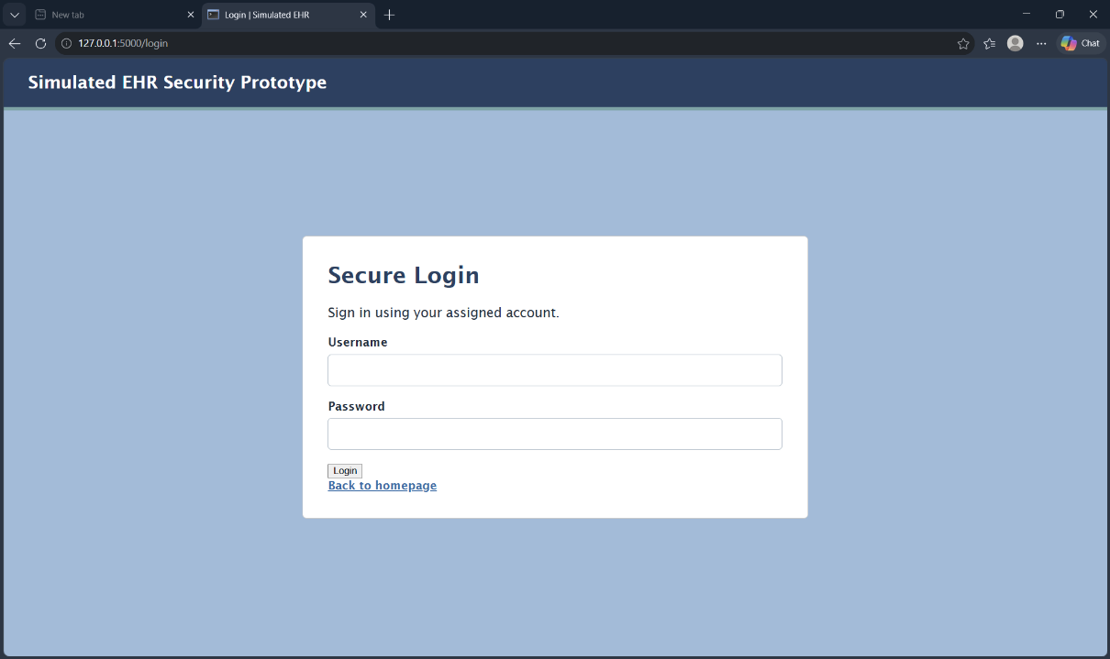

Figure A 1: Login page displayed following authentication failure or logout.
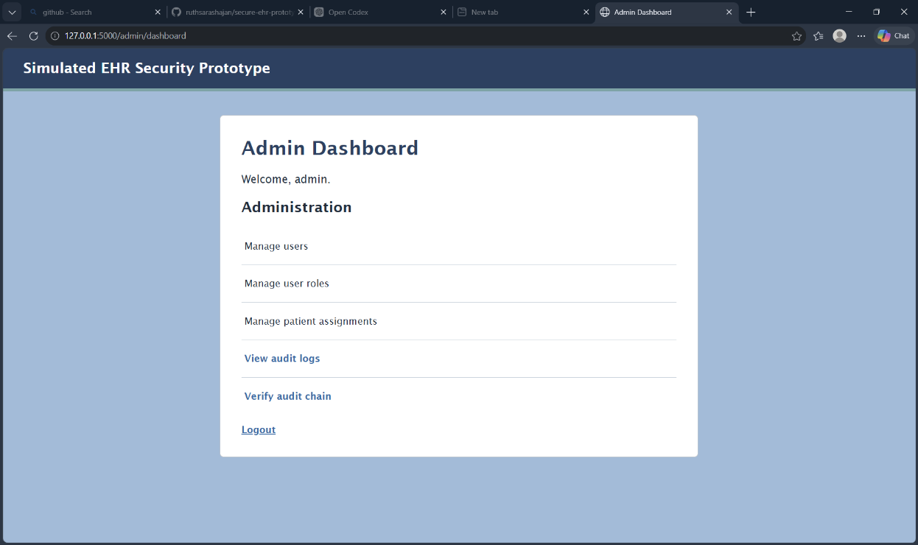
Figure A 2: Administrator successfully accessing protected administrative functions.

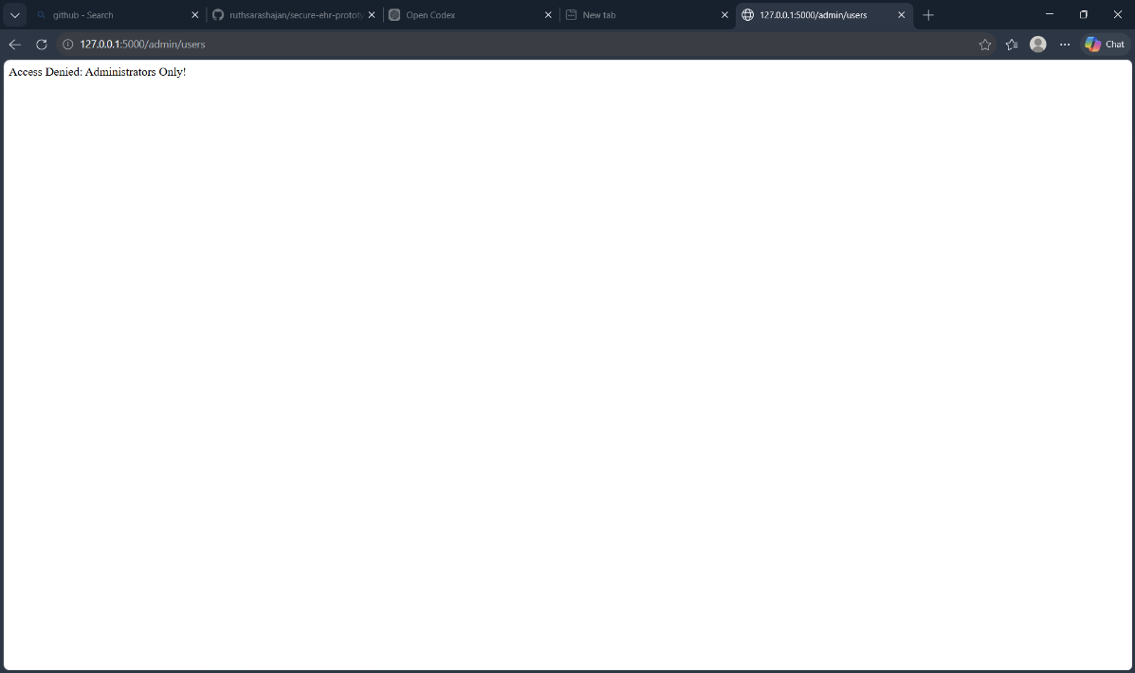

Figure A 3: Non-administrator access to the system-user page rejected by the server.
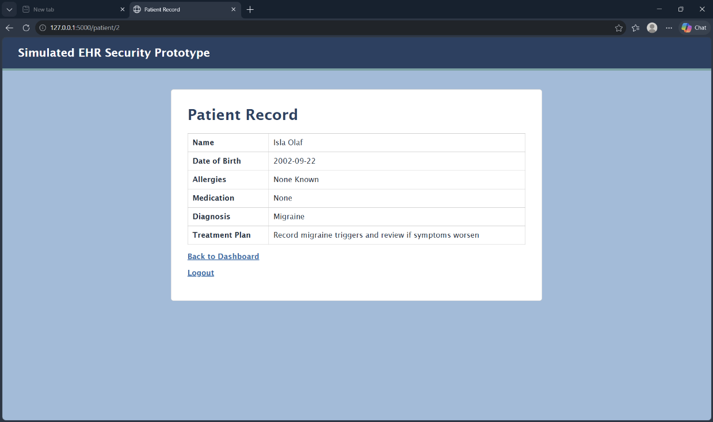
Figure A 4: Authorised access to the fictional patient record.


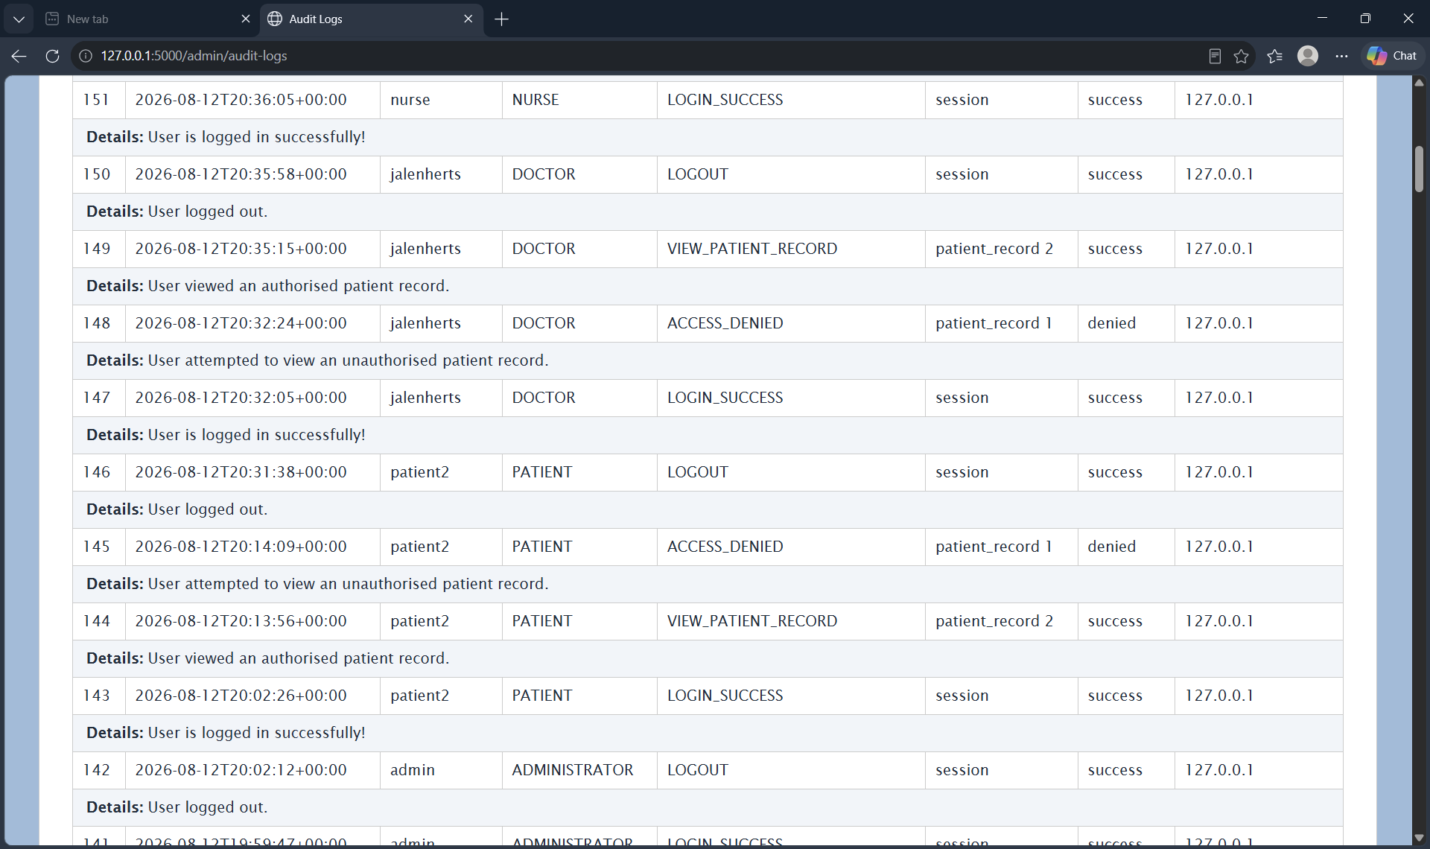
Figure A 6: Successful verification of the SHA-256 audit-log chain.
Figure A 5: Audit records showing authorised and denied patient-record access.

APPENDIX B: CRYPTOGRAPHIC EXPERIMENT RECORD

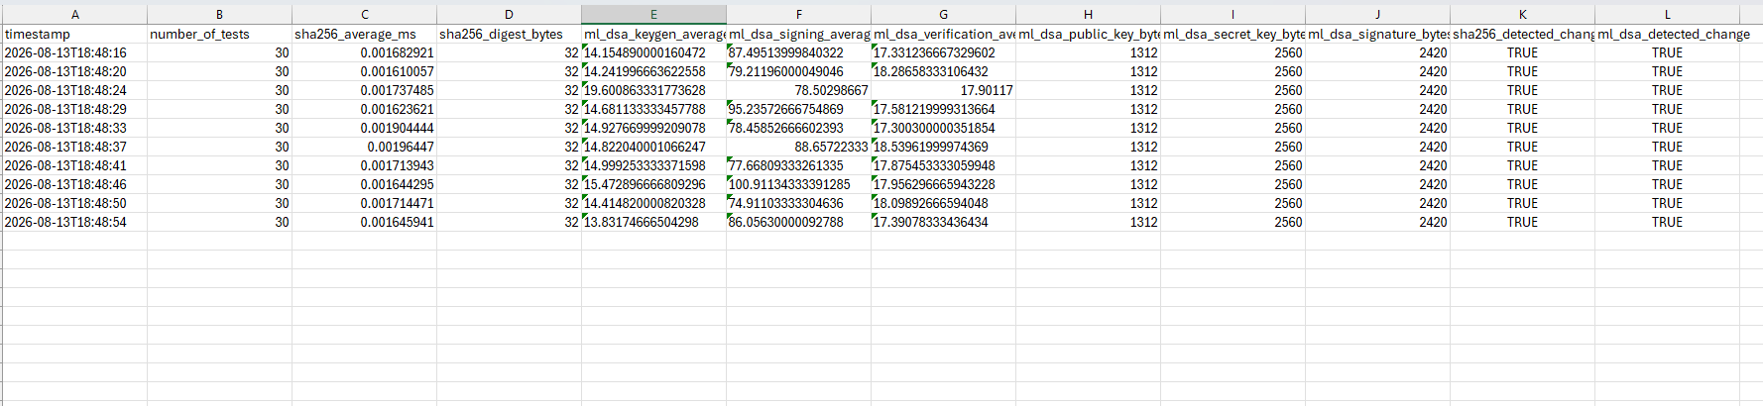
Table B 1: Raw results from the ten saved SHA-256 and ML-DSA-44 comparison runs.

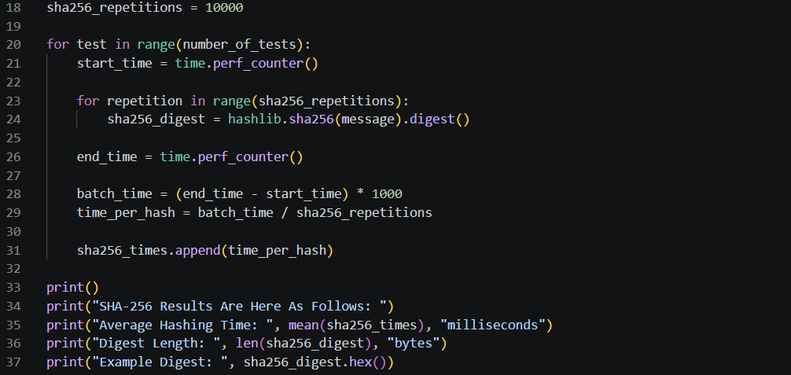
Listing B 1: Repeated SHA-256 timing procedure using 10,000 hash operations per measurement.

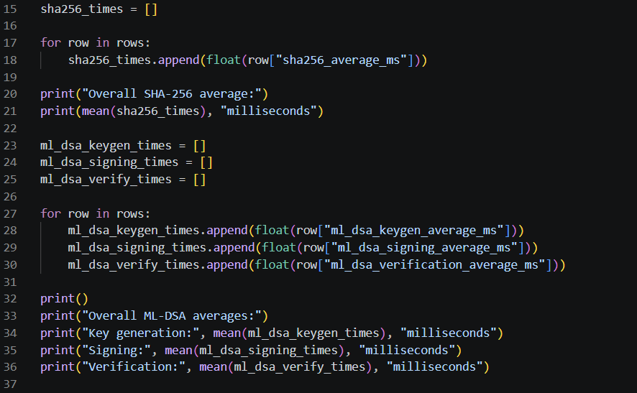
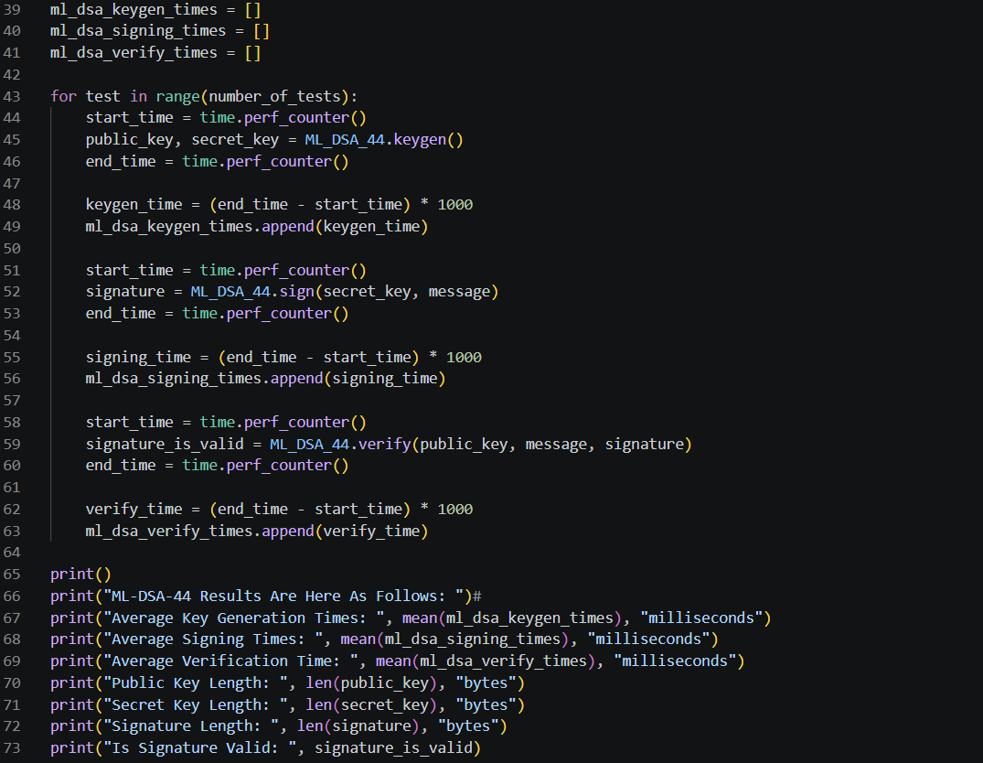
Listing B 3: Calculation of aggregate performance results from the ten saved experiment runs.
Listing B 2: ML-DSA-44 key generation, signing, verification and controlled changed-message testing.

APPENDIX C: SELECTED PROTOTYPE SOURCE CODE

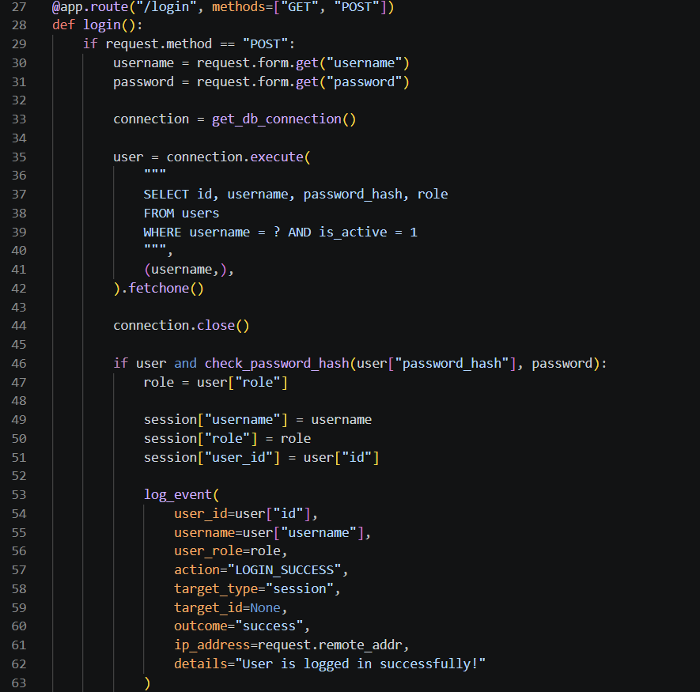

Listing C 1 Password-hash verification, session creation and successful-login audit recording.

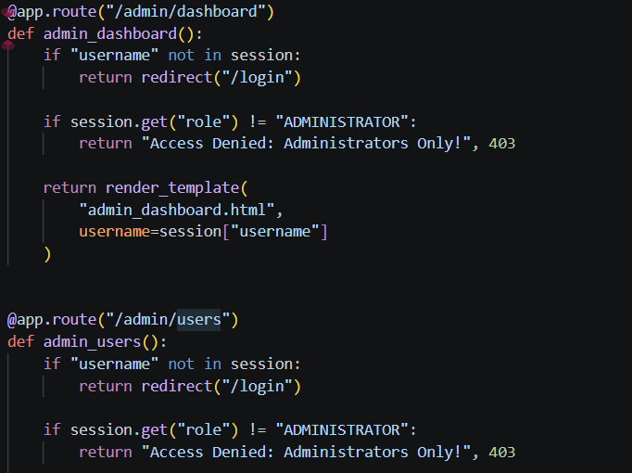

Listing C 2: Server-side authentication and administrator-role checks.

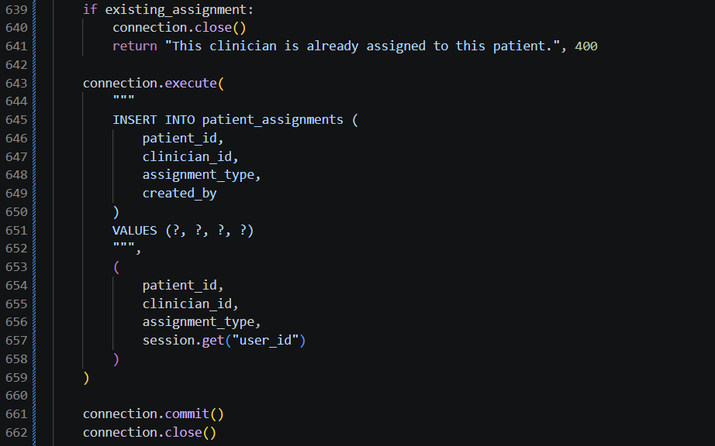
Listing C 3: Duplicate checking and insertion of a patient–clinician assignment.
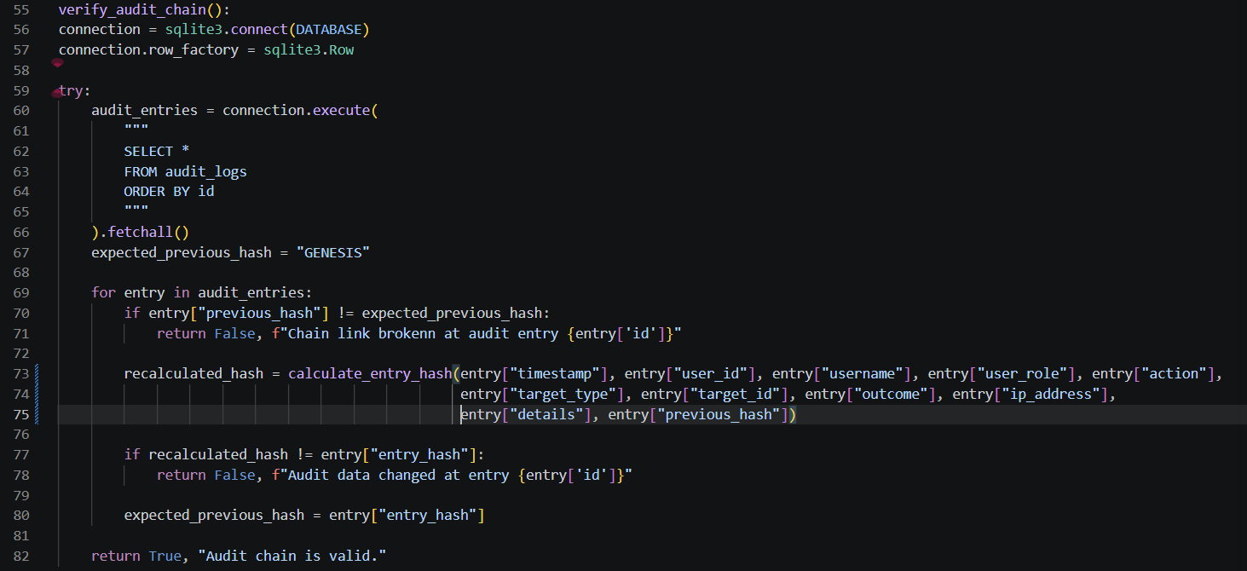
Listing C 4: Recalculation and verification of the SHA-256 audit-log chain.

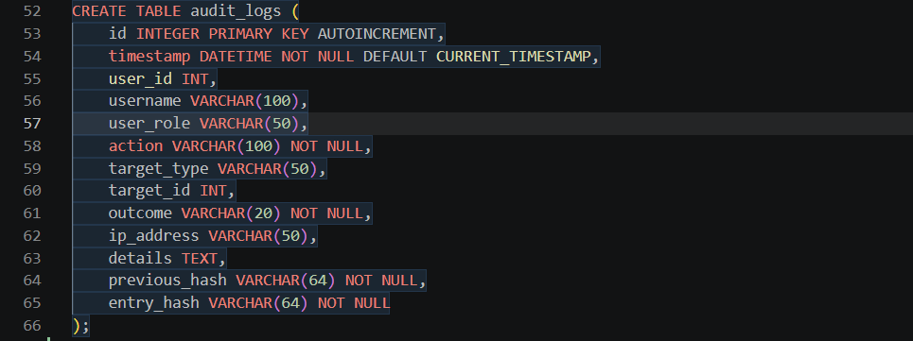
Listing C 5: Audit-log schema containing event details and hash-chain fields.

APPENDIX D: PROJECT PROCESS DOCUMENTATION, PROJECT SPECIFICATION & GITHUB LINKS

Project documentation Links: https://studentmailuwsac-my.sharepoint.com/:f:/g/personal/b01828711_studentmail_uws_ac_uk/IgBulJcj_MkHSKEXsA6c-sVgAR8IQAa-sQtCQsVN9TJwkow?e=Z5SQhD

Project specification Link: https://studentmailuwsac-my.sharepoint.com/:w:/g/personal/b01828711_studentmail_uws_ac_uk/IQAHVJUbAMqbRYFrgKV8XvlbAXViWAdZuFAGaf7kg2tjan0?e=5hz8M5

GitHub Link: https://github.com/ruthsarashajan/secure-ehr-prototype

