Sara Hashemi: Community Talk Feedback             Mark: ? /10

# 17 Jan: Clothes Exchange Event

# Sara Hashemi: Community Talk Feedback             Mark: ? /10

## Student Survey Feedback

### Project Goals

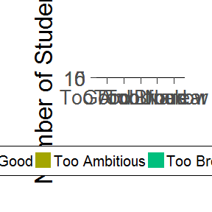

### Project Ecological Info

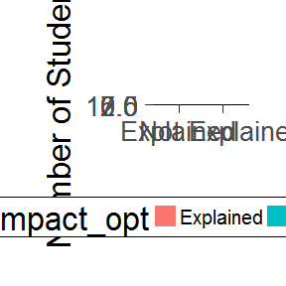

### Amount of Information

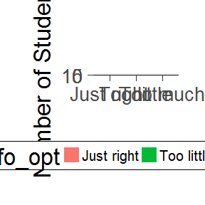

### Potential Problems

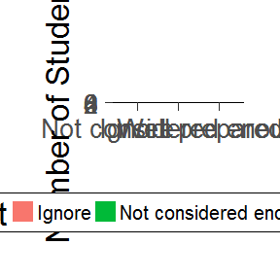

# Community Involvement and Impact

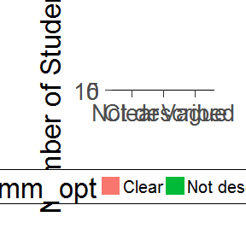

# Presentation

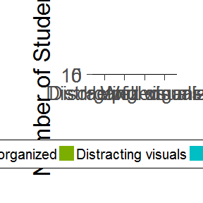

## Comments from Ruth

*comments

*comment2

## Comments from Rosie

## Comments from students

*comments

*comment2