Community Talk

17 Jan: Clothes Exchange Event

# "Sara Hashemi: Community Talk Feedback             Mark: ? "/10"

## Student Survey Feedback

### Project Goals

### 

### Project Ecological Info

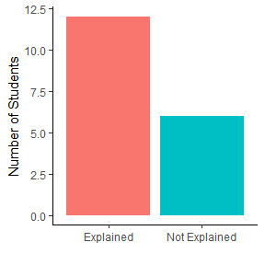

### Amount of Information

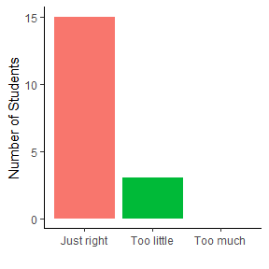

### Potential Problems



 