Wasin Chalanuchpong: Community Talk Feedback             Mark: ? /10

# Talk Date: 17 Jan

# Project Title: : Beaty Museum Green Roof

## 

## Student Survey Feedback

### Project Goals

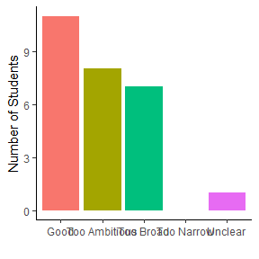

### Project Ecological Info

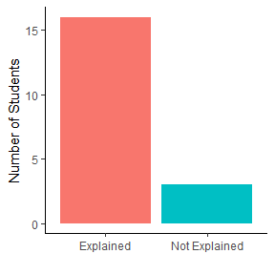

### Amount of Information

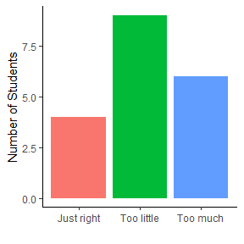

### Potential Problems

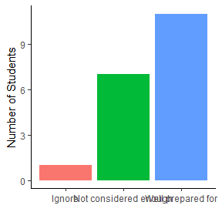

### Community Involvement and Impact

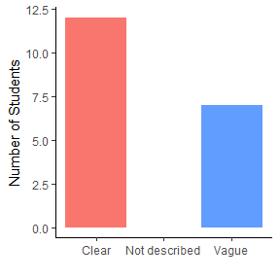

### Presentation

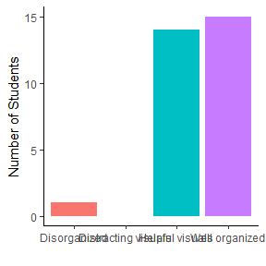

## Comments from Ruth

*comments

*comment2

## Comments from Rosie

## Comments from students

*comments

*comment2