Dispersal Model Graphs

Ruth Sharpe

03 March, 2017

# Metapopulation survival with no environmental variation

### Metapopulation Age Until Extinction

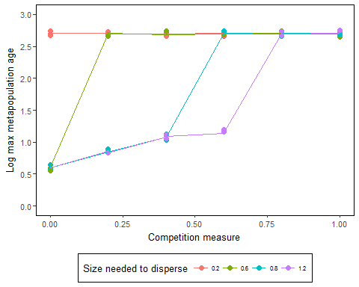

1. *Figure :Metapopulation survival against competition type, where competition type ranges from 0 to 1, with 0 being full scramble competition and 1 is full contest competition. Environmental variance is 0 and number of offspring set to 6. No generations removed*

As competition changes from scramble to contest competition the metapopulation age increases, but this interacts with the body size needed to disperse, unless the populations survive to 500 generations, in which cases obviously.

**Both dipsersal and intraspecific compeition type affects metapopulation survival**

#### Why dispersal increases metapopulation survival?

The simulation only starts with x number of colonies, but there are ‘spaces’ for 200. More dispersal means that these spaces get filled up.

#### How does this interact with competition?

If food is shared via contest competition then normally some individuals will get enough food to disperse, even if individuals have to be large to disperse. However if food is shared via contest competition then this is not the case.

## Population survival

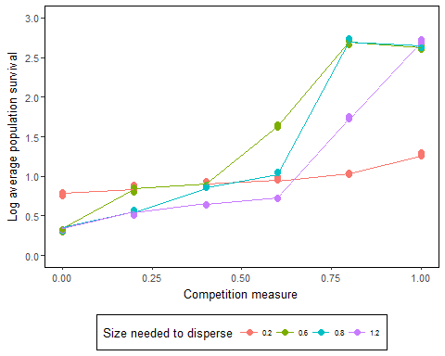

1. *Figure :Population survival against competition type, where competition type ranges from 0 to 1, with 0 being full scramble competition and 1 is full contest competition. Environmental variance is 0 and number of offspring set to 6. All generations included. Survival calculated from survival function*

As competition increases the population survival time increases. But the size needed to disperse surprisingly does not have a massive effect on population survival esp compared to competition.

**The main thing that affects population survival is compeition type, dispersal has little effect**

## Metapopulation survival against population survival

Warning: Removed 50 rows containing missing values (geom_smooth).

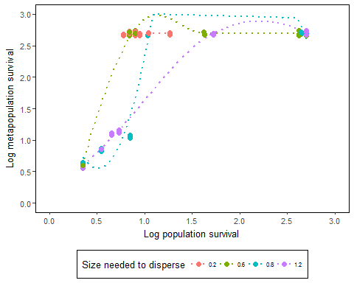

1. *Figure :Metapopulation against population survival. Environmental variance is 0 and number of offspring set to 6. All generations included. Survival calculated from survival function*

From this graph we can see that dispersal affects whether populations survival affects metapopulation survival. When the size needed to disperse is 0.2 (i.e. low) then the metapopulation survives to 500 generations regardless of the survival of the populations. The higher the disperal size is, the more the population survival affects the metapopulation survival.

## Metapopulation survival and dispersal

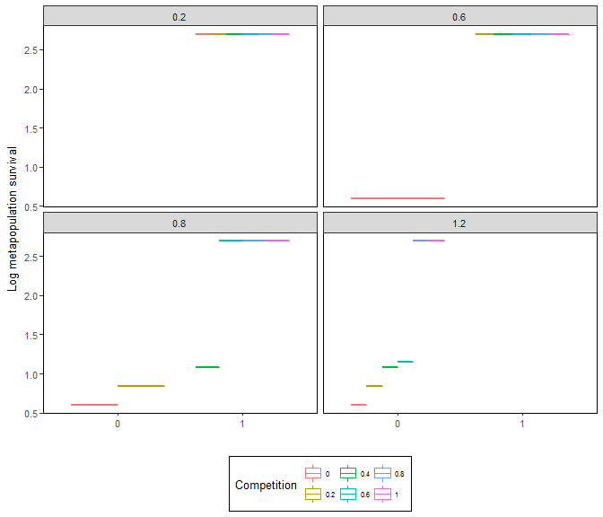

1. *Figure : Comparing metapopulation survival to whether any populations produced dispersers*

This shows how metapopulations have short survival if dispersal is restricted, but that metapopulations can survive no dispersal if competition within populations is contest like.

## What affects dispersal?

### make summary file for this graph

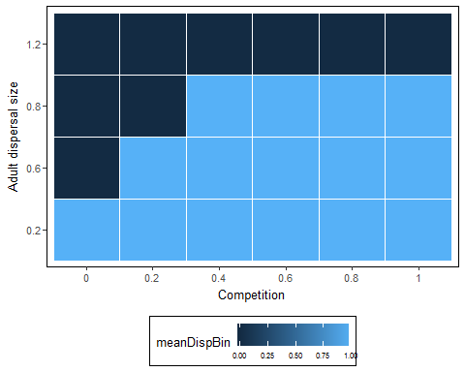

1. *Figure : Comparing metapopulation survival to whether any populations produced dispersers*

This shows how metapopulations have short survival if dispersal is restricted, but that metapopulations can survive no dispersal if competition within populations is contest like.

## Conclusion

Competition affects population survival and therefore metapopulation survival, but low population survival is off-set by disperal to increase metapopulation survival.

# Metapopulation and population survival and environmental variance

### TODO: could remove come layers of comp variables

## Metapopulation Survival

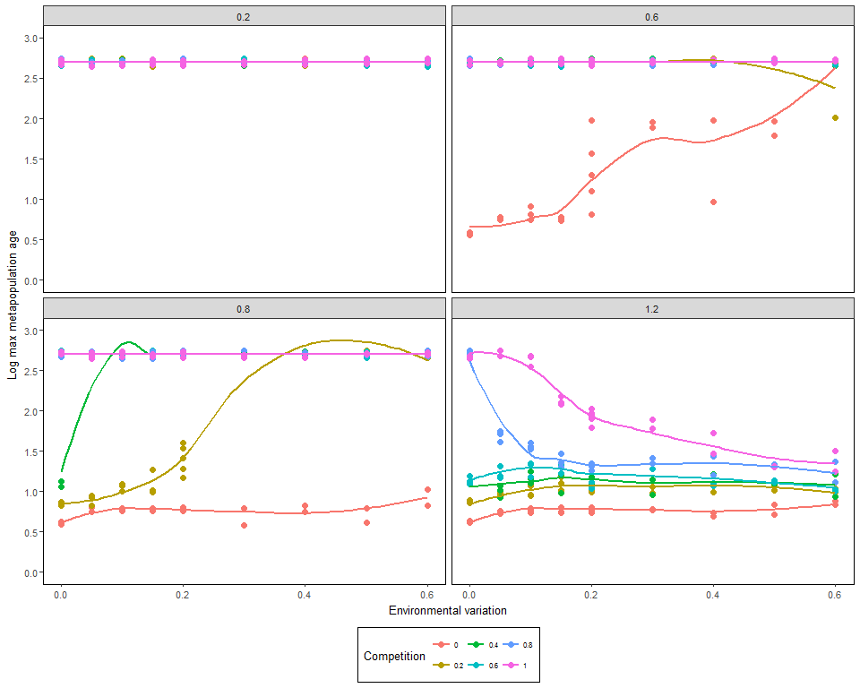

1. *Figure :Metapopulation survival environmental variance. Number of offspring set to 6. All generations included*

Intermediate environmental variance increases metapopulation survival for some competition measures when dispersal is restricted.

## Survival against environmental variation

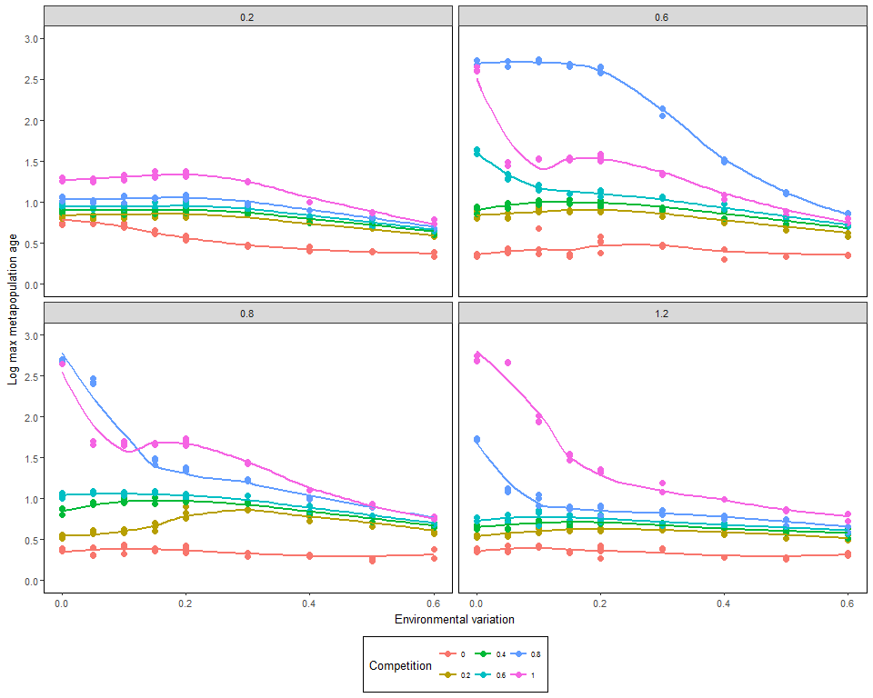

1. *Figure :Metapopulation survival environmental variance. Number of offspring set to 6. All generations included*

Intermediate environmental variance increases metapopulation survival for some competition measures when dispersal is restricted.

## Population Survival vs Metapopulation survival by variance

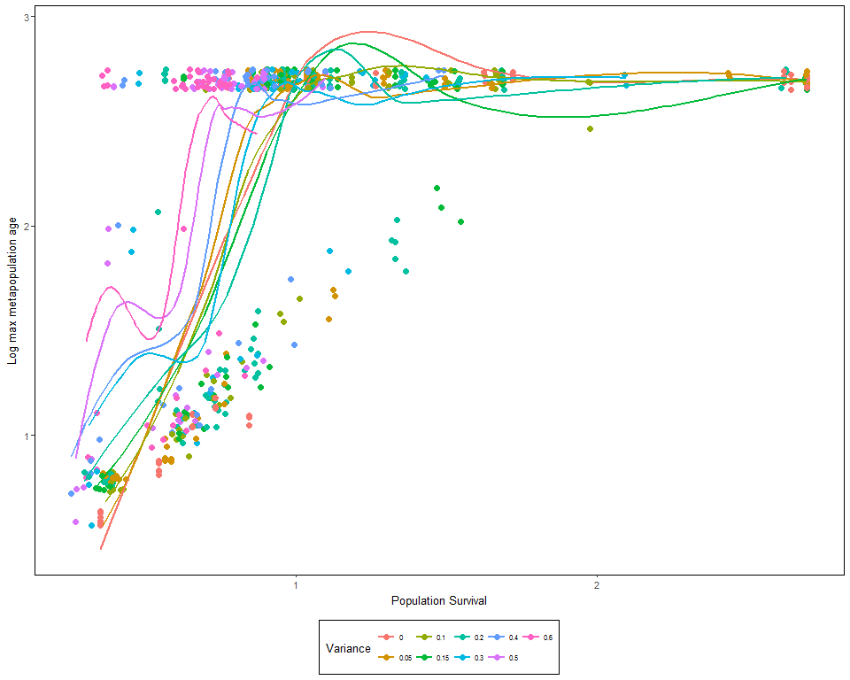

## Population Survival vs Metapopulation survival by competition

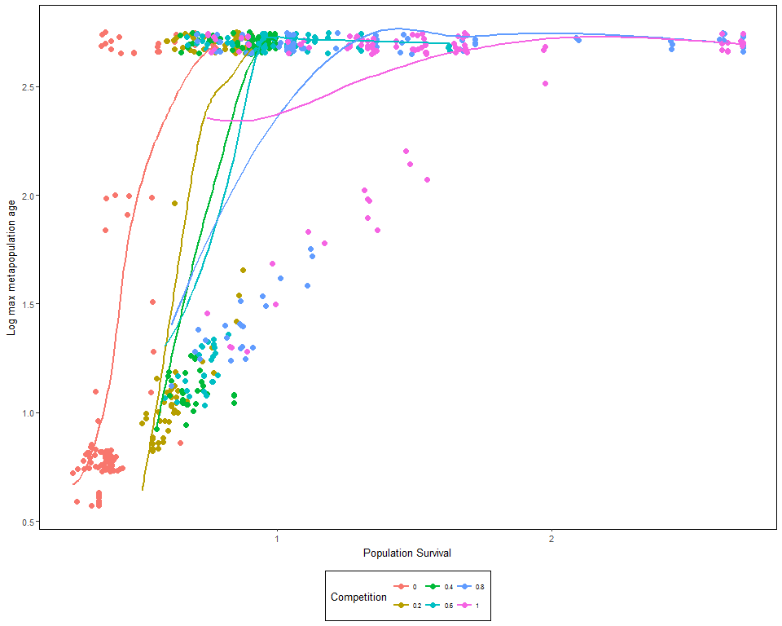

## Population Survival vs Metapopulation survival by Adult Dispersal Size

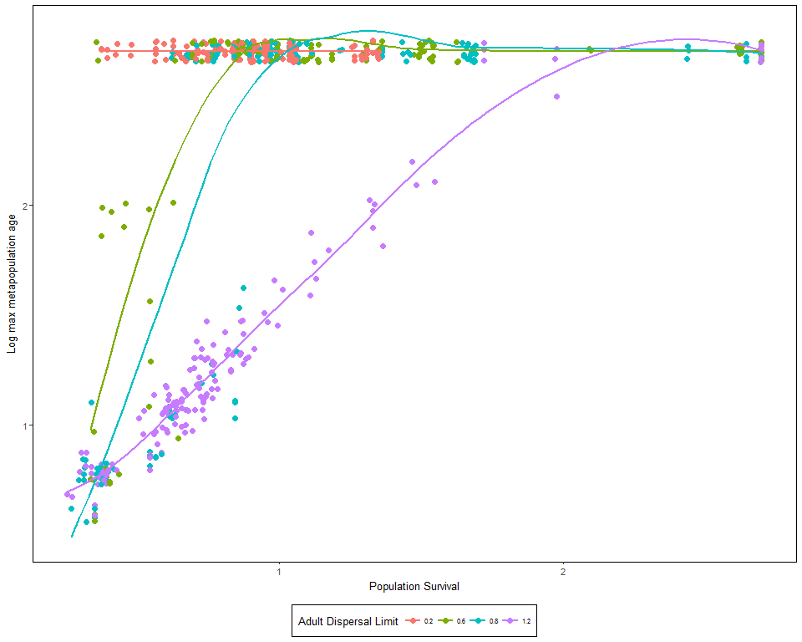

# Binary dispersal

