Dispersal Simulation Results For Committee

Ruth Sharpe

27 September, 2016

# Size of dispersing population

## vs. ad size and comp

Warning: Removed 13 rows containing missing values (geom_point).

Warning: Removed 7 rows containing missing values (geom_path).

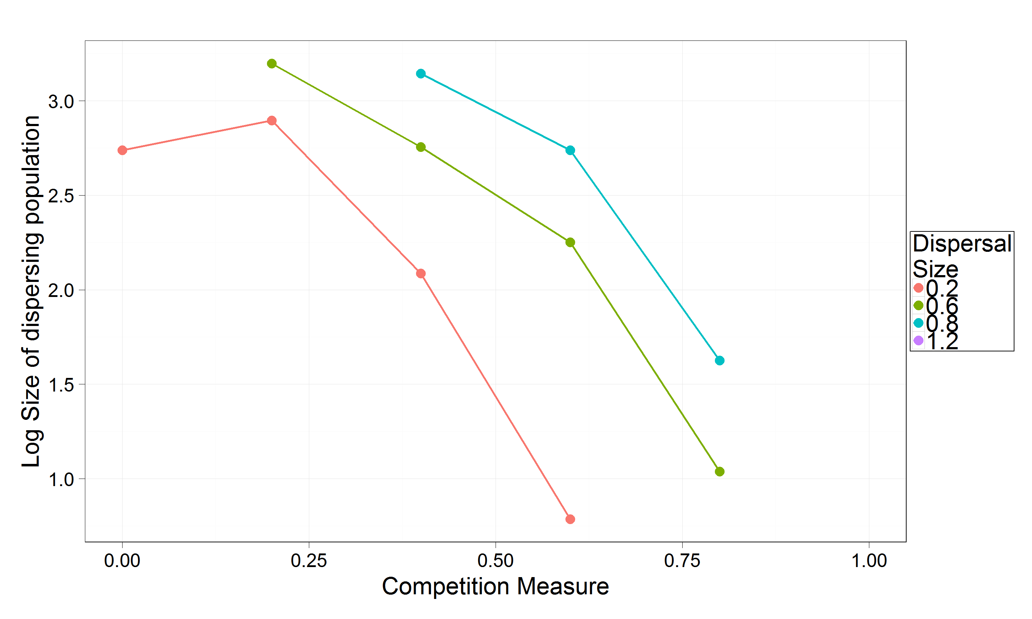

## vs. offspring number and environment variation

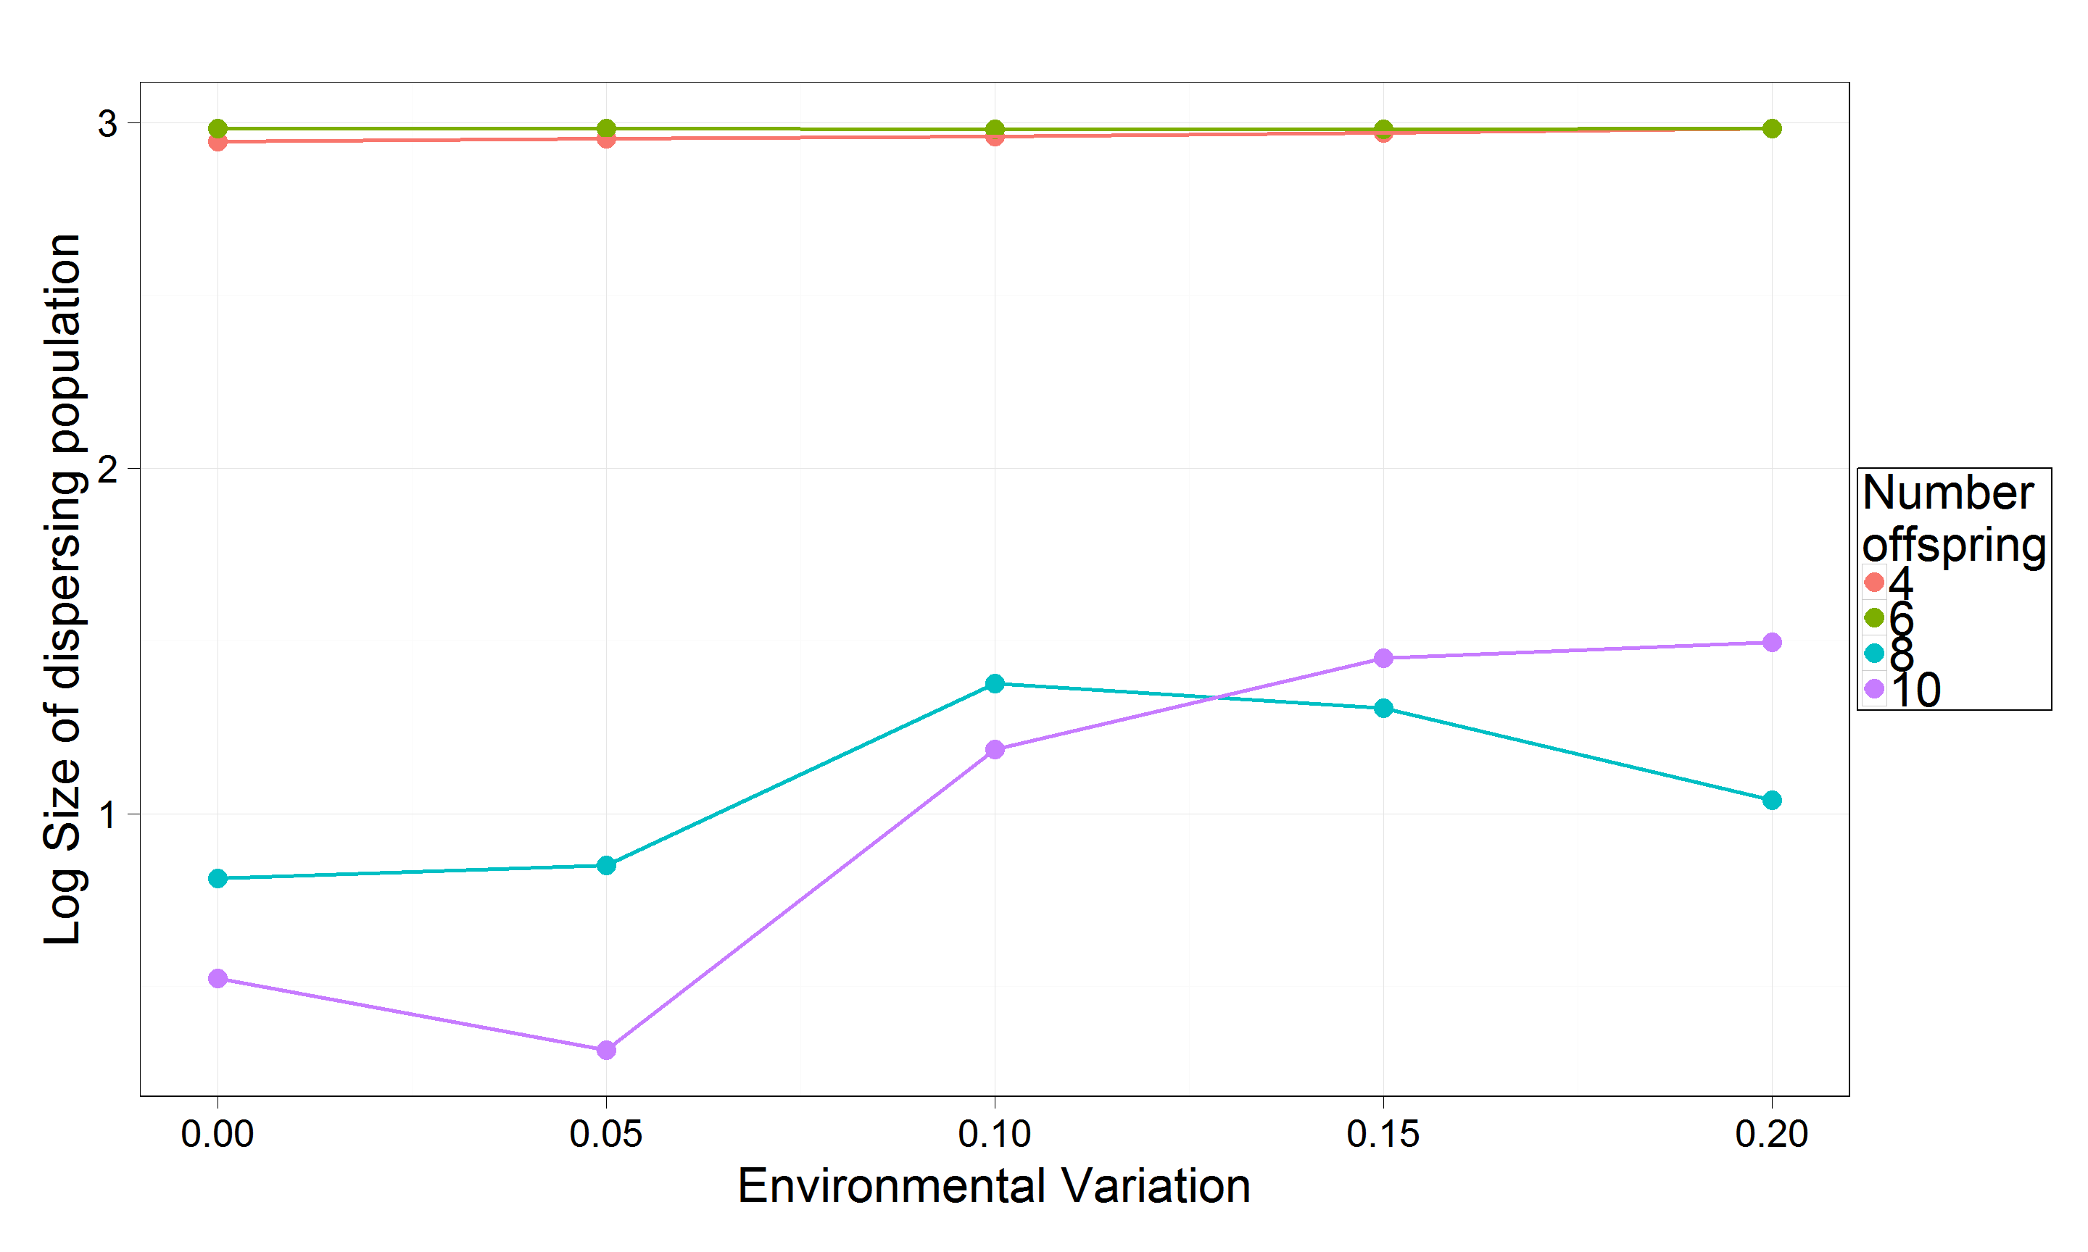

# dispersal frequency

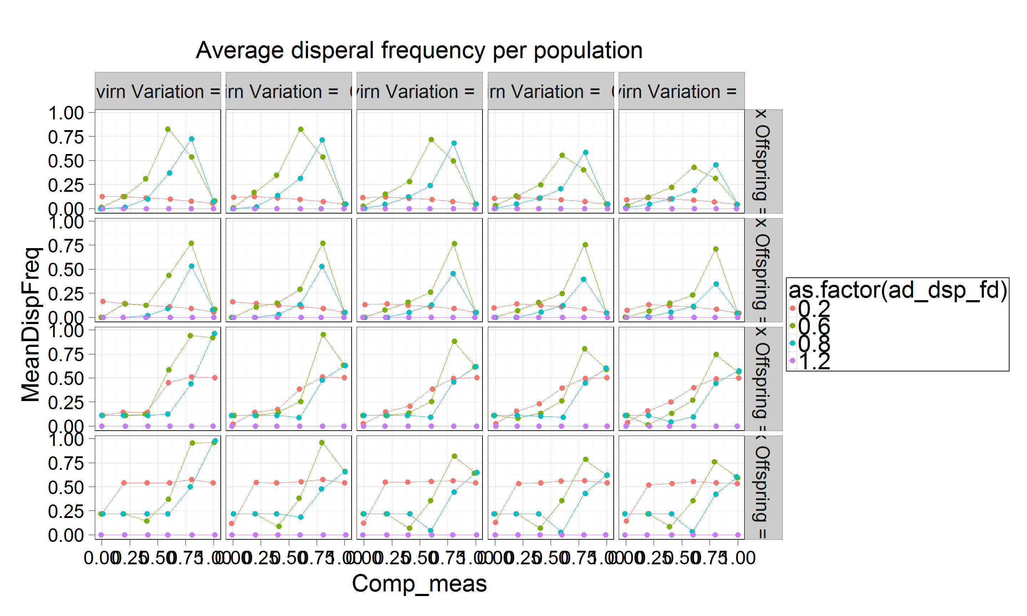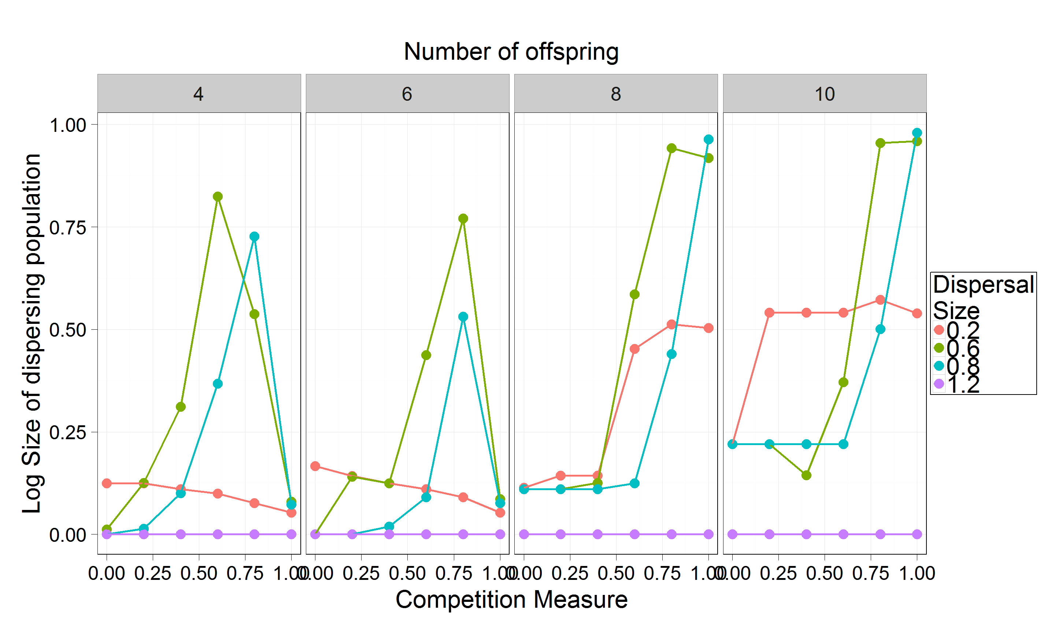

# survival of population

## vs. comp vs adult disperal size

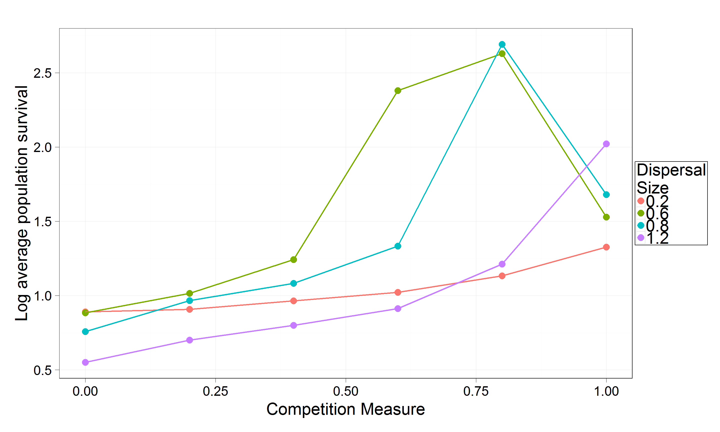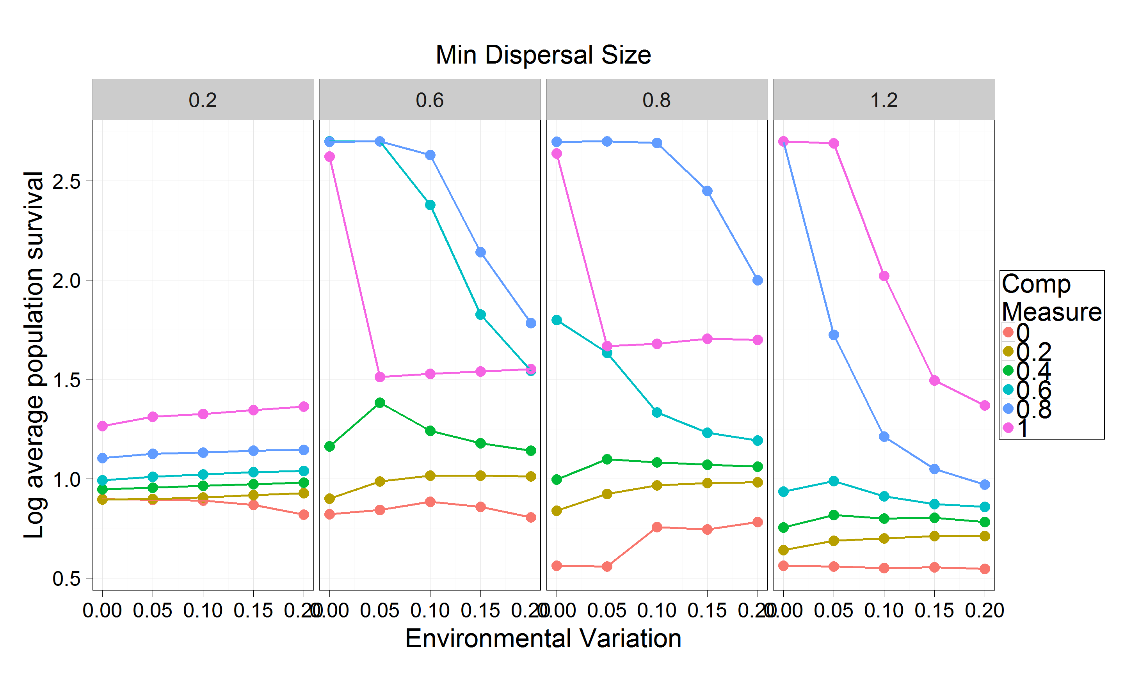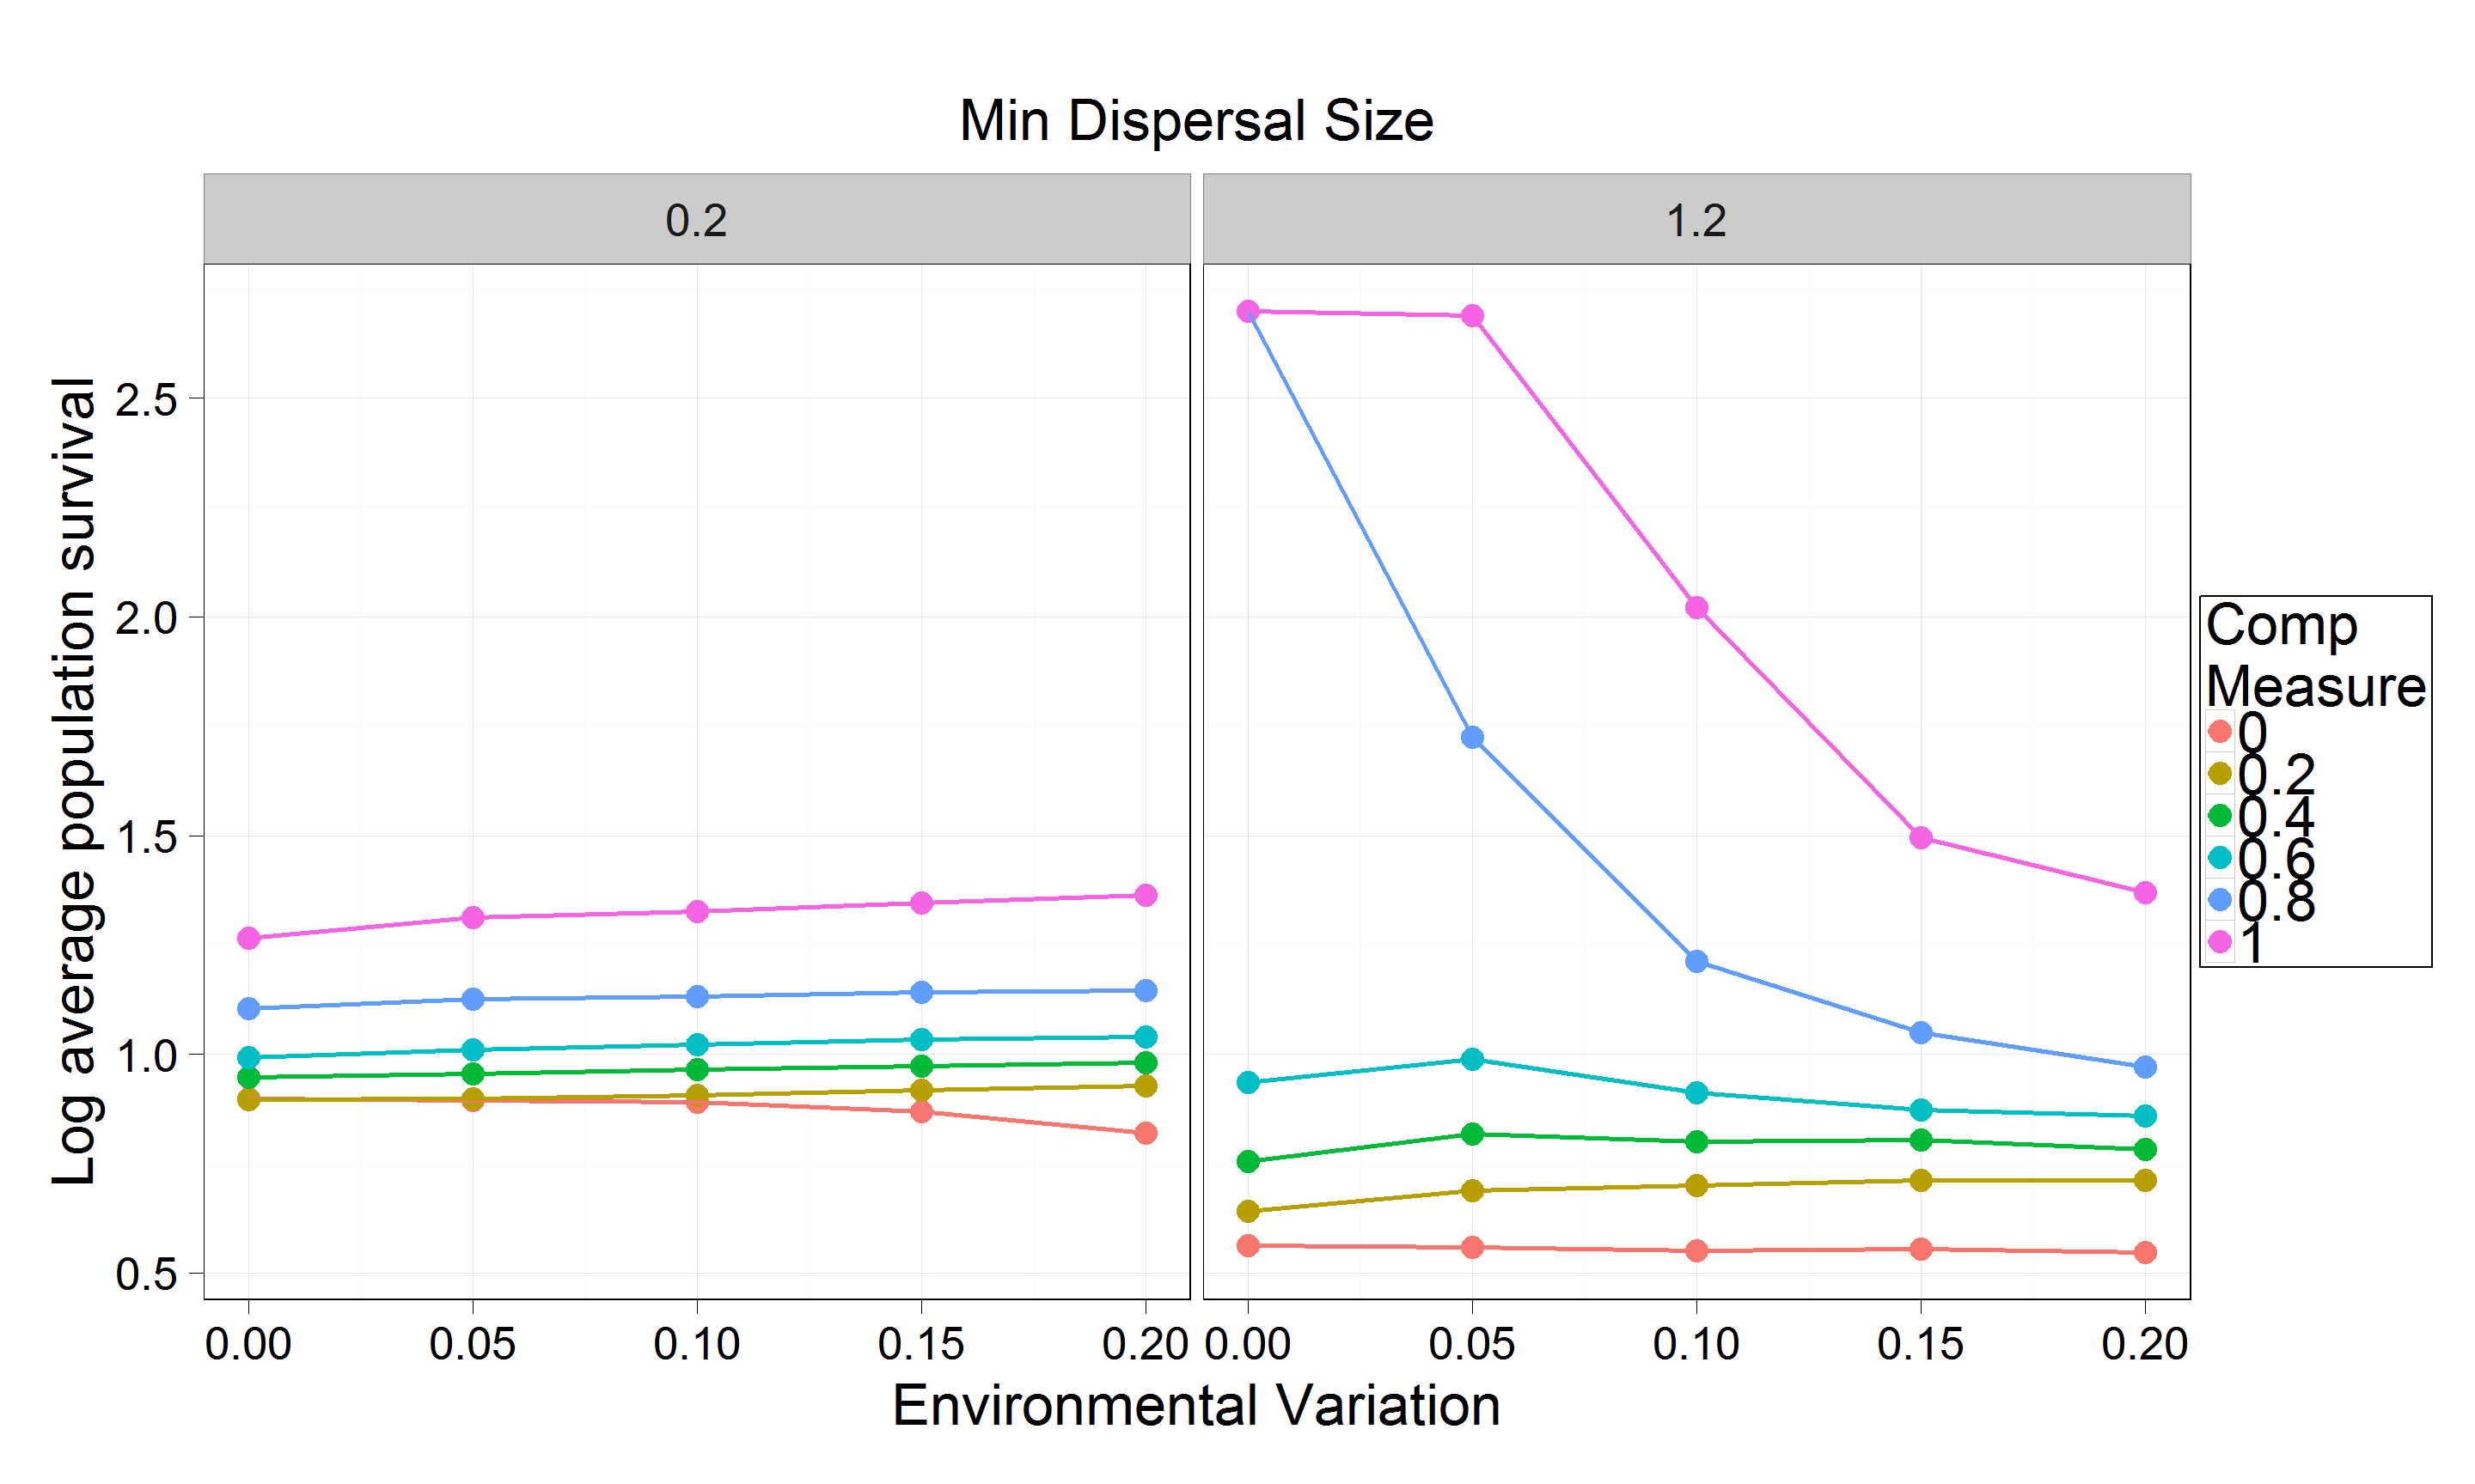

# extinct without dispersing

Warning: Removed 8 rows containing missing values (geom_point).

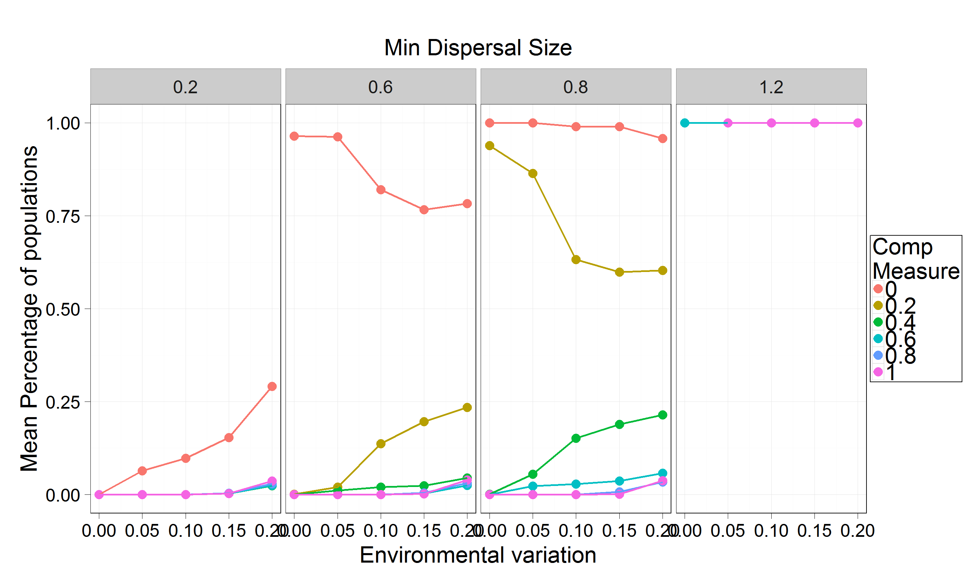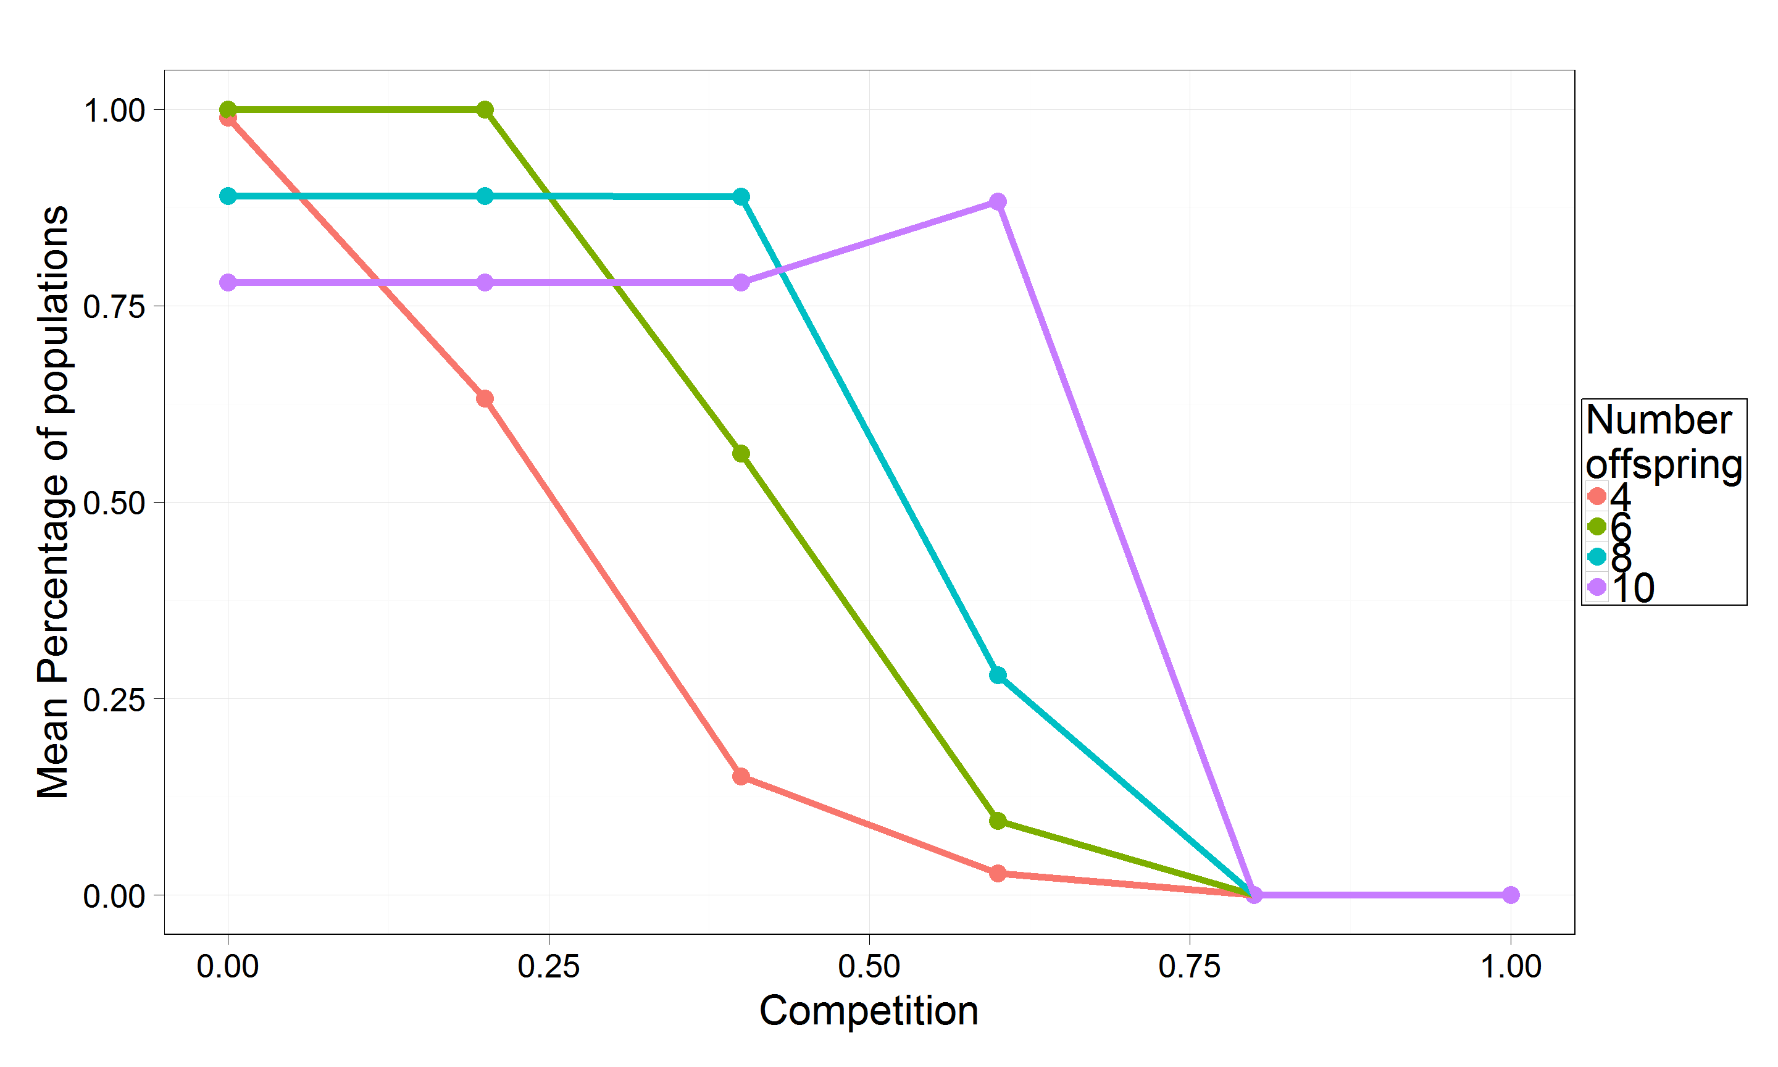

# Metapopulation

