Dispersal Simulation Results

Ruth Sharpe

18 August, 2016

Note: Each simulation was ran for 500 generations or until the metapopulation went extinct. Number of generations removed from start of each simulation is 50. Missing points in the graphs below are due to those populations not surviving more than 50 generation.

# Individual Behaviour

## Size of populations when a dispersal takes place i.e when do individuals disperse?

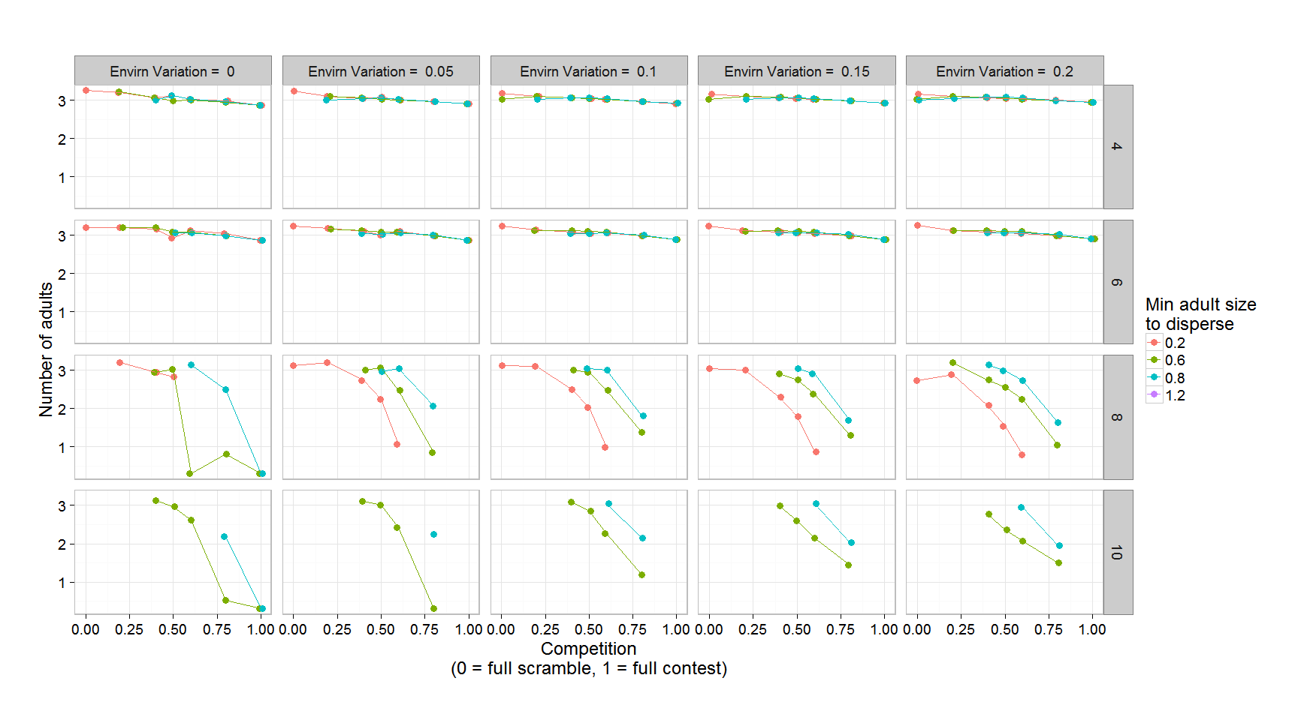

Figure 1: Size of populations when at least one individual disperses.

The size of population when a dispersal takes place decreases as competition becomes more contest-like and less scramble-like.

## Percentage of adults dispersing i.e. who disperses?

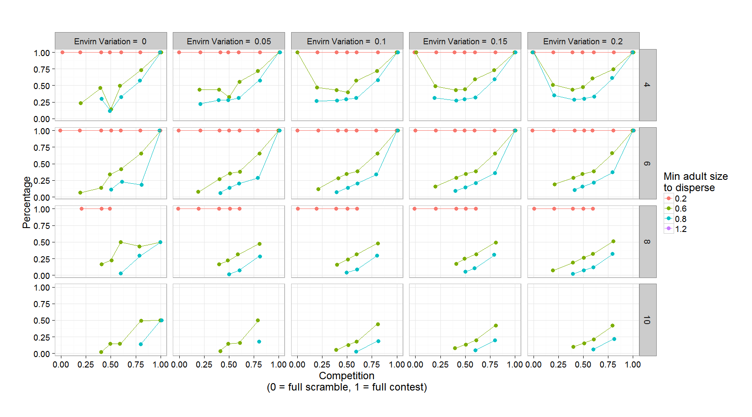

Figure 2: Percentage of adults that disperse from a colony when a disperal event takes place

Obviously the percentage of a population that disperses increases as the size that an individiual has to be decreases. Counterintuitively the percentage of a colony dispersing increases as as the competition coefficent increases.

# Population behaviour

## Average population survival

Note: all generations included

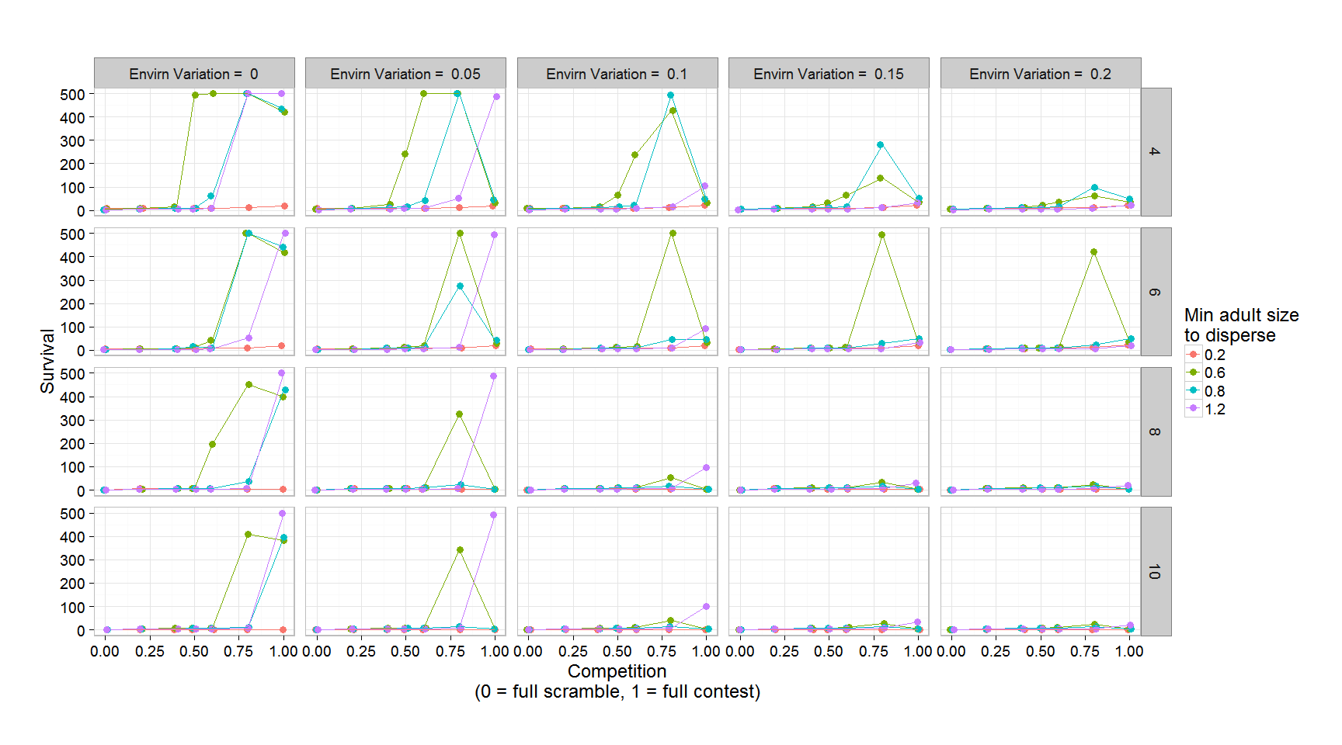

Figure 3: Average population survival.

Mid-range adult disperal size have the highest survival. If the dispersal limit is high, this causes too few individuals disperse so colonies die as they get too large. If the limit is low then all individuals disperse from the nest so the original nest goes extinct.

## Average population size

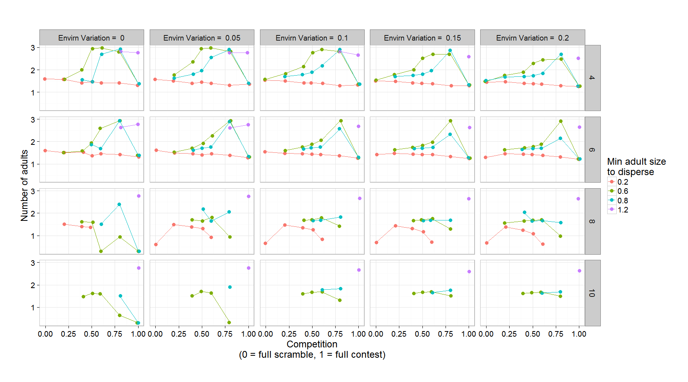

Figure 4: Overall average size of the populations

# Metapulation behaviour

## Metapopulation age

Note: all generations included

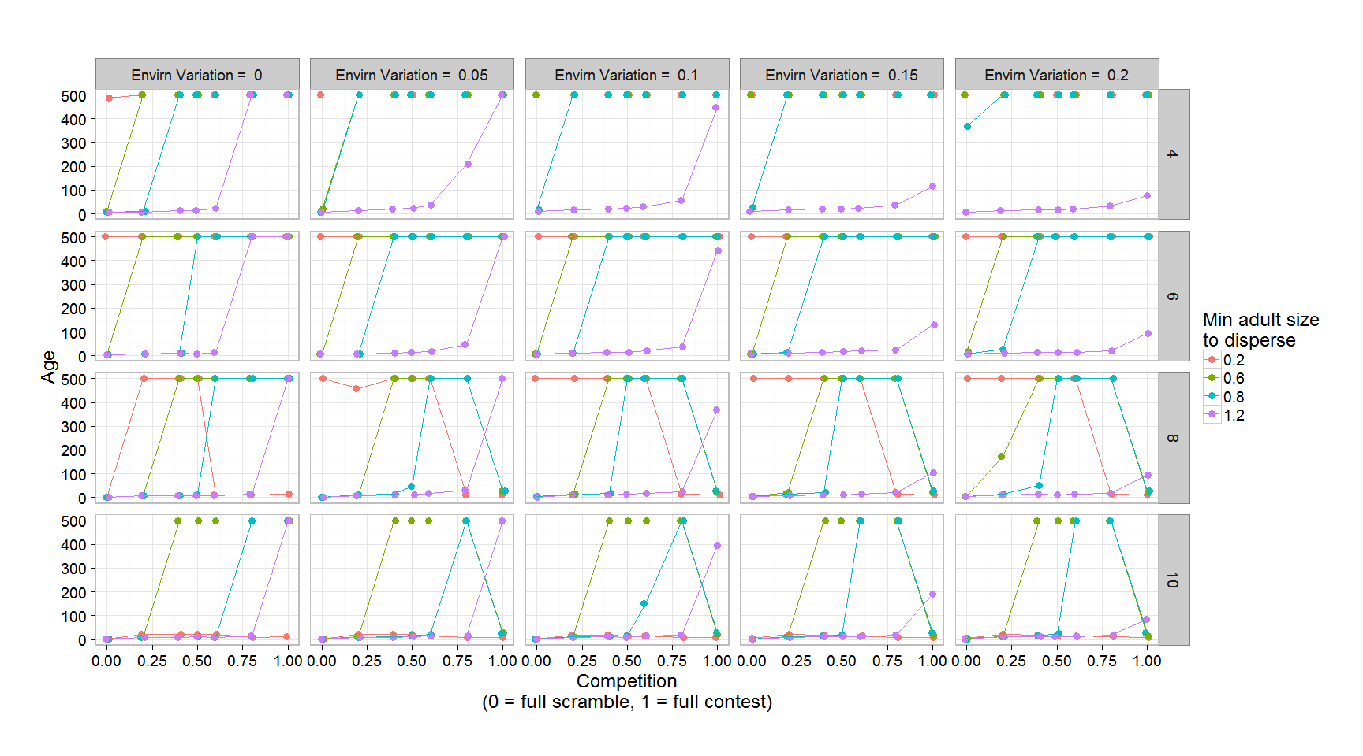 Note: I think this graph is wrong- incorrect thing on the yaxis