Chapter

Ruth Sharpe

28 August, 2017

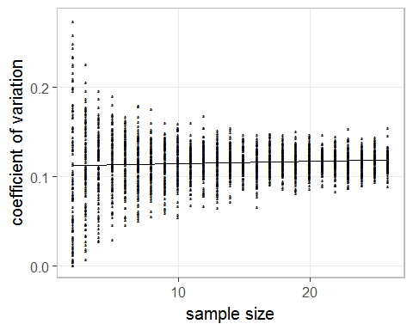

Analysis of Variance Table  
  
Model 1: cv ~ mean + I(mean^2) + N  
Model 2: cv ~ mean + I(mean^2)  
 Res.Df RSS Df Sum of Sq F Pr(>F)   
1 2496 1.3117   
2 2497 1.3213 -1 -0.0095449 18.163 2.104e-05 ***  
---  
Signif. codes: 0 '***' 0.001 '**' 0.01 '*' 0.05 '.' 0.1 ' ' 1

figure x: sample size against cv

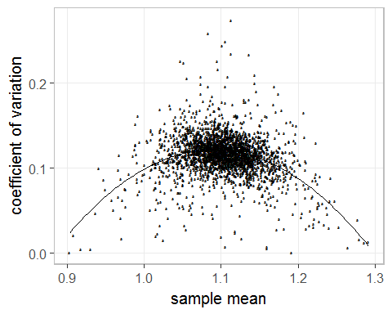

Analysis of Variance Table  
  
Model 1: cv ~ mean + I(mean^2) + N  
Model 2: cv ~ N  
 Res.Df RSS Df Sum of Sq F Pr(>F)   
1 2496 1.3117   
2 2498 1.5897 -2 -0.27797 264.46 < 2.2e-16 ***  
---  
Signif. codes: 0 '***' 0.001 '**' 0.01 '*' 0.05 '.' 0.1 ' ' 1

figure x: mean against cv

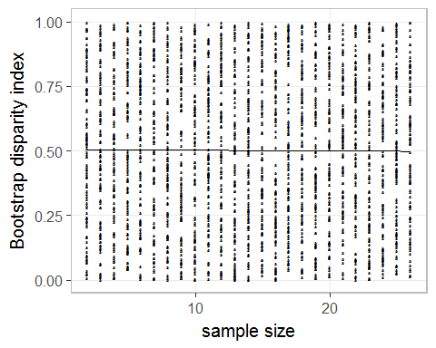

Analysis of Variance Table  
  
Response: bootSD_var  
 Df Sum Sq Mean Sq F value Pr(>F)  
N 1 0.01 0.010150 0.1207 0.7283  
Residuals 2498 210.03 0.084081

figure x: my boot variance against sample size

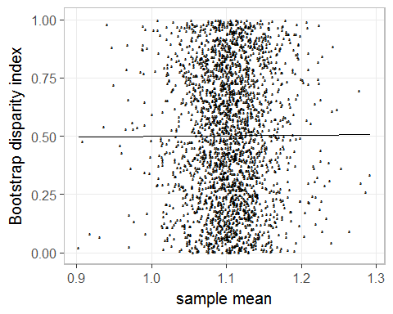

Analysis of Variance Table  
  
Response: bootSD_var  
 Df Sum Sq Mean Sq F value Pr(>F)  
data_mean 1 0.003 0.003459 0.0411 0.8393  
N 1 0.010 0.009824 0.1168 0.7326  
Residuals 2497 210.031 0.084113

figure x: my boot variance against mean of sample