Weight Vs Colony Size Results with instar as numeric

Ruth Sharpe

02 October, 2016

note: All models had to include nest size and instar number.

## Leg Vs. Nest Size

The model with the lowest AIC had nest size x instar age and the three-way interaction nest size x instar age x instar sex as fixed effects. Using this as the full model and all the terms that include nest size removed as the reduced model, we found that leg length increases as colony size increases (lmer; 2~4 ,7~= 63.64, p = < 0.001 *** , figure 1).

Leg length was significantly correlated with instar age, but that is not surprising due to their different physiology (lmer; 24 ,7= 4342.93, p = < 0.001 *** ).

In addition, the interaction nest size x instar age x instar sex was significant, (lmer; 24 ,7= 4342.93, p = < 0.001 *** ), with male leg size changing faster with nest size compared to females.

In addition the effect of colony size on spider size was not significant in the youngest instars (Table 1); it was first detectable in subadult males and females.

Testing each instar separately, the only juvenile stage 4 and subadult stage 1 spiders did not show a significant decrease in leg length with colony size (table 1).

|  |  |  |
| --- | --- | --- |
| Instar | 2 | p value |
| Juv4 | 1.48 | 0.224 |
| Sub1 | 0.29 | 0.588 |
| Sub2 | 10.66 | < 0.001 *** |
| Adult | 8.54 | 0.003 ** |
| Sub Male | 6.7 | 0.01 ** |
| Adult Male | 11.8 | < 0.001 *** |

Table 1: Statistical results of leg length against colony size for each instar tested individually

Note: If line on graph is blue R could not plot the lmer, plotting a simple lm instead

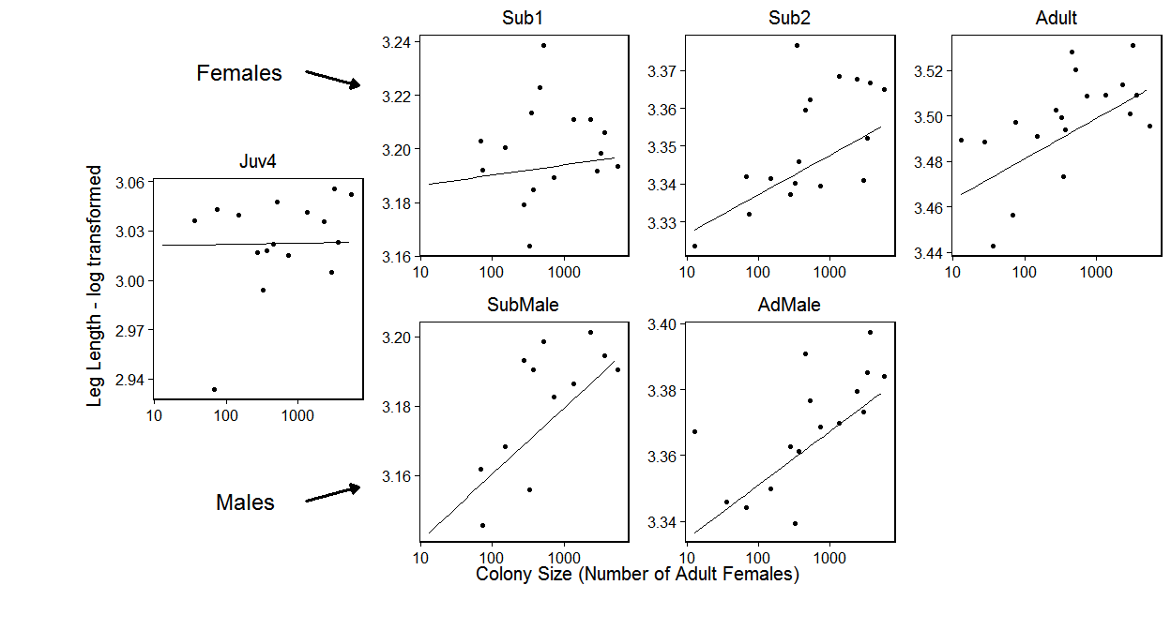

1. Figure: Leg length against colony size. The overlaid model is logLeg ~ logCtFm + Instar + logCtFm:Instar + (1 | NestID). Overall leg length decreases with colony size (p = < 0.001 *** ) and there was a significant interaction with instar (p = < 0.001 *** ).

## Condition Vs. Colony Size

The model with the lowest AIC included colony size and instar x colony size interaction. Nest size combined with the nest size x instar interaction was significant (lmer; 23 ,5= 11.12, p = 0.004 ** ).

There was a significant interaction between instar and colony size (lmer; 24,5 = 1.15, p = 0.284 ), with condition appearing to decrease faster with nest size as the instars increase in age (figure 3).

However, when performing ad-hoc tests on the instars individually we find that only adult condition decreases with colony size (lmer; 23,4 = 7.64, p = 0.006 ** ).

Note: If line on graph is blue R could not plot the lmer, plotting a simple lm instead

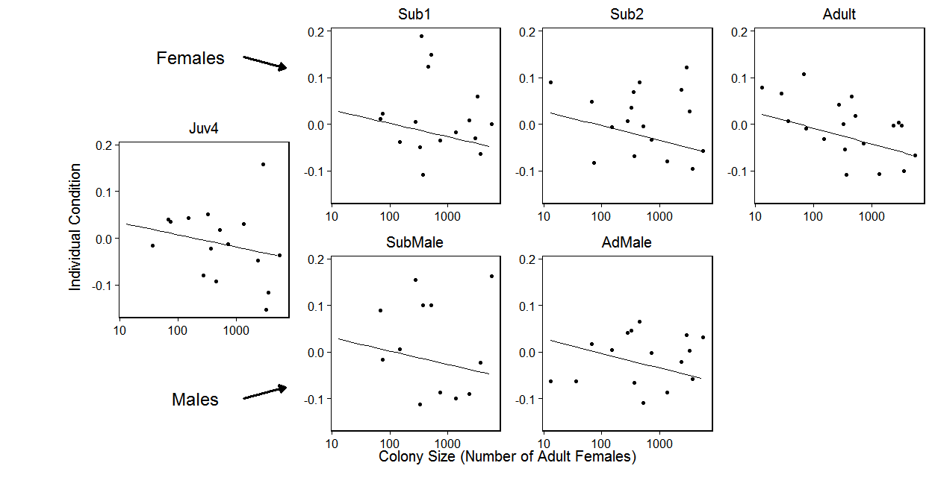

1. Figure : Individual condition against colony size. The overlaid model is condResiduals ~ logCtFm + logCtFm:InstarNumber + (1 | NestID). Overall leg length decreases with colony size (p = 0.004 ** ) and there was a significant interaction with instar(p = < 0.001 *** ).

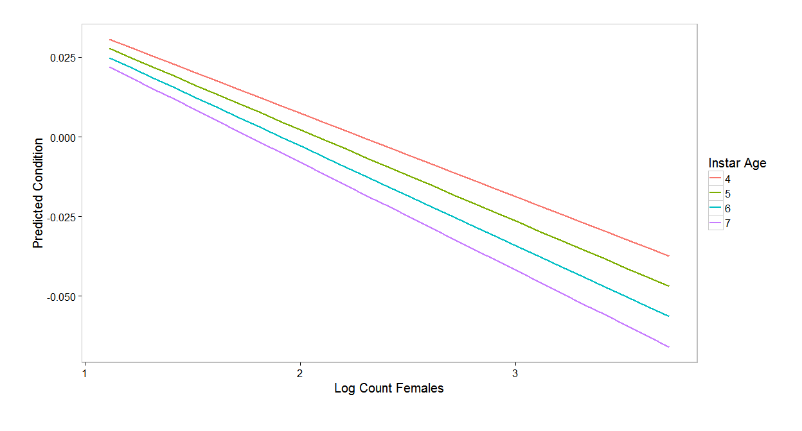

1. Figure : The results of the linear model showing individual condition of each instar age against nest size. However only adults had a significant effect.

## Within Colony Variance Vs. colony size

### Leg Length Variance

Rows removed with 2 or fewer data points.

The model with the lowest AIC value had instar age x instar sex, nest size x instar age and the square of instar age as fixed effects

Nest size combined with the nest size x instar age interaction was significant (lmer; 2~6 ,8~= 6.8, p = 0.033 * )

Tested together all the instar age terms, including the square of the instar age, were significant (lmer; 2~4 ,8~= 16.24, p = 0.003 ** , figure 5) with the variance in leg length within nests being a curved function, peaking at subadult instars.

However, even though it was included in the lowest AIC model, the instar age x instar sex interaction was not significant (lmer; 2~7 ,8~= 2.15, p = 0.143 ). Doing adhoc tests on each instar age individually against nest size we found that none were significant (figure 4).

Note: If line on graph is blue R could not plot the lmer, plotting a simple lm instead

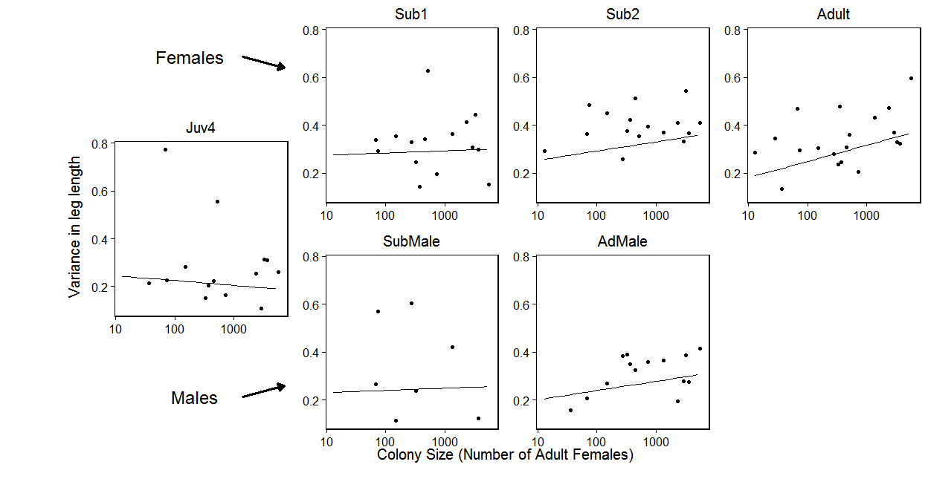

1. Figure : Variance in leg length against colony size

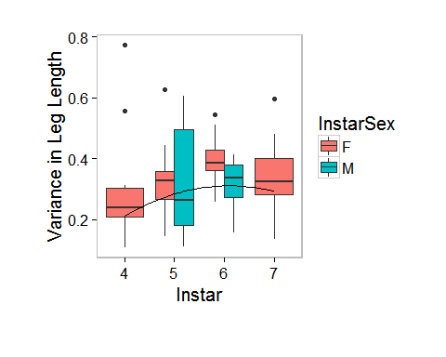

1. Figure :Leg length variance within colonies by instar. Overlaid is the linear model.

### Condition Variance

The model with the lowest AIC included instar age, instar sex, instar age squared and the interaction instar age squared x instar sex.

Colony size was not significant (lmer; 27 ,8= 1.68, p = 0.195 ),

but instar age was significant (lmer; 24 ,8= 25.63, p = < 0.001 *** ).

In addition, the instar age x sex interaction was also significant (lmer; 24 ,8= 8.45, p = 0.015 * ), with the variance in condition within nests being larger for males compared to females (figure 7)

Note: If line on graph is blue R could not plot the lmer, plotting a simple lm instead

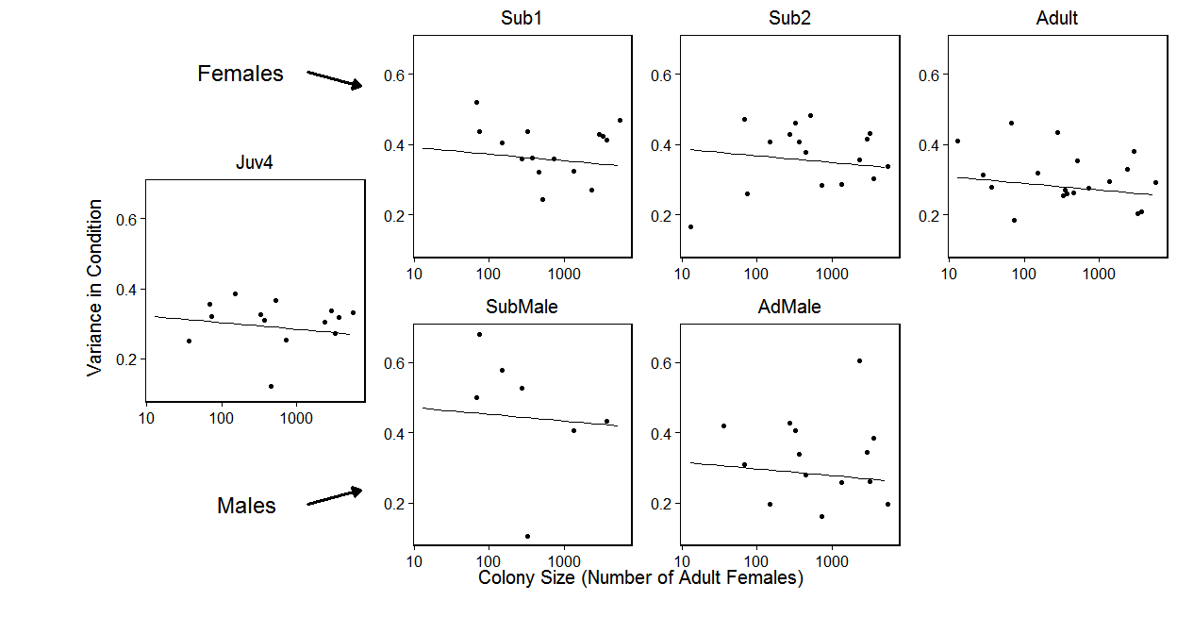

1. Figure : Variance in condition against colony size

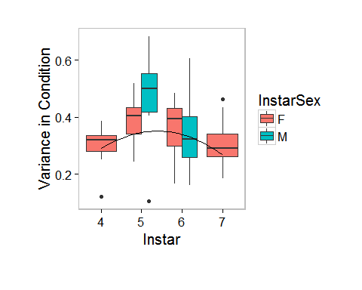

1. Figure :Condition Length variance within colonies by instar. Overlaid is the linear model.

# Biomass per capita vs colony size

Date and colony ID were used as random factors in the model.

Within the range of nests measured, biomass per capita increases as nest size increased (lmer; 24 ,5= 5.86, p = 0.015 * ).

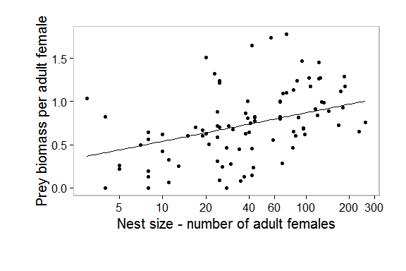

1. Figure : Prey biomass per capita was significant p = 0.015

* ). Model overlaid.

# Original Colony Vs Propagule

Leg length was larger in propagules compared to the source colony (lmer; 24,5= 3.9, p = 0.048 * ).

as was condition (lmer; 24,5= 9.45, p = 0.002 ** ), with those in propagules having a greater condition compared to those in the source nest.

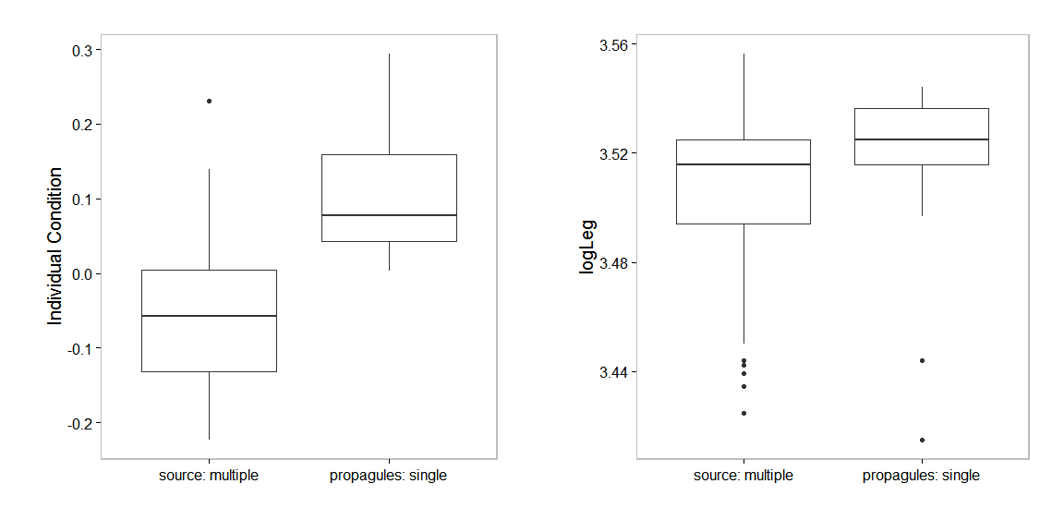

1. Figure: Condition and leg length of adult females in propagues and their source nest

## Propagule survival

We found that nests with single females spiders had a very low survival rate (figure 5).

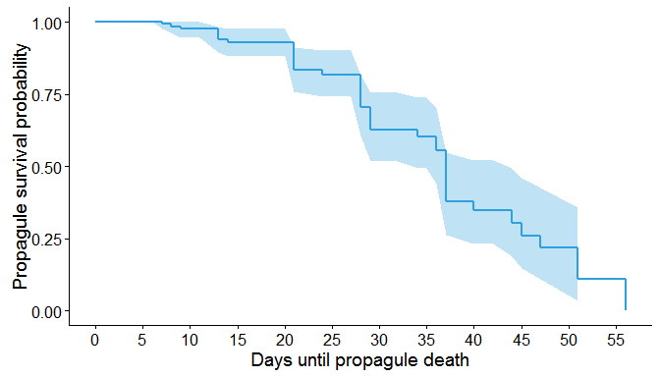

1. Figure: The survival function of 40 propagules from 10 source nests.

## List of full models used

|  |
| --- |
| modelList |
| logLeg = logCtFm + InstarAge + logCtFm:InstarAge + logCtFm:InstarAge:InstarSex + (1|Nest) |
| condResiduals = logCtFm + logCtFm:InstarAge + (1|Nest) |
| relativeVar = logCtFm + InstarAge + InstarAge:InstarSex + logCtFm:InstarAge + sqr(InstarAge) + (1|Nest) |
| relativeVar = logCtFm + InstarAge + InstarAge:InstarSex + sqr(InstarAge) + sqr(InstarAge):InstarSex + (1|Nest) |
| BiomsPerAdFm = log0AdFm + ColonyID + Date |
| logLeg = type + (1|Nest) + (1|OrigNst) |
| condResiduals = type + (1|Nest) + (1|OrigNst) |