Weight Vs Colony Size Appendix

Ruth Sharpe

13 April, 2017

## Count of number of spiders

|  |  |  |  |  |  |
| --- | --- | --- | --- | --- | --- |
| Adult | Sub2 | Sub1 | Juv4 | AdMale | SubMale |
| 401 | 250 | 284 | 233 | 106 | 32 |

*Count of the number of spiders weighed and measured*

## Histogram of nest sizes measured

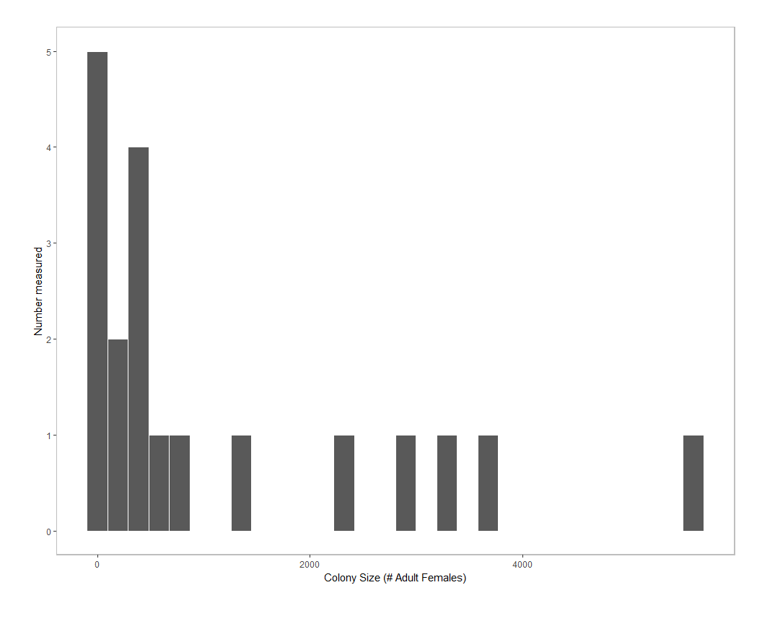

1. *Figure :Histogram of the size of colonies investigated*

## List of full models used

*Table 1: The full models used for each test. Varibles printed as (1|*****) indicate random factors. Colony represents the colony from which each individual spider was collected.*

|  |  |
| --- | --- |
| Test | Full Model |
| Leg length vs. colony size | log(LegLength)=log(ColonySize) + InstarAge + log(ColonySize):InstarAge + log(ColonySize):InstarAge:InstarSex + (1|Colony) |
| Condition vs. colony size | Condition=log(ColonySize) + log(ColonySize):InstarAge + (1|Colony) |
| Condition Variance vs. colony size | Variance=log(ColonySize) + InstarAge:InstarSex + InstarSex:sqr(InstarAge) |
| Leg length dispersed female vs. source colony | log(LegLength)=ColonyType + (1|Colony) + (1|SourceColony) |
| Condition dispersed female vs. source colony | Condition=ColonyType + (1|Colony) + (1|SourceColony) |