Weight Vs Colony Size Results with instar as numeric

Ruth Sharpe

25 August, 2017

Remember Note: If line on graph is blue R could not plot the lmer, plotting a simple lm instead[1]

### Leg length against colony size

The model with the lowest AIC value included the two-way interaction colony size by instar age and the three-way interaction colony size by instar age by instar sex as fixed effects, but did not include the instar age by instar sex interaction .

After confirming, not surprisingly, that leg length was highly correlated with instar age (lmer; 2~4 ,7~= 4339.88, p = < 0.001 *** ), we found that

leg length increased as colony size increased (lmer; 25 ,7= 32.68, p = < 0.001 *** , (figure 3.1),

but with a significant interaction with instar age (lmer; 2~6 ,7~= 22.83, p = < 0.001 *** )

and a significant interaction between instar age and instar sex (lmer; 26 ,7= 27.35, p = < 0.001 *** ).

Due to the significant interaction between instar age and colony size we performed tests on each instar individually. We found that leg length increased with colony size in the older instars, but not significantly so in the younger ones (table 3.1) and  
(figure 3.1).

|  |  |  |  |
| --- | --- | --- | --- |
| Instar name | Instar Age | 2 | p value |
| Juvenile | 4 | 1.48 | 0.224 |
| Subadult 1 | 5 | 0.79 | 0.374 |
| Subadult 2 | 6 | 13.64 | < 0.001 *** |
| Adult | 7 | 8.54 | 0.003 ** |

(table 3.1)

*TABLE: Results of separate analysis of leg length against colony size for each instar age. Leg length increases with colony size in the overall model (p = < 0.001 *** ). When tested individually the relationship is only significant for the older instars.*

Note: If line on graph is blue R could not plot the lmer, plotting a simple lm instead[1] "lmer"

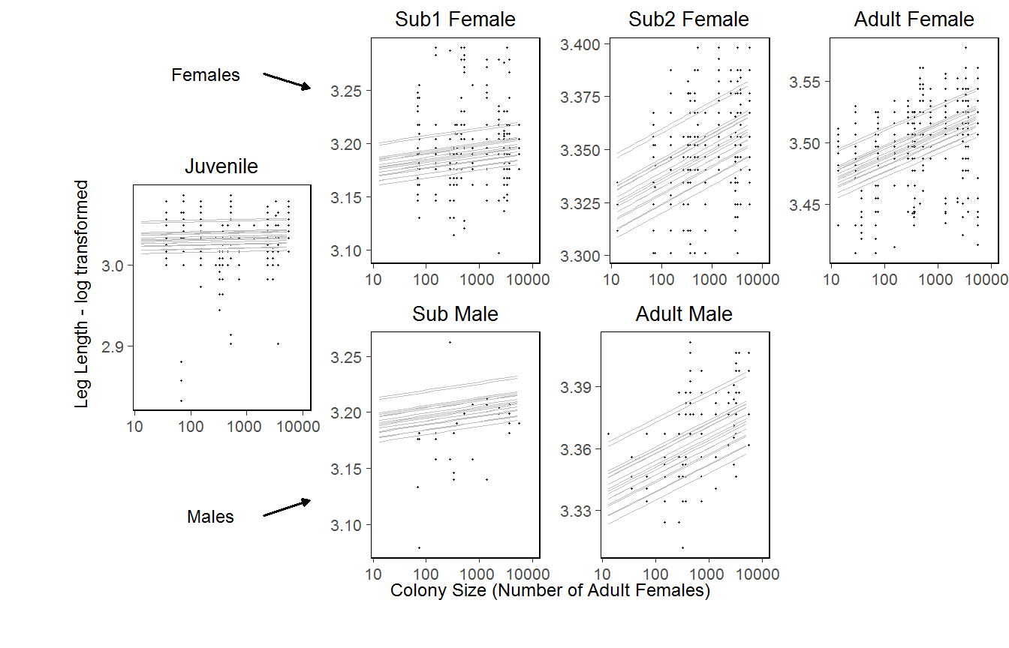

[1] "(figure 3.1)"

*FIGURE: Leg length (tiba plus patella) as a function of colony size with the full linear model, which contains a significant interaction with colony size, superimposed. Overall, leg length increased with colony size (p = < 0.001 *** ), but with a significant interaction between colony size and instar,. When tested individually, only the older instars exhibited a significant relationship. n= 19 colonies.*

### Individual condition against colony size

The model with the lowest AIC value included only one interaction term, instar age by colony size, and did not include instar sex or instar age as fixed effects (see appendix) .

The effect of colony size was significant (lmer; 24,5 = 4.66, p = 0.031 * ) with individual condition decreasing as colony size increased (figure 3.2).

In addition, instar was significant (lmer; 24, 5 = 5.81, p = 0.016 * ), with ......

Note: If line on graph is blue R could not plot the lmer, plotting a simple lm instead[1] "lmer"

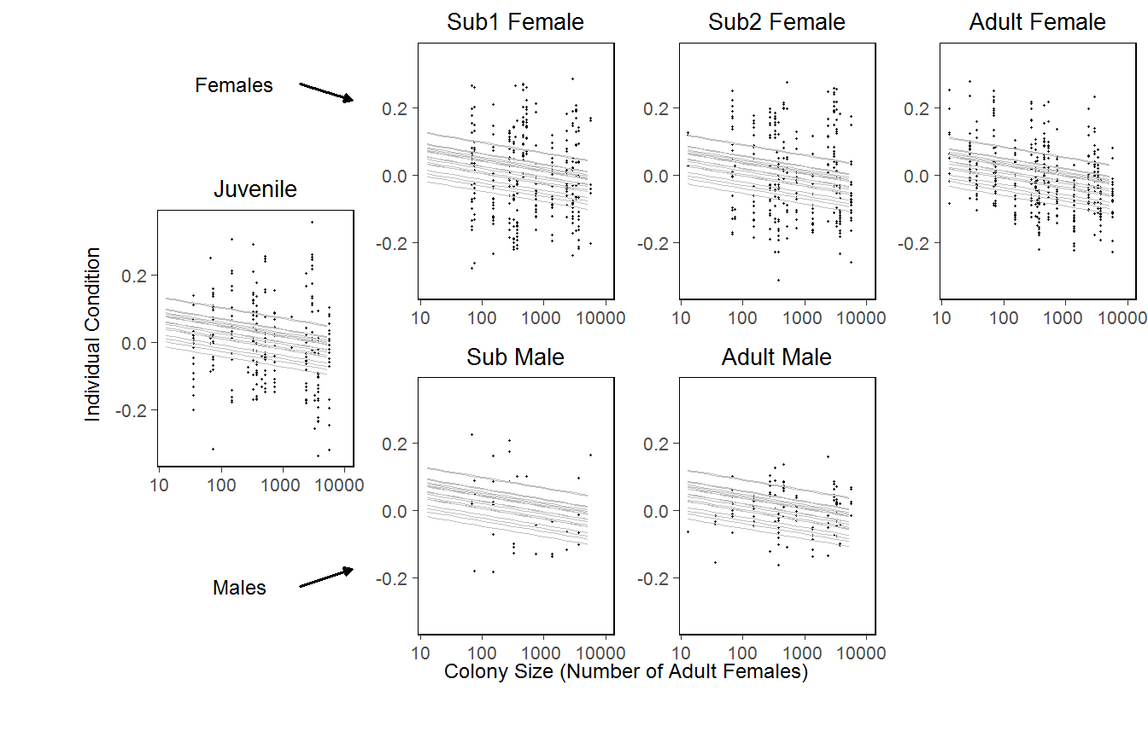

[1] "(figure 3.2)"

*FIGURE : Individual condition against colony size, with the linear model superimposed. Overall condition decreases with colony size (p = 0.031 * )*

### Within-colony variance against colony size

#### Leg length variance

There was no significant effect of nest size on within-colony variance in leg length. However, the average within-colony uniformity in leg length 0.09 0.02, which is large given that the range of possible values is between zero and one.

#### Condition variance

|  |  |  |  |  |  |  |  |
| --- | --- | --- | --- | --- | --- | --- | --- |
|  | (Intercept) | logCtFm | I(InstarNumber^2) | InstarNumber:InstarSexF | InstarNumber:InstarSexM | InstarNumber:InstarSexF:I(InstarNumber^2) | InstarNumber:InstarSexM:I(InstarNumber^2) |
| L1 | 0 | 1 | 0 | 0 | 0 | 0 | 0 |

The average within-colony condition variance was also small at 0.07 0.02. However, there were significant fixed effects.

The model ..... (see appendix).

Colony size had a significant effect (glmmPQR; 21 = 7.184, p 0.007 **) as within-colony condition variance decreased with increasing colony size (figure 3.3).

|  |  |  |  |  |  |  |  |
| --- | --- | --- | --- | --- | --- | --- | --- |
|  | (Intercept) | logCtFm | I(InstarNumber^2) | InstarNumber:InstarSexF | InstarNumber:InstarSexM | InstarNumber:InstarSexF:I(InstarNumber^2) | InstarNumber:InstarSexM:I(InstarNumber^2) |
| L1 | 0 | 0 | 0 | 1 | 0 | 0 | 0 |
| L2 | 0 | 0 | 0 | 0 | 1 | 0 | 0 |

Interactions of instar age or sex with colony size were not significant.

The interaction instar age by sex was significant (glmmPQR; 22 = 37.92, p 0 ***),

|  |  |  |  |  |  |  |  |
| --- | --- | --- | --- | --- | --- | --- | --- |
|  | (Intercept) | logCtFm | I(InstarNumber^2) | InstarNumber:InstarSexF | InstarNumber:InstarSexM | InstarNumber:InstarSexF:I(InstarNumber^2) | InstarNumber:InstarSexM:I(InstarNumber^2) |
| L1 | 0 | 0 | 0 | 0 | 0 | 1 | 0 |
| L2 | 0 | 0 | 0 | 0 | 0 | 0 | 1 |

as was instar age squared crossed with sex (glmmPQR; 22 = 24.159, p 0 *** (figure 3.3). Within-colony variance in condition peaked at intermediate instar ages and was higher for males (figure 3.4).

Note: If line on graph is blue R could not plot the lmer, plotting a simple lm instead[1] "glmmpql"

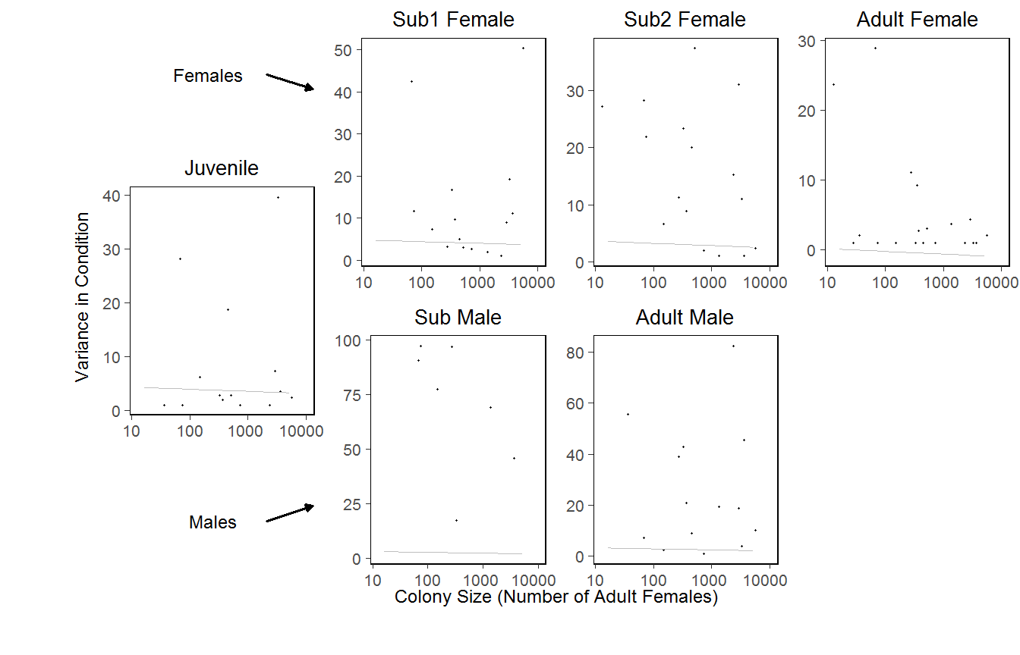

[1] "(figure 3.3)"

_FIGURE : Within-colony condition variance against colony size with the results of the generalized linear model for individual instars superimposed. Colony size had a significant effect on condition variance (p 0.007 **)._

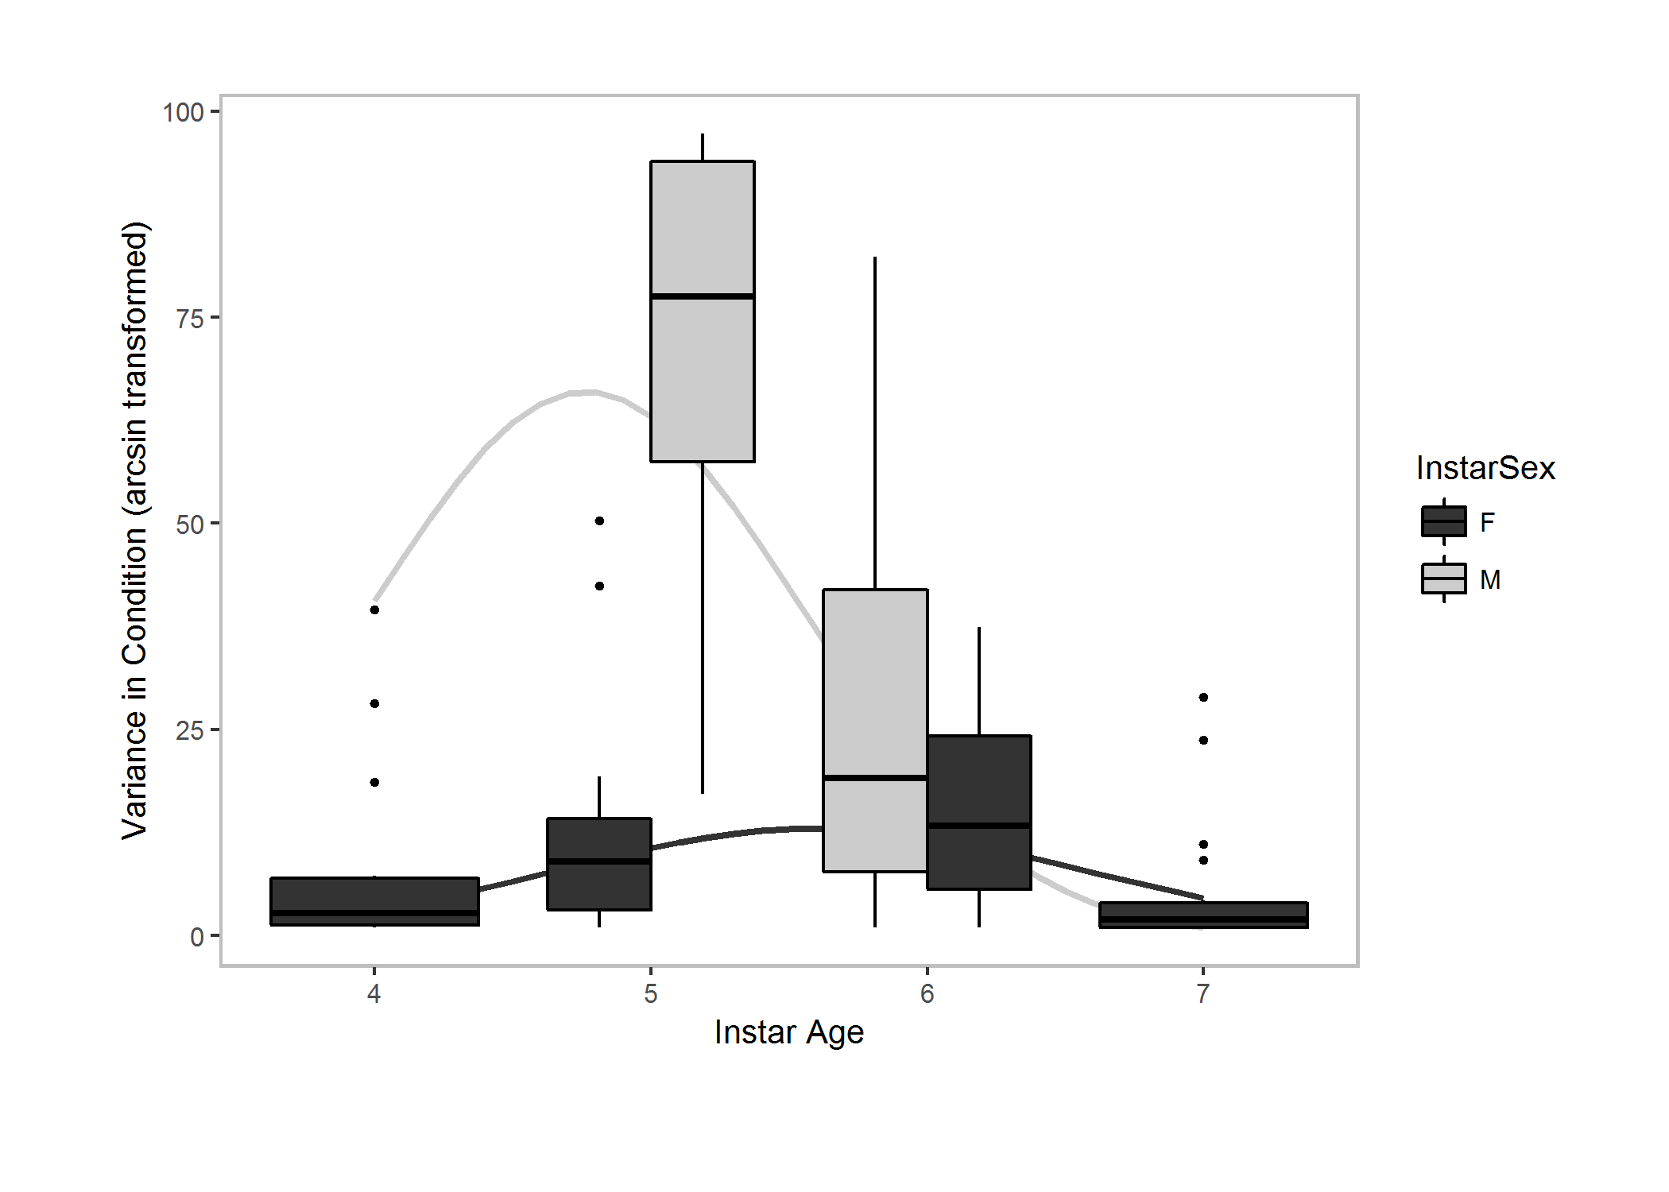

[1] "(figure 3.4)"

*FIGURE :Within-colony condition variance as a function of instar age and sex. Overlaid is the generalized linear model, which has the square of instar age as a significant term.*

### Size and condition of dispersers

Adult female leg length was larger (lmer; 24,5= 3.9, p = 0.048 * ),

and their individual condition greater (lmer; 24,5= 9.45, p = 0.002 ** ), when dispersed in propagules compared to adult females in their natal colonies (figure 3.5).

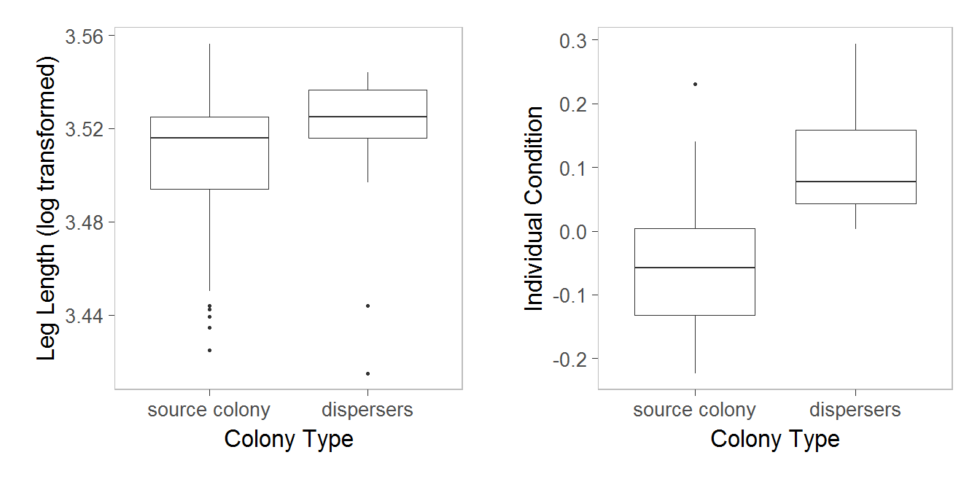

[1] "(figure 3.5)"

*FIGURE: Leg length and individual condition of adult females in propagules compared to adult females in their natal colony following dispersal. There was a significant difference between the two for both variables (leg lengh: stats, condition: stats), n source colonies = 2, n propagules = 39*

## Instar Age x nest size Interaction Graph

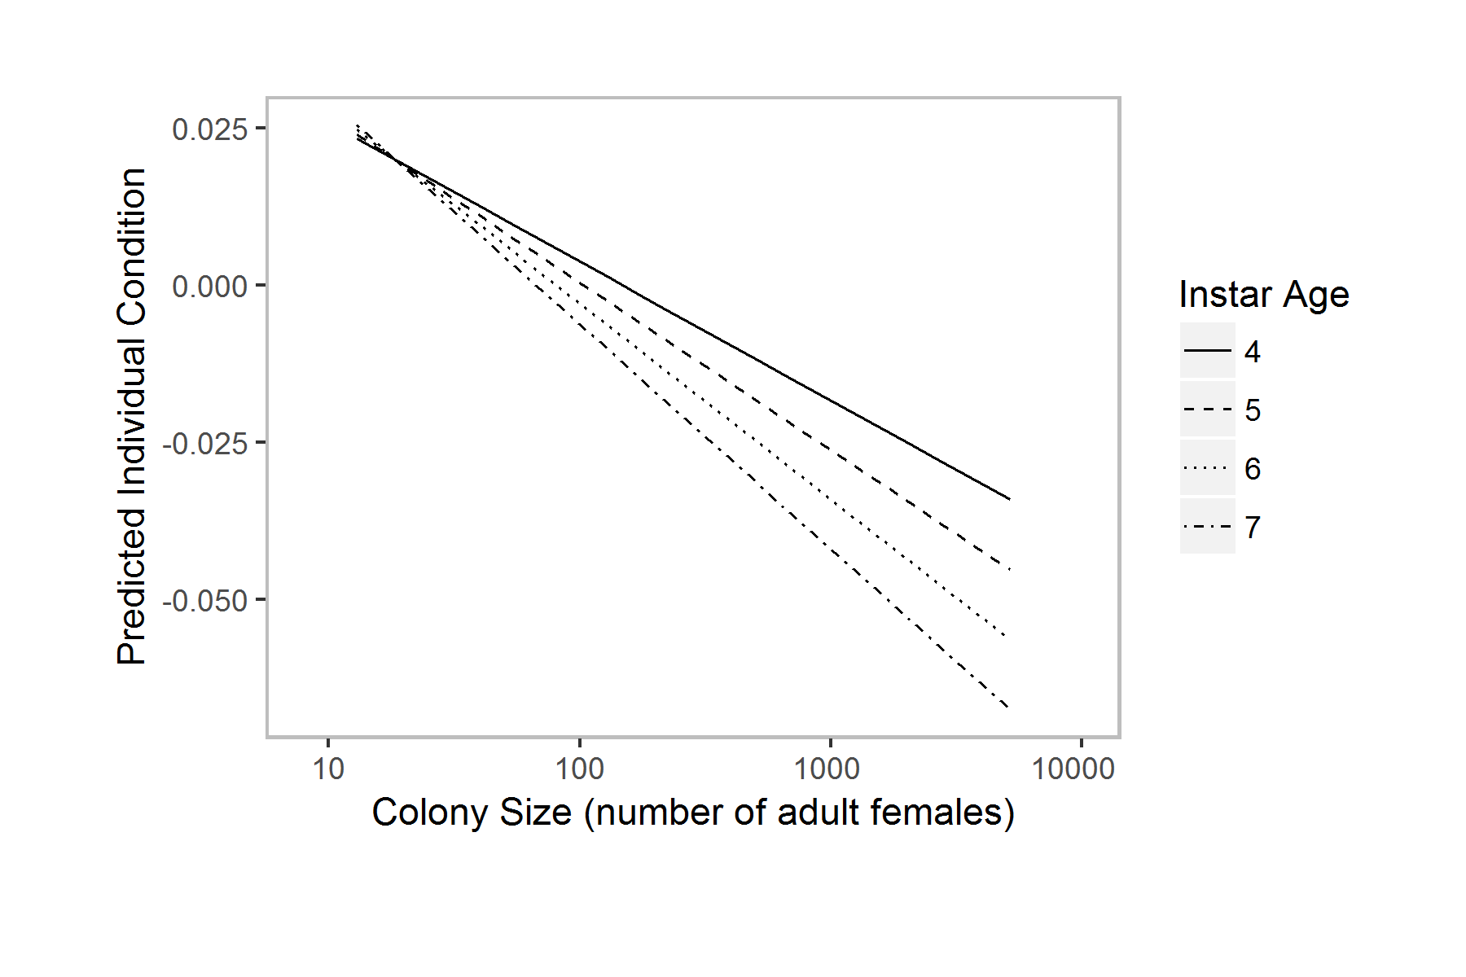

### Single female colony survival

We found that propagules established by single females had a very low survival rate, with a mid-life of xx days and only a ~15% surviving to 50 days after establishment  
(figure 3.6).

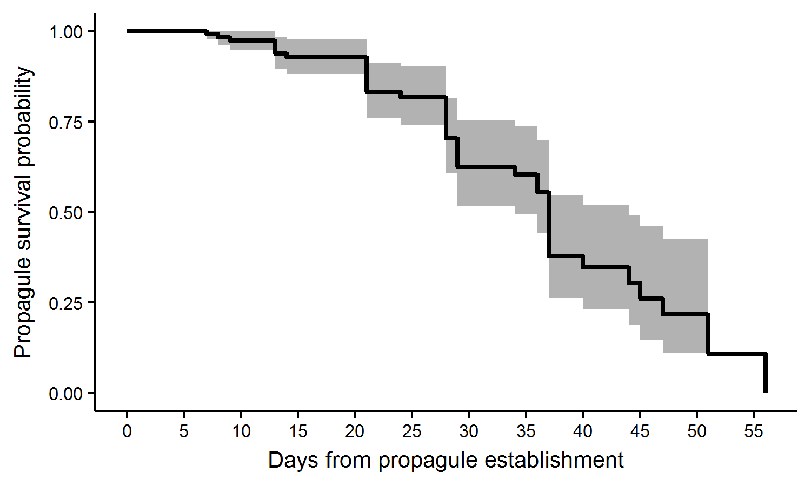

[1] "(figure 3.6)"

*FIGURE: The survival function of 40 propagules from 10 source colonies. Grey shading represents the 95% confidence interval.*