Leg Length vs Nest Size Up Step model addition

Ruth Sharpe

Run on 23 August, 2017 at 2017-08-23 16:11:37

# Model Addition

logLeg ~ logCtFm + InstarNumber + (1 | NestID) vs logLeg ~ logCtFm + InstarNumber + (1 | NestID) + InstarNumber:InstarSex

logLeg ~ logCtFm + InstarNumber + (1 | NestID) + InstarNumber:InstarSex vs logLeg ~ logCtFm + InstarNumber + (1 | NestID) + I(logCtFm^2) + InstarNumber:InstarSex

logLeg ~ logCtFm + InstarNumber + (1 | NestID) + I(logCtFm^2) + InstarNumber:InstarSex vs logLeg ~ logCtFm + InstarNumber + (1 | NestID) + I(logCtFm^2) + InstarNumber:InstarSex + logCtFm:InstarNumber

logLeg ~ logCtFm + InstarNumber + (1 | NestID) + I(logCtFm^2) + InstarNumber:InstarSex + logCtFm:InstarNumber vs logLeg ~ logCtFm + InstarNumber + (1 | NestID) + I(logCtFm^2) + InstarNumber:InstarSex + logCtFm:InstarNumber + logCtFm:InstarNumber:InstarSex

Final model is logLeg ~ logCtFm + InstarNumber + (1 | NestID) + I(logCtFm^2) + InstarNumber:InstarSex + logCtFm:InstarNumber

## Checking full model fit

log(LegLength)=log(ColonySize) + InstarAge + (1|Colony) + Ilog(ColonySize)2 + InstarAge:InstarSex + log(ColonySize):InstarAge

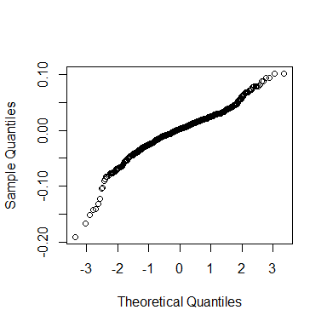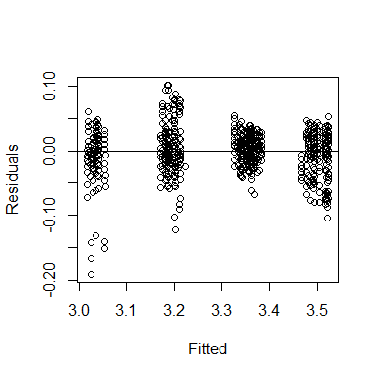

# Graph with full model superimposed

Model:  
logLeg ~ logCtFm + InstarNumber + (1 | NestID) + I(logCtFm^2) + InstarNumber:InstarSex + logCtFm:InstarNumber

Note: If line on graph is blue R could not plot the lmer, plotting a simple lm instead[1] "lmer"

